We have updated the Transit Worker Assault Flag so that “Y/N” values are accurate for all years of the file, not just years 2023 and later.
Following the 2023 reporting change, where transit agencies were required to provide additional detail when a transit worker was injured in an assault, we began capturing a transit worker assault flag in the NTD Datamart and publishing the flag in the Major Events file at data.transportation.gov. This flag is useful for creating summary counts of TWA since the reporting change. However, for events prior to the reporting change the values in this column are misleading. For data users unfamiliar with the change in reporting circa 2023, they may be under the impression that we did not collect transit worker assault data prior to 2023, or even that there were no transit worker assault events prior to 2023. Example from query of the file on data.transportation.gov:
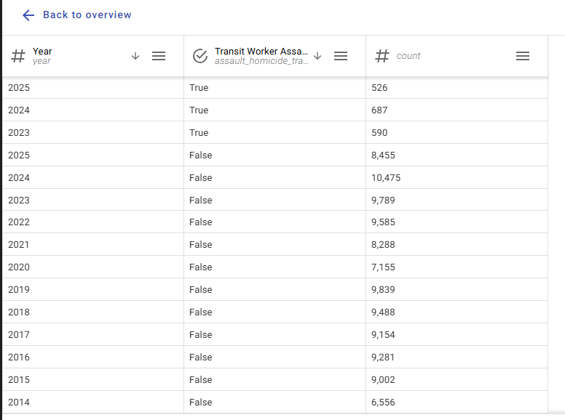If users of the dossier or the public file want to get details on TWA events prior to the reporting change they have to apply the following filter logic (column positions based on Excel export):
"When the sum of Transit Vehicle Operator Fatalities (column CC), Non-Operator Transit Employee Fatalities (column CD), Other Worker Fatalities (column CE), Transit Operator Injuries (column CS), Non-Operator Transit Employee Injuries (column CU) and Other Worker Injuries (column CW) is greater than zero, filter event type raw to Assault and Homicide. You can then filter by year."
This leaves lots of room for user error if a column is filtered incorrectly. Additionally, the performance of the public facing file lags considerably when conducting the query on the data.transportation.gov platform.
In order that this flag column can show accurate data for years prior to 2023 and allow for more streamlined filtering and interaction with the file, we have incorporated the filter logic further upstream in our file production process. Now, for any event prior to the 2023 reporting change, the column reflects the result of the logic described above.
In developing the change to the TWA flag column, we have also determined that “Other Worker Fatalities” and “Other Worker Injuries” should not be used when identifying Transit Worker Assaults for years prior to 2023.

The Major Events file currently counts 231 events from 2014 to mid-2023 as Assault/Homicide Events Involving Transit Workers that this change will impact. These events only have a non-zero injury or fatality count in the other worker columns, so they should not be included in the sum. The count will decrease by an average of around 13.5 for each of these years. Counts from 2008–2013 will also need change because the time series files include those years.

