TranslateIT
TranslateIT is a simple translation tool that allows localizing our innovation prototypes and mobile products.

Access
To access TranslateIT you should direct your browser to this url:
http://translate-it.appspot.com/

Login with a Google account
If you have provided a Google account (e.g. yourname@GMAIL.COM) you can click on the “Sign in with Google” button:
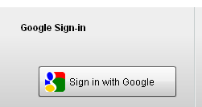

Login with another account
If you have been provided a login and password you can use the login form on the right hand side:
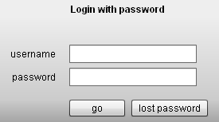

Change Password
Once you have authenticated you can change your password anytime by clicking on the profile button:
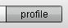

Usage

Translating keywords
The Application itself is as simple to use as an Excel table:
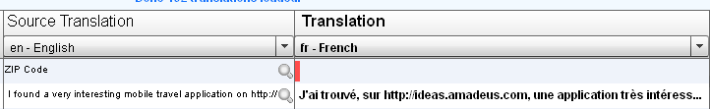
In the "Source Translation" column (left) you see e.g. the English original translation that you need to translate into your language.

The fields marked in red are not translated. Just click into them (on the right) and type the translation:
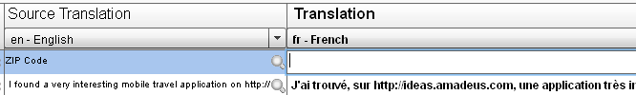

Once you press “Enter” or click on another field the changes will be saved automatically.

Note: Some languages are more equal than others. If you are e.g. doing a Russian translation you might want to see what your Ukrainian colleague has translated. To do so you can use the drop-down on the left:
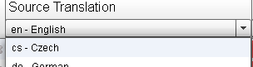

Translation Wizard
A very useful feature is the translation wizard. You can launch it by clicking the little icon next to the keyword:
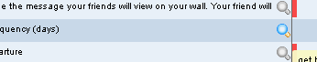

When you click it a window opens up:

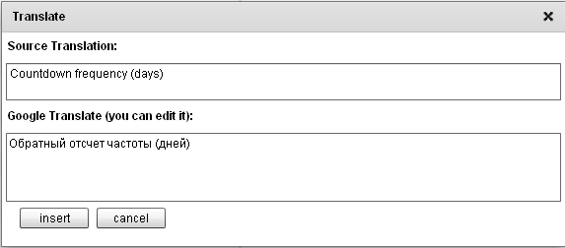
In this window you get a translation from Google translate.

Sometimes it is correct and sometimes you need to correct it or rewrite everything. But it gives you a little help to ease the work.
Press “insert” when you are done.

Control Bar
Some useful functions are grouped in the top control bar
.. the features are:
 | A progress indicator showing how much % is done
 | A search box to filter the list by a keyword. This can often be very helpful when you want to correct an existing translation.
 | The refresh button is only needed if you want to reload all translation from the server. This can be a good way to check that all your changes where saved correctly.
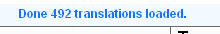 | A message text that gives you feedback from the server.

Feedback
For any feedback you can contact ingolf.tobias.rothe@amadeus.com

Thank you for helping us translating our prototypes and mobile products.

