**Mission**

From the language industry, for the language industry.

The mission of translate5 is the community-driven and continuous development of the open source and cloud-based translation management system of the language industry.

**Realisation of the translate5 mission**

The translate5 mission is realised via a continuous cycle of development and improvement. It describes the translate5 business model which consists of the following four process elements:

Ein Bild, das drinnen, Flasche, klein, sitzend enthält.

2: Continuous cycle of development and improvement

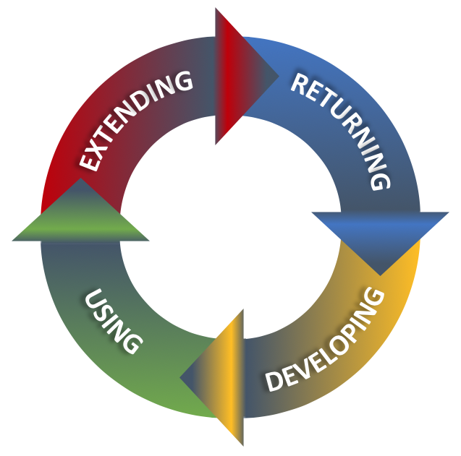

1: Four process elements of

the translate5 software development

1. **Developing**

Translate5 is developed by the collaboration of professionals. They come together as translation experts, language researchers and translation software developers who are aware of the special needs of a translation tool. Communicating and discussing their expectations with each other let to the realisation of their special needs and become true as cloud-based TMS. This process is led and organised by MittagQI as the lead development company doing large parts of the development work behind translate5. MittagQI coordinates the road-map with the community and ensures good architecture and a high code quality.