Mission
From the language industry, for the language industry.
The mission of translate5 is the community-driven and continuous development of the open source and cloud-based translation management system of the language industry.
Realisation of the translate5 mission
The translate5 mission is realised via a continuous cycle of development and improvement. It describes the translate5 business model which consists of the following four process elements:
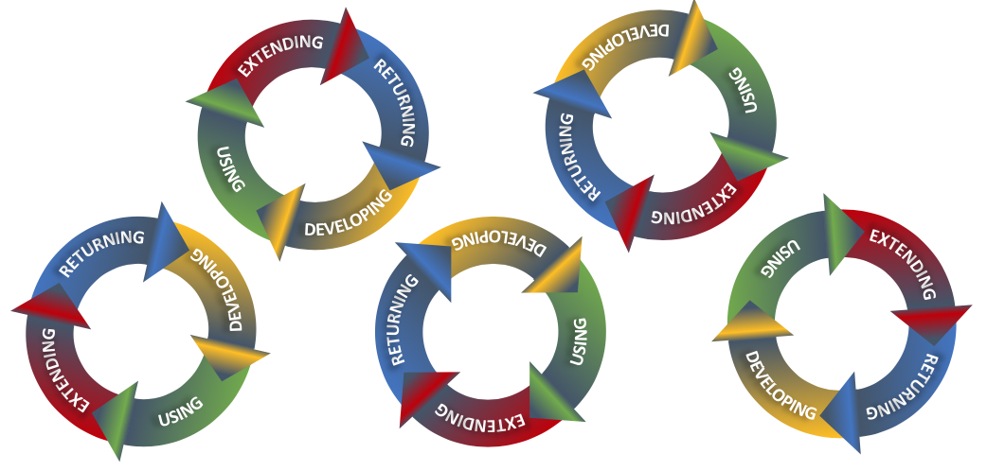
2: Continuous cycle of development and improvement

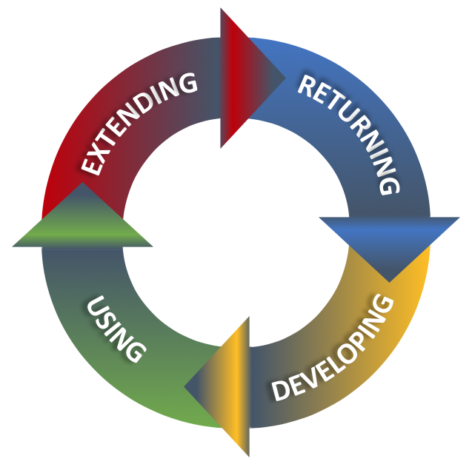
1: Four process elements of
the translate5 software development

- Developing

Translate5 is developed by the collaboration of professionals. They come together as translation experts, language researchers and translation software developers who are aware of the special needs of a translation tool. Communicating and discussing their expectations with each other let to the realisation of their special needs and become true as cloud-based TMS. This process is led and organised by MittagQI as the lead development company doing large parts of the development work behind translate5. MittagQI coordinates the road-map with the community and ensures good architecture and a high code quality.

- Using

The stable and user-friendly cloud-based translation software product translate5 can be integrated and used by different target groups like language service providers, companies, freelancers and state institutions.

- Extending

Joining the community and enhancing the strength of translate5 is meant by extending. This can happen in different ways like:

- Spread the idea of an open source and cloud-based TMS
- Give feedback to our developers
- Fund features
- Contribute to documentation
- Develop plug-in’s
- Contribute to core development
- Permanent funding

The aim of translate5 is to provide to all users the control of their own relevant software development. Therefore, all users are allowed to extend translate5 according to their special needs. This opportunity is given because open source is the conceptual base of translate5 and the flexible, extendable architecture of the system.

- Returning

The whole philosophy of translate5 means not only that you can use and extend the software tool for own usage but also to give new versions and features back to the community and into translate5 as core product. That philosophy is based on both the AGPLv3 as well as the GPL3 license model and the idea of freedom of software.

