# How to add a macro keyboard shortcut in Microsoft Office

1. Open Microsoft Word, and clicn on « **File**»

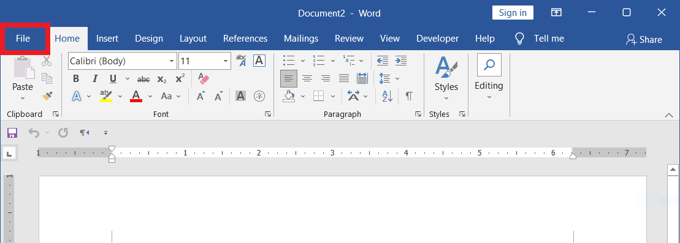

1. Click on « **Options** » menu

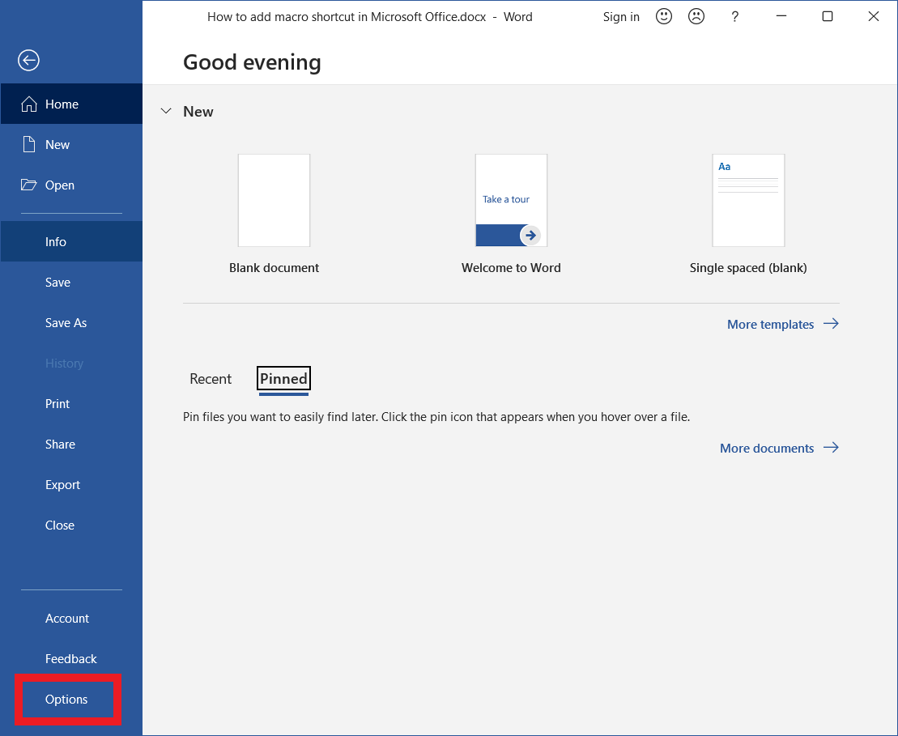

1. Select « **Customize Ribbon** » and then Keyboard shortcuts « **Customize** »

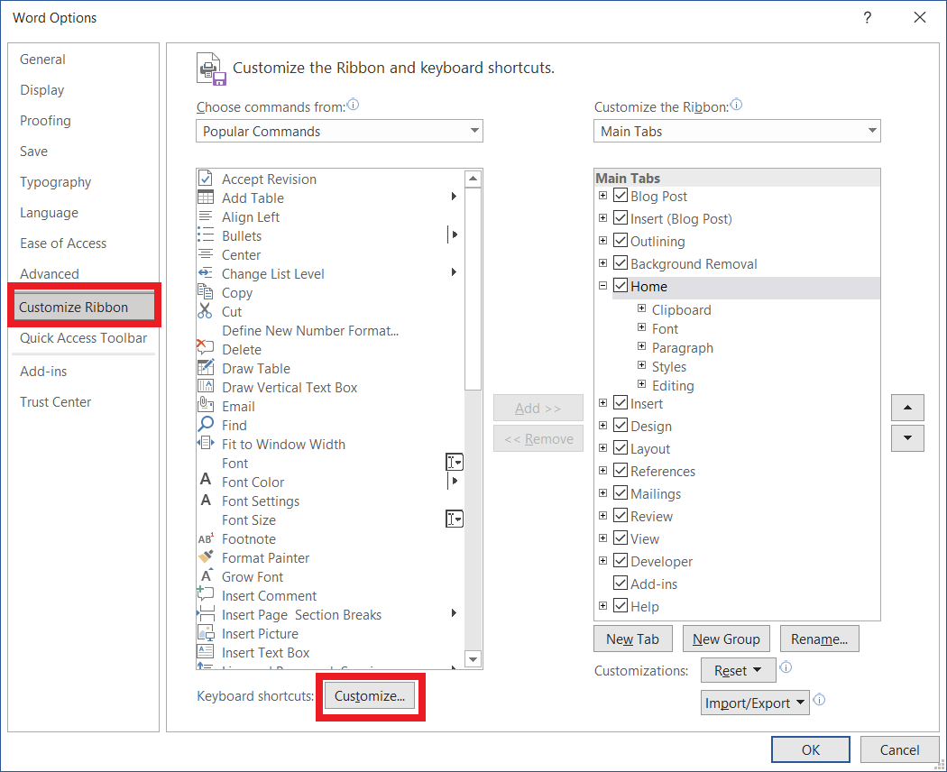

1. Select « **Macros** », the macro name and create a keyboard shortcut

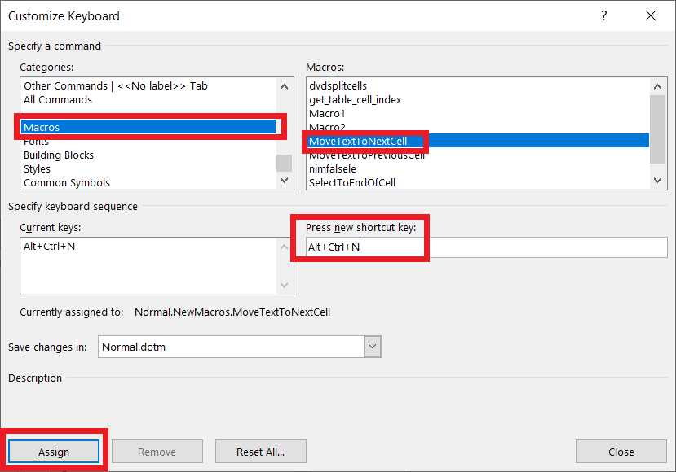

In this example we assign **CTRL+ALT+N** for the **MoveTextToNextCell** Macro.

Also set **CTRL+ALT+P** for the **MoveTextToPreviousCell** Macro.

# How to use the macro keyboard shortcut in Microsoft Office

1. Open a word document and select the position where the text is to be moved.

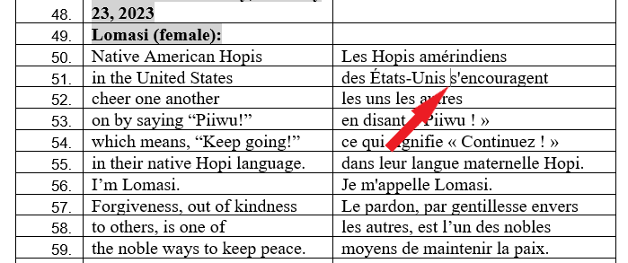

Position the cursor where the end of the line must be move the the cell on the line below or the beginning of the line on the cell of the previous line.

1. Run the macro using the shortcut

* Type CTRL-ALT-N to move the end of the current line to the beginning of the cell on the next line.
* Type CTRL-ALT-P to move the beginning of the current line to the end of the cell on the previous line.