To setup a clinical trial, experimental medicine study, or internal study for security:

- Public Studies must not have security setup for the study. The necessary infrastructure is maintained as part of the data loading process. All users of tranSMART have access to Public Studies.
- Get the bio_experiment_id that was assigned to the trial or study as a step in the data loading process.
  - Select accession, bio_experiment_id from biomart.bio_experiment
where accession in (list of trial/study ids)
  - There are cases where the accession name is not the same as the name shown in Dataset Explorer. They include:
Dataset Explorer Path | Accession
- \BRC Antidepressant Study\ | - BRC_ANTIDEP_STUDY
- \BRC Depression Study\ | - BRC_DEP_STUDY
- \SebastianJohnston_Asthma_Study\ | - SJ_ASTHMA
- \Veridex_BreastCancer_2003\ | - VERIDEXBC2003
- \Veridex_ColonCancer_2003\ | - VERIDEXCC2003
- \Veridex_LungCancer_2003\ | - VERIDEXLC2003
- \Veridex_OvaryCancer_2004\ | - VERIDEXOC2004
- \Veridex_ProstateCancer_2004\ | - VERIDEXPC2004
- Get the top-level path name for the trial or study
  - Select c_fullname from i2b2metadata.i2b2
where c_hlevel = 0
order by c_fullname
  - This will list the top-level path name for all trials and studies
- Logon to TranSMART using an account with Administrator role.
  - Development, QA and Production must be done separately.
  - Once a trial or study has had its security information loaded into development, the same information should be populated into the other two environments as the data is promoted.
- Navigate to Admin=>Add Study
  - Bio Data Id: enter the bio_experiment_id
  - Data Type: BIO_CLINICAL_TRIAL
  - Bio Data Unique Id: EXP: plus the accession (for example, EXP:C0168T37, EXP:SJ_ASTHMA)
  - Display Name:
    - For Clinical Trials, Clinical Trial – accession.
    - For Experimental Medicine Studies, Experimental Medicine Study – (long name from c_fullname with underscores replaced by spaces).
    - For Internal Studies, Internal Study – (long name from c_fullname with underscores replaced by spaces).
  - click the Create link
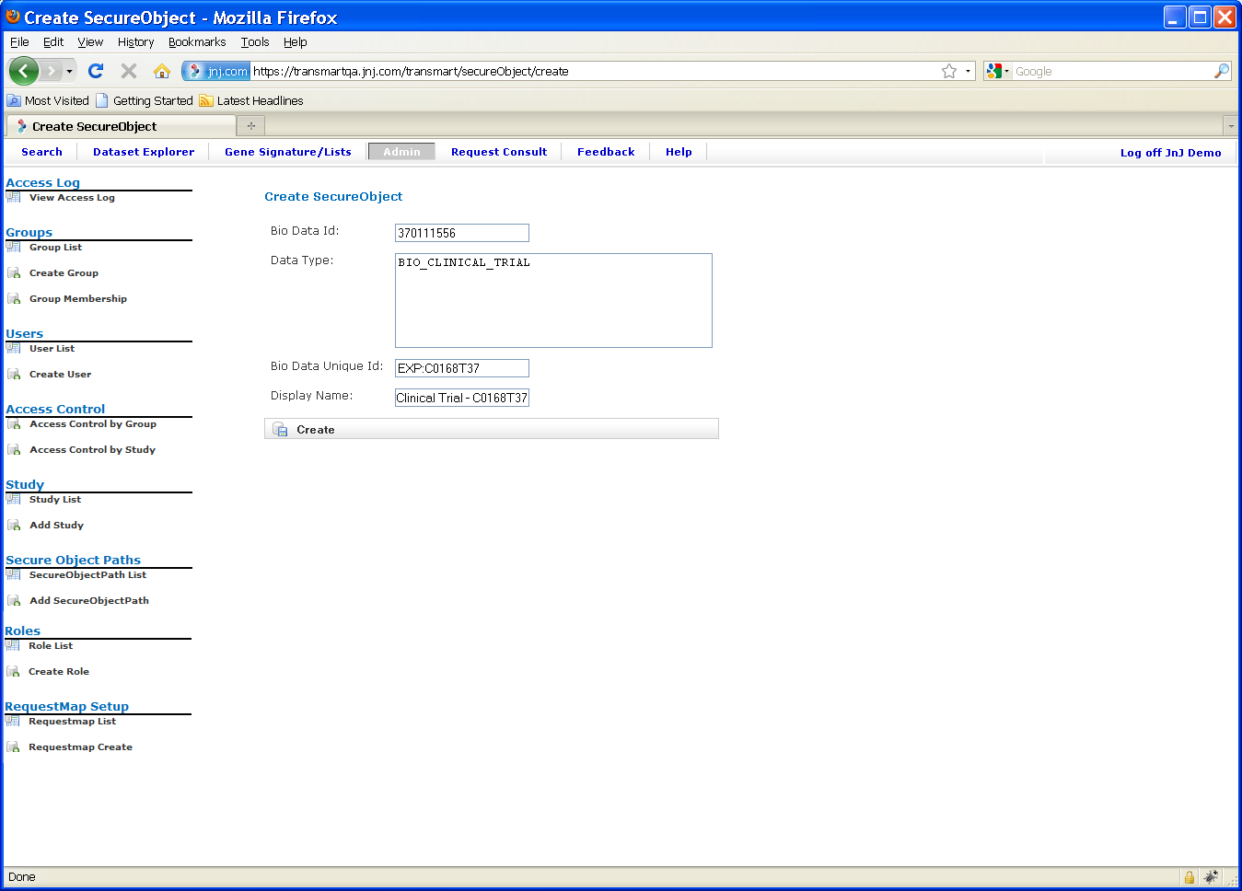
  - The Show SecureObject window appears, confirming that the secure object was created.
- Assign users and/ or user groups access rights to the new secure object, as follows:
  - Click Access Control by Study.
  - In the Secure Object field of the Manage Study Access window, specify the name of the secure object you just created:
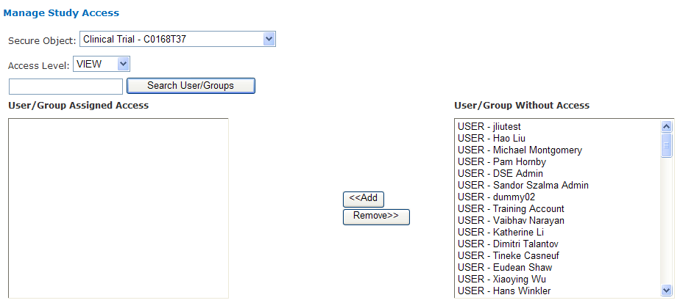
  - Specify the Access Level (OWN, EXPORT, VIEW).
  - Below Access Level, optionally specify part or all of a user or group name, then click Search User/Groups.
  - In Available Studies, select one or more users and/or groups to assign access privileges to the new secure object, then click Add:
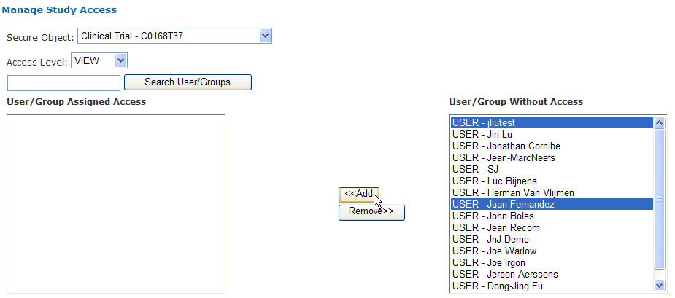
  - When the name(s) appear in the User/Group Assigned Access box, the access permissions for the new secure object have been granted. There is no “Save” or other confirmation button that you need to click.

