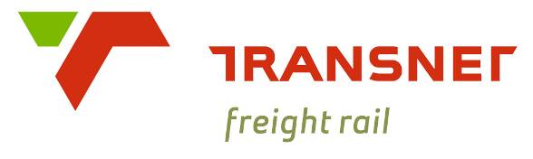

A Division of Transnet SOC Limited

**TECHNOLOGY MANAGEMENT**

**CONCEPT OF OPERATIONS**

**TRAIN TRACKING AND IDENTIFICATION**

|  |  |  |  |
| --- | --- | --- | --- |
| Author: | Engineer  Technology Management | F. van Rooyen |  |
| Approved: |  |  |  |
| Authorised: |  |  |  |
| Date: | | | July 2025 |

Circulation Restricted To:

Transnet Freight Rail

Transnet and Relevant Third Parties

© This document as a whole is protected by copyright. The information herein is the sole property of Transnet SOC Ltd. It may not be used, disclosed or reproduced in part or in whole in any manner whatsoever, except with the written permission of and in a manner permitted by the proprietors.

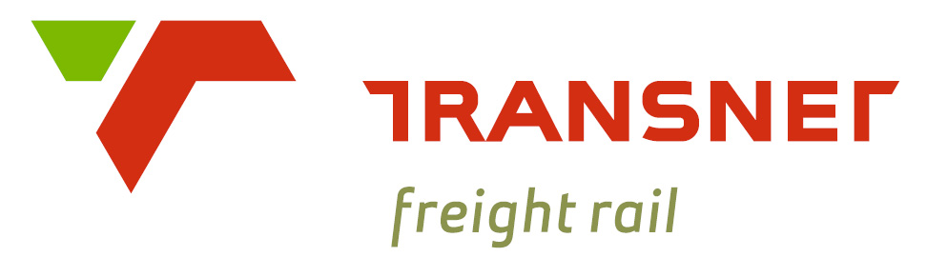

Table of Contents

Glossary 1

Introduction 1

1.1. Background 1

1.2. Document overview 1

1.3. Documents referenced 1

2. Current System 2

2.1. Current Situation 2

2.2. Justification for changes 3

2.3. Capability needs 4

2.4. Capabilities considered but not included at this time 4

3. Operations and Support Description 4

3.1. Missions (Primary/Secondary) 4

3.2. Users and other stakeholders 4

3.3. Policies, assumptions, and constraints 5

3.4. Operational Description 5

3.4.1. Operating Concept 5

3.4.2. Dependencies 8

3.4.3. Operating Environment 8

4. Scenarios 1

# Glossary

|  |  |
| --- | --- |
|  |  |
|  |  |
|  |  |
|  |  |
|  |  |
|  |  |
|  |  |
|  |  |
|  |  |
|  |  |
|  |  |
|  |  |
|  |  |
|  |  |
|  |  |

# Introduction

## Background

This Concept of Operations (ConOps) serves as the first in a series of engineering documents describing the implementation of vehicle identification and tracking within Transnet Freight Rail (TFR). The purpose of the ConOps is to convey a high-level view of the concept.

The eventual goal is to firstly accurately identify vehicles and trains on the TFR network and secondly track their location in real time.

Various technologies and processes have been implemented within TFR to this purpose, with mostly underwhelming results. This new proposed concept attempts to learn from previous attempts to achieve track and trace capabilities.

## Document overview

This document contains the following information:

* Chapter 1 provides background for the problem, identifies all documents referenced and provides an overview of the document.
* Chapter 2 discusses the capability need and gives an overview of the current system and its capability gaps
* Chapter 3 provides and operational and support description of the system
* Chapter 4 described how the project is envisioned to operate from various perspectives (scenario based)

## Documents referenced

|  |  |  |
| --- | --- | --- |
| Document Name | Document Type | Internal or external reference |
|  |  |  |
|  |  |  |
|  |  |  |
|  |  |  |
|  |  |  |
|  |  |  |
|  |  |  |
|  |  |  |
|  |  |  |
|  |  |  |
|  |  |  |
|  |  |  |

# Current System

## Current Situation

We are unable to consistently identify vehicles, match them to trains, or track their movements accurately.

Train numbers and vehicle lists are generated by the ITP. Whenever there is a replan the train number changes. Exceedingly difficult for systems to track this. TCOs, due to the frequent changes and/or human error, enter train numbers into the VDU Train authorisation interface that do not align with the ITP. The VDU train authorisation interface datastore is the TMS. The vehicle lists also become non-aligned due to on-the-fly substitutions made by yard officials whilst building the trains. The actual vehicle lists are manually captured once a train is built and uploaded to the ITP, from where a copy is made to the TMS. There is a big time delay between the train departing and the vehicle list being accurately updated to the ITP.

The TCO authorises all train movements. As the train moves, it drops the track relays. This track relay drops are displayed on the VDU, allowing the TCO to track the movement. The track relays are sometimes placed up to 50 kilometres apart. Train tracking is therefore not very granular. Much of the track infrastructure is broken due to lack of spares, vandalism and/or theft posing further challenges to tracking the train accurately.

Along the train track, Vehicle Identification Systems (VIS) are placed to supplement the train authorisation systems train tracking capabilities and automatically create up to date vehicle lists. These VIS work by reading each vehicle’s RFID tag and compiling a vehicle list. This vehicle list is then coupled to a train number by searching the local TMS datastore for any trains that was listed as being in the vicinity of the VIS site optic within a time window around the train’s passing. The following issues:

* Cannot always find a train number to couple the vehicle lists to.
* VIS are frequently vandalised and out of commission resulting in large gaps in the tracking ability.
* Vehicle tags are either not present (they fall off due to inadequate adhesion methods) or inaccurately programmed. Incomplete vehicle lists.

Condition Assessment Systems (CAS) obtain train numbers and subsequently, vehicle numbers through a search algorithm managed by the ITCMS. When a train passes over a CAS site, the ITCMS searches the local TMS datastore for any trains that was listed as being in the vicinity of the CAS site optic within a time window around the train’s passing. Once a train number has been obtained, the ITCMS searches a different table in the datastore for that train’s vehicle list. The measurements taken are then coupled to the vehicle list obtained. Many problems with this process:

* The ITCMS cannot always find a train number for the following reasons:
  + Time window is either too big or too small, resulting in the algorithm getting multiple train numbers or none at all
  + Incorrectly configured optics.
  + Process relies on reliable and accurate VIS’s.
* Once a train number has been obtained, accurate vehicle numbers cannot be obtained due to the following reasons:
  + The train number saved in the TMS datastore by the TCO and the ITP train number to which the vehicle list is coupled aren’t the same.
  + The vehicle list in the ITP does not reflect reality and haven’t been updated to reflect reality at the moment of the search.
  + The vehicle lists produced by the VIS aren’t complete.

Multiple tracking solutions have been implemented in locomotives. Most of which failed.

* **Triton**: The TRITON unit is an integrated locomotive data communication and tracking system. The unit allows for the communication between locomotive peripheral systems and the Transnet WAN. Triton has GPS tracking functionality which is communicated alongside locomotive system information over GSM, WIFI and UHF Radio communication channels. Issues:
  + Because TRITON relies on GSM network for data transmission, data reception depends on the area's network coverage. Therefore, the reception of the data is inconsistent just as GSM network coverage across Transnet lines.
  + Coupling the TRITON unit identification number to a train number has proven to be nigh on impossible.
* Telemeter: The telemeter unit is used to enforce emergency braking of trains. Each locomotive carries a telemeter. The telemeter units transmit their telemeter id’s along with their GPS coordinates where upon reception the data is stored within a Transnet Postgres database.
  + The telemeter is on the trains' rear, so only the rear GPS position is transmitted. This is an issue when trains are 4 km long.
  + telemeter housing boxes are swapped during servicing, causing a mismatch between the external and internal unique telemeter IDs. Since the telemeter ID is used to link locomotives to GPS positions and train numbers, this mismatch results in incorrect locomotive-train associations, leading to invalid data.
* Locomotive Controller Unit: Many of the locomotives come equipped with onboard Electrical Control Units (ECU) that often include basic GPS positioning functionality. The ECU samples positioning data and transmits it through the onboard communication channels. Issues:
  + This data is considered non-vital and is thus not maintained to a high standard.
  + Inconsistent and infrequent reporting intervals
  + Communication drops

## Capability needs

The following requirements have been identified as necessary to achieve tracking and identification of trains.

1. Single source of train numbers for OT systems that preferably never changes.
2. Accurate matching of a train number to a vehicle list or at least a leading loco.
3. Accurate and reliable capturing of vehicle lists by VIS.
4. Accurate and reliable capturing of vehicle lists by CAS sites.
5. Real time locomotive position communicated promptly.

Possible, but not necessary capabilities include knowing where the end of the train is.

## Capabilities considered but not included at this time

The following capabilities were identified but will not be implemented at this time:

# Operations and Support Description

## Missions (Primary/Secondary)

Within this section, the primary and secondary missions/applications of the tracking and identification capability is presented.

The primary mission of this capability is:

* + 1. Enable the accurate tracking and identification of trains and the vehicles that collectively form them.

Secondary missions of this capability are:

## Users and other stakeholders

Users are those who will directly interact with the capability once it is operational. The following user classes have been identified:

* **TCO’s**: This user class consists of the people physically manning the Central Train Control and interacting with the VDU. These users will hence forth be the single source of train numbers and responsible for ensuring correct coupling of train numbers and their leading locomotive numbers.
* **Train Drivers**: These users drive trains and will help ensure accurate coupling of train numbers and leading locomotive numbers.
* **Support and maintenance users**: This class consists of those who will support and maintain the capability and all supporting systems throughout its lifecycle.

The following key internal stakeholders are responsible for the implementation of the capability:

* **Technology Management - TAT Office**: Redevelopment of the VDU.
* **Technology Management – CAT Office**: Redevelopment of the ITCMS and VIS systems.
* **Technology Management** – TMT Office: Redevelopment of the TMS.
* **OCC – Rail Traffic Control and Compliance**: Development and enforcement of new TCO SOP and TCO-Train Driver train number validation protocols.
* **Technology Management – LIT Office**: Oversee Development and installation of Locomotive Tracking Units.
* **Transnet Engineering**: Installation and maintenance of new Locomotive Tracking Units.

External stakeholders are:

* Service Providers
* Vendors
* Rail Safety Regulator

## Policies, assumptions, and constraints

#### Policies

The proposed capability will be subjected to or influenced by the following policies:

* TFR Digital Strategy.
* TFR Architecture Standards

#### Assumptions

#### Constraints

The proposed capabilities will operate within the following constraints:

* Limited funding for the system and supporting technologies
* Procurement constraints (bottlenecks, local content requirements, active list of vendors etc.)
* Connectivity issues in many areas of operation.
* Power constraints within Locomotives.

## Operational Description

### Operating Concept

The overarching concept of the tracking and identification capability is depicted in Figure 1. The tracking and identification capability is achievable only if we are able to 1. Accurately identify vehicles at various points along the network and 2. Accurately track the position of our locomotives. These two abilities will be useless unless we are able to link, with 100% accuracy, vehicle lists with train numbers.



Figure 1: Track and Identification Capability Pillars

Achieving this capability will require development and redevelopment across various systems as seen in Figure 2:



Figure 2: System View of Capability Achievement

The identification and tracking capability dataflows and system integrations are shown in Figure 3 and Figure 4.



Figure 3: Context Diagram - DFD0



Figure 4: Data Flow Diagram 1

### Dependencies

Unlocking the capability fully will rely on the following supporting projects:

* Updating CTC and train driver directives to incorporate the operating concept described in this document.
* Onboarding satellite communications to eliminate system failure due to insufficient GSM availability.
* Securing VIS systems from theft and vandalism
* RFID tag reader integration on CAS sites.

### Operating Environment

Components enabling this capability spans three main environments as shown in Figure 5. Lines between environments indicate communication interfaces available.



Figure 5: Operating Environments

# Scenarios

