COMPARATIVE STUDY OF SUDOKU SOLVERS
SAT, CP-SAT, Mixed-Integer Programming, and Scaled Sudoku Instances

Research Project Report
Author: [Add author name]
Institution: [Add institution]
Course: [Add course name]
Date: [Add submission date]

Table of Contents
Open in Word to update this field

Abstract
This project studies several approaches to solving Sudoku as a constraint satisfaction problem. The implemented methods include Boolean satisfiability (SAT), Google OR-Tools CP-SAT, IBM CPLEX mixed-integer programming (MIP), and Gurobi MIP. The evaluation contains a 9x9 dataset of 30 instances grouped by difficulty and additional scaled Sudoku instances of sizes 16x16 and 25x25. The report summarizes measured solving times and successful solution checks from the stored benchmark results. Performance conclusions are restricted to these datasets and the tested software and hardware configuration.
Keywords: Sudoku, SAT, cardinality constraints, CP-SAT, MIP, benchmarking, constraint programming.

1. Introduction
Sudoku is a constraint satisfaction problem in which symbols must be assigned to cells while satisfying row, column, and subgrid constraints. Although the rules are simple, the search space grows rapidly with grid size. Sudoku therefore provides a useful setting for comparing general-purpose constraint and optimization solvers.
The goal of this project is to implement multiple mathematical formulations, validate their solutions, and compare empirical solving times. The project also investigates SAT cardinality encodings and extends the evaluation beyond the standard 9x9 grid.

1.1 Research questions
- How do SAT, CP-SAT, CPLEX MIP, and Gurobi MIP compare on 9x9 Sudoku?
- How does solving time change for 16x16 and 25x25 instances?
- What limitations must be considered when interpreting benchmark results?

2. Mathematical formulation

2.1 Generalized Sudoku
Let the grid have size N x N, where N = q^2 for an integer q. Each cell (r,c) receives a symbol from {1,...,N}. Every row, column, and q x q subgrid must contain each symbol exactly once. Given clues are fixed to their original values.
The number of possible assignments before constraints are applied is N^(N^2). The constraints eliminate invalid assignments, but the search difficulty depends strongly on the instance and formulation.

2.2 SAT formulation
Define a Boolean variable x[r,c,v] that is true if cell (r,c) contains value v. There are N^3 such variables. A valid encoding enforces that each cell has exactly one value, each value occurs exactly once in every row and column, and each value occurs exactly once in each subgrid. Clue constraints fix the corresponding variables.
For a set of Boolean variables X, an exactly-one constraint can be written as an at-least-one clause together with an at-most-one constraint:
OR(x in X) AND AMO(X).
The pairwise AMO encoding adds a clause (not x_i OR not x_j) for every distinct pair i < j. It is simple but uses quadratically many binary clauses in the size of X. Sequential-counter encodings use auxiliary variables to reduce clause growth for larger cardinalities. The exact encoding and implementation details should be checked against the source code before submission.

2.3 CP-SAT and MIP
CP-SAT expresses the Sudoku rules as integer constraints and solves the resulting constraint model using OR-Tools. The MIP formulations use binary decision variables x[r,c,v] and linear constraints.
For each cell, the sum over all candidate values equals one. For each row, column, and subgrid, the sum of variables associated with any fixed value equals one. Clues are imposed as fixed variables.
Although the formulations express equivalent Sudoku rules, their internal propagation, presolve, branching, and conflict-learning mechanisms differ. Runtime comparisons therefore measure complete solver systems, not just mathematical notation.

3. Experimental design

3.1 Datasets
Dataset | Instances | Purpose
9x9 | 30: 10 easy, 10 medium, 10 hard | Difficulty-based comparison
16x16 | 10 | Scaled Sudoku evaluation
25x25 | 10 | Larger-instance evaluation

The 9x9 instances are stored in data/sudoku_instances.json. The scaled datasets are stored under data/scaled-sudoku-sample/. The scaled-instance format uses '.' for empty cells and symbols to represent values above 9. Dataset provenance and any transformations should be documented with the final submission.

3.2 Solvers
Solver | Model family | Role
SAT | Boolean satisfiability | Boolean encoding of Sudoku rules
CP-SAT | Constraint programming / SAT hybrid | Integer constraint model
CPLEX MIP | Mixed-integer programming | Binary-variable linear model
Gurobi | Mixed-integer programming | Binary-variable linear model
CPLEX CP | Constraint programming | Additional 9x9 comparison where recorded

3.3 Timing and validation
The 9x9 benchmark CSV records five measured runs per instance and solver, with median_time_seconds as the per-instance statistic. The scaled benchmark CSV records size, puzzle, solver, status, validity, and elapsed time. Scaled solver comparisons in this report include only records marked SOLVED and valid=True.
Timing measurements depend on hardware, operating system, library versions, solver parameters, warm-up policy, and system load. The hardware model and exact package versions were not supplied to this report generator and must be recorded separately for reproducibility.

4. Results on 9x9 Sudoku
Difficulty | Solver | Instances | Mean (s) | Median (s)
Easy | CP-SAT | 10 | 0.0158 | 0.0157
Easy | CPLEX CP | 10 | 0.0246 | 0.0242
Easy | CPLEX MIP | 10 | 0.0080 | 0.0074
Easy | Gurobi | 10 | 0.0149 | 0.0152
Easy | SAT | 10 | 0.0134 | 0.0128
Medium | CP-SAT | 10 | 0.0154 | 0.0155
Medium | CPLEX CP | 10 | 0.0345 | 0.0343
Medium | CPLEX MIP | 10 | 0.0108 | 0.0106
Medium | Gurobi | 10 | 0.0186 | 0.0187
Medium | SAT | 10 | 0.0161 | 0.0158
Hard | CP-SAT | 10 | 0.0223 | 0.0177
Hard | CPLEX CP | 10 | 0.0291 | 0.0267
Hard | CPLEX MIP | 10 | 0.0090 | 0.0085
Hard | Gurobi | 10 | 0.0193 | 0.0191
Hard | SAT | 10 | 0.0129 | 0.0123

Table values are calculated from the per-instance median times recorded in the CSV. The mean shown here is the arithmetic mean of those instance-level medians, not the mean of all individual runs.
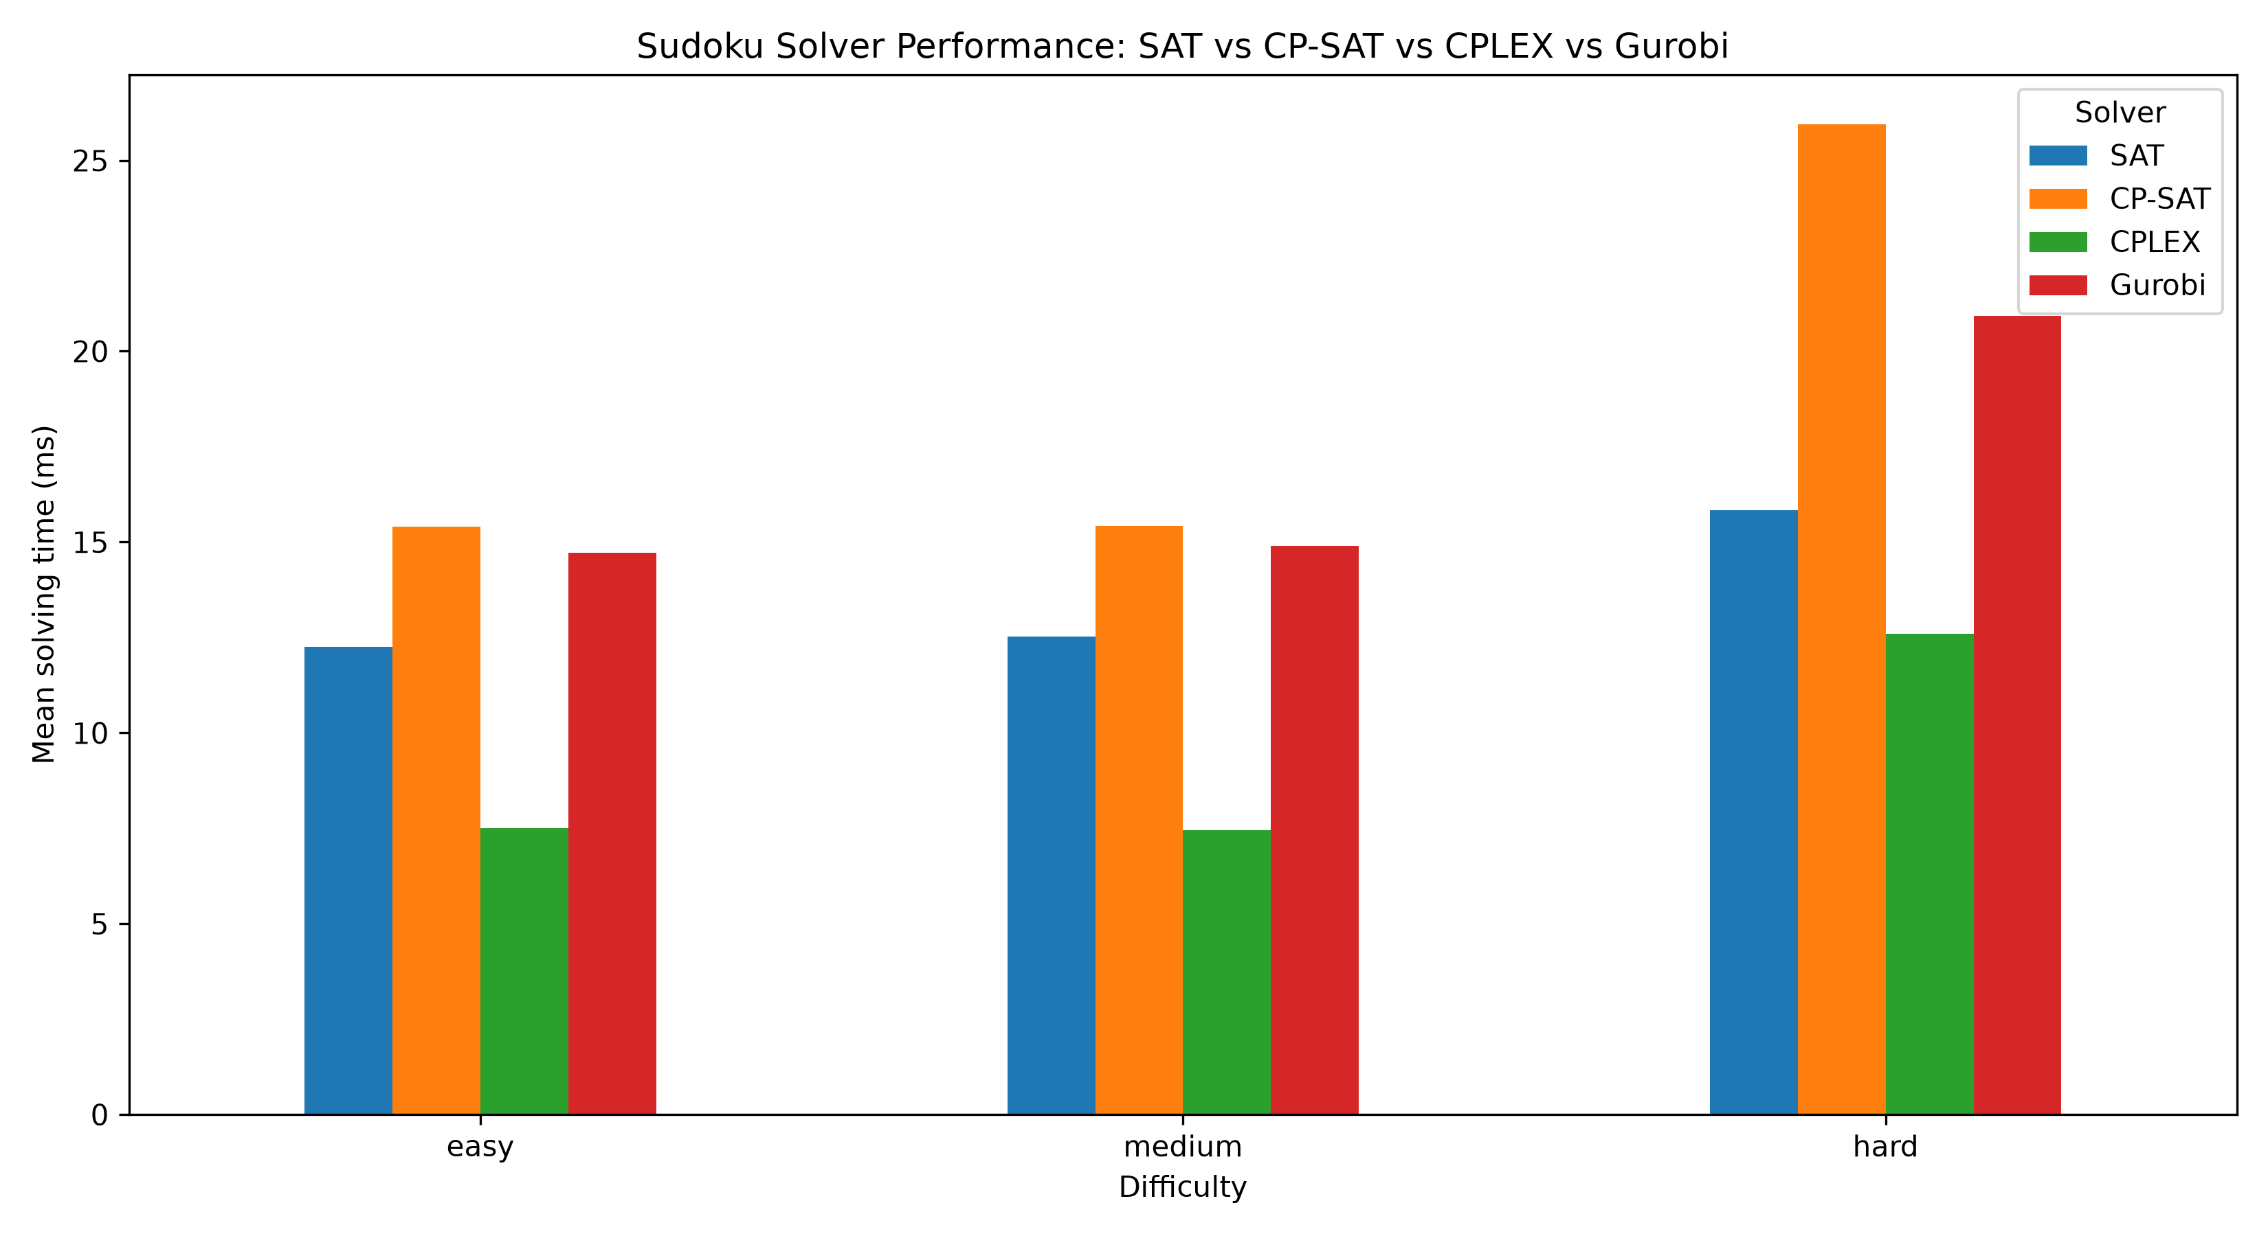
Figure 1. Existing 9x9 comparison chart. Verify its solver set and data provenance against the benchmark CSV before final submission.

4.1 Interpretation
The 9x9 results allow a comparison across difficulty groups. Small differences should not be treated as universal performance rankings. The benchmark covers a finite dataset, and the observed ordering may change with puzzle selection, solver versions, parameters, and hardware.

5. Results on scaled Sudoku
Grid | Solver | Valid solutions | Mean (s) | Median (s)
16x16 | CP-SAT | 10 | 0.1193 | 0.1307
16x16 | CPLEX MIP | 10 | 0.0818 | 0.0529
16x16 | Gurobi | 10 | 0.1998 | 0.1378
16x16 | SAT | 10 | 0.1142 | 0.1127
25x25 | CP-SAT | 10 | 5.5830 | 3.1902
25x25 | CPLEX MIP | 10 | 59.6947 | 25.9734
25x25 | Gurobi | 10 | 457.0009 | 133.1285
25x25 | SAT | 10 | 4.9870 | 4.1317

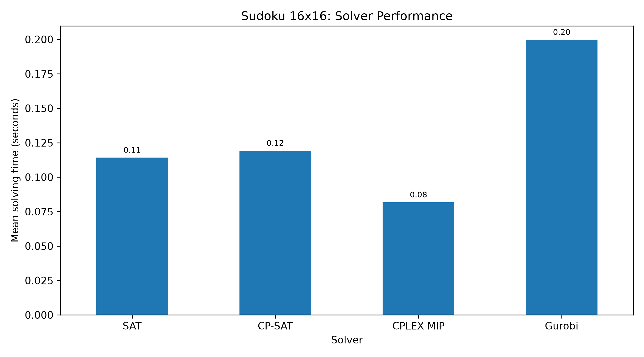
Figure 2. Runtime comparison for 16x16 Sudoku instances.
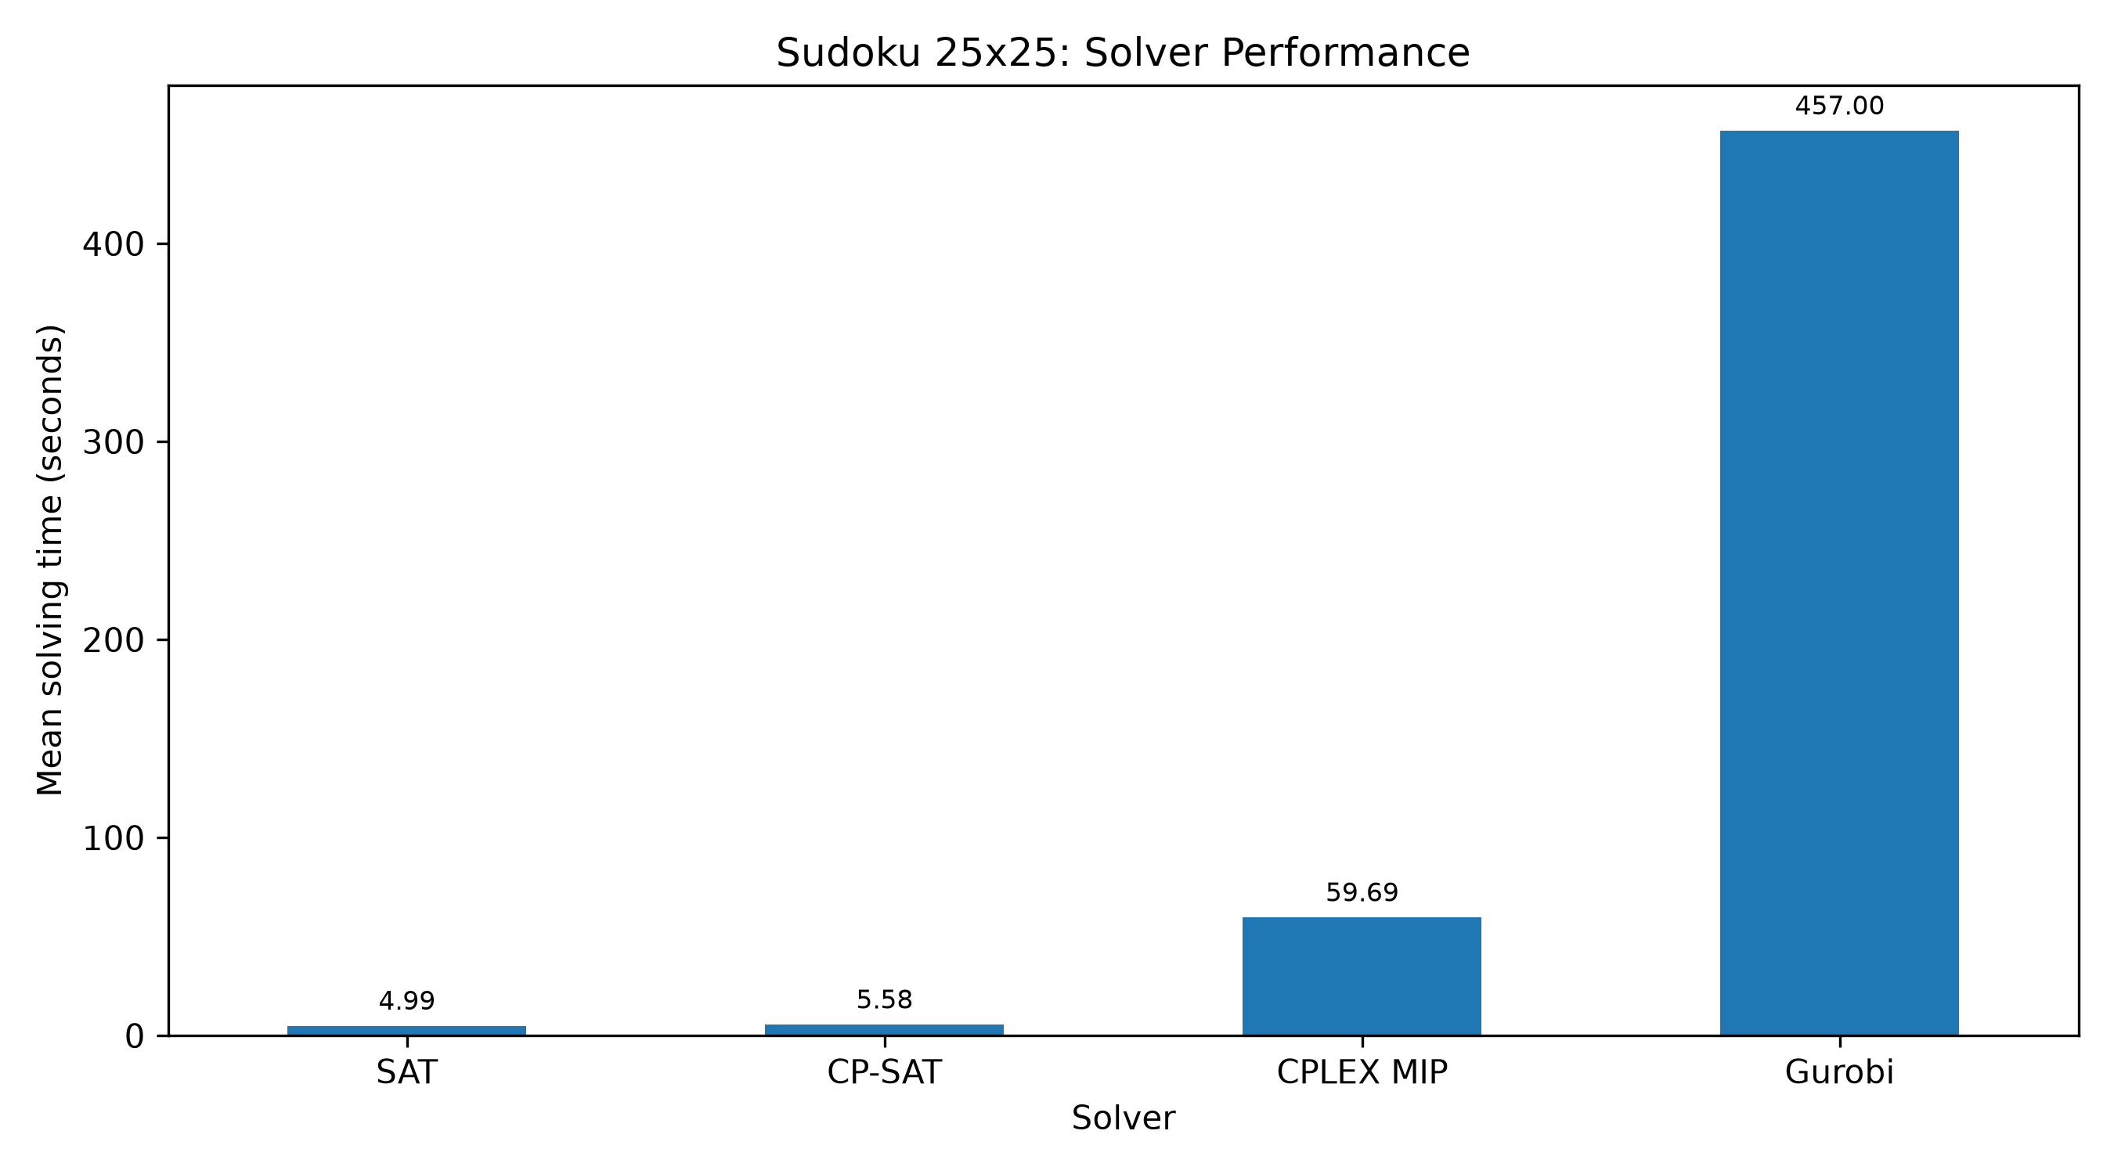
Figure 3. Runtime comparison for 25x25 Sudoku instances.

5.1 Interpretation
The scaled results should be interpreted separately from the 9x9 experiment. Larger grids increase the number of decision variables and constraints, and runtime can grow nonlinearly. Mean and median are both reported because a small number of difficult instances can strongly affect the mean.
Only valid solved records are included in the summary table. This filter makes the timing comparison easier to interpret but does not by itself describe timeouts or failures. Any omitted or timed-out runs should be discussed explicitly in the final evaluation.

6. Threats to validity and limitations
- The benchmark uses a limited number of instances at each grid size.
- Runtime depends on the computer, operating system, solver versions, parameters, and background load.
- Different solvers may use different default heuristics and presolve strategies, so this is a system-level comparison.
- Only successful, valid scaled solutions appear in the scaled summary; timeouts and errors require separate reporting.
- The report generator does not independently verify every solution grid; it relies on the benchmark's recorded validity field.
- The exact hardware and software version inventory must be added before presenting the experiment as fully reproducible.

7. Conclusion and future work
This project provides a practical comparison of SAT, CP-SAT, and MIP approaches to Sudoku, with additional results for larger grids. The stored CSV files make it possible to regenerate summary tables and compare valid solving times consistently. No single solver should be declared universally superior from these experiments alone.
Future work includes increasing the number and diversity of instances, recording hardware and package versions, standardizing time limits and warm-up procedures, reporting timeout rates, and evaluating SAT cardinality encodings using clause and variable counts as well as time.

References
- Biere, A., Heule, M., van Maaren, H., and Walsh, T. (eds.). Handbook of Satisfiability. IOS Press, 2009.
- Google OR-Tools. CP-SAT Solver documentation. https://developers.google.com/optimization/cp/cp_solver
- IBM. IBM ILOG CPLEX Optimization Studio documentation. https://www.ibm.com/docs/en/icos
- Gurobi Optimization. Gurobi Optimizer documentation. https://docs.gurobi.com/
- Scaled Sudoku Instances dataset. https://github.com/zayenz/scaled-sudoku-instances
- Project repository: Sudoku SAT Solver. https://github.com/transonnn/sudoku-sat-solver

Appendix A. Reproducing the experiments
Run commands from the repository root after activating the project virtual environment. The exact command and required solver installation may depend on the current scripts and license configuration.
python -m pytest -v
python -m benchmarks.benchmark
python -m benchmarks.benchmark_scaled_solvers
python -m benchmarks.plot_scaled_results
Before submission, confirm that the command names match the current repository, update the author and institution fields, record the hardware and software versions, and verify that every figure caption matches the data used to generate the figure.

