Trần Tấn Phát
MSSV: 2274802010644

LAB6

Bài làm
Bài tập: tạo dasboard bằng lập trình python thông qua khoảng 5-6 biểu đồ như: Tròn, cột, đường, miền, bảng,... tùy trên sự lựa chọn của các bạn và sử dụng data của bạn để vẽ thành một dasboard trực quan trên local thông qua flask

- Biểu đồ tròn:
# 1) Pie: positions (top positions)
pie = go.Pie(
labels=agg_position["position_applied"],
values=agg_position["candidate_count"],
hole=0.4,
textinfo="percent+label",
insidetextorientation="radial",
marker=dict(colors=["#c7d2fe","#a5b4fc","#93c5fd","#86efac","#fde68a","#fca5a5","#fcd34d","#99f6e4"])
)
fig1 = go.Figure(pie)
fig1.update_layout(
title=dict(text="Candidates by Position", x=0.02, xanchor="left", font=dict(size=24, color="#111827")),
template="plotly_white",
legend_title_text="Position",
margin=dict(t=60, r=20, b=60, l=20)
)
fig1.add_annotation(text="Share of candidates by applied position", x=0.02, y=-0.18, xref="paper", yref="paper", showarrow=False, font=dict(color="#6b7280"))
plots["pie_positions"] = pio.to_html(fig1, full_html=False, include_plotlyjs="cdn")

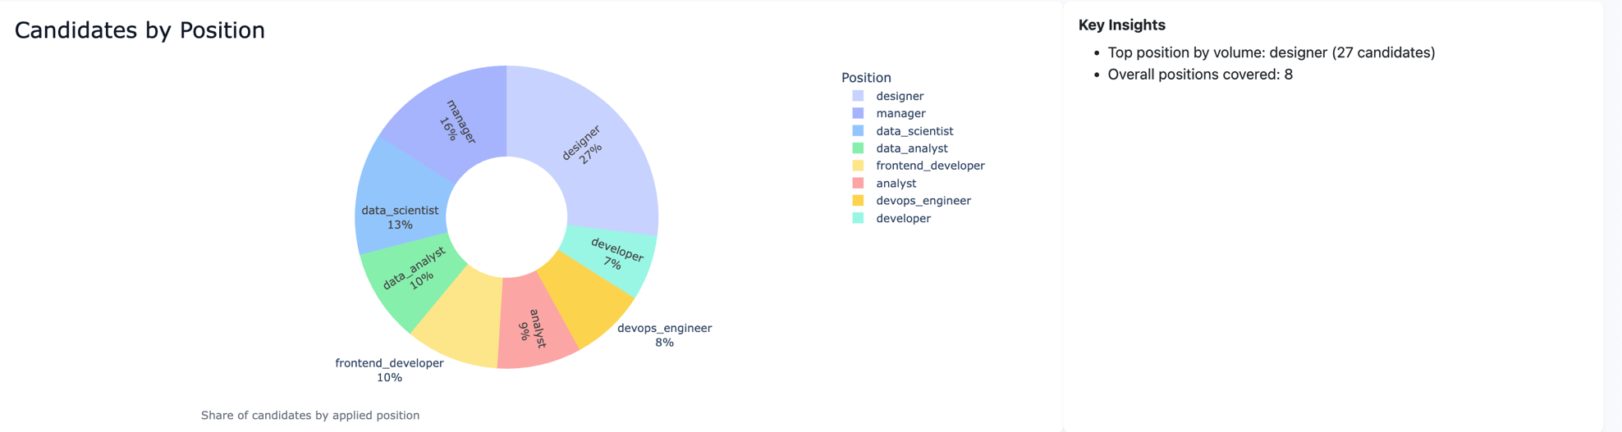

- Biểu đồ cột
# 2) Bar: education levels
bar = go.Bar(
x=agg_education["education_level"],
y=agg_education["candidate_count"],
text=agg_education["candidate_count"],
textposition="outside",
marker_color="#93c5fd",
marker_line_width=0
)
fig2 = go.Figure(bar)
fig2.update_layout(
title=dict(text="Candidates by Education Level", x=0.02, xanchor="left", font=dict(size=24, color="#111827")),
xaxis=dict(title="Education Level", gridcolor="#e5e7eb"),
yaxis=dict(title="Count", gridcolor="#e5e7eb"),
template="plotly_white",
uniformtext_minsize=10,
uniformtext_mode="hide",
margin=dict(t=60, r=20, b=60, l=60)
)
fig2.add_annotation(text="Counts per education level", x=0.02, y=-0.18, showarrow=False, xref="paper", yref="paper", font=dict(color="#6b7280"))
plots["bar_education"] = pio.to_html(fig2, full_html=False, include_plotlyjs=False)

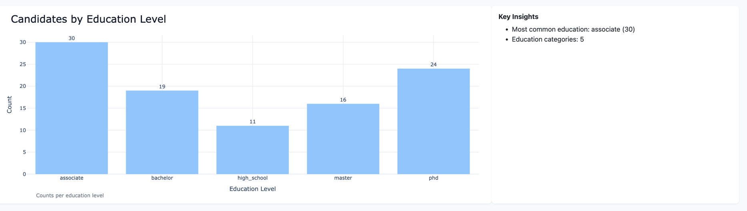

- Biểu đồ đường + biểu đồ cột
# 3) Line + Bars combo: years_experience vs candidate_count and suitable_rate (secondary axis)
fig3 = go.Figure()
# Bars with value labels on top, soft color
fig3.add_trace(go.Bar(
x=agg_experience["years_experience"],
y=agg_experience["candidate_count"],
name="candidate_count",
marker_color="#c7d2fe", # light periwinkle
marker_line_width=0,
text=agg_experience["candidate_count"],
textposition="outside",
textfont=dict(color="#111827", size=12)
))
# Smooth line with markers on secondary axis
fig3.add_trace(go.Scatter(
x=agg_experience["years_experience"],
y=agg_experience["suitable_rate"],
name="suitable_rate",
yaxis="y2",
mode="lines+markers",
line=dict(color="#84cc16", width=3, shape="spline", smoothing=0.8),
marker=dict(size=7, color="#a3e635", line=dict(width=0)),
hovertemplate="Years=%{x}<br>Rate=%{y:.2f}<extra></extra>"
))
fig3.update_layout(
title=dict(text="Candidate Count and Suitability Rate by Years of Experience", x=0.02, xanchor="left", font=dict(size=28, family="Inter, Arial, sans-serif", color="#111827")),
xaxis=dict(title="Years of Experience", gridcolor="#e5e7eb", zeroline=False, tickmode="linear"),
yaxis=dict(title="Candidate Count", gridcolor="#e5e7eb", zeroline=False),
yaxis2=dict(title="", overlaying="y", side="right", range=[0,1], tickformat=".1f", showgrid=False),
bargap=0.2,
template="plotly_white",
plot_bgcolor="#ffffff",
paper_bgcolor="#ffffff",
margin=dict(t=80, r=20, b=80, l=60),
legend=dict(orientation="h", yanchor="bottom", y=1.02, xanchor="left", x=0.02)
)
fig3.add_annotation(text="Bar: candidate_count · Line: suitable_rate (0–1)", x=0.02, xref="paper", y=-0.2, yref="paper", showarrow=False, font=dict(color="#6b7280"))
plots["combo_experience"] = pio.to_html(fig3, full_html=False, include_plotlyjs=False)

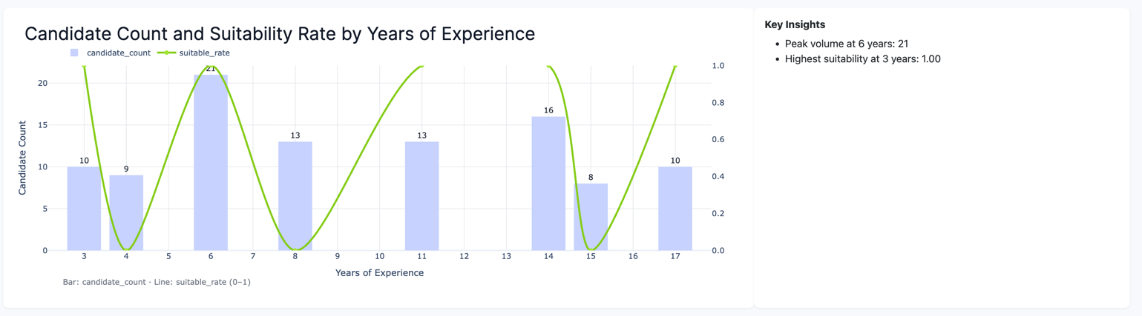

- Biểu đồ vùng
agg_experience["cum_count"] = agg_experience["candidate_count"].cumsum()
fig4 = go.Figure()
fig4.add_trace(go.Scatter(x=agg_experience["years_experience"], y=agg_experience["cum_count"], fill='tozeroy', name="Cumulative candidates", line=dict(color="#6366f1", width=3)))
fig4.update_layout(
title=dict(text="Cumulative Candidates by Experience", x=0.02, xanchor="left", font=dict(size=24, color="#111827")),
xaxis=dict(title="Years of Experience", gridcolor="#e5e7eb"),
yaxis=dict(title="Cumulative Count", gridcolor="#e5e7eb"),
template="plotly_white",
margin=dict(t=60, r=20, b=60, l=60)
)
# Annotate max point
if not agg_experience.empty:
max_x = agg_experience["years_experience"].iloc[-1]
max_y = agg_experience["cum_count"].iloc[-1]
fig4.add_annotation(x=max_x, y=max_y, text=f"Max: {int(max_y)}", showarrow=True, arrowhead=2)
fig4.add_annotation(text="Cumulative sum across experience", x=0.5, y=-0.18, showarrow=False, xref="paper", yref="paper")
plots["area_cumulative"] = pio.to_html(fig4, full_html=False, include_plotlyjs=False)

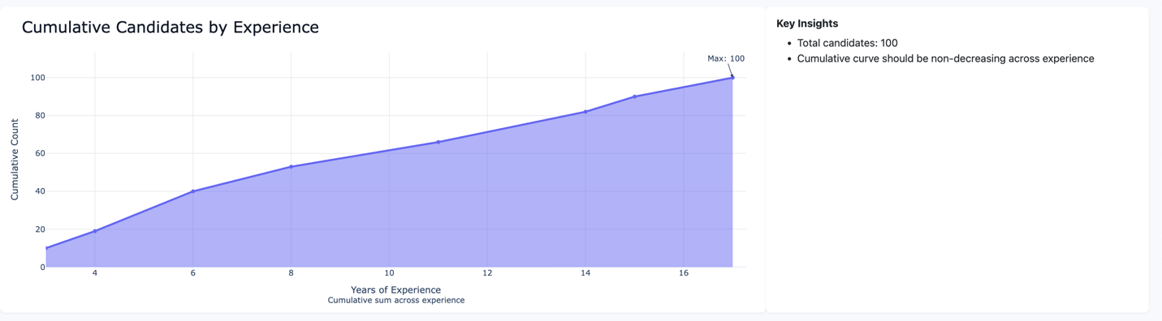

- Biểu đồ nhiệt
# 5) Heatmap: Position vs Binned Years of Experience (suitable for this dataset)
bins = [0, 2, 5, 8, 11, 20]
labels = ["0–2", "3–5", "6–8", "9–11", "12+" ]
df["years_bin"] = pd.cut(df["years_experience"], bins=bins, labels=labels, right=True, include_lowest=True)
hm = df.pivot_table(index="position_applied", columns="years_bin", values="candidate_id", aggfunc="count", fill_value=0)

fig5 = go.Figure(data=go.Heatmap(
z=hm.values,
x=list(hm.columns.astype(str)),
y=list(hm.index.astype(str)),
colorscale="Blues",
colorbar=dict(title="Count")
))
fig5.update_layout(
title=dict(text="Position vs Years of Experience (Count Heatmap)", x=0.02, xanchor="left", font=dict(size=24, color="#111827")),
xaxis=dict(title="Years of Experience (bins)", gridcolor="#e5e7eb"),
yaxis=dict(title="Position", gridcolor="#e5e7eb"),
template="plotly_white",
margin=dict(t=60, r=20, b=60, l=100)
)
# Optional annotations of counts on heatmap
annotations = []
for i, y_val in enumerate(hm.index):
for j, x_val in enumerate(hm.columns):
annotations.append(dict(
x=str(x_val), y=str(y_val), text=str(hm.values[i][j]),
xref='x', yref='y', showarrow=False, font=dict(color='#111827', size=10)
))
fig5.update_layout(annotations=annotations)
fig5.add_annotation(text="Count of candidates per position and experience bin", x=0.02, y=-0.18, showarrow=False, xref="paper", yref="paper", font=dict(color="#6b7280"))
plots["scatter_individuals"] = pio.to_html(fig5, full_html=False, include_plotlyjs=False)

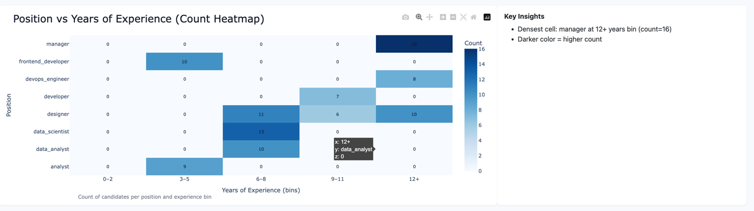

- Biểu đồ cột

# 6) Alternative: Average Years Experience by Position (horizontal bar)
avg_pos = df.groupby("position_applied").agg(
avg_years=("years_experience", "mean"),
candidate_count=("candidate_id", "count")
).reset_index().sort_values("avg_years", ascending=False)

fig6 = go.Figure(go.Bar(
y=avg_pos["position_applied"],
x=avg_pos["avg_years"].round(2),
orientation='h',
text=avg_pos["avg_years"].round(2),
textposition='outside',
marker_color="#c7d2fe",
marker_line_width=0
))
fig6.update_layout(
title=dict(text="Average Years Experience by Position", x=0.02, xanchor="left", font=dict(size=24, color="#111827")),
xaxis=dict(title="Average Years", gridcolor="#e5e7eb"),
yaxis=dict(title="Position", gridcolor="#e5e7eb"),
template="plotly_white",
margin=dict(t=60, r=20, b=60, l=120)
)
fig6.add_annotation(text="Numbers denote mean years of experience", x=0.02, y=-0.18, showarrow=False, xref='paper', yref='paper', font=dict(color="#6b7280"))
plots["stacked_position_education"] = pio.to_html(fig6, full_html=False, include_plotlyjs=False

