Trần Tấn Phát

2274802010644

Lab3

Bài làm

1. Sử dụng hàm sắp xếp QuickSort



1. Sử dụng hàm MergeSort

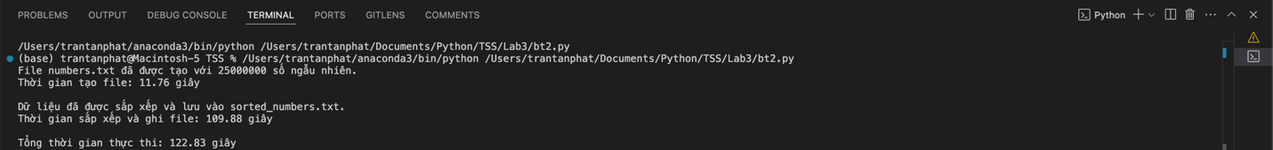

1. Sử dụng hàm SelectionSort

1. Sử dụng hàm CountingSort

