

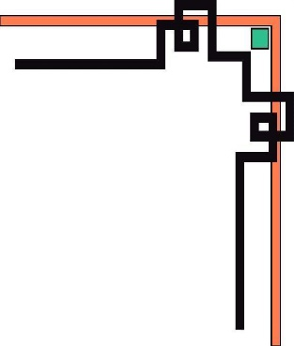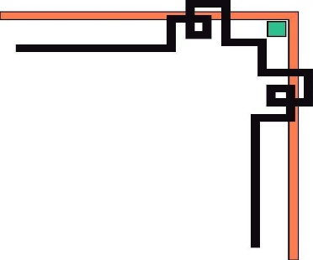

**SOFTWARE TECHNOLOGY CENTER CAN THO UNIVERSITY**

**CUSC COMPUTER EDUCATION**

**PROJECT REPORT JAVA**

**TOPIC:**

**MANAGINF THE BOOK LIBRARY AT THE STUDY MATERIAL CENTER OF CAN THO UNIVERSITY**

**Course module** : Java Project Semester 2 Aptech

**Students perform:**

**Name**: Trần Hữu Phúc **MSSV**:1400253

**Name**: Trần Hồng Tem **MSSV**: 1400250

**Can Tho, February 26, 2023.**



**SOFTWARE TECHNOLOGY CENTER CAN THO UNIVERSITY**

**CUSC COMPUTER EDUCATION**

**PROJECT REPORT JAVA**

**TOPIC :**

**MANAGINF THE BOOK LIBRARY AT THE STUDY MATERIAL CENTER OF CAN THO UNIVERSITY**

**Instructors :** Ths. Luong Xuan Viet

**Can Tho, February 26, 2023.**

**Table of contents**

**1 Introduction** 5

* 1. Purpose 5
  2. Scope 5

1.2.1 Data range 5

1.2.2 System requirements 5

1.2.3 Request from user 5

1.2.4 Execution time 6

1.3 Definitions, Acronyms, and Abbreviations 6

1.4 References

1.5 Overview

**PREAMBLE**

After two courses of both theory and practice on the Java programming language, Database SQL. Have a basic understanding of java language: Java core, OOP, thread, .... along with how to build a database database for an actual Swing interface software application. Realize the need to build a practical product to apply the knowledge learned. My group of 2 students: Tran Huu Phuc and Tran Hong tem decided to conduct research and build a practical project on the swing application interface language with Java combined with SQL for the purpose of database management. Is there a purpose from a specific request?

After a period of research, our group unanimously decided to build a library management software application, the project aims to combine java and SQL languages ​​to manage books and readers in a library, in order to help Library managers can more conveniently control the number of books, as well as readers, easily keep track of your loan and return list. Through this project, in addition to having a hands-on experience with a specific application, we also learned a lot of new knowledge, which is necessary for the development of specific projects in Java and SQL languages.

Sincere thanks to Mr. Luong Xuan Viet, the instructor who wholeheartedly taught and helped our team during the construction of this project. Due to limited knowledge and not much practical experience, there are many mistakes in the process of building software applications. Although we have tried our best, this project cannot avoid errors and many incomplete points. Please consider and comment to make our project more complete.

1. **INTRODUCTION**
   1. **Purpose:**

In modern society, in order to meet the needs of developing educational, scientific, cultural, economic activities, etc., reading books and newspapers (and other documents) for the purpose of exploiting and using information trust, knowledge, becomes more and more urgent. Along with that, the number of daily borrowings of books in the library reached thousands of times. The manual management of books faced many difficulties. Therefore, it is necessary to develop an information management program related to borrowing, returning, and searching for information about books. From there, it makes library management easier and more convenient

Realizing that necessity, our group decided to conduct research and build a Library Management application with the main function of managing books, types of books in the existing library, and managing books. register readers as a member as well as borrow books to return books..In order to make it easier for management staff to track, monitor and search for information when needed to avoid many errors when managing manual types. work, write and write as before.

* 1. **Scope:**

The library management application program allows library managers to manage a large amount of information about: Registering reader membership cards, Managing book borrowing and returning, allowing to store new and delete books. old information or update alternative information for titles and types of books in the library, perform the information search function to query out the required information such as the title of the book, the name of the reader, the date loan payment, ...

**1.2.1 Data Range**

- Information about the book: Book title, book code, book type code, publication year, author's name, book's selling price....

- Card registration information: Reader's name, reader code, CCCD, registration date, registration card expiration date, date of birth, gender, ...

- Information about the book loan voucher: Borrowing date, appointment date to return the book, Borrowed book code, Borrower code, status (borrowing or returned),...

**1.2.2** **System Requirements**

- Close to each and easy use.

- Easily track, manage readers as well as borrow and return books of readers.

- Easy to install and upgrade the system.

**1.2.3** **Request From User**

- There is a system to log in to ensure security and safety.

- High manageability, easy.

- Easily track the loan and return of books, book information as well as readers.

- can delete old information, add new data and update information for data to be replaced easily.

**1.2.4 Execution Time**

From February 20, 2023 to March 31, 2023, the total period of 42 days is equivalent to 6 weeks.

* 1. **Definitions, Acronyms, and Abbreviations**
* (Bổ sung sau)
  1. **References**
* Channel TITV: <https://titv.vn/>
* Channel Jmaster IO: <https://www.youtube.com/@jmasterio/playlists>
* Page Greek for Greek: <https://www.geeksforgeeks.org/java-tutorial/?ref=gcse>

...

* 1. **Overview**
* In part one, it mainly introduces the purpose and scope of the product from system requirements to customers, acronyms, process overview how the product looks, what it has. a preliminary overview for users to refer to before going into details on specific product topics.
* In part 2 contains a deeper and more complete definition of the requirements of Library Management software. This section is intended for customers and other stakeholders who may not be familiar with the actual software engineering process. This section contains little or no technical information regarding the software process required to turn this document into actual software.
* In section 3 contains all the technical requirements for the software, including a complete list of functional and non-functional requirements. This section is intended to be used by software developers to create actual software. Much of the information in this section is of a very technical and field-specific nature, is therefore not intended to be read or understood by anyone outside the field of software engineering.

**2 Description**

**2.1 Product Perspective**

The library management software is developed to bring convenience in the statistics of the list of books borrowed and returned, titles of books, content, author names, fields,... Neat arrangement This helps to look up information related to books easily, periodic statistics are simpler and more systematic.

2.2 **Product Functions**

Basic functions to help manage library books:

* Membership registration function (readers).
* Function to manage all books in the library according to each school separately.
* The function of overall management of the list of readers who borrow books from the library, the date of borrowing and the date of return.
* The function of borrowing books and extending the loan and returning books of readers.
* Book search function by title, type of book, author.

**2.3 User Characteristics**

The use of this Library Management software application mainly serves the following subjects.

- Book management staff:

+ Log in to the server system: monitor, add, delete, edit... update the system with documents and related reader information.

- Group of readers: follow doi to find related book information

- Maintenance staff: update, install new version application for software.

**2.4 Operating Environment(bổ sung sau)**

Is a library's book lending application that helps manage book borrowers and return books and titles in the library.

**2.5 Design and Implementation Constraints (bổ sung sau)**

**2.6 User Documentation**

- Online help: technical department will work directly through.

+ teamview, Anydesk...

* Tài liệu hướng dẫn: (bổ sung sau)

**2.7 Assumptions and Dependencies(hỏi lại)**