**Essential components and operation summary**

The operational components of the SB-256 memory tube consist of a cathode, selector bars, collector plate, storage eyelets, write plate, read plate, Faraday cage, and read-sensing wires. The cathode emits electrons via thermionic emissions. These electrons are directed through an array of ‘windows’ formed by 36 horizontal and nine vertical selection bars. In the quiescent state of the device, all selector bars are at cathode potential (nominally 0V), thus there are 256 electron beams accelerated at the collector plate, +180V relative to the cathode. The storage eyelets are physically sandwiched between the collector plate and write-control plate with mica insulators, thus rendering the storage eyelets electrically isolated. However, by virtue of these insulators, each eyelet is capacitively coupled to the collector plate with an effective capacitance C=1pF, as well as to the write plate with a similar C=1pF. The write plate, with carefully timed pulses and selection of storage eyelets, is used to write information to the eyelets. Similarly, the read plate is used to control electron current to the Faraday cage, which has a fluorescent coating providing a visual indication of the state of the storage eyelet. Finally, read-sense wires collect secondary electrons ejected from the fluorescent screen to provide an electronic signal corresponding to the eyelet’s stored value.

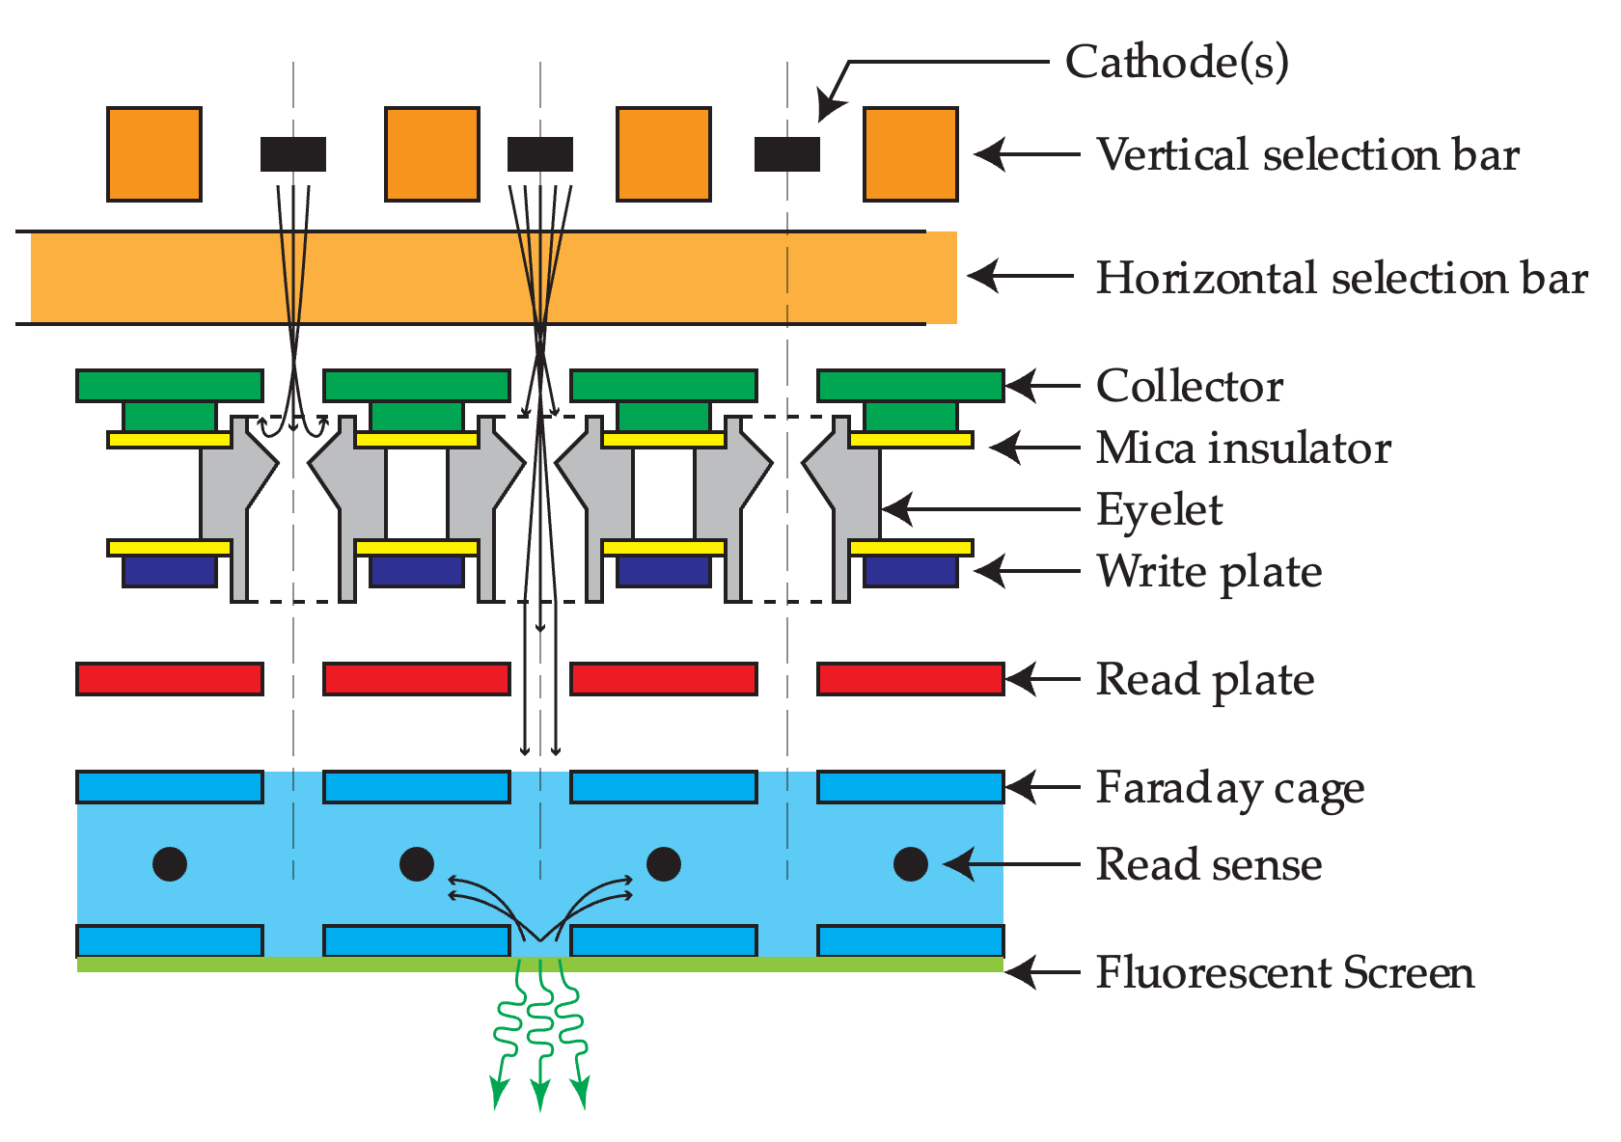

*Essential components of the SB-256. Representative electron trajectories are shown with selection bars in the quiescent state (V=0) for an eyelet near 0V (left) and an eyelet near the collector potential (middle). Also shown are electron paths with the read plate active. Electrons incident on the fluorescent screen produce light and secondary electrons.*

An operating SB-256 tube with all bits set. The tube is in the quiescent state, with read plate active. Also shown, a 12AU7 for size comparison.

**How bi-value information is stored.**

In the RCA SB-256 tube, the eyelets are electrically isolated. However, if there was an external connection to the eyelet by which its potential could be varied, the curve of detected current with show three potentials where there is a balance of incoming and outgoing current (INet=0). There are two potentials V0 and VC where the zero-current crossings have negative slopes, making these potentials stable for an isolated eyelet. The third point VA is not stable for an electrically isolated eyelet.

The equilibrium potential of the electrically isolated eyelet depends on the balance of incoming electrons and out-going secondary electrons. The potential of an electrically isolated, and initially uncharged conductor in the presence of electron beam emitted by a cathode at 0V will tend to collect electrons until the eyelet develops a small negative potential, V0. When the eyelet is in this state, it will reject the electron beam directed towards it. When this eyelet is selected and read, there will be no passed current, thus no fluorescence or detected current on the read-sense wires. However, if the eyelet can be made more positive, the kinetic energy of the incoming electron beam will eject more electrons than are incident. This will positively charge the isolated eyelet, giving an equilibrium potential near that of the collector plate, VC. When selected and read, the eyelet passes approximately 10uA, which gives a visual indication on the fluorescent screen and can be sensed with read wires.

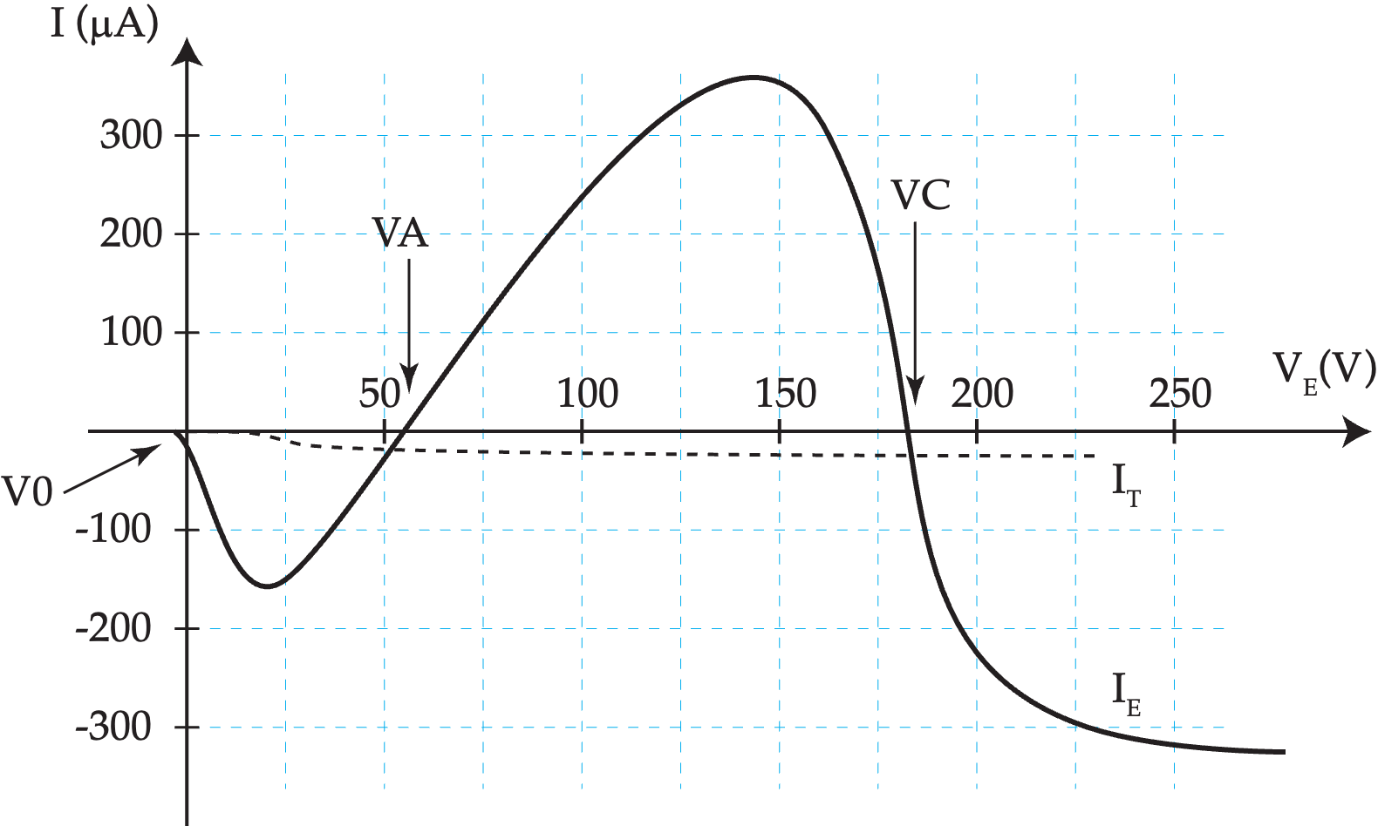

*Representative curves showing current collected on (IE) and current transmitted through (IT) the eyelet if eyelet potential could be manually fixed. Production SB-256 eyelets are electrically isolated. Potentials V0 and VC are bi-stable potentials for an isolated eyelet.*

**How selection bars select eyelets (bits)**

The storage bits of the SB-256 are organized into two, 128-bit panels one on each side of the tube. The 128 bits on each side are visibly organized into two groups of 64. The SB-256 has two sets of read and write control electrodes, for each 128-bit side, allowing for independent of read/write for the two sides. Reading and writing of information is conceptually easiest when accessing one bit of 256 at a time.

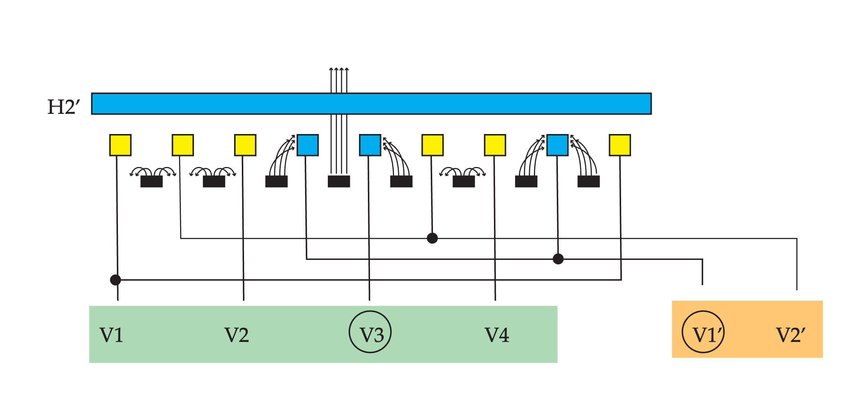

*One-dimensional representation of how the selection bars select a desired window. In this 1-D slice, circuits H2’ and H2 are also selected at 0V (blue) as are circuits V3 and V1’. All other circuits are biased near -250V (yellow). Representative electron trajectories are also shown.*

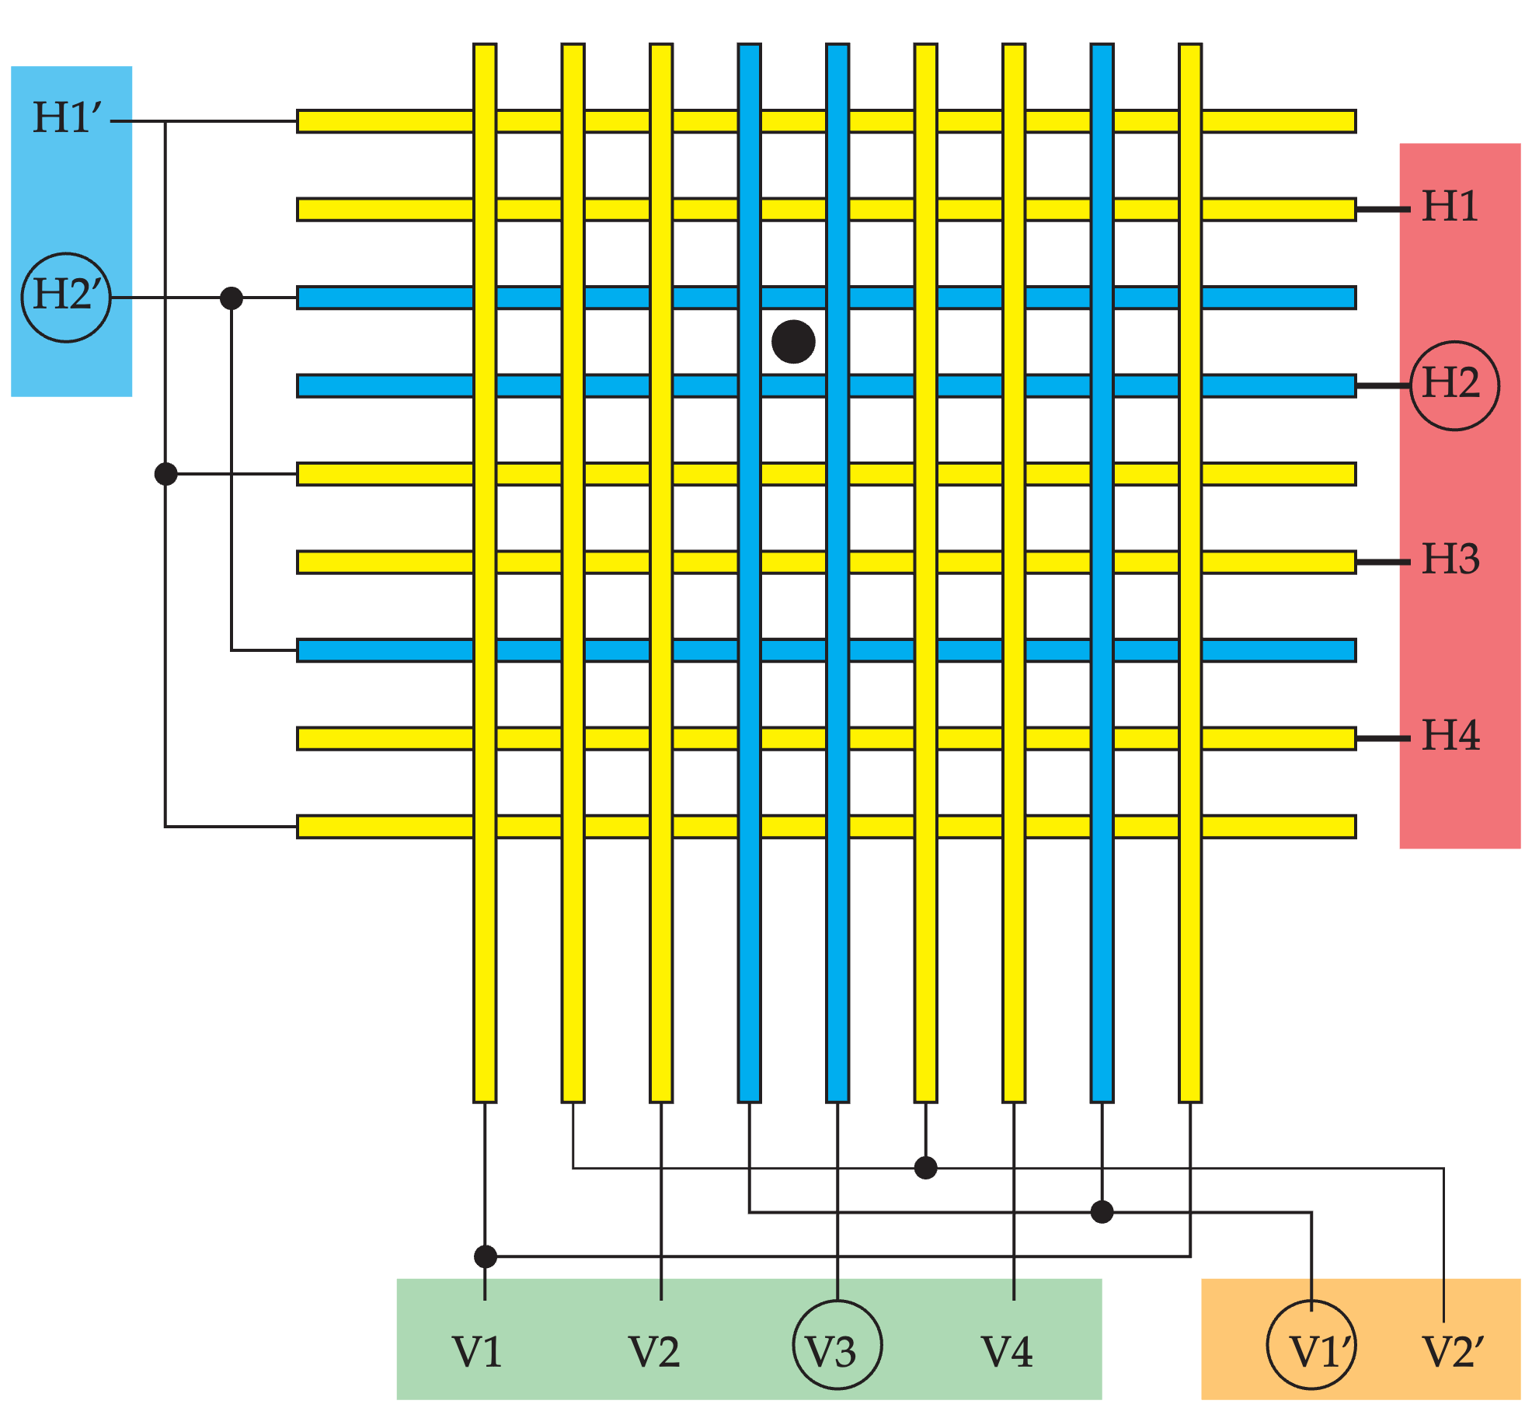

*Two-dimensional matrix of selection bars. To select a given bit, one and only one circuit from each of the four groups H, V’, V, and H’ are set to 0V (blue). All other circuits are biased near -250V (yellow). Only the top group of 64 bits of one side are illustrated.*

Selection bars are organized into circuits, each circuit organized by one of four groups: the H, H’, V, and V’ group. In the quiescent state of the device, all bars are near cathode potential (0V). To select a given eyelet (storage bit), one, and only one, circuit from each of the four groups (H, H’, V, and V’) is left at 0V while all other circuits are biased negatively (~ - 250V). The bars forming a window for the selected eyelet will be at 0V, allowing electron beam transmission to the collector plate and appropriate eyelet. All other ‘de-selected’ eyelets will have at least one bar of their respective window at -250V, deflecting the electron beam preventing it from reaching all other eyelets.

The internal organization and connection of the selector bars is designed to reduce the total number of electrical connections through the glass envelope. They are also arranged and interconnected in such a way to permit simple decoding of an eight-bit digital address. When selecting an eyelet, one of four connections from H group are selected (0V) thus determined by decoding the least two significant bits (LSB) of the address. The V’ group has two connections, so the third address bit determines one of two V’ circuits. The decoding of the next two address bits determines the one of four connections in the V group. Finally, the H’ group has eight possible selections, requiring decoding of the final three most significant bits (MSB) of the address. In summary, if an address is represented by bits A7 A6 A5 A4 A3 A2 A1 A0, then one circuit from each of the four groups is selected by:

Group H: decoded from bits A1 A0

Group V’: decoded from bit A2

Group V: decoded from bits A4 A3

Group H’: decoded from bits A7 A6 A5

Writing.

To write to a given bit, the corresponding eyelet is selected (0V). Then a positive pulse is delivered to the write plate. Since