SB256

Operational summary
The Selectron further modified the basic holding gun concept through the use of individual metal eyelets that were used to store charge in a more predictable and long-lasting fashion.

The original 4096-bit Selectron[7] was a 10-inch-long (250 mm) by 3-inch-diameter (76 mm) vacuum tube configured as 1024 by 4 bits. It had an indirectly heated cathode running up the middle, surrounded by two separate sets of wires — one radial, one axial — forming a cylindrical grid array, and finally a dielectric storage material coating on the inside of four segments of an enclosing metal cylinder, called the signal plates. The bits were stored as discrete regions of charge on the smooth surfaces of the signal plates.

The smaller capacity 256-bit (128 by 2 bits) "production" device[8] is in a similarly sized vacuum-tube envelope.

Essential components

The operational components of the SB-256 memory tube consist of a cathode, selector bars, collector plate, storage eyelets, write plate, read plate, Faraday cage, and read-sensing wires. The cathode emits electrons via thermionic emission. These electrons are directed through an array of ‘windows’ formed by 36 horizontal and nine vertical selection bars. In the quiescent state of the device, all selector bars are at cathode potential (nominally 0V), thus there are 256 electron beams accelerated to the collector plate, nominally +180V relative to the cathode. The storage eyelets are physically sandwiched between the collector plate and write-control plate with mica insulators, thus rendering the storage eyelets electrically isolated. However, by virtue of these insulators, each eyelet is capacitively coupled to the collector plate with an effective capacitance C=1pF, as well as to the write plate with a similar C=1pF. The write plate, with carefully timed pulses and selection of storage eyelets, is used to write information to the eyelets. Similarly, the read plate is used to control electron current to the Faraday cage, which has a fluorescent coating providing a visual indication of the state of the storage eyelet. Finally, read-sense wires collect secondary electrons ejected from the fluorescent screen to provide an electronic signal corresponding to the eyelet’s stored value.

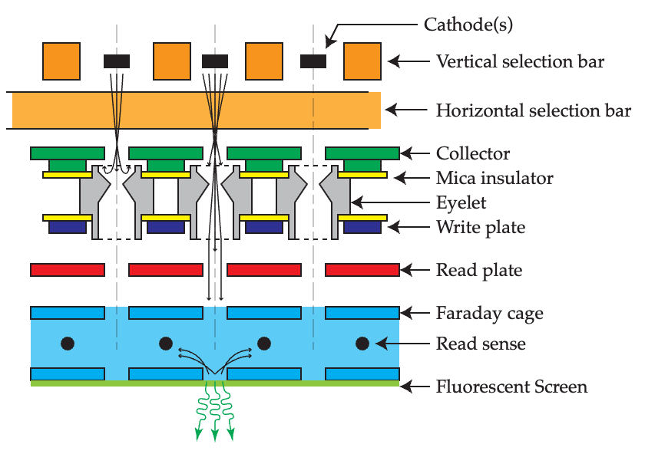
Essential components of the SB-256. Representative electron trajectories are shown with selection bars in the quiescent state (V=0) for an eyelet near 0V (left) and an eyelet near the collector potential (middle).

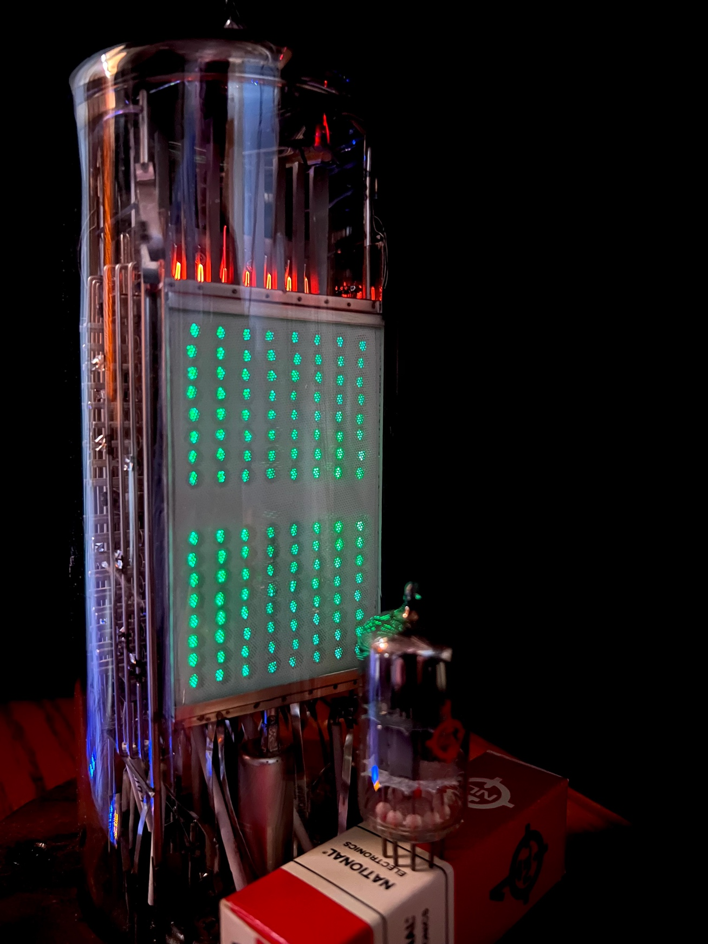
An operating SB-256 tube with all bits set to “1”. The tube is in the quiescent state, with read plate active. Also shown, a 12AU7 tube for size comparison.

How bi-value information is stored.

The Selectron works in the opposite sense of the Williams tube. In the Williams tube, the beam is continually scanning in a read/write cycle which is also used to regenerate data. In contrast, the Selectron is almost always maintaining the entire tube, only breaking this periodically to do actual reads and writes.

In the ‘production’ RCA SB-256 tube, the eyelets are electrically isolated. However, if there was an external connection to the eyelet by which its potential could be varied, the current-voltage curve of the eyelet (Figure 6 reference1, Figure 8 reference 2) with show three potentials where there is a balance of incoming and outgoing current. The first crossing, V0, is at a slightly negative potential (~-1V) given the thermal distribution of electrons emitted from a cathode biased at 0V. The other two zero-current crossings are at VA (~50V) and at a potential near the collector VC~180V). The equilibrium potential of the electrically isolated eyelet depends on the balance of incoming electrons (negative current) and out-going secondary electrons (positive current).

Consider an eyelet initially at V0. If, for some reason such as ohmic leakage current, the eyelet potential drifts positive, the increased negative current in the region of V0 will reduce the eyelet’s potential back to V0. When this eyelet is selected and read, there will be no current passed through the eyelet, thus no fluorescence nor detected current on the read-sense wires.

If, on the other hand, the potential on the eyelet is near VC, and the potential increases for some reason (e.g. during the write process), the negative current will return the potential to VC. If the potential drifts below VC, as may happen with leakage currents, the increased positive current, due to secondary electron production, will raise the potential back to VC. When selected and read, the eyelet at potential VC passes approximately IT=10uA, which provides a visual indication on the fluorescent screen and may be sensed with read wires.

The two points V0 and VC are stable equilibrium potentials because the slope of the IE-VE curve near these potentials is negative. The point VA is not stable. If the eyelet finds itself at VA, any perturbation in potential will tend to raise the potential beyond VA and settle at VC.

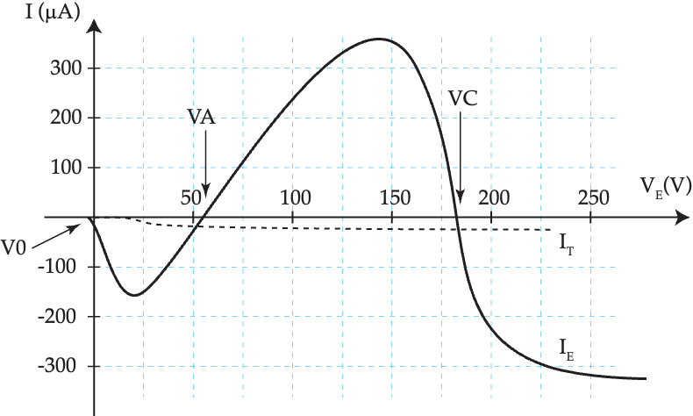
Representative curves showing current collected on (IE) and current transmitted through (IT) the eyelet as a function of eyelet potential VE. Potentials V0 and VC are bi-stable potentials for an isolated eyelet.

How selection bars select eyelets (bits)

The storage bits of the SB-256 are organized into two, 128-bit panels one on each side of the tube. The 128 bits on each side are visibly organized into two groups of 64. The SB-256 has two sets of read and write control electrodes, for each 128-bit side, allowing for independent of read/write for the two sides. Reading and writing of information is conceptually easiest when accessing one bit of 256 at a time.

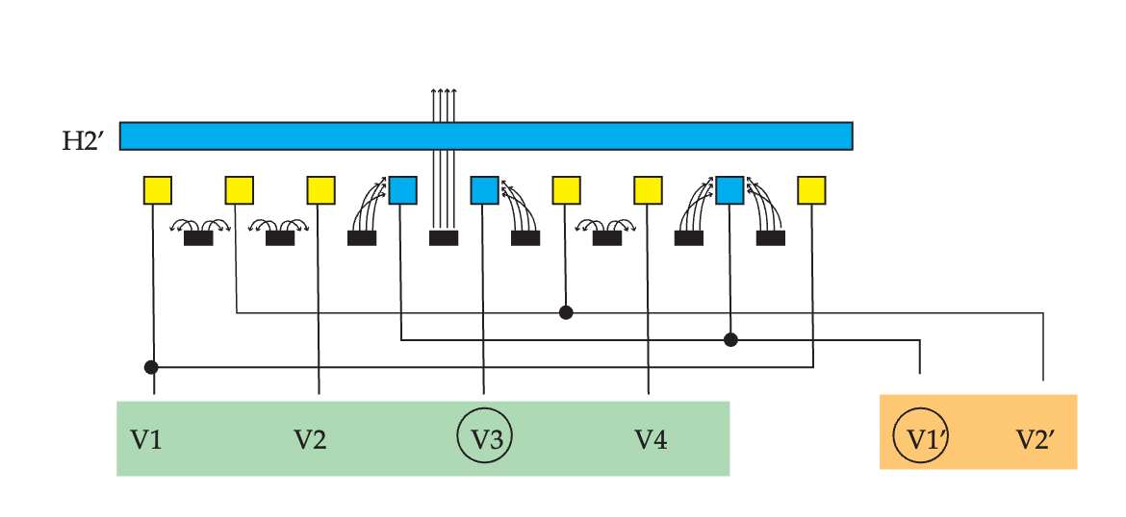
One-dimensional representation of how the selection bars select a desired window. Selector bars H2’, H2,V3, and V1’ are at 0V (blue). All other bars are biased near -250V (yellow). Representative electron trajectories are also shown.

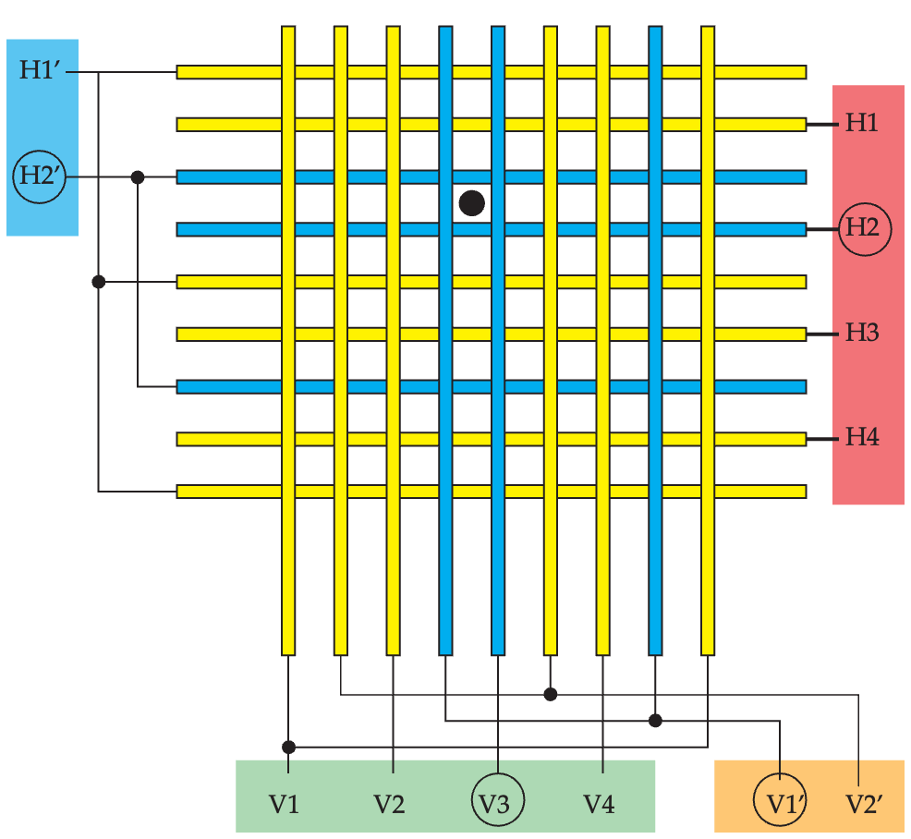
Two-dimensional matrix of selection bars. To select a given bit, one and only one circuit of selection bars from each of the four groups H, V’, V, and H’ are set to 0V (blue). All other circuits are biased near -250V (yellow).

Selection bars are organized into circuits with each circuit organized into one of four groups: the H, H’, V, or V’ group. In the quiescent state of the device, all bars are near cathode potential (0V) passing a ‘maintaining’ current to the eyelets, reinforcing the eyelet’s equilibrium potential. To select a given eyelet (storage bit), one, and only one, circuit from each of the four groups (H, H’, V, and V’) is left at 0V while all other circuits are biased negatively (~ - 250V). The bars forming a square window for the selected eyelet will be at 0V, allowing electron beam transmission to the collector plate and appropriate eyelet. All other ‘de-selected’ eyelets will have at least one bar of their respective window at -250V, deflecting the electron beam preventing it from reaching all other eyelets.

The internal organization and connection of the selector bars is designed to reduce the total number of electrical connections through the glass envelope. They are also arranged and interconnected in such a way to permit simple decoding of an eight-bit digital address. When selecting an eyelet, one of four connections from H group are selected (0V) thus determined by decoding the least two significant bits (LSB) of an eight-bit address. The V’ group has two connections, so the third address bit determines one of two V’ circuits. The decoding of the next two address bits determines the one of four connections in the V group. Finally, the H’ group has eight possible selections, requiring decoding of the final three most significant bits (MSB) of the address. In summary, if an address is represented by bits A7 A6 A5 A4 A3 A2 A1 A0, then one circuit from each of the four groups is selected by:
Group H: decoded from bits A1 A0
Group V’: decoded from bit A2
Group V: decoded from bits A4 A3
Group H’: decoded from bits A7 A6 A5

Writing data.

There are multiple approaches (1,8) to writing data. In all methods, the write plate is used to change the potential of a selected eyelet via capacitively coupled displacement current. Since the eyelets are also capacitively coupled to the collector, there is an additional displacement current from eyelet to the collector. In the absence of any other current, the eyelet will rise by ½ the write plate potential change. To make any changes, the potential of the eyelet must be brough past the potential VA. The minimum write-plate potential is twice the difference (VC-VA). For a collector at 180V, VA is about 50V, so the absolute minimum is 260V. A value of 360V is recommended (1,2).

Method 1. “Selector bar keying”. To write to a given bit, the corresponding eyelet is selected by leaving the appropriate H, V’, V, H circuits at 0V and forcing all remaining circuits to -250V. One and only eyelet has a ‘maintaining’ current directed to it. The write plate is made to rise rapidly from 0V to 360V followed by a sufficiently long plateau to allow an eyelet originally at 180V, brought to 180+360/2 = 360 V, to decay back to 180V (see the I-V curve). This requires an irreducible amount of time, on the order of 1uS, and is due to charging the effective capacitance with the incoming electron-beam current. An eyelet originally at 0V will be at 0+ 360/2 = 180V, with the limiting time from the displacement current from the write pulse. At the end of the plateau, the eyelet will be at 180V, independent of the initial potential. Then, the write plate is slowly lowered to 0V over a time equal to the plateau time. If positive registry in the eyelet is desired (Veyelet = 180V, digital bit=1), nothing else is done. If a bit=0 (Veyelet = 0V) is desired, the current to the eyelet is keyed off just before the beginning of the write decay. With no external current to the eyelet, its potential will fall to near zero; 180 – 360/2 = 0V, owing to the write-plate displacement current. Once the write procedure is completed, quiescent current is returned to all eyelets.

Method 2. “Write plate keying” In this method, the electron beam is not keyed. The write plate is made to rise rapidly to 360V as before. If the bit is to be 1 (180V), the write pulse decays slowly to cause the displacement current to be smaller than the net positive incoming electron current (see I-V) curve. This will effectively charge the element positively. If the bit is to be 0 (0V), the write plate is kept positive+ 360V for a sufficient time to allow an element at twice collector to decay to +180V. Then the write plate is made to drop as rapidly as it rose resulting in a negative displacement current.

Reading Data

To read data from a given eyelet, it is selected in the same manner as in the write operation. If the eyelet is near the collector potential (~180V) a small current is transmitted to the read plate. The read plate is pulsed from negative bias (-50V) to positive potential (~120V), transmitting the electrons the Faraday cage. The secondary electrons produced by the energetic electron beam impinging on the phosphor coating is collected by the read-sense wires. A pulse of current on the read sense wires corelated with the read plate pulse is interpreted as a binary ‘1’. If the selected eyelet is near 0V, no current is transmitted when the read plate is pulsed and no pulse of current is detected. This is interpreted as a binary ‘0’.

1. US Patent 2,635,201
2. Jan Rajchman, The Selective Electrostatic Storage Tube, RCA Review, Volume XII, No. 1, pp 53 - 97, March, 1951

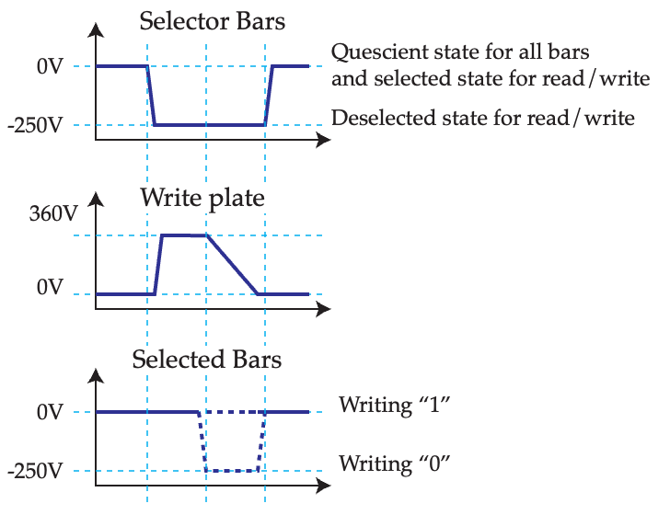
Timing diagram for the write process using “selection bar keying”.

