Read Detector current amplifier
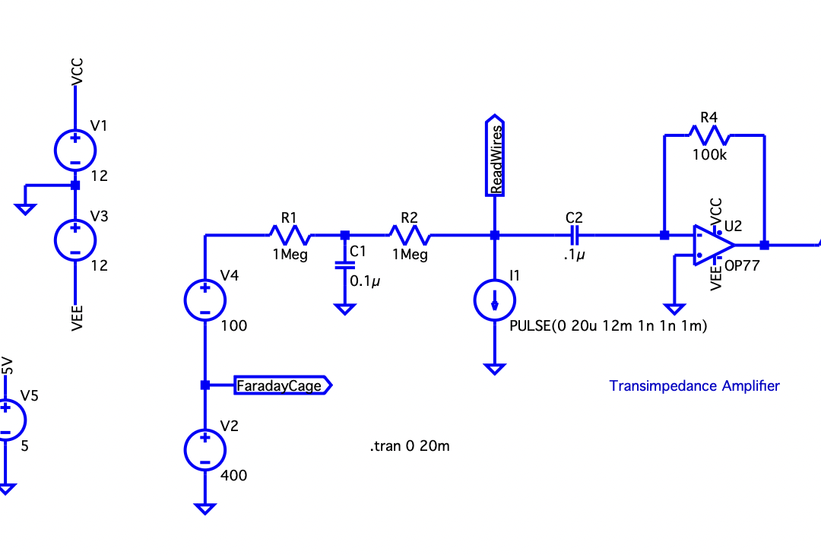
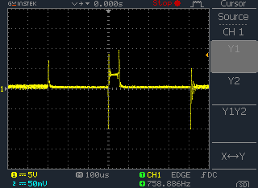
Output of transimpedance amplifier when read plate is pulsed.
~3V output so I = 3V/100,000Ω = 30μA.
Pulses at t=-300μs and t=+400μs are when quiescent current (by de-selecting non relevant bars for this bit address) is turned off, then on, respectively.
Read Detector low pass filter
2nd order Butterworth
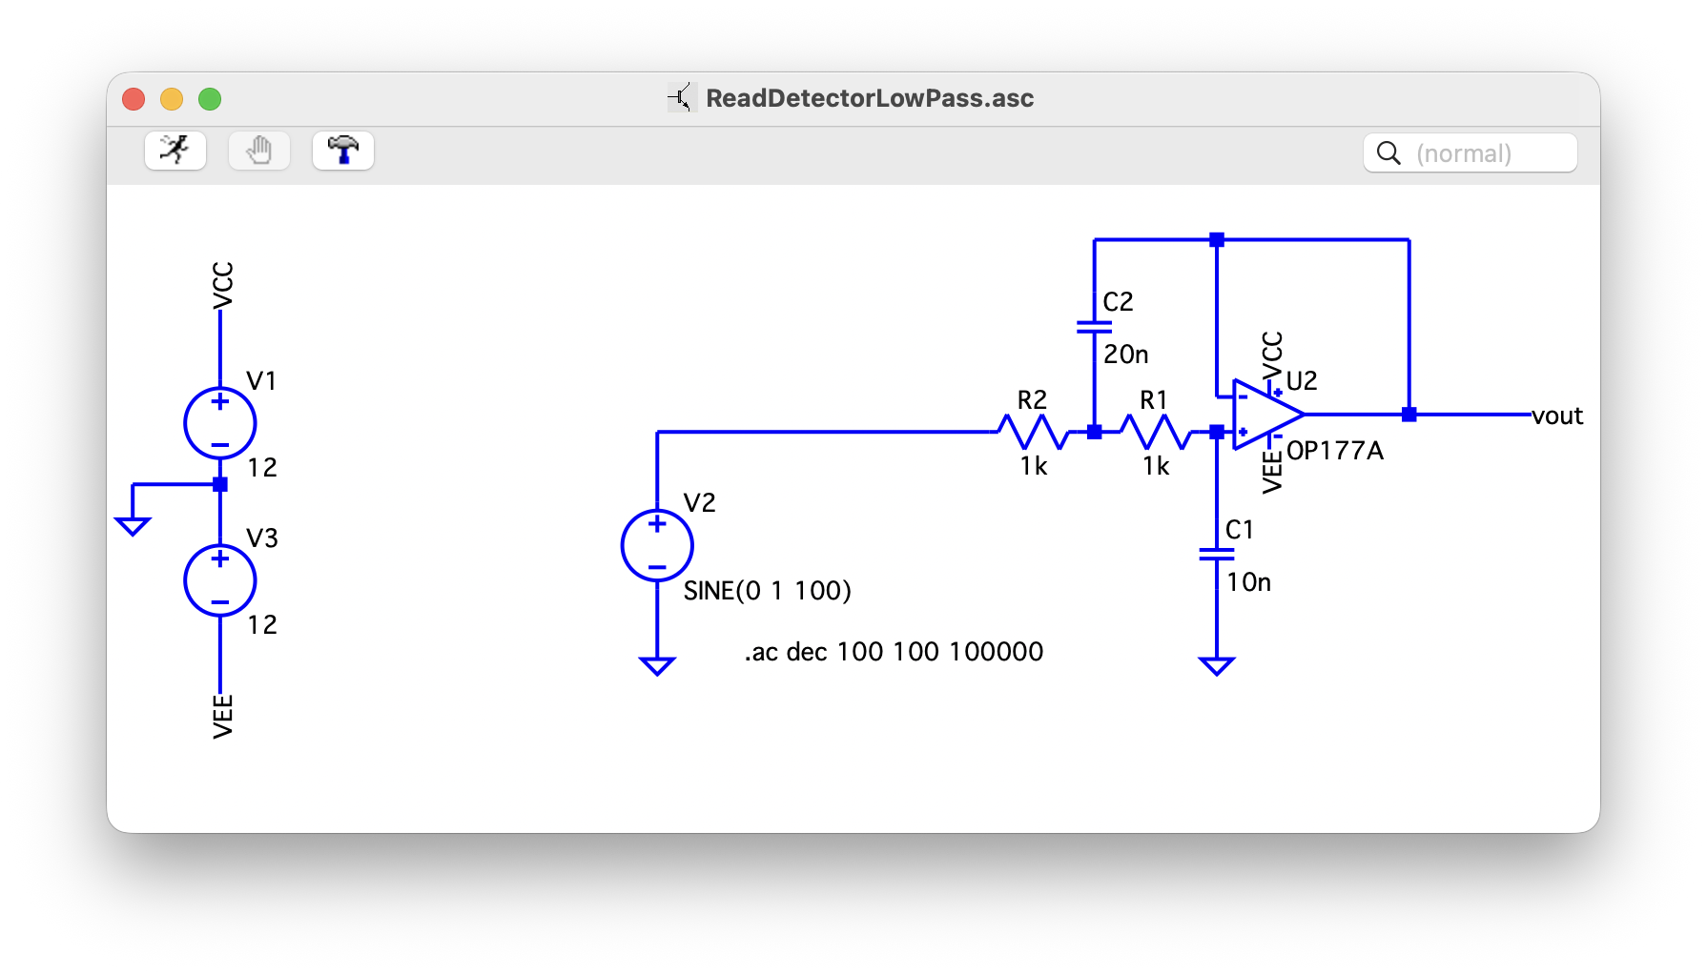
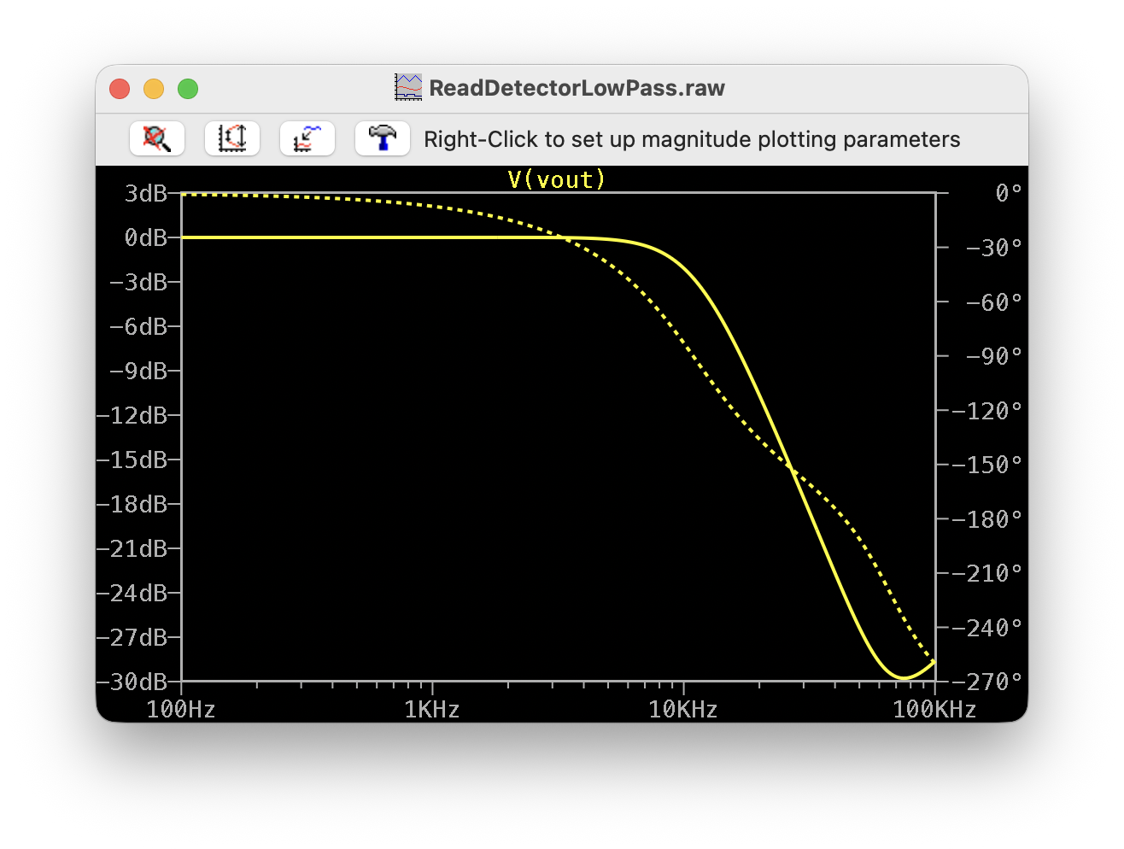

Read Detector full analog section
C3 and C4 changed to 5n and 10n respectively.
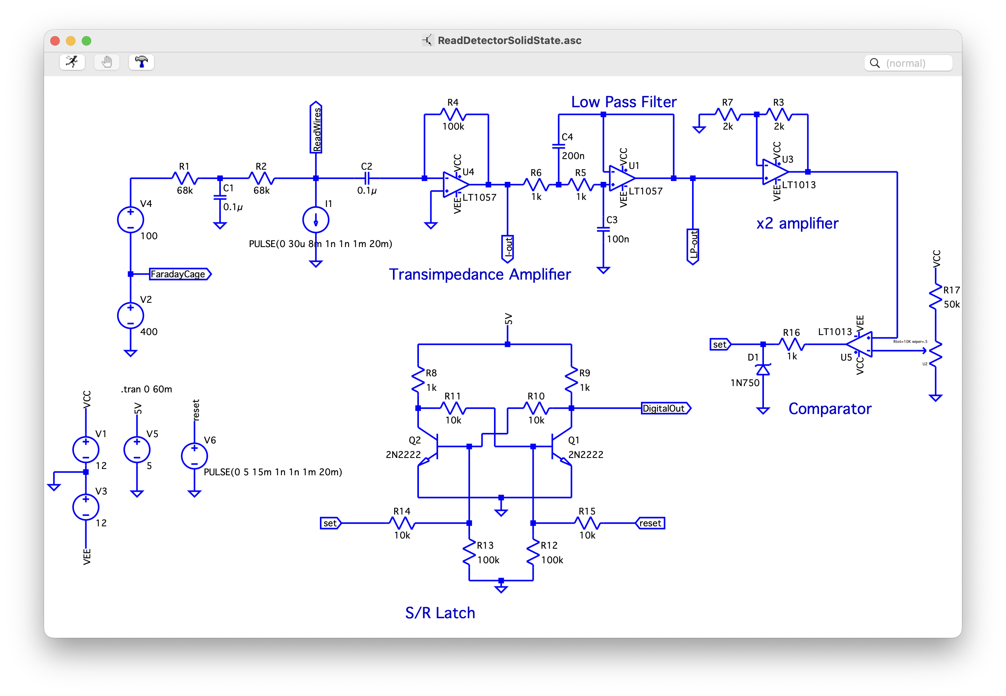
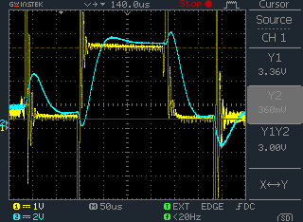
Representative, typical signals. Yellow: output of transimpedance amplifier. Blue, output of x2&low-pass.

