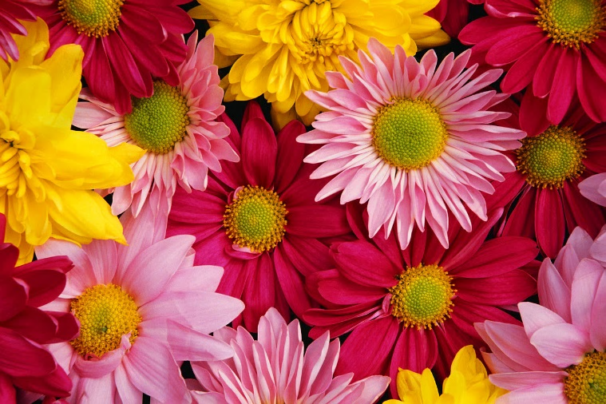
Blaine Flower &
Garden Festival

Blaine Central
Park
May
17-19
Celebrating the beauty of Central California

Grand Parade
May 18, 10:00 am
Displays
Floral design
Landscape design
Hardscape/architecture
Orchids & exotics

Just for Kids
Beginners’ planting
Floral arts & crafts
Scavenger hunt
Story time

Demos/Classes
Gardening & planting
Floral arrangement
Beginners’ bonsai clinic
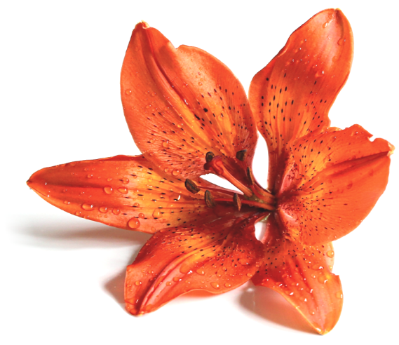

Presented by
Pacific Coast Festival Association | www.pacificcoastfestivals.com
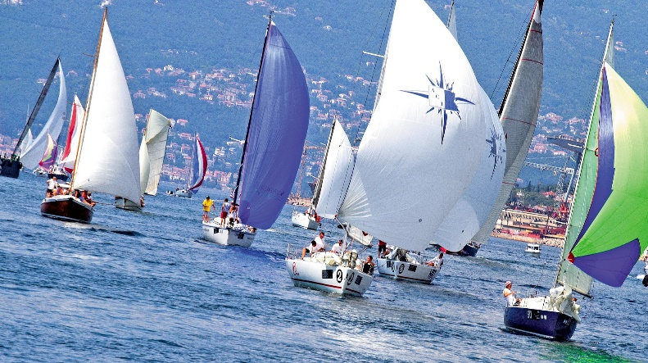

WINDWARD SAILING FESTIVAL
SKIPPERS’ BRIEFING 8:30 AM
SEPTEMBER 5 -7TH
SAN FRANCISCO BAY
Presented by
Pacific Coast Festival Association | www.pacificcoastfestivals.com
Races
Marine Junior Match Race
Day Sailer Regatta
Five Mile Fleet Race
Pro Team Race
Offshore Yacht Race

Just for Kids
Dinghy Flotilla
Knot Tying Class
Paint Your Own Sailboat
Sandcastle Competition

Vendors
Bosun Sailing Gear
Latte-Da Coffee
Salt & Sand Apparel
Max’s Sandwich Shop

