

Power Query: A Beginner's Guide
In the world of data analysis, having the right tools can make all the difference. One such tool that I have found invaluable in my journey is Power Query. If you're new to data manipulation and analysis, you might be wondering, "What exactly is Power Query, and how can it help me?" In this blog post, I will provide a comprehensive overview of Power Query, where to find and access it, and a detailed look at the Power Query interface in Power BI Desktop. So, grab a cup of coffee, and let’s dive into the fascinating world of data transformation!

What is Power Query?

Power Query is a powerful data connection technology that enables users to discover, connect, combine, and refine data across a wide variety of sources. Think of it as your personal data assistant, helping you to clean and prepare your data for analysis. It allows you to import data from various sources such as Excel spreadsheets, databases, web pages, and more, and then transform that data into a format that is suitable for analysis.

When I first started using Power Query, I was amazed at how much time it saved me. Before discovering this tool, I would spend hours manually cleaning and organizing data in Excel. With Power Query, I could automate many of these tasks, allowing me to focus on the analysis itself rather than the tedious preparation work.

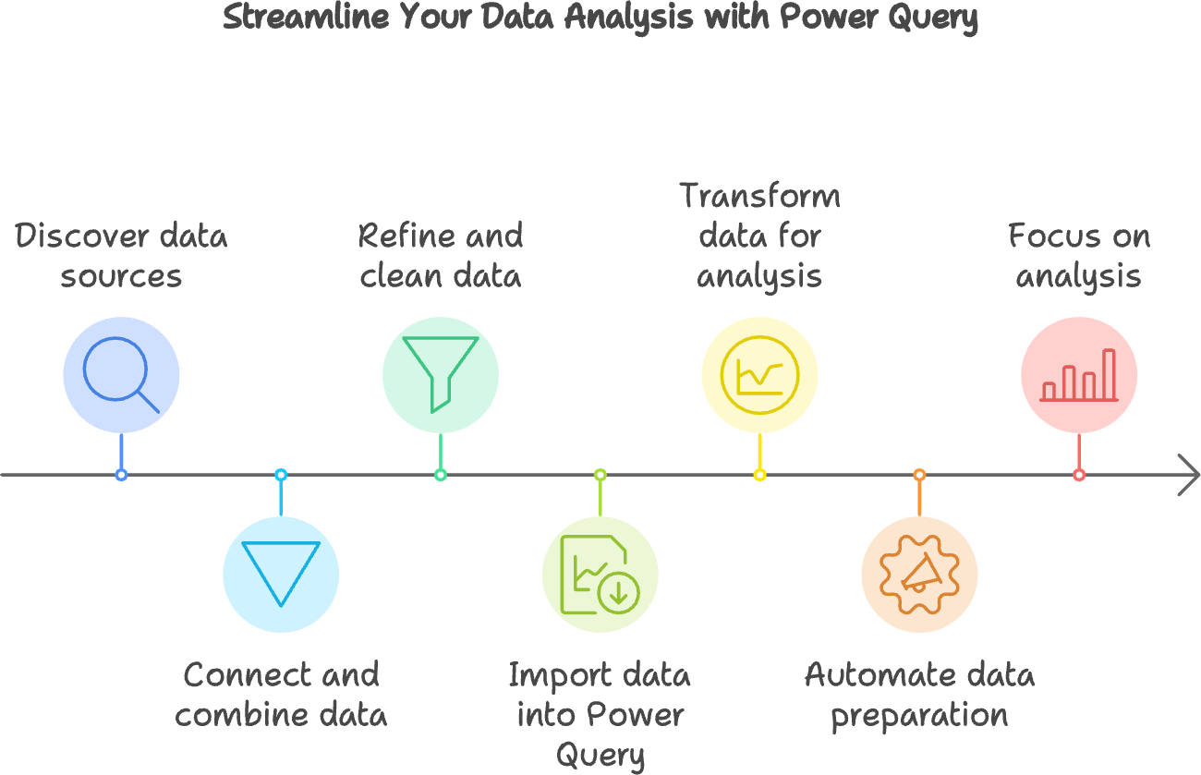

Where Can I Find and Access Power Query?

Power Query is integrated into several Microsoft products, including Excel and Power BI. If you're using Excel, you can find Power Query under the "Data" tab, where it is labeled as "Get & Transform Data." In Power BI Desktop, Power Query is also readily accessible, allowing you to import and transform your data seamlessly.

To access Power Query in Power BI Desktop, follow these simple steps:

- Open Power BI Desktop: If you haven't already installed it, you can download it for free from the Microsoft website.
- Get Data: Click on the "Home" tab in the ribbon, and then click on the "Get Data" button. This will open a window with various data source options.
- Choose Your Data Source: Select the type of data source you want to connect to, such as Excel, SQL Server, or a web page, and click "Connect."
- Launch Power Query Editor: Once you've connected to your data source, you can click on "Transform Data" to open the Power Query Editor, where the magic happens.

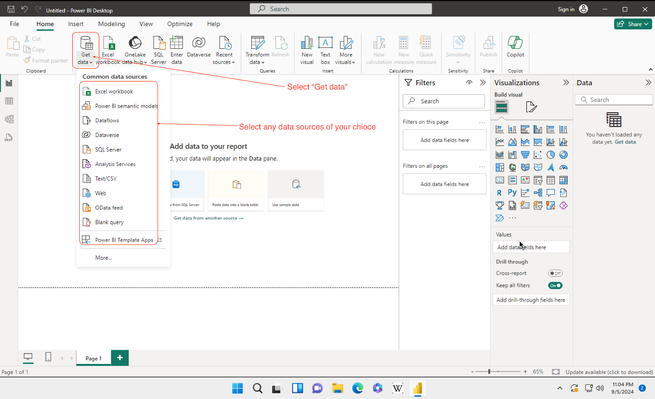

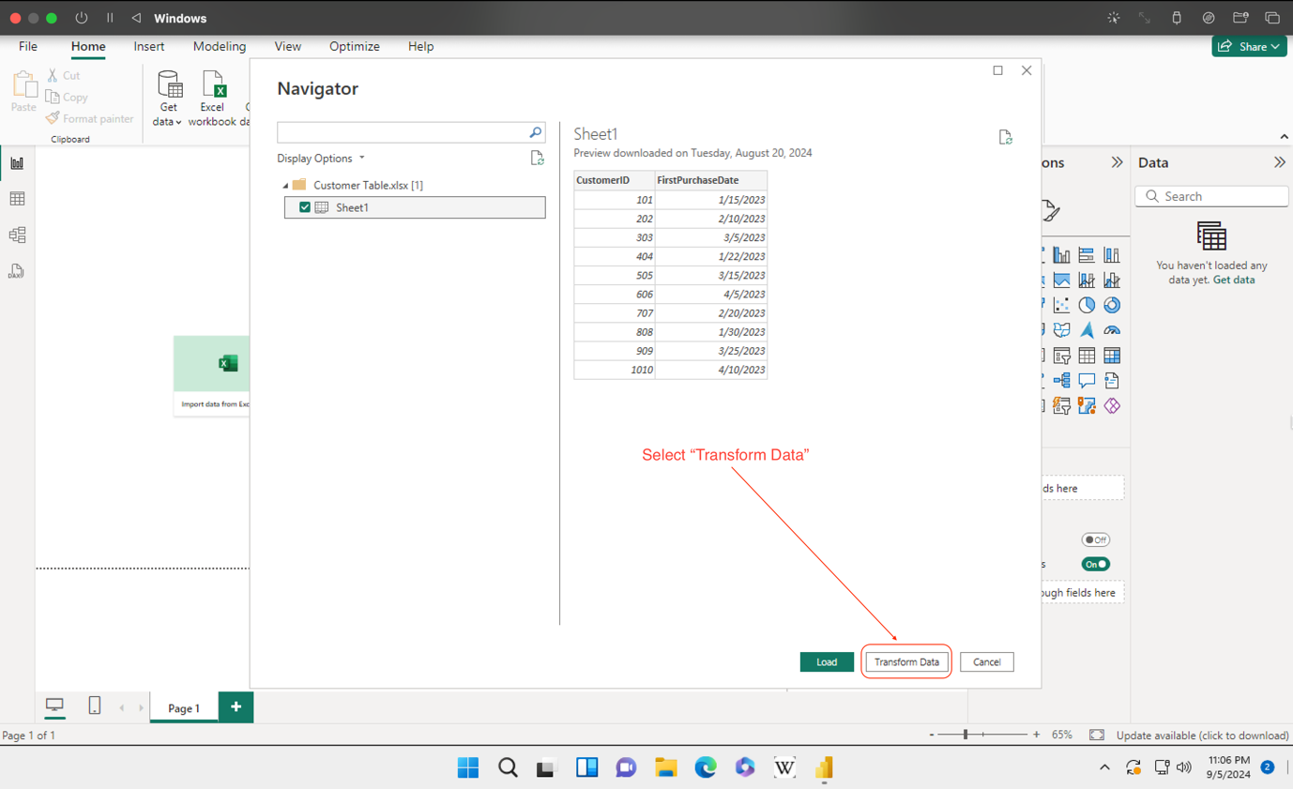

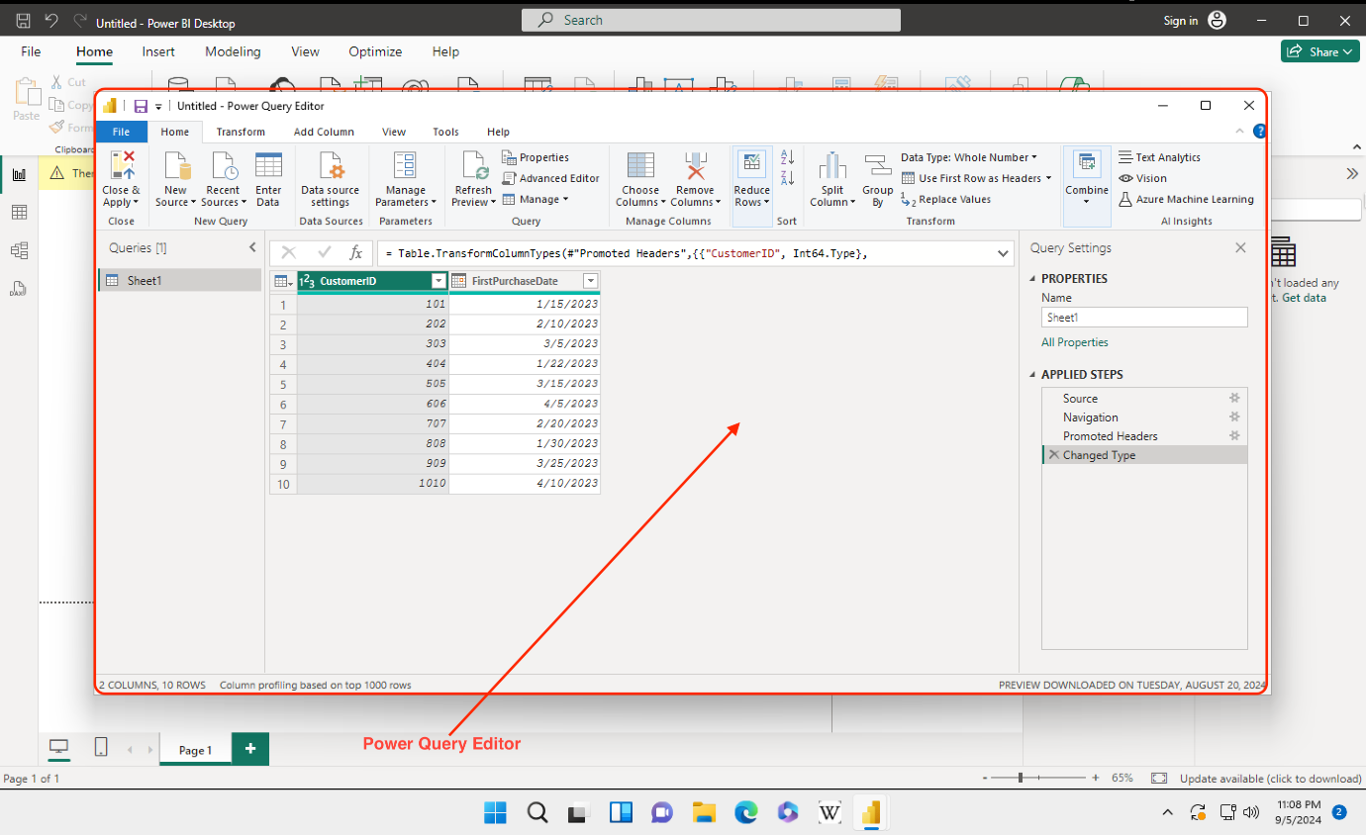

Overview of the Power Query Interface in Power BI Desktop

Now that you know how to access Power Query, let’s take a closer look at the Power Query interface itself. As a beginner, it can be a bit overwhelming at first, but I assure you, with a little practice, you’ll become comfortable navigating through it.

The Power Query Editor

When you open the Power Query Editor, you will see a clean and organized interface. Here are the main components you will encounter:
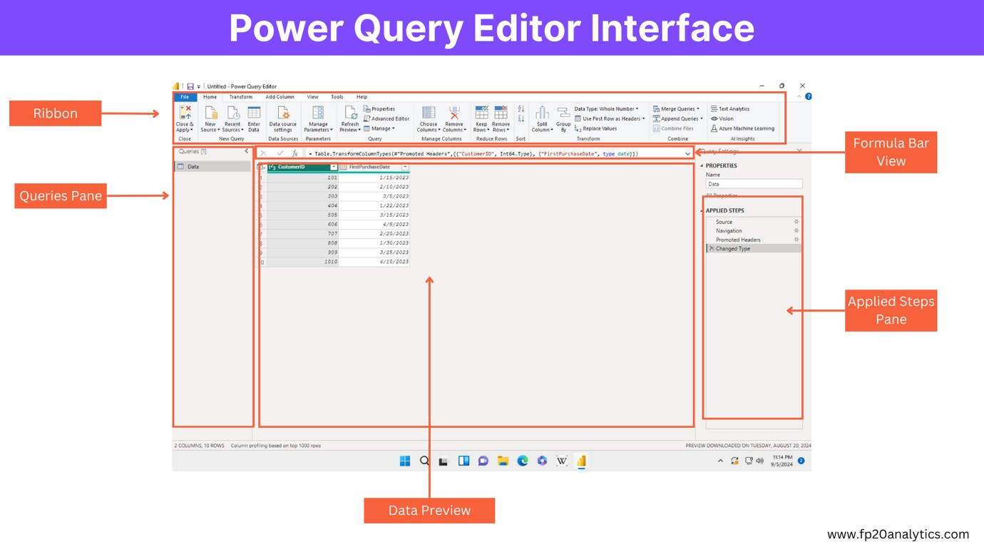

- Ribbon: At the top of the Power Query Editor, you will find the ribbon, which contains various tabs such as "Home," "Transform," "Add Column," and "View." Each tab has a set of tools that you can use to manipulate your data.

- Queries Pane: On the left side of the interface, you will see the Queries Pane. This is where all your queries will be listed. You can create new queries, rename them, or delete them as needed.

- Data Preview: In the center of the interface, you will see the Data Preview area. This is where you can view your data in a table format. You can scroll through the data, and as you apply transformations, you will see the changes reflected here in real-time.

- Applied Steps Pane: On the right side of the interface, you will find the Applied Steps Pane. This is one of my favorite features of Power Query. It allows you to see a step- by-step history of all the transformations you have applied to your data. If you make a mistake, you can easily go back and remove or modify any step.

- Formula Bar: If you want to dive deeper into your transformations, you can enable the Formula Bar from the "View" tab in the ribbon. This allows you to see and edit the M code that Power Query generates behind the scenes. While you don’t need to know M code to use Power Query effectively, having access to it can be helpful for advanced users.

Basic Transformations

Now that you are familiar with the interface, let’s explore some basic transformations you can perform using Power Query. These transformations are essential for cleaning and preparing your data for analysis

- Removing Columns: Often, datasets contain columns that are not relevant to your analysis. To remove a column, simply right-click on the column header and select "Remove." Alternatively, you can select the column and click on the "Remove Columns" button in the ribbon.

- Filtering Rows: If you only want to analyze a specific subset of your data, you can filter rows. Click on the dropdown arrow in the column header, and you will see options to filter your data based on specific criteria.

- Changing Data Types: Ensuring that your data types are correct is crucial for accurate analysis. You can change the data type of a column by right-clicking on the column header, selecting "Change Type," and then choosing the appropriate data type.

- Merging Queries: If you have multiple datasets that you want to combine, you can use the Merge Queries feature. This allows you to join two or more queries based on a common column, similar to a SQL JOIN operation.

- Appending Queries: If you have similar datasets that you want to stack on top of each other, you can use the Append Queries feature. This is particularly useful when you have data spread across multiple files or tables.

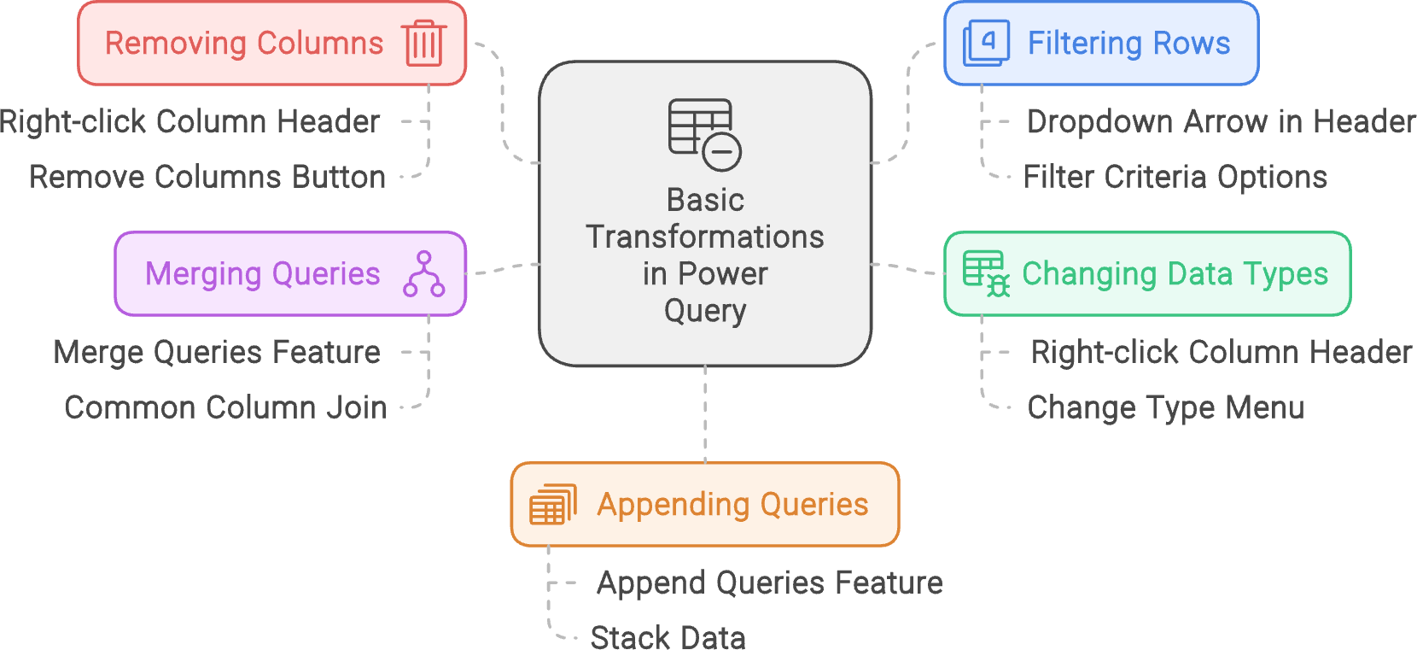

Advanced Transformations

As you become more comfortable with Power Query, you may want to explore some advanced transformations. Here are a few techniques that I have found particularly useful:

- Grouping Data: If you want to summarize your data, you can use the Group By feature. This allows you to group your data based on one or more columns and perform aggregations such as sum, average, or count.

- Creating Custom Columns: Sometimes, you may need to create new columns based on existing data. You can do this by using the "Add Column" tab in the ribbon and selecting "Custom Column." This opens a dialog where you can write a formula to define the new column.

- Using Conditional Columns: If you want to create a new column based on certain conditions, you can use the Conditional Column feature. This allows you to set up rules that determine the values in the new column based on the values in existing columns.

- Pivoting and Unpivoting Data: If your data is in a format that is not suitable for analysis, you can pivot or unpivot it. Pivoting allows you to turn unique values from one column into multiple columns, while unpivoting does the opposite.

- Using Parameters: For more advanced users, Power Query allows you to create parameters that can be used in your queries. This is particularly useful for making your queries dynamic and reusable.

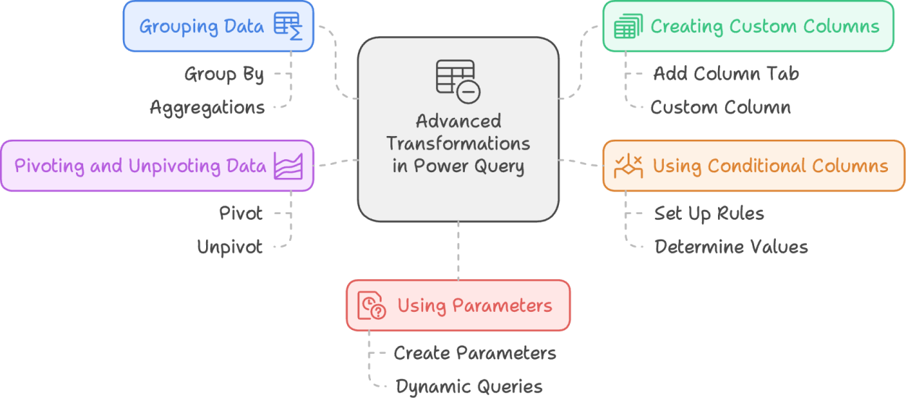

Best Practices for Using Power Query

As I’ve navigated through the world of Power Query, I’ve learned a few best practices that can help you make the most of this powerful tool:

- Keep Your Queries Organized: As you create multiple queries, it’s essential to keep them organized. Use meaningful names for your queries and group related queries together.

- Document Your Steps: While the Applied Steps Pane is helpful, it’s also a good idea to document your transformations. You can add comments to your queries to explain what each step does, making it easier for others (or yourself) to understand later.

- Test Your Queries: Before loading your data into Power BI, take the time to test your queries. Make sure that the transformations are producing the expected results and that there are no errors.

- Use the Load Options Wisely: When you’re ready to load your data into Power BI, you can choose to load it directly to the data model or create a connection only. If you’re working with large datasets, consider using the connection-only option to improve performance.

- Stay Updated: Power Query is continually evolving, with new features and enhancements being added regularly. Stay updated with the latest releases and best practices by following blogs, forums, and official Microsoft documentation.

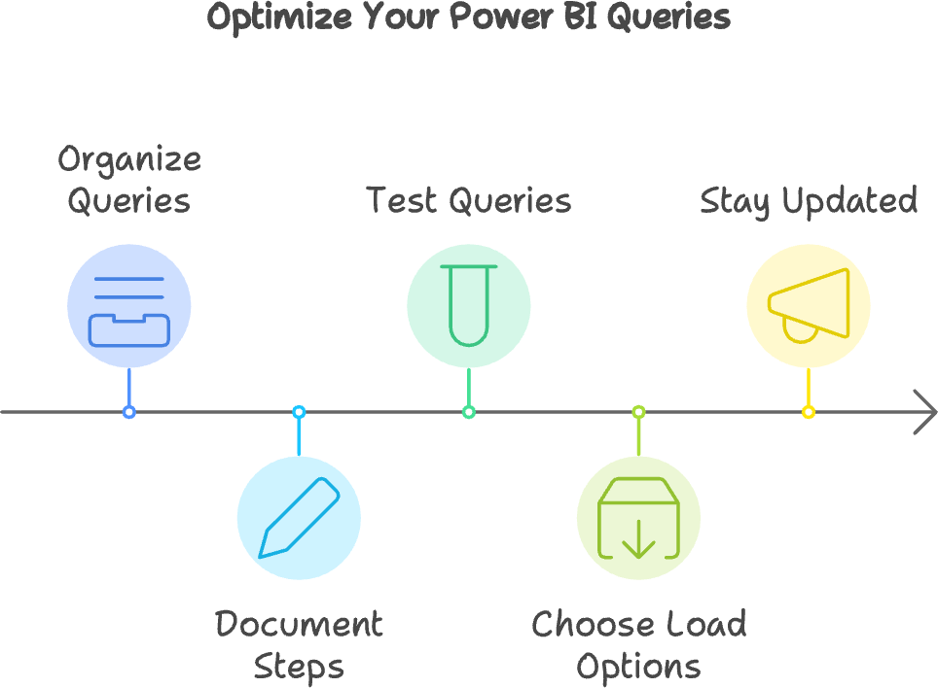

Conclusion

Power Query is an essential tool for anyone looking to analyze and manipulate data effectively. With its user-friendly interface and powerful transformation capabilities, it can save you countless hours of manual work. Whether you’re a complete beginner or someone looking to enhance your data skills, I encourage you to explore Power Query further.

As you embark on your Power Query journey, remember that practice makes perfect. Don’t hesitate to experiment with different transformations and features. The more you use it, the more comfortable you will become.

I hope this guide has provided you with a solid foundation to get started with Power Query in Power BI Desktop. Happy querying!

