Trần Thế Thịnh 20194853

Report Project 1

Example1.kpl

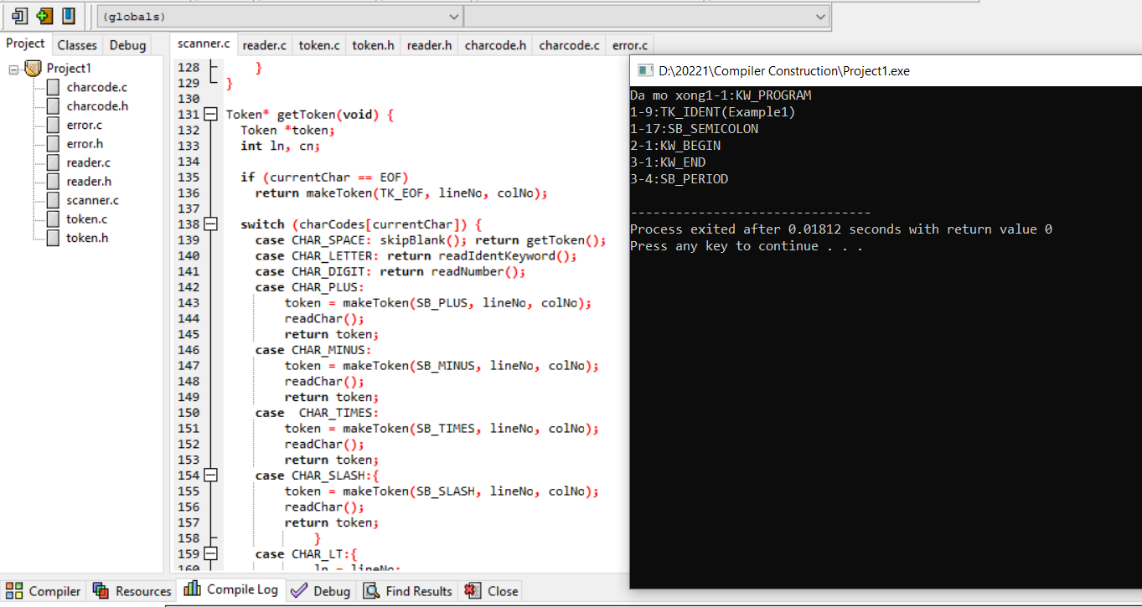

Example2.kpl

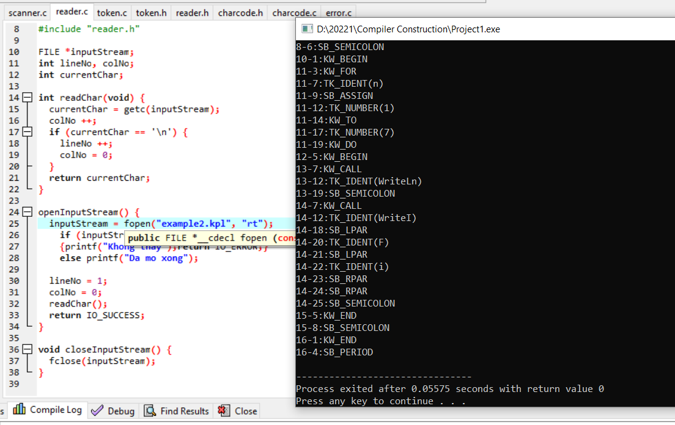

ERM_ENDOFCOMMENT "End of comment expected!"

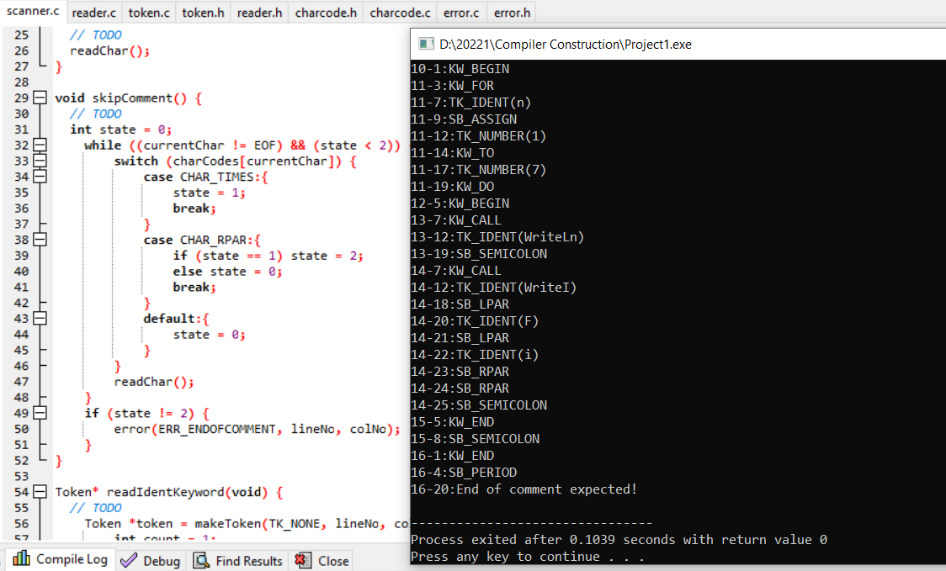

ERM_IDENTTOOLONG "Identification too long!"

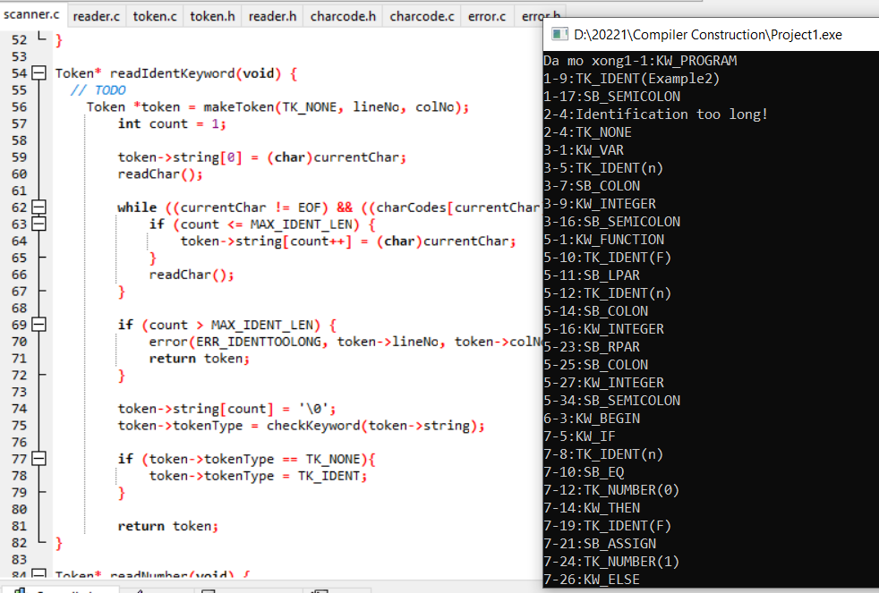

ERM_INVALIDCHARCONSTANT "Invalid const char!"

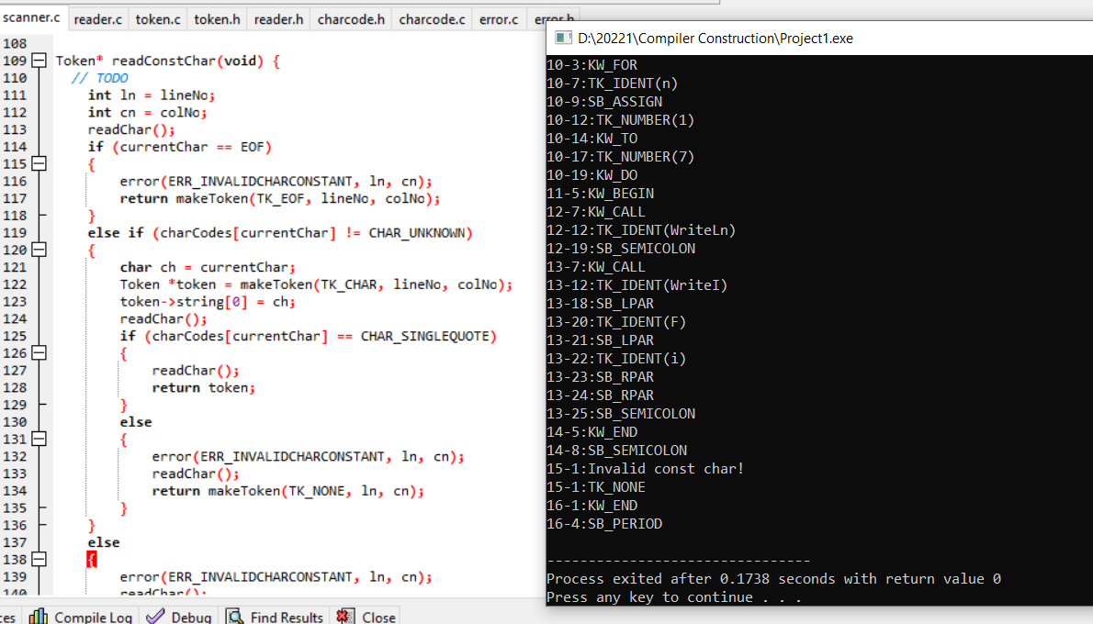

ERM_INVALIDSYMBOL "Invalid symbol!"

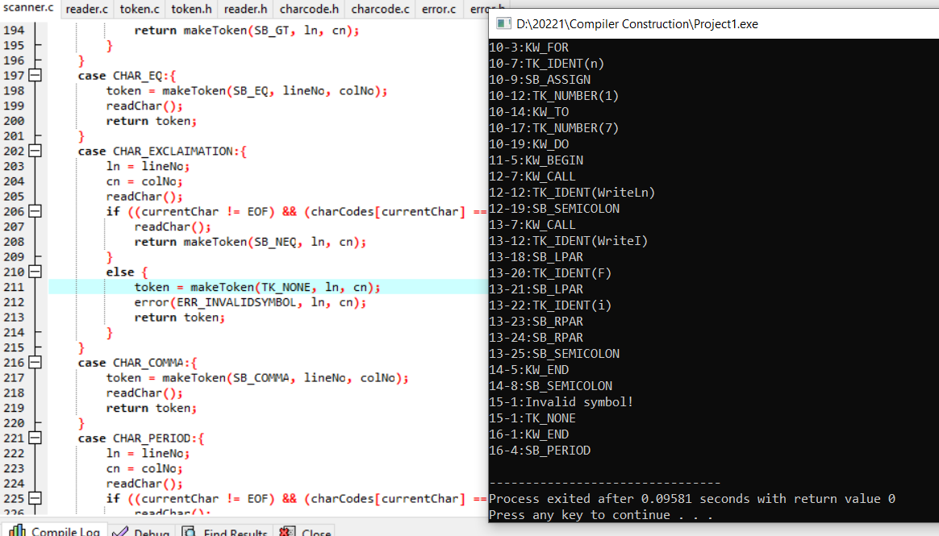

Example3.kpl

