Trần Thế Thịnh 20194853

Report Project 1b

A valid identifier can have letters (both uppercase and lowercase letters), digits and underscores.

1. The first letter of an identifier should be either a letter or an underscore.
2. You cannot use keywords as identifiers.
3. There is no rule on how long an identifier can be. However, only 15 characters are significant
4. Identifiers are case-sensitive

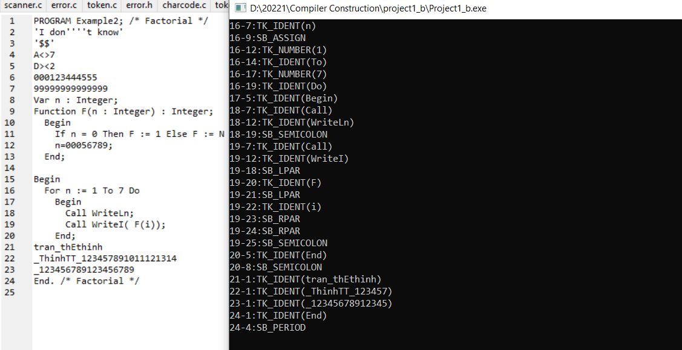

Keywords: All keywords must be written in uppercase

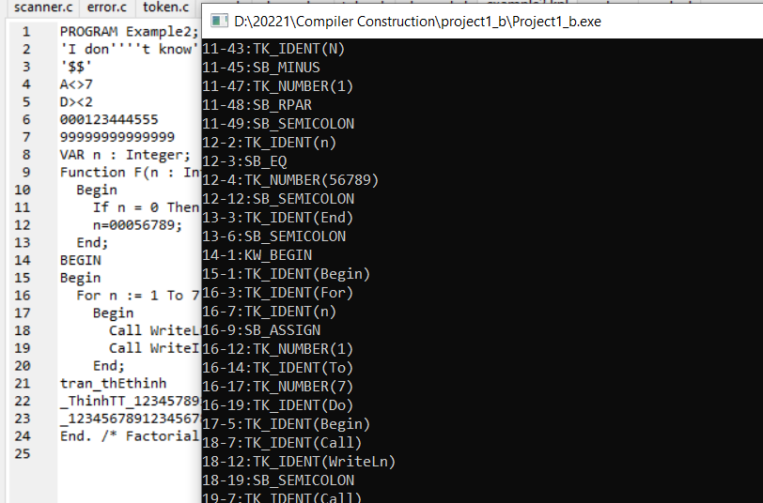

Comments: Multi-line Comments : between /\* and \*/

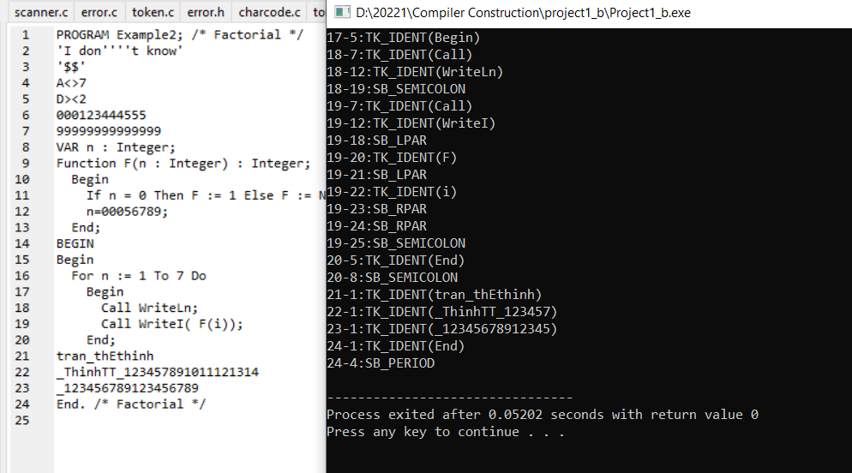

Special Symbols: Relop: not equal to => 2 choices <> or ><

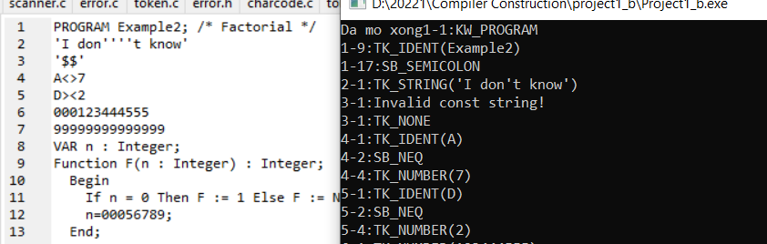

Character/String constants: String constants are allowed in KPL. A string constant can contain a sequence of printable symbols, length not exceeding 255, enclosed in single quotes. A single quote is written as ''''

