Report_project2b

Invalid statement

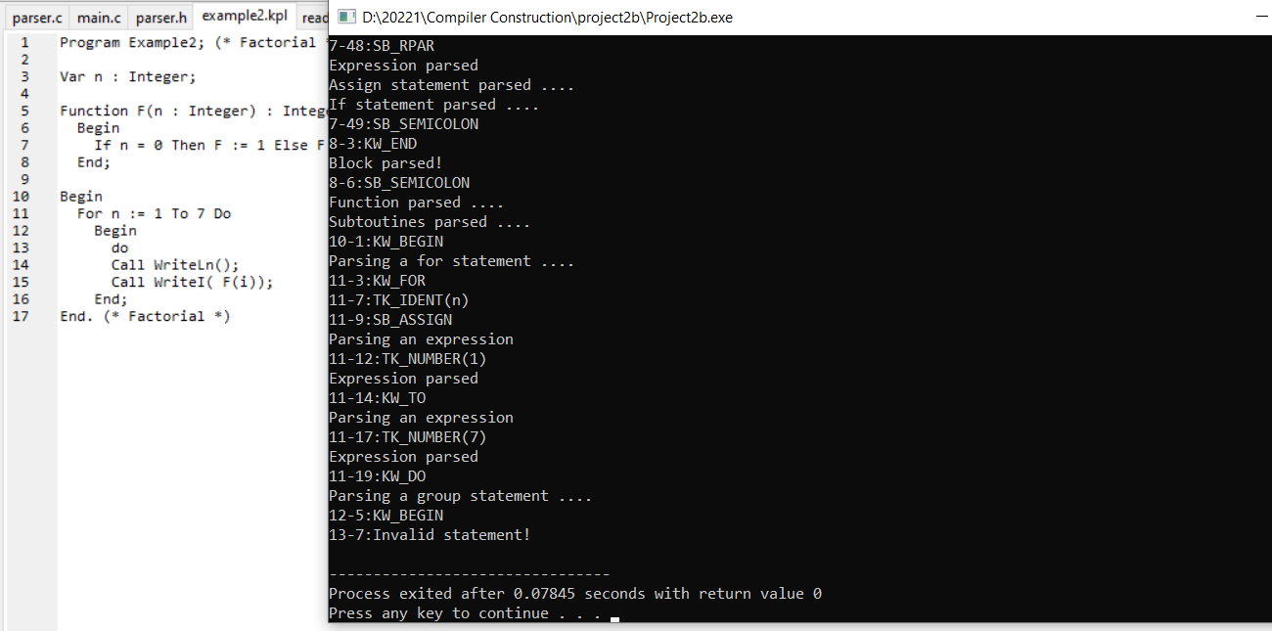

Arguments ::= SB_LPAR Arguments1 SB_RPAR

Arguments1 ::= Expression Arguments2

Arguments1 ::= eps

Arguments2::= SB_COMMA Expression Arguments2

Arguments2::= eps

