Nail Shops

Software Requirement Specification

Project Code: <Code of the project>

Document Code: <Code of the document >– v<x.x>

**<Location, issued date of the Document>**

Record of change

*A - Added M - Modified D - Deleted

|  |  |  |  |  |
| --- | --- | --- | --- | --- |
| Effective Date | Changed Items | A* M, D | Change Description | New Version |
| 02/12/2016 | Initial | a | Add project over view |  |
|  |  |  |  |  |
|  |  |  |  |  |
|  |  |  |  |  |
|  |  |  |  |  |
|  |  |  |  |  |
|  |  |  |  |  |
|  |  |  |  |  |
|  |  |  |  |  |
|  |  |  |  |  |
|  |  |  |  |  |
|  |  |  |  |  |
|  |  |  |  |  |
|  |  |  |  |  |
|  |  |  |  |  |
|  |  |  |  |  |
|  |  |  |  |  |
|  |  |  |  |  |
|  |  |  |  |  |
|  |  |  |  |  |
|  |  |  |  |  |

SIGNATURE PAGE

**ORIGINATOR:** PHAM TANG GIAU 8/7/2021

TRAN THI HAI HA

DINH THI NHU QUYNH

<Position>

**REVIEWERS:** <Name> <Date>

<Position>

<Name, if it’s needed> <Date>

<Position>

**APPROVAL:** <Name> <Date>

<Position>

Table of Contents

1 Introduction 5

1.1 Purpose 5

1.2 Scope 5

1.3 Definitions, Acronyms, and Abbreviations 6

1.4 References 6

1.5 Overview 6

2 Overall Description 7

2.1 Product Perspective 7

2.2 Product Functions 7

2.3 Constraints 8

2.4 Assumptions & Dependencies 8

3 FUNCTIONAL Requirements 9

3.1. <Use Case Diagram> 9

3.2 <Register> 9

3.3.<Login> 11

3.4 <Customer> View history 13

3.5 <Customer> Cancel booking 14

3.6. <Customer> Send feedback 16

3.7. <Shop Manager>Cancel Booking 17

3.8. <Shop Manager> Finish Booking 19

3.9. <Shop Manager> View booking 20

3.10. <Shop Manager> Send Feedback 22

3.11. <Customer> Search shops 24

3.12. <Customer> View a shop 26

3.13. <Customer> View a service 27

3.14. <Customer> Book services 29

3.15. <Customer> Save voucher 32

3.16. <Admin> View customers 34

3.17. <Admin> Disable customers 36

3.18. <Admin> View shops 38

3.19. <Admin> Disable shops 40

3.20. < Shop Manager > Add a new service 41

3.21. < Shop Manager > Edit service 43

3.22. <Shop Manager> Delete service 45

3.23. <Shop Manager> Add a new voucher 46

3.24. <Shop Manager> Edit voucher 48

3.25. <Shop Manager> Delete voucher 50

3.26. <Shop Manager> Close shop 51

3.27. <Shop Manager> View customer’s feedback 53

3.28. <Logout> 55

4 NON-FUNCTIONAL Requirements 56

4.1 Usability 56

4.2 Reliability 56

4.3 Performance 56

5 Supporting Information 56

# Introduction

NailShops is an intermediary application that helps user book appointments at nail shops easily.

Users can quickly find and choose the right nail shops with reasonable prices. Besides, nail shops have more customers and increase income.

This software provides a clear and friendly interface to the users.

## Purpose

The purpose of this app is to help connect customers with nail shops.

## Scope

NailShops designed to run on mobile phone.

Customers can search for shops; book appointments by selecting services; cancel bookings and rate services.

Nail shops can manage services, view bookings and cancel booking, rate customers.

## Definitions, Acronyms, and Abbreviations

NailShops: The name of the application

SRS: Software Requirement Specification

## References

HB final document

## Overview

The rest of this SRS contains the following information:

* Overall Description
* Functional Requirements
* Non-functional Requirements
* Supporting Information

# Overall Description

## Product Perspective

Nailshops database system stores the following information:

• **Customer description:**

It includes the customer's code, name, address, phone number, etc. This information may be used to keep customer records.

• **Shop manager description:**

It includes shop manager code, name, address, and phone number…. This information can be used to keep the shop manager's record.

**• Shop details:**

It includes shop code, name, address, phone number, services, etc. This information can be used to store the shop records.

**• Description of booking:**

It includes detailed information about the customer, the service, the name of the shop, the address of the shop, the date and time of the appointment, and the status.

## Product Functions

**Admin**: has the right to view information and disable customers and shops

**Custome**r:

- Ability to search for shops

- View shops and book services

- Rate the service after use

**Shop manager**:

- Can add, delete, edit services

- Can add, delete, edit vouchers

- Can cancel the booking and send feedback

## Constraints

Login is used for user authentication

## Assumptions & Dependencies

Assumption

- Users with an Internet connection have access to this application.

Dependence

- All subsequent operations that the user does on the application will depend on the internet

# FUNCTIONAL Requirements

## 3.1. <Use Case Diagram>

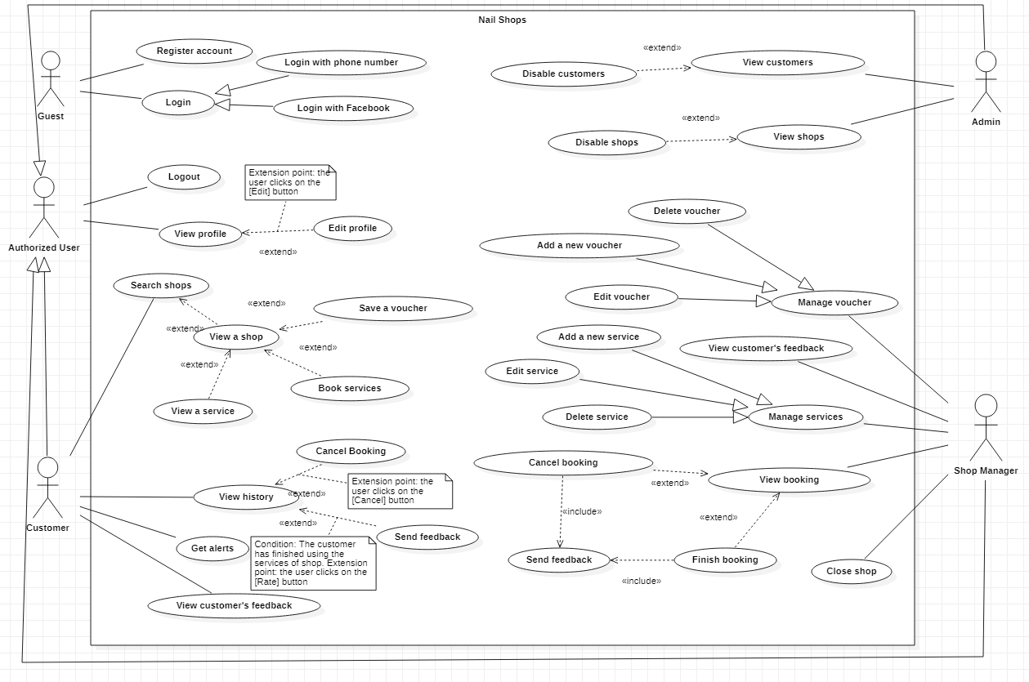

## 3.2 <Register>

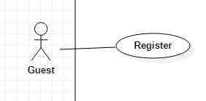

|  |  |  |  |  |
| --- | --- | --- | --- | --- |
| **USE CASE - Nail shops_UC001** | | | | |
|  | | | | |
| **Use-case No.** | UC001 | **Use-case Version** | | <1.0> |
| **Use-case Name** | Register | | | |
| **Author** | Pham Tang Giau | | | |
| **Date** | 28/05/2021 | **Priority** | High | |
| **Actor**:   * Guest   **Summary**:   * This use case allows user to register an account   **Goal**:   * Guest can register an account   **Trigger**:   * Guest clicks “Register” button.   **Precondition**:   * Guest is on the login screen.   **Post Conditions:**   * Success: User registers to the system successfully.   **Main Success Scenario:**   |  |  |  | | --- | --- | --- | | Step | Actor system | System Response | | 1 | Guest chooses “Register” button | The system requires the following input from Guest includes:   * Phone: text, required and unique and must contain 10 digits. * Fullname: text, required have more than 6 and less than 30 characters. * Password: password, required and have more than 6 and less than 20 characters. * Confirm password: password, required and reconfirm matches the password. * Address: text, and have more than 6 and less than 50 characters.   [Exceptions] | | 2 | Guest inputs information. |  | | 3 | Guest clicks “Confirm” | The system check validation, send OTP to phone number. | | 4 | Guest inputs OTP and click “OK” | The system show message “Registered successfully”. |   **Alternative Scenario: N/A**  **Exceptions:**   |  |  |  | | --- | --- | --- | | No | Actor system | System response | | 1 | Phone is used by another account | System shows message “Account is existed.” | | 2 | “Confirm password” does not match | System shows message “Password doesn’t match” |   **Relationships:** N/A  **Business Rules:** N/A | | | | |

## 3.3.<Login>

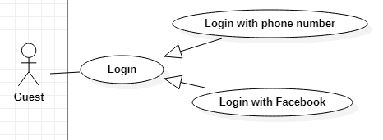

|  |  |  |  |  |
| --- | --- | --- | --- | --- |
| **USE CASE - Nail shops_UC002** | | | | |
| **Use-case No.** | UC002 | **Use-case Version** | | <1.0> |
| **Use-case Name** | Login | | | |
| **Author** | Pham Tang Giau | | | |
| **Date** | 28/05/2021 | **Priority** | High | |
| **Actor**:   * Guest   **Summary:**   * This use case allows user to login to the system.   **Goal:**   * Guest cans login to the system   **Trigger:**   * Guest clicks on “Login”   **Precondition:**   * Guest is on the login screen   **Post Conditions:**   * Success: User logins to the system successfully   **Main Success Scenario:**   |  |  |  | | --- | --- | --- | | Step | Actor system | System Response | | 1 | Guest is on the login screen | The system requires the following input from User includes:   * Phone: text, required * Password: password, required | | 2 | User inputs information. |  | | 3 | Guest clicks “Login” button | The system check validation, and redirect to the homepage.  [Exception 1] |   **Alternative Scenario:**   |  |  |  | | --- | --- | --- | | Step | Actor system | System response | | 1 | User click “Login with Facebook” | System links to Facebook. | | 2 | User input password | System check validation and redirect to the homepage.  [Exception 2] |   **Exceptions:**   |  |  |  | | --- | --- | --- | | No | Actor system | System response | | 1 | Phone or password is incorrect | Shows message “Phone or password is incorrect” | | 2 | Password is incorrect | Shows message “Password is incorrect” |   **Relationships:** N/A  **Business Rules:** N/A | | | | |

## 3.4 <Customer> View history

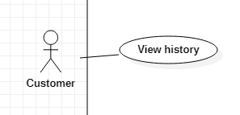

|  |  |  |  |  |
| --- | --- | --- | --- | --- |
| **USE CASE - Nail shops_UC003** | | | | |
| **Use-case No.** | UC003 | **Use-case Version** | | <1.0> |
| **Use-case Name** | View history | | | |
| **Author** | Pham Tang Giau | | | |
| **Date** | 28/05/2021 | **Priority** | normal | |
| **Actor:**   * Customer   **Summary:**   * This use case allows customer to view booking history   **Goal:**   * Customer cans view booking history.   **Triggers:**   * Customer clicks on “History”.   **Preconditions:**   * User must login into the system with role Customer.   **Post conditions:**   * Success: View the booking history successfully   **Main Success Scenario:**   |  |  |  | | --- | --- | --- | | Step | Actor system | System Response | | 1 | Customer clicks “History” on menu task bar | Show list of orders screen  [Exception 1] | | 2 | Customer selects a detail order | The system redirects to the user's booking history screen includes:  + ID of booking  + Shop’s name  + Services  + Date and arrival time  + Voucher  + Total price  + Create date  + Status  + Feedback button |   **Alternative Scenario:** N/A  **Exceptions:**   |  |  |  | | --- | --- | --- | | Step | Actor system | System response | | 1 | Customer do not have booking | System show message “You don't have any orders” |   **Relationships:** N/A  **Business Rules:**  - Create date is the date the customer place the booking  - Date and arrival time is the date is the date and time the customer comes to the nail shop  - When the order is complete, there must be a feedback button  -“Status” include:  + Processing  + Finished  + Canceled | | | | |

## 3.5 <Customer> Cancel booking

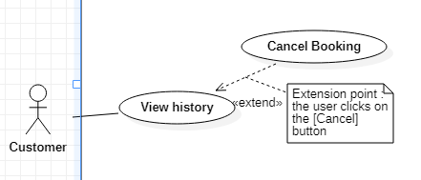

|  |  |  |  |  |
| --- | --- | --- | --- | --- |
| **USE CASE - Nail shops_UC004** | | | | |
| **Use-case No.** | UC004 | **Use-case Version** | | <1.0> |
| **Use-case Name** | Cancel Booking | | | |
| **Author** | Pham Tang Giau | | | |
| **Date** | 28/05/2021 | **Priority** | normal | |
| **Actor:**   * Customer   **Summary:**   * This use case allows customer to cancel booking.   **Goal:**   * Customer can cancel booking.   **Triggers:**   * Customer clicks on “Cancel”.   **Preconditions:**   * User must login into the system with role Customer.   **Post conditions:**   * Success: Cancel the order successfully.   **Main Success Scenario:**   |  |  |  | | --- | --- | --- | | Step | Actor system | System Response | | 1 | Customer clicks “History” on menu task bar | Show list of orders screen. | | 2 | Customer clicks on “Cancel” button of an order | System ask user to confirm the action.  - OK: button  - Cancel: button | | 3 | Customer chooses “OK” | Show message “Cancel successfully”. |   **Alternative Scenario: N/A**  **Relationships:**  -The use case “Cancel booking” extended by the use case “View history”  **Business Rules:**  - Status of booking will change to “Canceled”.  - Can only be canceled when the service has not been completed. | | | | |

## 3.6. <Customer> Send feedback

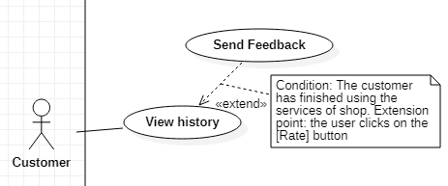

|  |  |  |  |  |
| --- | --- | --- | --- | --- |
| **USE CASE - Nail shops_UC005** | | | | |
| **Use-case No.** | UC005 | **Use-case Version** | | <1.0> |
| **Use-case Name** | Send feedback | | | |
| **Author** | Pham Tang Giau | | | |
| **Date** | 28/05/2021 | **Priority** | normal | |
| **Actor:**   * Customer   **Summary:**  - This use case allows customers to review booking.  **Goal:**  - Customer can review booking.  **Triggers:**  - Customer touch “Feedback”.  **Preconditions:**  - Customer must use services of shop and status of booking is “Finish”.  **Post conditions:**  - Success: Review booking successfully.  **Main Success Scenario:**   |  |  |  | | --- | --- | --- | | Step | Actor system | System Response | | 1 | Customer is on booking detail and click “Feedback” button | The system redirects to the review page includes:  + Comment: textarea  + Star number (the lowest star is 1 and the highest is 5.)  +Send: button | | 2 | Customer click on “Send” button | System will show message “Feedback successfully”. |   **Alternative Scenario:** N/A  **Exceptions:** N/A  **Relationships:**  -The use case “Send Feedback” extended by the use case “View history”  **Business Rules:** N/A | | | | |

## 3.7. <Shop Manager>Cancel Booking

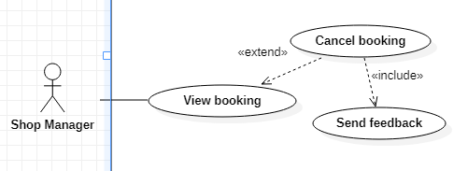

|  |  |  |  |  |
| --- | --- | --- | --- | --- |
| **USE CASE - Nail shops_UC006** | | | | |
| **Use-case No.** | UC006 | **Use-case Version** | | <1.0> |
| **Use-case Name** | Cancel booking | | | |
| **Author** | Pham Tang Giau | | | |
| **Date** | 28/05/2021 | **Priority** | High | |
| **Actor:**   * Shop Manager   **Summary:**   * This use case allows the shop manager to cancel a booking.   **Goal:**   * Shop Manager cancel a booking.   **Triggers:**   * Shop Manager click “Cancel”   **Preconditions:**   * Shop Manager must login to the system.   **Post conditions:**   * Success: The booking is canceled successfully.   **Main Success Scenario:**   |  |  |  | | --- | --- | --- | | Step | Actor system | System Response | | 1 | Shop Manager chooses “Cancel” button | System ask user to confirm the message  - OK: button  - Cancel: button | | 2 | Shop Manager chooses “OK” | Show message “Cancel successfully” and redirect to the feedback page includes:  +Star number (the lowest star is 1 and the highest is 5.)  +Comment: textarea, required  +Later: button  +Send: button |   **Alternative Scenario:** N/A  **Exceptions:** N/A  **Relationships:**  -The use case “Cancel booking” extended by the use case “View booking”  -The use case “Cancel booking” includes the use case “Send feedback”  **Business Rules:**  - The system shows the status change to “Canceled”.  - When Shop Manager chooses “Later” button, the system shows the message “You must send feedback” | | | | |

## 3.8. <Shop Manager> Finish Booking

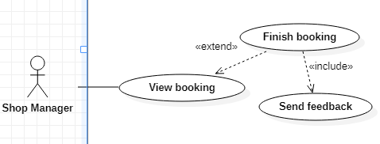

|  |  |  |  |  |
| --- | --- | --- | --- | --- |
| **USE CASE - Nail shops_UC007** | | | | |
| **Use-case No.** | UC007 | **Use-case Version** | | <1.0> |
| **Use-case Name** | Finish booking | | | |
| **Author** | Pham Tang Giau | | | |
| **Date** | 28/05/2021 | **Priority** | High | |
| **Actor:**   * Shop Manager   **Summary:**   * This use case allows the shop manager to finish a booking.   **Goal:**   * Shop Manager finish a booking.   **Triggers:**   * Shop Manager clicks “Finish”   **Preconditions:**   * Shop Manager must login to the system   **Post conditions:**   * Success: The booking is finished successfully.   **Main Success Scenario:**   |  |  |  | | --- | --- | --- | | Step | Actor system | System Response | | 1 | Shop Manager clicks on “Finish” button | System ask user to confirm the action  - OK: button  - Cancel: button | | 2 | Shop Manager chooses “OK” | Show message “Finish successfully” and redirect to the feedback page includes:  + Star number (the lowest star is 1 and the highest is 5.)  +Comment: textarea, required  +Later: button  +Send: button |   **Alternative Scenario:** N/A  **Exceptions:** N/A  **Relationships:**  -The use case “Finish booking” extended by the use case “View booking”  -The use case “Finish booking” includes the use case “Send feedback”  **Business Rules:**  -The System shows the status change to “Finished”. | | | | |

## 3.9. <Shop Manager> View booking

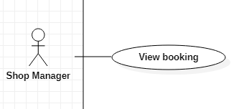

|  |  |  |  |  |
| --- | --- | --- | --- | --- |
| **USE CASE - Nail shops_UC008** | | | | |
| **Use-case No.** | UC008 | **Use-case Version** | | <1.0> |
| **Use-case Name** | View booking | | | |
| **Author** | Pham Tang Giau | | | |
| **Date** | 28/05/2021 | **Priority** | High | |
| **Actor:**   * Shop Manager   **Summary:**   * This use case allows the shop manager to view the booking.   **Goal:**   * Shop Manager view the booking.   **Triggers:**   * Shop Manager click “List of booking” button.   **Preconditions:**   * Shop Manager must login to the system.   **Post conditions:**   * Success: Shop Manager viewed the booking successfully.   **Main Success Scenario:**   |  |  |  | | --- | --- | --- | | Step | Actor system | System Response | | 1 | Shop Manager touchs “List of booking” button. | Display list of booking includes:  + Customer name  + Total price  + Create date  + Status  And buttons:  +Cancel  +Finish  +Detail | | 2 | Shop Manager chooses “Detail” button | Display on the screen of the customer's booking includes:  + Customer name  + Services  + Date and arrival time  + Voucher  + Total price  + Create date  + Status |   **Alternative Scenario:** N/A  **Relationships:** N/A  **Business Rules:**  -List of booking is arranged by day  **-**“Status” include:  + Processing  + Finished  + Canceled | | | | |

## 3.10. <Shop Manager> Send Feedback

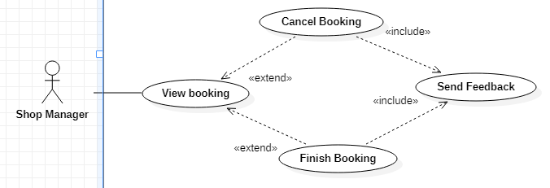

|  |  |  |  |  |
| --- | --- | --- | --- | --- |
| **USE CASE - Nail shops_UC005** | | | | |
| **Use-case No.** | UC005 | **Use-case Version** | | <1.0> |
| **Use-case Name** | Send feedback | | | |
| **Author** | Pham Tang Giau | | | |
| **Date** | 28/05/2021 | **Priority** | normal | |
| **Actor:**   * Shop Manager   **Summary:**   * This use case allows shop manager to review customer   **Goal:**   * Shop Manager reviews the booking.   **Triggers:**   * Shop Manager clicks "Finish" or "Cancel"   **Preconditions:**   * Shop Manager must click "Finish" or "Cancel" in list of booking of customer.   **Post conditions:**   * Success: Review successfully   **Main Success Scenario:**   |  |  |  | | --- | --- | --- | | Step | Actor system | System Response | | 1 | Shop Manager must click "Finish" or "Cancel" | The system redirects to the review page includes:  + Comment: textarea, required  + Number of stars (the lowest star is 1 and the highest is 5.)  +Later: button  +Send: button | | 2 | Shop Manager clicks on “Send” button | System will show message “Feedback successfully”. |   **Alternative Scenario:** N/A  **Exceptions:** N/A  **Relationships:**  -The use case “Cancel booking” includes the use case “Send feedback”  -The use case “Finish booking” includes the use case “Send feedback”  **Business Rules:** N/A | | | | |

## 3.11. <Customer> Search shops

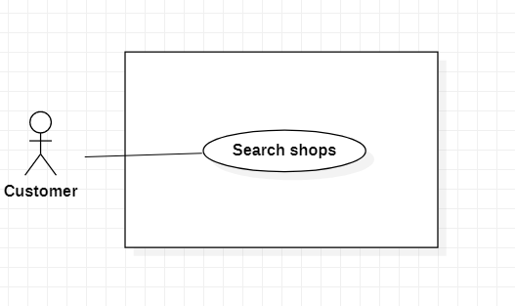

|  |  |  |  |  |
| --- | --- | --- | --- | --- |
| **USE CASE - Nail shops_UC010** | | | | |
| **Use-case No.** | UC010 | **Use-case Version** | | <1.0> |
| **Use-case Name** | Search shops | | | |
| **Author** | Tran Thi Hai Ha | | | |
| **Date** | 28/05/2021 | **Priority** | normal | |
| **Actor:**   * Customer   **Summary:**  *This use case allows the customer to find the desired nail shops*  **Goal:**  *Customer can find the nail shops*  **Triggers**  *Customer click on “Search”*  **Preconditions:**  *Customer is on home screen.*  **Post Conditions:**  *Success: Shops are displayed*  **Main Success Scenario:**   |  |  |  | | --- | --- | --- | | Step | Actor system | System Response | | 1 | Customer click on the search bar |  | | 2 | Enter the word customer wants to search | Display similar search list. | | 3 | Customer clicks on “Search” | The system validates the word and display shops  [exception 1] |   **Alternative Scenario: N/A**  **Exceptions:**   |  |  |  | | --- | --- | --- | | No | Actor system | System response | | 1 |  | System show message the "Not found" |   **Relationships:** N/A  **Business Rules:**  - Customer must be login to app before use this function. | | | | |

## 3.12. <Customer> View a shop

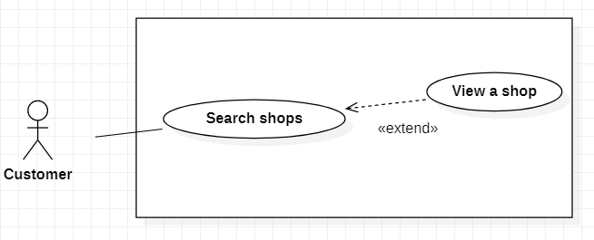

|  |  |  |  |  |
| --- | --- | --- | --- | --- |
| **USE CASE - Nail shops_UC013** | | | | |
| **Use-case No.** | UC013 | **Use-case Version** | | <1.0> |
| **Use-case Name** | View a shop | | | |
| **Author** | Tran Thi Hai Ha | | | |
| **Date** | 28/05/2021 | **Priority** | normal | |
| **Actor:**   * Customer   **Summary:**  This use case helps customer *can view a shop.*  **Goal:**  *Customers can view a shop.*  **Triggers**  *Customer clicks on a shop.*  **Preconditions:**  *Customer must login to the system.*  **Post Conditions:**  *Success: A shop are displayed.*  **Main Success Scenario:**   |  |  |  | | --- | --- | --- | | Step | Actor system | System Response | | 1 | Customer choose a specific shop | Show detail of a shop:  -Name  -Logo  -Open time  -Close time  -Address  -Phone  -List of shop’s vouchers  -Services of the shop  -Distance  -Star number |   **Alternative Scenario:** N/A  **Exceptions: N/A**  **Relationships:** The use case “View a shop” extended by the use case “Search shops”  **Business Rules:**  - “Distance” is the distance from the customer to the shop.  - “Star number” is the average rate that the shop has received from customers. | | | | |

## 3.13. <Customer> View a service

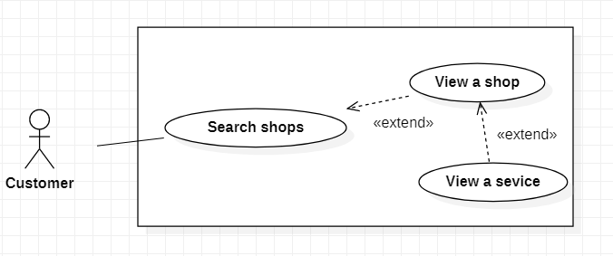

|  |  |  |  |  |
| --- | --- | --- | --- | --- |
| **USE CASE - Nail shops_UC011** | | | | |
| **Use-case No.** | UC011 | **Use-case Version** | | <1.0> |
| **Use-case Name** | View a service | | | |
| **Author** | Tran Thi Hai Ha | | | |
| **Date** | 28/05/2021 | **Priority** | normal | |
| **Actor:**   * Customer   **Summary:**  This use case helps customer *can view a service.*  **Goal:**  *Customers can view a specific service.*  **Triggers**  *Customer clicks on a service.*  **Preconditions:**  *Customer must login to the system.*  **Post Conditions:**  *Success: Service is displayed.*  **Main Success Scenario:**   |  |  |  | | --- | --- | --- | | Step | Actor system | System Response | | 1 | Customer clicks on a shop | Show services of a shop includes:  -Name  -Price  -Star number | | 2 | Choose a specific service | Show detail of service:  -Name  -Price  -Execute Time  -Nail style  -Rating |   **Alternative Scenario:** N/A  **Exceptions: N/A**  **Relationships:** The use case “View a service” extended by the use case “View a shop”  **Business Rules:**  - “Execute time” is the estimated time to do a certain service.  - “Rating” includes: star number and comment. | | | | |

## 3.14. <Customer> Book services

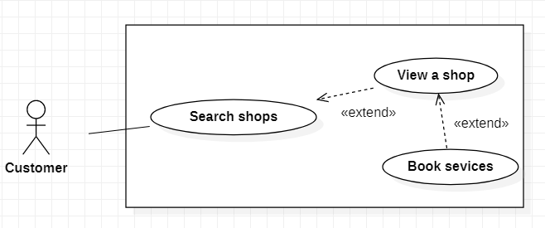

|  |  |  |  |  |
| --- | --- | --- | --- | --- |
| **USE CASE - Nail shops_UC012** | | | | |
| **Use-case No.** | UC012 | **Use-case Version** | | <1.0> |
| **Use-case Name** | Book services | | | |
| **Author** | Tran Thi Hai Ha | | | |
| **Date** | 28/05/2021 | **Priority** | high | |
| **Actor:**   * Customer   **Summary:**  This use case allows customer to *book services.*  **Goal:**  *Customers can book services.*  **Triggers**  *Customer clicks on “Book”.*  **Preconditions:**  *Customer must login to the system.*  **Post Conditions:**  *Success:* Customer books services successfully.  **Main Success Scenario:**   |  |  |  | | --- | --- | --- | | Step | Actor system | System Response | | 1 | Customer clicks on “Book”. | The system asks the user to input the following information:   * Arrival date and time: datetime picker, required * Choose services: multi-select listbox with checkboxes, required * Promo code: dropdown list * Continue: button | | 3 | Customer inputs the information and click on “Continue” | Check validation and reconfirm the order:  -Full name  -Phone  -Arrival date and time  -Shop name  -Service name  -Promo code  -total  -OK: button  -Cancel: button | | 4 | Customer press “OK” | Show message “Booking success” |   **Alternative Scenario: N/A**  **Exception:**   |  |  |  | | --- | --- | --- | | No | Actor system | System response | | 1 | Date and time are not picked in “Arrival date and time” | System shows error message “Date and time must be selected” |   **Relationships:** The use case “Book services” extended by the use case “View a shop”  **Business Rules:**  - User must have at least 1 service  - Booking time must be at least 30 minutes after current time  - Limit of booking day is one week.  - Invalid dates and time are blurred. | | | | |

## 3.15. <Customer> Save voucher

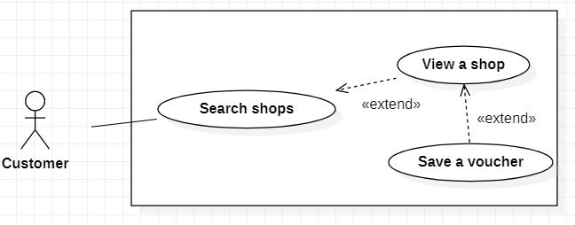

|  |  |  |  |  |
| --- | --- | --- | --- | --- |
| **USE CASE - Nail shops_UC014** | | | | |
| **Use-case No.** | UC014 | **Use-case Version** | | <1.0> |
| **Use-case Name** | Save a voucher | | | |
| **Author** | Tran Thi Hai Ha | | | |
| **Date** | 27/06/2021 | **Priority** | normal | |
| **Actor:**   * Customer   **Summary:**  *This use case allows the customer to save a voucher.*  **Goal:**  *Customer can save a voucher.*  **Triggers**  *Customer click on “Save”.*  **Preconditions:**  *Customer must login to the system.*  **Post Conditions:**  *Success:* Save the voucher successfully.  **Main Success Scenario:**   |  |  |  | | --- | --- | --- | | Step | Actor system | System Response | | 1 | Customer chooses a specific voucher | The System displays detail include:   * Name * Value * Start date * Expiry date * Save: button | | 2 | Customer clicks on “Save” | Show message “Save successfully” |   **Alternative Scenario: N/A**  **Exceptions: N/A**  **Relationships:** The use case “Save a voucher” extended by the use case “View a shop”  **Business Rules: N/A** | | | | |

## 

## 3.16. <Admin> View customers

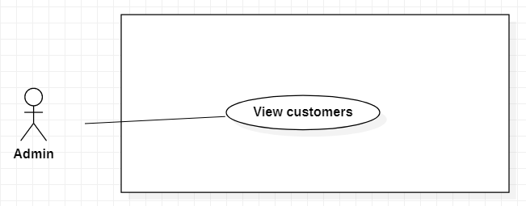

|  |  |  |  |  |
| --- | --- | --- | --- | --- |
| **USE CASE - Nail shops_UC015** | | | | |
| **Use-case No.** | UC015 | **Use-case Version** | | <1.0> |
| **Use-case Name** | View customers | | | |
| **Author** | Tran Thi Hai Ha | | | |
| **Date** | 27/06/2021 | **Priority** | high | |
| **Actor:**   * Admin   **Summary:**  *This use case allows the admin to view the customer account.*  **Goal:**  *Admin can view the customer account.*  **Triggers**  *Admin clicks on “*List of Customers*”.*  **Preconditions:**  *Admin must login to the system.*  **Post Conditions:**  *Success:* Display the customer account successfully.  **Main Success Scenario:**   |  |  |  | | --- | --- | --- | | Step | Actor system | System Response | | 1 | User click on “List of Customers” button | The system shows list of customers:  -userID  -Name  -Star number  -Detail: button  -Disable: button | | 2 | User chooses “Detail” button of a customer account | The system displays the customer’s information include:   * Fullname * Phone number * Avatar * Address * Feedback |   **Alternative Scenario: N/A**  **Exceptions: N/A**  **Relationships: N/A**  **Business Rules:**   * “Feedback” includes the comments and the star number that the customer has received from the shop. * “Star number” is the average rate that the customer has received from the shop. * The lowest star is 1 and the highest is 5. | | | | |

## 3.17. <Admin> Disable customers

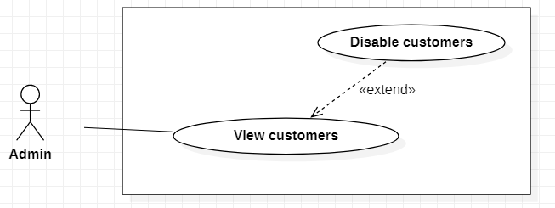

|  |  |  |  |  |
| --- | --- | --- | --- | --- |
| **USE CASE - Nail shops_UC016** | | | | |
| **Use-case No.** | UC016 | **Use-case Version** | | <1.0> |
| **Use-case Name** | Disable customers | | | |
| **Author** | Tran Thi Hai Ha | | | |
| **Date** | 27/06/2021 | **Priority** | normal | |
| **Actor:**   * Admin   **Summary:**  *This use case allows the admin to disable a customer’s account.*  **Goal:**  *Admin can disable a customer’s account.*  **Triggers**  *Admin clicks on “Disable”.*  **Preconditions:**  *Admin must login to the system.*  **Post Conditions:**  *Success:* Disable the customer’s account successfully.  **Main Success Scenario:**   |  |  |  | | --- | --- | --- | | Step | Actor system | System Response | | 1 | User click button “Disable” | System ask user to confirm the message:  OK: button  Cancel: button | | 2 | User clicks on “OK” | System reloads list of customers. |   **Alternative Scenario: N/A**  **Exceptions: N/A**  **Relationships:** The use case “Disable customers” extended by the use case “View customers”  **Business Rules:** The status of customer account changes from active to inactive. | | | | |

## 3.18. <Admin> View shops

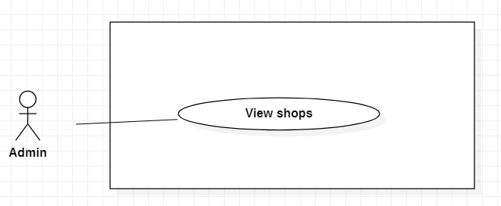

|  |  |  |  |  |
| --- | --- | --- | --- | --- |
| **USE CASE - Nail shops_UC017** | | | | |
| **Use-case No.** | UC017 | **Use-case Version** | | <1.0> |
| **Use-case Name** | View shops | | | |
| **Author** | Tran Thi Hai Ha | | | |
| **Date** | 27/06/2021 | **Priority** | high | |
| **Actor:**   * Admin   **Summary:**  *This use case allows the admin to view the shop.*  **Goal:**  *Admin can view the shop.*  **Triggers**  *Admin clicks on “*List of shops*”.*  **Preconditions:**  *Admin must login to the system.*  **Post Conditions:**  *Success:* Shops are displayed successfully.  **Main Success Scenario:**   |  |  |  | | --- | --- | --- | | Step | Actor system | System Response | | 1 | User click on “List of shops” button | The system shows list of shops:  -shopID  -Shop name  -Star number  -Detail: button  -Disable: button | | 2 | User chooses “Detail” button of a shop | The system displays the  information include:   * Name * Phone number * Logo * Address * Feedback |   **Alternative Scenario: N/A**  **Exceptions: N/A**  **Relationships: N/A**  **Business Rules:**   * “Feedback” includes the comments and the star number that the shop has received from the customer. * “Star number” is the average rate that the shop has received from customers. * The lowest star is 1 and the highest is 5. | | | | |

## 3.19. <Admin> Disable shops

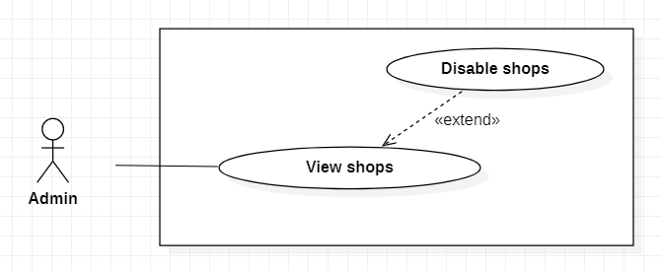

|  |  |  |  |  |
| --- | --- | --- | --- | --- |
| **USE CASE - Nail shops_UC018** | | | | |
| **Use-case No.** | UC018 | **Use-case Version** | | <1.0> |
| **Use-case Name** | Disable shops | | | |
| **Author** | Tran Thi Hai Ha | | | |
| **Date** | 27/06/2021 | **Priority** | normal | |
| **Actor:**   * Admin   **Summary:**  *This use case allows the admin to disable the shop.*  **Goal:**  *Admin can disable the shop.*  **Triggers**  *Admin click on “Disable”.*  **Preconditions:**  *Admin must login to the system and on the list of shops screen.*  **Post Conditions:**  *Success:* Disable the shop successfully.  **Main Success Scenario:**   |  |  |  | | --- | --- | --- | | Step | Actor system | System Response | | 1 | User click button “Disable” | System ask user to confirm the message.  OK: button  Cancel: button | | 2 | User clicks on “OK” | System reloads list of shop. |   **Alternative Scenario: N/A**  **Exceptions: N/A**  **Relationships:** The use case “Disable shops” extended by the use case “View shops”  **Business Rules:** The status of a shop changes from active to inactive. | | | | |

## 3.20. < Shop Manager > Add a new service

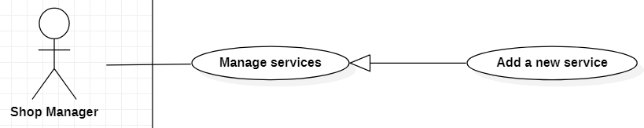

|  |  |  |  |  |
| --- | --- | --- | --- | --- |
| **USE CASE - Nail shops_UC019** | | | | |
| Use-case No. | UC019 | Use-case Version | | <1.0> |
| Use-case Name | Add a new service | | | |
| Author | Dinh Thi Nhu Quynh | | | |
| Date | 28-05-2021 | Priority | High | |
| Actor:  - Shop Manager  Summary:  - This use case allows the Shop Manager to create new a service  Goal:  - A new service is added  Triggers:  - Shop Manager clicks “Add a service” button  Preconditions:  - Guest must login to the system with role Shop Manage  Post Conditions:  - Success: A new service is added successfully  Main Success Scenario:     |  |  |  | | --- | --- | --- | | Step | Actor Action | System Response | | 1 | Shop Manager clicks “Add a new service” button | The system displays a form with the following information:  - Name of a service: textbox, required, min length:5, max length:100 characters  - Price: textbox, required  - Execute time: textbox, required  - Category: select  - Submit: button  - Cancel: button | | 2 | Shop Manager inputs information and enter “Submit” | The system validates the information and shows the message “added successfully”  [Exception 1] |   Alternative Scenario: N/A  Exceptions:   |  |  |  | | --- | --- | --- | | No | Actor Action | System Response | | 1 | The character length of "Name of a service" is invalid | Show a message "Name of a service must be more than 5 and less than 100 characters" |   Relationships: N/A  Business Rules:   * “Execute time” is the estimated time to do a certain service. * When added successfully, system reload “list of services” page. | | | | |

## 3.21. < Shop Manager > Edit service

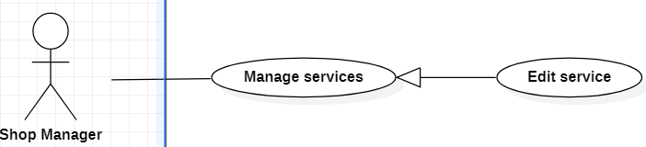

|  |  |  |  |  |
| --- | --- | --- | --- | --- |
| **USE CASE - Nail shops_UC020** | | | | |
| Use-case No. | UC020 | Use-case Version | | <1.0> |
| Use-case Name | Edit service | | | |
| Author | Dinh Thi Nhu Quynh | | | |
| Date | 28-05-2021 | Priority | Normal | |
| Actor:  - Shop Manager  Summary:  - This use case allows the Shop Manager to edit a service  Goal:  - A service is updated  Triggers:  - Shop Manager clicks “Edit” button  Preconditions:  - Guest must login to the system with role Shop Manage  Post Conditions:  - Success: A service is edited successfully  Main Success Scenario:   |  |  |  | | --- | --- | --- | | Step | Actor Action | System Response | | 1 | Shop Manager clicks “edit” button | The system re a form with the following information:  - Name of a service: textbox, min length:5, max length:100 characters  - Price: textbox  - Execute time: textbox  - Category: select  - Submit: button  - Cancel: button | | 2 | Shop Manger inputs information and enter “Submit” | The system validates the information and shows the message “edited successfully”  [Exception 1] |     Alternative Scenario:  - N/A  Exceptions:   |  |  |  | | --- | --- | --- | | No | Actor Action | System Response | | 1 | The character length of "Name of a service" is invalid | Show a message “Name of a service must be more than 5 and less than 100 characters” |     Relationships: N/A  Business Rules:   * If Shop Manager does not change the information, the default is to keep the old information. * When edited successfully, system reload “list of services” page. | | | | |

## 3.22. <Shop Manager> Delete service

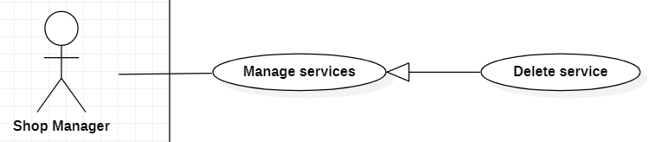

|  |  |  |  |  |
| --- | --- | --- | --- | --- |
| **USE CASE - Nail shops_UC021** | | | | |
| Use-case No. | UC021 | Use-case Version | | <1.0> |
| Use-case Name | Delete service | | | |
| Author | Dinh Thi Nhu Quynh | | | |
| Date | 28-05-2021 | Priority | Normal | |
| Actor:  - Shop Manager  Summary:  - This use case allows the Shop Manager to delete a service  Goal:  - A service is deleted  Triggers:  - Shop Manager clicks “Delete” button  Preconditions:  - Guest must login to the system with role Shop Manage  Post Conditions:  - Success: A service is deleted successfully  Main Success Scenario:     |  |  |  | | --- | --- | --- | | Step | Actor Action | System Response | | 1 | Shop Manager clicks “delete” button | System will show a confirm message  - OK: button  - Cancel: button | | 2 | Shop Manager enters “OK” | The system shows the message “deleted successfully” |     Alternative Scenario:  - N/A  Exceptions:  - N/A  Relationships: N/A  Business Rules:   * Shop Manager press "delete", status will change a service from active to inactive. * When deleted successfully, system reload “list of services” page. | | | | |

## 3.23. <Shop Manager> Add a new voucher

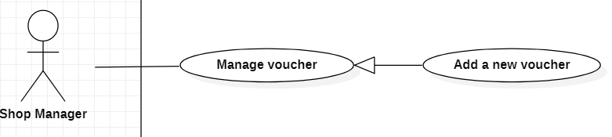

|  |  |  |  |  |
| --- | --- | --- | --- | --- |
| **USE CASE - Nail shops_UC022** | | | | |
| Use-case No. | UC022 | Use-case Version | | <1.0> |
| Use-case Name | Add a new voucher | | | |
| Author | Dinh Thi Nhu Quynh | | | |
| Date | 28-05-2021 | Priority | Normal | |
| Actor:  - Shop Manager  Summary:  - This use case allows the Shop Manager to create a new voucher  Goal:  - A new voucher is added  Triggers:  - Shop Manager clicks “Add a voucher” button  Preconditions:  - Guest must login to the system with role Shop Manage  - Shop Manager is on “list of vouchers” screen  Post Conditions:  - Success: A new voucher is added successfully  Main Success Scenario:   |  |  |  | | --- | --- | --- | | Step | Actor Action | System Response | | 1 | Shop manager clicks “Add a voucher” button | The system displays a form with the following information:  - Voucher code: text box, required, unique and min length: 4, max length: 10  - Name of voucher: text box, required, min length: 5, max length: 50 characters  - Value: textbox, required, min value:1, max value: 99%  - Start_date: datetime picker, required  - Expiry_date: datetime picker, required  - Applicable shop: dropdown list, required,  - Applicable service: “All services”  - Submit: button  - Cancel: button | | 2 | Shop Manger inputs information and enter “Submit” | The system validates the information and shows the message “Added successfully”  [Exception 1,2,3,4] |     Alternative Scenario:  - N/A  Exceptions:   |  |  |  |  | | --- | --- | --- | --- | | No | Actor Action | System Response |  | | 1 | “Voucher code” is existing | Show a message “Voucher code has already existed” | | 2 | The character length of "Voucher code" is invalid | Show a message “Voucher code must be more than 4 and less than 10 characters” | | 3 | The character length of "Name of voucher" is invalid | Show a message “Name of voucher must be more than 5 and less than 20 characters” | | 4 | “Value” is invalid | Show a message “Value must be about 1~ 99%” |     Relationships: N/A  Business Rules:   * When added successfully, system reload “list of vouchers” page. | | | | |

## 3.24. <Shop Manager> Edit voucher

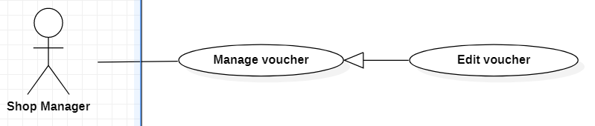

|  |  |  |  |  |
| --- | --- | --- | --- | --- |
| **USE CASE - Nail shops_UC023** | | | | |
| Use-case No. | UC023 | Use-case Version | | <1.0> |
| Use-case Name | Edit voucher | | | |
| Author | Dinh Thi Nhu Quynh | | | |
| Date | 28-05-2021 | Priority | Normal | |
| Actor:  - Shop Manager  Summary:  - This use case allows Shop Manager to edit voucher  Goal:  - A voucher is edited  Triggers:  - Shop Manager press “Edit” button  Preconditions:  - Guest must login to the system with role Shop Manage  - Shop Manager is on “list of vouchers” screen  Post Conditions:  - Success: A voucher is edited successfully  Main Success Scenario:     |  |  |  | | --- | --- | --- | | Step | Actor Action | System Response | | 1 | Shop Manager clicks “Edit” button | The system displays a form with the following information:  - Name of voucher: text box, required, min length: 5, max length: 20 characters  - Value: text box, required, min value:1, max value: 99%  - Start_date: datetime picker  - Expiry_date: datetime picker  - Applicable shop: dropdown list  - Applicable service: “All services”  - Submit: button  - Cancel: button | | 2 | Shop Manger inputs information and enter “Submit” | The system validates the information and shows the message “Edited successfully”  [Exception 1,2] |     Alternative Scenario:  - N/A  Exceptions:     |  |  |  |  |  |  | | --- | --- | --- | --- | --- | --- | | No | Actor Action | System Response |  |  |  | | 1 | The character length of "Name of voucher" is invalid | Show a message “Name of voucher must be more than 5 and less than 20 characters” |  |  |  | | 2 | “Value” is invalid | Show a message “Value must be about 1~ 99%” |  |  |  |     Relationships: N/A  Business Rules:   * Shop manager cannot update voucher code. * If Shop Manager does not change the information, the default is to keep the old information * When edited successfully, system reload “list of vouchers” page. | | | | |

## 3.25. <Shop Manager> Delete voucher

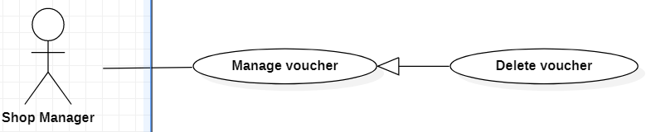

|  |  |  |  |  |
| --- | --- | --- | --- | --- |
| **USE CASE - Nail shops_UC024** | | | | |
| Use-case No. | UC024 | Use-case Version | | <1.0> |
| Use-case Name | Delete voucher | | | |
| Author | Dinh Thi Nhu Quynh | | | |
| Date | 28-05-2021 | Priority | Normal | |
| Actor:  - Shop Manager  Summary:  - This use case allows the Shop Manager to delete a voucher  Goal:  - A voucher is deleted  Triggers:  - Shop Manager clicks “Delete” button  Preconditions:  - Guest must login to the system with role Shop Manage  - Shop Manager is on “list of vouchers” screen  Post Conditions:  - Success: A voucher is deleted successfully  Main Success Scenario:     |  |  |  | | --- | --- | --- | | Step | Actor Action | System Response | | 1 | Shop Manager clicks “Delete” button | System will show a confirm message  - OK: button  - Cancel: button | | 2 | Shop Manager enters “OK” | The system shows the message “deleted successfully” |     Alternative Scenario:  - N/A  Exceptions:  - N/A  Relationships: N/A  Business Rules:   * When deleted successfully, system reload “list of vouchers” page. | | | | |

## 3.26. <Shop Manager> Close shop

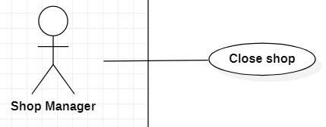

|  |  |  |  |  |
| --- | --- | --- | --- | --- |
| **USE CASE - Nail shops_UC025** | | | | |
| Use-case No. | UC025 | Use-case Version | | <1.0> |
| Use-case Name | Close shop | | | |
| Author | Dinh Thi Nhu Quynh | | | |
| Date | 28-05-2021 | Priority | Normal | |
| Actor:  - Shop Manager  Summary:  - This use case allows the Shop Manager to close shop  Goal:  - Shop can be closed  Triggers:  - Shop Manager clicks “close shop” button  Preconditions:  - Guest must login to the system with role Shop Manage  - Shop Manager is on “Shop setup” screen  Post Conditions:  - Success: The Shop Manager has closed shop successfully  Main Success Scenario:   |  |  |  | | --- | --- | --- | | Step | Actor Action | System Response | | 1 | Shop Manager clicks “close shop” | The system displays a form with the following information:  - Day off: datetime picker, required  - Day reopen: datetime picker, required  - Setup: button | | 2 | Shop Manager enter “Setup” | The system validates the information and shows the message “Edited successfully”  [Exception 1,2] |     Alternative Scenario:  - N/A  Exceptions:     |  |  |  | | --- | --- | --- | | No | Actor Action | System Response | | 1 | “Day off” is invalid | Show a message “Please choose at least 1 day before” | | 2 | “Day reopen” is invalid | Show a message “The earliest opening time after 3 hours” |   Relationships: N/A  Business Rules:   * Day off will be blurred to customers do not choose. * Day off must be selected at least 1 day before. * Day reopen must be at the earliest after 3 hours. | | | | |

## 3.27. <Shop Manager> View customer’s feedback

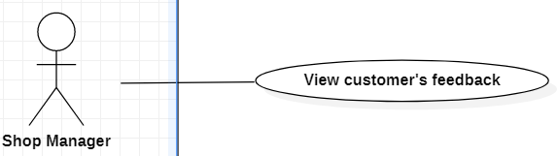

|  |  |  |  |  |
| --- | --- | --- | --- | --- |
| **USE CASE - Nail shops_UC026** | | | | |
| Use-case No. | UC026 | Use-case Version | | <1.0> |
| Use-case Name | View customer’s feedback | | | |
| Author | Dinh Thi Nhu Quynh | | | |
| Date | 28-05-2021 | Priority | Normal | |
| Actor:  - Shop Manager  Summary:  - This use case allows the Shop Manager to view feedback of customer  Goal:  - Shop Manager is viewed feedback of customer  Triggers:  - Shop Manager clicks “View feedback” button  Preconditions:  - Guest must login to the system with role Shop Manage  Post Conditions:  - Success: The Shop Manager is viewed feedback of customer successfully  Main Success Scenario:   |  |  |  | | --- | --- | --- | | Step | Actor Action | System Response | | 1 | Shop Manager clicks “View feedback” | The system will display a list of the following information:  - Feedback of shop: total star/5  - Feedback of services:  + Service Name  + Customer Name  + Star number  + Detail: button  [Exception 1] | | 2 | Shop Manager clicks “Detail” | The system redirects to service detail feedback screen:  + ID of booking  + Service Name  + Customer Name  + Date created  + Star number  + Comment |     Alternative Scenario:  - N/A  Exceptions:  - N/A  Relationships: N/A  Business Rules:  - “Star number”: The lowest star is 1 and highest is 5.  - “Comment”: is contents of customer feedback. | | | | |

## 3.28. <Logout>

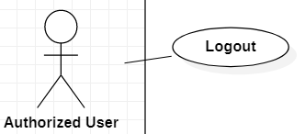

|  |  |  |  |  |
| --- | --- | --- | --- | --- |
| **USE CASE - Nail shops_UC027** | | | | |
| Use-case No. | UC027 | Use-case Version | | <1.0> |
| Use-case Name | Logout | | | |
| Author | Dinh Thi Nhu Quynh | | | |
| Date | 28-05-2021 | Priority | Normal | |
| Actor:  - Authorized User  Summary:  - This use case allows the Authorized User to logout  Goal:  - Authorized User logout the app  Triggers:  - Authorized User press “Logout” button  Preconditions:  - User must login to the system  - User is on “account setting” screen  Post Conditions:  - Success: Authorized User logout to the system successfully  Main Success Scenario:   |  |  |  | | --- | --- | --- | | Step | Actor Action | System Response | | 1 | User clicks “logout” | System will show a confirm message  - OK: button  - Cancel: button | | 2 | User enters “OK” | The system logout successfully |     Alternative Scenario:  - N/A  Exceptions:  - N/A  Relationships: N/A  Business Rules:   * When User clicks “OK”:   - Redirect to “Login” screen. | | | | |

# NON-FUNCTIONAL Requirements

## Usability

Shop Manager should need less than one day of training to be productive with the system.

## Reliability

This application ensures users can access when needed and use within a continuous time frame of 2-3 hours.

## Performance

The application’s load time should not be more than 2 seconds for users.

The system works 24/7.

# Supporting Information

N/A