Ngày báo cáo: 26/10/2020

Module báo cáo: LAB4

Mã sinh viên: 18019701

Họ và tên: Trần Mạnh Thìn

**NỘI DUNG**

**Bài 1:** Đọc số từ 0 - 100

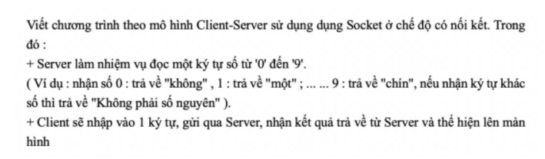

**Code:**

*Server:*

import java.io.IOException;

import java.io.PrintStream;

import java.net.ServerSocket;

import java.net.Socket;

import java.util.Scanner;

public class Server1{

    public static String ReadNum(String x) {

        String rd;

        if(x.matches("[0-9]+")){

            int n = Integer.parseInt(x);

            if(n <= 100) {

                String chuc = "",dv = "";

                int mod = n%10;

                int div = n/10;

                switch(div) {

                    case 2:{ dv = "hai"; break; }

                    case 3:{ dv = "ba"; break; }

                    case 4:{ dv = "bốn"; break; }

                    case 5:{ dv = "năm"; break; }

                    case 6:{ dv = "sáu"; break; }

                    case 7:{ dv = "bảy"; break; }

                    case 8:{ dv = "tám"; break; }

                    case 9:{ dv = "chín"; break; }

                }

                switch(mod) {

                    case 1:{ chuc = "mốt"; break; }

                    case 2:{ chuc = "hai"; break; }

                    case 3:{ chuc = "ba"; break; }

                    case 4:{ chuc = "bốn"; break; }

                    case 5:{ chuc = "lăm"; break; }

                    case 6:{ chuc = "sáu"; break; }

                    case 7:{ chuc = "bảy"; break; }

                    case 8:{ chuc = "tám"; break; }

                    case 9:{ chuc = "chín"; break; }

                }

                if(n < 10) {

                    if(n == 0) {rd = "không";}

                    else if(n == 5) {rd = "năm";}

                    else {rd = chuc;}

                }

                else {

                    if(n == 10) rd = "mười";

                    else if(n == 100) rd = "một trăm";

                    else

                    rd = dv + " mươi " + chuc;

                }

            }

            else {

                rd = "Dữ liệu là số dưới 100";

            }

        }

        else {

            rd = "Không phải là số";

        }

        return rd;

    }

    public static void main(String[] args){

        try {

        @SuppressWarnings("resource")

        ServerSocket server = new ServerSocket(9540);

        System.out.println("Server da duoc tao");

        Socket client = server.accept();

        System.out.println("Client da ket noi den server");

        Scanner inFromClient = new Scanner(client.getInputStream());

        PrintStream outToClient = new PrintStream(client.getOutputStream());

        outToClient.println("Nhap so :");

        String txt = inFromClient.nextLine();

        outToClient.println("Result : " + ReadNum(txt));

        } catch (IOException e) {

        // TODO Auto-generated catch block

        e.printStackTrace();

        }

        }

}

*Client*

import java.io.IOException;

import java.io.PrintStream;

import java.net.Socket;

import java.net.UnknownHostException;

import java.util.Scanner;

public class Client1 {

    public static void main(String[] args) {

        try {

        @SuppressWarnings("resource")

        Socket client = new Socket("LocalHost", 9540);

        System.out.println("Client da duoc tao");

        Scanner inFromServer = new Scanner(client.getInputStream());

        PrintStream outToServer = new PrintStream(client.getOutputStream());

        System.out.println("server: " + inFromServer.nextLine());

        System.out.print(">>> ");

        @SuppressWarnings("resource")

        Scanner scan = new Scanner(System.in);

        String ten = scan.nextLine();

        outToServer.println(ten);

        System.out.println("server: " + inFromServer.nextLine());

        } catch (UnknownHostException e) {

        // TODO Auto-generated catch block

        e.printStackTrace();

        } catch (IOException e) {

        // TODO Auto-generated catch block

        e.printStackTrace();

        }

        }

}

**Kết quả hiển thị:**

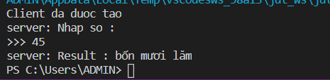

**Bài 2:** Chat TCP

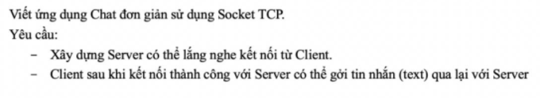

**Code:**

*Server*

import java.io.DataInputStream;

import java.io.DataOutputStream;

import java.io.IOException;

import java.net.ServerSocket;

import java.net.Socket;

import java.util.Scanner;

public class Server {

    public static void main(String[] args) {

        try{

        ServerSocket server = new ServerSocket(1021);

        System.out.println("Server da duoc tao");

        Socket socket = server.accept();

        System.out.println("Client da ket noi den server");

        DataOutputStream out = new DataOutputStream(socket.getOutputStream());

        DataInputStream in = new DataInputStream(socket.getInputStream());

        Scanner input = new Scanner(System.in);

        while (true) {

            String str = in.readUTF();

            if (str.equalsIgnoreCase("Exit")) {

                break;

            } else {

                System.out.println("Client said: " + str);

            }

            System.out.print("\nServer: ");

            out.writeUTF(input.nextLine());

            out.flush();

        }

        in.close();

        out.close();

        socket.close();

        server.close();

        } catch(IOException e){

        }

    }

}

*Client*

import java.io.DataInputStream;

import java.io.DataOutputStream;

import java.io.IOException;

import java.net.Socket;

import java.util.Scanner;

public class Client {

    public static void main(String[] args){

        try{

        Socket socket = new Socket("localhost",1021);

        DataOutputStream out = new DataOutputStream(socket.getOutputStream());

        DataInputStream in = new DataInputStream(socket.getInputStream());

        Scanner input = new Scanner(System.in);

        while(true){

            System.out.print("\nClient: ");

            out.writeUTF(input.nextLine());

            out.flush();

            String str = in.readUTF();

            if(str.equalsIgnoreCase("Exit")){

                break;

            }

            else System.out.println("Server said: "+str);

        }

        in.close();

        out.close();

        socket.close();

        } catch(IOException e){

        }

    }

}

**Kết quả hiển thị:**

