WEB PROGRAMMING Lab Final

Use the template below to create a website about you. You must follow the HTML structure of the template but you can style the contents however you like (colors etc). You will be graded on and must include the following elements:
-Change the title tag to: “Web Programming Final: Your Name”
-Logo with your name and student ID number
-Facebook icon with link to your FB (or the class FB page)
-Navigation with 3 – 5 links (you can use a place holder HREF=”#”)
-Banner with image and a text about your site (ie quote)
-Three front blocks with information about you in the headings
-An image gallery with (6) images of you or something intteresting (no images from the Labs!!!). You should use jQuery in the code hints to add Lightbox functionality.
-Add an embedded google map of Saigon
-Add a footer with (4) blocks
-Add at least one Media Query to the CSS for tablet or mobile display
-Overall site should be responsive

!!--DO NOT--!!
-Do not use code from the Lab site (I will know!)
-Do not use images from the Lab site. I included Shinchan images if you want to use those.

BONUS:
-Add a user registration form with three fields: User Name, Password, Re-enter Password
-Check user name is between 4 – 20 characters
-Check password > 6 characters
-Check retype password == password

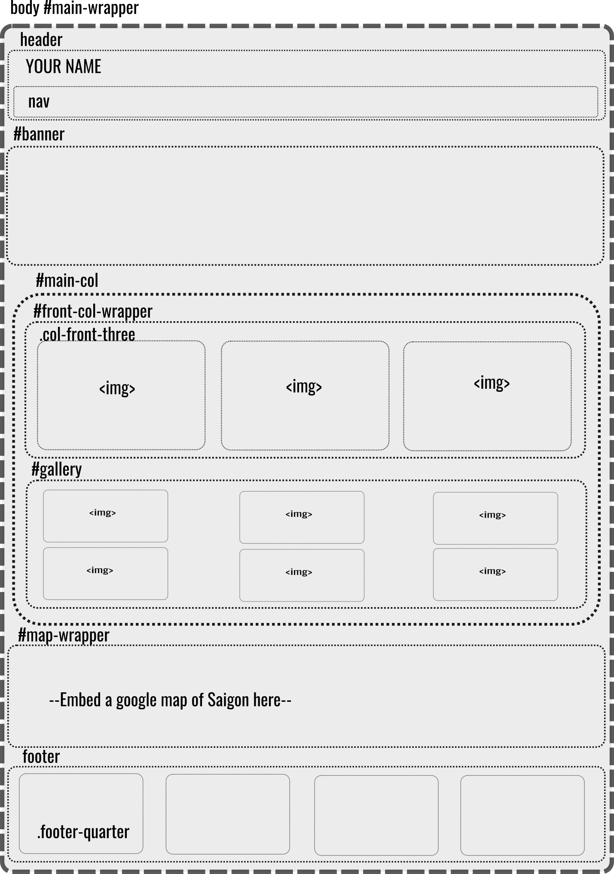

jQuery Hints

var overlay = $('<div id="overlay"><img src""><ul><li class="gallery-control prv"><</li><li class="gallery-control nxt">></li><li class="gallery-control ext">X</li></ul></div>');
$('body').append(overlay);
$('#overlay').hide();
var galLength = $(".gallery-img a").length;
var activeImg = 0;
var nextImg = 0;
var imgUrl = "";
// Load Gallery Function
$(".gallery-img a").click(function(event) {
event.preventDefault();
activeImg = $(".gallery-img a").index(this);
imgUrl = $(this).attr("href");
$('#overlay').fadeIn(500);
$("#overlay img").attr("src", imgUrl);
var imgHeight = $("#overlay img").height();
var winHeight = $(window).height();
var imgOffset = (winHeight - imgHeight) / 2;
$("#overlay img").css("margin-top", imgOffset);
$("#overlay li.ext").click(function() {
$("#overlay").fadeOut(500);
})
})
// End Load Gallery function
// START NEXT Image
$("#overlay li.nxt").click(function() {
console.log("acti img" + activeImg);
nextImg = activeImg + 1;
if(nextImg >= galLength) {
nextImg = 0;
activeImg = nextImg;
cycleImage(nextImg);
} else {
activeImg++;
cycleImage(nextImg);
}
}) // END NEXT Image

// START PREV Image
$("#overlay li.prv").click(function() {
// Write the previous function yourself!!
})// END PREV Image

// START Cycle Next Image function
function cycleImage(index) {
imgUrl = $(".gallery-img a")[index].getAttribute("href");
$("#overlay img").fadeOut(500, function() {
$("#overlay img").attr("src", imgUrl).fadeIn(500);
})
} // END Cycle Next Image function

}) // END DOC READY

CSS Hints
background-image: url();
min-height: 450px;
background-size: cover;
background-attachment: fixed;
position: fixed;
overflow: auto;
width: 90%;
margin: auto;
float: left;
box-shadow: 0px 0px 20px black;
position: absolute;
width: 100%;
right: 0px;
top: 0px;
display: inline-block;
TEXT-DECORATION
LIST-STYLE

@media screen and (max-width: XXXXpx) {

}

