

**Orient HBU-18HF03**

**Rs. 113,000/-**

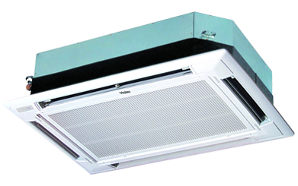

**Product Features**

* Remote Control Pocket
* Three Minutes Protection
* Rust Resistant Cabinet
* Reserved Air Outlet
* State of the Art

**Specification**

**Type** Ceiling Cassette AC

**Cooling (Btu/h)** 42000

**Voltage (V)** 220-240

**Power Input (W)** 4800

**EER (Btu/W-h-W/W)** 6.6-2.35