

**Orient Econotech Series 1 Ton**

**Rs. 36,500/-**

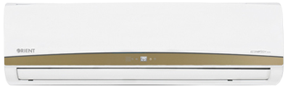

**Product Features**

* Three Minutes Protection
* Rust Resistant Cabinet
* Reserved Air Outlet
* State of the Art
* Air Vane Technology

**Specification**

**Type** Wall Mounted Split AC

**Cooling (Btu/h)** 52000

**Voltage (V)** 220-240

**Power Input (W)** 4800

**EER (Btu/W-h-W/W)** 6.2-3.4