

**Orient DC Inverter Ultron Plus 2 Ton**

**Rs. 96,000/-**

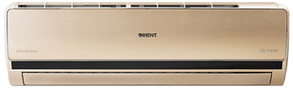

**Product Features**

* State of the Art
* Air Vane Technology
* Auto Swing
* power mode
* precise system control technology

**Specification**

**Type** Wall Mounted Split AC

**Cooling (Btu/h)** 53000

**Voltage (V)** 220-240

**Power Input (W)** 4800

**EER (Btu/W-h-W/W)** 5.5-3.2