BÀI TẬP ASYNC / AWAIT / PROMISE – TYPESCRIPT

Link github: https://github.com/trantuanhung1209/React_Native_Lab/tree/main/TranTuanHung_23659581_Week_2

A. Basics with Promise
Câu 1. Create a Promise that returns the string "Hello Async" after 2 seconds.
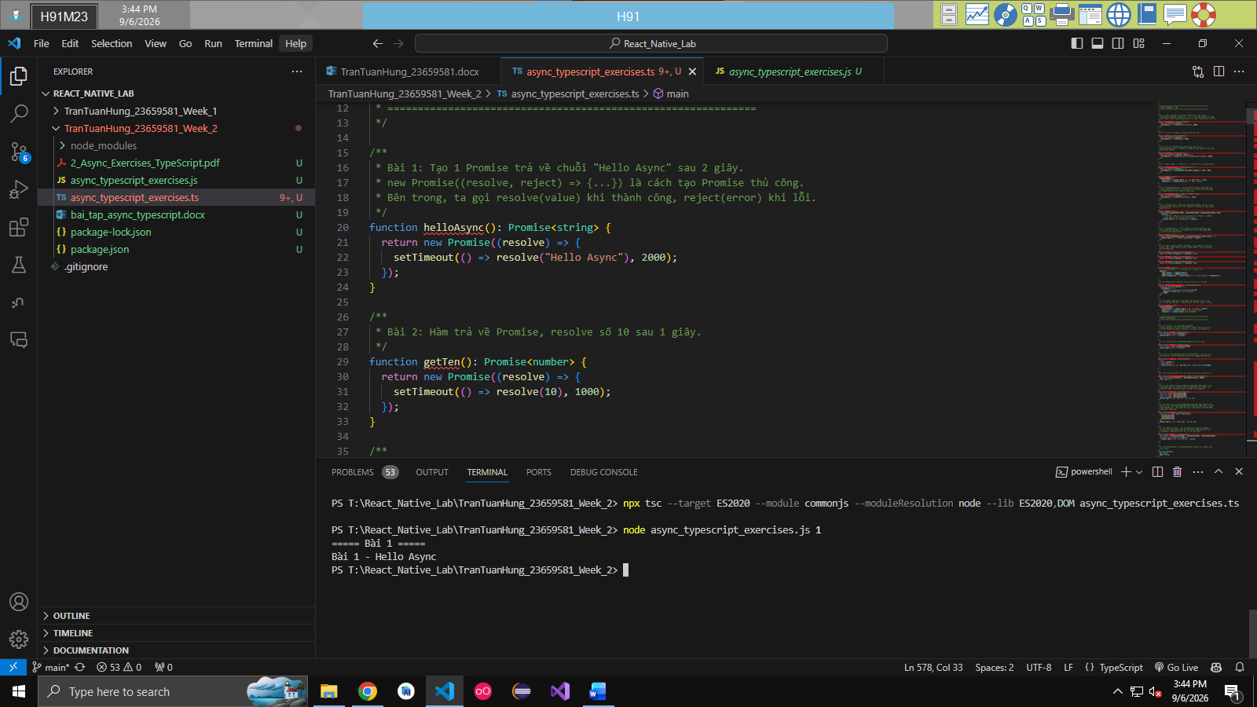

Câu 2. Write a function that returns a Promise resolving with the number 10 after 1 second.
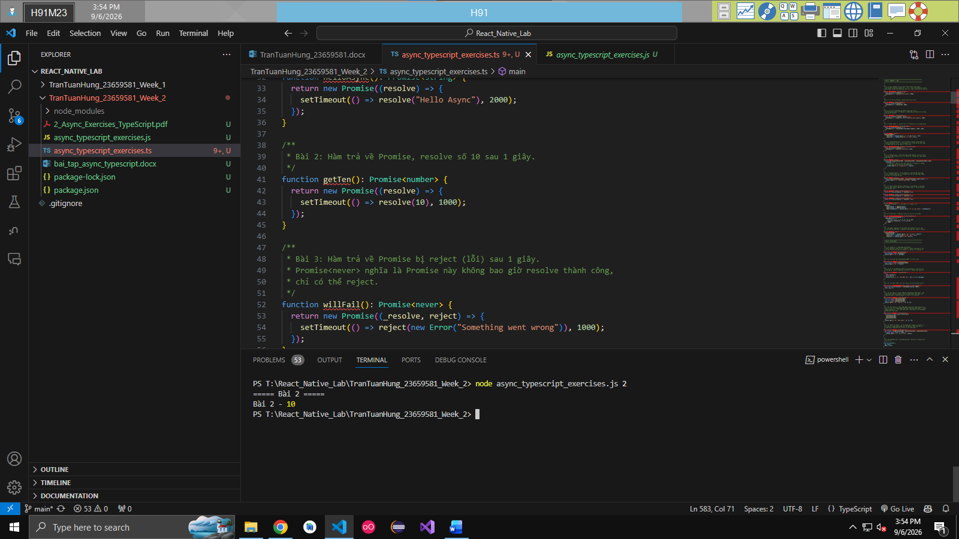

Câu 3. Write a function that rejects a Promise with the error "Something went wrong" after 1 second.

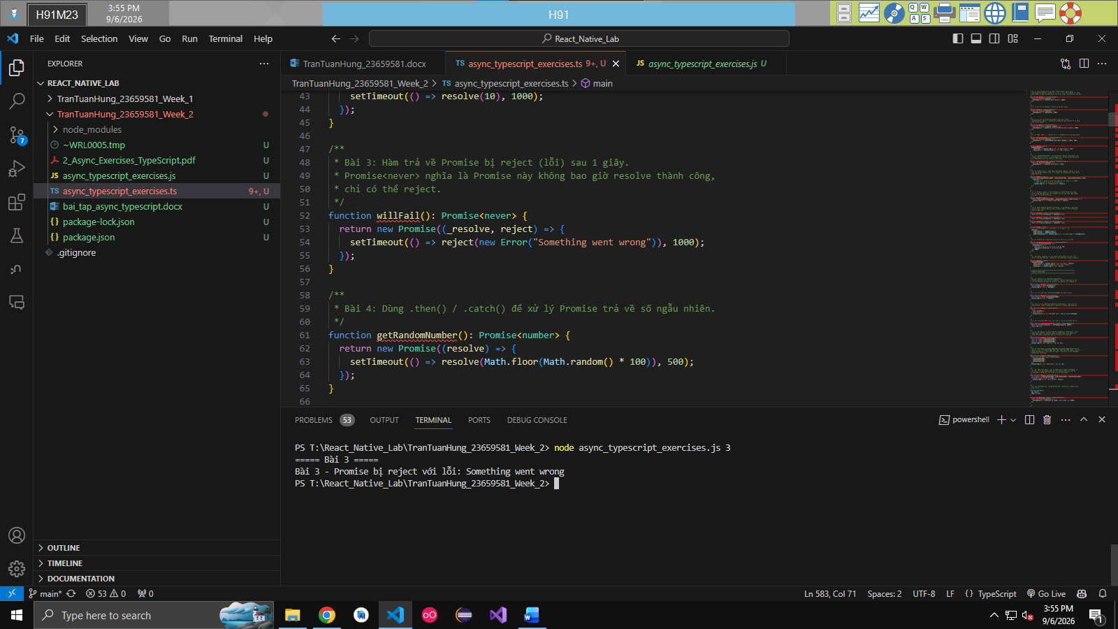

Câu 4. Use .then() and .catch() to handle a Promise that returns a random number.
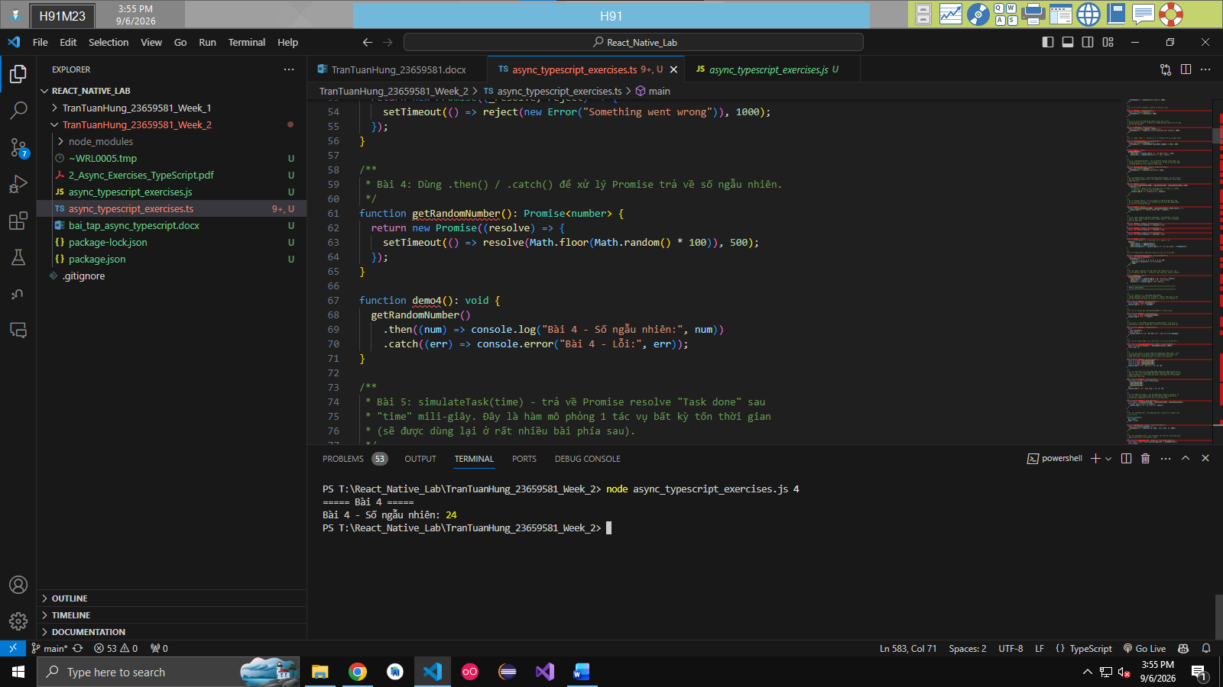

Câu 5. Create a function simulateTask(time) that returns a Promise resolving with "Task done" after time ms.

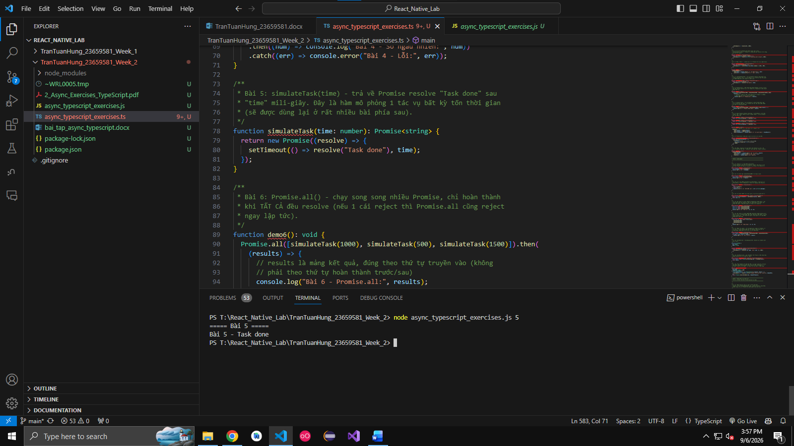

Câu 6. Use Promise.all() to run 3 simulated Promises in parallel and print the result.

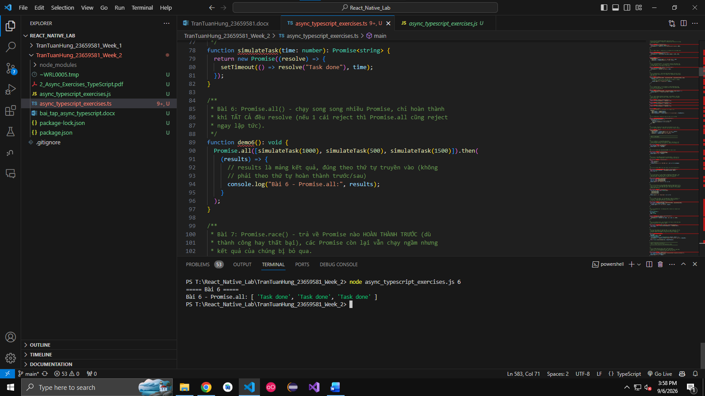

Câu 7. Use Promise.race() to return whichever Promise resolves first.
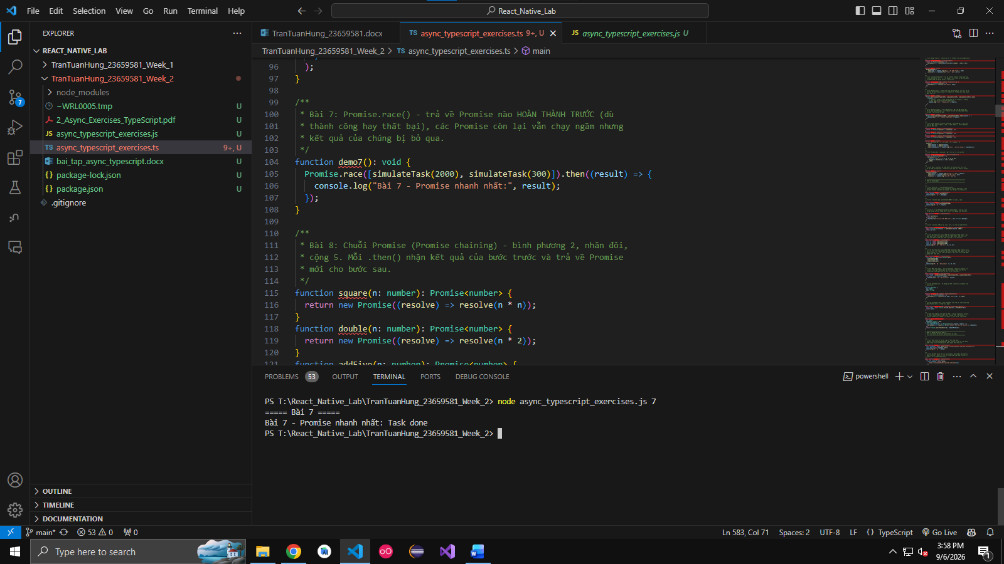

Câu 8. Create a Promise chain: square the number 2, then double it, then add 5.
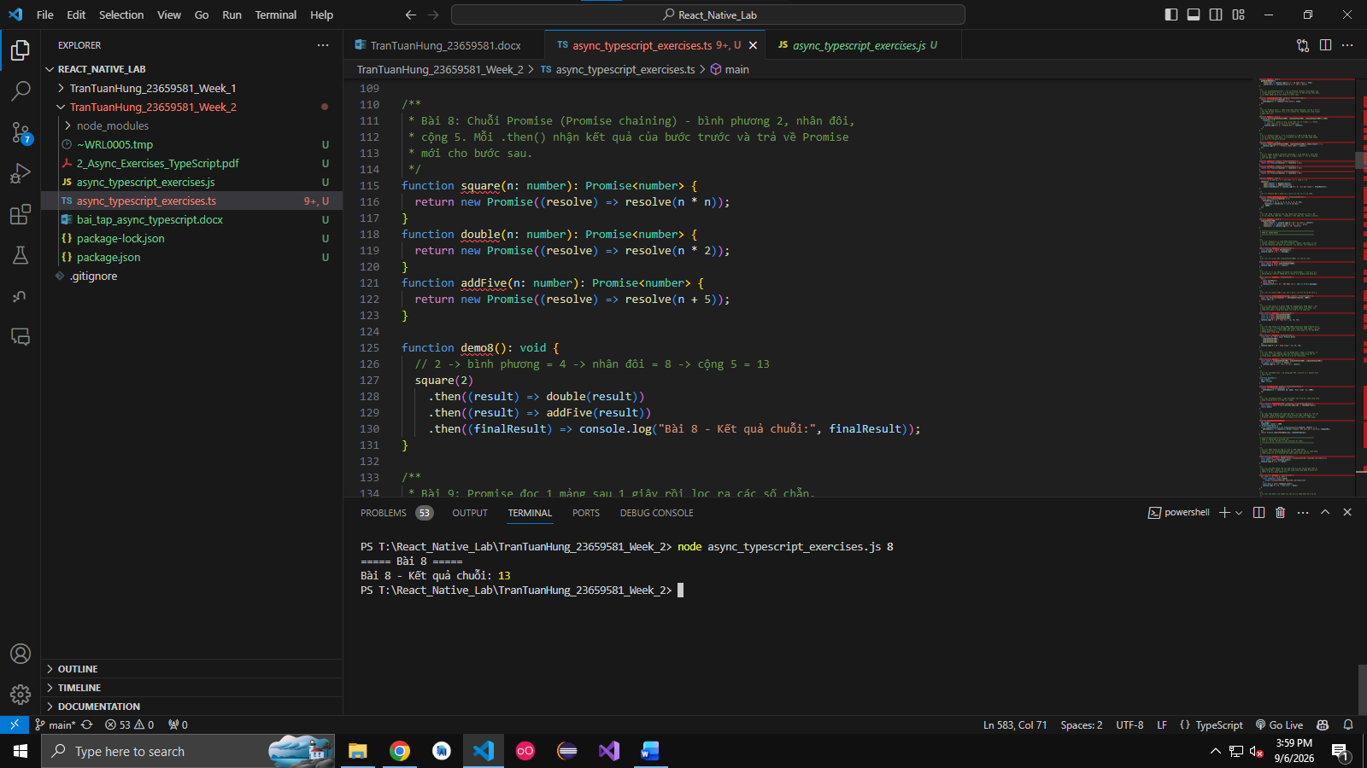

Câu 9. Write a Promise that reads an array after 1 second and filters even numbers.
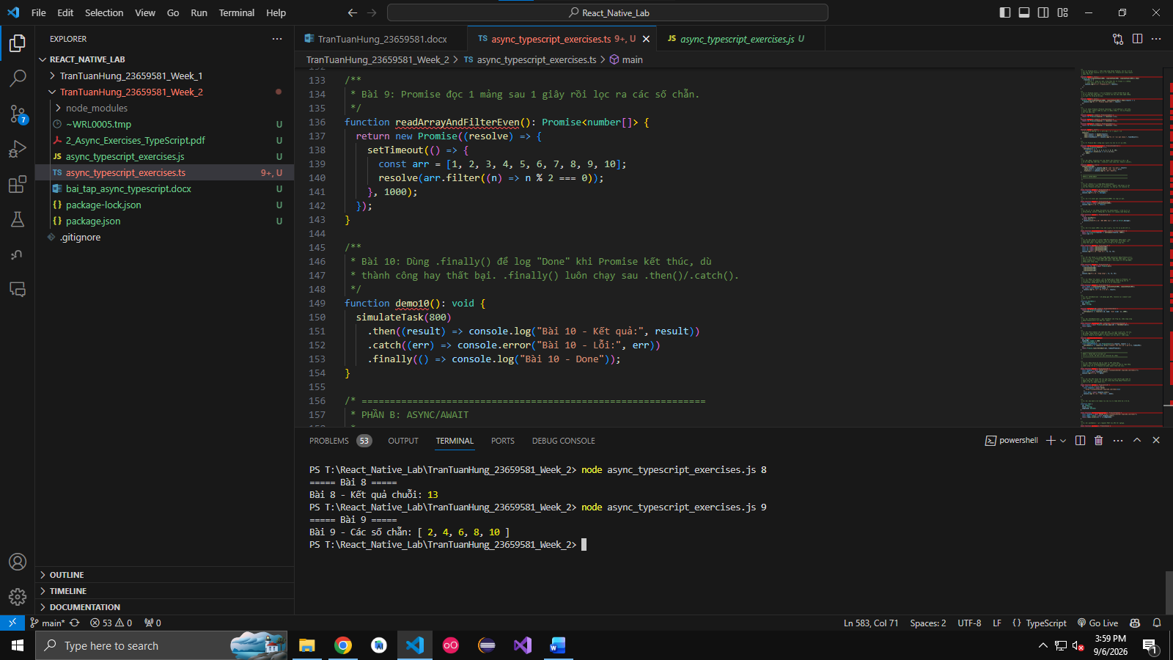

Câu 10. Use .finally() to log "Done" when a Promise finishes (success or failure).
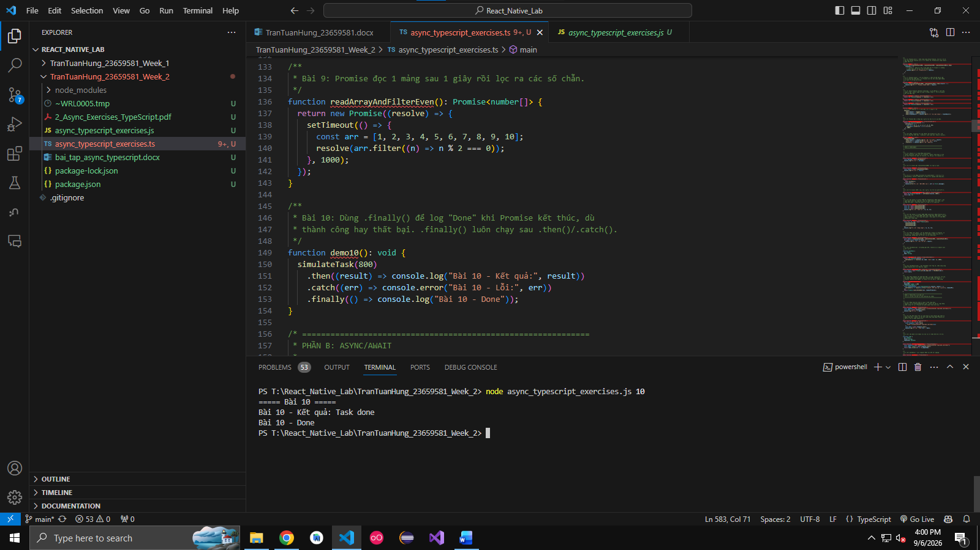

B. Async/Await
Câu 11. Convert Exercise 1 into async/await.
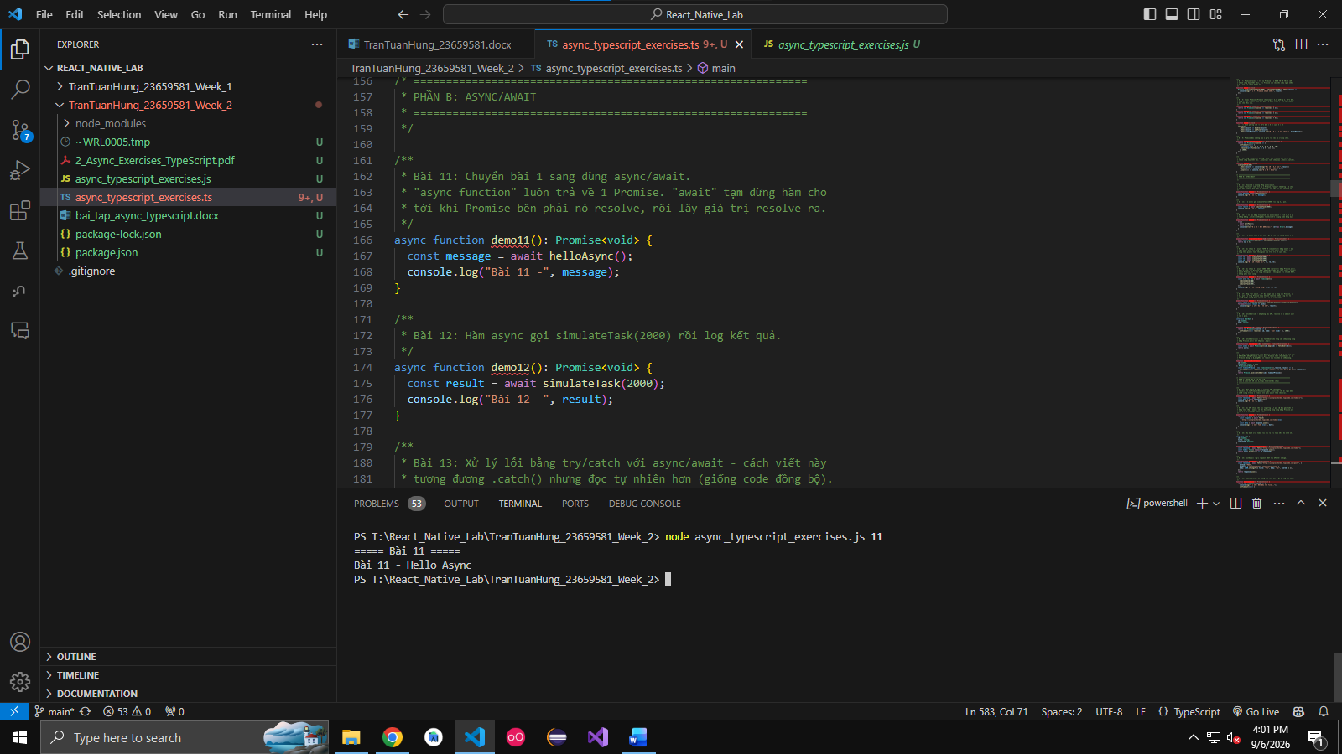

Câu 12. Write an async function that calls simulateTask(2000) and logs the result.
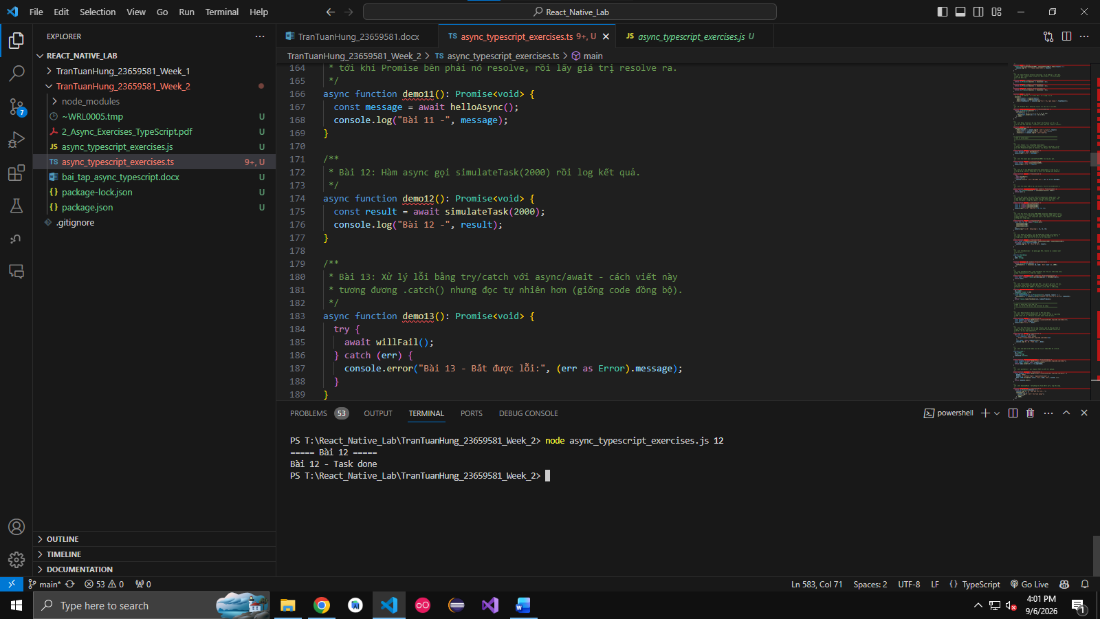

Câu 13. Handle errors using try/catch with async/await.
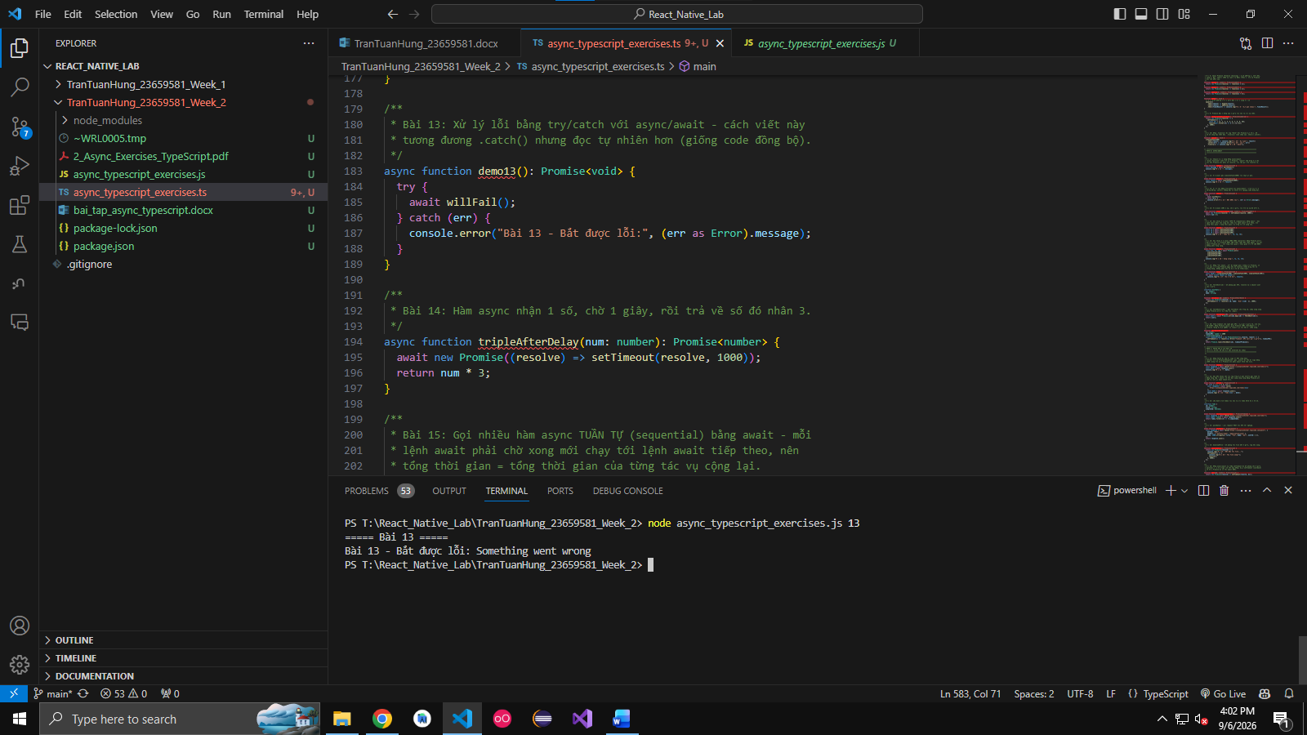

Câu 14. Write an async function that takes a number, waits 1 second, and returns the number × 3.

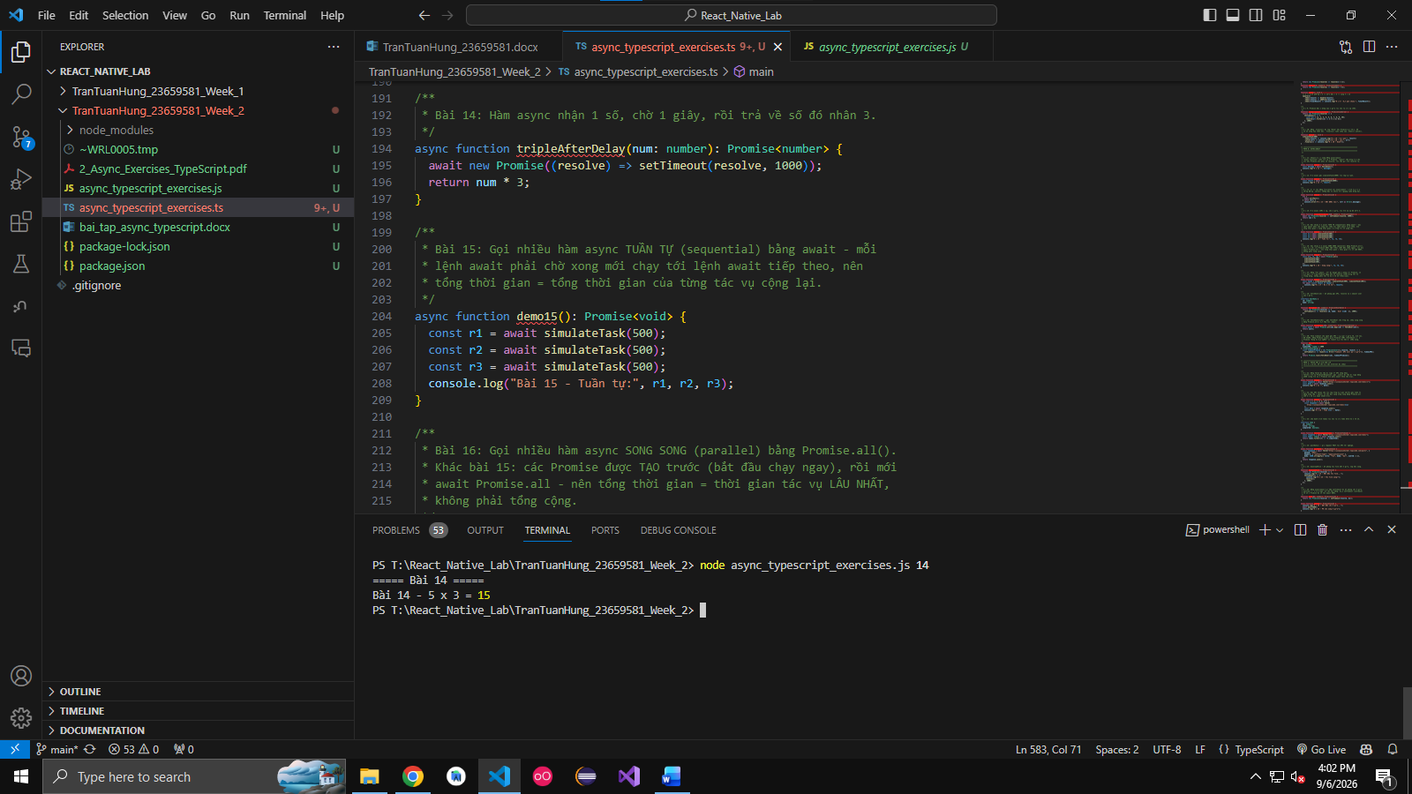

Câu 15. Call multiple async functions sequentially using await.
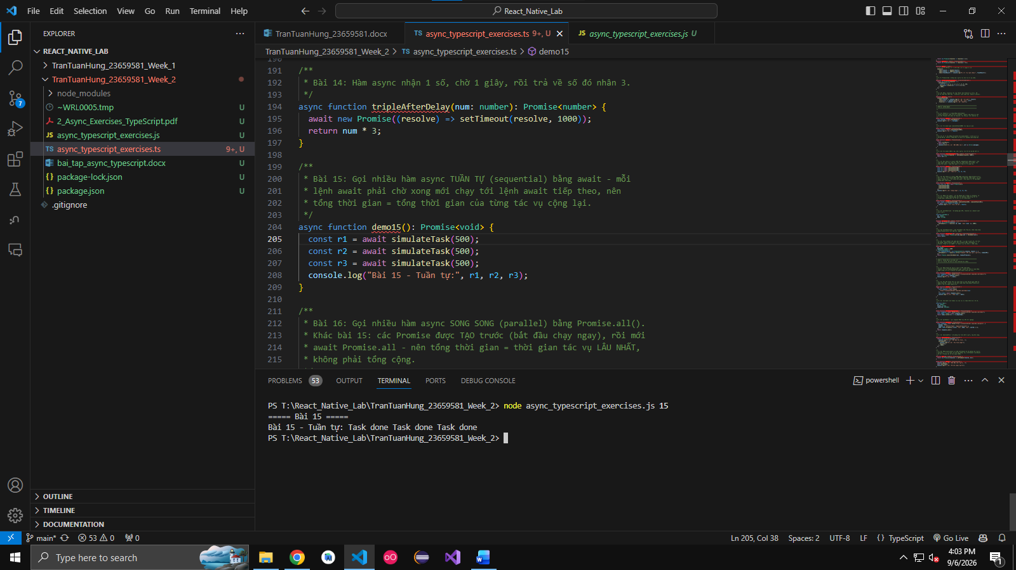

Câu 16. Call multiple async functions in parallel using Promise.all().
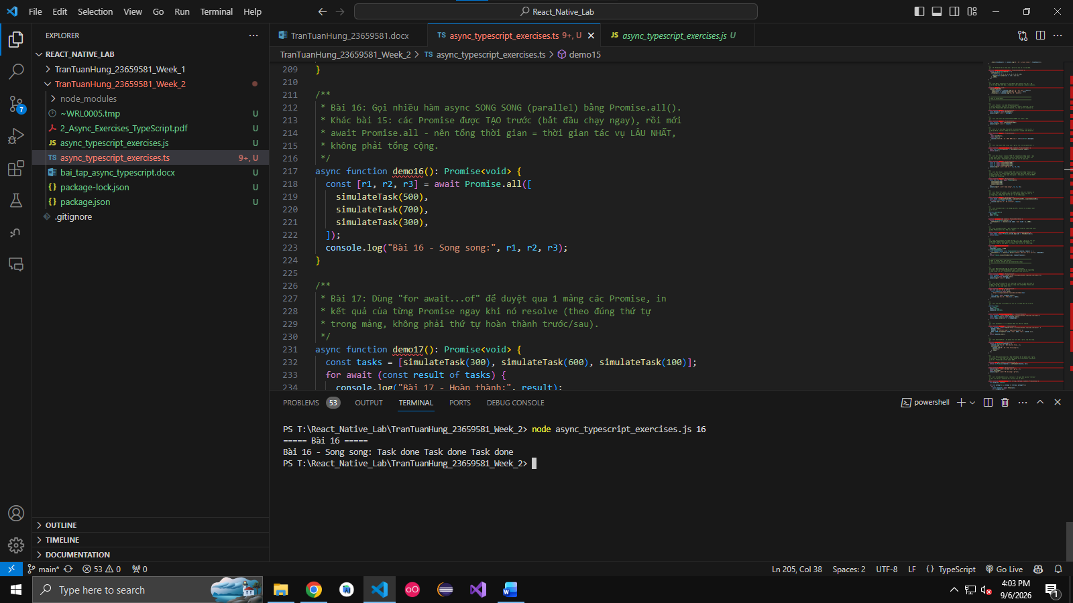

Câu 17. Use for await...of to iterate over an array of Promises.

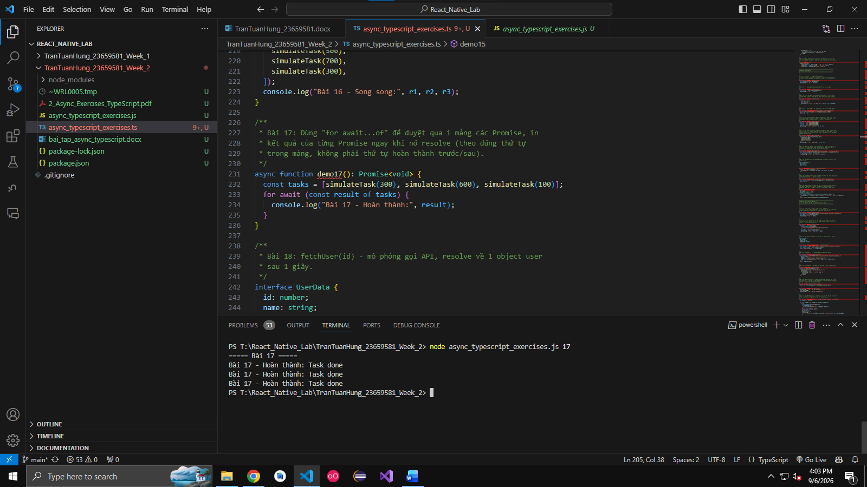

Câu 18. Write an async function fetchUser(id) that simulates an API call (resolves a user object after 1 second).

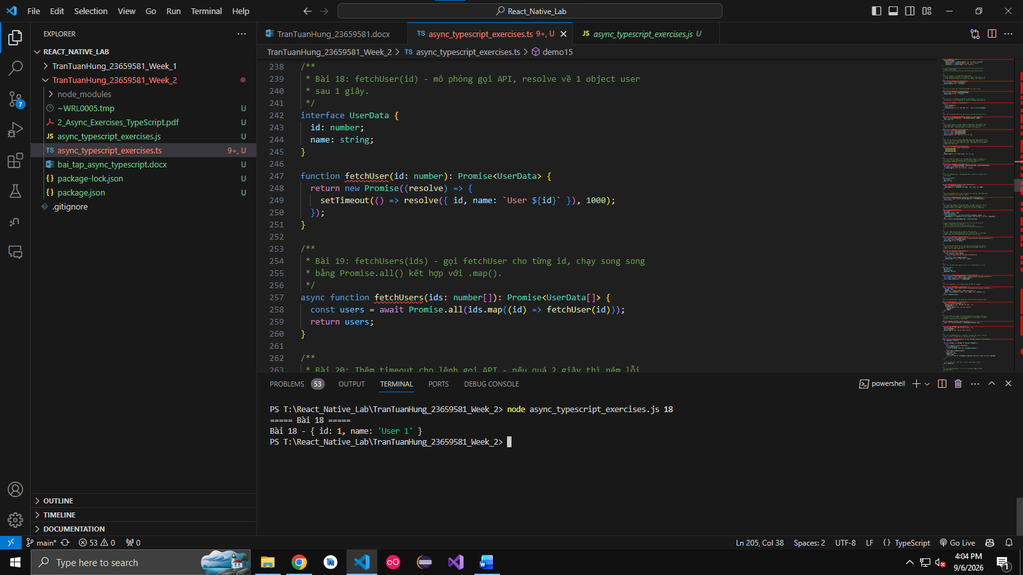

Câu 19. Create an async function fetchUsers(ids: number[]) that calls fetchUser for each ID.
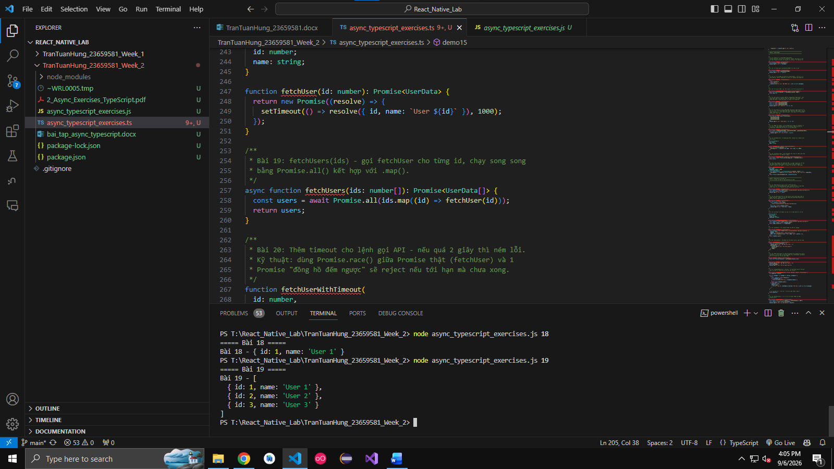

Câu 20. Add a timeout: if the API call takes more than 2 seconds, throw an error.

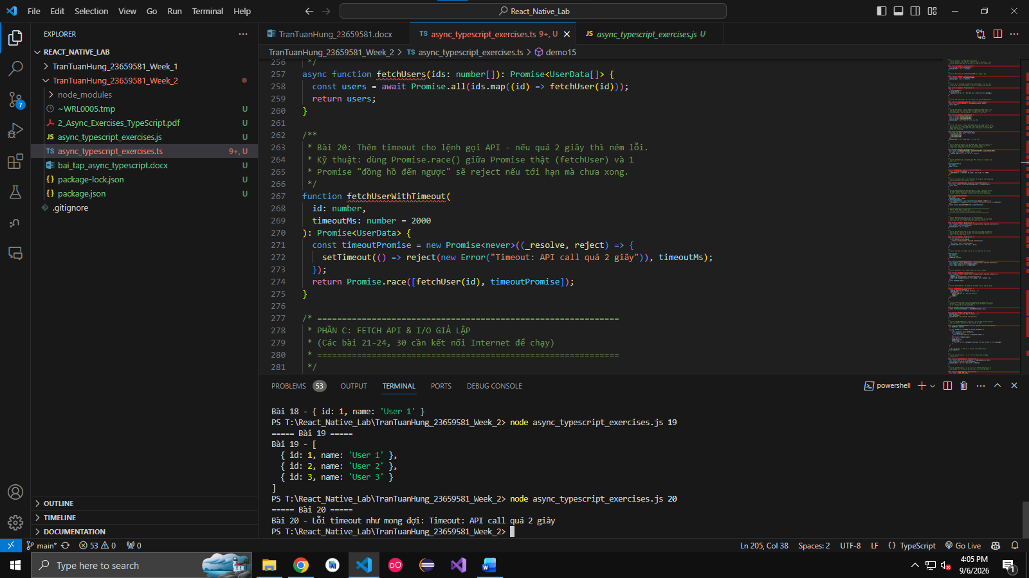

C. Fetch API & Simulated I/O
Câu 21. Use fetch to get data from a public API (e.g., https://jsonplaceholder.typicode.com/todos/1).

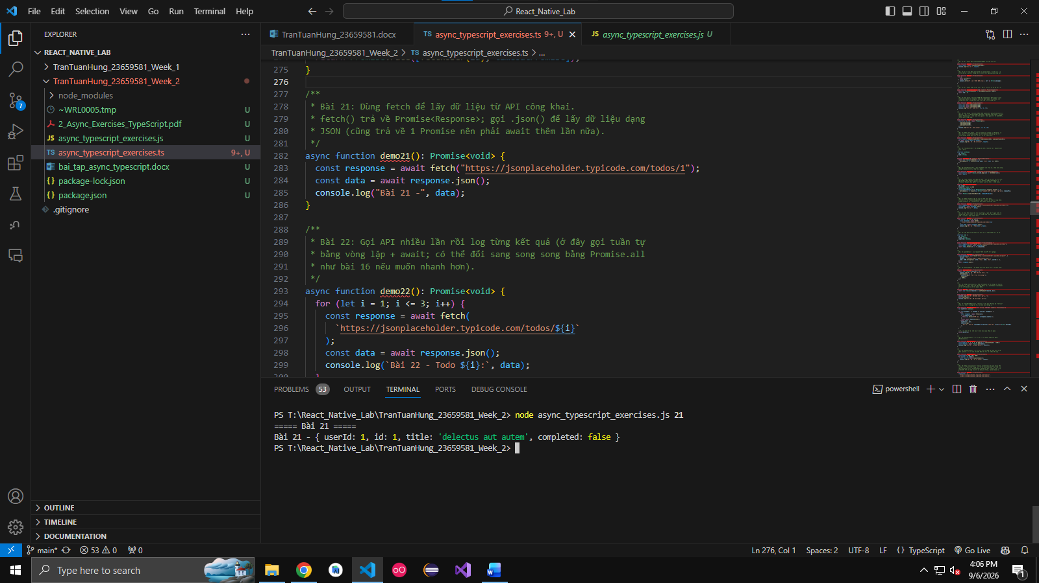

Câu 22. Call the API multiple times and log the results.
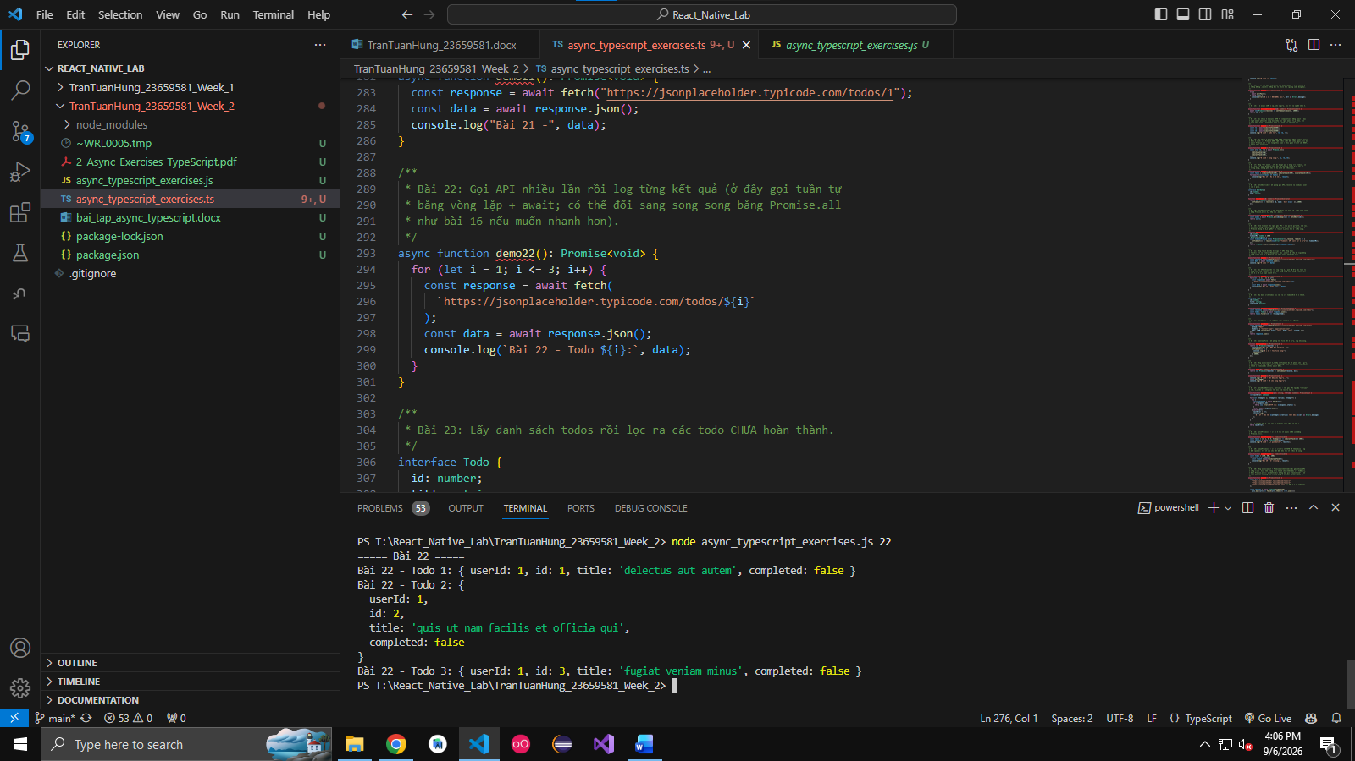

Câu 23. Write an async function that fetches a list of todos and filters out those that are not completed.
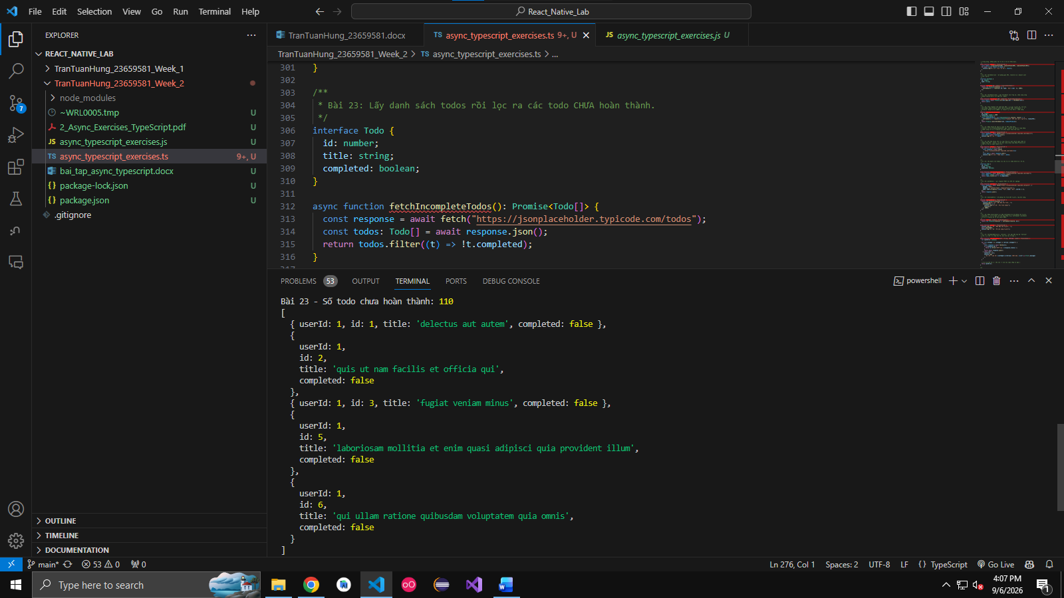

Câu 24. Write an async function postData() that sends a POST request to a test API.
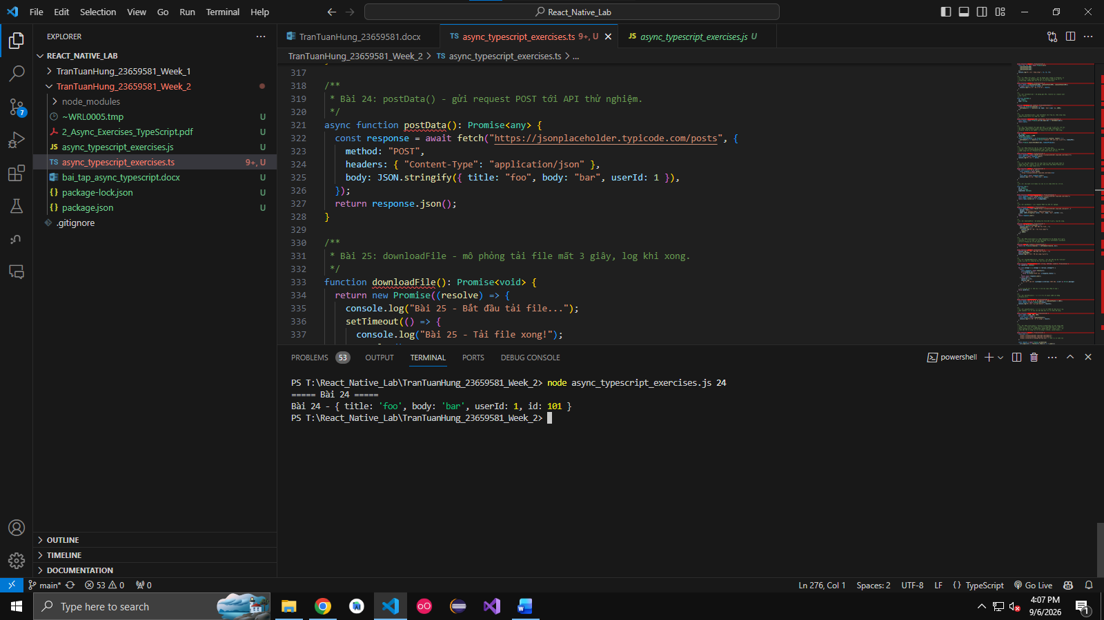

Câu 25. Create a function downloadFile that simulates downloading a file in 3 seconds and logs when done.
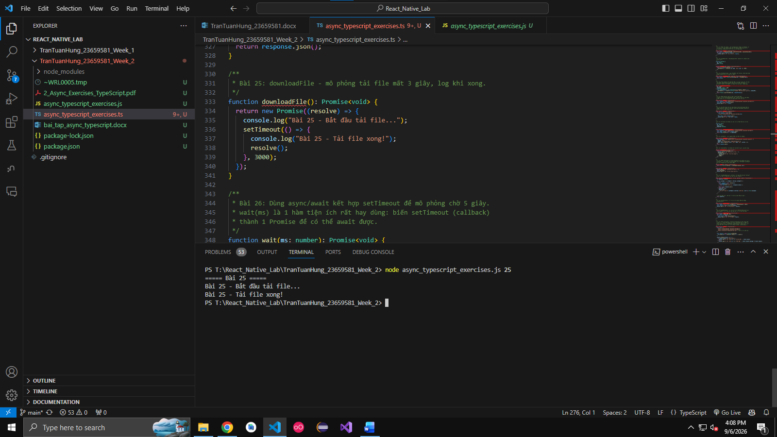

Câu 26. Use async/await with setTimeout to simulate a 5-second wait.
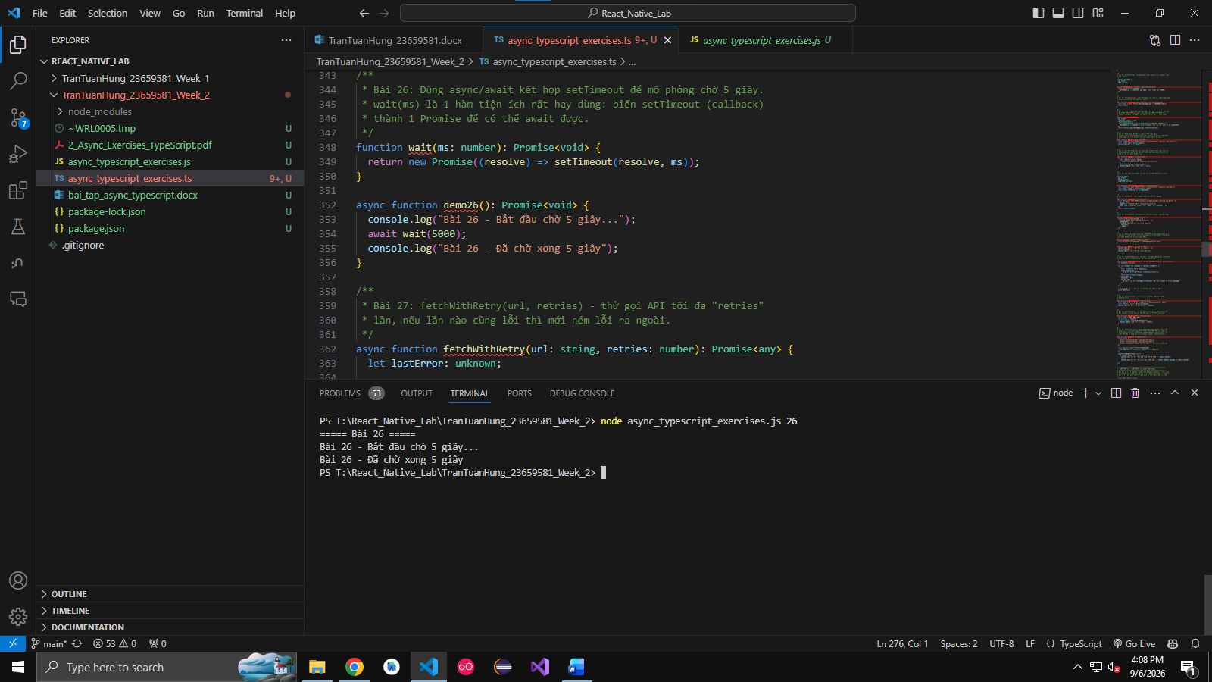

Câu 27. Write a function fetchWithRetry(url, retries) that retries up to retries times if the API call fails.
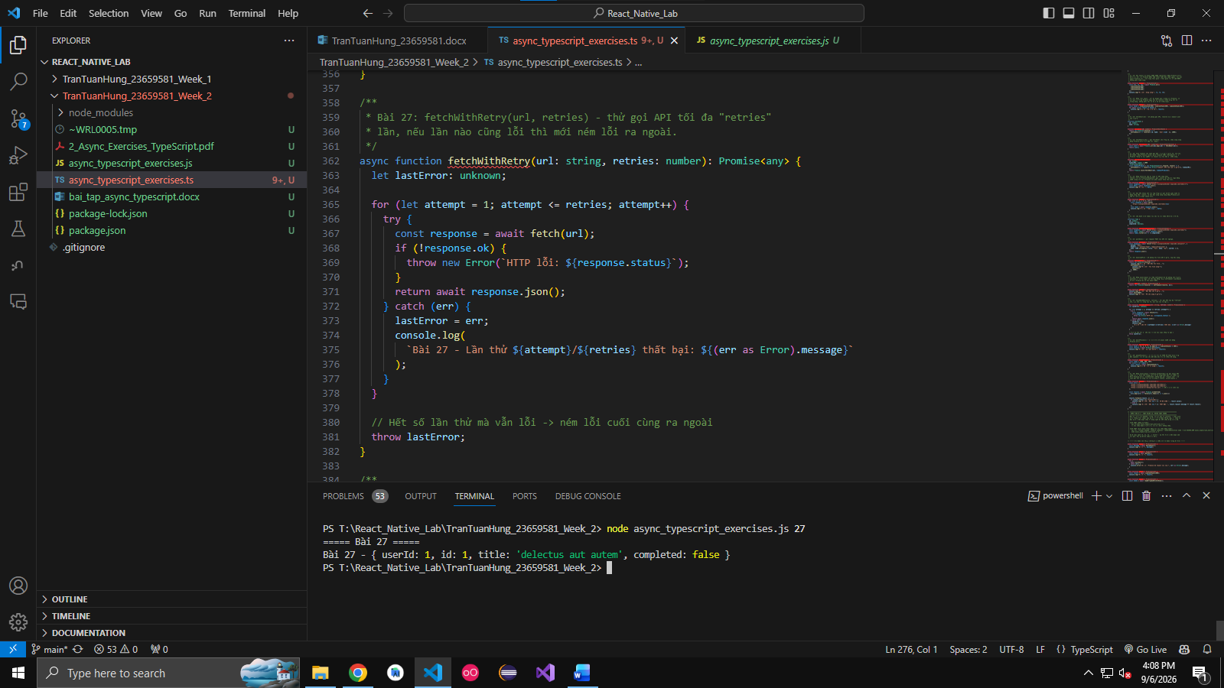

Câu 28. Write an async function batchProcess() that processes 5 async tasks at once (use Promise.all).
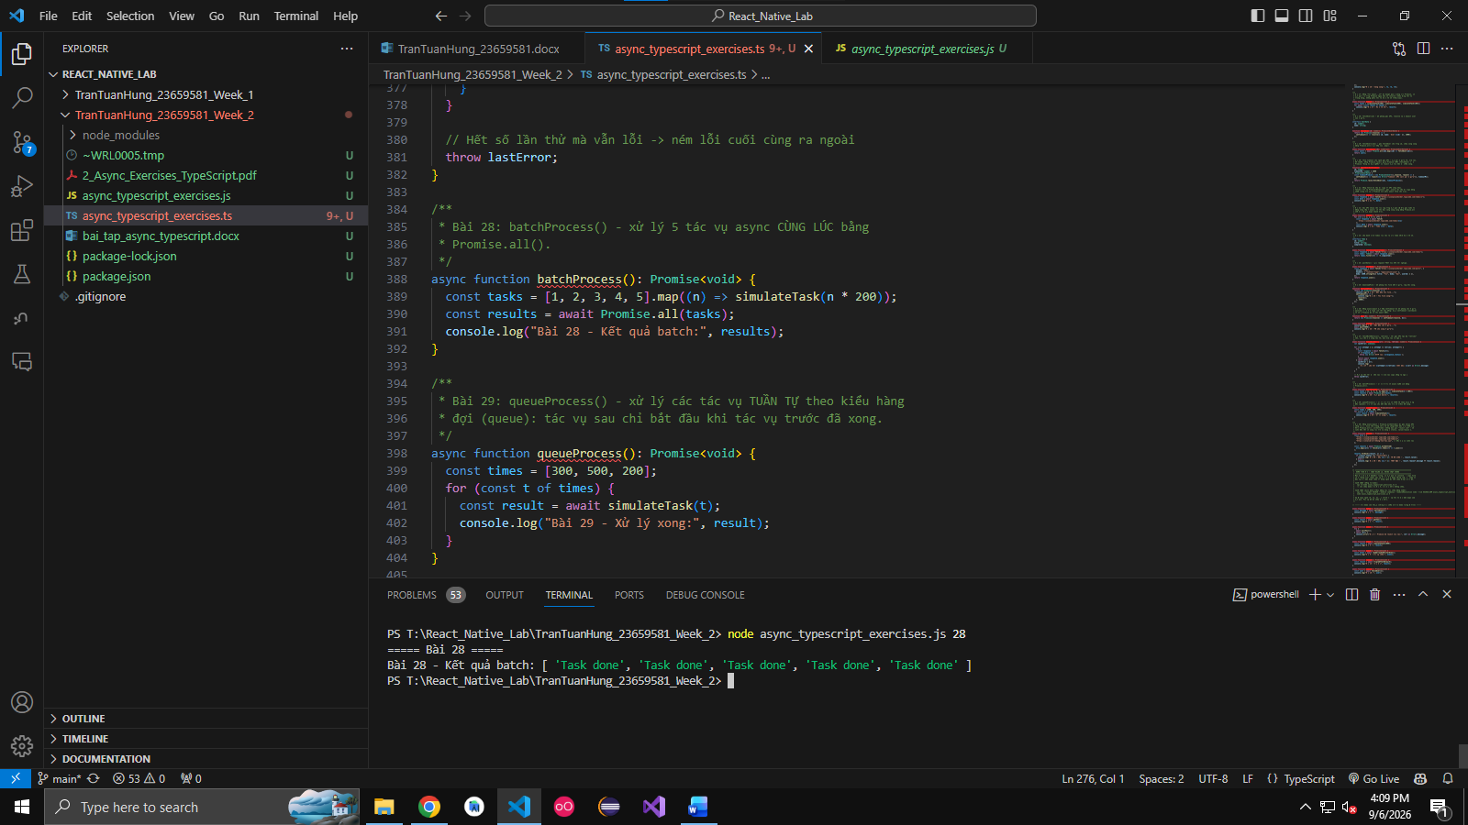

Câu 29. Write an async function queueProcess() that processes tasks sequentially in a queue.

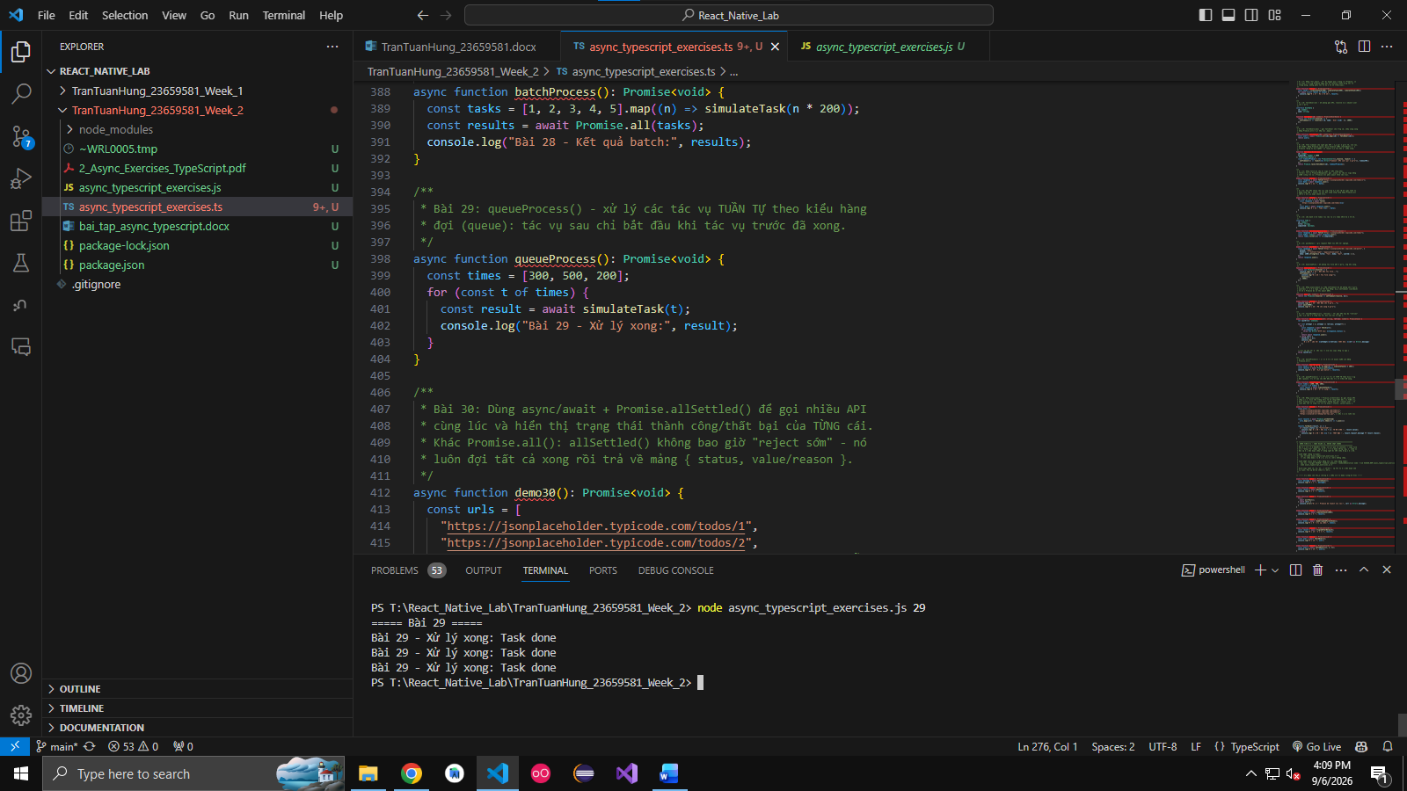

Câu 30. Use async/await + Promise.allSettled() to handle multiple API calls and display their success/failure status.
