BÀI TẬP THỰC HÀNH TYPESCRIPT OOP
Câu 1. Create a class Person with attributes name and age. Write a method to display this information.
Câu 2. Write a class Student extending Person with an additional attribute grade. Add a method to display all info.
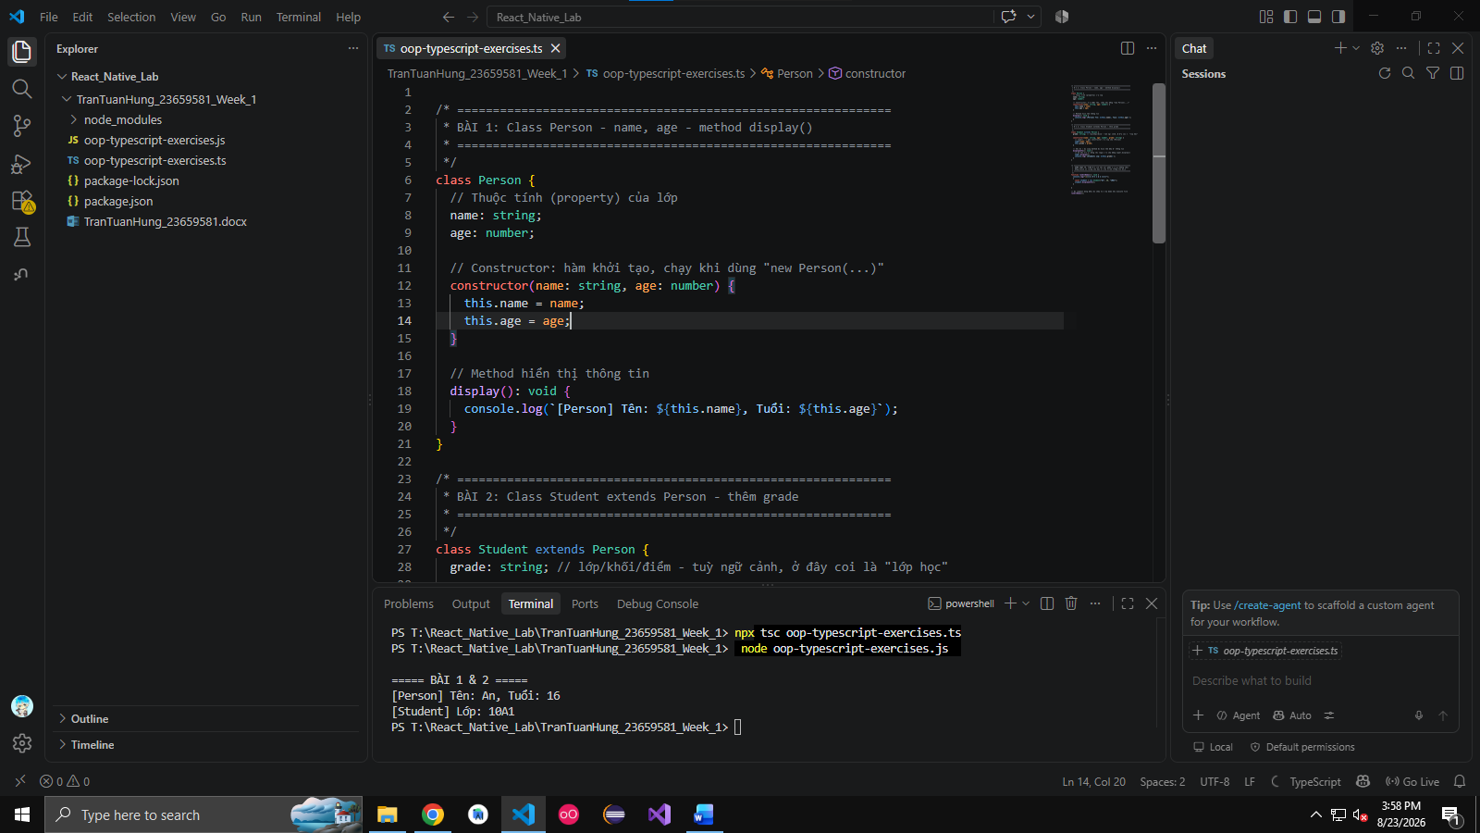
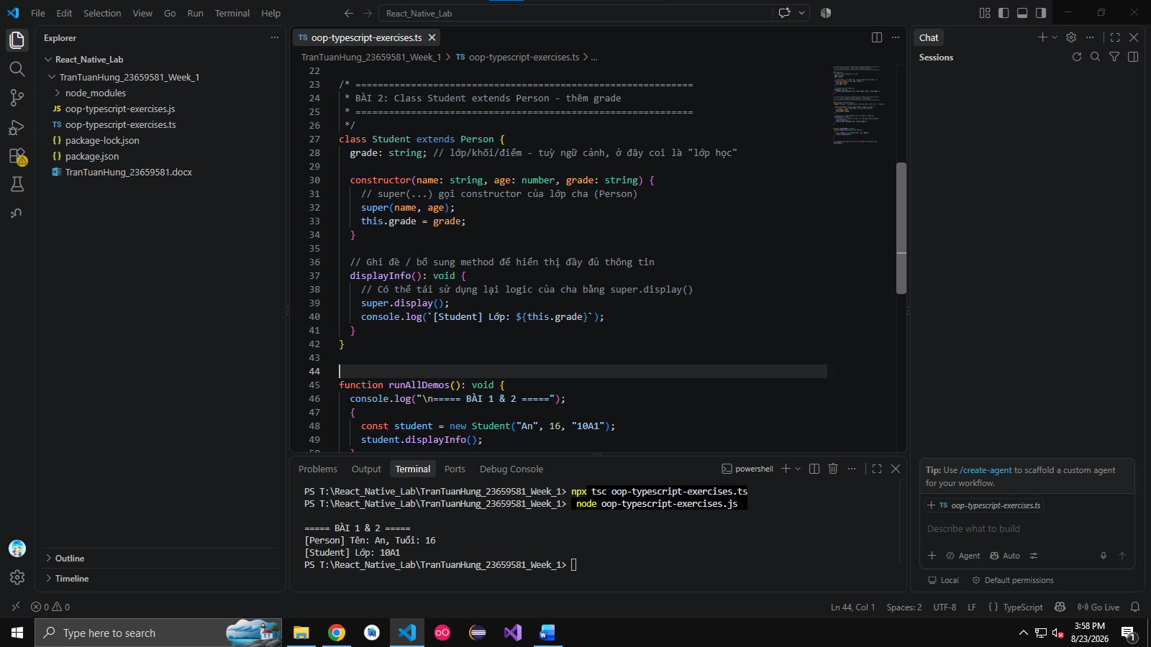

Câu 3. Create a class Car with properties brand, model, year. Write a method to show car info.

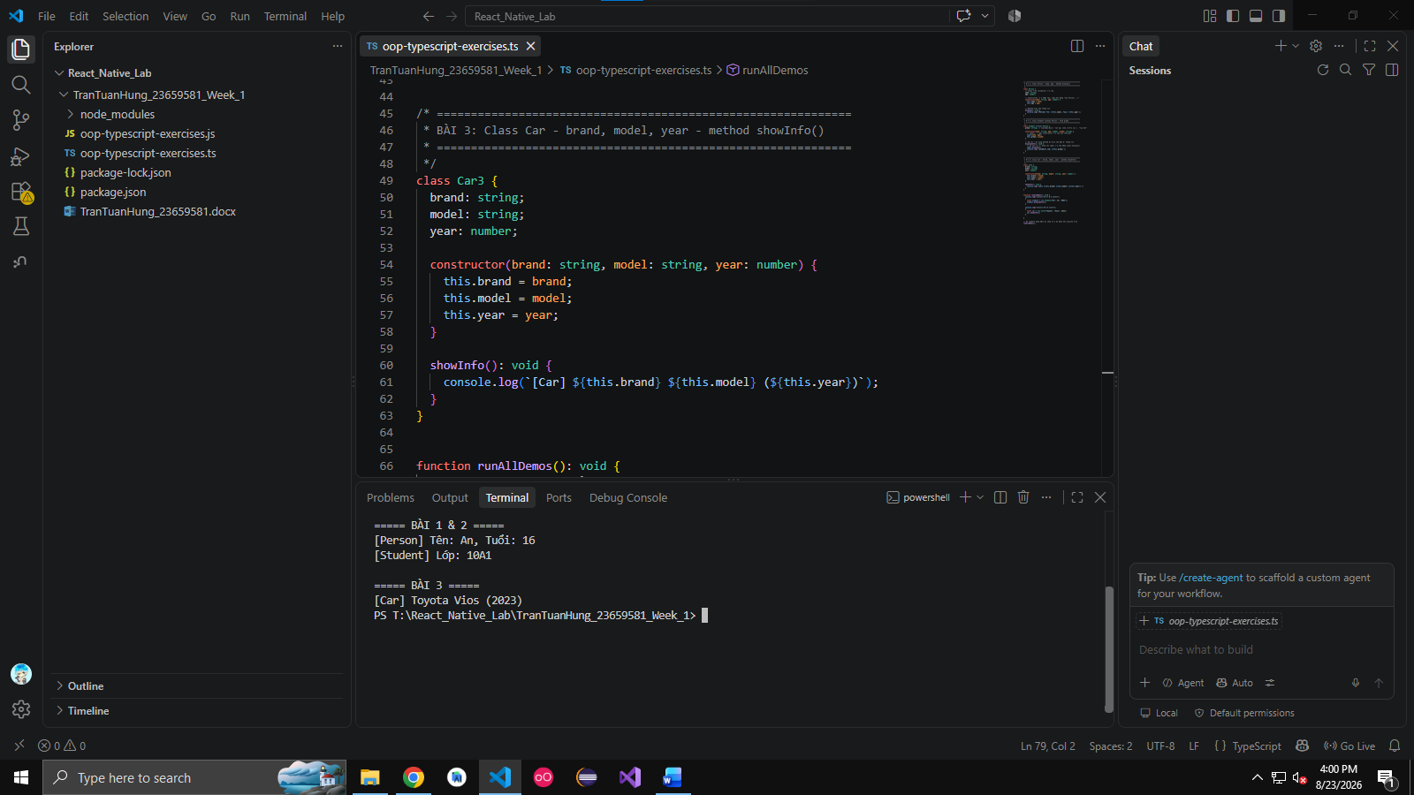

Câu 4. Create a class Rectangle with width and height. Write a method to calculate area and perimeter.

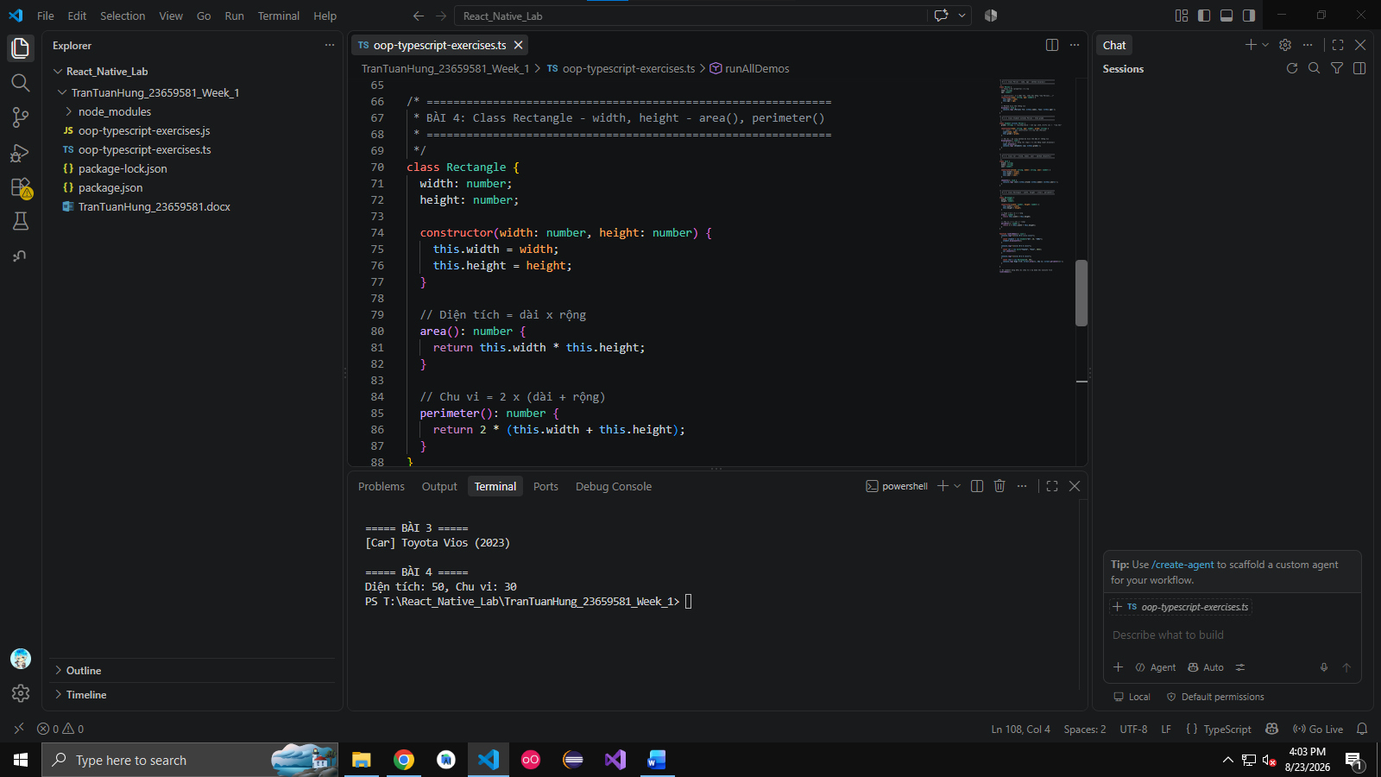
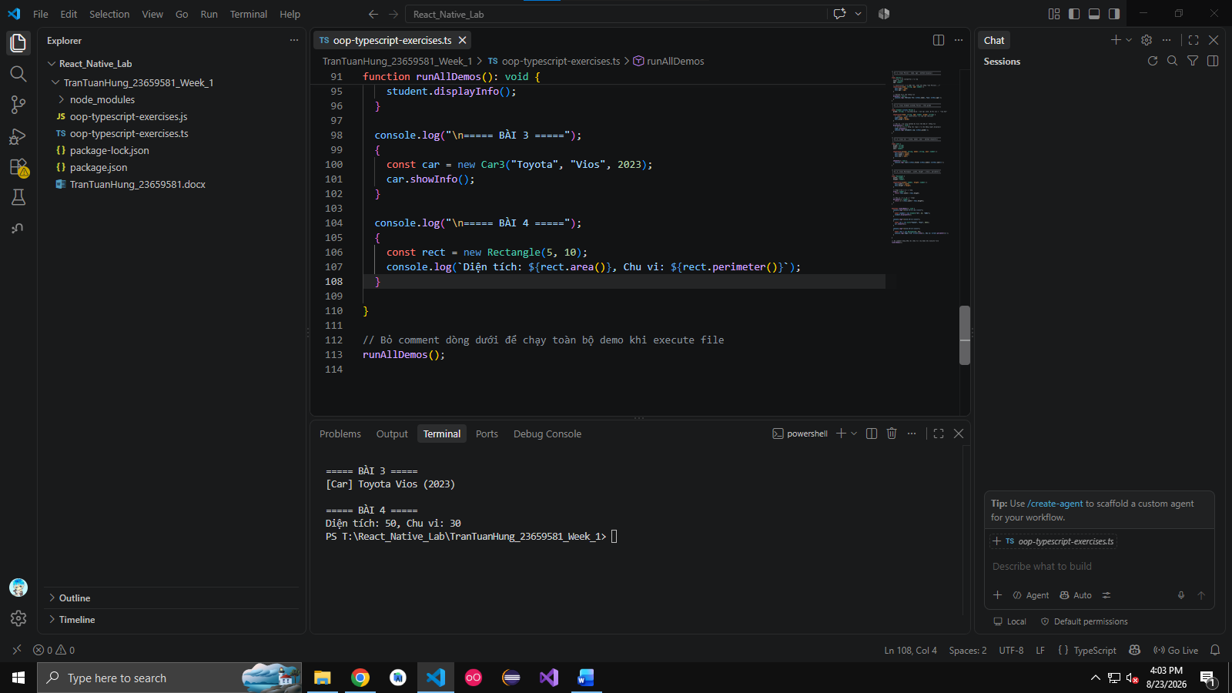

Câu 5. Create a class BankAccount with balance. Add methods deposit() and withdraw().

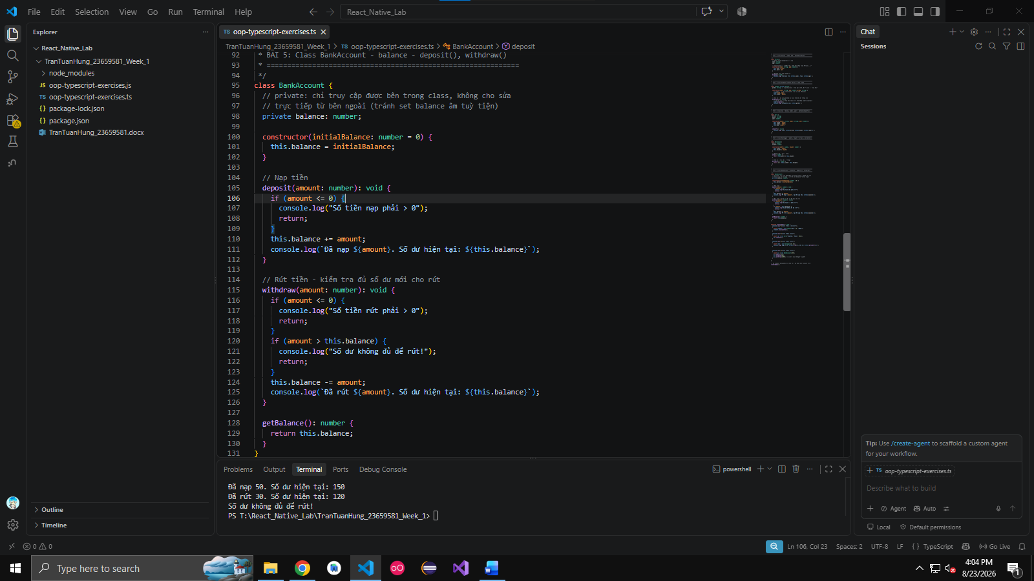

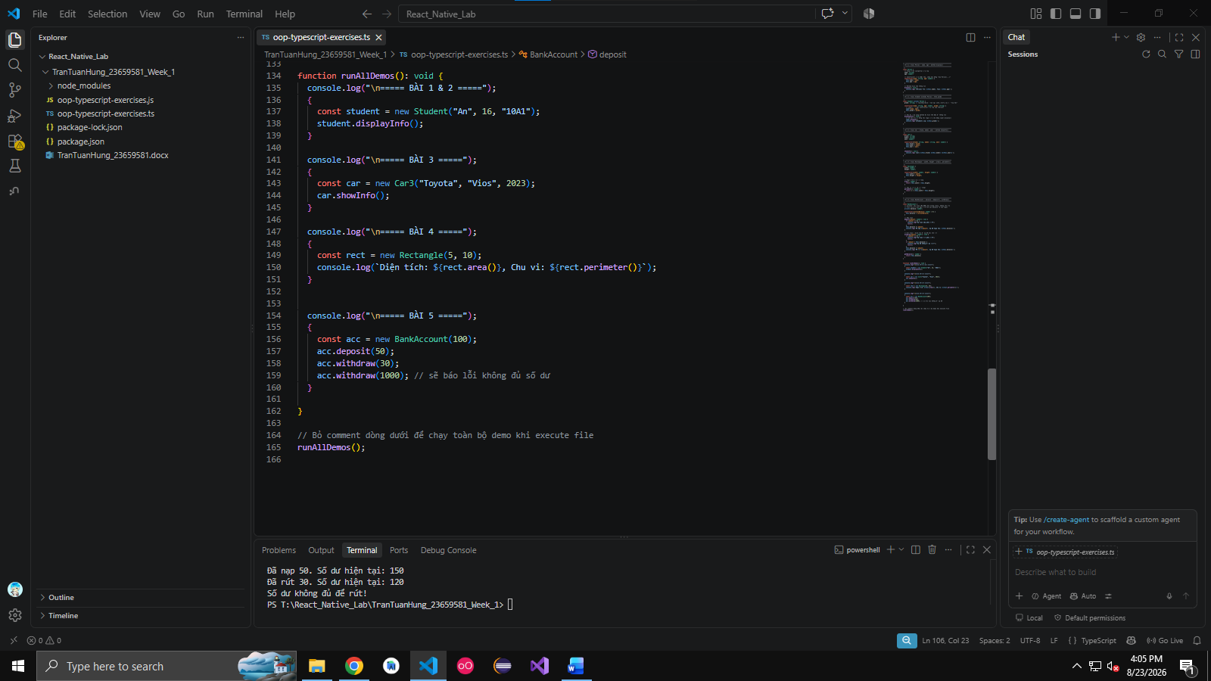

Câu 6. Create a class Book with attributes title, author, year.

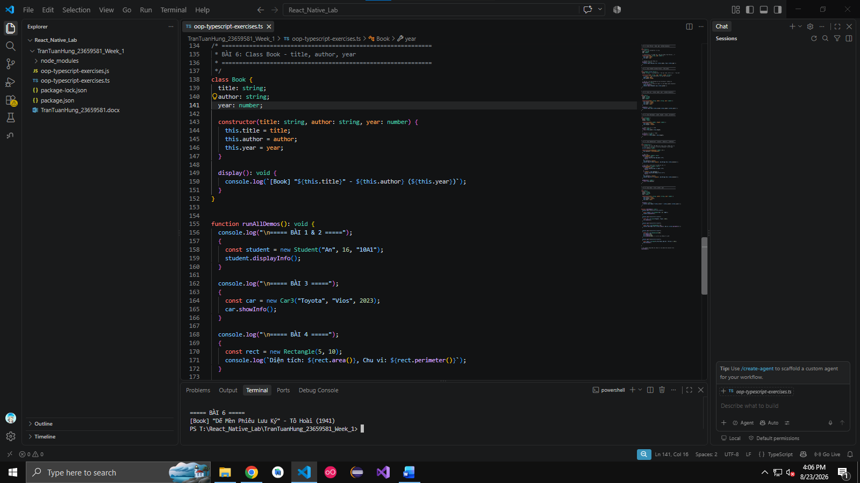
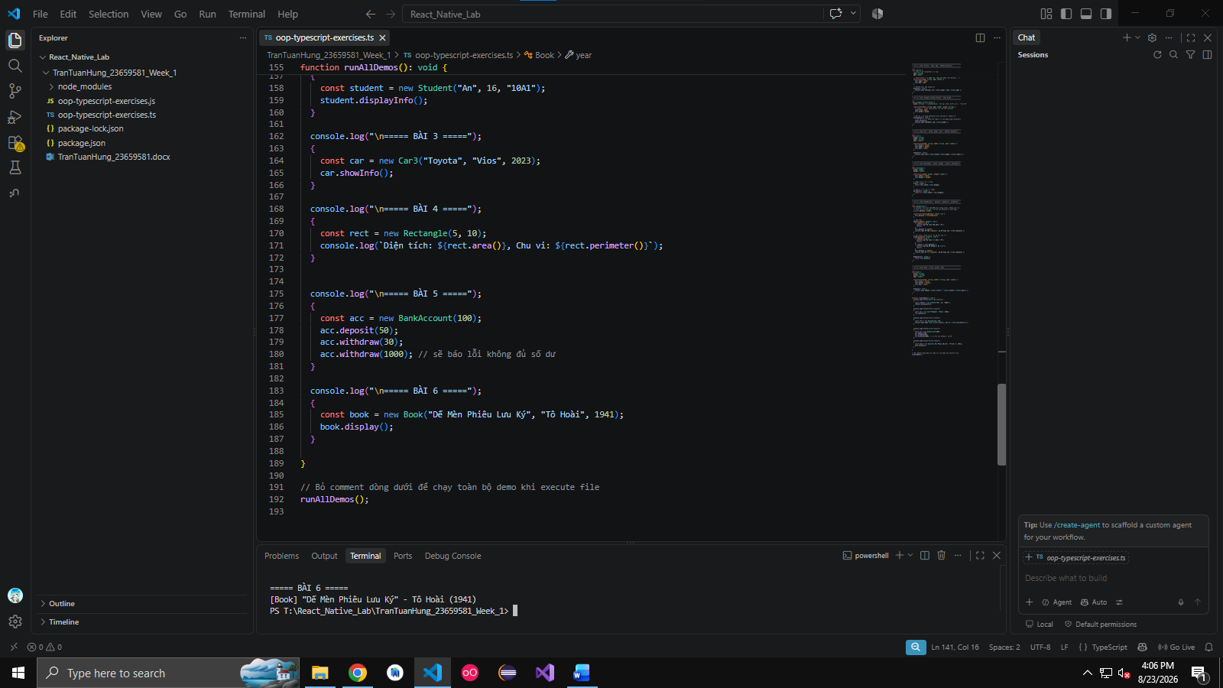

Câu 7. Write a class User with private property name and getter/setter.

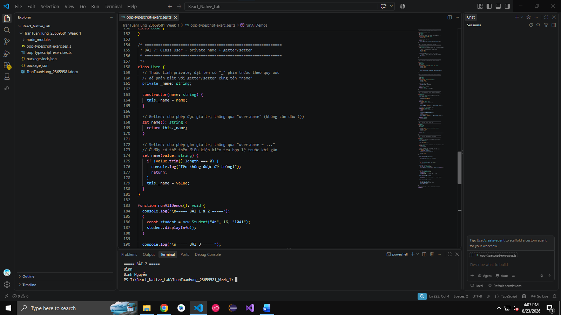

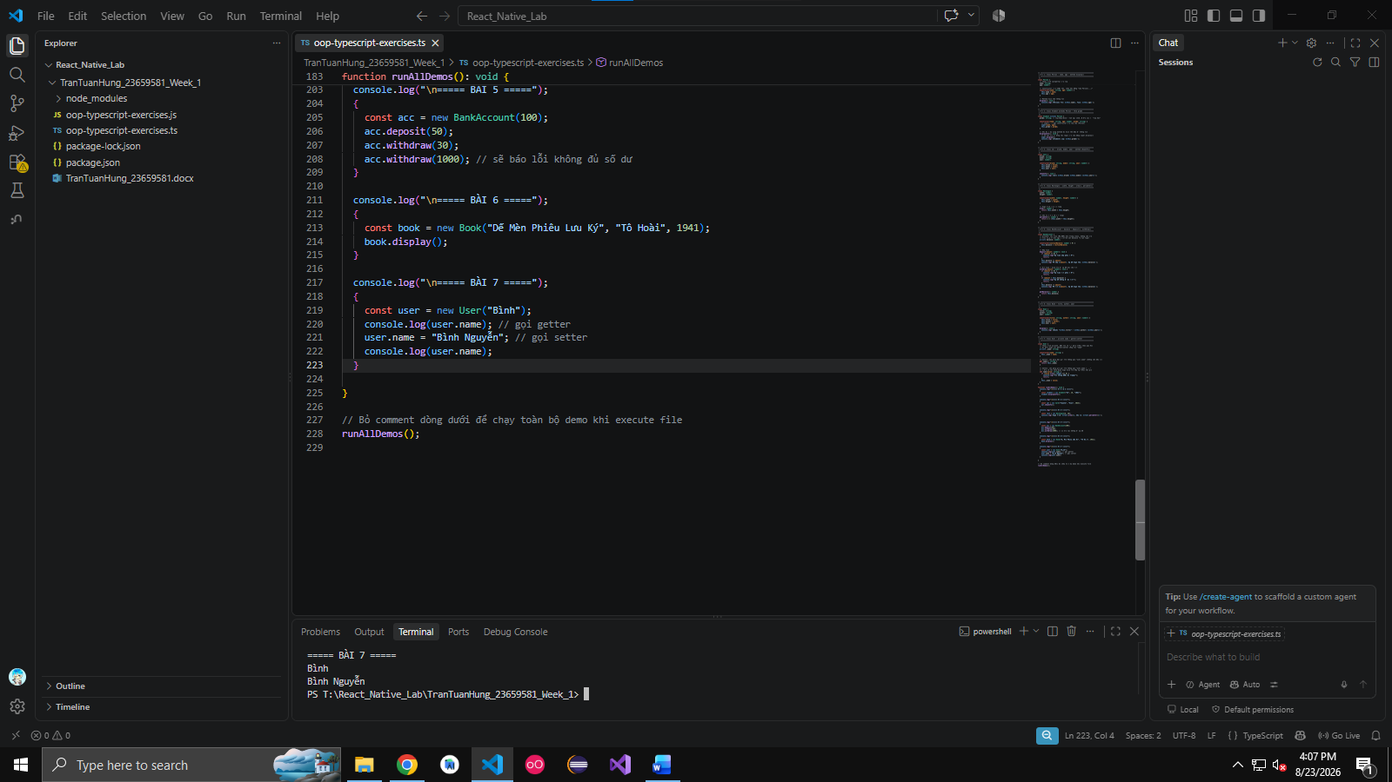

Câu 8. Create a Product class with name, price. Create an array of products and filter products with price > 100.

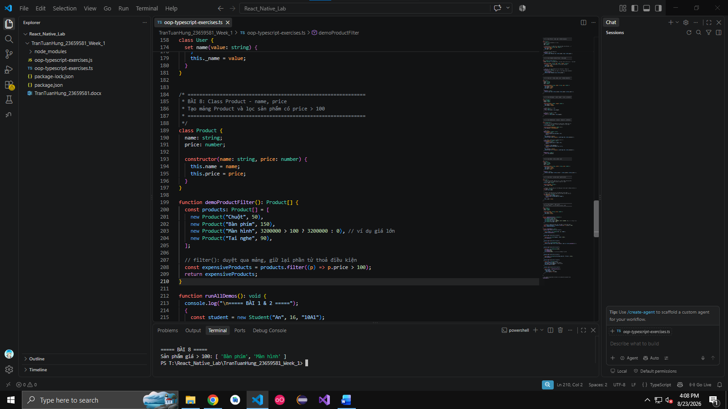
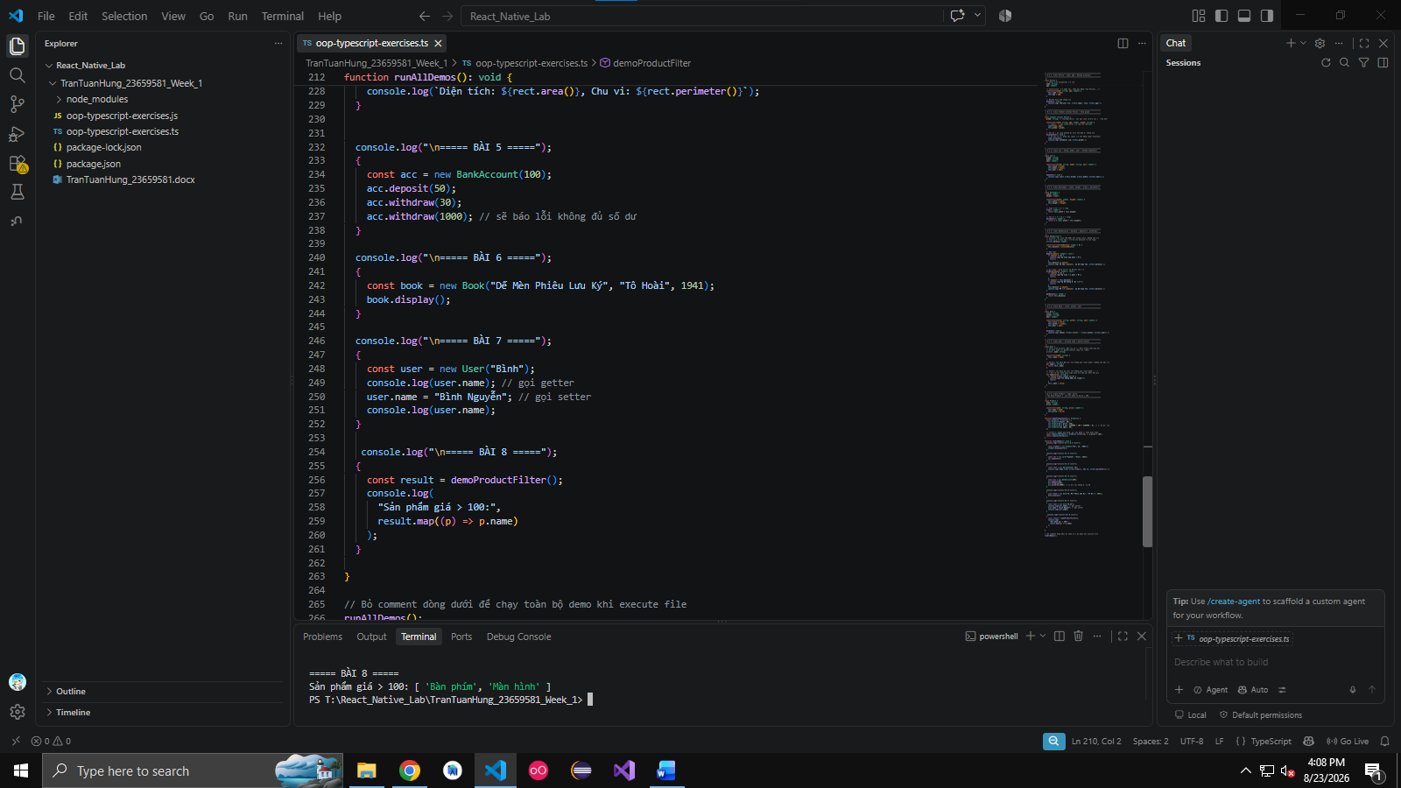

Câu 9. Define an interface Animal with name and method sound().
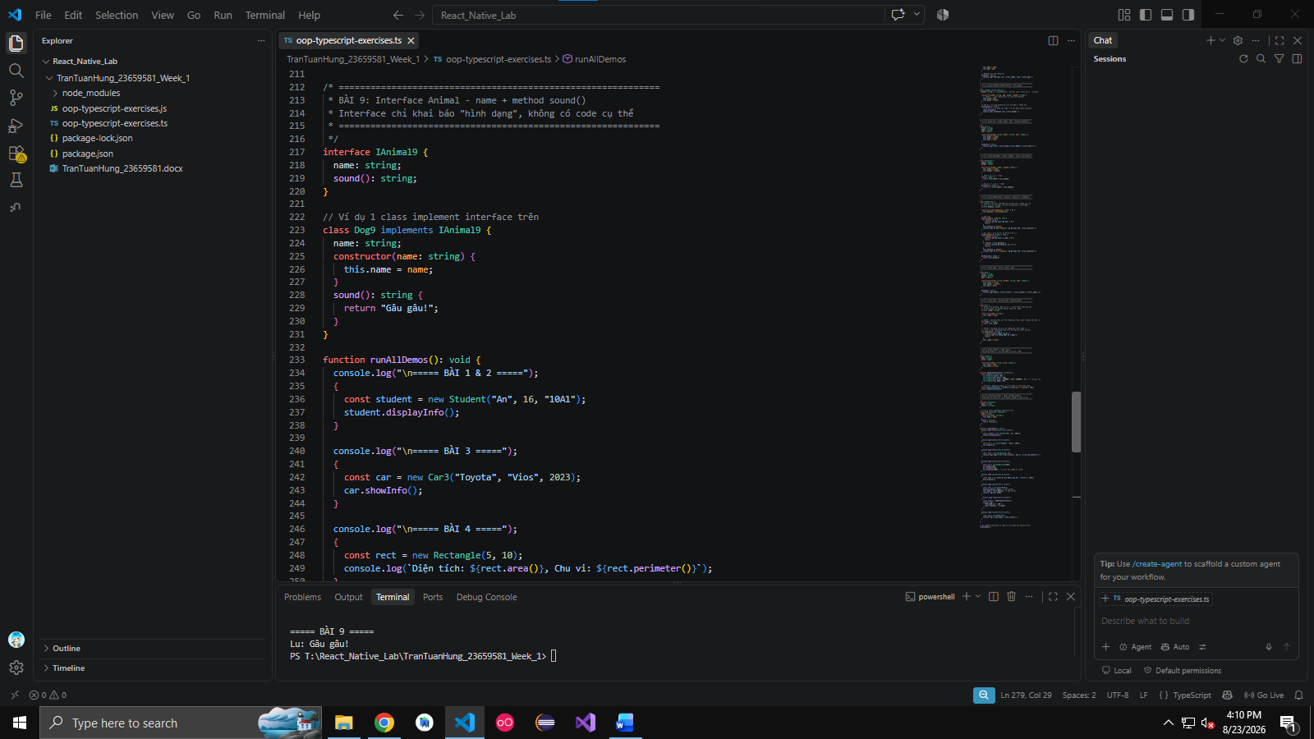
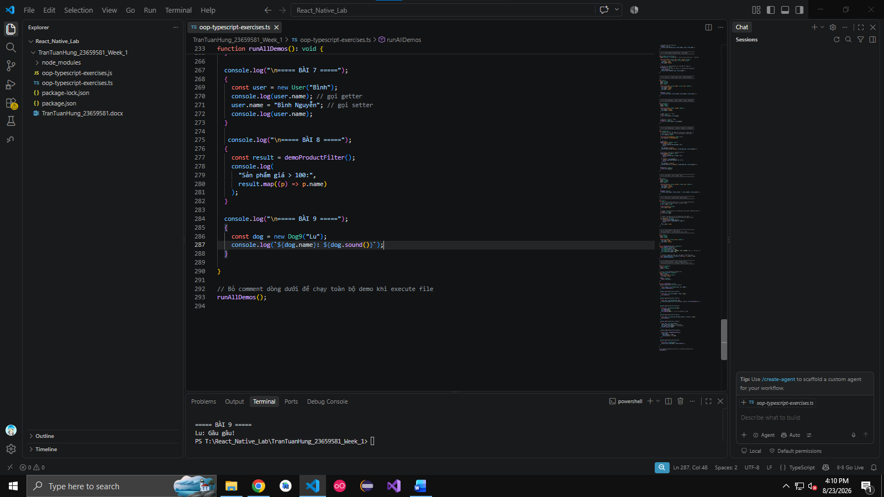

Câu 10. Create a class Account with public, private and readonly fields.
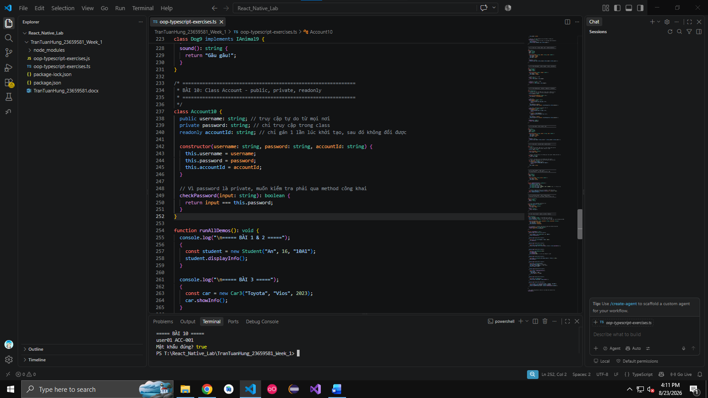
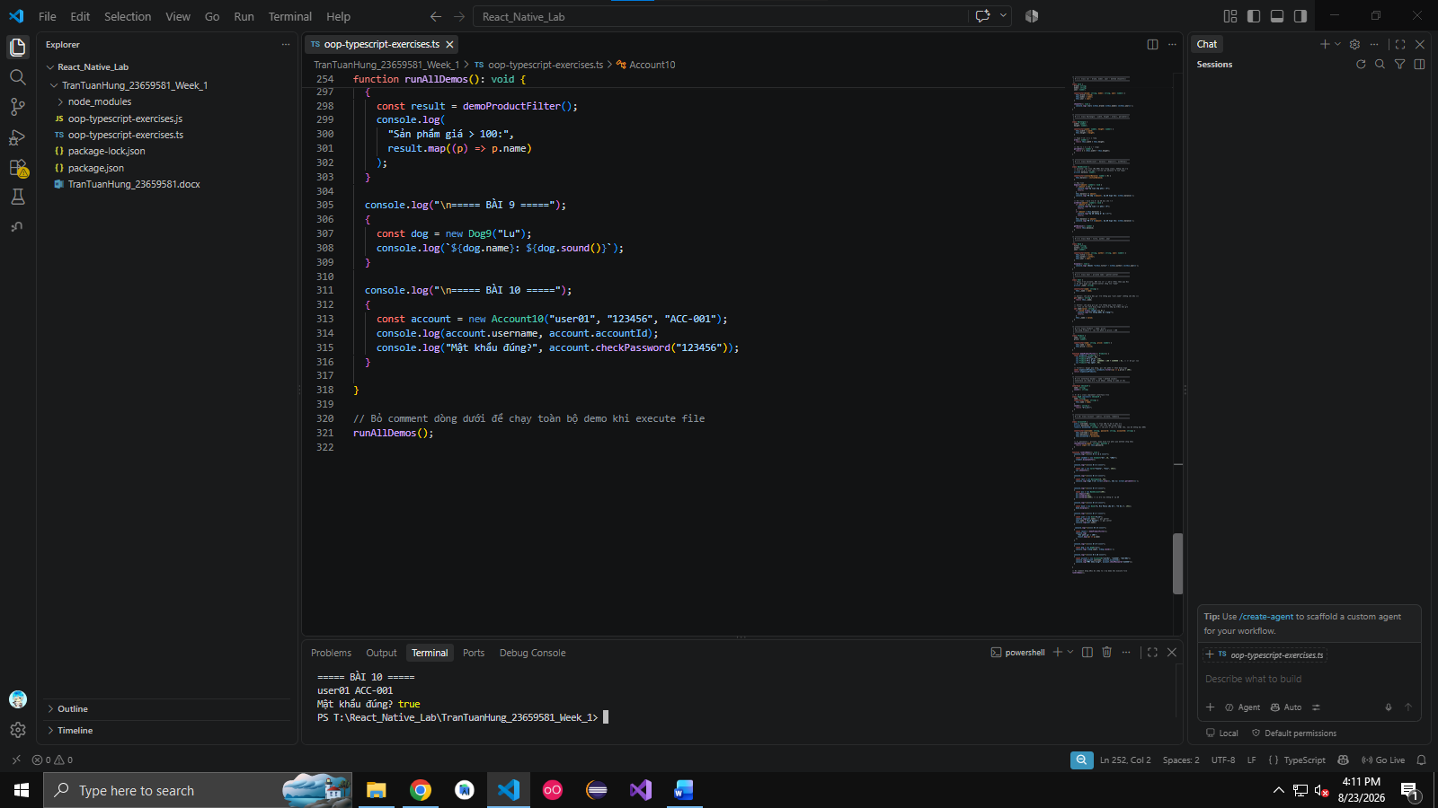

Câu 11. Create a base class Animal. Extend Dog and Cat classes with methods bark() and meow().

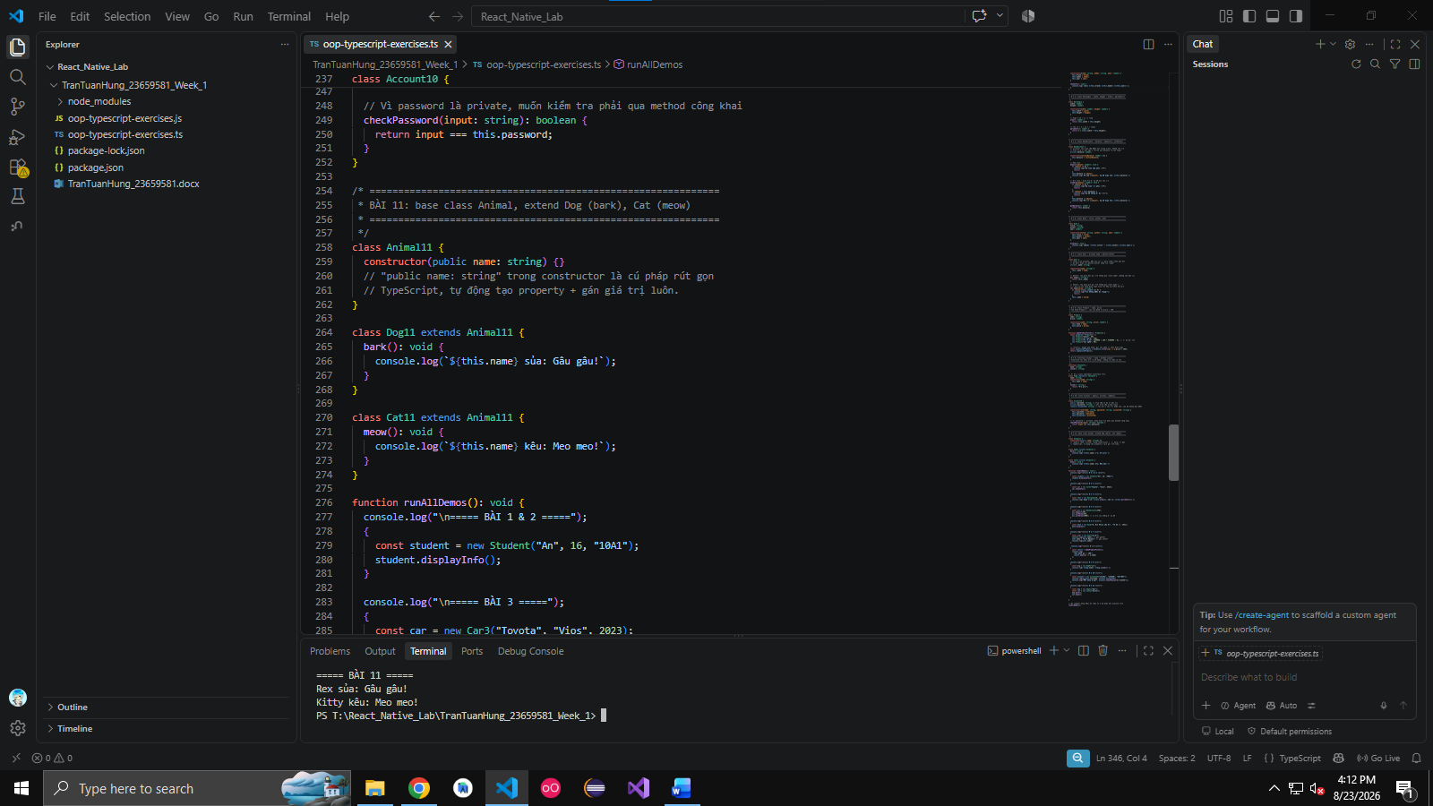

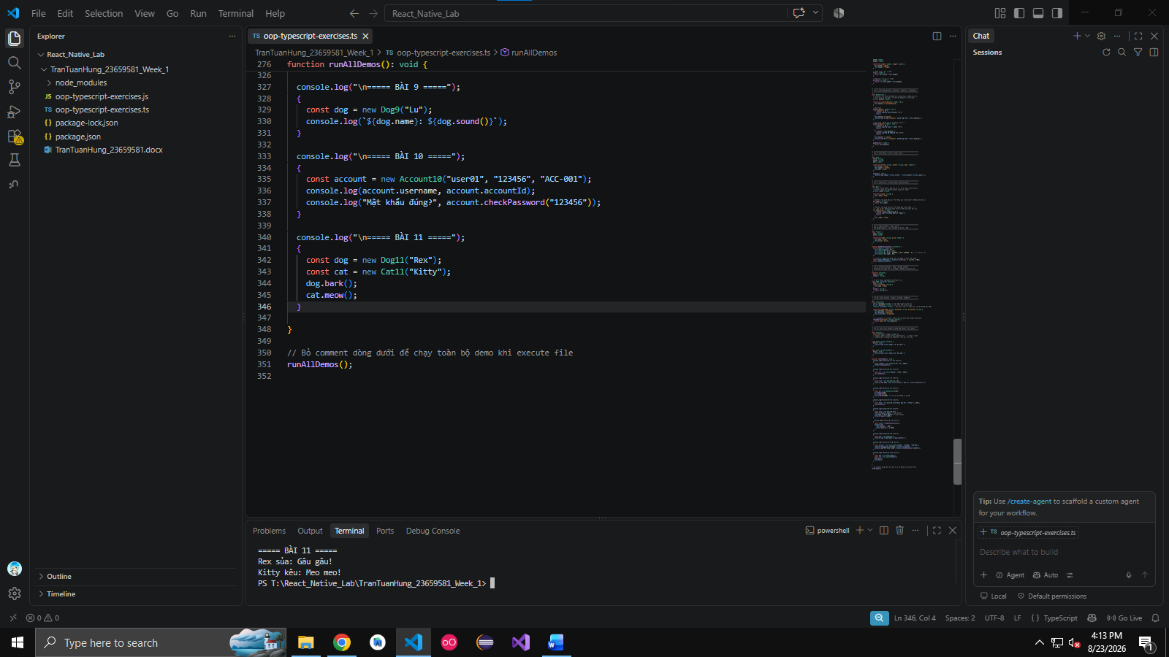

Câu 12. Define interfaces Flyable and Swimmable. Implement them in Bird and Fish classes.

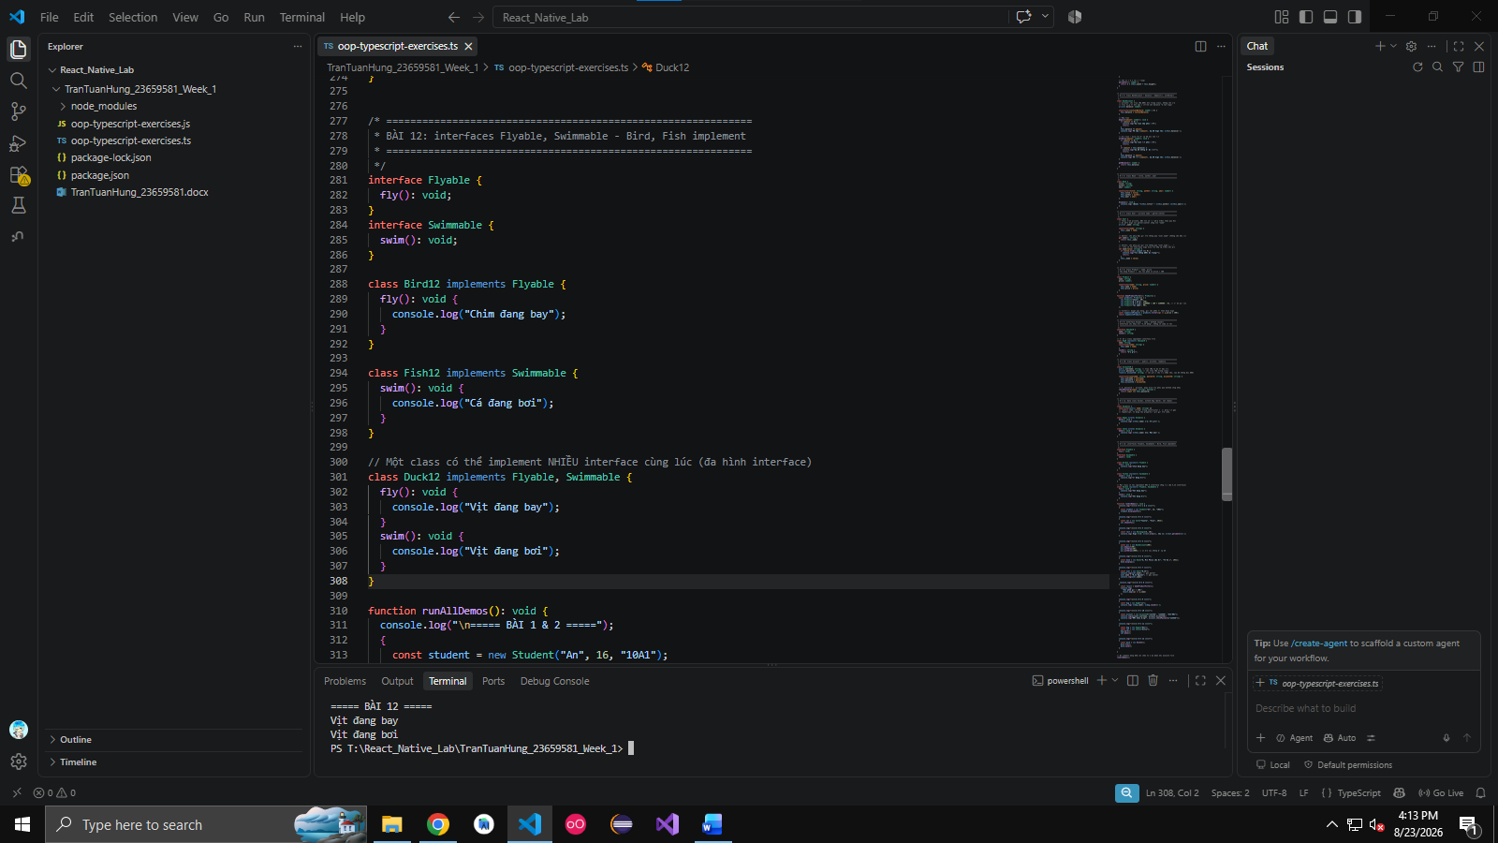
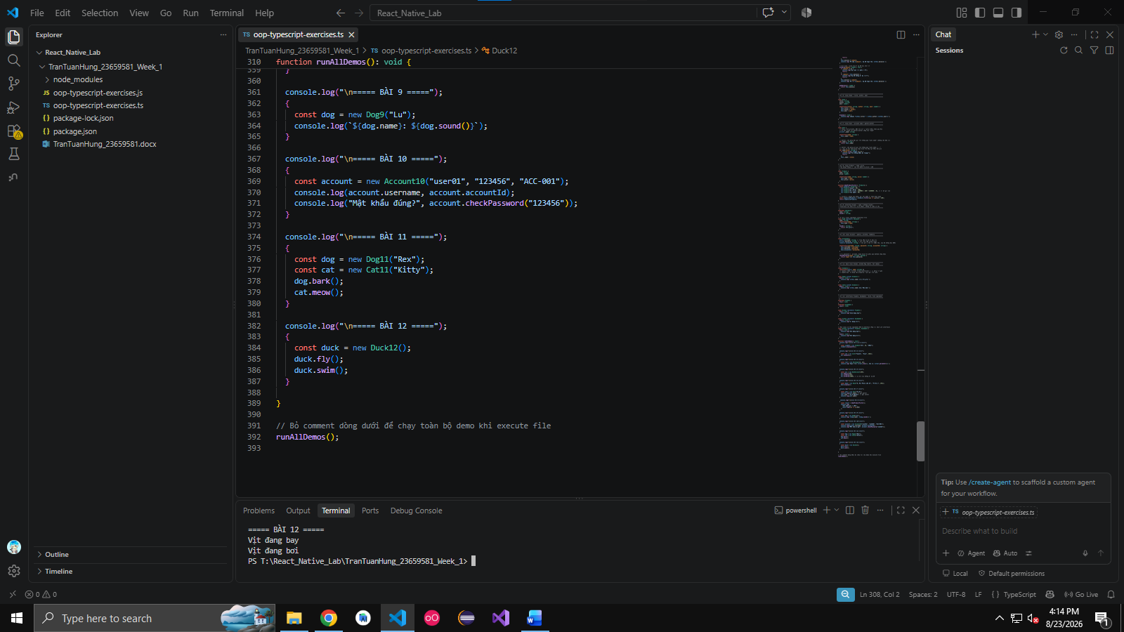

Câu 13. Create an abstract class Shape with method area(). Implement Square and Circle.

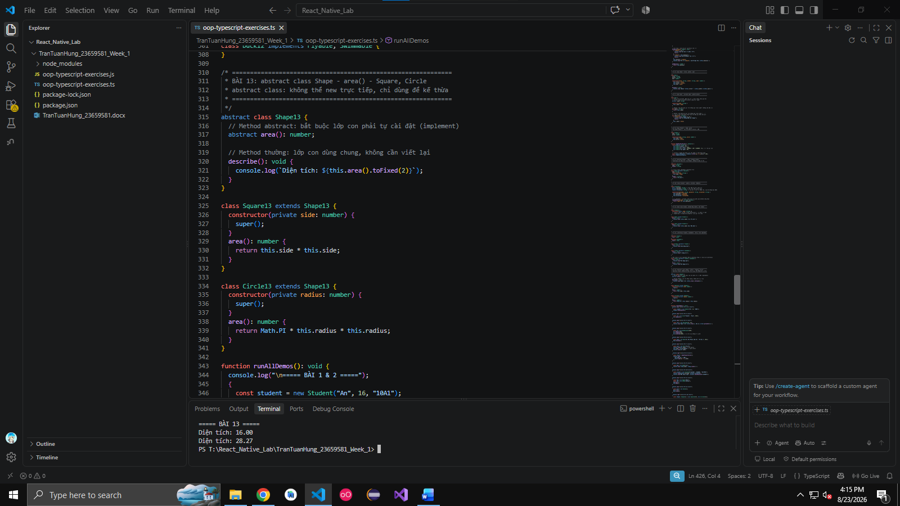

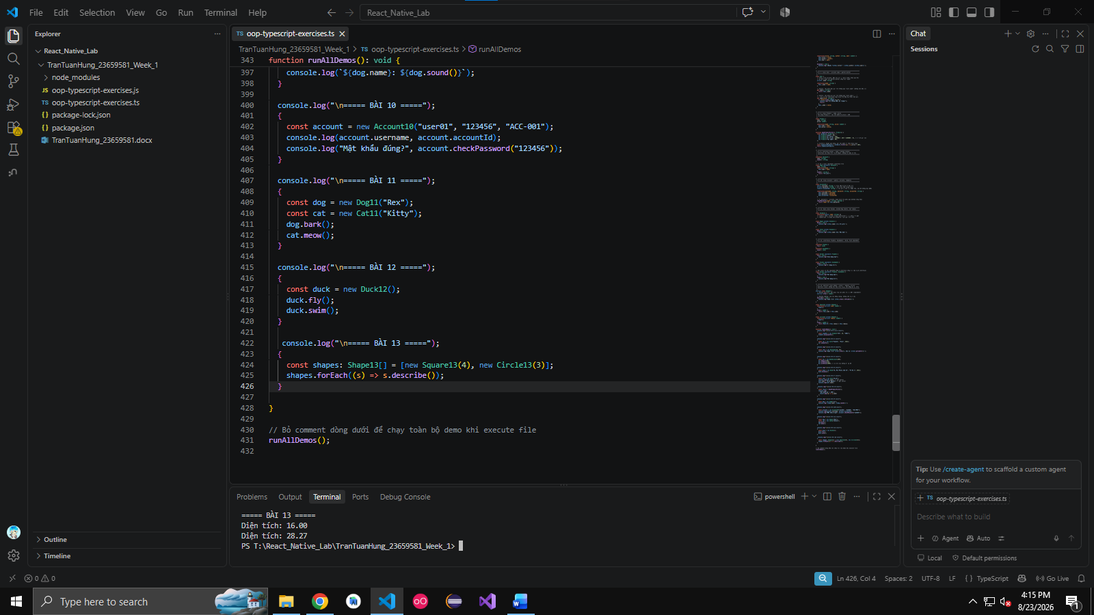

Câu 14. Create a base class Employee. Extend Manager and Developer with specific methods.

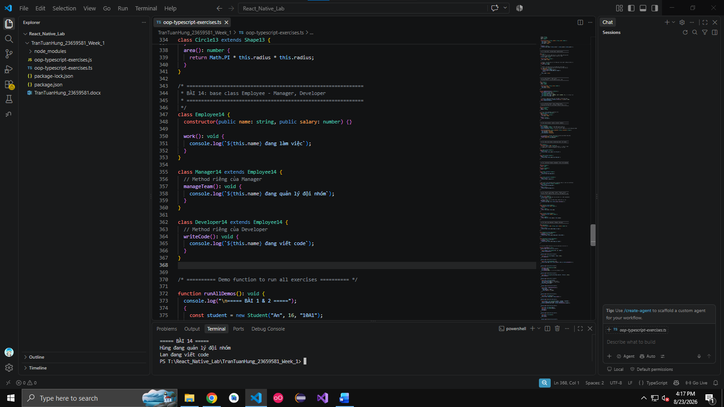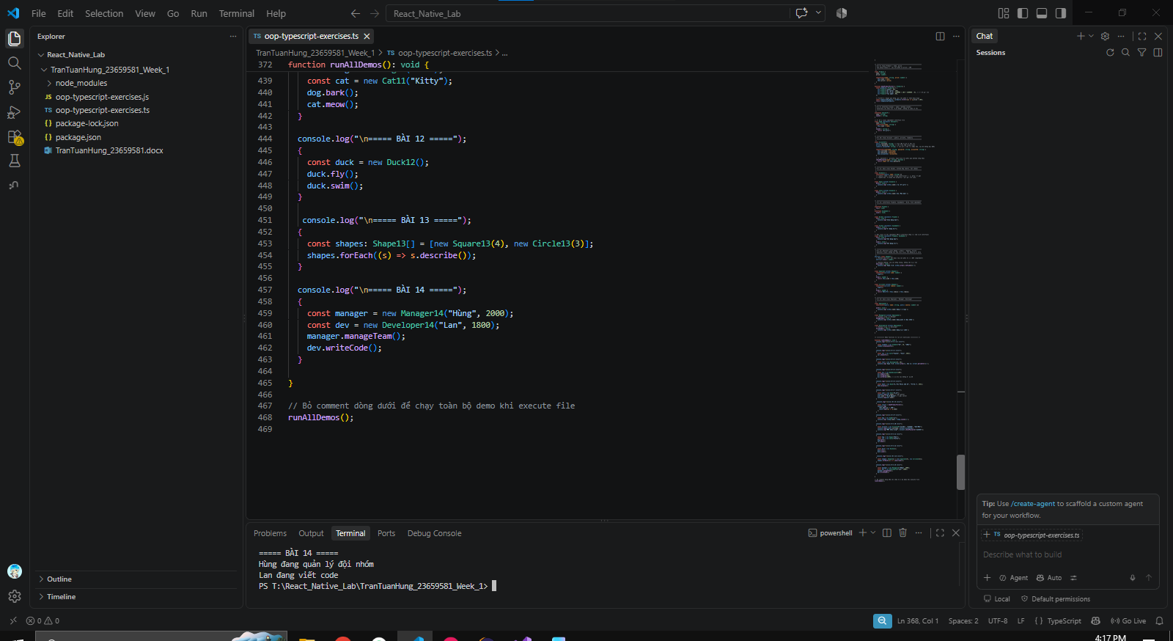

Câu 15. Create a Library class that can store Book and User objects. Add method to add books.

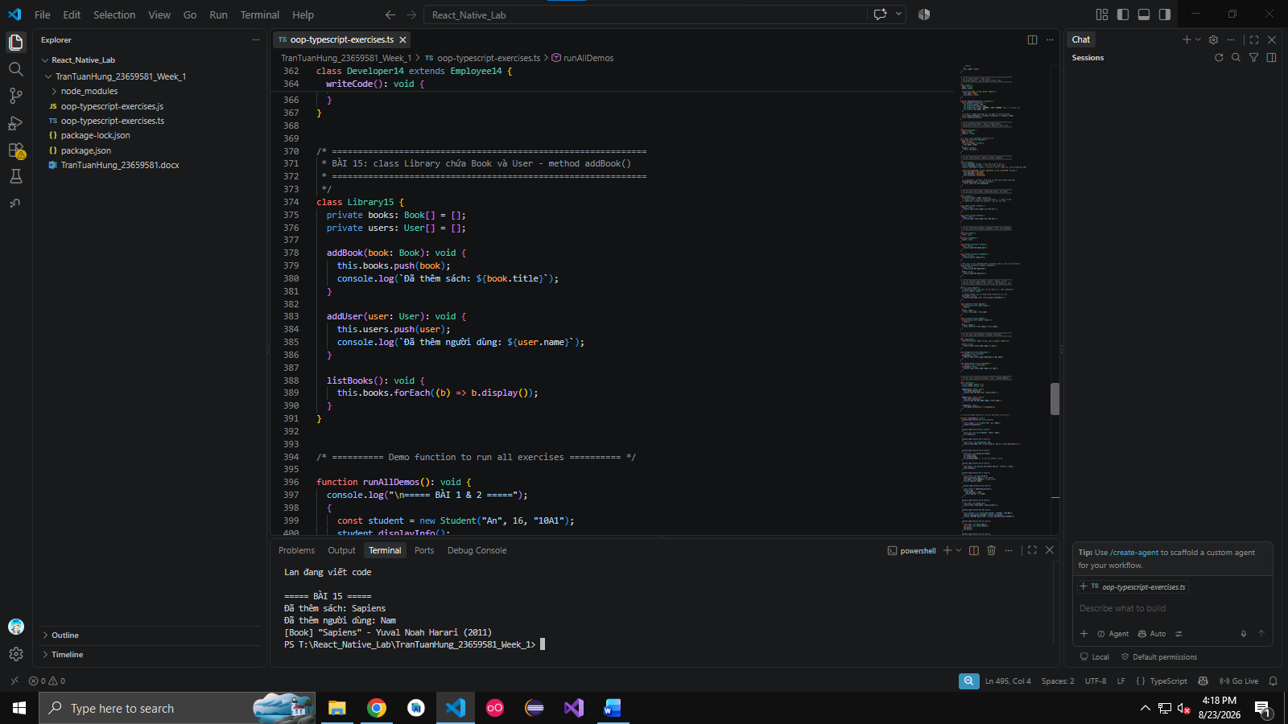

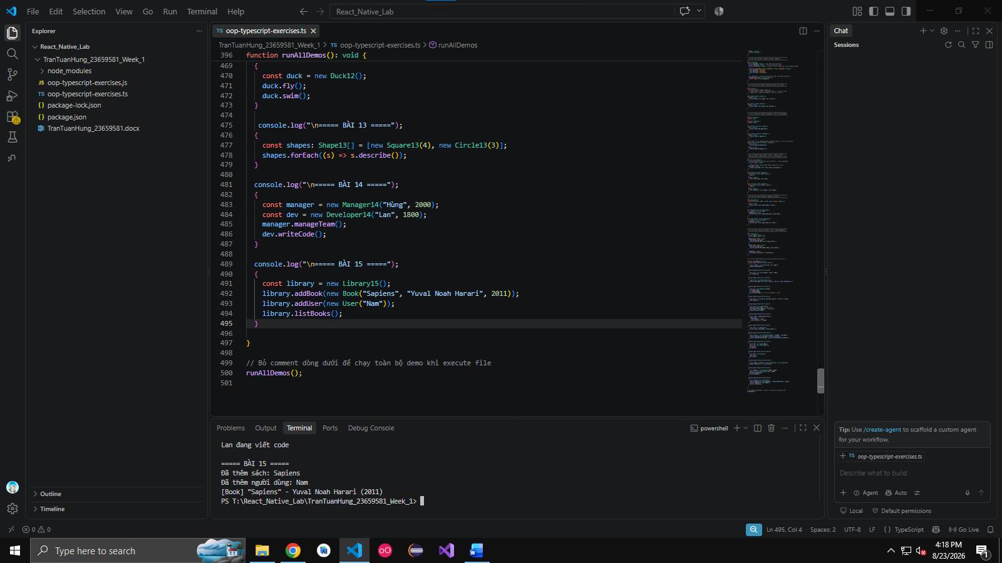

Câu 16. Create a generic class Box that can store any type of value.

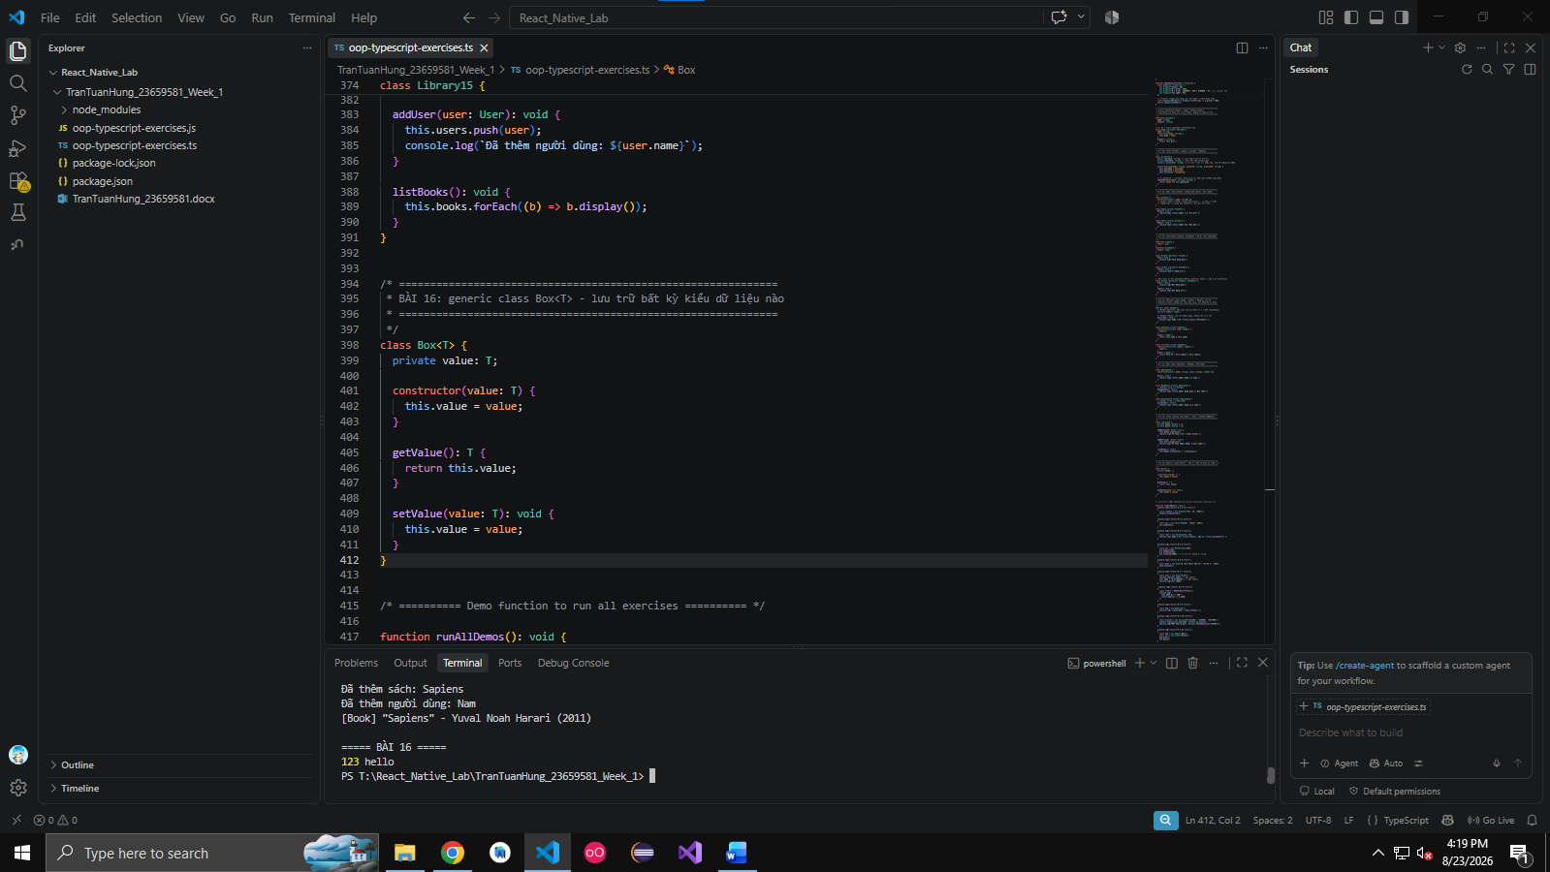

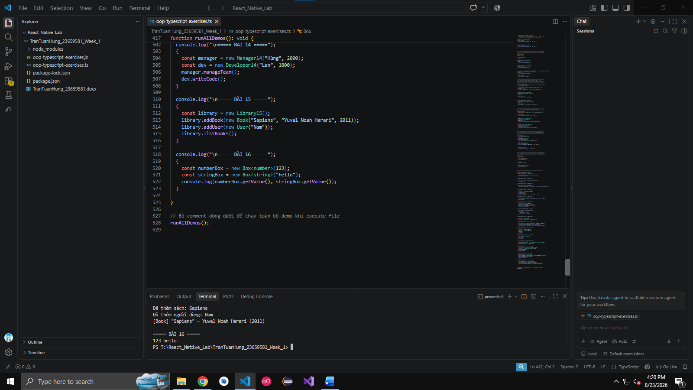

Câu 17. Write a singleton Logger class that logs messages to console.
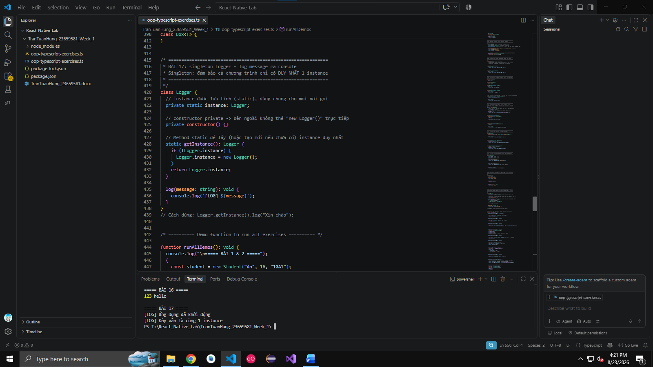
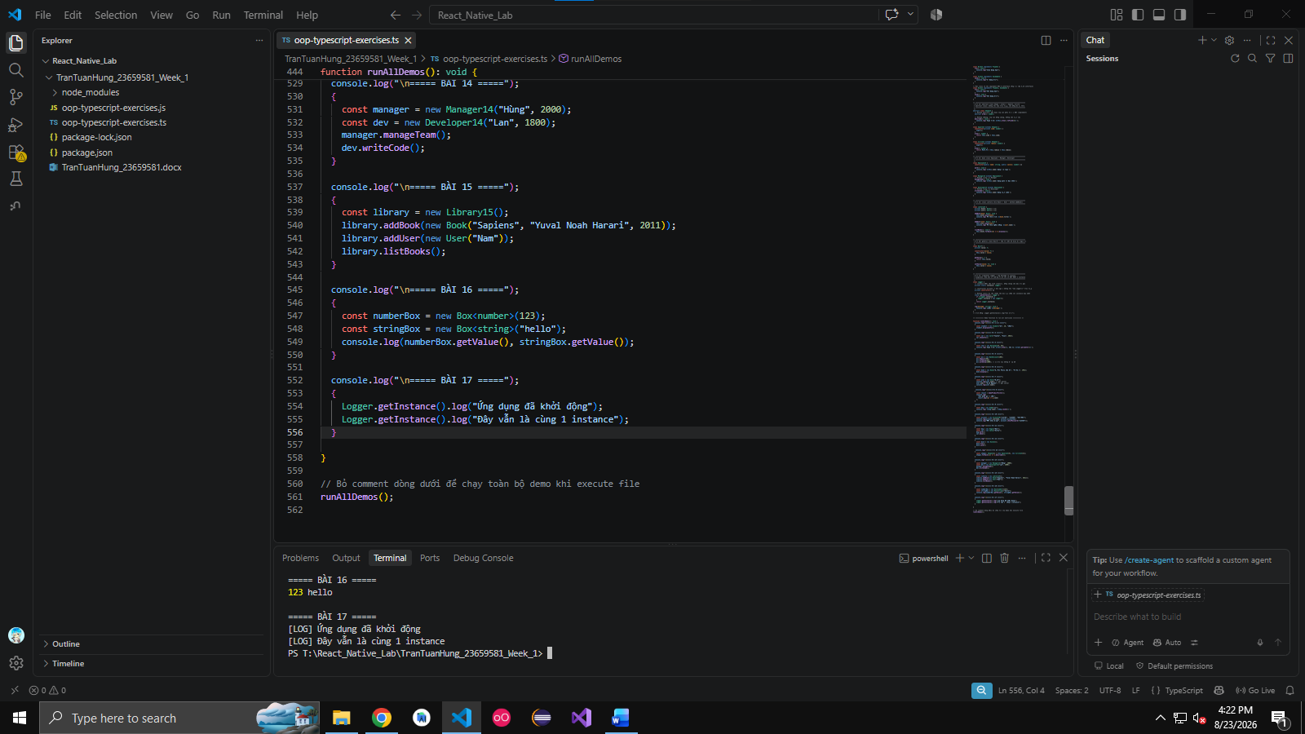

Câu 18. Create a static class MathUtil with methods add(), subtract(), multiply(), divide().

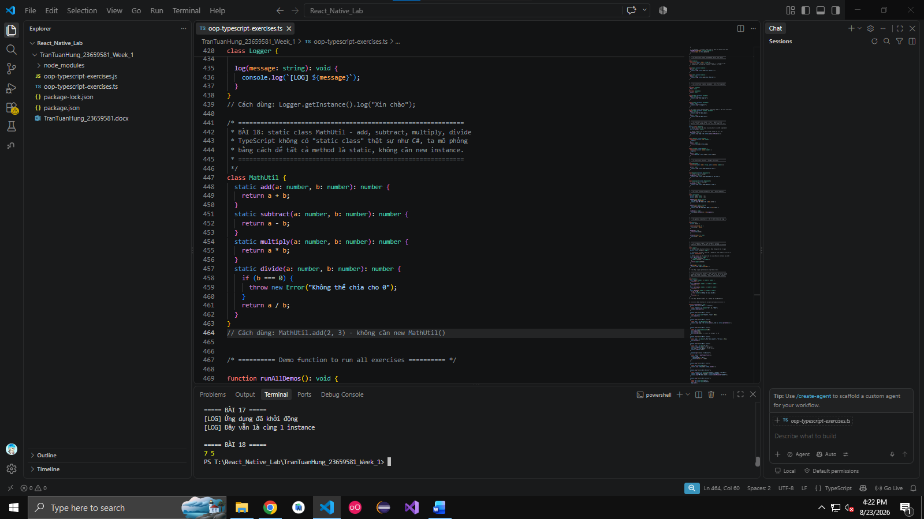
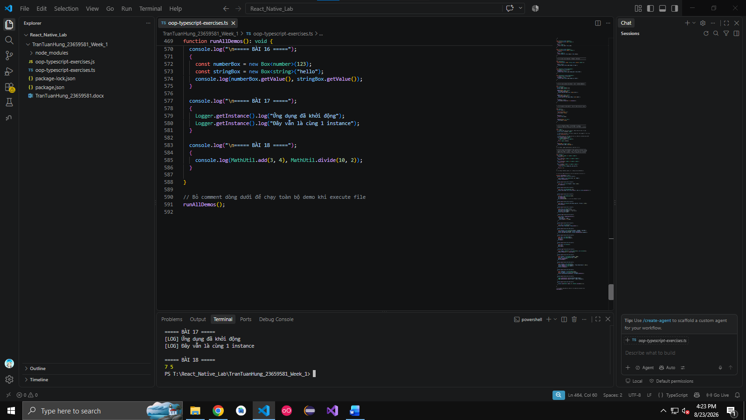

Câu 19. Demonstrate method overriding using polymorphism with Animal and subclasses.
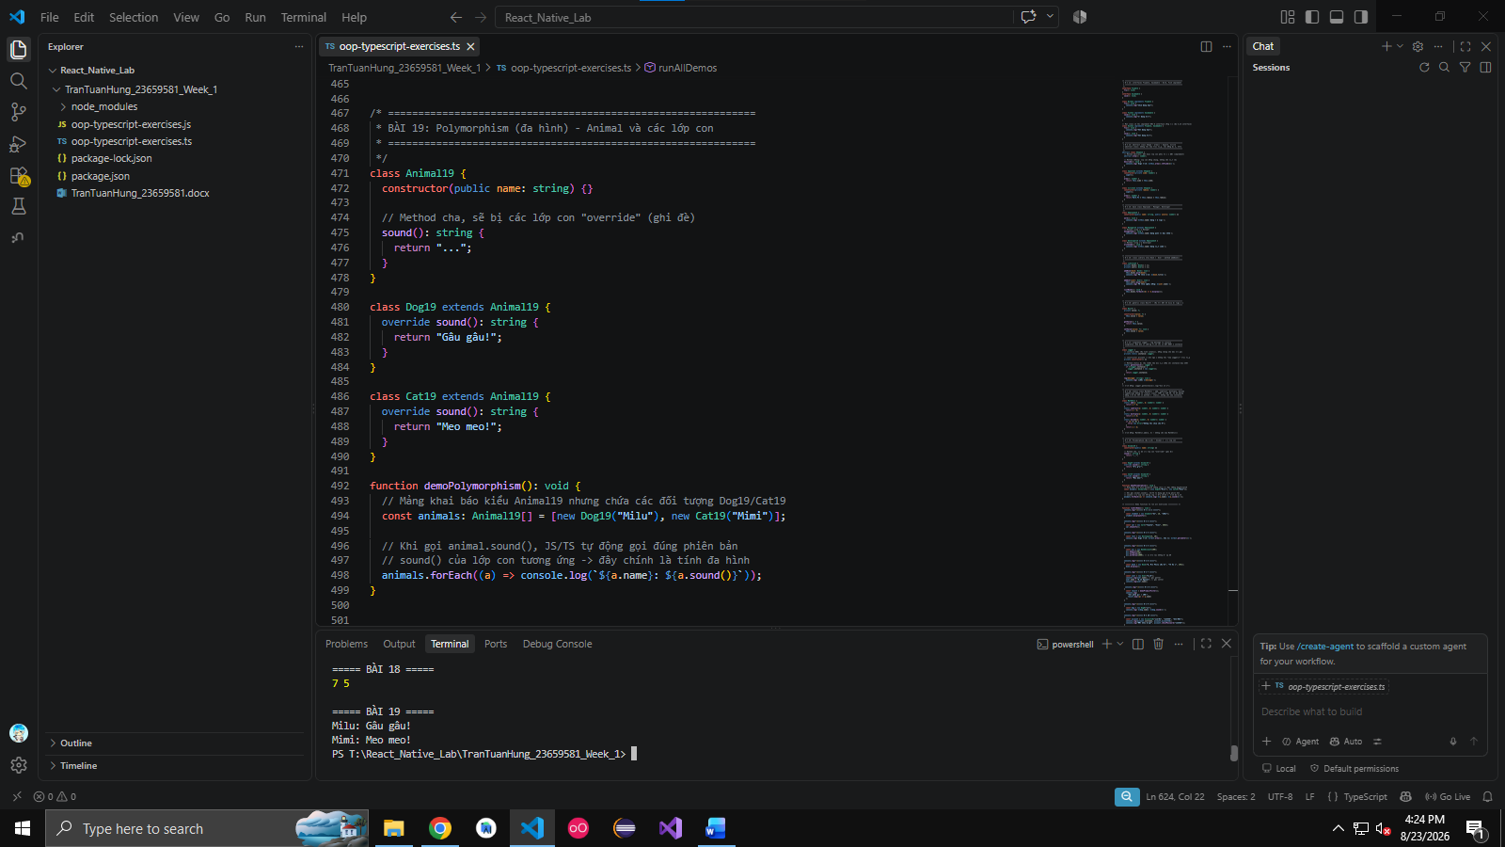
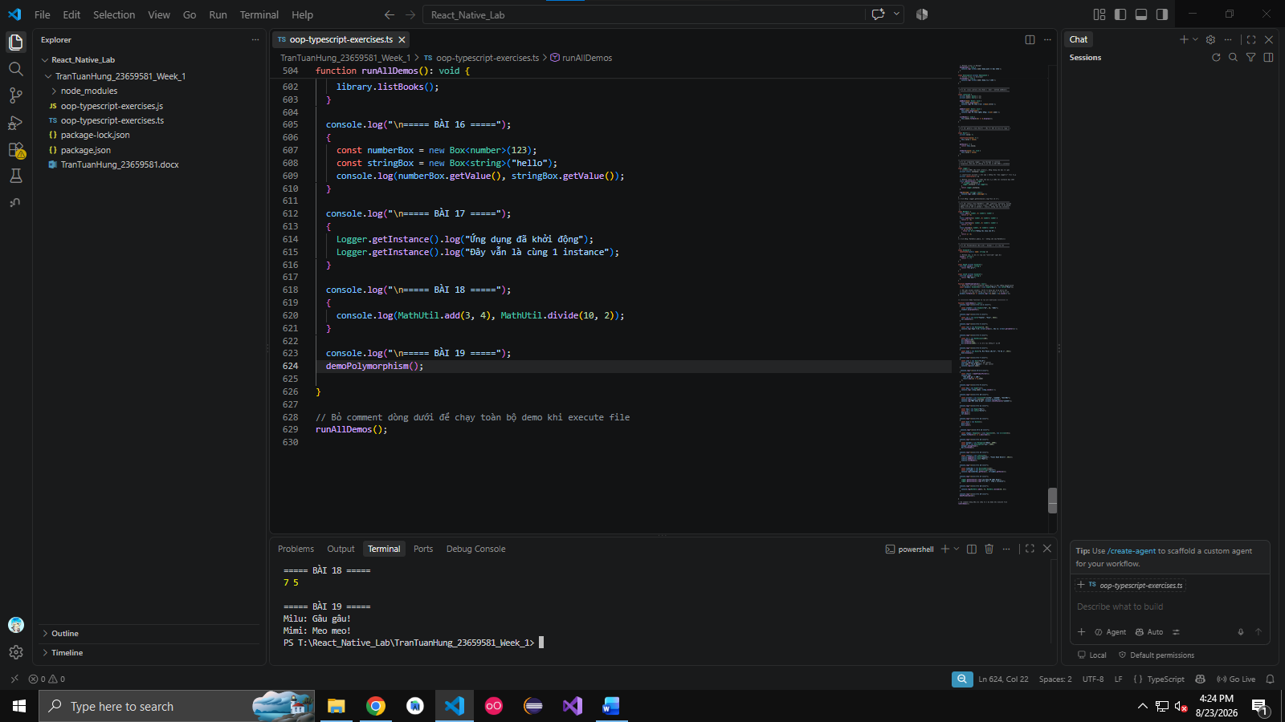

Câu 20. Write a Vehicle interface and implement it in Car and Bike classes.
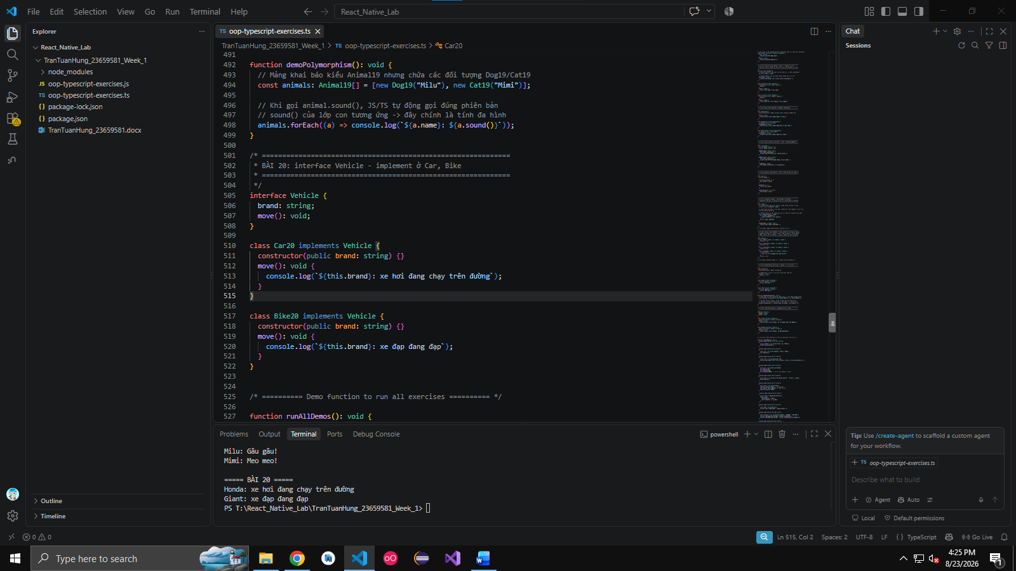

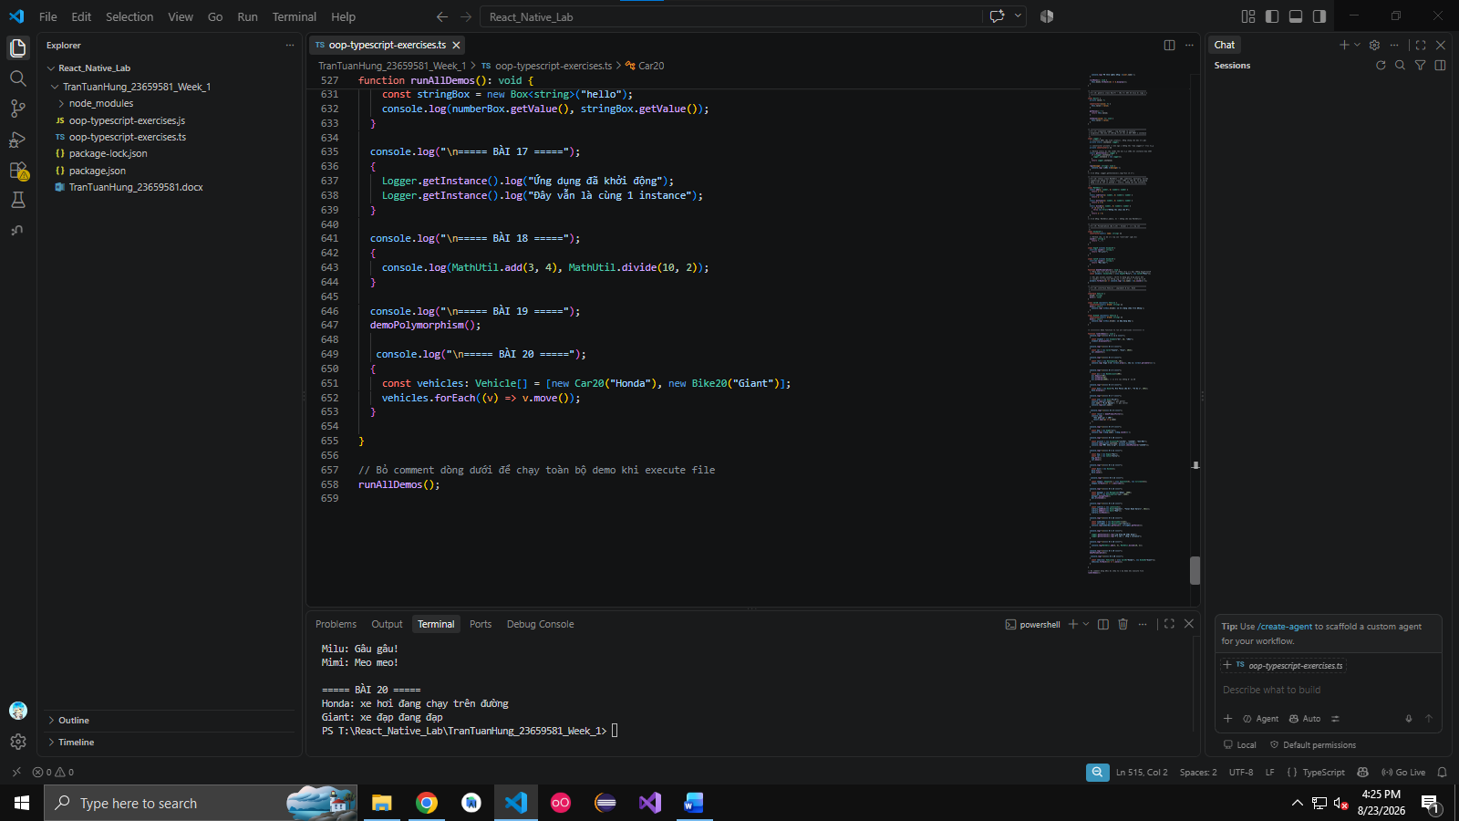

Câu 21. Create a generic Repository class with methods add(), getAll().

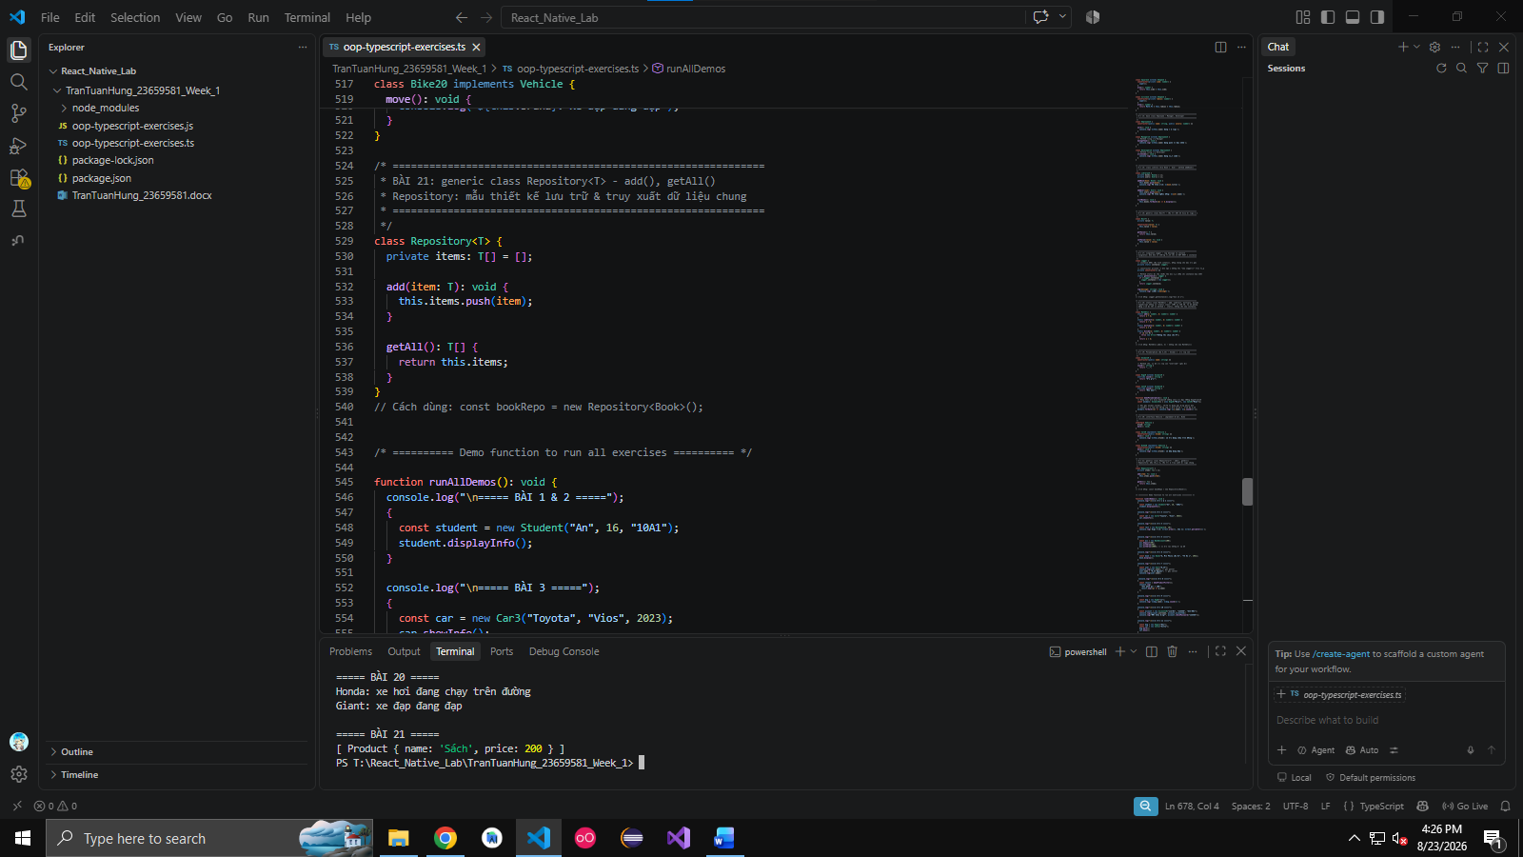
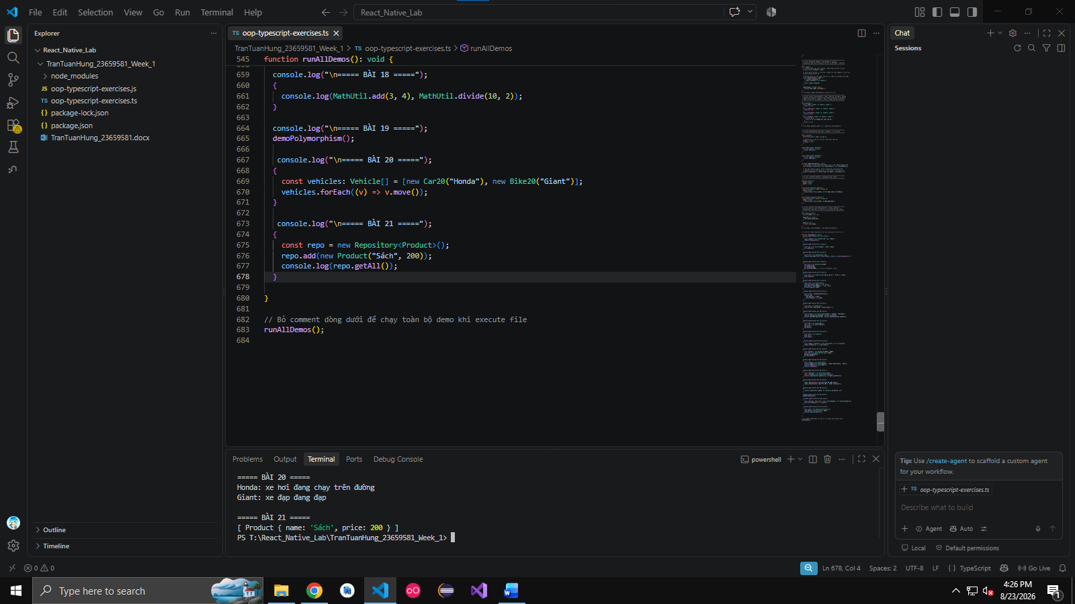

Câu 22. Create a class Stack with push, pop, peek, isEmpty methods.
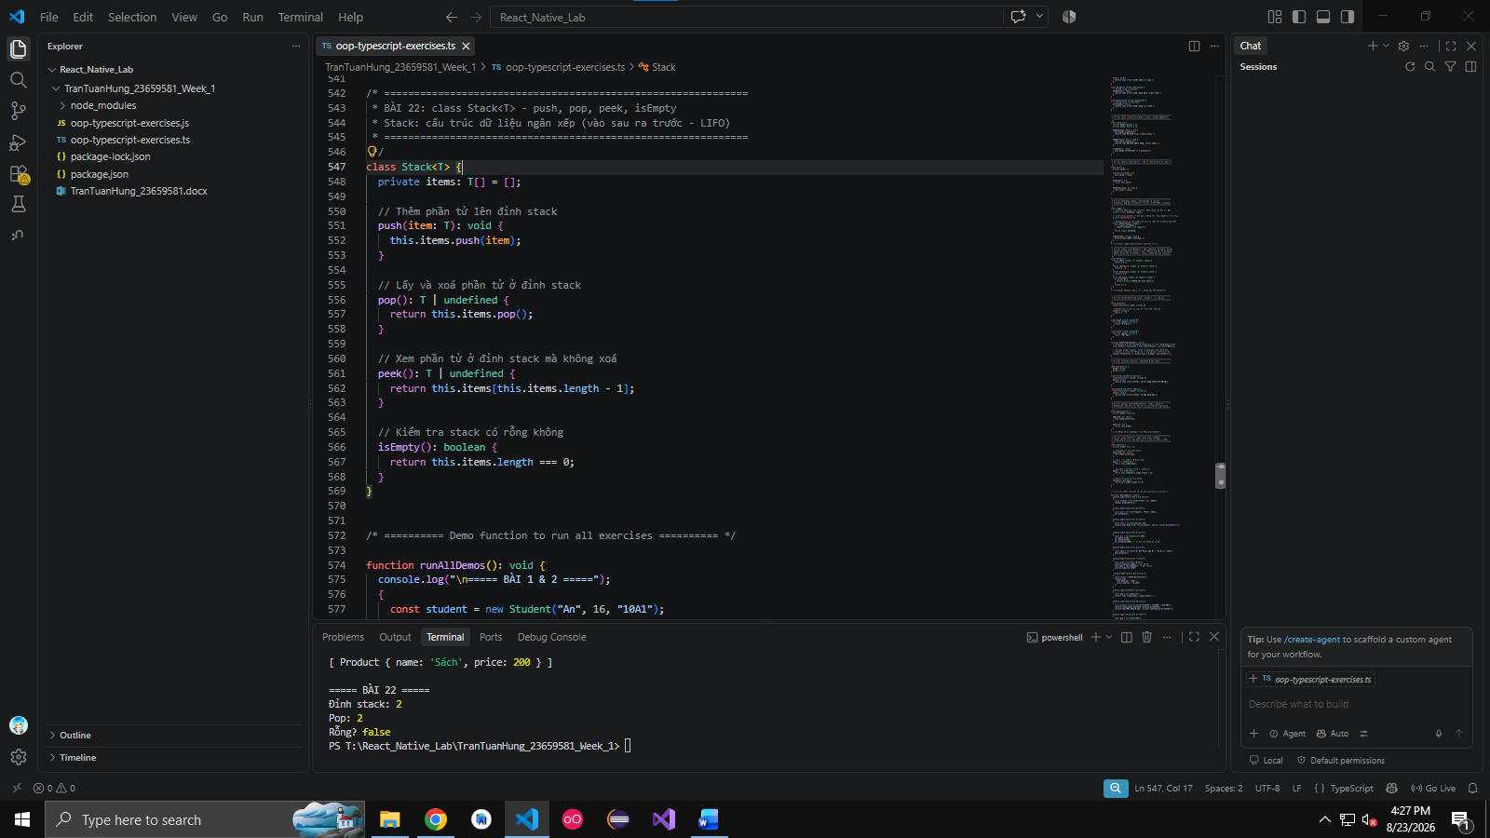
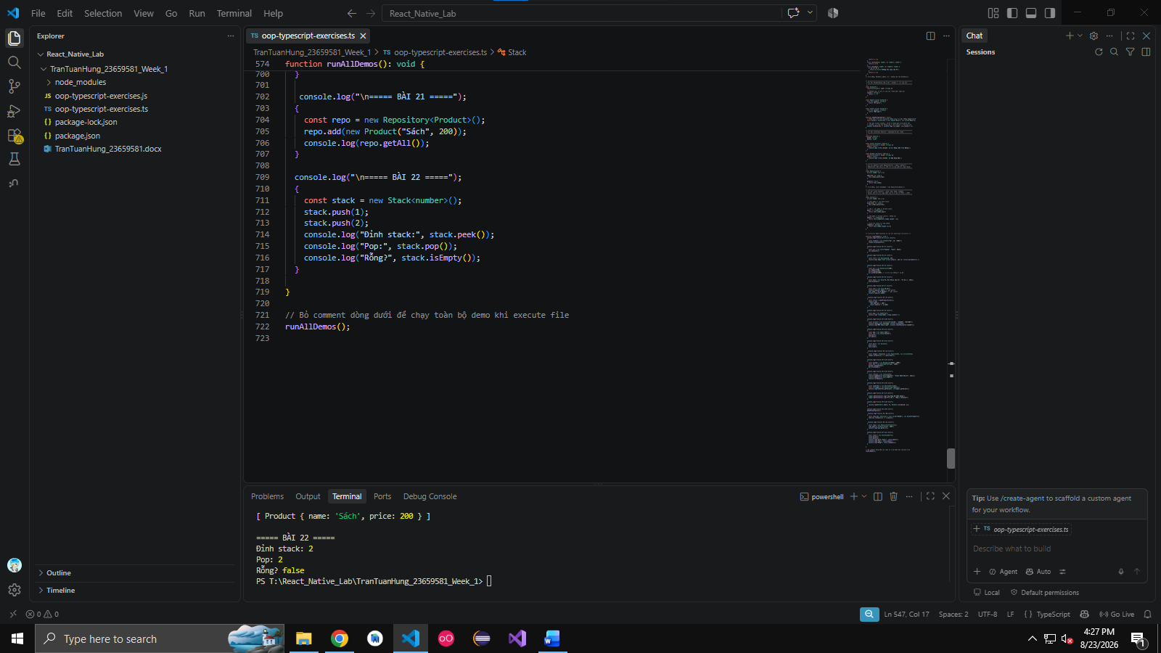

Câu 23. Create an interface Payment with method pay(amount). Implement CashPayment and CardPayment.

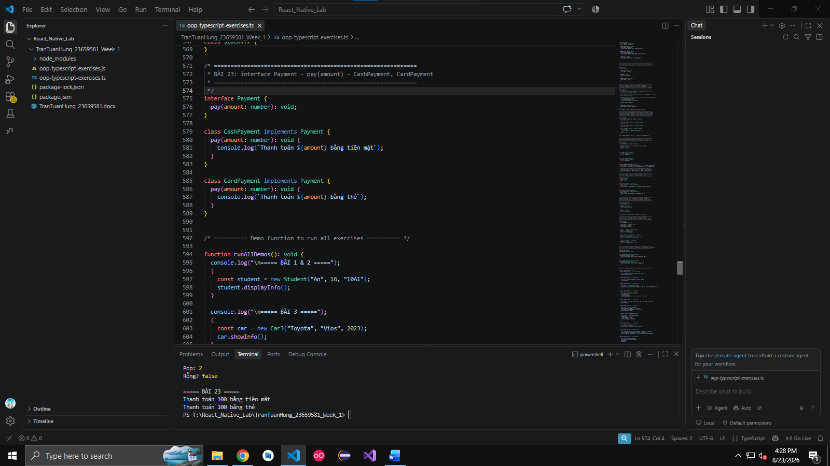

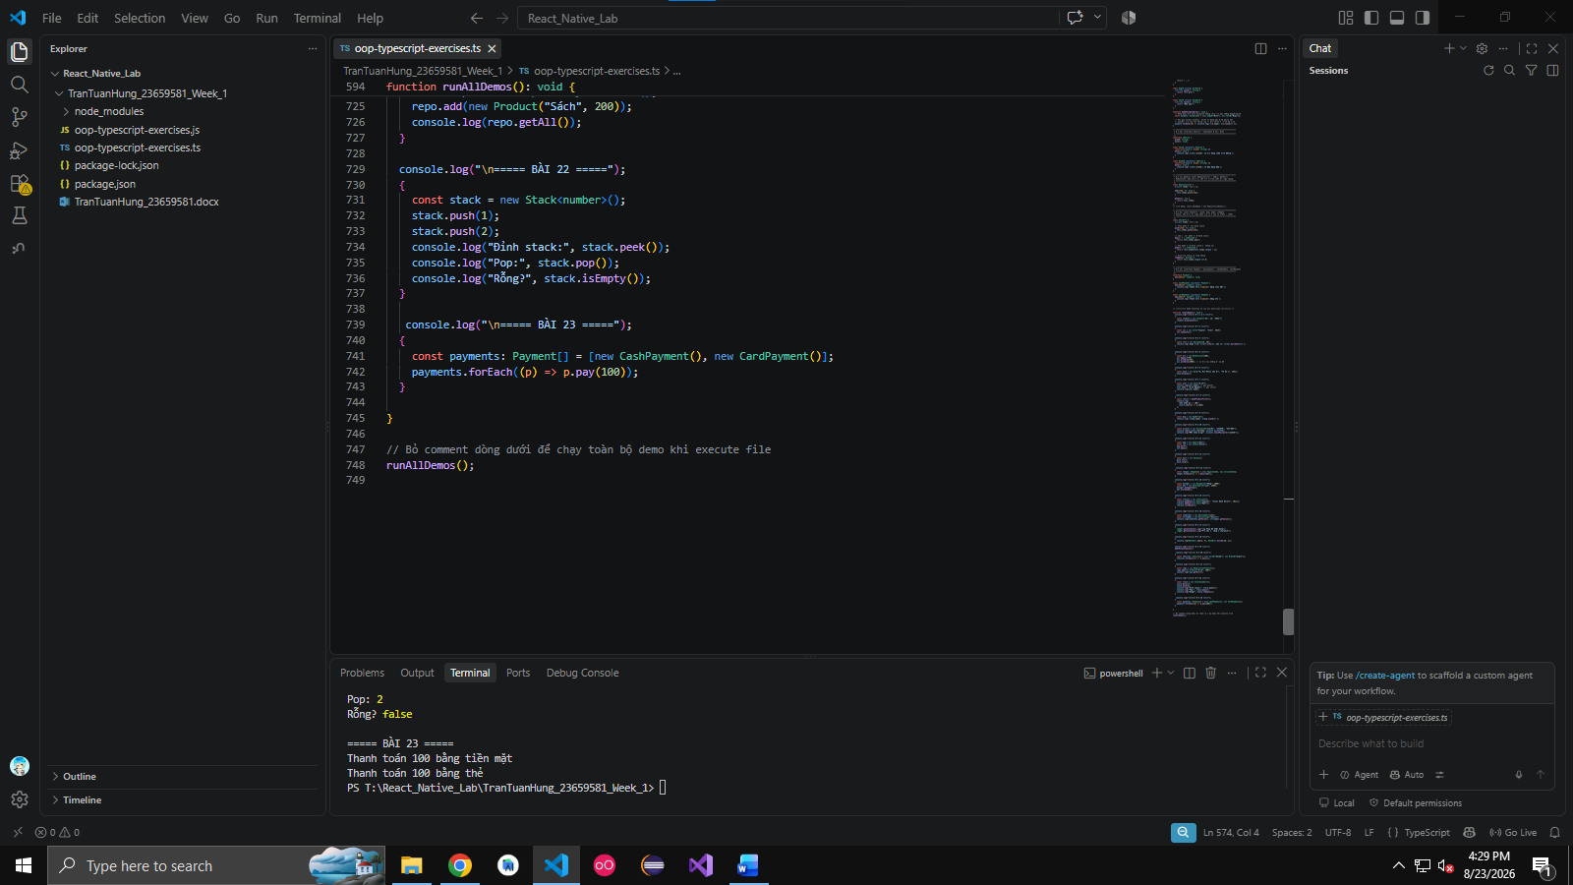

Câu 24. Create an abstract class Appliance with method turnOn(). Implement Fan and AirConditioner.
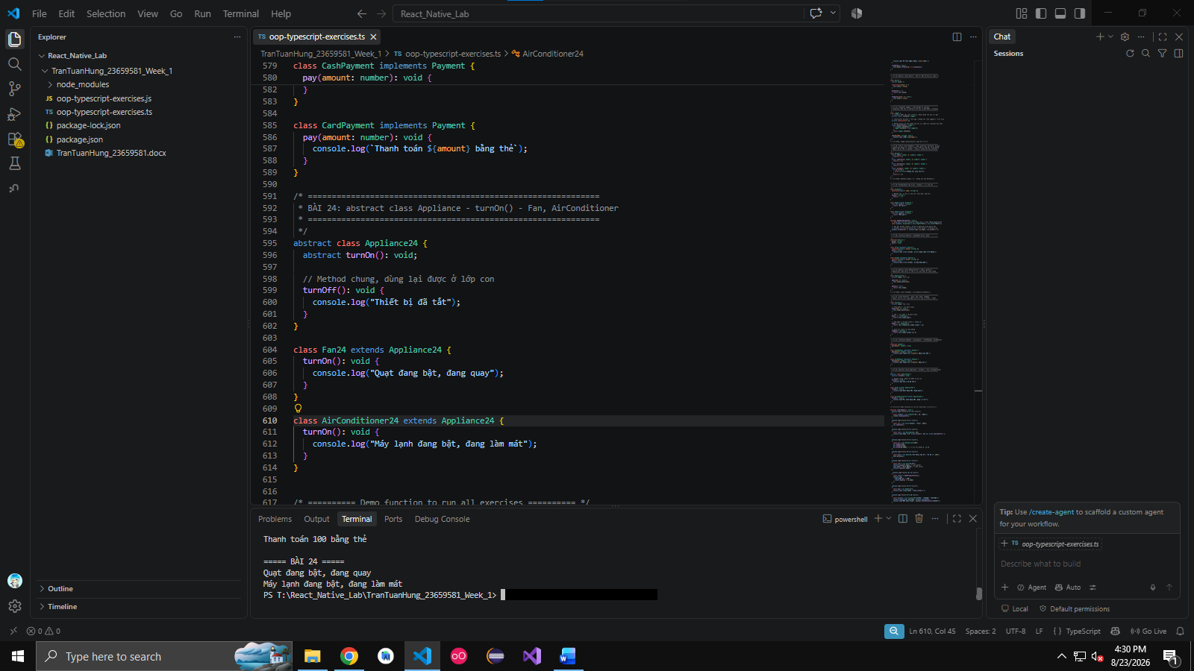

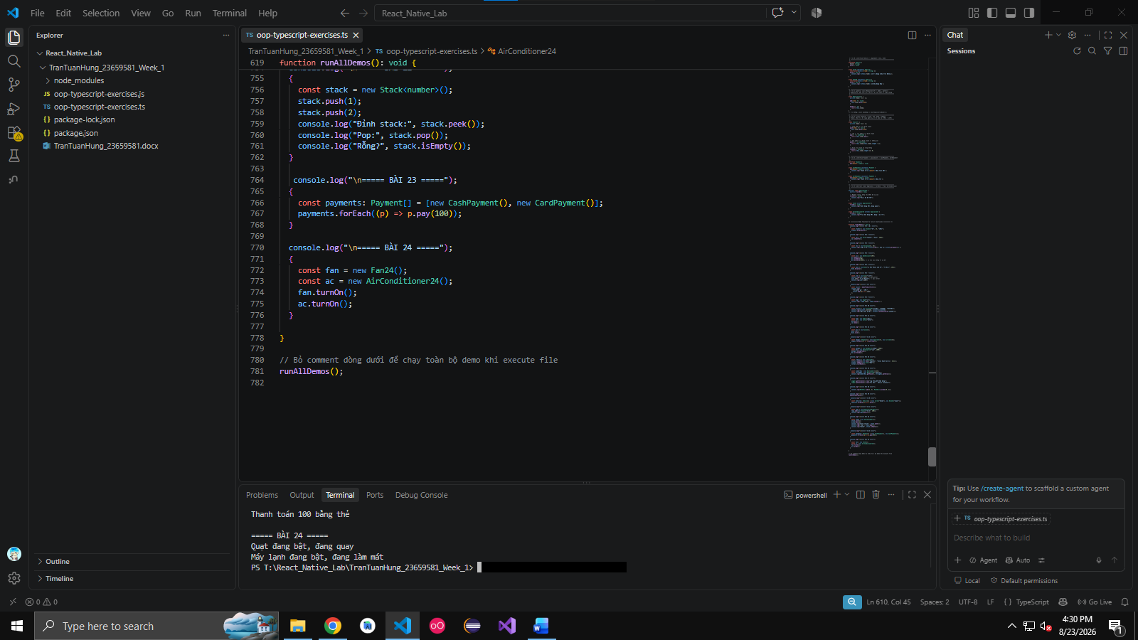

Câu 25. Create a class Shape with a static method describe().
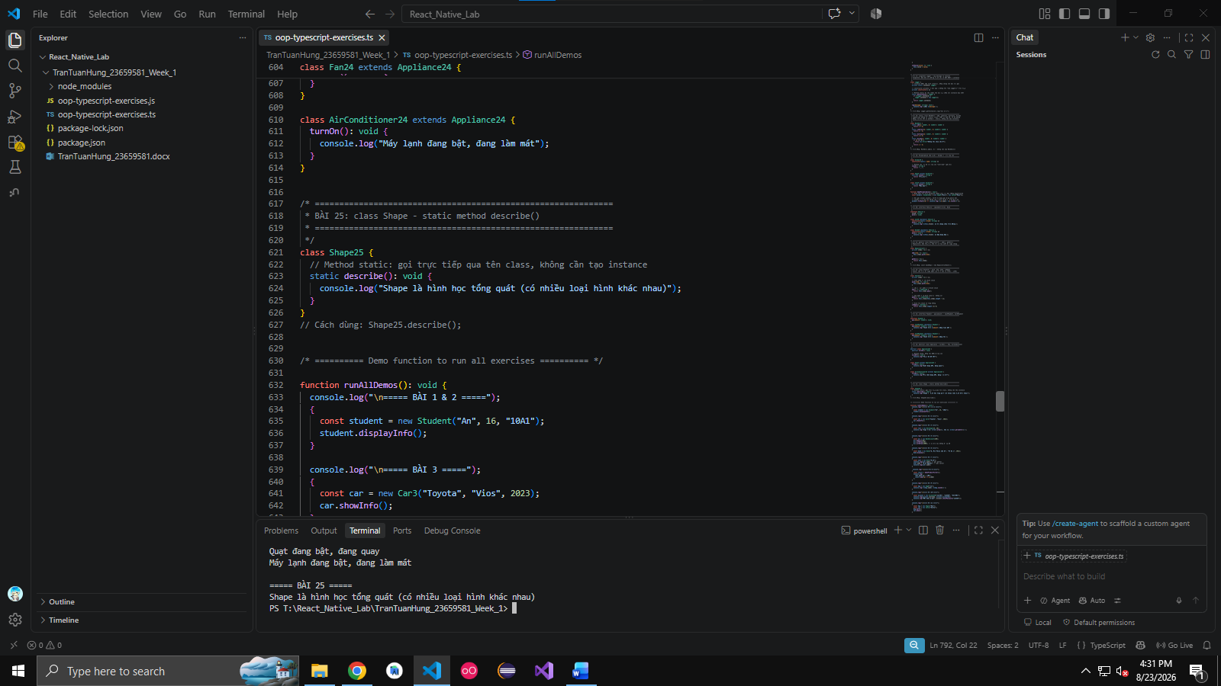
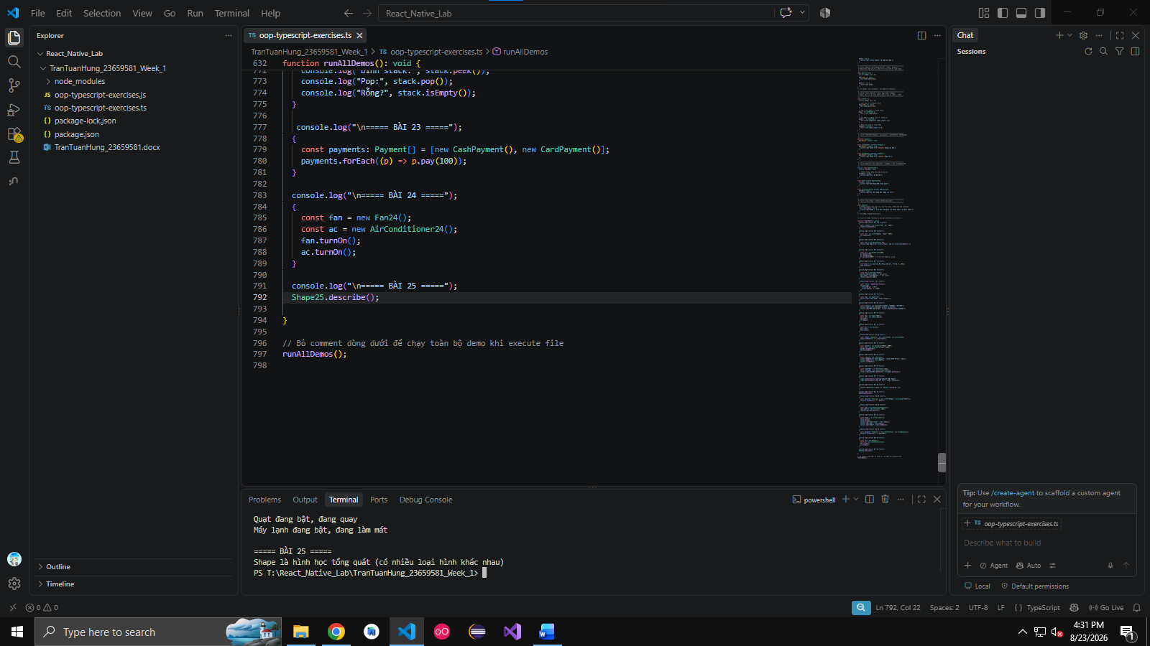

Câu 26. Create a class Order with list of products. Add method to calculate total price.
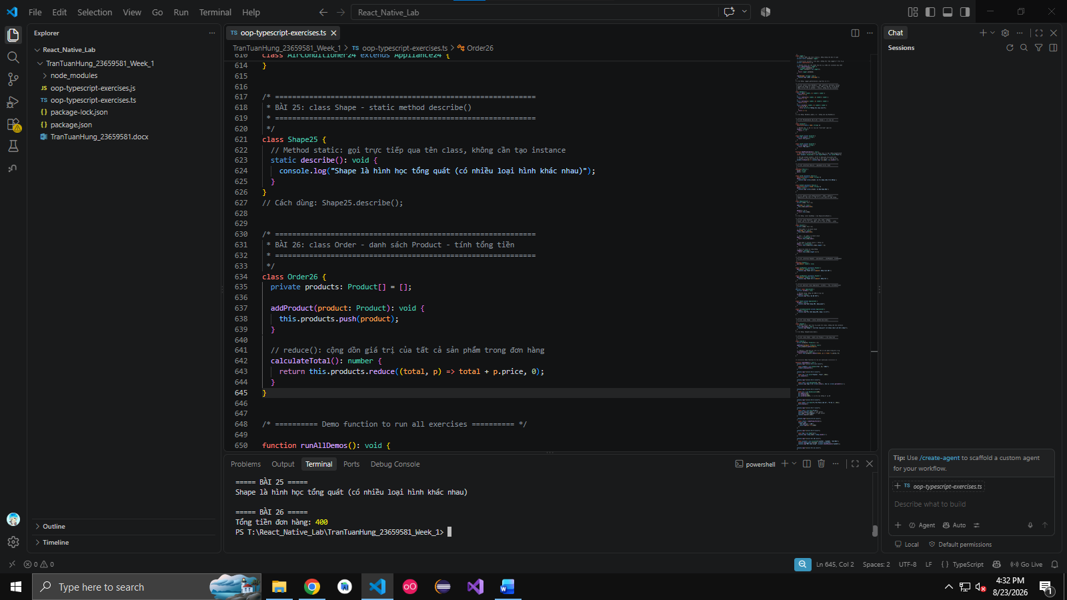
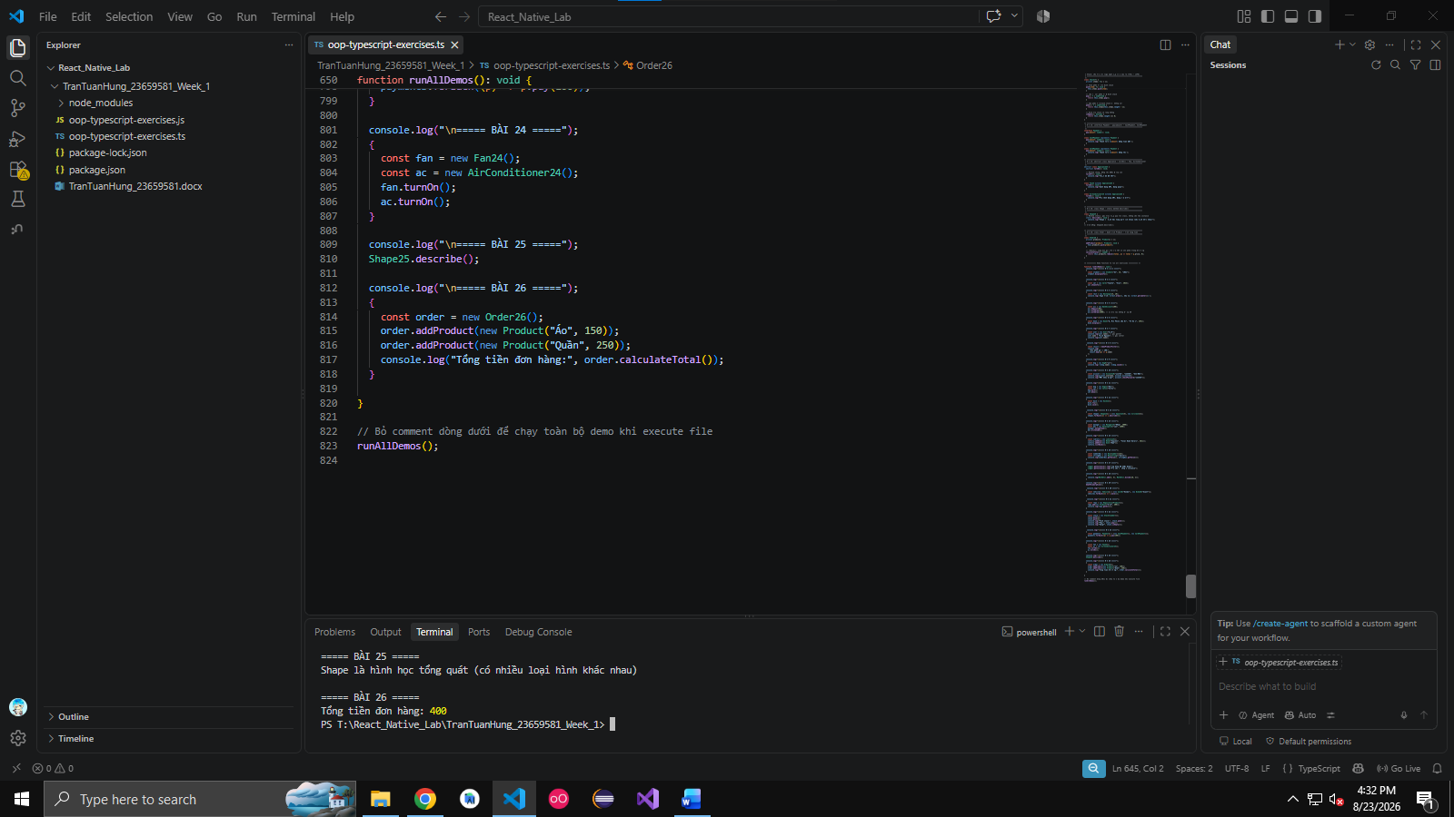

Câu 27. Create a class Teacher that extends Person. Add subject attribute and introduce method.
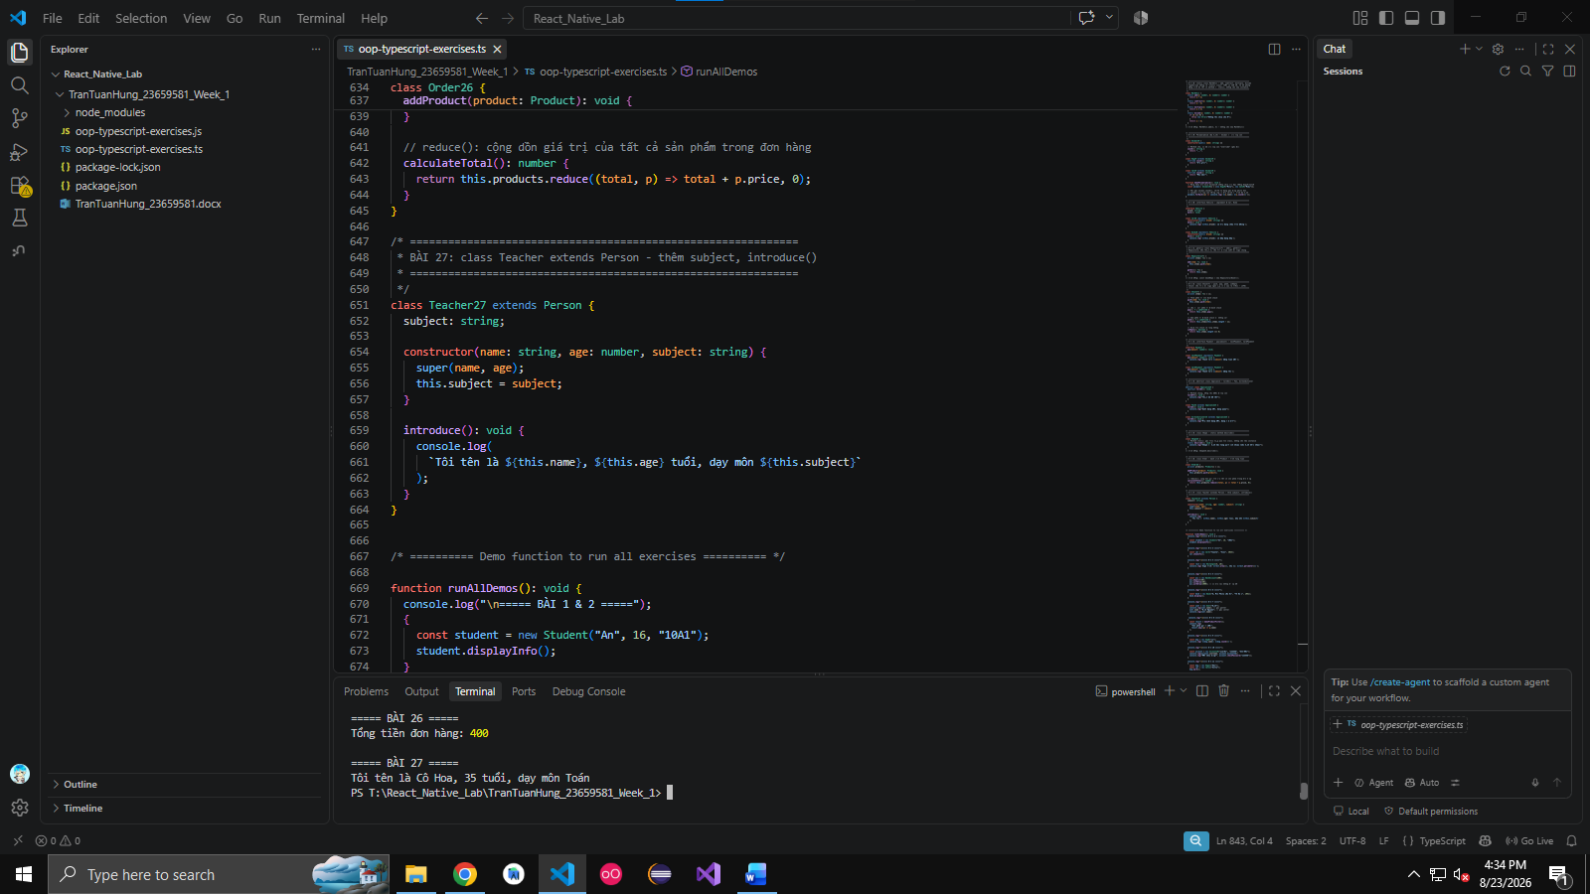

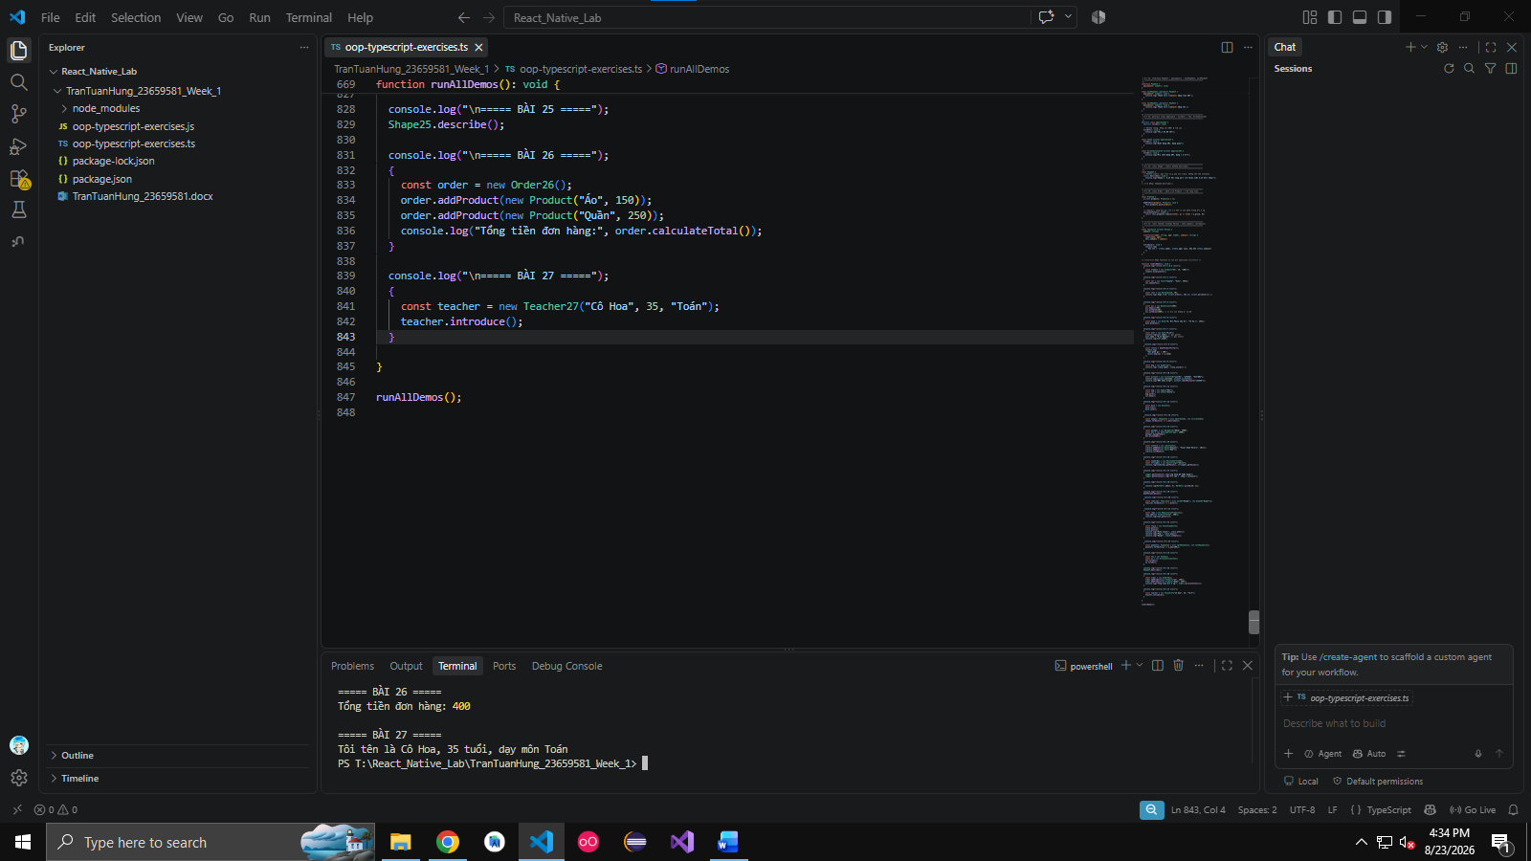

Câu 28. Create a class Animal with protected method makeSound(). Extend Dog and Cat to override it.
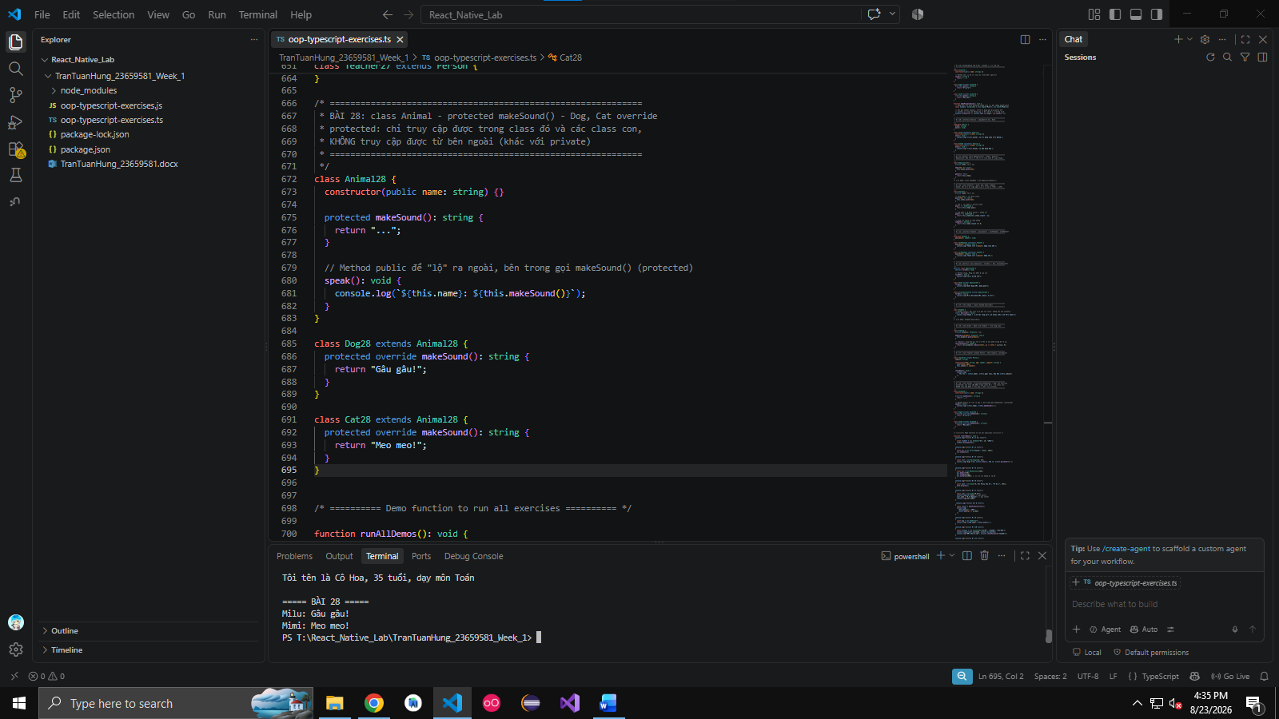
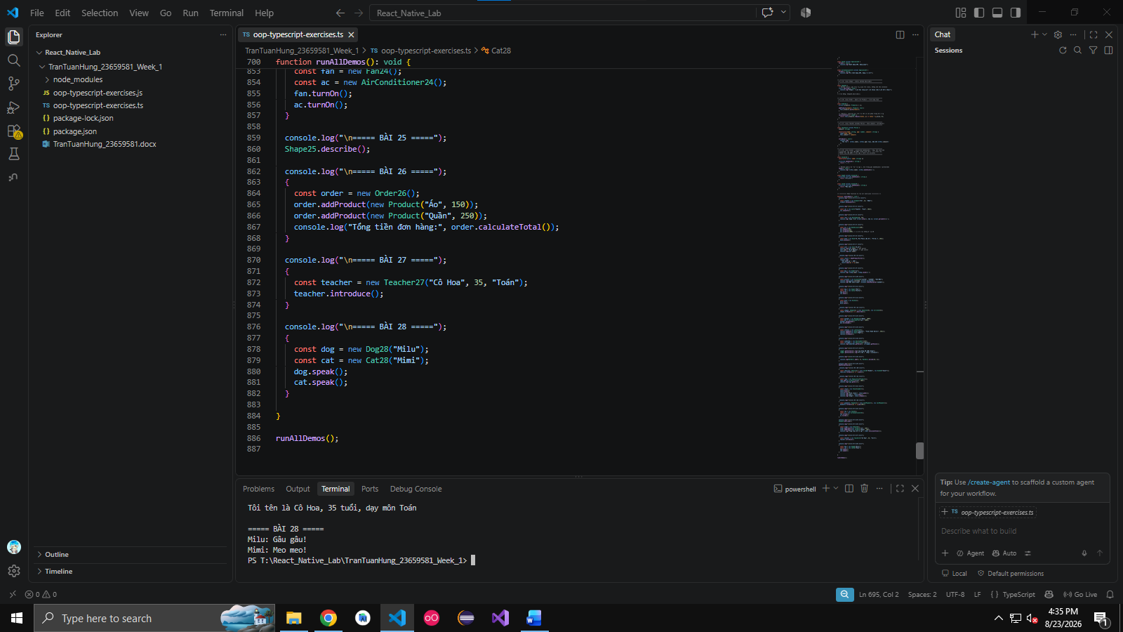

Câu 29. Create an interface Movable with method move(). Implement it in Car and Robot.

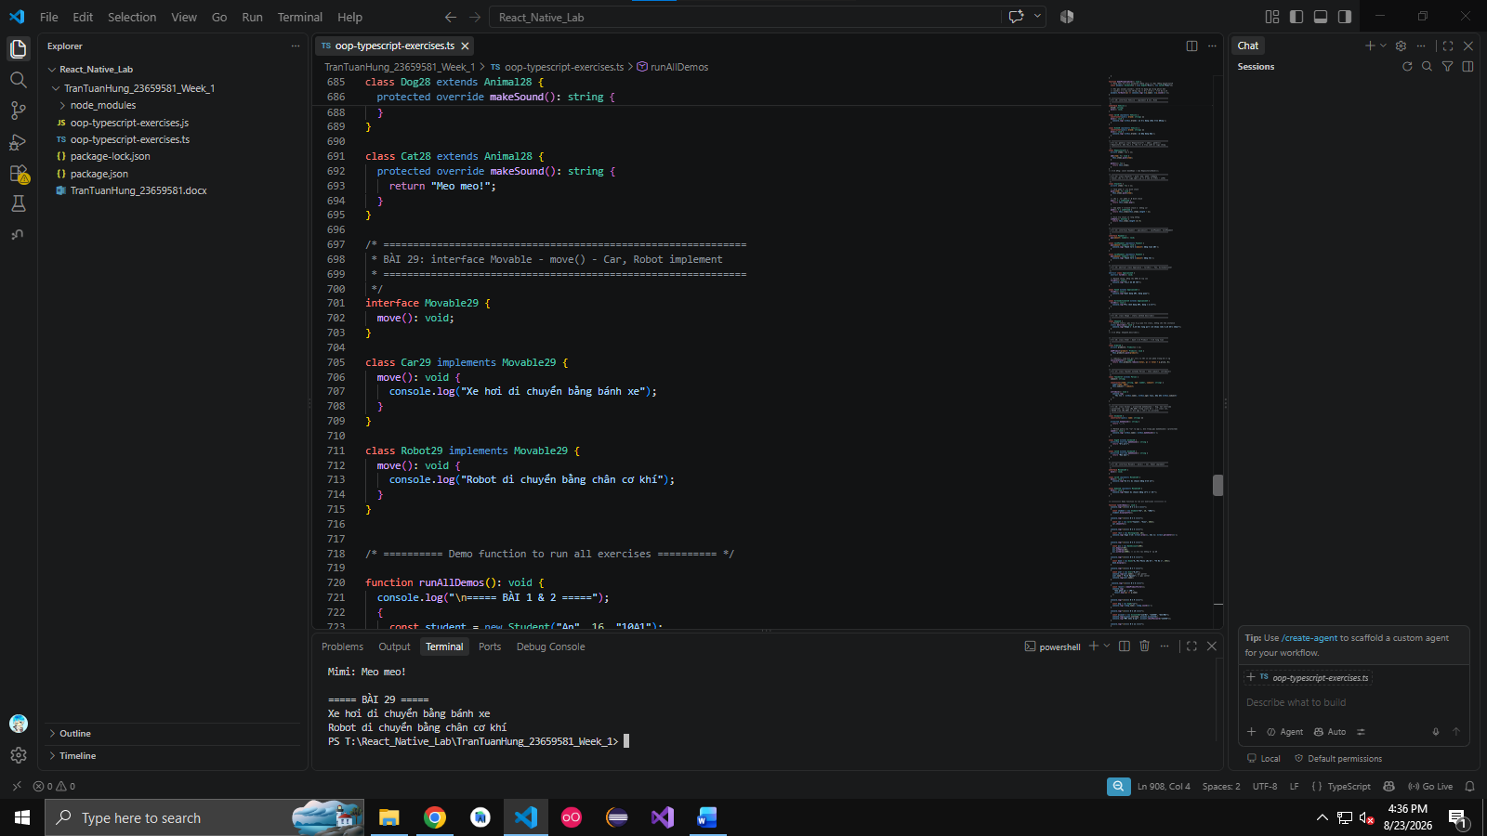
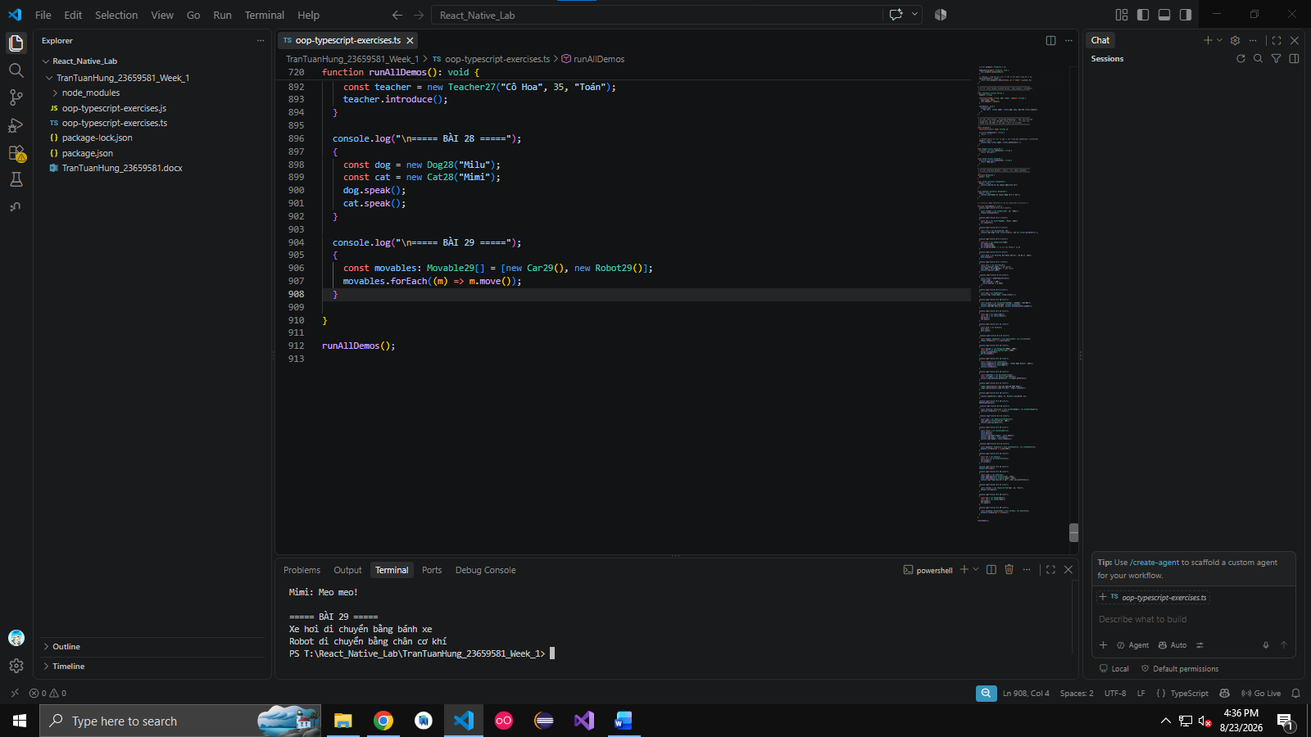

Câu 30. Create a class School with list of Students and Teachers. Add method to display info.
