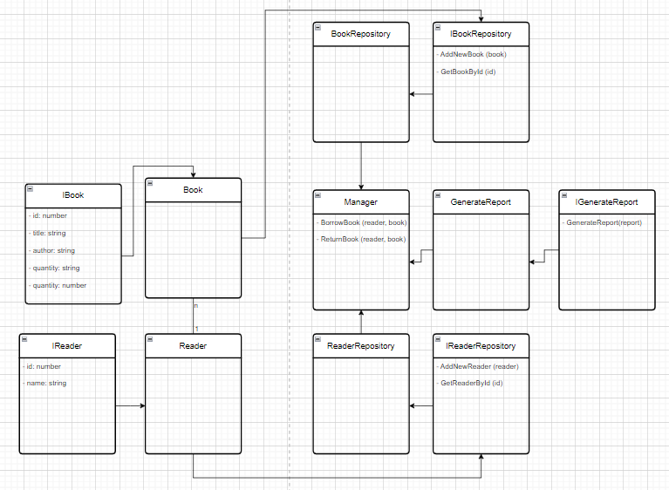
Entities
- Book: Represents a book in the library.
- Reader: Represents a library reader.
Interfaces (Abstraction Layer)
- IBook: Defines the data structure for books.
- IReader: Defines the data structure for readers.
- IBookRepository: Defines methods for interacting with book data.
- IReaderRepository: Defines methods for interacting with reader data.
- IGenerateReport: Defines methods for generating reports.
Repositories (Data Access Layer)
- BookRepository: Implements IBookRepository, manages book data.
- ReaderRepository: Implements IReaderRepository, manages reader data.
Service/Manager (Business Logic Layer)
- Manager: Handles book borrowing and returning operations.
- GenerateReport: Responsible for generating reports based on IGenerateReport.
Applying SOLID Principles
- Interface Segregation: Interfaces are small and separated based on functionality.
- Dependency Inversion: The Manager class does not directly depend on repositories but interacts through interfaces.

