Singleton Pattern: only 1 database is created throughout the application
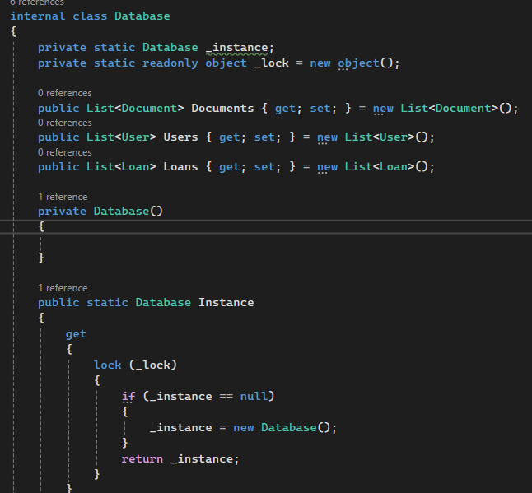
Factory Method Pattern: involves creating an abstract class Document, and then defining concrete classes like Book, Magazine, and Newspaper, each implementing the abstract method(s) from Document
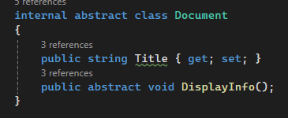
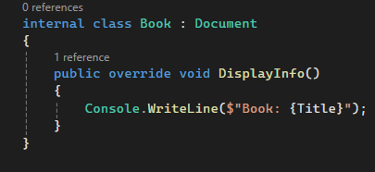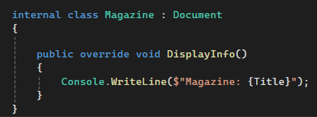
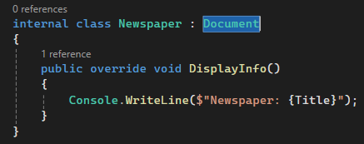
Observer Pattern: involves creating a notification system for each library that is created. Whenever a new library is added, all registered observers should be notified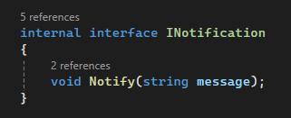
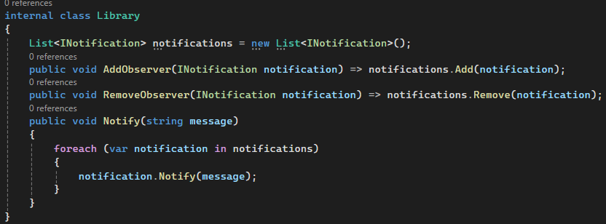
Strategy Pattern: involves defining an interface that shares a function with all its implementing classes. A separate class uses this interface to access the function, which was declared earlier. This allows dynamic selection of different behaviors at runtime.