Reflection: used to inspect and manipulate objects, and types at runtime
Expression Trees represents code in a tree structure and enable dynamic code manipulation
Analyze Redundancy:
3 separate methods but have same patterns: get 2 parameters, log to console
Rewrite:
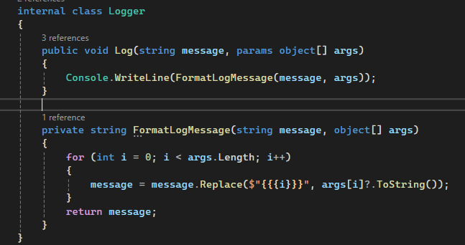

Identify DRY violations:
2 Repositories have same get all format
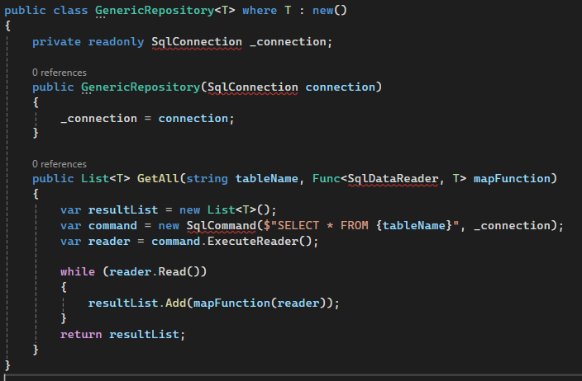

Identify Redundancy:

Rewrite:
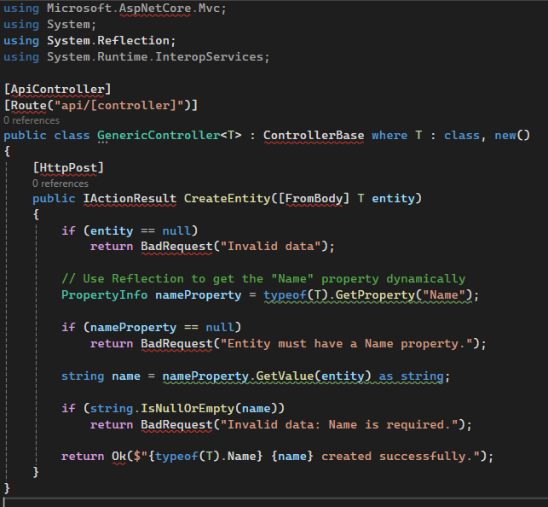

The Strategy Pattern defines a family of algorithms, encapsulates each one, and makes them interchangeable at runtime without modifying the client code.
The Factory Pattern is used to create objects without specifying their concrete class. Instead, a factory method is responsible for object creation based on input parameters.
Identify DRY violations: 3 separate methods but have same patterns: get 1 parameter, log to console
Rewrite:
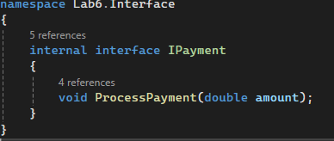
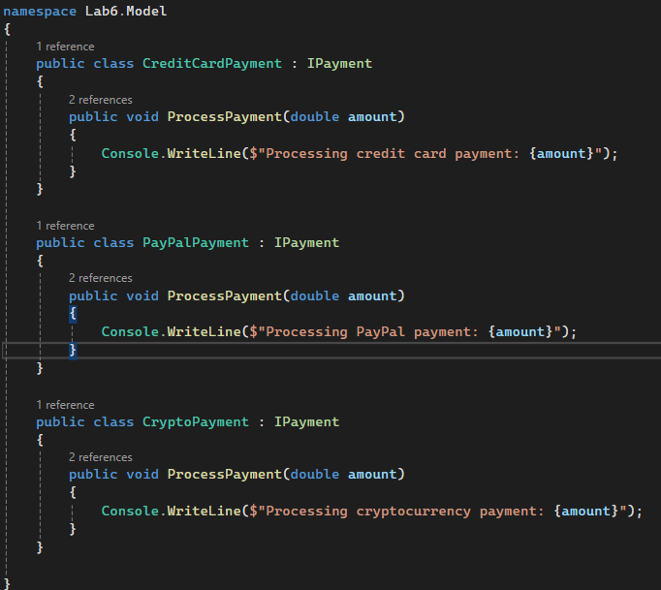
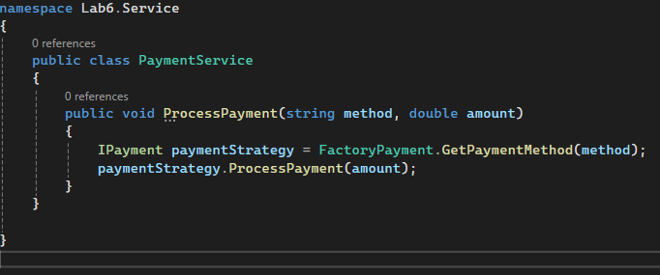
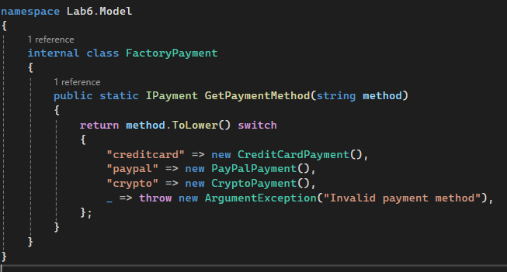

Identify Redundancy: 2 services have get 1 item pattern
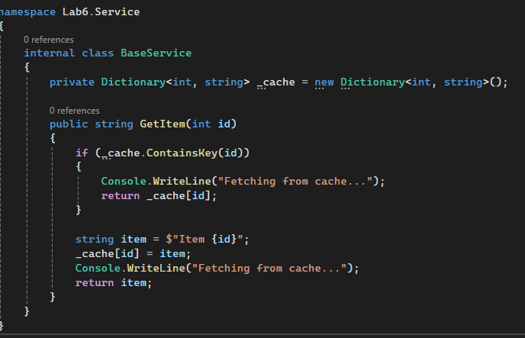

A scalable and maintainable Library Management System in .NET should follow a multi-project architecture with six key projects: Library.Core (domain models and business rules), Library.Infrastructure (data access with EF Core), Library.Application (service layer with DTOs and business logic), Library.API (ASP.NET Core Web API for client interaction), Library.Web (frontend using Blazor, Angular, or React), and Library.Shared (common utilities like logging and helpers). This modular structure ensures separation of concerns, easy upgrades, and high reusability while enabling independent scaling of different components.

