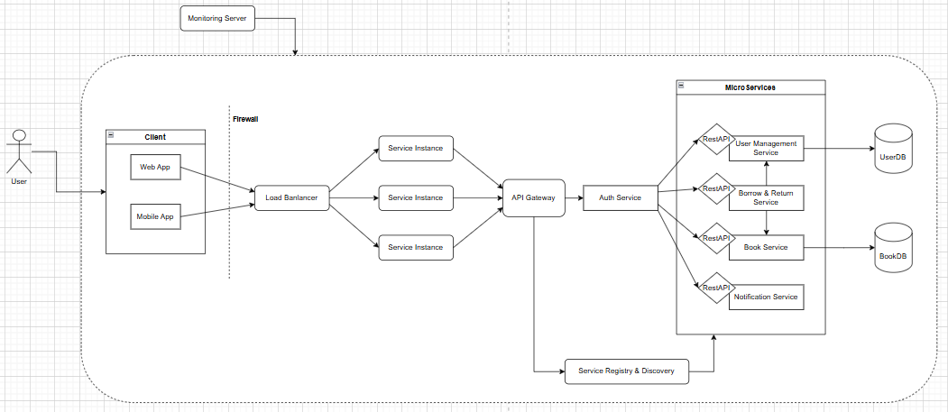
Client: The client represents the end-user or an external system that interacts with the application. It could be a web browser, mobile app, or another service making API requests to the backend.
Firewall: A firewall is a security layer that monitors and controls incoming and outgoing traffic based on predefined security rules. It protects the system from unauthorized access, cyberattacks, and malicious traffic.
Load Balancer: The load balancer distributes incoming traffic across multiple Service Instances to ensure High availability, Scalability, Improved performance.
Service Instance: A service instance is an individual running instance of a microservice.
API Gateway: The API Gateway acts as the single entry point for all client requests.
MicroServices: Microservices are independent, loosely coupled services that handle different business functionalities.
Database: The database stores and manages application data.
Service Registry & Discover: A Service Registry keeps track of all running service instances.
Monitoring Server: The monitoring server collects metrics and logs from services to provide insights into system health.
Propose Technologies:
Web App: React - Mobile App: Flutter
API Gateway: Ocelot (for .NET-based microservices)
Backend Services: ASP.NET Core
Load Banlancer: Nginx
Firewall: Cloudflare WAF
Service Registry & Dícovery: Consul
Database: SQL Server
Monitoring Server: ELK Stack

