Config:
npm create vite@latest app-name -- --template react-ts
npm install tailwindcss @tailwindcss/vite
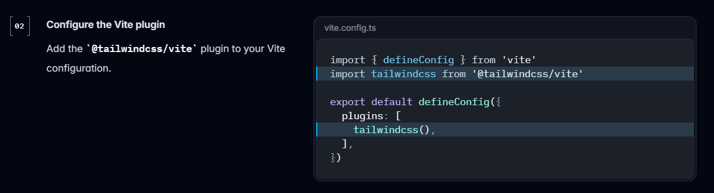
import tailwindcss from '@tailwindcss/vite'
tailwindcss()

import “tailwindcss”;
npm run dev

