**A)**

**I. DAO**

**1. SinhVienRepo.java**

package com.tvdat.dp.sf.DAO;

import java.sql.SQLException;

import java.util.ArrayList;

import com.tvdat.dp.sf.MODELS.SinhVien;

public interface SinhVienRepo {

void insertSinhVien(SinhVien sv);

ArrayList<SinhVien> getSinhVien() throws SQLException;

void deleteSinhVien(String maSinhVien);

}

**2. SinhVienRepoSQL.java**

package com.tvdat.dp.sf.DAO;

import java.sql.Connection;

import java.sql.PreparedStatement;

import java.sql.ResultSet;

import java.sql.SQLException;

import java.sql.Statement;

import java.text.Format;

import java.text.ParseException;

import java.text.SimpleDateFormat;

import java.util.ArrayList;

import java.util.Date;

import com.tvdat.dp.sf.MODELS.SinhVien;

public class SinhVienRepoSQL implements SinhVienRepo {

private static Connection cnn = null;

public SinhVienRepoSQL(String cnnString) {

this.cnn = SinhVienDB.getInstance(cnnString).getConnection();

}

public void insertSinhVien(SinhVien sv) {

try {

String queryString = "INSERT INTO SinhVien VALUES (?, ?, ?, ?)";

PreparedStatement pstmt = this.cnn.prepareStatement(queryString);

int index = 1;

Format formatter = new SimpleDateFormat("yyyy-MM-dd");

String svDate = formatter.format(sv.getNgaySinh());

pstmt.setString(index++, sv.getMaSinhVien());

pstmt.setString(index++, sv.getHoTen());

pstmt.setBoolean(index++, sv.isGioiTinhNam());

pstmt.setString(index++, svDate);

int n = pstmt.executeUpdate();

pstmt.close();

if(n == 1) {

System.out.println("Them sinh vien thanh cong!!!");

}

} catch (SQLException e) {

// TODO: handle exception

System.out.println("Sinh vien da ton tai trong DB!!!");

}

}

public ArrayList<SinhVien> getSinhVien() throws SQLException {

Statement stmt = this.cnn.createStatement();

String queryGetListSinhVien = "SELECT * FROM SinhVien";

ResultSet rs = stmt.executeQuery(queryGetListSinhVien);

ArrayList<SinhVien> lst = new ArrayList();

while (rs.next()) {

try {

SimpleDateFormat formatter = new SimpleDateFormat("yyyy-MM-dd");

Date dateDB = formatter.parse(rs.getString("NgaySinh"));

SinhVien x = new SinhVien(rs.getString("MaSinhVien"), rs.getString("HoTen"), rs.getBoolean("GioiTinhNam"), dateDB);

lst.add(x);

rs.close();

} catch (ParseException e) {

// TODO Auto-generated catch block

e.printStackTrace();

} catch (SQLException e) {

// TODO Auto-generated catch block

e.printStackTrace();

}

}

return lst;

}

public void deleteSinhVien(String MaSinhVien) {

try {

String queryString = "DELETE FROM SinhVien "

+ "WHERE MaSinhVien = ? ";

PreparedStatement pstmt = this.cnn.prepareStatement(queryString);

pstmt.setString(1, MaSinhVien);

int n = pstmt.executeUpdate();

pstmt.close();

if(n == 1) {

System.out.println("Xoa sinh vien thanh cong!!!");

}

} catch (SQLException e) {

System.out.println("Sinh vien khong ton tai trong DB!!!");

}

}

}

**3. SinhVienRepoTXT.java**

package com.tvdat.dp.sf.DAO;

import java.io.BufferedReader;

import java.io.BufferedWriter;

import java.io.File;

import java.io.FileNotFoundException;

import java.io.FileReader;

import java.io.FileWriter;

import java.io.IOException;

import java.sql.Date;

import java.text.Format;

import java.text.SimpleDateFormat;

import java.util.ArrayList;

//import java.util.Date;

import com.tvdat.dp.sf.MODELS.SinhVien;

public class SinhVienRepoTEXT implements SinhVienRepo {

private static String path = null;

public SinhVienRepoTEXT(String path) {

this.path = path;

}

public void insertSinhVien(SinhVien sv) {

try {

BufferedReader br = new BufferedReader(new FileReader(this.path));

String line;

boolean exists = false;

while ((line = br.readLine()) != null) {

String[] parts = line.split(",");

if (parts.length > 0 && parts[0].equals(sv.getMaSinhVien())) {

exists = true;

break;

}

}

br.close();

if (!exists) {

BufferedWriter writer = new BufferedWriter(new FileWriter(this.path, true));

Format formatter = new SimpleDateFormat("yyyy-MM-dd");

String ngaySinh = formatter.format(sv.getNgaySinh());

String[] parts = ngaySinh.split("-");

if (parts.length == 3) {

ngaySinh = parts[0] + "/" + parts[1] + "/" + parts[2];

} else {

System.out.println("Invalid date format: " + ngaySinh);

}

writer.write(sv.getMaSinhVien() + "," + sv.getHoTen() + "," + sv.isGioiTinhNam() + "," + ngaySinh);

writer.newLine();

writer.close();

System.out.println("Thêm sinh viên thành công!");

} else {

System.out.println("Mã sinh viên đã tồn tại!");

}

} catch (FileNotFoundException e) {

// TODO Auto-generated catch block

e.printStackTrace();

} catch (IOException e) {

// TODO Auto-generated catch block

e.printStackTrace();

}

}

public ArrayList<SinhVien> getSinhVien() {

ArrayList<SinhVien> lstSV = new ArrayList<SinhVien>();

try{

BufferedReader br = new BufferedReader(new FileReader(this.path));

while (true) {

String line = br.readLine();

if (line == null || line == "") {

break;

} else {

String lineSinhVien[] = line.trim().split(",");

if(lineSinhVien.length == 4) {

for(int i = 0; i < lineSinhVien.length; i++) {

String maNhanVien = lineSinhVien[0].trim();

String hoTen = lineSinhVien[1].trim();

boolean gioiTinhNam = Boolean.parseBoolean(lineSinhVien[2].trim());

String ngaySinh = lineSinhVien[3].trim();;

String[] parts = ngaySinh.split("/");

if (parts.length == 3) {

ngaySinh = parts[0] + "-" + parts[1] + "-" + parts[2];

} else {

System.out.println("Invalid date format: " + ngaySinh);

}

SinhVien sv = new SinhVien(maNhanVien, hoTen, gioiTinhNam, Date.valueOf(ngaySinh));

lstSV.add(sv);

break;

}

}

}

}

br.close();

} catch (IOException e) {

e.printStackTrace();

}

return lstSV;

}

public void deleteSinhVien(String MaSinhVien) {

File inputFile = new File(this.path);

File tempFile = new File("/Users/spiderman/Documents/DHKH_2021-2025/DP_Java/21T1020285-Dat-TranVanDat/lib/sinhvientmp.txt");

try {

BufferedReader reader = new BufferedReader(new FileReader(inputFile));

BufferedWriter writer = new BufferedWriter(new FileWriter(tempFile));

String currentLine;

while((currentLine = reader.readLine()) != null) {

String[] trimmedLine = currentLine.trim().split(",");

if(trimmedLine[0].equals(MaSinhVien)) {

continue;

};

writer.write(currentLine + System.getProperty("line.separator"));

}

writer.close();

reader.close();

inputFile.delete();

boolean successfull = tempFile.renameTo(inputFile);

if(successfull) {

System.out.println("Xoa sinh vien thah cong!!!");

}

else {

System.out.println("Xoa sinh vien that bai!!!");

}

} catch (FileNotFoundException e) {

// TODO Auto-generated catch block

e.printStackTrace();

} catch (IOException e) {

// TODO Auto-generated catch block

e.printStackTrace();

}

}

}

**4. UtilsDAO.java**

package com.tvdat.dp.sf.DAO;

import java.sql.Connection;

import java.sql.DriverManager;

import java.sql.SQLException;

final class SinhVienDB {

private static SinhVienDB _instance = null;

private Connection cnn = null;

public Connection getConnection() {

return this.cnn;

}

private SinhVienDB(String path) {

String connectionUrl = path;

try {

cnn = DriverManager.getConnection(connectionUrl);

System.out.println("Connect success!!!");

} catch (SQLException e) {

// TODO Auto-generated catch block

e.printStackTrace();

}

}

public static SinhVienDB getInstance(String path) {

if(_instance == null) {

_instance = new SinhVienDB(path);

}

return _instance;

}

}

**II. MODELS**

**1. CauHinh.java**

package com.tvdat.dp.sf.MODELS;

import java.io.BufferedReader;

import java.io.FileReader;

import java.io.IOException;

import lombok.*;

@Data

public class CauHinh {

private String loaiNguon = null;

private String chuoiKetNoi = null;

private static CauHinh _instance = null;

public String getChuoiKetNoi () {

return this.chuoiKetNoi;

}

private CauHinh(String pathLocal) {

try {

BufferedReader br = new BufferedReader(new FileReader(pathLocal));

this.loaiNguon = br.readLine();

this.chuoiKetNoi = br.readLine();

br.close();

} catch (IOException e) {

// TODO Auto-generated catch block

e.printStackTrace();

}

}

public static CauHinh getInstance(String pathLocal) {

if(_instance == null) {

_instance = new CauHinh(pathLocal);

}

return _instance;

}

}

**2.SinhVien.java**

package com.tvdat.dp.sf.MODELS;

import java.util.Date;

import lombok.*;

@Data

@AllArgsConstructor

public class SinhVien {

private String MaSinhVien;

private String HoTen;

private boolean GioiTinhNam;

private Date NgaySinh;

}

**III. UI**

**1. ChuongTrinh.java**

package com.tvdat.dp.sf.UI;

import java.sql.Date;

import com.tvdat.dp.sf.DAO.SinhVienRepo;

import com.tvdat.dp.sf.MODELS.CauHinh;

import com.tvdat.dp.sf.MODELS.SinhVien;

public class ChuongTrinh {

public void getListSinhVien(CauHinh cfg) {

SinhVienRepo svRepo = null;

SinhVienRepoFactory svRepoFac = new SinhVienRepoFactory();

svRepo = svRepoFac.createSinhVienRepo(cfg);

try {

for(int i = 0; i < svRepo.getSinhVien().size(); i++) {

SinhVien sv = svRepo.getSinhVien().get(i);

System.out.println(sv);

}

} catch (Exception e) {

e.printStackTrace();

}

}

public static void main(String[] args) {

ChuongTrinh ct = new ChuongTrinh();

CauHinh cfg = CauHinh.getInstance("/Users/spiderman/Documents/DHKH_2021-2025/DP_Java/21T1020285-Dat-TranVanDat/lib/config.txt");

SinhVienRepo repo = new SinhVienRepoFactory().createSinhVienRepo(cfg);

SinhVien sv01 = new SinhVien("21T1020313", "Trần Hoài Bão", true, Date.valueOf("2003-10-20"));

// selectAll

ct.getListSinhVien(cfg);

// insert

ct.getListSinhVien(cfg);

repo.insertSinhVien(sv01);

ct.getListSinhVien(cfg);

// delete

ct.getListSinhVien(cfg);

repo.deleteSinhVien("21T1020313");

ct.getListSinhVien(cfg);

}

}

**2. SinhVienRepoFactory.java**

package com.tvdat.dp.sf.UI;

import com.tvdat.dp.sf.DAO.SinhVienRepo;

import com.tvdat.dp.sf.DAO.SinhVienRepoSQL;

import com.tvdat.dp.sf.DAO.SinhVienRepoTEXT;

import com.tvdat.dp.sf.MODELS.CauHinh;

public class SinhVienRepoFactory {

public SinhVienRepo createSinhVienRepo(CauHinh cfg) {

if("SQLife".equals(cfg.getLoaiNguon())) {

return new SinhVienRepoSQL(cfg.getChuoiKetNoi());

}

else {

return new SinhVienRepoTEXT(cfg.getChuoiKetNoi());

}

}

}

**B)**

**1. Lấy danh sách sinh viên**

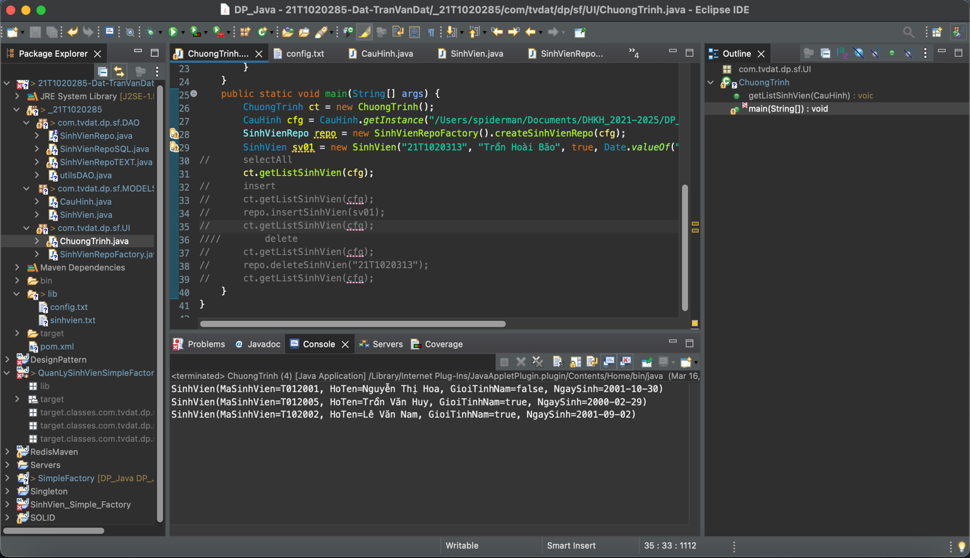

**2. Thêm mới một sinh viên**

**\* Thành Công:**

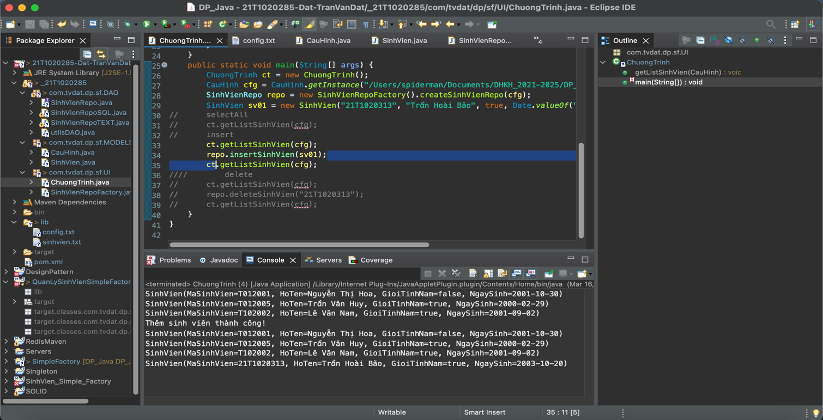

**\* Thêm thất bại**

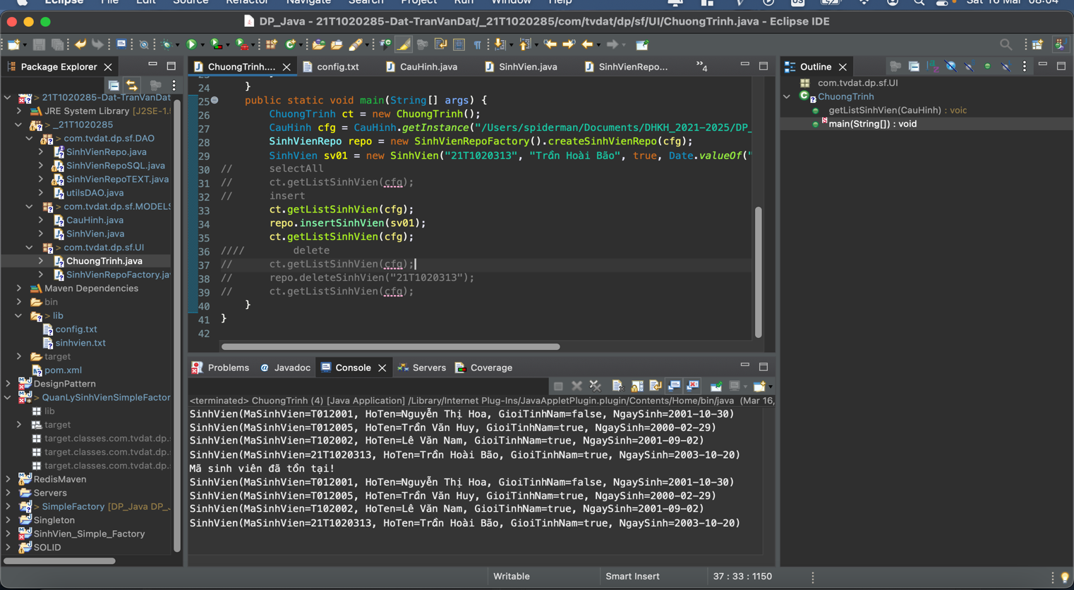

**3. Xóa một sinh viên**

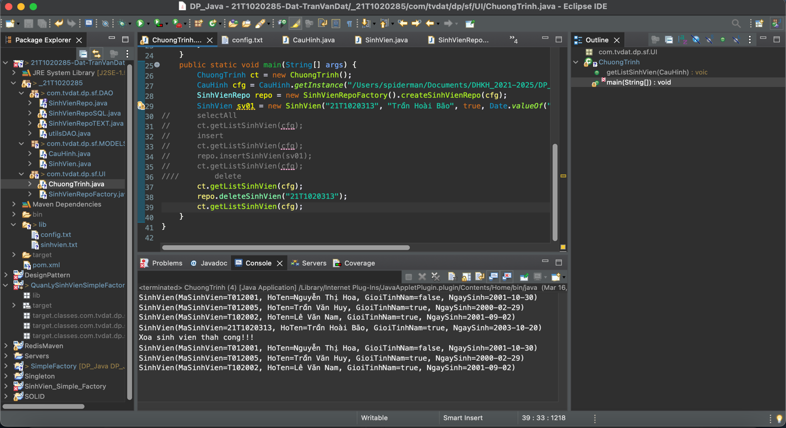

**C) script lược đồ và dữ liệu (SQLife)**

BEGIN TRANSACTION;

CREATE TABLE IF NOT EXISTS "SinhVien" (

"MaSinhVien" TEXT,

"HoTen" TEXT,

"GioiTinhNam" BLOB,

"NgaySinh" DATE,

PRIMARY KEY("MaSinhVien")

);

INSERT INTO "SinhVien" ("MaSinhVien","HoTen","GioiTinhNam","NgaySinh") VALUES ('21T1020313','Trần Hoài Bão',1,'2003-10-20');

COMMIT;

**D)**

**IV. lib**

**1. config.txt**

**FILE:**

TEXT_FILE

/Users/spiderman/Documents/DHKH_2021-2025/DP_Java/21T1020285-Dat-TranVanDat/lib/sinhvien.txt

**SQLife:**

SQLife

jdbc:sqlite:/Users/spiderman/Documents/DHKH_2021-2025/SQL_Server/SinhVien.db

**2. SinhVien.txt**

T012001,Nguyễn Thị Hoa,False,2001/10/30

T012005,Trần Văn Huy,True,2000/02/29

T102002,Lê Văn Nam,True,2001/09/02