**機械学習教師付き学習レポート課題**

**SVMの実装**

チャンヴァンサン

０５—１６１０２３

実装コード

#language: GNU Octave

#SVM with backtracking line search

clear all;

#gendata

rand('state',0);

randn('state',0);

global n = 200;

a = linspace(0,4*pi,n/2);

u = [a.*cos(a) (a+pi).*cos(a)]'+rand(n,1);

v = [a.*sin(a) (a+pi).*sin(a)]'+rand(n,1);

global x = [u v];

global y = [ones(1,n/2) -ones(1,n/2)]';

#kernel

#configuration

global step = 1;

global eps = 1;

global h = 0.7;

global C = 0.5;

global hh = 2*h^2;

#backtracking line search

global alpha = 0.5;

global beta = 0.8;

function retval = gauss(u, v)

global hh;

w = u - v;

retval = exp(- w * w' / hh);

endfunction

function retval = calc_K()

global n;

global x;

retval = zeros(n, n);

for i = 1:n

for j = 1:i

retval(i, j) = gauss(x(i, :), x(j, :));

retval(j, i) = retval(i, j);

endfor

endfor

endfunction

global K = calc_K(x, n, hh);

global K2 = 2 * K;

function retval = f(theta)

global C;

global K;

global y;

t = 1 - (K * theta) .* y;

t(t < 0) = 0;

retval = C * sum(t) + theta' * K * theta;

endfunction

global K_signed = K .* repmat(y, 1, n);

function retval = delta(theta)

global K_signed;

global K;

global y;

s = sign(1 - (K * theta) .* y);

s(s < 0) = 0;

retval = -(s' * K_signed)';

endfunction;

function retval = nabla(theta)

global C;

global K2;

retval = C * delta(theta) + K2 * theta;

endfunction

function retval = next_theta(theta)

ok = false;

global step;

global alpha;

global beta;

st = step;

i = 0;

threshold = 10;

do

i = i + 1;

nl = nabla(theta);

if (f(theta - st * nl) - f(theta) > -alpha * st * (theta' * theta))

st = beta * st;

else

ok = true;

endif

until (ok || i > threshold)

retval = theta - st * nl;

endfunction;

function retval = SVM()

global n;

retval = randn(n, 1);

#retval = zeros(n, 1);

i = 0;

threshold = 50;

do

i = i + 1;

last = retval;

retval = next_theta(retval);

diff = retval - last;

#norm(retval - last)

until (abs(norm(retval - last)) < eps || i > threshold);

endfunction;

t = SVM();

#draw

m = 100;

X = linspace(-15,15,m)';

X2 = X.^2;

U = exp(-(repmat(u.^2,1,m)+repmat(X2',n,1)-2*u*X')/hh);

V = exp(-(repmat(v.^2,1,m)+repmat(X2',n,1)-2*v*X')/hh);

figure(1);

clf;

hold on;

axis([-15 15 -15 15]);

contourf(X,X,sign(V'*(U.*repmat(t,1,m))));

plot(x(y == 1,1),x(y == 1,2),'bo');

plot(x(y == -1,1),x(y == -1,2),'rx');

colormap([1 0.7 1; 0.7 1 1]);

実行結果：

初期値（ランダム）

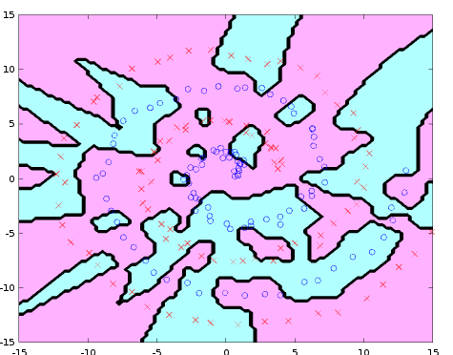

次はそれぞれ１回、２回、３回、１０回、２０回、５０回backtracking line search を繰り返した結果：

