premium members area is fully wrong in front end

please check my home page screen

no need any search functions

no need any Premium members search function in home page

also premium member displaying style is wrong

hope still you didn't catch the idea

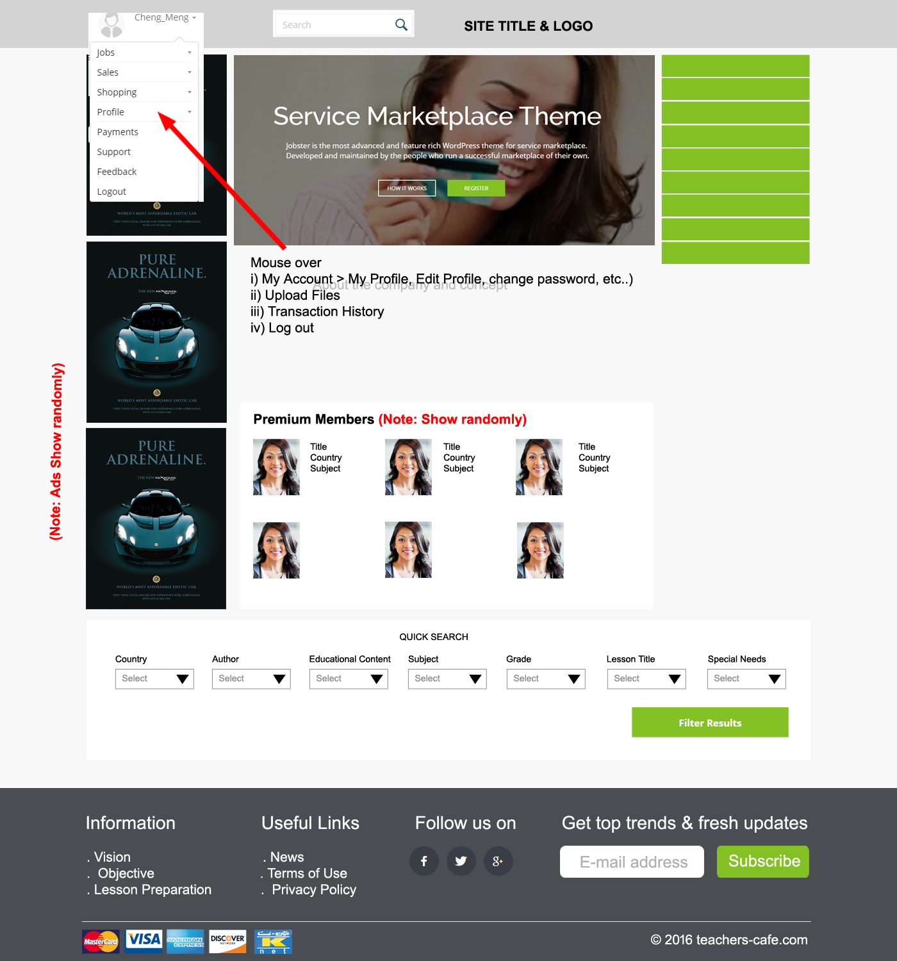

pls see the "premium members" area

Just, Title, Country, Subjects

Once clicked author, student can see his all uploaded files like category page

Only his files

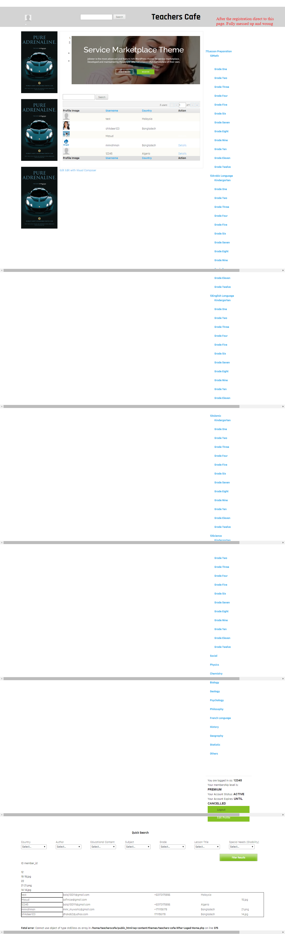

please arrange to view category pages like we discussed

how to view file upload, author dashboard, etc..

give me the link

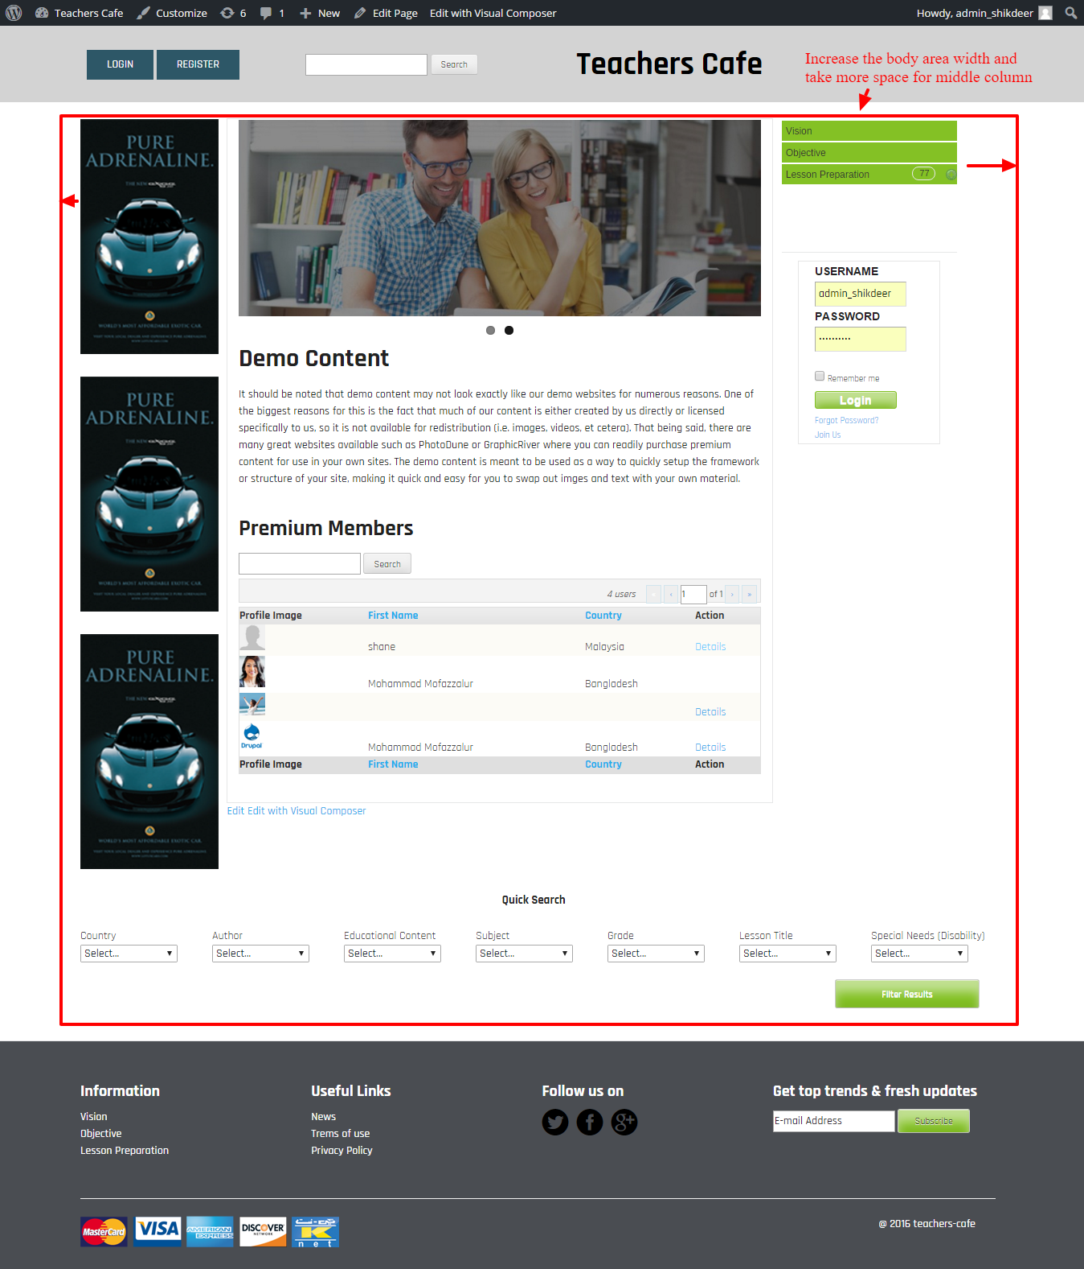

I cant face my client with this type of presentation

I think we are in the wrong track

still you didn't catch the proper layout structure

please please follow up the screens