

MEDBOOKING – Online Medical Appointment Booking and Management System
Version: 3.0

Record of Changes

Version | Date | A*  M, D | In charge | Change Description
*A - Added M - Modified D - Deleted

Contents
Record of Changes 2
Contents 3
I. Overview 14
1. User Requirements 14
1.1 Actors 14
1.2 Use Cases 15
a. Diagram(s) 15
b. Descriptions 22
2. Overall Functionalities 27
2.1 Screens Flow 27
2.2 Screen Descriptions 29
2.3 Screen Authorization 33
2.4 Non-UI Functions 39
3. System High Level Design 39
3.1 Database Design 39
a. Database Schema 39
b. Table Descriptions 40
3.2 Code Packages 42
1. Authentication 44
1.1 UC-01_Register_Account 44
a. Functionalities 44
b.Business Rule 46
1.2 UC-02_Complete_Onboarding_Survey 46
a. Functionalities 46
b.Business Rule 47
1.3 UC-03_Login 47
a. Functionalities 47
b.Business Rule 48
1.4 UC-04_Reset_Pasword 48
a. Functionalities 48
b.Business Rule 50
1.5 UC-05_View_And_Update_Profile 50
a. Functionalities 50
b.Business Rule 51
2. Manage Admin's job posting 51
2.1 UC-06_Search_Doctor 51
a. Functionalities 51
b. Business Rules 52
2.2 UC-07_Filter_Doctor_bySpecialty 52
a. Functionalities 52
b. Business Rules 53
2.3 UC-08_View_Doctor_Profile_and_Schedule 53
a. Functionalities 53
b. Business Rules 54
2.4 UC-09_Search_Department 54
a. Functionalities 54
b. Business Rules 54
2.5 UC-10_Book_Apponitment 55
a. Functionalities 55
b. Business Rules 55
2.6 UC-11_Select_Package_and_Time_Slot 56
a. Functionalities 56
b. Business Rules 57
2.7 UC-12_Pay_Deposit 57
a. Functionalities 57
b. Business Rules 58
2.8 UC-13_View_Upcoming_Appointments 58
a. Functionalities 58
b. Business Rules 59
2.9 UC-14_Cancel_Appointment 59
a. Functionalities 59
b. Business Rules 60
2.10 UC-15_Reschedule_Appointment 60
a. Functionalities 60
b. Business Rules 61
2.11 UC-16_View_Payment_History 61
a. Functionalities 61
b. Business Rules 62
3. Manage Admin's job posting 62
3.1 UC-25_View_Work_Schedule_&_Location 62
a. Functionalities 62
b. Business Rules 63
3.2 UC-26_Add_Time_Slot 63
a. Functionalities 63
b. Business Rules 64
3.3 UC-27_Edit_Time_Slot 64
a. Functionalities 64
b. Business Rules 65
3.4 UC-28_Delete_Time_Slot 65
a. Functionalities 65
b. Business Rules 66
3.5 UC-29_View_Patient_List 66
a. Functionalities 66
b. Business Rules 67
3.6 UC-30_Confirm_Appointment 67
a. Functionalities 67
b. Business Rules 68
3.7 UC-31_Decline_Appointment 68
a. Functionalities 68
b. Business Rules 69
3.8 UC-32_State_Decline_Reason 69
a. Functionalities 69
b. Business Rules 70
4.Consultation 70
4.1 UC-17_Join_Video_Call 70
a. Functionalities 70
b. Business Rules 71
4.2 UC-18_Chat_with_Doctor 71
a. Functionalities 71
b. Business Rules 72
4.3 UC-37_Conduct_Vide 72
a. Functionalities 72
b. Business Rules 73
4.4 UC-38_Chat_with_Patient 73
a. Functionalities 73
b. Business Rules 74
5.Apply for a job 74
5.1 UC-19_View_Diagnosis_ad_Health_Book 74
a. Functionalities 74
b. Business Rules 75
5.2 UC-20_Download_Prescription 75
a. Functionalities 75
b. Business Rules 76
5.3 UC-21_Rate_Dotor 76
a. Functionalities 76
b. Business Rules 77
5.4 UC-22_Write_Text_Review 77
a. Functionalities 77
b. Business Rules 78
5.5 UC-23_Submit_Complaint 78
a. Functionalities 78
b. Business Rules 79
5.6 UC-33_View_Patient_Record 79
a. Functionalities 79
b. Business Rules 80
5.7 UC-34_Fill_Examination_Form 80
a. Functionalities 80
b. Business Rules 81
5.8 UC-35_OrderLab_Test 81
a. Functionalities 81
b. Business Rules 82
5.9 UC-36_Write_Diagnosis_and_Issue_Prescription 82
a. Functionalities 82
b. Business Rules 83
6. Recruitment for job 83
6.1 UC-39_Review_and_Approve_Doctor 83
a. Functional Description 83
b. Business Rules: 84
6.2 UC-40_Reject_Doctor 84
a. Functional Description 84
b. Business Rules 85
6.3 UC-41_Lock_Account 85
a. Functional Description 85
b. Business Rules 86
6.4 UC-42-Add_Department 86
a. Functional Description 86
b. Business Rules 87
6.5 UC-43_Edit-Department 87
a. Functional Description 87
b. Business Rules 88
6.6 UC-44_Assign_Doctor_to_Departmet 88
a. Functional Description 88
b. Business Rules 89
6.7 UC-45_View_Doctors_by_Department 89
a. Functional Description 89
b. Business Rules 90
6.8 UC-46_Add_Specialty 90
a. Functional Description 90
b. Business Rules 91
6.9 UC-47_Edit_Specialty 91
a. Functional Description 91
b. Business Rules 92
6.10 UC-48_Add_Examination_Package 92
a. Functional Description 92
b. Business Rules 93
6.11 UC-49_Edit_Examination_Package 93
a. Functional Description 93
b. Business Rules 94
6.12 UC-50_View_Paymet_Statitics 94
a. Functional Description 94
b. Business Rules 95
7. Work online through JobTrans 95
7.1 UC-51_View_Booking_Statistics 95
a. Functionalities 95
b. Business Rules 96
7.2. UC-52_Export_Statistics_Report 96
a. Functionalities 96
b. Business Rules 96
7.3. UC-53_View_Cancellation_Statistics 97
a. Functionalities 97
b. Business Rules 97
7.4.UC-54_Handle_Complaint 97
a. Functionalities 97
b. Business Rules 98
7.5. UC-55_Post_Epidemic_Alert 99
a. Functionalities 99
b. Business Rules 99
III. Design Specifications 100
1. Authentication 100
a. Register 100
UI Design 101
Database Access 103
b. Login 104
UI Design 104
Database Access 106
2. USES 106
a. Homepage 106
UI Design 107
Database Access 109
b. About Us 110
UI Design 111
Database Access 112
c. Doctor Listing and Filter 113
UI Design 113
Database Access 115
d. Health Packages 116
UI Design 116
Database Access 118
e. Online Health Assessment 119
UI Design 120
Database Access 121
f. Medical News and Blog 122
UI Design 123
Database Access 125
g. My Appointments Dashboard 125
UI Design 126
Database Access 128
3. DOCTOR 129
a. Doctor Dashboard 129
UI Design 129
Database Access 130
b. Medical Profile Management 131
UI Design 131
Database Access 132
c. Certification Catalog 132
UI Design 133
Database Access 134
d. Duty Schedule Configurator 134
UI Design 134
Database Access 135
e. Appointment Management Workspace 136
UI Design 136
Database Access 137
f. Patient Roster Index 137
UI Design 138
Database Access 138
g. Telemedicine Teleconsultation Room 139
UI Design 139
Database Access 140
h. In-App Messaging Panel 140
UI Design 140
Database Access 141
4. ADMIN 142
a. Admin Dashboard Overview 142
UI Design 142
Database Access 143
b. Member Account Directory 144
UI Design 144
Database Access 145
c. Master Appointment Logs 146
UI Design 146
Database Access 147
d. Bank Transfer Audit 148
UI Design 148
Database Access 149
e. Doctor Verification & Audit 149
UI Design 149
Database Access 150
f. Medical Specialties Management 151
UI Design 151
Database Access 152
g. Clinics & Facility Branches 152
UI Design 153
Database Access 154
h. Content and Feedback Management 154
UI Design 155
Database Access 156
i. Statistics & Reports 157
UI Design 157
Database Access 158
IV. Appendix 159
1. Assumptions & Dependencies 159
2. Limitations & Exclusions 160
3. Business Rules 160
4. Application Messages List 163

I. Overview

1. User Requirements

1.1 Actors
# | Actor | Description
1 | Admin | The Admin is responsible for managing and monitoring the entire MEDBOOKING system. The Admin has the highest management authority and can view, create, search, update, and delete system information.  - Has authority to manage patient accounts, doctor accounts, and receptionist accounts.  - Has authority to manage medical specialties and doctor information.  - Has authority to manage appointments and monitor transactions.  - Has authority to manage their own profile.  - Has authority to manage users, transaction, recruitment post  - Has authority to manage profile
2 | Doctor | A Doctor is a medical professional who uses the MEDBOOKING platform to manage their schedules, view appointments, examine patients, and update medical examination results.  - Can manage their working schedules.  - Can view their appointment list and patient information.  - Can record examination results and create prescriptions.  - Can view patient medical histories.
3 | Patient | A Patient is a user who uses the MEDBOOKING platform to search for doctors, book medical appointments, make payments, and manage their personal medical information.  - Can search for doctors and view doctor information.  - Can book, view, and cancel appointments.  - Can make payments and view payment history.  - Can view medical examination results and appointment history.
4 | Guest | A Guest is a visitor who accesses the MEDBOOKING website without logging in. Guests can explore publicly available information before registering or logging into the system.  - Can view information about the clinic and medical specialties.  - Can search for doctors and view doctor profiles.  - Can view general appointment booking instructions.  - Must register or log in to book an appointment.

1.2 Use Cases

a. Diagram(s)
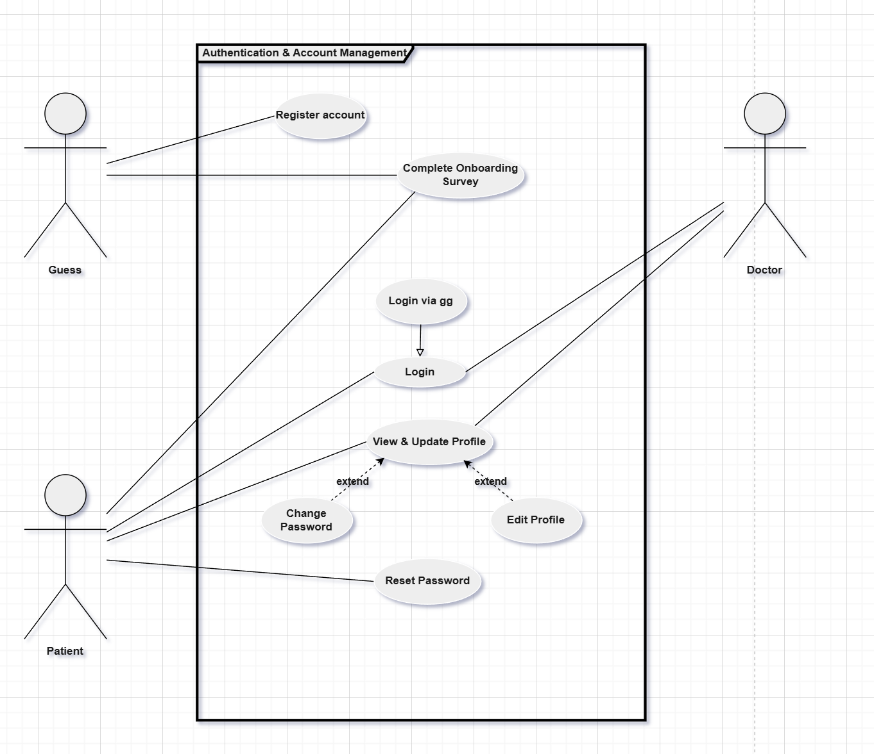
Figure 1. Authentication use case diagram
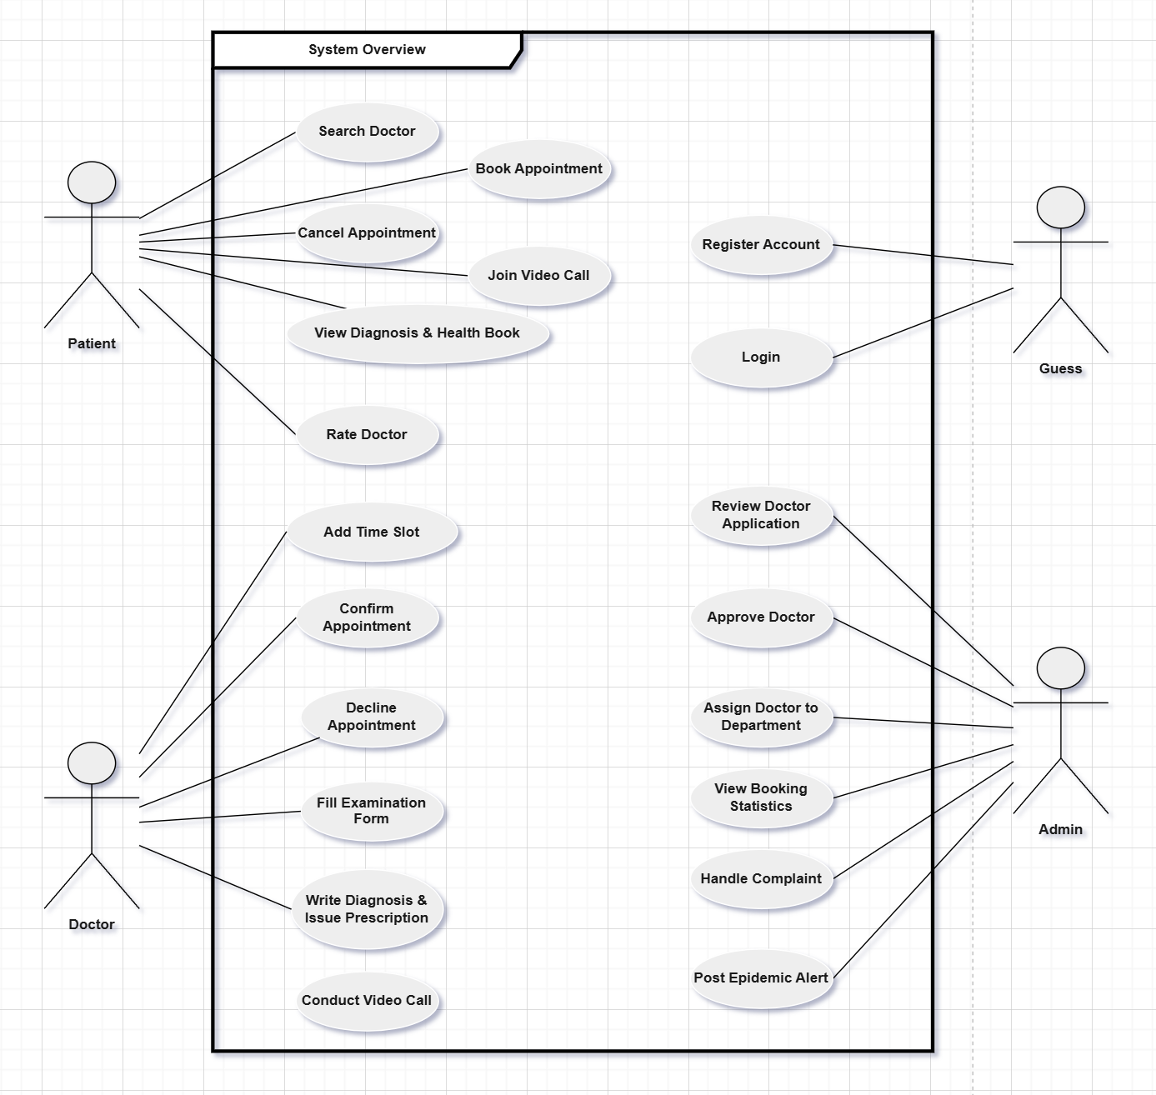
Figure 2. Overview use case diagram
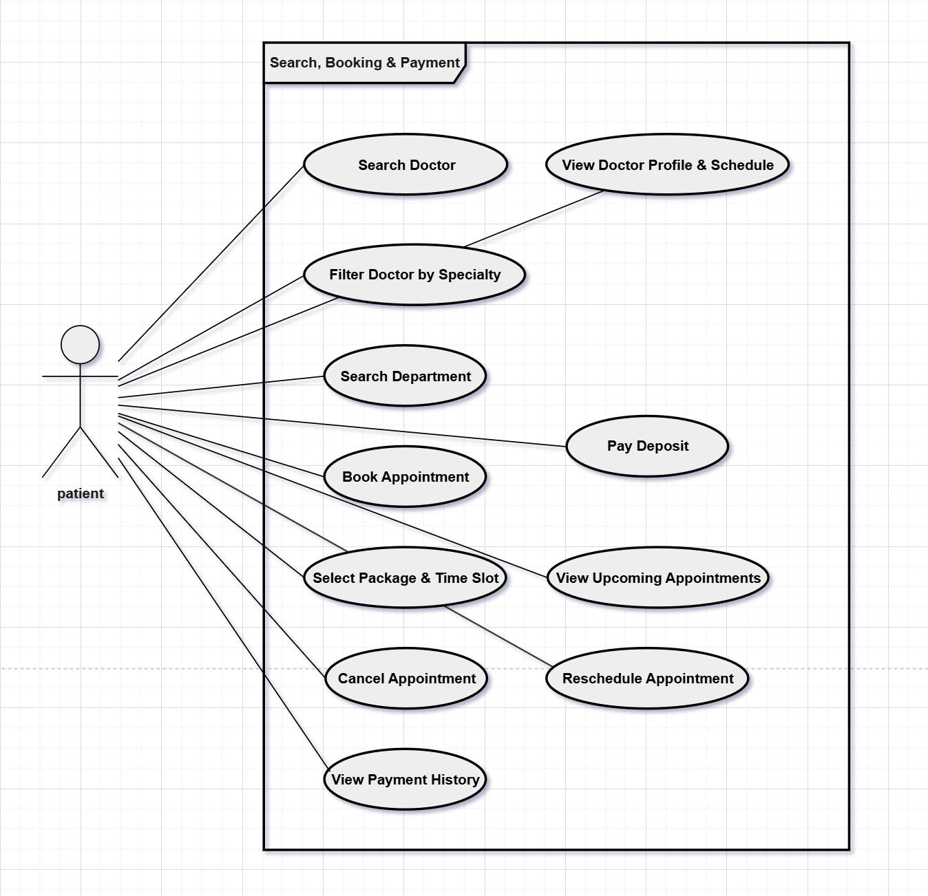Figure 3. Search,Booking & Payment use case diagram
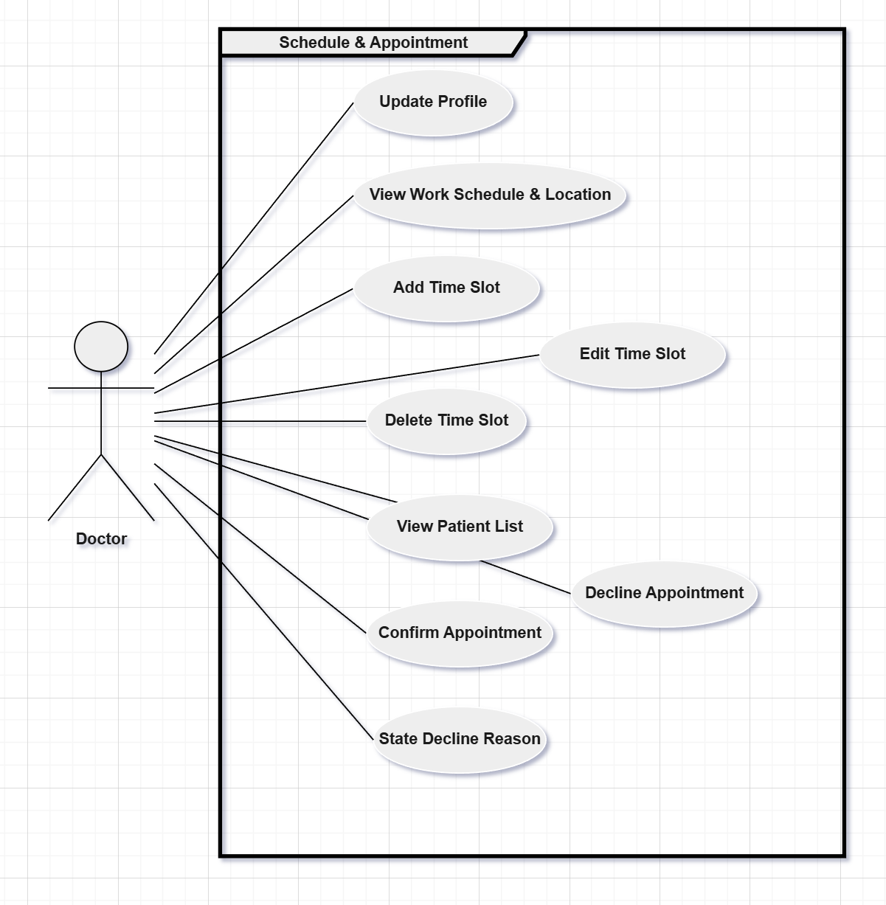
Figure 4. Doctor Schedule & Appointment use case diagram
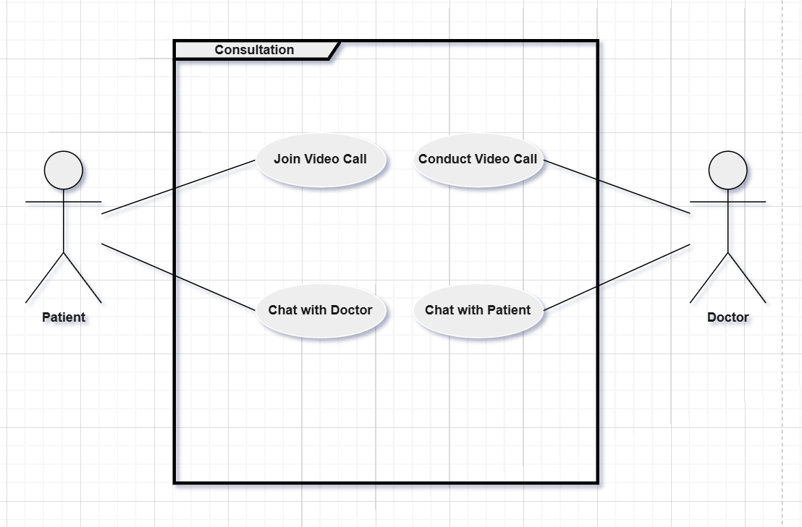
Figure 5. Consultation use case diagram
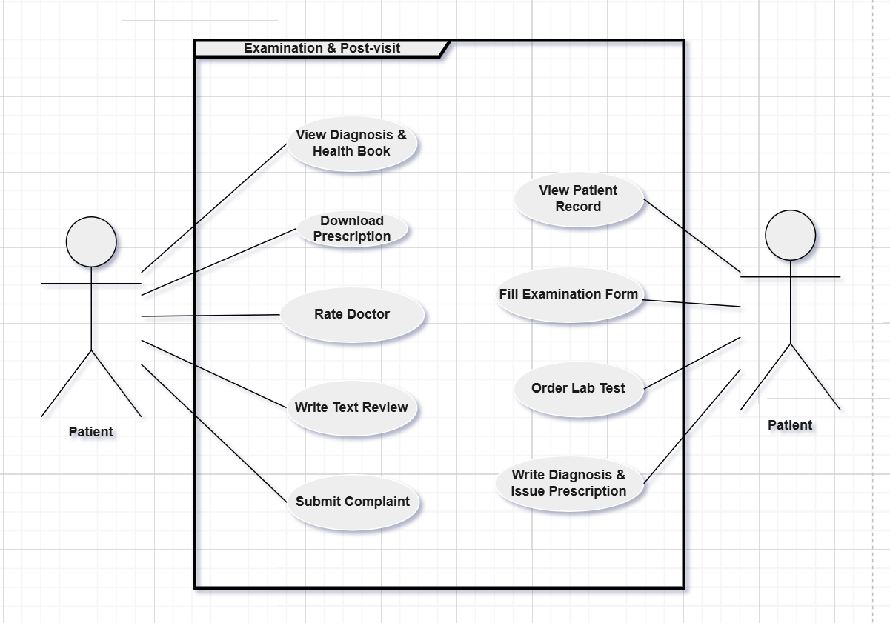
Figure 6. Examination & Post-visit use case diagram
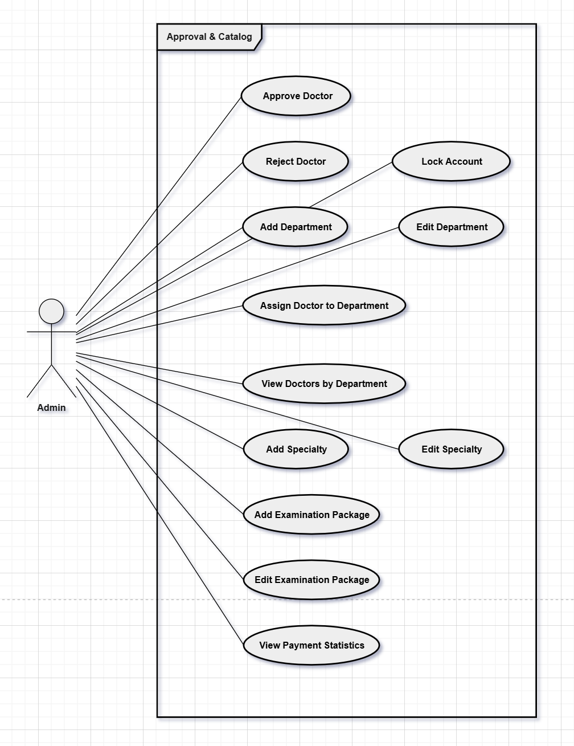
Figure 7. Admin:Approval & Catalog use case diagram
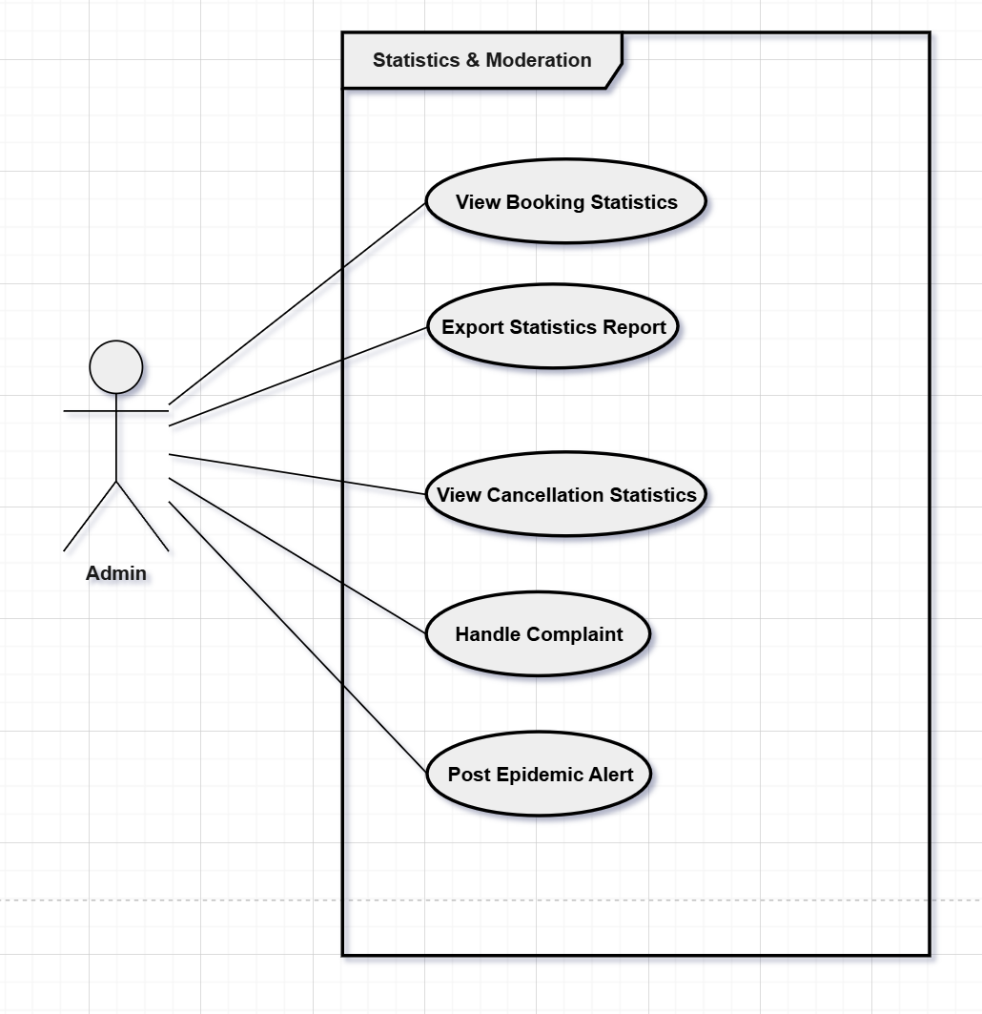
Figure 8. Admin:Statistics & Moderation use case diagram

b. Descriptions

ID | Feature | Use Case | Description
UC-01 | Authentication — Patient | Register Account | Register a new account using email and verify via OTP to access the hospital system.
UC-02 | Authentication — Patient | Complete Onboarding Survey | Fill in personal health info: gender, date of birth, medical history, and drug allergies after registration.
UC-03 | Authentication — Patient | Login | Access the system using email/password or Google OAuth.
UC-04 | Authentication — Patient | Reset Password | Request a password reset link sent to registered email.
UC-05 | Authentication — Patient | View & Update Profile | View and edit personal information and profile avatar.
UC-06 | Search & Discovery — Patient | Search Doctor | Search for doctors by name or specialty.
UC-07 | Search & Discovery — Patient | Filter Doctor by Specialty | Filter search results by medical specialty.
UC-08 | Search & Discovery — Patient | View Doctor Profile & Schedule | View doctor profile: fee, ratings, department, and available time slots.
UC-09 | Search & Discovery — Patient | Search Department | Search for hospital departments by name or specialty.
UC-10 | Booking — Patient | Book Appointment | Select an examination package and time slot, confirm booking, and pay deposit.
UC-11 | Booking — Patient | Select Package & Time Slot | Choose an examination package and an available time slot.
UC-12 | Booking — Patient | Pay Deposit | Pay the required deposit via payment gateway to confirm booking.
UC-13 | Booking — Patient | View Upcoming Appointments | View list of upcoming appointments and their current status.
UC-14 | Booking — Patient | Cancel Appointment | Cancel a booked appointment; refund deposit according to cancellation policy.
UC-15 | Booking — Patient | Reschedule Appointment | Reschedule an appointment to a different available time slot.
UC-16 | Booking — Patient | View Payment History | View transaction history and refund status.
UC-17 | Consultation — Patient | Join Video Call | Join a video consultation session with the doctor.
UC-18 | Consultation — Patient | Chat with Doctor | Send and receive real-time messages with the doctor.
UC-19 | Post-visit — Patient | View Diagnosis & Health Book | View diagnosis results, lab test results, and full medical record history.
UC-20 | Post-visit — Patient | Download Prescription | Download the prescription as a PDF file.
UC-21 | Post-visit — Patient | Rate Doctor | Submit a star rating and review after a completed appointment.
UC-22 | Post-visit — Patient | Write Text Review | Write a detailed text review alongside the star rating.
UC-23 | Post-visit — Patient | Submit Complaint | Submit a complaint about the doctor or service to Admin.
UC-24 | Profile & Schedule — Doctor | Update Profile | Update qualifications, experience, specialty, and profile photo.
UC-25 | Profile & Schedule — Doctor | View Work Schedule & Location | View weekly/monthly schedule overview and assigned department.
UC-26 | Profile & Schedule — Doctor | Add Time Slot | Create a new available appointment time slot.
UC-27 | Profile & Schedule — Doctor | Edit Time Slot | Edit information of an existing time slot.
UC-28 | Profile & Schedule — Doctor | Delete Time Slot | Remove a time slot that is no longer available.
UC-29 | Appointment — Doctor | View Patient List | View the list of patients who have booked appointments.
UC-30 | Appointment — Doctor | Confirm Appointment | Confirm an appointment booking request from a patient.
UC-31 | Appointment — Doctor | Decline Appointment | Decline an appointment booking; must provide a reason.
UC-32 | Appointment — Doctor | State Decline Reason | Enter and send the reason for declining the appointment to the patient.
UC-33 | Examination — Doctor | View Patient Record | View the patient's medical history and health profile.
UC-34 | Examination — Doctor | Fill Examination Form | Record vital signs, symptoms, and clinical notes. Required before issuing diagnosis.
UC-35 | Examination — Doctor | Order Lab Test | Request lab tests for the patient during examination.
UC-36 | Examination — Doctor | Write Diagnosis & Issue Prescription | Write the diagnosis and prescribe medicines after completing the examination form.
UC-37 | Consultation — Doctor | Conduct Video Call | Initiate or join a video consultation session with a patient.
UC-38 | Consultation — Doctor | Chat with Patient | Send and receive real-time messages with the patient.
UC-39 | Doctor Approval — Admin | Review & Approve Doctor | Review doctor registration profile and approve or reject the request.
UC-40 | Doctor Approval — Admin | Reject Doctor | Reject a doctor registration and record the reason shown to the doctor.
UC-41 | Doctor Approval — Admin | Lock Account | Lock a doctor or patient account that violates system policies.
UC-42 | Department — Admin | Add Department | Add a new hospital department to the system.
UC-43 | Department — Admin | Edit Department | Edit information of an existing hospital department.
UC-44 | Department — Admin | Assign Doctor to Department | Assign a doctor to a specific department.
UC-45 | Department — Admin | View Doctors by Department | View the list of doctors belonging to each department.
UC-46 | Specialty Catalog — Admin | Add Specialty | Add a new medical specialty to the catalog.
UC-47 | Specialty Catalog — Admin | Edit Specialty | Edit information of an existing medical specialty.
UC-48 | Examination Package — Admin | Add Examination Package | Create a new examination package: name, price, and included services.
UC-49 | Examination Package — Admin | Edit Examination Package | Edit information of an existing examination package.
UC-50 | Examination Package — Admin | View Payment Statistics | View statistics on revenue, deposit payments, and refunds.
UC-51 | Statistics — Admin | View Booking Statistics | View booking statistics by time period, specialty, and department.
UC-52 | Statistics — Admin | Export Statistics Report | Export statistics report to a file.
UC-53 | Statistics — Admin | View Cancellation Statistics | View appointment cancellation and reschedule rates.
UC-54 | Moderation — Admin | Handle Complaint | Receive, review, and respond to patient complaints.
UC-55 | Moderation — Admin | Post Epidemic Alert | Post epidemic alerts and send notifications to patients.

2. Overall Functionalities

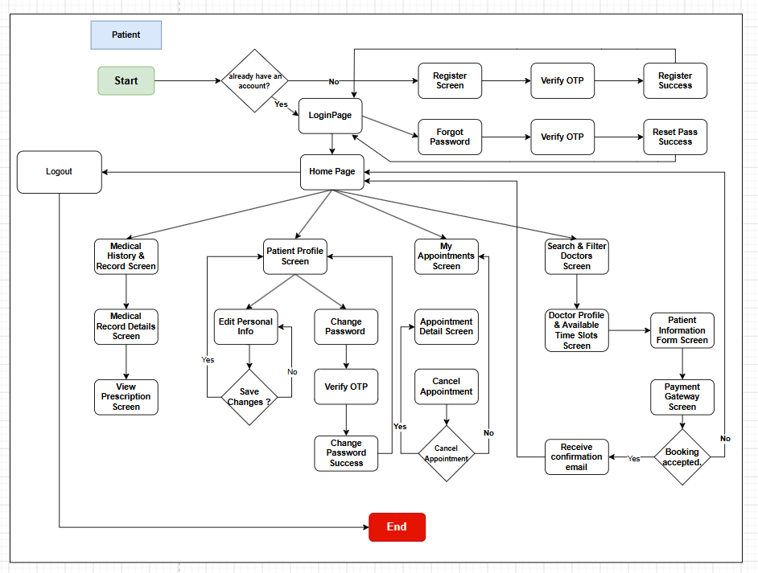
2.1 Screens Flow
Figure 8. Screen flow Diagram – Patient
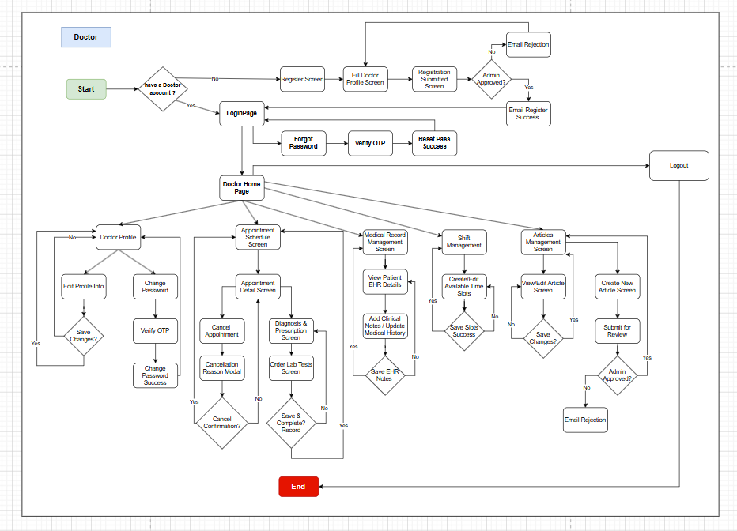
Figure 9. Screen flow Diagram – Doctor

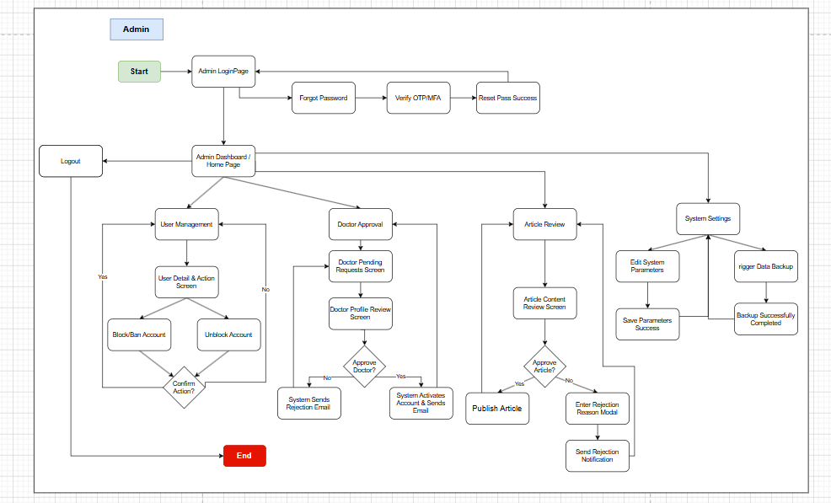
Figure 10. Screen flow Diagram – Admin

2.2 Screen Descriptions

ID | Feature | Screen | Description
1 | View list job post - Admin | Job management | Allows administrators to view a list of job postings and perform actions such as editing or deleting posts.
2 | View details job post - Admin | Job post details | Allows admins to view details about a specific job posting including job information and requirements.
3 | Refund money to employer - Admin | Job post details | Allows administrators to refund employers in cases where jobs are not completed or there are problems.
4 | Salary transfer to seeker - Admin | Job post details | Allows admin to transfer salary to candidate after job is completed.
5 | View list user | User management | Allows administrators to view a list of users and perform management actions such as locking accounts or editing information.
6 | View user information | Account details | Allows administrators to view detailed information about a specific user, including personal information and projects worked on.
7 | Register | Register | Allows users to register new accounts to use the system.
8 | Login | Login | Allows users to log into the system using their registered accounts or Google account.
9 | Logout | Logout | Allows users to log out of the system.
10 | View Profile | Profile | Allows users to view their personal profile information in the system.
11 | Edit profile | Edit profile | Allows users to edit their personal information.
12 | Change Password | Change password | Allows the user to change his current password.
13 | Forgot password | Forgot password | Allows users to recover their passwords through the "Forgot Password" function.
14 | Create CV | Create CV | Allows seekers to create online CVs for job search.
15 | View CV | View CV | Allows seekers to review the online CV they have created.
16 | Update CV | Update CV | Allows seekers to update information in their online CV.
17 | Delete CV | Manage CV | Allows seekers to delete the online CV they have created.
18 | View wallet | Wallet | Allows users to view their balance and information related to their e-wallet in the system (transaction history).
19 | View transaction history | Wallet | Allows users to view transaction history related to e-wallet.
20 | Add money into wallet | Wallet, 3-rd party online payment page | Allows users to deposit money into e-wallets to use for transactions within the system.
21 | Search job post | HomePage | Allows seekers to search for job postings based on keywords, location, or other criteria.
22 | View employer’s information | Employer’s information page | Allows seekers to view detailed information about the employer, including company name, address, and description.
23 | View job post | Job page | Allows seekers to view details of a job posting including job requirements and detailed description.
24 | Apply for job | Job page | Allows seekers to apply for a specific job through the system.
25 | View applied job list | Applied job list | Allows seekers to view a list of jobs they have applied for.
26 | CRUD job post | Manage job | Allows employers to create, view, update, and delete job postings.
27 | View posted list | View posted list | Allows employers to view a list of jobs they have posted on the system.
28 | View applied seeker list | Recruitment management | Allows employers to view a list of candidates who have applied to their jobs.
29 | View applied seeker’s information | Applied information | Allows employers to view detailed information about candidates who have applied for a job.
30 | Update interview | Post’s detail | Allows employers to update interview details and google meet links.
31 | Confirm successful seeker | Recruitment management | Allows employers to confirm that a candidate has been successfully selected for a job.
32 | Prepay for work | Prepaying | Allows employers to prepay a portion of the cost of a job through the system.
33 | Deposit to accept job | Depositing | Allows seekers to deposit money into the system to accept jobs.
34 | Chat | My Job List | Allows employers and seekers to exchange information and discuss jobs via online chat.
35 | Manage progress | Job progress management | Allows employers and candidates to track and manage the progress of assigned work.
36 | Submit period submission online | Submitting period’s result | Allow seekers to submit phased work progress reports online through the system.
37 | View list confirmed job- Employer | My job list | Allows employers to view a list of confirmed jobs on the JobTrans system.
38 | View list confirmed job - Seeker | My job list | Allows seekers to view a list of jobs they have been confirmed for on the JobTrans system.
39 | Submit final result online | Submitting final result | Allows seekers to submit final results of their work online through the system.
40 | Submit final result offline | Submitting final result | Allow seekers to submit final work results offline (in person) if the job requires it.
41 | Give feedback | Employer Information, Applied Information | Allows seekers and candidates to provide feedback on the collaboration after the job is completed.

2.3 Screen Authorization

Screen | Guest | Patient | Doctor | Admin
Landing Page | X | X | X | X
View hospital introduction and CTA | X | X | X | X
Register | X
Fill in registration information | X
Complete Onboarding Survey | X
Verify OTP via email | X
Login | X | X | X | X
Enter email and password | X | X | X | X
Redirect by role after login |  | X | X | X
Logout |  | X | X | X
Forgot Password | X | X | X | X
Fill in email | X | X | X | X
Receive OTP code | X | X | X | X
Enter OTP and set new password | X | X | X | X
Patient Dashboard |  | X
View upcoming appointments |  | X
View recent medical records |  | X
View notifications |  | X
Search & Discovery | X | X
Search doctor by name or specialty | X | X
Filter doctor by specialty | X | X
View doctor profile and schedule | X | X
Search hospital department | X | X
Book Appointment |  | X
Select examination package |  | X
Select available time slot |  | X
Pay Deposit |  | X
View booking confirmation |  | X
Appointment List |  | X
View upcoming and past appointments |  | X
Reschedule appointment |  | X
Cancel appointment |  | X
Payment History |  | X
View transaction list and refund status |  | X
Appointment Detail |  | X
View appointment information |  | X
Send message to doctor |  | X
Join video call with doctor |  | X
Submit appointment rating |  | X
Submit complaint |  | X
Health Book |  | X
View all medical records |  | X
View record detail (diagnosis, meds) |  | X
View lab test results |  | X
Download prescription PDF |  | X
Profile |  | X | X | X
View profile information |  | X | X | X
Edit name, avatar, phone |  | X | X | X
Change Password |  | X | X | X
Fill in old and new password |  | X | X | X
Confirm password change |  | X | X | X
Notification Settings |  | X | X
Toggle email notification |  | X | X
Toggle push notification |  | X | X
Doctor Dashboard |  |  | X
View today's appointment schedule |  |  | X
View pending appointments |  |  | X
View Work Schedule & Location |  |  | X
View weekly/monthly schedule overview |  |  | X
View assigned department |  |  | X
Doctor Schedule Management |  |  | X
Add time slot |  |  | X
Edit time slot |  |  | X
Delete time slot |  |  | X
Appointment Management (Doctor) |  |  | X
View all assigned appointments |  |  | X
Confirm appointment |  |  | X
Decline appointment with reason |  |  | X
Examination |  |  | X
View patient medical record |  |  | X
Record patient vitals and symptoms |  |  | X
Request lab tests |  |  | X
Update lab test results |  |  | X
Medical Record |  |  | X
Write diagnosis and prescribe medicines |  |  | X
Issue prescription (PDF generated) |  |  | X
Messaging (Doctor) |  |  | X
Send message to patient |  |  | X
View message history per appointment |  |  | X
Video Call (Doctor) |  |  | X
Initiate video call with patient |  |  | X
Admin Dashboard |  |  |  | X
View system overview statistics |  |  |  | X
View recent complaints and alerts |  |  |  | X
User Management |  |  |  | X
View all users list |  |  |  | X
Search and filter users by role |  |  |  | X
Ban or unban user account |  |  |  | X
Delete user account |  |  |  | X
Doctor Approval |  |  |  | X
View pending doctor registrations |  |  |  | X
Approve doctor registration |  |  |  | X
Reject doctor with reason |  |  |  | X
Department & Specialty Management |  |  |  | X
Add department |  |  |  | X
Edit department |  |  |  | X
Assign doctor to department |  |  |  | X
View doctors by department |  |  |  | X
Add specialty |  |  |  | X
Edit specialty |  |  |  | X
Examination Package Management |  |  |  | X
Add examination package |  |  |  | X
Edit examination package |  |  |  | X
Payment Statistics |  |  |  | X
View revenue and deposit statistics |  |  |  | X
View refund history |  |  |  | X
Complaint Management |  |  |  | X
View all complaints |  |  |  | X
Respond to and resolve complaint |  |  |  | X
Booking & Cancellation Statistics |  |  |  | X
View booking statistics by time/specialty |  |  |  | X
Export statistics report |  |  |  | X
View cancellation statistics |  |  |  | X
Moderation |  |  |  | X
Post epidemic alert |  |  |  | X
Send notification to all patients |  |  |  | X

2.4 Non-UI Functions

ID | Feature | System Function | Description
1 | <<Feature Name>> | <<Function Name1>> | <<Function Name1 Description>>
2 | …

3. System High Level Design

3.1 Database Design

a. Database Schema

b. Table Descriptions
No | Table Name | Description
1 | User | Stores login accounts for all user types (Patient/User, Doctor, Admin). Role-based access is managed via the 'role' field (enum: USER, DOCTOR, ADMIN). Also embeds personal health data (blood type, allergies, chronic diseases, personal and family history) directly, replacing the old Patients and Health_Books tables.
2 | OTP | Manages one-time passcodes (OTP) sent via email for account registration, email verification, and password reset flows. Replaces the old Password_Resets table.
3 | Specialty | Reference catalogue of medical specialties (e.g. Cardiology, Pediatrics, Dermatology). Referenced by Doctor to define expertise and by Voucher for specialty-scoped discounts.
4 | Doctor | Stores professional information of doctors (experience, hospital, consultation fee, phone, bio). Linked 1-to-1 with a User account. Approval status (PENDING / APPROVED / REJECTED) and rejection reason are stored directly here, replacing the separate Doctor_Approvals table.
5 | Clinic | Catalogue of clinics or medical facilities that doctors belong to (replaces the old Departments table). Each doctor is linked to a clinic via 'clinicId'.
6 | Article | Health-related articles, news, or knowledge-sharing posts published by Admin or Doctor accounts.
7 | Complaint | Manages complaints submitted by users about the system or a specific appointment. Stores subject, message body, supporting images, processing status, and Admin response.
8 | DoctorSchedule | Pre-registered weekly working schedule of a doctor (dayOfWeek, startTime, endTime, isAvailable). Used as the basis for patients to book appointments.
9 | Appointment | Core table managing booking records between a patient and a doctor (or a MedicalPackage). Stores appointment date, status (AppointmentStatus), notes, transaction code, amount, actual patient info (when booking on behalf of another person), discount details, and cancellation reason.
10 | MedicalRecord | Medical record created by the doctor after each completed examination. Embeds clinical examination results and vital signs (temperature, blood pressure, heart rate, height, weight, SpO2, symptoms, preliminary/final diagnosis, treatment plan), replacing the old Examinations table.
11 | Prescription | Detailed prescription lines for a medical record. Acts as a join table between MedicalRecord and Medicine, storing dosage, frequency, duration, and quantity for each medicine.
12 | DoctorCertificate | Professional certificates and academic qualifications submitted by doctors. Stores certificate image/file URL, certificate number, and verification status (PENDING / VERIFIED / REJECTED) with rejection reason, ensuring doctor legitimacy on the platform.
13 | Review | Patient ratings and reviews for a doctor after a completed appointment (replaces the old Appointment_Ratings table). Each appointment can have at most one review.
14 | Payment | Payment transaction record for an appointment. Stores amount, payment method (VNPAY / PAYOS / MOCK), transaction status (PaymentStatus), order code, payment timestamp, and transaction expiry time.
15 | MedicalPackage | Catalogue of health check-up packages or screening programs offered by medical facilities (package name, description, price, hospital, included services, preparation guide).
16 | Conversation | Manages chat sessions. Establishes a communication link between a specific User (patient) and a specific Doctor. Each (userId, doctorId) pair is unique.
17 | Message | Individual messages within a Conversation between a patient and a doctor. Records sender, message content, read status (isRead), and timestamp.
18 | AdminLog | Audit log recording all administrative actions performed by Admin accounts (lock/unlock accounts, approve doctors, verify certificates, manage specialties/clinics, etc.).
19 | AdminNotification | Internal notifications sent exclusively to administrators for system events requiring immediate attention (new doctor pending approval, new complaint received, etc.).
20 | LabOrder | Lab test request generated during an examination (replaces the old Lab_Tests table). Records test name, test type, doctor's notes, test results, and execution status (PENDING / COMPLETED / CANCELLED).
21 | Medicine | Catalogue of medicines used in the system. Stores medicine name, active ingredient, form (tablet, liquid, powder), unit, default usage instructions, and category.
22 | VideoCallLog | History log of online video consultation calls between doctors and patients (replaces the old Video_Calls table). Records appointment ID, start/end time, call duration in seconds, and call initiator.
23 | Notification | In-app push notifications for users and doctors. Sends updates about appointment confirmation, 24-hour reminders, cancellations, new lab results, doctor account approval status, etc.
24 | Voucher | List of active discount vouchers/promotions. Defines discount rules: percentage or fixed amount, discount value, applicable target (ALL / PACKAGE / SPECIALTY / DOCTOR), usage limit, validity period, and minimum deposit requirement.
25 | VoucherUsage | Detailed history of voucher usage per appointment. Records original deposit amount, discount amount applied, and final deposit amount after discount.
26 | BookingProfile | Secondary patient profile. Allows a User to create and manage personal and health information (blood type, allergies, medical history) for family members to conveniently book appointments on their behalf.
27 | SavedVoucher | Tracks vouchers saved by users to their account for use in future appointment bookings.

3.2 Code Packages
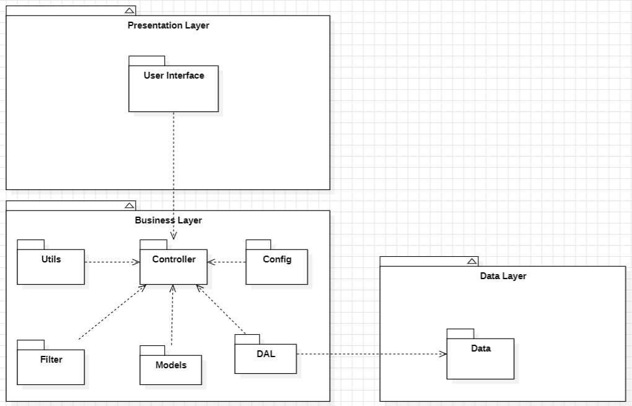
Package descriptions
No | Package | Description
1 | Presentation Layer | Contains the User Interface components, handling the user's interaction with the hospital system (booking, medical records, dashboards).
2 | Business Layer | Contains the core business logic and processing modules, managing data flow, appointment scheduling, and medical workflows.
3 | Data Layer | Manages the data access logic, handling storage and retrieval from the hospital database.
4 | Controller | Acts as a bridge between the User Interface and other modules in the Business Layer, routing HTTP requests to appropriate services.
5 | Utils | Provides utility functions and common services used across the application (date formatting, token generation, validators).
6 | Config | Manages configuration settings and application environment variables (database connection, JWT secret, mail server config).
7 | Filter / Middleware | Contains filters for data validation, authentication, authorization, and request processing (JWT verification, role checks).
8 | Models | Represents the data structure and entities used within the hospital domain (Users, Doctors, Patients, Appointments, etc.).
9 | DAL (Data Access Layer) | Handles database operations specifically for retrieving and saving data via ORM or raw SQL queries.
10 | Auth Service | Manages user authentication flows: login, registration, password reset via OTP, and session management.
11 | User Service | Handles CRUD operations for user accounts, profile management, and notification preference settings.
12 | Doctor Service | Manages doctor profiles, approval workflow by Admin, schedule creation, and specialty/department assignments.
13 | Appointment Service | Core service for booking, confirming, cancelling, and rescheduling appointments, and linking them to doctor schedules.
14 | Examination Service | Records clinical examination results (vitals, symptoms) and manages lab test requests per appointment.
15 | Medical Record Service | Creates and manages patient health records including diagnosis, doctor notes, and prescribed medicines per appointment.
16 | Messaging Service | Handles real-time or asynchronous messaging between doctors and patients within the context of an appointment.
17 | Video Call Service | Manages video call sessions initiated between doctor and patient for telemedicine consultations.
18 | Rating & Complaint Service | Handles post-visit appointment ratings submitted by patients and manages complaint submission and Admin review workflow.
19 | Payment Service | Manages deposit payment and refund flows when a patient books or cancels an appointment. Integrates with third-party payment gateway (e.g. VNPay/Momo). Tracks all transactions in Payment History.
20 | Email Notification Service | Sends automated emails to users for key events: appointment confirmation, appointment reminder (24h/1h before), lab result availability, prescription PDF, and deposit/refund receipts.
21 | Examination Package Service | Manages examination packages created by Admin: name, price, and included services. Provides package selection during the booking flow and links packages to appointments.
22 | Content Service | Manages creation and publishing of health-related articles and epidemic alerts by Admins for patient education and public health notification.

II. Requirement Specifications

1. Authentication

1.1 UC-01_Register_Account

a. Functionalities
UC ID and Name: | UC-01_Register_Account
Created By: | Hospital Dev Team | Date Created: | 01/Jun/2025
Primary Actor: | Guest | Secondary Actors: | None
Trigger: | Guest clicks the 'Register' button on the landing page.
Description: | As a Guest, I want to register a new account so that I can access the hospital booking and medical features.
Preconditions: | The email address must not already be registered in the system.
Postconditions: | A new Patient account is created, an OTP verification email is sent, and the Guest is redirected to the OTP verification screen.
Normal Flow: | 1.0 Register Account  1. Guest navigates to the platform and clicks the 'Register' button.  2. System displays a registration form requesting email, password, confirm password, and full name.  3. Guest fills in all required fields with valid information.  4. Guest clicks the 'Register' button to submit the form.  5. System validates the input (email format, password length ≥ 8, email uniqueness).  6. System creates a new user record with role PATIENT.  7. System sends a 6-digit OTP to the provided email (expires in 10 minutes).  8. System redirects the Guest to the OTP verification screen.  9. Guest enters the 6-digit OTP received by email.  10. System verifies the OTP and activates the account.  11. System redirects the user to the Onboarding screen (UC-02).
Alternative Flows: | None
Exceptions: | 1.0.E1 Invalid field format  1. System displays inline error MSG01 if email format is invalid.  2. System displays inline error MSG02 if password < 8 characters.  3. System displays inline error MSG11 if confirm password does not match.  1.0.E2 Email already registered  1. System displays toast error MSG03.  1.0.E3 OTP incorrect or expired  1. System displays toast error MSG09.  2. Guest can request a new OTP after 60 seconds.
Priority: | Must Have
Frequency of Use:
Business Rules: | BR-01, BR-02, BR-03, BR-08
Other Information:
Assumptions:

b.Business Rule
ID | Business Rule | Business Rule Description
BR-01 | Wrong email rule | Notify Guest with MSG01 if they do not provide a valid email address.
BR-02 | Wrong password rule | Notify User with MSG02 if password is less than 8 characters.
BR-03 | Used email rule | Notify Guest with MSG03 if the email has already been registered.
BR-08 | Wrong re-entered password rule | Notify User with MSG11 if confirm password does not match.

1.2 UC-02_Complete_Onboarding_Survey

a. Functionalities
UC ID and Name: | UC-02_Complete_Onboarding_Survey
Created By: | Hospital Dev Team | Date Created: | 01/Jun/2025
Primary Actor: | Patient (new) | Secondary Actors: | None
Trigger: | System automatically redirects the Patient to Onboarding after successful registration.
Description: | As a new Patient, I want to complete the onboarding survey so that my health profile is initialized.
Preconditions: | Patient has successfully registered and verified OTP (UC-01). Onboarding not yet completed.
Postconditions: | Patient health profile saved. Health Book created. Patient redirected to dashboard.
Normal Flow: | 2.0 Complete Onboarding Survey  1. System redirects Patient to the Onboarding screen after OTP verification.  2. System displays a multi-step form: gender, date of birth, blood type, medical history, drug allergies.  3. Patient fills in all required fields.  4. Patient clicks 'Complete' to submit the survey.  5. System saves the health profile to the Patients table.  6. System creates a Health Book record linked to the Patient.  7. System redirects the Patient to the main dashboard.
Alternative Flows: | None
Exceptions: | None
Priority: | Must Have
Frequency of Use:
Business Rules: | BR-27
Other Information:
Assumptions:

b.Business Rule
ID | Business Rule | Business Rule Description
BR-27 | Health Book creation rule | Each Patient account must have exactly one Health Book, created automatically upon profile creation.

1.3 UC-03_Login

a. Functionalities
UC ID and Name: | UC-03_Login
Created By: | Hospital Dev Team | Date Created: | 01/Jun/2025
Primary Actor: | Patient / Doctor / Admin | Secondary Actors: | None
Trigger: | User clicks the 'Login' button on the landing page or header.
Description: | As a User, I want to log in to the system so that I can access my personalized dashboard and authenticated features.
Preconditions: | User must have a registered and active account in the system.
Postconditions: | User is authenticated, JWT token issued, redirected to role-based homepage.
Normal Flow: | 3.0 Login  1. User navigates to the platform and clicks the 'Login' button.  2. System displays the login form requesting email and password.  3. User enters valid email and password credentials.  4. User clicks the 'Login' button.  5. System validates the credentials against the database.  6. System issues a JWT token and stores it in a secure cookie.  7. System redirects the User to the appropriate homepage based on role.
Alternative Flows: | 3.1 Google OAuth Login  1. User clicks 'Login with Google'.  2. System redirects to Google OAuth 2.0 consent screen.  3. User selects a Google account and grants permission.  4. Google redirects back with an authorization token.  5. System verifies the token and retrieves or creates the user account.  6. Return to step 6 of Normal Flow.
Exceptions: | 3.0.E1 Authentication failed  1. System displays toast error MSG04.  2. User may retry or click 'Forgot Password?' (→ UC-04).
Priority: | Must Have
Frequency of Use:
Business Rules: | BR-01, BR-02, BR-04
Other Information:
Assumptions:

b.Business Rule
ID | Business Rule | Business Rule Description
BR-01 | Wrong email rule | Notify User with MSG01 if email format is invalid.
BR-02 | Wrong password rule | Notify User with MSG02 if password is less than 8 characters.
BR-04 | Login notification rule | Notify with MSG04 if credentials are wrong; notify with MSG05 and redirect by role if correct.

1.4 UC-04_Reset_Pasword

a. Functionalities
UC ID and Name: | UC-04_Reset_Password
Created By: | Hospital Dev Team | Date Created: | 01/Jun/2025
Primary Actor: | Patient / Doctor / Admin | Secondary Actors: | None
Trigger: | User clicks the 'Forgot Password?' link on the login screen.
Description: | As a User, I want to reset my password via email OTP so that I can regain access to my account.
Preconditions: | User must have a registered email in the system.
Postconditions: | User's password is updated and the user can log in with the new password.
Normal Flow: | 4.0 Reset Password  1. User clicks 'Forgot Password?' on the login screen.  2. System displays an email input form.  3. User enters their registered email address.  4. System checks if the email exists in the database.  5. System sends a 6-digit OTP to the email (expires in 10 minutes).  6. System notifies User with MSG08 that OTP has been sent.  7. User enters the OTP on the verification screen.  8. System verifies the OTP.  9. System redirects User to the set new password form.  10. User enters and confirms the new password.  11. System updates the password and notifies User with MSG10.  12. System redirects User to the Login screen.
Alternative Flows: | None
Exceptions: | 4.0.E1 Email not registered  System displays toast MSG07.  4.0.E2 OTP incorrect  System displays toast MSG09. User can request new OTP after 60 seconds.  4.0.E3 Passwords do not match  System displays inline error MSG11.
Priority: | Must Have
Frequency of Use:
Business Rules: | BR-06, BR-07, BR-08
Other Information:
Assumptions:

b.Business Rule
ID | Business Rule | Business Rule Description
BR-06 | Email check rule | Notify with MSG07 if email not registered, or MSG08 if OTP sent successfully.
BR-07 | OTP validation rule | Notify with MSG09 if OTP incorrect; notify with MSG10 and redirect if correct.
BR-08 | Password match rule | Notify User with MSG11 if re-entered password does not match.

1.5 UC-05_View_And_Update_Profile

a. Functionalities
UC ID and Name: | UC-05_View_and_Update_Profile
Created By: | Hospital Dev Team | Date Created: | 01/Jun/2025
Primary Actor: | Patient / Doctor / Admin | Secondary Actors: | None
Trigger: | User navigates to the Profile page from the navigation menu.
Description: | As a User, I want to view and edit my personal information and avatar so that my profile is up to date.
Preconditions: | User must be logged in.
Postconditions: | Updated profile information is saved to the database.
Normal Flow: | 5.0 View & Update Profile  1. User clicks on their avatar or 'Profile' in the navigation menu.  2. System displays the profile page with current information.  3. User clicks 'Edit' to modify fields (name, phone, avatar, gender, date of birth).  4. User makes changes and clicks 'Save'.  5. System validates the input and saves the updated information.  6. System displays a success notification.
Alternative Flows: | None
Exceptions: | None
Priority: | Should Have
Frequency of Use:
Business Rules:
Other Information:
Assumptions:

b.Business Rule
None

2. Manage Admin's job posting

2.1 UC-06_Search_Doctor

a. Functionalities
UC ID and Name: | UC-06_Search_Doctor
Created By: | Hospital Dev Team | Date Created: | 01/Jun/2025
Primary Actor: | Guest / Patient | Secondary Actors: | None
Trigger: | User enters a keyword in the doctor search bar.
Description: | As a Guest or Patient, I want to search for doctors by name or specialty so that I can find the right doctor.
Preconditions: | None
Postconditions: | A list of matching doctors is displayed.
Normal Flow: | 6.0 Search Doctor  1. User navigates to the Find Doctor page.  2. User enters a doctor name or specialty keyword in the search bar.  3. System queries the database and returns matching doctor profiles.  4. System displays results with name, specialty, rating, and examination fee.  5. User can click a doctor card to view full profile (UC-08).
Alternative Flows: | 6.1 No results found  System displays MSG12 informing that no doctors were found.
Exceptions: | None
Priority: | Must Have
Frequency of Use:
Business Rules: | BR-12
Other Information:
Assumptions:

b. Business Rules
ID | Business Rule | Business Rule Description
BR-12 | No result rule | Notify with MSG12 if no doctors are found.

2.2 UC-07_Filter_Doctor_bySpecialty

a. Functionalities
UC ID and Name: | UC-07_Filter_Doctor_by_Specialty
Created By: | Hospital Dev Team | Date Created: | 01/Jun/2025
Primary Actor: | Guest / Patient | Secondary Actors: | None
Trigger: | User selects a specialty filter on the Find Doctor page.
Description: | As a Guest or Patient, I want to filter doctors by specialty so that I can narrow down my search results.
Preconditions: | User is on the Find Doctor page.
Postconditions: | Doctor list is filtered to show only doctors of the selected specialty.
Normal Flow: | 7.0 Filter Doctor by Specialty  1. User selects a specialty from the filter dropdown.  2. System filters the doctor list to show only matching specialties.  3. System updates the displayed results.
Alternative Flows: | None
Exceptions: | None
Priority: | Should Have
Frequency of Use:
Business Rules: | BR-12
Other Information:
Assumptions:

b. Business Rules

ID | Business Rule | Business Rule Description
BR-12 | No result rule | Notify with MSG12 if no doctors are found after applying the filter.

2.3 UC-08_View_Doctor_Profile_and_Schedule

a. Functionalities
UC ID and Name: | UC-08_View_Doctor_Profile_and_Schedule
Created By: | Hospital Dev Team | Date Created: | 01/Jun/2025
Primary Actor: | Guest / Patient | Secondary Actors: | None
Trigger: | User clicks on a doctor card from the search results.
Description: | As a Guest or Patient, I want to view a doctor's profile and available schedule so that I can decide whether to book.
Preconditions: | Doctor must have an approved account.
Postconditions: | Doctor profile and available time slots are displayed.
Normal Flow: | 8.0 View Doctor Profile & Schedule  1. User clicks on a doctor card from search results.  2. System displays the doctor's full profile: name, specialty, department, experience, fee, ratings.  3. System displays available time slots for the next 30 days.  4. User can click 'Book Appointment' to proceed (UC-10).
Alternative Flows: | None
Exceptions: | None
Priority: | Must Have
Frequency of Use:
Business Rules: | BR-10, BR-11
Other Information:
Assumptions:

b. Business Rules
ID | Business Rule | Business Rule Description
BR-10 | Doctor approval rule | Only approved doctors can receive bookings.
BR-11 | Schedule availability rule | Doctor must have at least one active schedule before Patients can book.

2.4 UC-09_Search_Department

a. Functionalities
UC ID and Name: | UC-09_Search_Department
Created By: | Hospital Dev Team | Date Created: | 01/Jun/2025
Primary Actor: | Guest / Patient | Secondary Actors: | None
Trigger: | User navigates to the Departments page and enters a search keyword.
Description: | As a Guest or Patient, I want to search for hospital departments so that I can find the right department.
Preconditions: | None
Postconditions: | A list of matching departments is displayed.
Normal Flow: | 9.0 Search Department  1. User navigates to the Departments page.  2. User enters a department name or specialty keyword.  3. System returns matching departments with description and location.  4. User can click a department to view its doctors.
Alternative Flows: | None
Exceptions: | None
Priority: | Should Have
Frequency of Use:
Business Rules:
Other Information:
Assumptions:

b. Business Rules
None

2.5 UC-10_Book_Apponitment

a. Functionalities
UC ID and Name: | UC-10_Book_Appointment
Created By: | Hospital Dev Team | Date Created: | 01/Jun/2025
Primary Actor: | Patient | Secondary Actors: | Payment Gateway
Trigger: | Patient clicks 'Book Appointment' on a doctor's profile page.
Description: | As a Patient, I want to book an appointment by selecting a package and time slot and paying a deposit so that my appointment is confirmed.
Preconditions: | Patient must be logged in. Doctor must have available schedule slots.
Postconditions: | Appointment created with status 'confirmed'. Deposit recorded. Confirmation email sent.
Normal Flow: | 10.0 Book Appointment  1. Patient clicks 'Book Appointment' on the doctor's profile.  2. System includes UC-11 (Select Package & Time Slot).  3. System includes UC-12 (Pay Deposit).  4. System creates an Appointment record with status 'confirmed'.  5. System marks the selected time slot as unavailable.  6. System sends a confirmation email to the Patient with appointment details.  7. System displays the booking confirmation screen.
Alternative Flows: | None
Exceptions: | 10.0.E1 Payment not completed within 15 minutes  1. System cancels the booking and releases the time slot.  2. System notifies Patient with MSG31.
Priority: | Must Have
Frequency of Use:
Business Rules: | BR-10, BR-11, BR-12, BR-30, BR-31, BR-35, BR-36
Other Information:
Assumptions:

b. Business Rules
ID | Business Rule | Business Rule Description
BR-10 | Doctor approval rule | Only approved doctors can receive bookings.
BR-11 | Schedule availability rule | Doctor must have at least one active schedule.
BR-12 | Slot availability rule | Slot must be available; marked unavailable after booking.
BR-30 | Payment timeout rule | Patient must complete deposit within 15 minutes or booking is cancelled.
BR-31 | Payment notification rule | Notify Patient with MSG27 on success or MSG28 on failure.
BR-35 | Deposit calculation rule | Deposit is a fixed percentage of package price.
BR-36 | Appointment reminder rule | Send reminder email 24h and 1h before appointment.

2.6 UC-11_Select_Package_and_Time_Slot

a. Functionalities
UC ID and Name: | UC-11_Select_Package_and_Time_Slot
Created By: | Hospital Dev Team | Date Created: | 01/Jun/2025
Primary Actor: | Patient | Secondary Actors: | None
Trigger: | Included from UC-10 (Book Appointment).
Description: | As a Patient, I want to select an examination package and an available time slot so that I can proceed to payment.
Preconditions: | Patient has initiated the booking flow (UC-10).
Postconditions: | Selected package and time slot are confirmed and held for 15 minutes pending payment.
Normal Flow: | 11.0 Select Package & Time Slot  1. System displays available examination packages with name, price, and included services.  2. Patient selects a package.  3. System displays available time slots for the selected doctor.  4. Patient selects an available time slot.  5. System temporarily holds the selected slot for 15 minutes.  6. System proceeds to UC-12 (Pay Deposit).
Alternative Flows: | None
Exceptions: | 11.0.E1 No packages available  System notifies Patient that no packages are currently available.
Priority: | Must Have
Frequency of Use:
Business Rules: | BR-34
Other Information:
Assumptions:

b. Business Rules
ID | Business Rule | Business Rule Description
BR-34 | Package validity rule | Examination Package must have at least one service and price > 0.

2.7 UC-12_Pay_Deposit

a. Functionalities
UC ID and Name: | UC-12_Pay_Deposit
Created By: | Hospital Dev Team | Date Created: | 01/Jun/2025
Primary Actor: | Patient | Secondary Actors: | Payment Gateway
Trigger: | Included from UC-10 after Patient selects package and time slot.
Description: | As a Patient, I want to pay the required deposit via a payment gateway so that my appointment booking is confirmed.
Preconditions: | Patient has selected a package and time slot (UC-11).
Postconditions: | Deposit payment is recorded. Appointment status set to 'confirmed'.
Normal Flow: | 12.0 Pay Deposit  1. System displays the payment summary (package, time slot, deposit amount).  2. Patient selects a payment method (VNPay / Momo / Bank Transfer).  3. Patient clicks 'Pay Now'.  4. System redirects Patient to the payment gateway.  5. Patient completes the payment on the gateway screen.  6. Payment gateway sends a callback to the system.  7. System records the transaction in the Payments table.  8. System notifies Patient with MSG27 (payment success).  9. System sets Appointment status to 'confirmed'.
Alternative Flows: | None
Exceptions: | 12.0.E1 Payment failed  1. Payment gateway returns failure callback.  2. System notifies Patient with MSG28.  3. Patient can retry or cancel.
Priority: | Must Have
Frequency of Use:
Business Rules: | BR-30, BR-31, BR-35
Other Information:
Assumptions:

b. Business Rules
ID | Business Rule | Business Rule Description
BR-30 | Payment timeout rule | Patient must complete deposit within 15 minutes.
BR-31 | Payment notification rule | Notify Patient with MSG27 on success or MSG28 on failure.
BR-35 | Deposit calculation rule | Deposit is a fixed percentage of package price.

2.8 UC-13_View_Upcoming_Appointments

a. Functionalities
UC ID and Name: | UC-13_View_Upcoming_Appointments
Created By: | Hospital Dev Team | Date Created: | 01/Jun/2025
Primary Actor: | Patient | Secondary Actors: | None
Trigger: | Patient navigates to the Appointments page from the dashboard.
Description: | As a Patient, I want to view my upcoming appointments and their status so that I can keep track of my scheduled visits.
Preconditions: | Patient must be logged in.
Postconditions: | List of upcoming appointments is displayed.
Normal Flow: | 13.0 View Upcoming Appointments  1. Patient navigates to the Appointments page.  2. System retrieves and displays all upcoming appointments with status, doctor name, date, and time.
Alternative Flows: | None
Exceptions: | None
Priority: | Must Have
Frequency of Use:
Business Rules:
Other Information:
Assumptions:

b. Business Rules
None

2.9 UC-14_Cancel_Appointment

a. Functionalities
UC ID and Name: | UC-14_Cancel_Appointment
Created By: | Hospital Dev Team | Date Created: | 01/Jun/2025
Primary Actor: | Patient | Secondary Actors: | Payment Gateway
Trigger: | Patient clicks 'Cancel' on an upcoming appointment.
Description: | As a Patient, I want to cancel an upcoming appointment so that the time slot is released and, if eligible, my deposit is refunded.
Preconditions: | Appointment must be in 'confirmed' status. Patient must be logged in.
Postconditions: | Appointment is cancelled. Deposit refund processed if eligible.
Normal Flow: | 14.0 Cancel Appointment  1. Patient clicks 'Cancel' on an upcoming appointment.  2. System displays a confirmation pop-up (MSG24).  3. Patient confirms the cancellation.  4. System checks cancellation policy (≥ 24 hours before appointment).  5. If eligible, system initiates a deposit refund via payment gateway.  6. System sets Appointment status to 'cancelled'.  7. System releases the time slot (is_available = TRUE).  8. System notifies Patient with MSG21 and MSG29.
Alternative Flows: | None
Exceptions: | 14.0.E1 Cancellation within 24 hours  Deposit is non-refundable. Appointment still cancelled but no refund issued.
Priority: | Must Have
Frequency of Use:
Business Rules: | BR-16, BR-32, BR-33
Other Information:
Assumptions:

b. Business Rules
ID | Business Rule | Business Rule Description
BR-16 | Cancellation confirmation rule | Display confirmation pop-up before Patient cancels.
BR-32 | Refund policy rule | Refund only processed if cancelled ≥ 24 hours before scheduled time.
BR-33 | Refund notification rule | Notify Patient with MSG29 on success or MSG30 if refund fails.

2.10 UC-15_Reschedule_Appointment

a. Functionalities
UC ID and Name: | UC-15_Reschedule_Appointment
Created By: | Hospital Dev Team | Date Created: | 01/Jun/2025
Primary Actor: | Patient | Secondary Actors: | None
Trigger: | Patient clicks 'Reschedule' on an upcoming appointment.
Description: | As a Patient, I want to reschedule an appointment to a different available time slot so that I can adjust my visit time.
Preconditions: | Appointment must be in 'confirmed' status. An alternative slot must be available.
Postconditions: | Appointment updated with new time slot. Old slot released.
Normal Flow: | 15.0 Reschedule Appointment  1. Patient clicks 'Reschedule' on an upcoming appointment.  2. System displays available time slots for the same doctor.  3. Patient selects a new time slot.  4. System updates the appointment with the new schedule_id.  5. System releases the old slot and marks the new slot as unavailable.  6. System sends a confirmation email with updated appointment details.
Alternative Flows: | None
Exceptions: | None
Priority: | Should Have
Frequency of Use:
Business Rules: | BR-12
Other Information:
Assumptions:

b. Business Rules
ID | Business Rule | Business Rule Description
BR-30 | Payment timeout rule | Patient must complete deposit within 15 minutes.
BR-31 | Payment notification rule | Notify Patient with MSG27 on success or MSG28 on failure.
BR-35 | Deposit calculation rule | Deposit is a fixed percentage of package price.

2.11 UC-16_View_Payment_History

a. Functionalities
UC ID and Name: | UC-16_View_Payment_History
Created By: | Hospital Dev Team | Date Created: | 01/Jun/2025
Primary Actor: | Patient | Secondary Actors: | None
Trigger: | Patient navigates to the Payment History page.
Description: | As a Patient, I want to view my transaction history and refund status so that I can track my payments.
Preconditions: | Patient must be logged in.
Postconditions: | List of transactions is displayed.
Normal Flow: | 16.0 View Payment History  1. Patient navigates to the Payment History page.  2. System retrieves all payment records linked to the Patient.  3. System displays transactions with amount, date, status (paid/refunded/failed), and related appointment.
Alternative Flows: | None
Exceptions: | None
Priority: | Should Have
Frequency of Use:
Business Rules:
Other Information:
Assumptions:

b. Business Rules
None

Manage Admin's job posting

3.1 UC-25_View_Work_Schedule_&_Location

a. Functionalities
UC ID and Name: | UC-25_View_Work_Schedule_and_Location
Created By: | Hospital Dev Team | Date Created: | 01/Jun/2025
Primary Actor: | Doctor | Secondary Actors: | None
Trigger: | Doctor navigates to the Work Schedule page from the dashboard.
Description: | As a Doctor, I want to view my weekly and monthly work schedule and the department I am assigned to so that I can plan my workload.
Preconditions: | Doctor must be logged in with an approved account.
Postconditions: | Doctor's schedule calendar and department assignment are displayed.
Normal Flow: | 25.0 View Work Schedule & Location  1. Doctor navigates to the Work Schedule page.  2. System retrieves all Doctor_Schedules records for the logged-in doctor.  3. System displays a weekly/monthly calendar view with shift dates, start/end times.  4. System displays the assigned department name and location.
Alternative Flows: | None
Exceptions: | None
Priority: | Should Have
Frequency of Use:
Business Rules:
Other Information:
Assumptions:

b. Business Rules
None

3.2 UC-26_Add_Time_Slot

a. Functionalities
UC ID and Name: | UC-26_Add_Time_Slot
Created By: | Hospital Dev Team | Date Created: | 01/Jun/2025
Primary Actor: | Doctor | Secondary Actors: | None
Trigger: | Doctor clicks 'Add Slot' on the Schedule Management page.
Description: | As a Doctor, I want to create a new available time slot so that Patients can book appointments with me.
Preconditions: | Doctor must be logged in with an approved account.
Postconditions: | A new Doctor_Schedule record created with is_available = TRUE.
Normal Flow: | 26.0 Add Time Slot  1. Doctor navigates to the Schedule Management page.  2. Doctor clicks 'Add Slot'.  3. System displays a form: work date, start time, end time.  4. Doctor fills in the details and clicks 'Save'.  5. System validates there is no time conflict with existing slots.  6. System creates the new schedule record.
Alternative Flows: | None
Exceptions: | None
Priority: | Must Have
Frequency of Use:
Business Rules: | BR-11
Other Information:
Assumptions:

b. Business Rules

ID | Business Rule | Business Rule Description
BR-11 | Schedule availability rule | Doctor must have at least one active schedule before Patients can book.

3.3 UC-27_Edit_Time_Slot

a. Functionalities
UC ID and Name: | UC-27_Edit_Time_Slot
Created By: | Hospital Dev Team | Date Created: | 01/Jun/2025
Primary Actor: | Doctor | Secondary Actors: | None
Trigger: | Doctor clicks 'Edit' on an existing time slot.
Description: | As a Doctor, I want to edit an existing time slot so that I can correct or update my schedule.
Preconditions: | The time slot must have no confirmed appointments linked to it.
Postconditions: | Doctor_Schedule record is updated.
Normal Flow: | 27.0 Edit Time Slot  1. Doctor navigates to the Schedule Management page.  2. Doctor clicks 'Edit' on an existing slot.  3. System displays the slot details in edit mode.  4. Doctor modifies the desired fields.  5. Doctor clicks 'Save'.  6. System validates and updates the record.
Alternative Flows: | None
Exceptions: | None
Priority: | Should Have
Frequency of Use:
Business Rules:
Other Information:
Assumptions:

b. Business Rules
None

3.4 UC-28_Delete_Time_Slot

a. Functionalities
UC ID and Name: | UC-28_Delete_Time_Slot
Created By: | Hospital Dev Team | Date Created: | 01/Jun/2025
Primary Actor: | Doctor | Secondary Actors: | None
Trigger: | Doctor clicks 'Delete' on an existing time slot.
Description: | As a Doctor, I want to delete an unavailable time slot so that Patients cannot book it.
Preconditions: | The time slot must have no confirmed appointments linked to it.
Postconditions: | Doctor_Schedule record is removed.
Normal Flow: | 28.0 Delete Time Slot  1. Doctor navigates to the Schedule Management page.  2. Doctor clicks 'Delete' on an existing slot.  3. System displays a confirmation pop-up.  4. Doctor confirms the deletion.  5. System deletes the schedule record.
Alternative Flows: | None
Exceptions: | None
Priority: | Should Have
Frequency of Use:
Business Rules:
Other Information:
Assumptions:

b. Business Rules
None

3.5 UC-29_View_Patient_List

a. Functionalities
UC ID and Name: | UC-29_View_Patient_List
Created By: | Hospital Dev Team | Date Created: | 01/Jun/2025
Primary Actor: | Doctor | Secondary Actors: | None
Trigger: | Doctor navigates to the Appointment Management page.
Description: | As a Doctor, I want to view the list of patients who have booked appointments with me so that I can prepare for upcoming consultations.
Preconditions: | Doctor must be logged in.
Postconditions: | List of booked appointments with patient information is displayed.
Normal Flow: | 29.0 View Patient List  1. Doctor navigates to the Appointment Management page.  2. System retrieves all appointments linked to the Doctor.  3. System displays appointments grouped by status with patient name, date, and time.
Alternative Flows: | None
Exceptions: | None
Priority: | Must Have
Frequency of Use:
Business Rules:
Other Information:
Assumptions:

b. Business Rules
None

3.6 UC-30_Confirm_Appointment

a. Functionalities
UC ID and Name: | UC-30_Confirm_Appointment
Created By: | Hospital Dev Team | Date Created: | 01/Jun/2025
Primary Actor: | Doctor | Secondary Actors: | None
Trigger: | Doctor clicks 'Confirm' on a pending appointment.
Description: | As a Doctor, I want to confirm a pending appointment request so that the Patient is notified and the appointment is scheduled.
Preconditions: | Appointment must be in 'pending' status.
Postconditions: | Appointment status updated to 'confirmed'. Patient receives MSG16.
Normal Flow: | 30.0 Confirm Appointment  1. Doctor navigates to the Appointment Management page.  2. Doctor clicks 'Confirm' on a pending appointment.  3. System updates Appointment status to 'confirmed'.  4. System notifies Patient with MSG16.
Alternative Flows: | None
Exceptions: | None
Priority: | Must Have
Frequency of Use:
Business Rules: | BR-22
Other Information:
Assumptions:

b. Business Rules

ID | Business Rule | Business Rule Description
BR-22 | Appointment confirmation rule | Notify Patient with MSG16 when appointment is confirmed.

3.7 UC-31_Decline_Appointment

a. Functionalities
UC ID and Name: | UC-31_Decline_Appointment
Created By: | Hospital Dev Team | Date Created: | 01/Jun/2025
Primary Actor: | Doctor | Secondary Actors: | None
Trigger: | Doctor clicks 'Decline' on a pending appointment.
Description: | As a Doctor, I want to decline an appointment request so that the time slot is released and the Patient is informed with a reason.
Preconditions: | Appointment must be in 'pending' status.
Postconditions: | Appointment status set to 'cancelled'. Patient receives MSG17. Time slot released.
Normal Flow: | 31.0 Decline Appointment  1. Doctor clicks 'Decline' on a pending appointment.  2. System includes UC-32 (State Decline Reason).  3. System sets Appointment status to 'cancelled'.  4. System releases the time slot.  5. System notifies Patient with MSG17.
Alternative Flows: | None
Exceptions: | None
Priority: | Must Have
Frequency of Use:
Business Rules: | BR-22
Other Information:
Assumptions:

b. Business Rules
ID | Business Rule | Business Rule Description
BR-22 | Cancellation notification rule | Notify Patient with MSG17 if appointment is cancelled by the Doctor.

3.8 UC-32_State_Decline_Reason

a. Functionalities
UC ID and Name: | UC-32_State_Decline_Reason
Created By: | Hospital Dev Team | Date Created: | 01/Jun/2025
Primary Actor: | Doctor | Secondary Actors: | None
Trigger: | Included from UC-31 when Doctor declines an appointment.
Description: | As a Doctor, I want to enter a reason for declining so that the Patient understands why their appointment was declined.
Preconditions: | Doctor has initiated appointment declination (UC-31).
Postconditions: | Decline reason saved to Appointments.cancellation_reason.
Normal Flow: | 32.0 State Decline Reason  1. System displays a text input field for the decline reason.  2. Doctor enters the reason.  3. Doctor clicks 'Confirm Decline'.  4. System saves the reason to Appointments.cancellation_reason.
Alternative Flows: | None
Exceptions: | None
Priority: | Must Have
Frequency of Use:
Business Rules:
Other Information:
Assumptions:

b. Business Rules
None

4.Consultation

4.1 UC-17_Join_Video_Call

a. Functionalities
UC ID and Name: | UC-17_Join_Video_Call
Created By: | Hospital Dev Team | Date Created: | 01/Jun/2025
Primary Actor: | Patient | Secondary Actors: | Doctor
Trigger: | Patient clicks 'Join Video Call' in an active appointment.
Description: | As a Patient, I want to join a video consultation session with my doctor so that I can receive remote medical advice.
Preconditions: | Appointment must be 'confirmed' and within the scheduled time window.
Postconditions: | Video call session is established between Patient and Doctor.
Normal Flow: | 17.0 Join Video Call  1. Patient navigates to the Appointment Detail page.  2. Patient clicks 'Join Video Call'.  3. System verifies that the appointment is confirmed and within the scheduled time window.  4. System connects Patient to the video call session.  5. Doctor joins the session (UC-37).
Alternative Flows: | None
Exceptions: | 17.0.E1 Appointment not confirmed or outside time window  System displays toast MSG34.
Priority: | Must Have
Frequency of Use:
Business Rules: | BR-24
Other Information:
Assumptions:

b. Business Rules
ID | Business Rule | Business Rule Description
BR-24 | Video call eligibility rule | Video Call can only be initiated if Appointment is 'confirmed' and within scheduled time window.

4.2 UC-18_Chat_with_Doctor

a. Functionalities
UC ID and Name: | UC-18_Chat_with_Doctor
Created By: | Hospital Dev Team | Date Created: | 01/Jun/2025
Primary Actor: | Patient | Secondary Actors: | Doctor
Trigger: | Patient clicks 'Message' in an active appointment.
Description: | As a Patient, I want to send and receive real-time messages with my doctor so that I can communicate before or after the visit.
Preconditions: | Appointment must exist and be linked to both Patient and Doctor.
Postconditions: | Message saved to Messages table and delivered to Doctor.
Normal Flow: | 18.0 Chat with Doctor  1. Patient navigates to the Appointment Detail page.  2. Patient clicks 'Message'.  3. System displays the message thread for this appointment.  4. Patient types a message and clicks 'Send'.  5. System validates the message is not empty.  6. System saves the message and delivers it to the Doctor in real-time.
Alternative Flows: | None
Exceptions: | 18.0.E1 Empty message  System displays inline error MSG18.
Priority: | Must Have
Frequency of Use:
Business Rules: | BR-25
Other Information:
Assumptions:

b. Business Rules
ID | Business Rule | Business Rule Description
BR-25 | Empty message rule | Notify with MSG18 if Patient tries to send an empty message.

4.3 UC-37_Conduct_Vide

a. Functionalities
UC ID and Name: | UC-17_Join_Video_Call
Created By: | Hospital Dev Team | Date Created: | 01/Jun/2025
Primary Actor: | Patient | Secondary Actors: | Doctor
Trigger: | Patient clicks 'Join Video Call' in an active appointment.
Description: | As a Patient, I want to join a video consultation session with my doctor so that I can receive remote medical advice.
Preconditions: | Appointment must be 'confirmed' and within the scheduled time window.
Postconditions: | Video call session is established between Patient and Doctor.
Normal Flow: | 17.0 Join Video Call  1. Patient navigates to the Appointment Detail page.  2. Patient clicks 'Join Video Call'.  3. System verifies that the appointment is confirmed and within the scheduled time window.  4. System connects Patient to the video call session.  5. Doctor joins the session (UC-37).
Alternative Flows: | None
Exceptions: | 17.0.E1 Appointment not confirmed or outside time window  System displays toast MSG34.
Priority: | Must Have
Frequency of Use:
Business Rules: | BR-24
Other Information:
Assumptions:

b. Business Rules
ID | Business Rule | Business Rule Description
BR-24 | Video call eligibility rule | Video Call can only be initiated if Appointment is 'confirmed' and within scheduled time window.

4.4 UC-38_Chat_with_Patient

a. Functionalities
UC ID and Name: | UC-38_Chat_with_Patient
Created By: | Hospital Dev Team | Date Created: | 01/Jun/2025
Primary Actor: | Doctor | Secondary Actors: | Patient
Trigger: | Doctor clicks 'Message' in an appointment.
Description: | As a Doctor, I want to send real-time messages to a Patient so that I can communicate before or after the visit.
Preconditions: | Appointment must exist and link both Doctor and Patient.
Postconditions: | Message saved and delivered to the Patient.
Normal Flow: | 38.0 Chat with Patient  1. Doctor navigates to the Appointment Detail page.  2. Doctor clicks 'Message'.  3. System displays the message thread.  4. Doctor types a message and clicks 'Send'.  5. System validates the message is not empty.  6. System saves and delivers the message to the Patient.
Alternative Flows: | None
Exceptions: | 38.0.E1 Empty message  System displays inline error MSG18.
Priority: | Must Have
Frequency of Use:
Business Rules: | BR-25
Other Information:
Assumptions:

b. Business Rules
ID | Business Rule | Business Rule Description
BR-25 | Empty message rule | Notify with MSG18 if Doctor attempts to send an empty message.

5.Apply for a job

5.1 UC-19_View_Diagnosis_ad_Health_Book

a. Functionalities
UC ID and Name: | UC-19_View_Diagnosis_and_Health_Book
Created By: | Hospital Dev Team | Date Created: | 01/Jun/2025
Primary Actor: | Patient | Secondary Actors: | None
Trigger: | Patient navigates to the Health Book page from the dashboard.
Description: | As a Patient, I want to view my diagnosis, lab results, and complete medical history so that I can track my health over time.
Preconditions: | Patient must have at least one completed appointment with a Medical Record.
Postconditions: | Medical records, diagnoses, lab results, and prescribed medicines are displayed.
Normal Flow: | 19.0 View Diagnosis & Health Book  1. Patient navigates to the Health Book page.  2. System retrieves all Medical Records linked to the Patient's Health Book.  3. System displays records sorted by date with diagnosis, doctor notes, lab results, and prescribed medicines.  4. Patient can expand each record to view full details.
Alternative Flows: | None
Exceptions: | None
Priority: | Must Have
Frequency of Use:
Business Rules: | BR-14, BR-15
Other Information:
Assumptions:

b. Business Rules
ID | Business Rule | Business Rule Description
BR-14 | Medical record dependency rule | Medical Record can only be issued after Examination record exists.
BR-15 | Prescription dependency rule | Medicines always linked to a Medical Record.

5.2 UC-20_Download_Prescription

a. Functionalities
UC ID and Name: | UC-20_Download_Prescription
Created By: | Hospital Dev Team | Date Created: | 01/Jun/2025
Primary Actor: | Patient | Secondary Actors: | None
Trigger: | Patient clicks 'Download Prescription' on a Medical Record.
Description: | As a Patient, I want to download my prescription as a PDF so that I can use it at a pharmacy.
Preconditions: | A Medical Record with prescribed medicines must exist for the appointment.
Postconditions: | Prescription PDF is downloaded to the Patient's device.
Normal Flow: | 20.0 Download Prescription  1. Patient navigates to a Medical Record in the Health Book.  2. Patient clicks 'Download Prescription'.  3. System generates a PDF of the prescription with doctor name, medicines, dosage, and date.  4. System provides the PDF for download.
Alternative Flows: | None
Exceptions: | None
Priority: | Should Have
Frequency of Use:
Business Rules: | BR-37
Other Information:
Assumptions:

b. Business Rules
ID | Business Rule | Business Rule Description
BR-37 | Prescription email rule | Send automated email with PDF prescription to Patient when Medical Record is issued.

5.3 UC-21_Rate_Dotor

a. Functionalities
UC ID and Name: | UC-21_Rate_Doctor
Created By: | Hospital Dev Team | Date Created: | 01/Jun/2025
Primary Actor: | Patient | Secondary Actors: | None
Trigger: | Patient clicks 'Rate' on a completed appointment.
Description: | As a Patient, I want to submit a star rating after a completed appointment so that I can provide feedback on the doctor.
Preconditions: | Appointment must have status 'completed'. Patient must not have rated this appointment before.
Postconditions: | Rating is saved to the Appointment_Ratings table.
Normal Flow: | 21.0 Rate Doctor  1. Patient navigates to a completed appointment.  2. Patient clicks 'Rate Doctor'.  3. System displays a rating form with 1–5 stars and optional text review field (UC-22).  4. Patient selects a star rating.  5. Patient clicks 'Submit'.  6. System saves the rating and displays a success notification.
Alternative Flows: | None
Exceptions: | 21.0.E1 Already rated  System blocks second attempt and displays MSG13.
Priority: | Should Have
Frequency of Use:
Business Rules: | BR-17
Other Information:
Assumptions:

b. Business Rules
ID | Business Rule | Business Rule Description
BR-17 | Rating uniqueness rule | Patient can submit only one rating per appointment; second attempt blocked with MSG13.

5.4 UC-22_Write_Text_Review

a. Functionalities
UC ID and Name: | UC-22_Write_Text_Review
Created By: | Hospital Dev Team | Date Created: | 01/Jun/2025
Primary Actor: | Patient | Secondary Actors: | None
Trigger: | Extended from UC-21 when Patient provides an optional written review.
Description: | As a Patient, I want to write a detailed text review alongside my star rating so that I can share my experience.
Preconditions: | Patient has selected a star rating in UC-21.
Postconditions: | Text review is saved along with the rating.
Normal Flow: | 22.0 Write Text Review  1. Patient types a text review in the review text field.  2. Patient clicks 'Submit'.  3. System saves the review_text alongside the rating in Appointment_Ratings.
Alternative Flows: | None
Exceptions: | None
Priority: | Could Have
Frequency of Use:
Business Rules:
Other Information:
Assumptions:

b. Business Rules
None

5.5 UC-23_Submit_Complaint

a. Functionalities
UC ID and Name: | UC-23_Submit_Complaint
Created By: | Hospital Dev Team | Date Created: | 01/Jun/2025
Primary Actor: | Patient | Secondary Actors: | Admin
Trigger: | Patient clicks 'Submit Complaint' on a completed appointment.
Description: | As a Patient, I want to submit a complaint about a doctor or service so that the Admin can review and resolve the issue.
Preconditions: | Appointment must have status 'completed'.
Postconditions: | Complaint saved with status 'open' and Admin notified.
Normal Flow: | 23.0 Submit Complaint  1. Patient navigates to a completed appointment.  2. Patient clicks 'Submit Complaint'.  3. System displays a complaint form with title and description fields.  4. Patient fills in the form and clicks 'Submit'.  5. System saves the complaint with status 'open'.  6. System notifies Patient with MSG22.
Alternative Flows: | None
Exceptions: | 23.0.E1 Appointment not completed  System blocks complaint submission for non-completed appointments.
Priority: | Should Have
Frequency of Use:
Business Rules: | BR-18, BR-28
Other Information:
Assumptions:

b. Business Rules
ID | Business Rule | Business Rule Description
BR-18 | Complaint eligibility rule | Complaint can only be filed against a completed appointment.
BR-28 | Complaint ownership rule | Only the linked Patient can submit a complaint for an appointment.

5.6 UC-33_View_Patient_Record

a. Functionalities
UC ID and Name: | UC-33_View_Patient_Record
Created By: | Hospital Dev Team | Date Created: | 01/Jun/2025
Primary Actor: | Doctor | Secondary Actors: | None
Trigger: | Doctor clicks on a Patient's name in the appointment list.
Description: | As a Doctor, I want to view a patient's medical history and health profile so that I can prepare for the consultation.
Preconditions: | Doctor must have a confirmed appointment with the Patient.
Postconditions: | Patient's Health Book, medical records, and lab test history are displayed.
Normal Flow: | 33.0 View Patient Record  1. Doctor clicks on a Patient in the appointment list.  2. System retrieves the Patient's Health Book and all linked Medical Records.  3. System displays health profile (blood type, allergies, diseases) and record history sorted by date.
Alternative Flows: | None
Exceptions: | None
Priority: | Must Have
Frequency of Use:
Business Rules:
Other Information:
Assumptions:

b. Business Rules
None

5.7 UC-34_Fill_Examination_Form

a. Functionalities
UC ID and Name: | UC-34_Fill_Examination_Form
Created By: | Hospital Dev Team | Date Created: | 01/Jun/2025
Primary Actor: | Doctor | Secondary Actors: | None
Trigger: | Doctor clicks 'Start Examination' on a confirmed appointment.
Description: | As a Doctor, I want to fill in the examination form with the patient's vitals and symptoms so that the clinical data is recorded.
Preconditions: | Appointment must be in 'confirmed' status.
Postconditions: | An Examination record is created and linked to the Appointment.
Normal Flow: | 34.0 Fill Examination Form  1. Doctor navigates to the appointment and clicks 'Start Examination'.  2. System displays the examination form: temperature, blood pressure, heart rate, weight, height, symptoms, notes.  3. Doctor fills in all fields.  4. Doctor clicks 'Save'.  5. System creates an Examination record linked to the Appointment.
Alternative Flows: | None
Exceptions: | None
Priority: | Must Have
Frequency of Use:
Business Rules: | BR-13
Other Information:
Assumptions:

b. Business Rules
ID | Business Rule | Business Rule Description
BR-13 | Examination sequence rule | Examination record can only be created after Appointment status is 'confirmed'.

5.8 UC-35_OrderLab_Test

a. Functionalities
UC ID and Name: | UC-35_Order_Lab_Test
Created By: | Hospital Dev Team | Date Created: | 01/Jun/2025
Primary Actor: | Doctor | Secondary Actors: | None
Trigger: | Doctor clicks 'Add Lab Test' while filling or after saving the Examination Form.
Description: | As a Doctor, I want to request lab tests for the patient so that additional diagnostic data can be collected.
Preconditions: | An Examination record must exist for the appointment.
Postconditions: | Lab_Tests records created and linked to the Examination.
Normal Flow: | 35.0 Order Lab Test  1. Doctor clicks 'Add Lab Test' on the Examination page.  2. System displays a lab test form: test name, notes.  3. Doctor fills in the test details and clicks 'Add'.  4. System creates a Lab_Tests record with status 'pending'.  5. Doctor can add multiple tests.
Alternative Flows: | None
Exceptions: | None
Priority: | Should Have
Frequency of Use:
Business Rules:
Other Information:
Assumptions:

b. Business Rules
None

5.9 UC-36_Write_Diagnosis_and_Issue_Prescription

a. Functionalities
UC ID and Name: | UC-36_Write_Diagnosis_and_Issue_Prescription
Created By: | Hospital Dev Team | Date Created: | 01/Jun/2025
Primary Actor: | Doctor | Secondary Actors: | None
Trigger: | Doctor clicks 'Write Diagnosis' after completing the Examination Form.
Description: | As a Doctor, I want to write the patient's diagnosis and prescribe medicines so that a Medical Record is created for the Health Book.
Preconditions: | An Examination record must exist for the appointment (UC-34 must be completed).
Postconditions: | Medical Record created with diagnosis, doctor notes, and prescribed medicines. Patient receives prescription email.
Normal Flow: | 36.0 Write Diagnosis & Issue Prescription  1. Doctor clicks 'Write Diagnosis' on the Examination page.  2. System displays the Medical Record form: diagnosis, doctor notes, medicines (name, dosage, category, unit).  3. Doctor fills in the diagnosis and adds medicines.  4. Doctor clicks 'Issue Record'.  5. System creates a Medical Record linked to the Health Book and Appointment.  6. System creates Medicines records linked to the Medical Record.  7. System generates a prescription PDF and sends it to the Patient via email.  8. System notifies Patient with MSG32.
Alternative Flows: | None
Exceptions: | None
Priority: | Must Have
Frequency of Use:
Business Rules: | BR-14, BR-15, BR-37
Other Information:
Assumptions:

b. Business Rules
ID | Business Rule | Business Rule Description
BR-14 | Medical record dependency rule | Medical Record can only be issued after Examination record exists.
BR-15 | Prescription dependency rule | Medicines always linked to a Medical Record.
BR-37 | Prescription email rule | Send automated email with PDF prescription to Patient when Medical Record is issued.

6. Recruitment for job

6.1 UC-39_Review_and_Approve_Doctor

a. Functional Description
UC ID and Name: | UC-39_Review_and_Approve_Doctor
Created By: | Hospital Dev Team | Date Created: | 01/Jun/2025
Primary Actor: | Admin | Secondary Actors: | None
Trigger: | Admin navigates to the Doctor Approval page and selects a pending registration.
Description: | As an Admin, I want to review doctor registration profiles and approve or reject them so that only qualified doctors can access the system.
Preconditions: | Admin must be logged in. At least one doctor registration with status 'pending' must exist.
Postconditions: | Doctor account status updated to 'approved' or 'rejected'. Doctor is notified.
Normal Flow: | 39.0 Review & Approve Doctor  1. Admin navigates to the Doctor Approval page.  2. System displays a list of pending doctor registrations.  3. Admin clicks on a registration to view the doctor's full profile.  4. Admin clicks 'Approve'.  5. System displays a confirmation pop-up.  6. Admin confirms.  7. System updates Doctor status to 'approved'.  8. System notifies Doctor with MSG14.
Alternative Flows: | 39.1 Admin rejects (UC-40)  Admin clicks 'Reject' and proceeds to UC-40.
Exceptions: | None
Priority: | Must Have
Frequency of Use:
Business Rules: | BR-20, BR-21
Other Information:
Assumptions:

b. Business Rules:
ID | Business Rule | Business Rule Description
BR-20 | Approval confirmation rule | Display confirmation pop-up before Admin approves or rejects.
BR-21 | Doctor notification rule | Notify Doctor with MSG14 when approved, or MSG15 with reason when rejected.

6.2 UC-40_Reject_Doctor

a. Functional Description
UC ID and Name: | UC-40_Reject_Doctor
Created By: | Hospital Dev Team | Date Created: | 01/Jun/2025
Primary Actor: | Admin | Secondary Actors: | None
Trigger: | Admin clicks 'Reject' on a pending doctor registration (included from UC-39).
Description: | As an Admin, I want to reject a doctor registration with a reason so that the doctor is informed of the decision.
Preconditions: | Admin has reviewed the doctor profile in UC-39.
Postconditions: | Doctor status set to 'rejected'. Doctor receives MSG15 with rejection reason.
Normal Flow: | 40.0 Reject Doctor  1. Admin clicks 'Reject' on a pending registration.  2. System displays a text input for the rejection reason.  3. Admin enters the reason and clicks 'Confirm Rejection'.  4. System saves the rejection reason to Doctor_Approvals.rejection_reason.  5. System updates Doctor status to 'rejected'.  6. System notifies Doctor with MSG15 including the reason.
Alternative Flows: | None
Exceptions: | None
Priority: | Must Have
Frequency of Use:
Business Rules: | BR-21
Other Information:
Assumptions:

b. Business Rules
ID | Business Rule | Business Rule Description
BR-21 | Doctor rejection notification rule | Notify Doctor with MSG15 including the rejection reason when rejected.

6.3 UC-41_Lock_Account

a. Functional Description
UC ID and Name: | UC-41_Lock_Account
Created By: | Hospital Dev Team | Date Created: | 01/Jun/2025
Primary Actor: | Admin | Secondary Actors: | None
Trigger: | Admin clicks 'Lock' or 'Unlock' on a user account in User Management.
Description: | As an Admin, I want to lock or unlock a user account that violates system policies so that the system remains safe.
Preconditions: | Admin must be logged in.
Postconditions: | User account status updated to 'inactive' (lock) or 'active' (unlock).
Normal Flow: | 41.0 Lock / Unlock Account  1. Admin navigates to User Management.  2. Admin searches for the target user.  3. Admin clicks 'Lock' (or 'Unlock') on the user.  4. System displays a confirmation pop-up.  5. Admin confirms.  6. System updates Users.status to 'inactive' (lock) or 'active' (unlock).
Alternative Flows: | None
Exceptions: | None
Priority: | Must Have
Frequency of Use:
Business Rules: | BR-19
Other Information:
Assumptions:

b. Business Rules
ID | Business Rule | Business Rule Description
BR-19 | Admin authorization rule | Only Admin accounts can access User Management and perform account lock/unlock.

6.4 UC-42-Add_Department

a. Functional Description
UC ID and Name: | UC-42_Add_Department
Created By: | Hospital Dev Team | Date Created: | 01/Jun/2025
Primary Actor: | Admin | Secondary Actors: | None
Trigger: | Admin clicks 'Add Department' on the Department Management page.
Description: | As an Admin, I want to add a new hospital department so that doctors can be assigned and patients can search for it.
Preconditions: | Admin must be logged in.
Postconditions: | A new Department record is created and visible in the system.
Normal Flow: | 42.0 Add Department  1. Admin navigates to Department Management.  2. Admin clicks 'Add Department'.  3. System displays a form: department name, description, location.  4. Admin fills in the details and clicks 'Save'.  5. System creates a new Departments record.
Alternative Flows: | None
Exceptions: | None
Priority: | Must Have
Frequency of Use:
Business Rules: | BR-19
Other Information:
Assumptions:

b. Business Rules
ID | Business Rule | Business Rule Description
BR-19 | Admin authorization rule | Only Admin accounts can access Department Management.

6.5 UC-43_Edit-Department

a. Functional Description
UC ID and Name: | UC-43_Edit_Department
Created By: | Hospital Dev Team | Date Created: | 01/Jun/2025
Primary Actor: | Admin | Secondary Actors: | None
Trigger: | Admin clicks 'Edit' on an existing department.
Description: | As an Admin, I want to edit an existing department's information so that it remains accurate.
Preconditions: | Admin must be logged in. Department must exist.
Postconditions: | Department record is updated.
Normal Flow: | 43.0 Edit Department  1. Admin navigates to Department Management.  2. Admin clicks 'Edit' on an existing department.  3. System displays the department details in edit mode.  4. Admin modifies the desired fields.  5. Admin clicks 'Save'.  6. System updates the Departments record.
Alternative Flows: | None
Exceptions: | None
Priority: | Must Have
Frequency of Use:
Business Rules: | BR-19
Other Information:
Assumptions:

b. Business Rules
ID | Business Rule | Business Rule Description
BR-19 | Admin authorization rule | Only Admin accounts can access Department Management.

6.6 UC-44_Assign_Doctor_to_Departmet

a. Functional Description
UC ID and Name: | UC-44_Assign_Doctor_to_Department
Created By: | Hospital Dev Team | Date Created: | 01/Jun/2025
Primary Actor: | Admin | Secondary Actors: | None
Trigger: | Admin selects a doctor and assigns them to a department.
Description: | As an Admin, I want to assign a doctor to a specific department so that the doctor's work location is recorded.
Preconditions: | Doctor must have an approved account. Department must exist.
Postconditions: | Doctor's department_id updated in the Doctors table.
Normal Flow: | 44.0 Assign Doctor to Department  1. Admin navigates to Department Management or Doctor Management.  2. Admin selects an approved doctor.  3. Admin selects the target department from a dropdown.  4. Admin clicks 'Assign'.  5. System updates Doctors.department_id.
Alternative Flows: | None
Exceptions: | None
Priority: | Must Have
Frequency of Use:
Business Rules: | BR-10, BR-19
Other Information:
Assumptions:

b. Business Rules
ID | Business Rule | Business Rule Description
BR-10 | Doctor approval rule | Only approved doctors can be assigned to a department.
BR-19 | Admin authorization rule | Only Admin accounts can assign doctors to departments.

6.7 UC-45_View_Doctors_by_Department

a. Functional Description
UC ID and Name: | UC-45_View_Doctors_by_Department
Created By: | Hospital Dev Team | Date Created: | 01/Jun/2025
Primary Actor: | Admin | Secondary Actors: | None
Trigger: | Admin selects a department on the Department Management page.
Description: | As an Admin, I want to view all doctors assigned to a department so that I can manage staffing.
Preconditions: | Admin must be logged in.
Postconditions: | List of doctors in the selected department is displayed.
Normal Flow: | 45.0 View Doctors by Department  1. Admin navigates to Department Management.  2. Admin clicks on a department.  3. System retrieves and displays all doctors assigned to that department.
Alternative Flows: | None
Exceptions: | None
Priority: | Should Have
Frequency of Use:
Business Rules: | BR-19
Other Information:
Assumptions:

b. Business Rules
ID | Business Rule | Business Rule Description
BR-19 | Admin authorization rule | Only Admin accounts can view department doctor lists.

6.8 UC-46_Add_Specialty

a. Functional Description
UC ID and Name: | UC-46_Add_Specialty
Created By: | Hospital Dev Team | Date Created: | 01/Jun/2025
Primary Actor: | Admin | Secondary Actors: | None
Trigger: | Admin clicks 'Add Specialty' on the Specialty Management page.
Description: | As an Admin, I want to add a new medical specialty to the catalog so that doctors can be associated with it.
Preconditions: | Admin must be logged in.
Postconditions: | A new Specialties record is created.
Normal Flow: | 46.0 Add Specialty  1. Admin navigates to Specialty Management.  2. Admin clicks 'Add Specialty'.  3. System displays a form: specialty name, description.  4. Admin fills in the details and clicks 'Save'.  5. System creates a new Specialties record.
Alternative Flows: | None
Exceptions: | None
Priority: | Must Have
Frequency of Use:
Business Rules: | BR-19
Other Information:
Assumptions:

b. Business Rules
ID | Business Rule | Business Rule Description
BR-19 | Admin authorization rule | Only Admin accounts can view department doctor lists.

6.9 UC-47_Edit_Specialty

a. Functional Description
UC ID and Name: | UC-47_Edit_Specialty
Created By: | Hospital Dev Team | Date Created: | 01/Jun/2025
Primary Actor: | Admin | Secondary Actors: | None
Trigger: | Admin clicks 'Edit' on an existing specialty.
Description: | As an Admin, I want to edit an existing specialty's information so that the catalog remains accurate.
Preconditions: | Admin must be logged in. Specialty must exist.
Postconditions: | Specialties record is updated.
Normal Flow: | 47.0 Edit Specialty  1. Admin navigates to Specialty Management.  2. Admin clicks 'Edit' on an existing specialty.  3. System displays the specialty details in edit mode.  4. Admin modifies the desired fields.  5. Admin clicks 'Save'.  6. System updates the Specialties record.
Alternative Flows: | None
Exceptions: | None
Priority: | Must Have
Frequency of Use:
Business Rules: | BR-19
Other Information:
Assumptions:

b. Business Rules
ID | Business Rule | Business Rule Description
BR-19 | Admin authorization rule | Only Admin accounts can view department doctor lists.

6.10 UC-48_Add_Examination_Package

a. Functional Description
UC ID and Name: | UC-48_Add_Examination_Package
Created By: | Hospital Dev Team | Date Created: | 01/Jun/2025
Primary Actor: | Admin | Secondary Actors: | None
Trigger: | Admin clicks 'Add Package' on the Examination Package Management page.
Description: | As an Admin, I want to create a new examination package so that Patients can select it when booking appointments.
Preconditions: | Admin must be logged in.
Postconditions: | A new Packages record created and available for booking.
Normal Flow: | 48.0 Add Examination Package  1. Admin navigates to Examination Package Management.  2. Admin clicks 'Add Package'.  3. System displays a form: package name, price, included services.  4. Admin fills in the details and clicks 'Save'.  5. System validates that price > 0 and at least one service is listed.  6. System creates a new Packages record.
Alternative Flows: | None
Exceptions: | None
Priority: | Must Have
Frequency of Use:
Business Rules: | BR-19, BR-34
Other Information:
Assumptions:

b. Business Rules
ID | Business Rule | Business Rule Description
BR-19 | Admin authorization rule | Only Admin accounts can manage Examination Packages.
BR-34 | Package validity rule | Package must have at least one service and price > 0.

6.11 UC-49_Edit_Examination_Package

a. Functional Description
UC ID and Name: | UC-49_Edit_Examination_Package
Created By: | Hospital Dev Team | Date Created: | 01/Jun/2025
Primary Actor: | Admin | Secondary Actors: | None
Trigger: | Admin clicks 'Edit' on an existing examination package.
Description: | As an Admin, I want to edit an existing examination package so that pricing and services remain up to date.
Preconditions: | Admin must be logged in. Package must exist.
Postconditions: | Packages record is updated.
Normal Flow: | 49.0 Edit Examination Package  1. Admin navigates to Examination Package Management.  2. Admin clicks 'Edit' on an existing package.  3. System displays the package details in edit mode.  4. Admin modifies the desired fields.  5. Admin clicks 'Save'.  6. System validates and updates the Packages record.
Alternative Flows: | None
Exceptions: | None
Priority: | Must Have
Frequency of Use:
Business Rules: | BR-19, BR-34
Other Information:
Assumptions:

b. Business Rules
ID | Business Rule | Business Rule Description
BR-19 | Admin authorization rule | Only Admin accounts can manage Examination Packages.
BR-34 | Package validity rule | Package must have at least one service and price > 0.

6.12 UC-50_View_Paymet_Statitics

a. Functional Description
UC ID and Name: | UC-50_View_Payment_Statistics
Created By: | Hospital Dev Team | Date Created: | 01/Jun/2025
Primary Actor: | Admin | Secondary Actors: | None
Trigger: | Admin navigates to the Payment Statistics page.
Description: | As an Admin, I want to view payment statistics so that I can monitor revenue, deposits, and refunds.
Preconditions: | Admin must be logged in.
Postconditions: | Payment statistics dashboard is displayed.
Normal Flow: | 50.0 View Payment Statistics  1. Admin navigates to Payment Statistics.  2. System retrieves all Payments records.  3. System displays: total revenue, total deposits collected, total refunds issued, and transaction list filterable by date/status.
Alternative Flows: | None
Exceptions: | None
Priority: | Should Have
Frequency of Use:
Business Rules: | BR-19
Other Information:
Assumptions:

b. Business Rules
ID | Business Rule | Business Rule Description
BR-19 | Admin authorization rule | Only Admin accounts can view department doctor lists.

7. Work online through JobTrans

7.1 UC-51_View_Booking_Statistics

a. Functionalities
UC ID and Name: | UC-51_View_Booking_Statistics
Created By: | Hospital Dev Team | Date Created: | 01/Jun/2025
Primary Actor: | Admin | Secondary Actors: | None
Trigger: | Admin navigates to the Booking Statistics page.
Description: | As an Admin, I want to view booking statistics by time period, specialty, and department so that I can monitor system usage.
Preconditions: | Admin must be logged in.
Postconditions: | Booking statistics displayed with charts and filters.
Normal Flow: | 51.0 View Booking Statistics  1. Admin navigates to Statistics.  2. System retrieves appointment data aggregated by date, specialty, and department.  3. System displays bar/line charts and summary numbers.  4. Admin can filter by date range, specialty, or department.
Alternative Flows: | 51.1 Export report (UC-52)  Admin clicks 'Export' to proceed to UC-52.
Exceptions: | None
Priority: | Should Have
Frequency of Use:
Business Rules: | BR-19
Other Information:
Assumptions:

b. Business Rules
ID | Business Rule | Business Rule Description
BR-19 | Admin authorization rule | Only Admin accounts can access Statistics pages.

7.2. UC-52_Export_Statistics_Report

a. Functionalities
UC ID and Name: | UC-52_Export_Statistics_Report
Created By: | Hospital Dev Team | Date Created: | 01/Jun/2025
Primary Actor: | Admin | Secondary Actors: | None
Trigger: | Admin clicks 'Export' on the Booking Statistics page.
Description: | As an Admin, I want to export the statistics report to a file so that I can share or archive the data.
Preconditions: | Admin must be on the Statistics page with data loaded.
Postconditions: | Report file (CSV or PDF) is downloaded.
Normal Flow: | 52.0 Export Statistics Report  1. Admin clicks 'Export' on the Statistics page.  2. System generates a report file in CSV or PDF format.  3. System provides the file for download.
Alternative Flows: | None
Exceptions: | None
Priority: | Could Have
Frequency of Use:
Business Rules: | BR-19
Other Information:
Assumptions:

b. Business Rules
ID | Business Rule | Business Rule Description
BR-19 | Admin authorization rule | Only Admin accounts can export Statistics reports.

7.3. UC-53_View_Cancellation_Statistics

a. Functionalities
UC ID and Name: | UC-53_View_Cancellation_Statistics
Created By: | Hospital Dev Team | Date Created: | 01/Jun/2025
Primary Actor: | Admin | Secondary Actors: | None
Trigger: | Admin navigates to the Cancellation Statistics page.
Description: | As an Admin, I want to view cancellation and rescheduling rates so that I can identify service quality issues.
Preconditions: | Admin must be logged in.
Postconditions: | Cancellation statistics are displayed.
Normal Flow: | 53.0 View Cancellation Statistics  1. Admin navigates to Cancellation Statistics.  2. System retrieves cancelled and rescheduled appointment records.  3. System displays cancellation rates by doctor, specialty, and time period.
Alternative Flows: | None
Exceptions: | None
Priority: | Should Have
Frequency of Use:
Business Rules: | BR-19
Other Information:
Assumptions:

b. Business Rules
ID | Business Rule | Business Rule Description
BR-19 | Admin authorization rule | Only Admin accounts can access Statistics pages.

7.4.UC-54_Handle_Complaint

a. Functionalities
UC ID and Name: | UC-54_Handle_Complaint
Created By: | Hospital Dev Team | Date Created: | 01/Jun/2025
Primary Actor: | Admin | Secondary Actors: | Patient
Trigger: | Admin navigates to the Complaint Management page and selects an open complaint.
Description: | As an Admin, I want to review and respond to patient complaints so that issues are resolved and patients are informed.
Preconditions: | Admin must be logged in. At least one complaint with status 'open' must exist.
Postconditions: | Complaint status updated to 'resolved'. Patient receives Admin's response.
Normal Flow: | 54.0 Handle Complaint  1. Admin navigates to Complaint Management.  2. System displays all open complaints.  3. Admin clicks on a complaint to view details.  4. Admin reviews the complaint and writes a response in the admin_response field.  5. Admin clicks 'Resolve'.  6. System updates Complaints.status to 'resolved'.  7. System notifies Patient with MSG23.
Alternative Flows: | None
Exceptions: | None
Priority: | Must Have
Frequency of Use:
Business Rules: | BR-18, BR-19
Other Information:
Assumptions:

b. Business Rules
ID | Business Rule | Business Rule Description
BR-18 | Complaint eligibility rule | Complaint can only be filed against a completed appointment.
BR-19 | Admin authorization rule | Only Admin accounts can access Complaint Management.

7.5. UC-55_Post_Epidemic_Alert

a. Functionalities
UC ID and Name: | UC-55_Post_Epidemic_Alert
Created By: | Hospital Dev Team | Date Created: | 01/Jun/2025
Primary Actor: | Admin | Secondary Actors: | None
Trigger: | Admin clicks 'Post Epidemic Alert' on the Moderation page.
Description: | As an Admin, I want to post epidemic alerts and send notifications to all Patients so that they are informed of public health risks.
Preconditions: | Admin must be logged in.
Postconditions: | Epidemic alert article published. Push/email notifications sent to all active Patients.
Normal Flow: | 55.0 Post Epidemic Alert  1. Admin navigates to Moderation.  2. Admin clicks 'Post Epidemic Alert'.  3. System displays an article form: title, content, type = 'epidemic_alert'.  4. Admin fills in the details and clicks 'Publish'.  5. System creates an Articles record.  6. System sends push and email notifications to all active Patients.
Alternative Flows: | None
Exceptions: | None
Priority: | Could Have
Frequency of Use:
Business Rules: | BR-19
Other Information:
Assumptions:

b. Business Rules
ID | Business Rule | Business Rule Description
BR-19 | Admin authorization rule | Only Admin accounts can post epidemic alerts.

III. Design Specifications

Authentication

Register
This use case allows Guests to register a new account on the MedBooking platform by selecting their role (Freelancer/Seeker or Employer), filling in their credentials, and verifying their account information to gain access to the sys

UI Design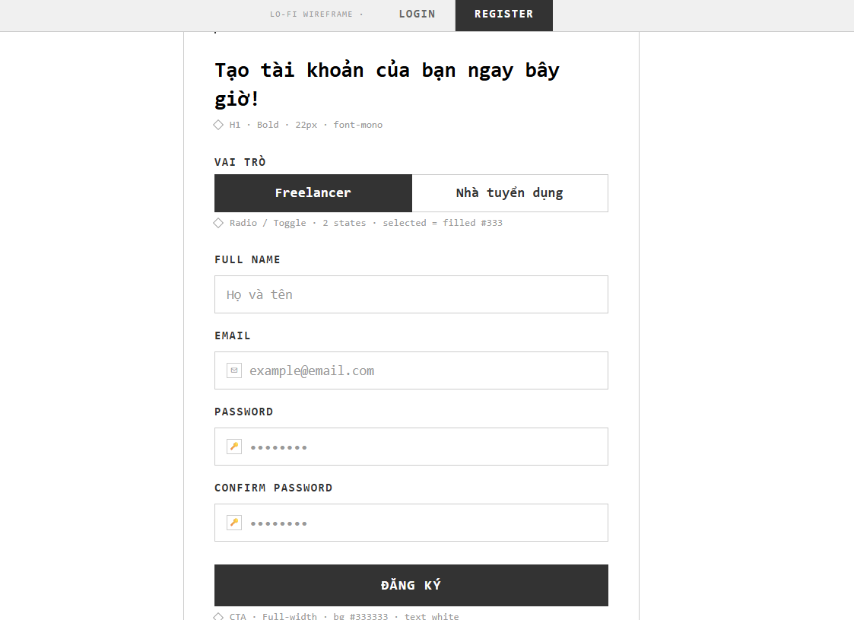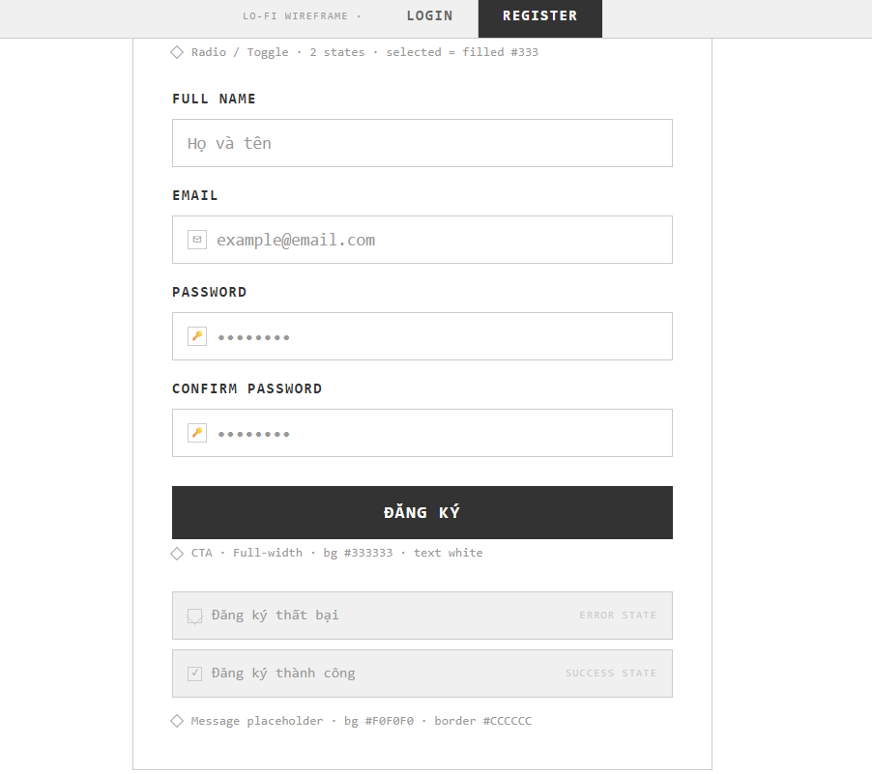

Field Name | Field Type | Description
Title | Heading | This field displays the main section headline: “Tạo tài khoản của bạn ngay bây giờ!”
Freelancer | Choice chip / Radio | Interactive toggle component button to choose the Seeker/Freelancer role for the account.
Nhà tuyển dụng | Choice chip / Radio | Interactive toggle component button to choose the Employer role for the account.
Tên người dùng | Input field | Rectangular text input field allowing the guest to enter their full name or display name.
Địa chỉ email | Input field | Rectangular text input field for entering a valid email address. Must follow the standard email format rules.
Mật khẩu | Input field | Secure rectangular input field allowing the user to set their password (masked format).
Nhập lại mật khẩu | Input field | Secure rectangular input field for the user to re-enter and confirm their chosen password.
Đăng ký | Button | Primary solid call-to-action button to submit the registration form parameters to the system.
Error Message | Text | Displays an inline or toast error message reading ”Đăng ký thất bại” when invalid inputs or system conflicts are detected.
Success Message | Text | Displays an inline or toast confirmation message reading “Đăng ký thành công” upon successful profile validation and creation.

Database Access
Table | CRUD | Description
Users | C | Insert a new account record with selected fields (username, email, password, role) into the user database table.
Users | R | Check for duplicate email references inside the database before executing the creation transaction.

- Inserting required registration data fields into the Users table

INSERT INTO Users (user_name, email, password, role, avatar_url, status, balance)
VALUES (?, ?, ?, ?, ?, 'active', 0.00);

- Verifying email uniqueness before account creation

SELECT COUNT(1) FROM Users WHERE email = ?;

Login
This use case allows registered Users (Patients, Doctors, and Admins) to authenticate themselves and access their customized dashboard workspaces by entering their credentials or utilizing third-party Google OAuth services.

UI Design
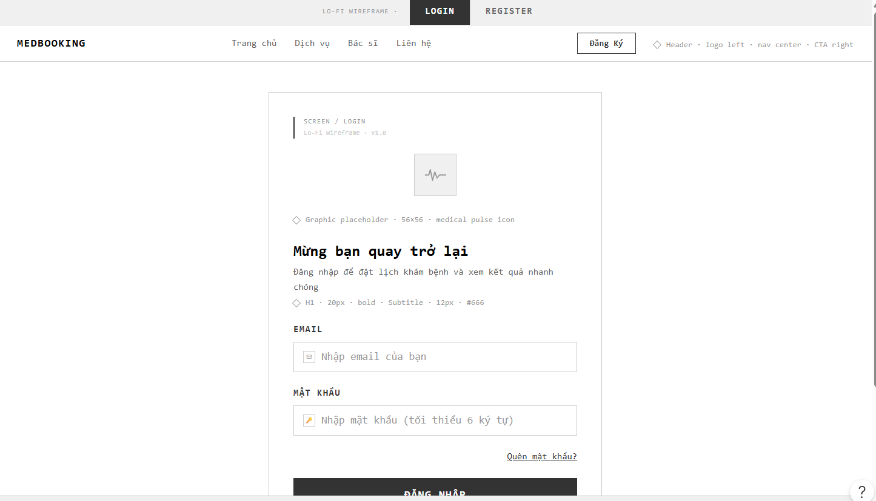

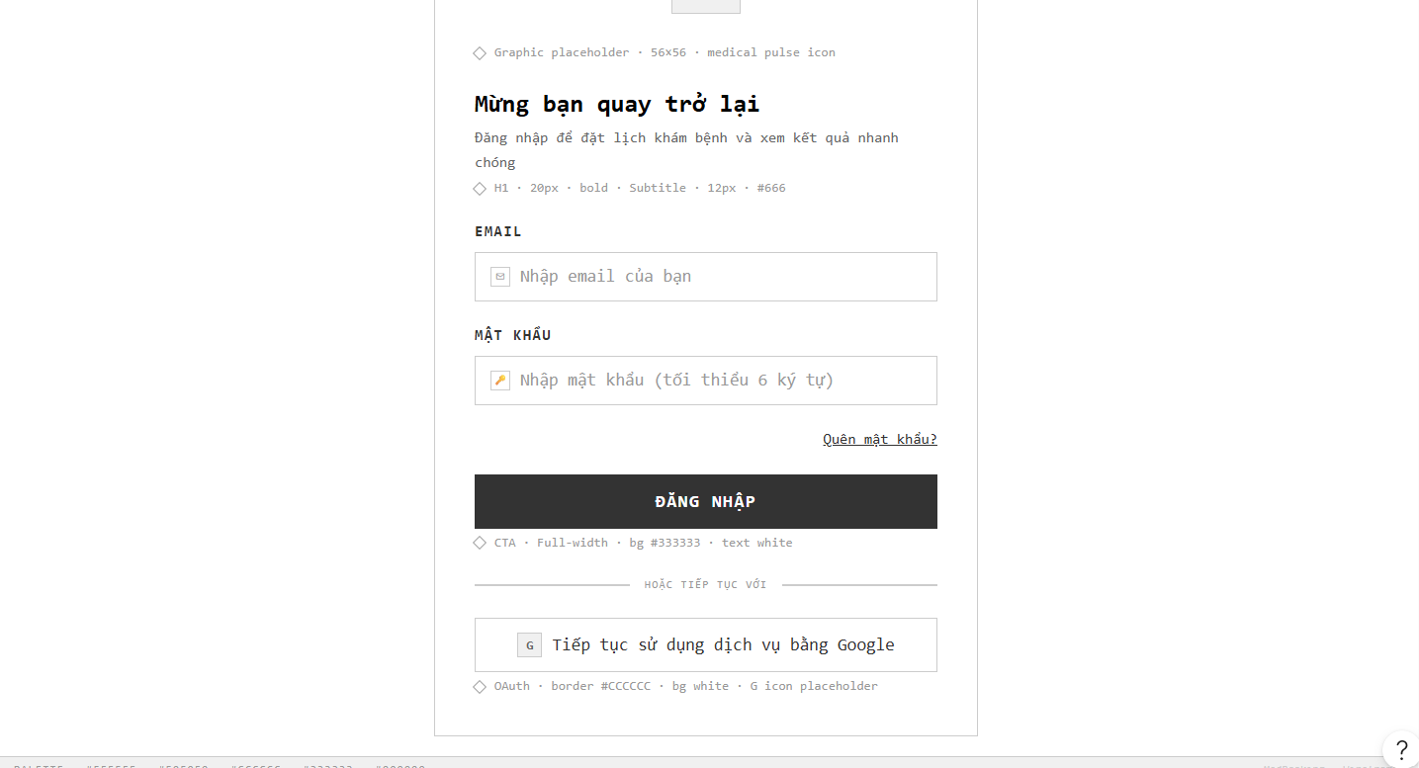

Field Name | Field Type | Description
Title | Heading | This field displays the dynamic section headline: “Chúng tôi rất vui được gặp lại bạn” hoặc “Mừng bạn quay trở lại”.
Subtitle | Text | Secondary instruction note placeholder: “Đăng nhập để đặt lịch khám bệnh và xem kết quả nhanh chóng”.
Địa chỉ email | Input field | Rectangular text input area with an email icon on the left, allowing the user to enter their registered email parameter.
Mật khẩu | Input field | Secure rectangular input area with a lock icon on the left, allowing the user to enter their password (minimum 6 characters masked layout).
Ghi nhớ mật khẩu | Check mark | Interactive tick-box option allowing users to preserve their active session cookies until token expiration.
Quên mật khẩu? | Hyperlink | Direct operational text link routing users to the automated OTP email password reset verification interface.
Đăng nhập | Button | Primary solid full-width capsule action button to execute the authorization credential match validation.
Đăng nhập bằng Google / Tiếp tục sử dụng dịch vụ bằng Google | Hyperlink / Button | Wide white framework button layout allowing instant secure login synchronization via third-party Google OAuth 2.0 services.
Error Message | Text | Displays a system alert notification reading ”Đăng nhập thất bại. Vui lòng kiểm tra lại thông tin” when credentials do not match.
Success Message | Text | Displays an automated system success notification reading ”Đăng nhập thành công” and triggers direct dashboard role routing.

Database Access
Table | CRUD | Description
Users | R | Match username and password entries to verify account existence and retrieve active state profiles.
Users | R | Check for email existence matching the returned Google OAuth token identifier key parameters.
Users | C | Auto-provision a new user account block row if a Google OAuth email registry does not yet exist in the platform system.

- Verifying user credentials matching the registered email and password hash parameters

SELECT user_id, user_name, email, role, status
FROM Users
WHERE email = ? AND password = ?;

- Checking for existing account parameters via a Google OAuth email lookup query

SELECT user_id, user_name, email, role, status
FROM Users
WHERE email = ?;

USES

Homepage
This use case allows users (Guests and logged-in Patients) to view platform statistics, overview core workflow steps, search for active medical specialists, and filter quick health criteria.

UI Design
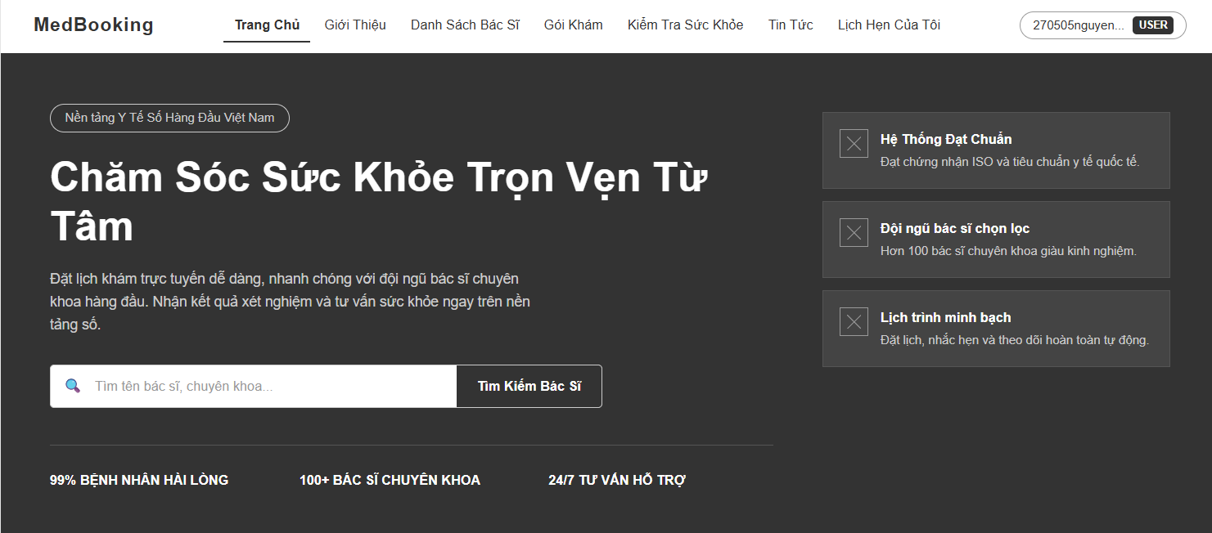
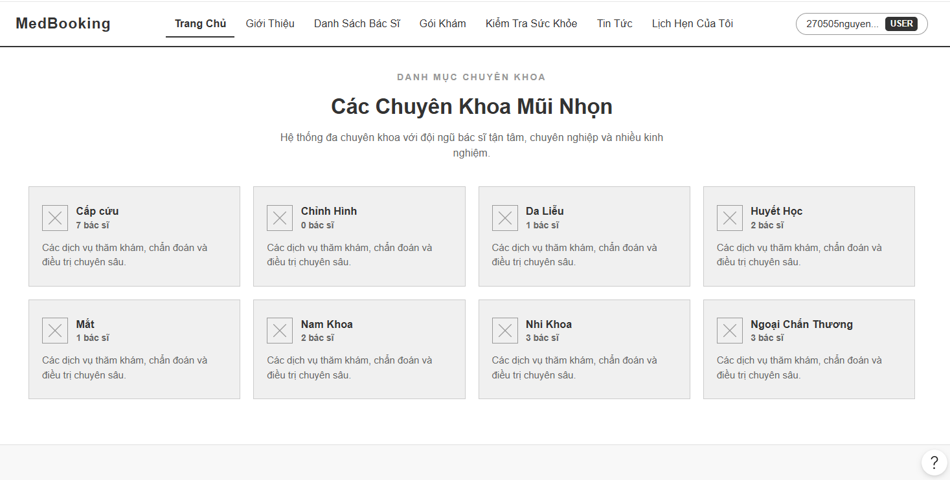
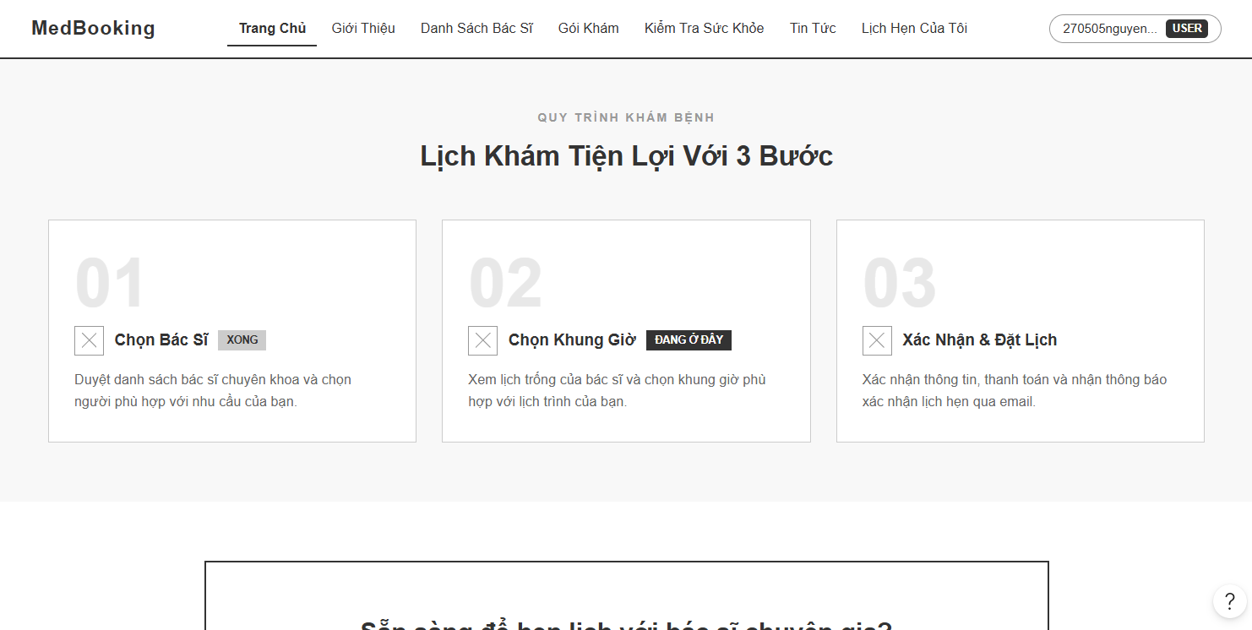
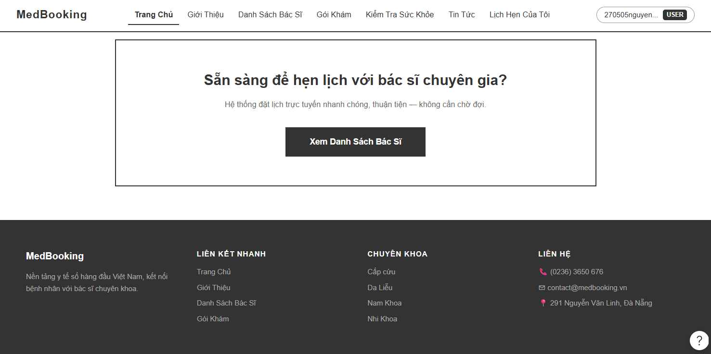

Field Name | Field Type | Description
Title | Heading | This field displays the core hero slogan: “Chăm Sóc Sức Khỏe Trọn Vẹn Từ Tâm”
Tìm tên bác sĩ, chuyên khoa... | Input field | Field to input full text query parameters such as physician name or general specialty group.
Tìm Kiếm Bác Sĩ | Button | Button to execute database query criteria based on the search query parameter.
Hệ Thống Đạt Chuẩn | Text block | Component box container displaying secure compliance infrastructure data.
Đội ngũ bác sĩ chọn lọc | Text block | Component box container displaying strict selection metrics for licensed specialists.
Lịch trình minh bạch | Text block | Component box container displaying real-time booking availability tracking data.
Bệnh nhân hài lòng | Text | Numeric database visualization field showing "99%" metric calculation.
Bác sĩ chuyên khoa | Text | Numeric database visualization field showing "100+" metric calculation.
Tư vấn hỗ trợ | Text | Static uptime service benchmark indicator field reading "24/7".

Database Access
Table | CRUD | Description
Doctors | R | Get complete filtered details of active physicians matching text parameter
Specialties | R | Fetch comprehensive list of core medical categories for the summary grid
Appointments | R | Pull aggregated status elements to compute runtime satisfaction metrics

- Get complete filtered details of active physicians matching text parameter

SELECT d.doctor_id, u.user_name, s.specialty_name, d.examination_fee
FROM Doctors d
JOIN Users u ON d.user_id = u.user_id
JOIN Specialties s ON d.specialty_id = s.specialty_id
WHERE u.user_name LIKE ? OR s.specialty_name LIKE ? AND u.status = 'active';
- Fetch comprehensive list of core medical categories for the summary grid

SELECT specialty_id, specialty_name, description, icon_url
FROM Specialties
WHERE is_active = 1;
- Pull aggregated status elements to compute runtime satisfaction metrics

SELECT COUNT(appointment_id) AS total_count
FROM Appointments
WHERE status = 'completed';

About Us
This use case allows users (Guests and logged-in Patients) to view the history, core background development values, and physical operational address credentials of the hospital system.

UI Design
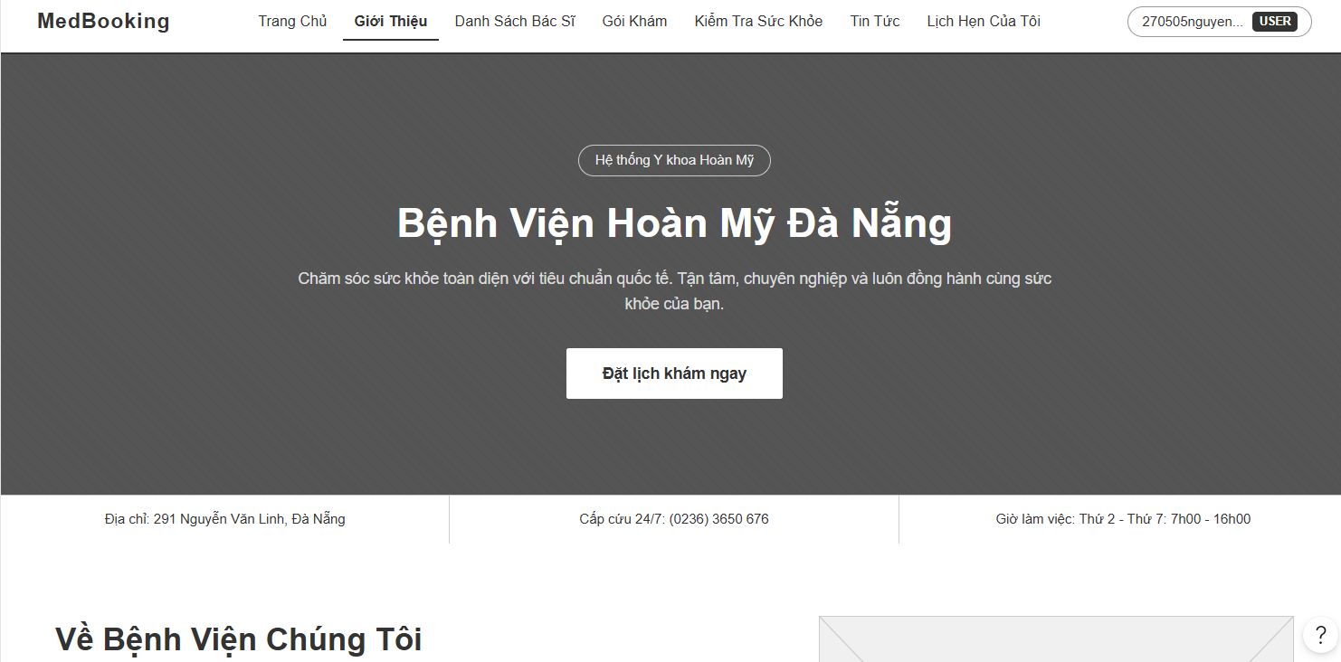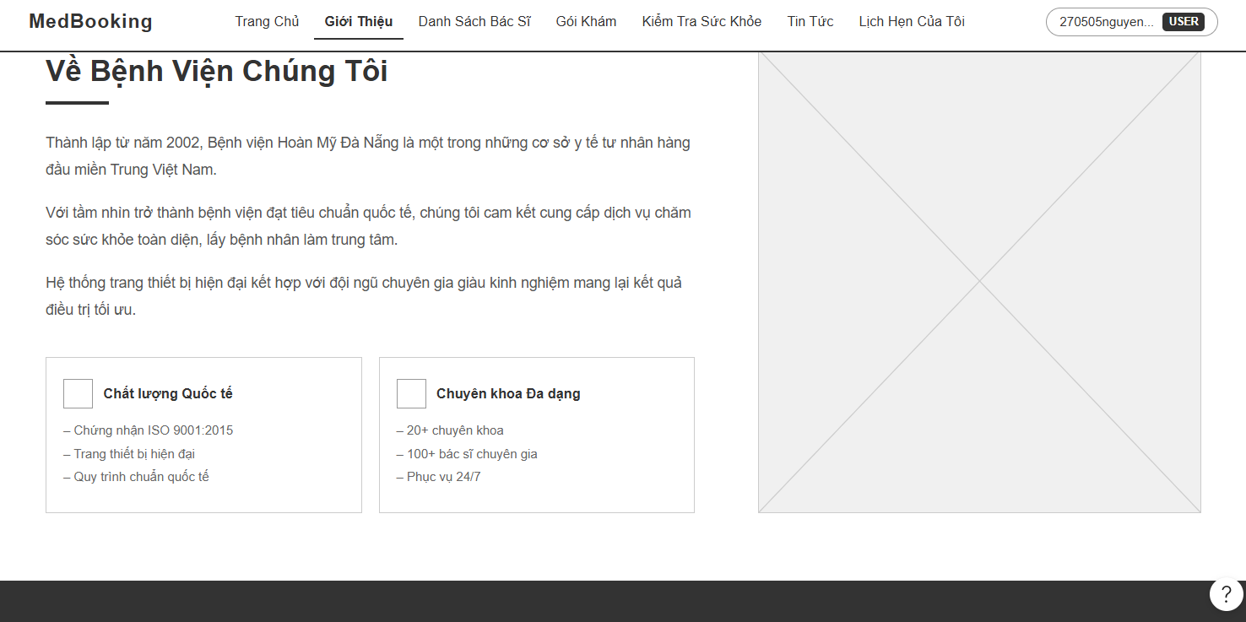

Field Name | Field Type | Description
Title | Heading | This field displays the main section headline: “Bệnh Viện Hoàn Mỹ Đà Nẵng”
Subtitle | Text | Page introduction abstract detailing standard global healthcare practices and dedicated visions.
Đặt lịch khám ngay | Button | Primary Call-To-Action button to redirect the user to the active Doctor Listing directory flow.
Địa chỉ | Text block | Component field visualizing physical coordinates data: “291 Nguyễn Văn Linh, Đà Nẵng”.
Cấp cứu 24/7 | Text block | Direct interactive urgent call routing field showing line indicator: “(0236) 3650 676”.
Giờ làm việc | Text block | Operational shift calendar data visualization reading: “Thứ 2 - Thứ 7: 7h00 - 16h00”.
Về Bệnh Viện Chúng Tôi | Heading | Subsection label anchoring detailed establishment narratives and development history data.
Chất lượng Quốc tế | Text block | Core values micro-card detailing standard evaluation and strict clinical parameters.
Chuyên khoa Đa dạng | Text block | Core values micro-card detailing comprehensive departments and flexible treatment solutions.

Database Access
Table | CRUD | Description
Departments | R | Fetch active hospital facility branches locations and contact metadata information
Specialties | R | Pull total count of distinct medical specialties to display available medical diversity

- Fetch active hospital facility branches locations and contact metadata information

SELECT department_id, name, location, contact_number, working_hours
FROM Departments
WHERE status = 'active' AND location LIKE N'%Đà Nẵng%';
- Pull total count of distinct medical specialties to display available medical diversity

SELECT COUNT(specialty_id) AS total_specialties
FROM Specialties
WHERE is_active = 1;

Doctor Listing and Filter
This use case allows users to search for medical specialists, filter doctors by distinct medical specialties, view basic credentials (experience, hospital branch), and navigate directly to the appointment scheduling interface.

UI Design

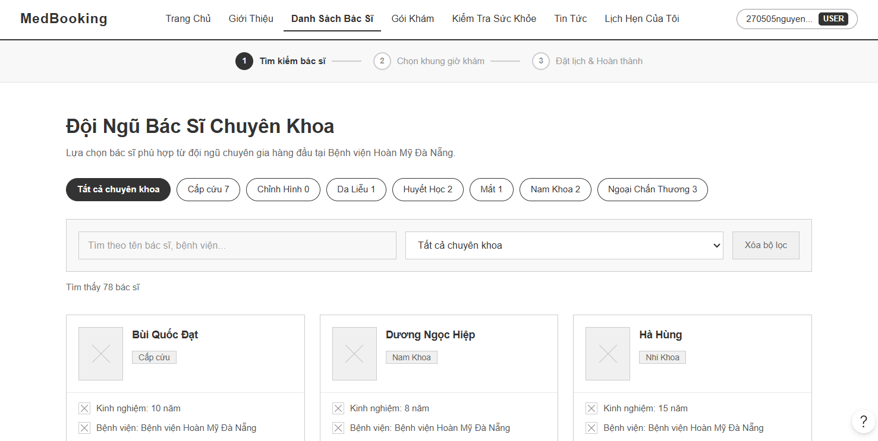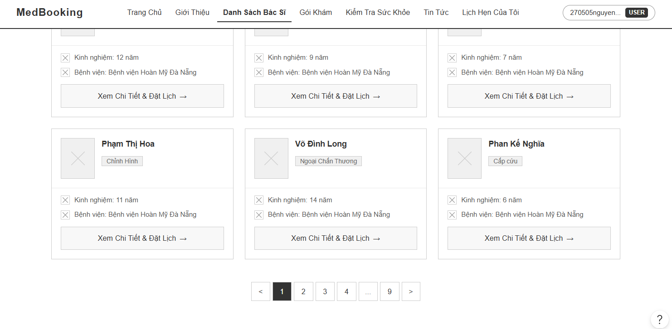
Field Name | Field Type | Description
Tìm kiếm bác sĩ | Progress Node | Step tracker ring circle container indicating that the user is currently on step 1 of the booking flow.
Title | Heading | This field displays the main directory headline: “Đội Ngũ Bác Sĩ Chuyên Khoa”
Specialty Chips | Radio Ribbon | Horizontal row of pill chips button components (e.g., “Tất cả chuyên khoa”, “Cấp cứu”, “Da Liễu”) to instantly filter doctors by category.
Tìm theo tên bác sĩ... | Input field | Rectangular search input query field allowing users to enter a text keyword for names or specific hospitals.
Tất cả chuyên khoa | Dropdown | Dropdown selection box to narrow down directory data parameters by standard specialty criteria.
Xóa bộ lọc | Button | Clear utility style click button to reset all active filtering selections to default states.
Tìm thấy... bác sĩ | Text | Dynamic counter indicator raw text block updating according to the current filtered result array length (e.g., "Tìm thấy 78 bác sĩ").
Doctor Portrait | Image placeholder | Rectangular image layer container acting as a placeholder for the physician’s professional portrait picture.
Specialty Tag | Label tag | Small contextual text capsule tag displaying the doctor's department assignment (e.g., “Nhi Khoa”, “Nam Khoa”).
Kinh nghiệm | Text | Information data line showing the number of active years in service (e.g., "Kinh nghiệm: 10 năm").
Bệnh viện | Text | Information data line fetching the target facility operational coordinates (e.g., "Bệnh viện: Bệnh viện Hoàn Mỹ Đà Nẵng").
Xem Chi Tiết & Đặt Lịch | Button | Prominent action link chevron button container to redirect the user profile node to the appointment date/time slot selection matrix.
Pagination Bar | Navigation Ribbon | Center-aligned horizontal pagination component layout row (<, active page 1, 2, 3, >, etc.) to browse multiple result indexes.

Database Access
Table | CRUD | Description
Doctors | R | Select complete records of doctors matching name, hospital keywords, and active specialty filters
Specialties | R | Pull list of active medical specialties alongside total system counts for category chips ribbon
Users | R | Join table user to pull active profile names, status values, and avatar picture URLs for cards

- Select complete records of doctors matching name, hospital keywords, and active specialty filters

SELECT d.doctor_id, u.user_name, s.specialty_name, d.experience_years, dept.name AS hospital_name, u.avatar_url
FROM Doctors d
JOIN Users u ON d.user_id = u.user_id
JOIN Specialties s ON d.specialty_id = s.specialty_id
LEFT JOIN Departments dept ON d.department_id = dept.department_id
WHERE (u.user_name LIKE ? OR dept.name LIKE ?)
AND (? IS NULL OR d.specialty_id = ?)
AND u.status = 'active'
ORDER BY d.experience_years DESC;

- Pull list of active medical specialties alongside total system counts for category chips ribbon

SELECT s.specialty_id, s.specialty_name, COUNT(d.doctor_id) AS total_doctors
FROM Specialties s
LEFT JOIN Doctors d ON s.specialty_id = d.specialty_id
WHERE s.is_active = 1
GROUP BY s.specialty_id, s.specialty_name;

Health Packages
This use case allows users to browse specialized health checkup packages, filter and search packages by target hospital facilities or keywords, view package pricing details (including deposit requirements), and initiate the package booking flow.

UI Design
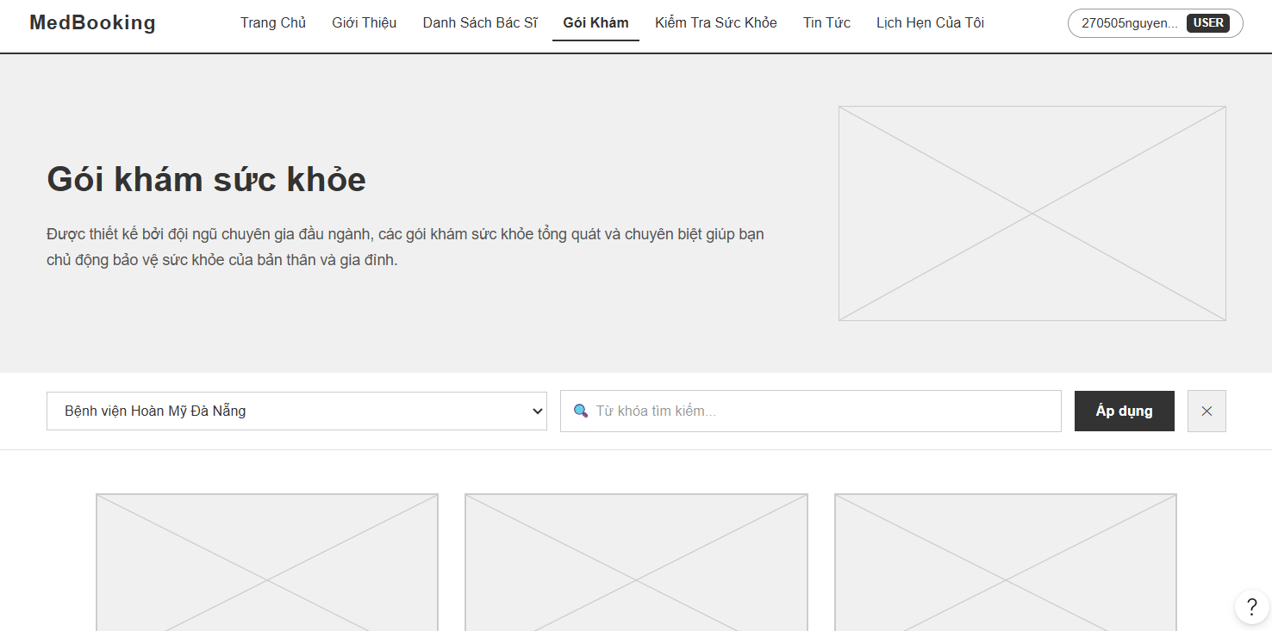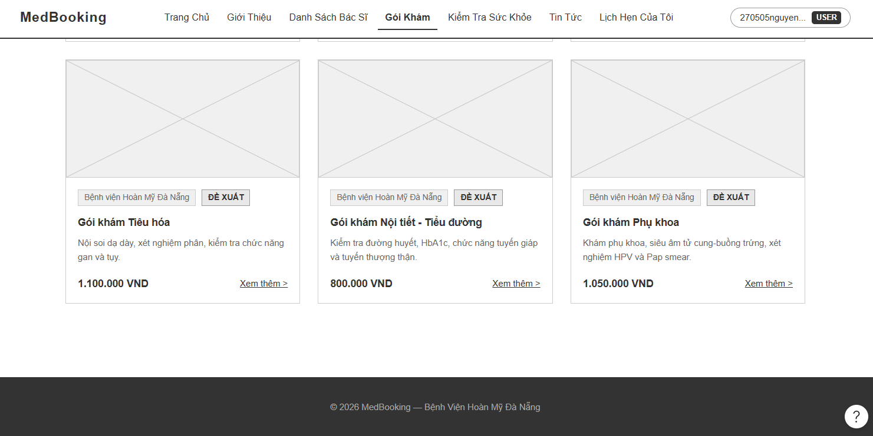

Field Name | Field Type | Description
Title | Heading | This field displays the main section hero headline: “Gói khám sức khỏe”
Subtitle | Text | Promotional abstract paragraph outlining dedicated clinical checkup packages designed by leading medical experts.
Gói khám Phổi - Lồng ngực... | Header Text | Main package identity text label displaying the specialized medical scope of the screening.
Bệnh viện Hoàn Mỹ Đà Nẵng | Dropdown | Dropdown selection query input bar allowing users to filter checkup criteria by specific hospital facility coordinates.
Từ khóa tìm kiếm... | Input field | Rectangular full-text search field area allowing users to enter custom medical keywords (e.g., Kidney, Heart, Liver).
Áp dụng | Button | Primary solid action trigger button to execute data matrix filtering based on selected hospital and keyword inputs.
ĐỀ XUẤT | Label tag | Small prominent contextual tag indicator badge overlaying on top-performing or recommended package card units.
Price Label | Text | Numeric database value display showing the complete package list price or flat service rate (e.g., "10.000 VND").
Giá niêm yết | Text | Static fee metric element anchoring the total official baseline checkup cost inside the package detailed card component.
Cọc giữ chỗ (20%) | Text / Shaded container | System-calculated monetary baseline displaying the fixed deposit requirement parameters (e.g., "1.000 đ" computed from the package price).
Đặt Lịch Ngay | Button | Prominent centered solid call-to-action capsule button to advance the user profile node directly into the active schedule reservation matrix.
Giới thiệu chung | Heading / Section | Subsection informational panel laying out clear medical scoping and targeted disease screening overview parameters.
Đối tượng phù hợp | Text block | Shaded structural box container displaying explicit patient profiling guidelines (e.g., recommended age brackets, diagnostic checkup routines).
Hướng dẫn chuẩn bị | Alert card block | Soft light-colored alert panel summarizing mandatory patient preparatory instructions prior to clinical samplings (e.g., fasting minimum 8 hours).
Dịch vụ bao gồm | List Grid | Matrix framework of bordered choice grids enumerating all explicit clinical service items bundled inside the package (e.g., Blood Test, X-Ray).
Chính sách hoàn/hủy cọc | Info box container | Bordered policy compliance container layout stating detailed standard regulations for transaction refunds based on cancellation windows (e.g., 24h rules).

Database Access
Table | CRUD | Description
Packages | R | Select complete records of available medical examination screening packages matching active facility and keyword query variables
Package_Services | R | Pull explicit clinical service items tied to a single parent package identity for the inclusion checkmark list
Departments | R | Join table to resolve branch identities, names, and contact records for proper package mapping definitions

- Select complete records of available medical examination screening packages matching active facility and keyword query variables

SELECT p.package_id, p.name AS package_name, p.price, p.description, p.target_audience, p.preparation_guidelines, d.name AS facility_name
FROM Packages p
JOIN Departments d ON p.department_id = d.department_id
WHERE (? IS NULL OR p.department_id = ?)
AND (p.name LIKE ? OR p.description LIKE ?)
AND p.is_active = 1;

- Pull explicit clinical service items tied to a single parent package identity for the inclusion checkmark list

SELECT service_id, service_name, category_type
FROM Package_Services
WHERE package_id = ? AND status = 'active'
ORDER BY sequence_order ASC;

- Fetch specific package pricing and computed deposit parameters for the booking summary panel

SELECT package_id, price, (price * 0.20) AS required_deposit
FROM Packages
WHERE package_id = ? AND is_active = 1;

Online Health Assessment
This use case allows users (Guests and logged-in Patients) to access automated medical screening utility tools, calculate standard health indexes (such as BMI), fill out standardized psychological screening surveys (PHQ-9, PSS-4), and receive instant clinical risk level warnings.

UI Design
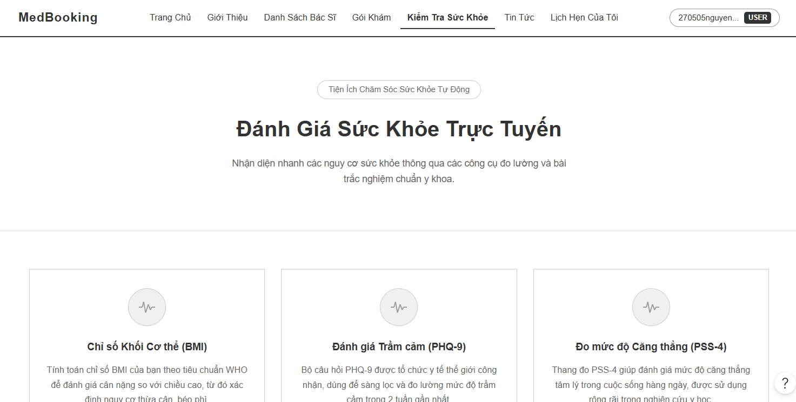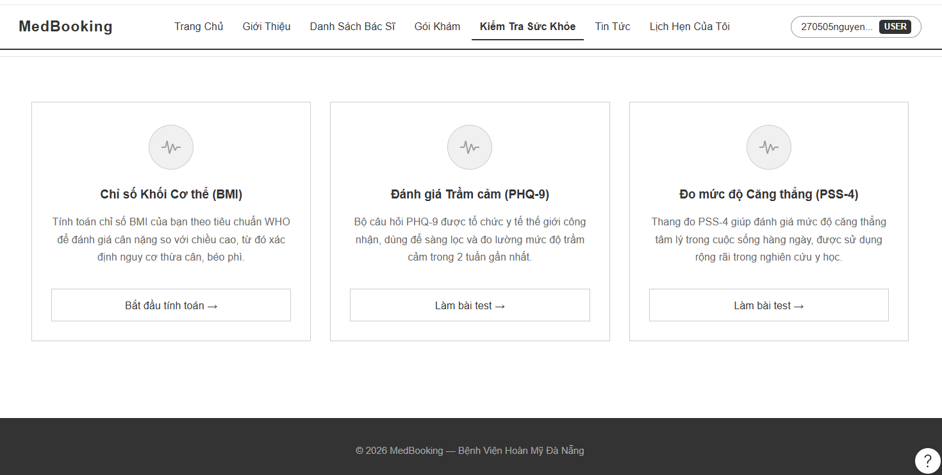

Field Name | Field Type | Description
Title | Heading | This field displays the main utility headline: “Đánh Giá Sức Khỏe Trực Tuyến”
Subtitle | Text | System description text block outlining automated medical tracking indexes and standardized clinical questionnaires.
Tiện Ích Chăm Sóc Sức Khỏe Tự Động | Label tag | Small prominent top ribbon pill capsule highlighting automated diagnostic utility features.
Chỉ số Khối Cơ thể (BMI) | Header Text | Utility card identity header text mapping the Body Mass Index calculation component module.
Đánh giá Trầm cảm (PHQ-9) | Header Text | Utility card identity header text mapping the standard 9-question clinical depression screening survey module.
Đo mức độ Căng thẳng (PSS-4) | Header Text | Utility card identity header text mapping the standard 4-question perceived stress scale metric module.
Card Body Description | Text block | Descriptive summary paragraphs outlining targeted screening metrics, input metrics requirements, or medical organization benchmark standards (e.g., WHO standards).
Bắt đầu tính toán | Button | Rounded framework call-to-action button to initiate the real-time biometric math calculation formula workspace.
Làm bài test | Button | Rounded framework call-to-action button to open the standardized step-by-step clinical assessment questionnaire modal sheet.

Database Access
Table | CRUD | Description
Assessment_Tools | R | Fetch complete metadata parameters, question data schemas, and baseline scoring scales for active checkup screening modules
Health_Books | C, R | Read historical patient metrics or create a new tracking record log entry to save completed assessment results directly into the patient's electronic health notebook database

- Fetch complete metadata parameters, question data schemas, and baseline scoring scales for active checkup screening modules

SELECT tool_id, name, type_category, description, scoring_matrix_json
FROM Assessment_Tools
WHERE is_enabled = 1;

- Create a new tracking record log entry to save completed assessment results directly into the patient's health notebook database

INSERT INTO Health_Assessment_Logs (health_book_id, tool_id, calculated_score, risk_classification_level, raw_responses_json, created_at)
VALUES (?, ?, ?, ?, ?, GETDATE());

Medical News and Blog
This use case allows users (Guests and logged-in Patients) to browse official medical articles, view disease prevention guidelines, toggle between external clinical news and internal updates, and read full verified article summaries directly synced from public health channels.

UI Design
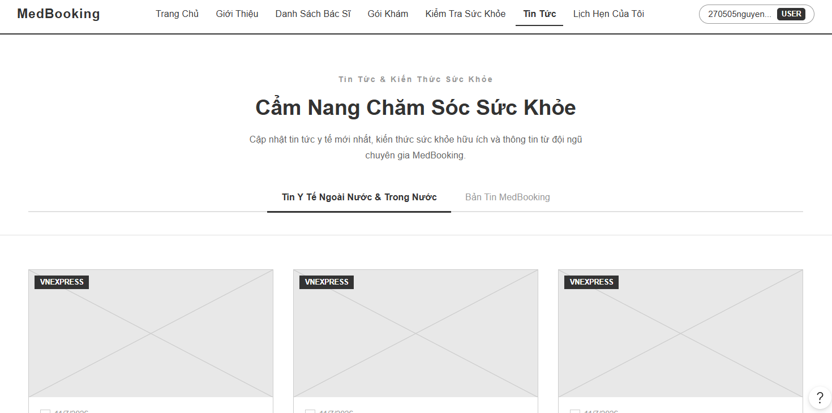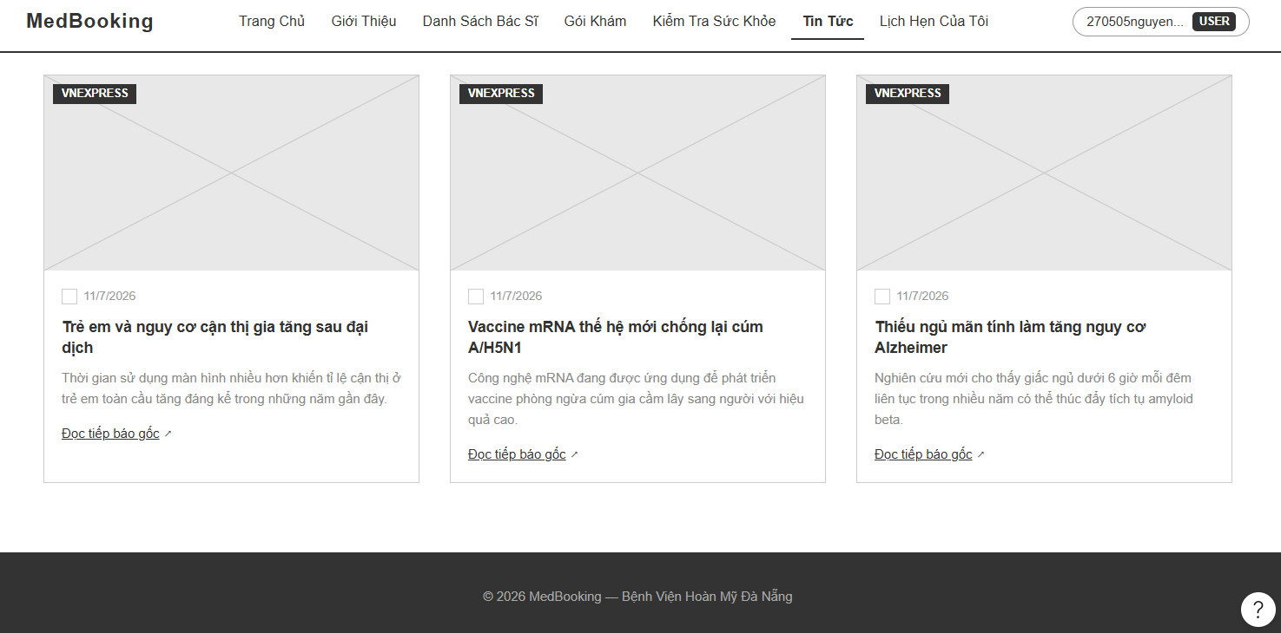

Field Name | Field Type | Description
Title | Heading | This field displays the main section blog headline: “Cẩm Nang Chăm Sóc Sức Khỏe”
Subtitle | Text | Secondary abstract line clarifying official clinical updates, epidemic warnings, and daily health notification feeds managed by the platform.
Tin Tức & Kiến Thức Sức Khỏe | Label tag | Small centered upper ribbon placeholder pill highlighting educational health catalog content.
Tin Y Tế Ngoài Nước & Trong Nước | Tab controller | Interactive active layout anchor button highlighted with an underline tab bar container to filter general medical press updates.
Bản Tin MedBooking | Tab controller | Interactive layout anchor button to switch the article array index feed exclusively to internal hospital announcements or custom epidemic alerts.
VNEXPRESS | Label tag | Solid dark alert tag indicator overlaying on top-left corner of the graphic frame to state the original publishing news channel source parameters.
Article Headline | Header Text | Strong headline block typography displaying the text title layout of the news entry (e.g., “Mang song thai, một trong một ngoài tử cung...”).
Article Snippet | Text block | Multi-line paragraph excerpt summary block visualizing a short introduction body of the medical document.
Date Stamp Field | Text notation | Light text field capturing explicit operational calendar timing matrices for the news release (e.g., “11/7/2026”).
Đọc tiếp báo gốc | Hyperlink | External navigation redirect link block with a small chevron arrow layout vector to open the raw complete official news website inside a separate tab.
Pagination Ribbon | Navigation Ribbon | Center-aligned horizontal pagination interface ribbon framework layout (<, active page item 1, 2, 3, >, etc.) to browse older blog posts.

Database Access
Table | CRUD | Description
Articles | R | Select complete records of verified articles, health tutorials, and system epidemic announcements matching categorized tab criteria and date matrix variables

- Select complete records of verified articles matching selected news category tabs

SELECT article_id, title, summary, content_url, source_publisher, thumbnail_url, publish_date
FROM Articles
WHERE type_category = ? AND is_published = 1
ORDER BY publish_date DESC, article_id DESC;

- Query older index rows filtering by runtime pagination parameter blocks

SELECT article_id, title, summary, thumbnail_url, publish_date
FROM Articles
WHERE is_published = 1
ORDER BY publish_date DESC
OFFSET ? ROWS FETCH NEXT ? ROWS ONLY;

My Appointments Dashboard
This use case allows logged-in Patients to track, monitor, and manage their personal appointment lifecycles. Users can filter checkup history by discrete status tabs (Pending Payment, Pending Approval, Confirmed, Completed, Cancelled/Expired) and initiate real-time telemedicine consultations directly from the feed list.

UI Design
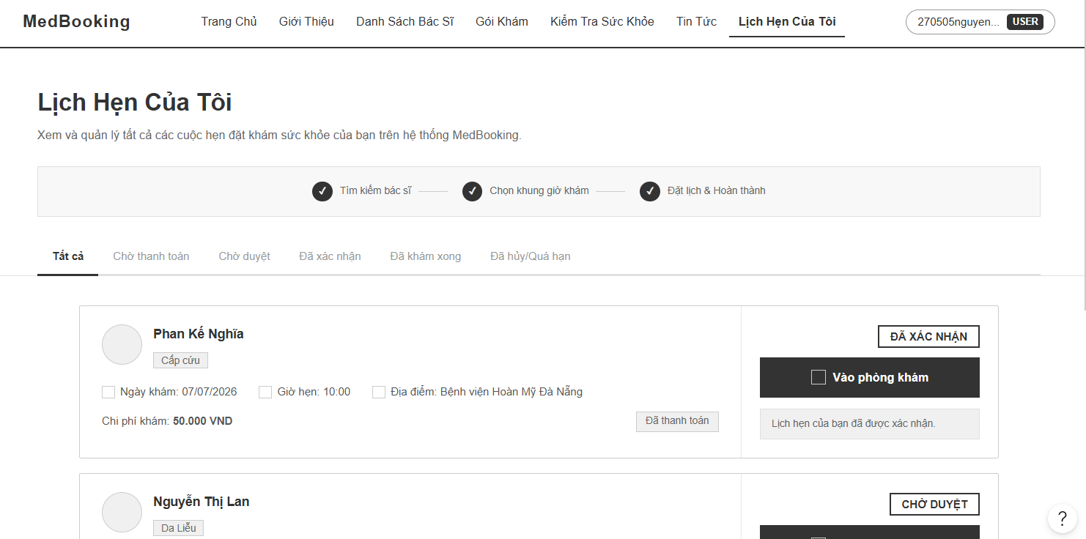
Field Name | Field Type | Description
Title | Heading | This field displays the main dashboard headline: “Lịch Hẹn Của Tôi”
Subtitle | Text | Overview paragraph outlining checking and management features for all healthcare reservation history logs.
Progress Watermark | Progress Node | A passive workflow status horizontal timeline tracker block mirrored from the active booking flow layout.
Tất cả | Tab controller | Master interactive selection tab button displaying the complete unstructured array feed of all appointment indexes.
Chờ thanh toán | Tab controller | Interactive filter tab button routing to pending deposit transaction records before the 15-minute checkout timeout.
Chờ duyệt | Tab controller | Interactive filter tab button routing to successful deposit checkups waiting for physician schedule approvals.
Đã xác nhận | Tab controller | Interactive filter tab button routing to active confirmed medical checkups within valid operational schedules.
Đã khám xong | Tab controller | Interactive filter tab button routing to historically completed examinations where final medical records have been issued.
Đã hủy/Quá hạn | Tab controller | Interactive filter tab button routing to cancelled records (by patient or doctor) or sessions expired due to payment timeout.
Doctor Name | Header Text | Strong text identity label displaying the assigned medical specialist name (e.g., “Phan Kế Nghĩa”).
Specialty Badge | Label tag | Small shaded text tag capsule capturing the target specialty department context (e.g., “Cấp cứu”).
Ngày khám | Text notation | Dynamic data line fetching explicit synchronized operational dates (e.g., “Ngày khám: 07/07/2026”).
Giờ hẹn | Text notation | Dynamic data line fetching explicit synchronized shift timing metrics (e.g., “Giờ hẹn: 10:00”).
Địa điểm | Text notation | Dynamic data line fetching explicit hospital facility branch coordinate strings (e.g., “Địa điểm: Bệnh viện Hoàn Mỹ...”).
Chi phí khám | Text label | Numeric database variable visualization tracking flat rates or complete checkup package fees (e.g., “Chi phí khám: 50.000 VND”).
Đã thanh toán | Label tag | Light gray/green shaded compliance status tag stating that deposit clearance was recorded successfully.
ĐÃ XÁC NHẬN | Header Status | Right-aligned uppercase text layout capsule visualizing the definitive structural record status parameter.
Vào phòng khám | Button | Prominent solid camera icon shortcut button to connect user profiles instantly into the active video call room session.
System Notice | Alert text block | Secondary soft caption note printing contextual automated guidelines (e.g., “Lịch hẹn của bạn đã được xác nhận.”).

Database Access
Table | CRUD | Description
Appointments | R | Select detailed matrix profiles of patient checkup reservations filterable by distinct lifecycle condition statuses
Doctors | R | Join table to pull full staff names and department identifiers for ticket banner headers
Specialties | R | Fetch specialty text definitions to map contextual capsule layout labels
Payments | R | Read matching transaction receipt logs to resolve deposit confirmation status parameters

- Select detailed checkup listings filtering by discrete active status tab criteria parameters

SELECT a.appointment_id, d.doctor_id, u.user_name AS doctor_name, s.specialty_name,
a.appointment_date, a.start_time, dept.name AS hospital_name,
a.status AS appointment_status, p.status AS payment_status, p.amount AS fee_amount
FROM Appointments a
JOIN Doctors d ON a.doctor_id = d.doctor_id
JOIN Users u ON d.user_id = u.user_id
JOIN Specialties s ON d.specialty_id = s.specialty_id
LEFT JOIN Departments dept ON d.department_id = dept.department_id
LEFT JOIN Payments p ON a.appointment_id = p.appointment_id
WHERE a.patient_id = ?
AND (? IS NULL OR a.status = ?)
ORDER BY a.appointment_date DESC, a.start_time DESC;

- Query telemedicine connection credentials for the interactive call room link router

SELECT appointment_id, status, video_room_url
FROM Appointments
WHERE appointment_id = ?
AND patient_id = ?
AND status = 'confirmed';

DOCTOR

Doctor Dashboard
This use case allows the authenticated Doctor to view real-time daily summary analytics metrics, check appointment trends, and view upcoming schedules.

UI Design
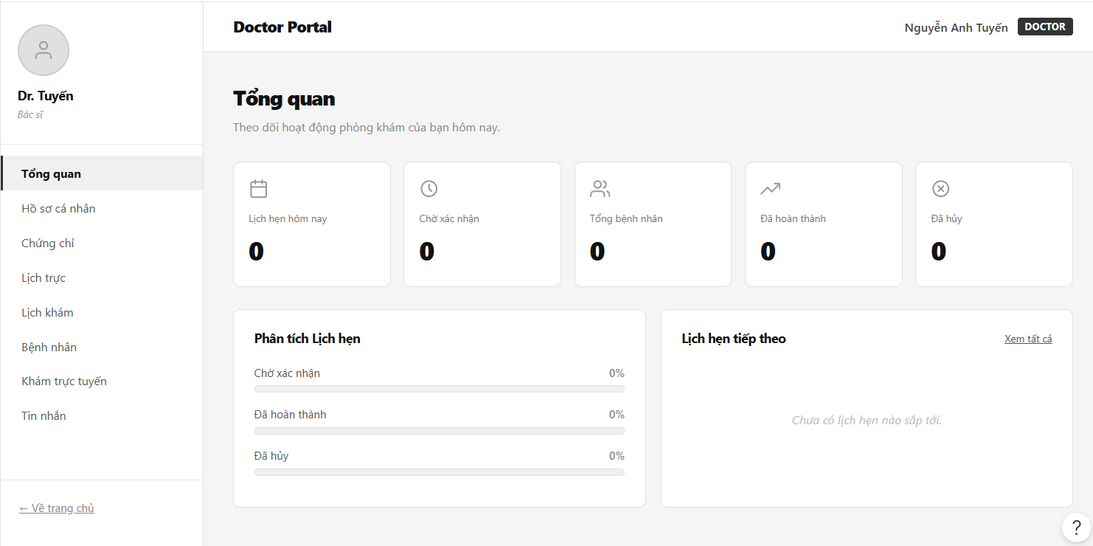
Field Name | Field Type | Description
Title | Heading | Main dashboard workspace header title reading: “Tổng quan”.
Subtitle | Text | Sub-description instruction: “Theo dõi hoạt động phòng khám của bạn hôm nay.”
Lịch hẹn hôm nay | Metric Card | Numerical display box showcasing the total count of scheduled checkups for the current date.
Chờ xác nhận | Metric Card | Numerical display box tracking the pending appointment request array size.
Tổng bệnh nhân | Metric Card | Numerical display box aggregating unique patient profile metrics under care.
Đã hoàn thành | Metric Card | Numerical display box tracking successfully processed medical examinations for the day.
Đã hủy | Metric Card | Numerical display box capturing the total canceled appointment records for the date.
Phân tích Lịch hẹn | Analytical Panel | Visual container displaying runtime status percentage bars (Pending, Completed, Canceled).
Lịch hẹn tiếp theo | Card Container | Quick preview dock displaying the immediate upcoming schedule details with a “Xem tất cả” utility router link.

Database Access
Table | CRUD | Description
Appointments | R | Aggregate status rows filtering by target doctor ID and current system date matrix to calculate performance variables.

- Aggregate status rows filtering by target doctor ID and current system date

SELECT status, COUNT(appointment_id) AS metric_count
FROM Appointments
WHERE doctor_id = ? AND CAST(appointment_date AS DATE) = CAST(GETDATE() AS DATE)
GROUP BY status;

Medical Profile Management
This use case allows the Doctor to modify public professional credentials, sync portrait directories, and update baseline treatment service pricing metrics.

UI Design
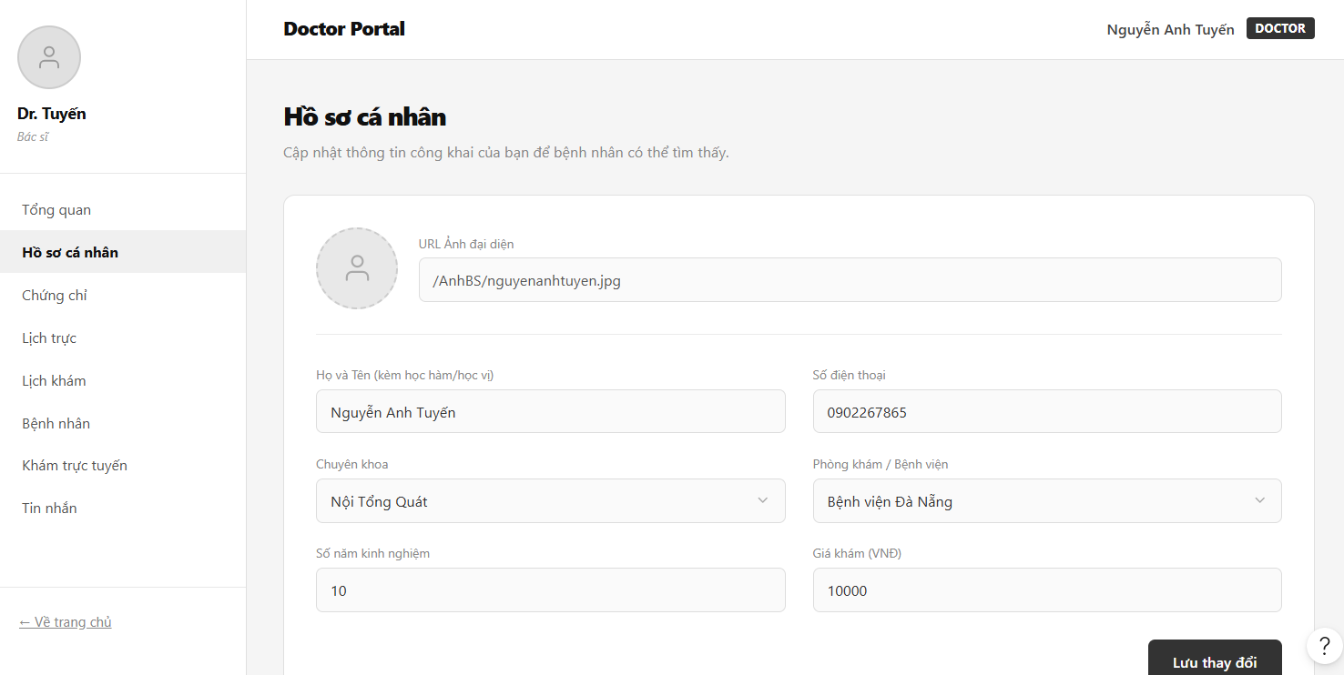
Field Name | Field Type | Description
Title | Heading | Section workspace header title reading: “Hồ sơ cá nhân”.
Subtitle | Text | System guidelines note reading: “Cập nhật thông tin công khai của bạn để bệnh nhân có thể tìm thấy.”
URL Ảnh đại diện | Input Field | Text field displaying the file directory routing reference to the professional portrait image.
Họ và Tên | Input Field | Text box entry containing the doctor’s official full name alongside academic titles placeholders.
Số điện thoại | Input Field | Text entry bar containing verified operational communication numbers.
Chuyên khoa | Dropdown | Select menu mapping the system's active licensed primary medical categories.
Phòng khám / Bệnh viện | Dropdown | Select menu locking facility assignment parameters to active hospital branches (e.g., “Bệnh viện Đà Nẵng”).
Số năm kinh nghiệm | Input Field | Numerical text field recording active clinical experience metrics.
Giá khám (VNĐ) | Input Field | Currency field adjusting the raw booking baseline fee parameter (e.g., “10000”).

Database Access
Table | CRUD | Description
Doctors | R, U | Pull current staff credentials or execute an update transaction to overwrite directory parameters.
Users | U | Overwrite synchronization metadata fields (names, phone records) inside the master identity log.

- Update medical credentials inside the Doctor metadata logs

UPDATE Doctors
SET specialty_id = ?, department_id = ?, experience_years = ?, examination_fee = ?
WHERE doctor_id = ?;

- Overwrite master account identity variables matching user reference keys

UPDATE Users
SET user_name = ?, phone_number = ?, avatar_url = ?
WHERE user_id = (SELECT user_id FROM Doctors WHERE doctor_id = ?);

Certification Catalog
This use case allows the Doctor to upload verified medical practice licenses, track educational degree institutions, and display official awards.

UI Design
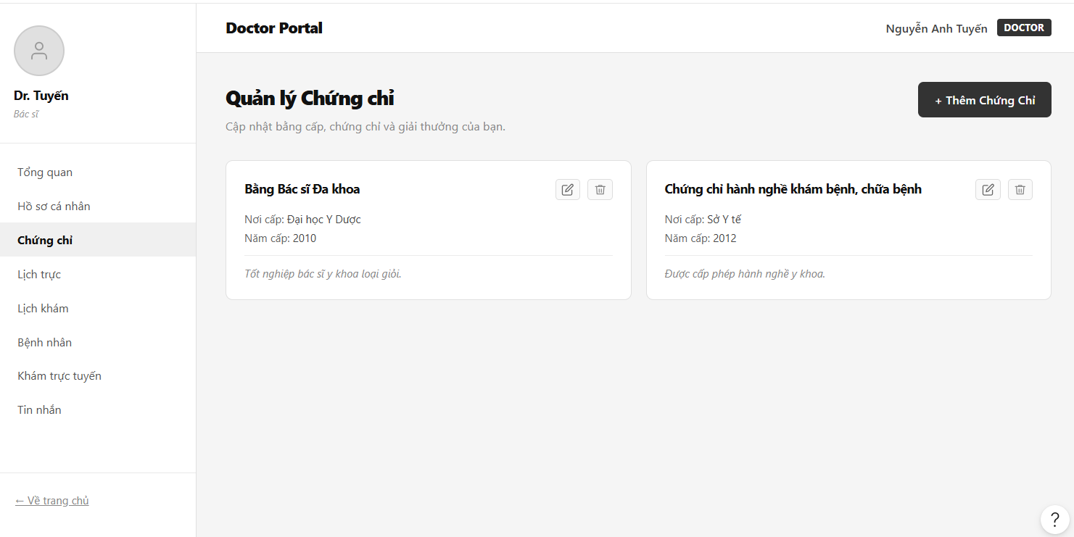
Field Name | Field Type | Description
Title | Heading | Section header title displaying: “Quản lý Chứng chỉ”.
Subtitle | Text | Dynamic micro-caption reading: “Cập nhật bằng cấp, chứng chỉ và giải thưởng của bạn.”
Thêm Chứng Chỉ | Button | Top-right solid clickable icon container button to append a new blank credentials modal record.
Bằng bác sĩ Đa khoa... | Card Header | Structural grid item container title detailing explicit certification names.
Nơi cấp | Text notation | Data row tracking the granting educational entity parameter (e.g., “Đại học Y Dược”).
Năm cấp | Text notation | Data row capturing the explicit validation release timestamp matrix (e.g., “2010”).
Edit Icon | Action Icon | Small click vector symbol layout to switch specific certification modules into active edit mode.
Trash Icon | Action Icon | Small click vector symbol layout to delete obsolete or invalid verification rows from the profile grid.

Database Access
Table | CRUD | Description
Certifications | C, R, U, D | Administer complete transactional catalog adjustments for certificates bound to the active doctor identity log.

- Query all active certifications bound to the requesting doctor account

SELECT certification_id, name, issuing_authority, graduation_year, description
FROM Certifications
WHERE doctor_id = ?;

Duty Schedule Configurator
This use case allows the Doctor to design flexible clinical availability blocks, configure daily work shifts, and clear operational hours.

UI Design
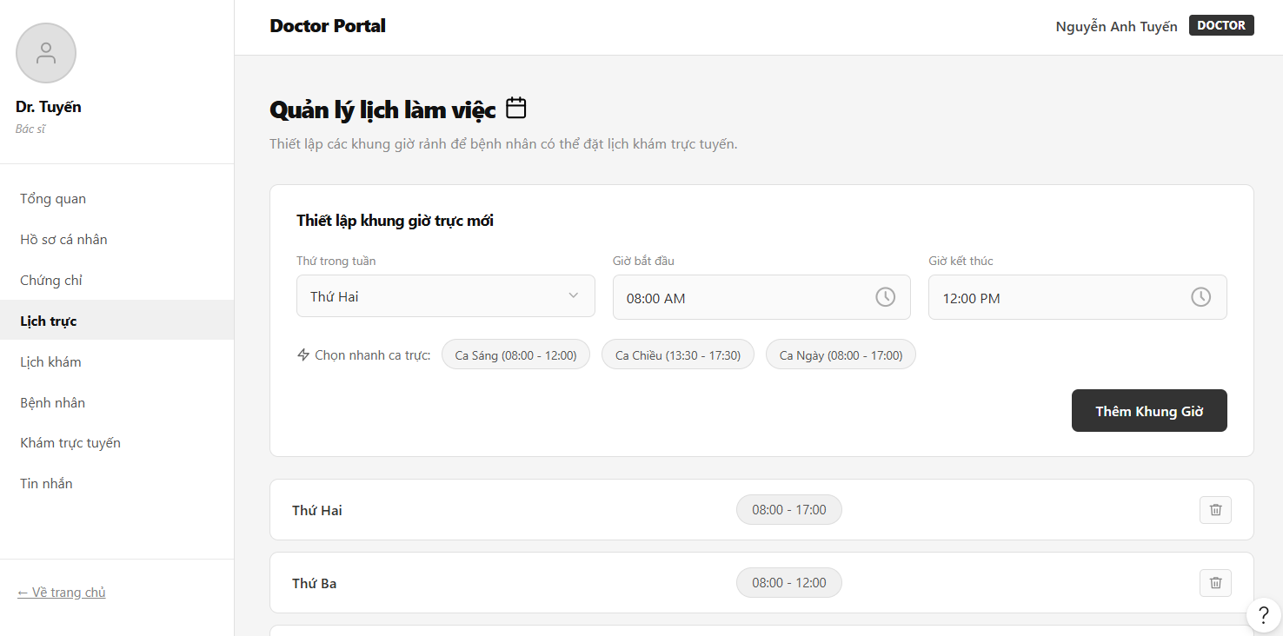
Field Name | Field Type | Description
Title | Heading | Section identity header text displaying: “Quản lý lịch làm việc”.
Subtitle | Text | Subtext instructions mapping out real-time schedule configurations for automated public booking visibility.
Thiết lập khung giờ trực mới | Heading | Field group boundary wrapping input selectors for compiling new duty shift metrics.
Thứ trong tuần | Dropdown | Select menu to pick target execution calendar days (e.g., “Thứ Hai”).
Giờ bắt đầu | Input Picker | Time-picker interface component capturing shift opening metrics (e.g., “08:00 AM”).
Giờ kết thúc | Input Picker | Time-picker interface component capturing shift closing metrics (e.g., “12:00 PM”).
Chọn nhanh ca trực | Quick Chips | Inline row segment shortcut blocks allowing instant shift adjustments (e.g., “Ca Sáng”, “Ca Chiều”).
Thêm Khung Giờ | Button | Primary solid trigger component button to insert the configured timeline row directly into the calendar database.
Card Calendar Grid | Dashboard Matrix | Multi-column grid array rows breaking down shifts day-by-day with small individual clear utility trash bins.

Database Access
Table | CRUD | Description
Doctor_Schedules | C, R, D | Insert new shift instances, query duty hours for display, or remove available appointment slots from public access.

- Insert a new configured duty shift time block row into the scheduler

INSERT INTO Doctor_Schedules (doctor_id, day_of_week, start_time, end_time, is_available)
VALUES (?, ?, ?, ?, 1);

Appointment Management Workspace
This use case allows the Doctor to review incoming booking streams, track request history queues, and update active appointment statuses.

UI Design
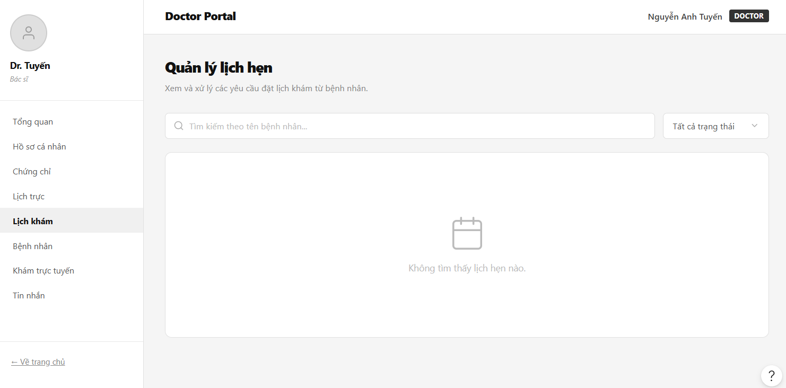
Field Name | Field Type | Description
Title | Heading | Functional section title display reading: “Quản lý lịch hẹn”.
Subtitle | Text | Descriptive operational directive label: “Xem và xử lý các yêu cầu đặt lịch khám từ bệnh nhân.”
Tìm kiếm theo tên bệnh nhân... | Input Field | Search text element filter tracking real-time character typing arrays matching patient files.
Tất cả trạng thái | Dropdown | Data matrix combo-box filter dividing active list feeds by current status values.
Bệnh nhân | Column Header | Table list column header layout classifying target consumer identity profiles.
Thời gian khám | Column Header | Table list column header layout classifying scheduled checkup shift dates and clock hours.
Trạng thái | Column Header | Table list column header layout classifying structural record system state codes.
Thao tác | Column Header | Table list column header layout anchoring active control triggers (Confirm, Decline, Postpone).
Không tìm thấy lịch hẹn nào | Empty State Box | Flat center-aligned graphic fallback illustration container triggered when the query array returns an empty index list.

Database Access
Table | CRUD | Description
Appointments | R, U | Pull descriptive reservation record sets matching search criteria parameters or append status state updates.

- Pull descriptive reservation record sets filterable by user name and status query matrices

SELECT a.appointment_id, u.user_name AS patient_name, a.appointment_date, a.start_time, a.status
FROM Appointments a
JOIN Patients p ON a.patient_id = p.patient_id
JOIN Users u ON p.user_id = u.user_id
WHERE a.doctor_id = ? AND (? IS NULL OR u.user_name LIKE ?) AND (? IS NULL OR a.status = ?);

Patient Roster Index
This use case allows the Doctor to view the historical patient base directory and open historical health records.

UI Design
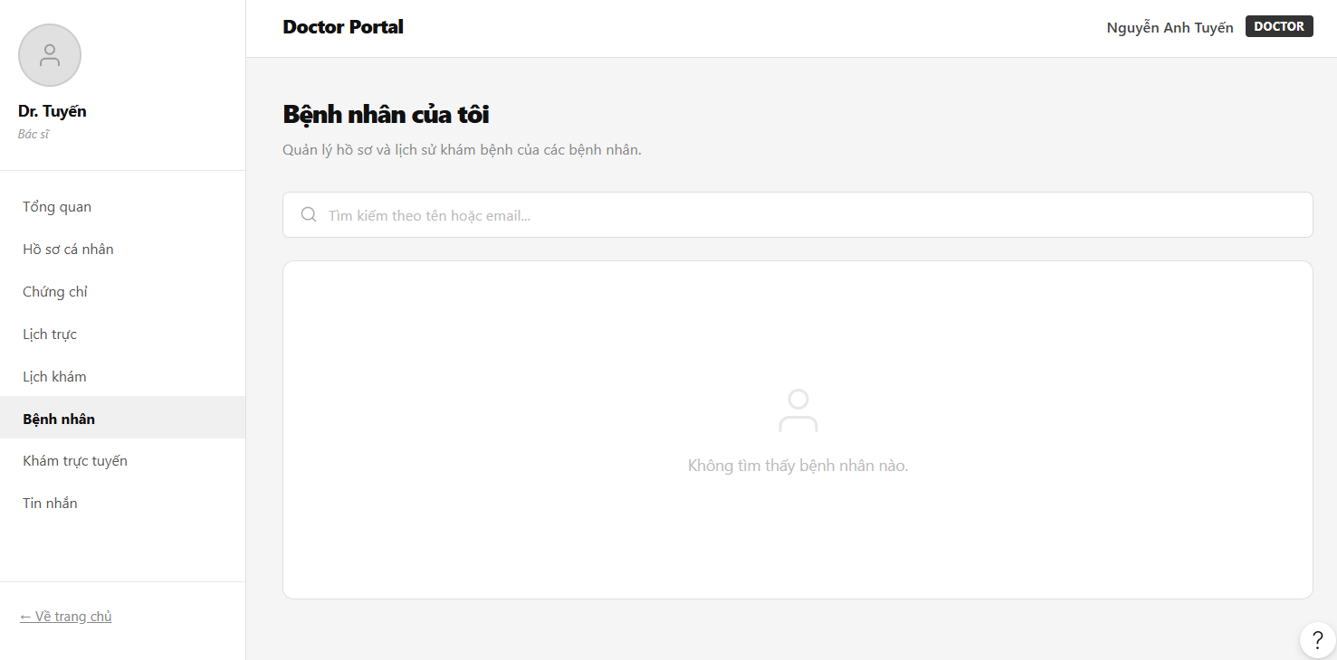
Field Name | Field Type | Description
Title | Heading | Main directory headline block reading: “Bệnh nhân của tôi”.
Subtitle | Text | Summary system guideline: “Quản lý hồ sơ và lịch sử khám bệnh của các bệnh nhân.”
Tìm kiếm theo tên hoặc email... | Input Field | Full-width filter layout text input query container filtering files by names or unique communication parameters.
Không tìm thấy bệnh nhân nào | Empty State Box | Center-aligned blank state fallback placeholder box container indicating zero database output results.

Database Access
Table | CRUD | Description
Patients | R | Pull structured identity dimensions of distinct patients who have completed historical checkups with the active staff ID.
- Query unique patient attributes linked via successfully completed historical appointments

SELECT DISTINCT p.patient_id, u.user_name, u.email, pat.blood_type, pat.medical_history
FROM Appointments a
JOIN Patients pat ON a.patient_id = pat.patient_id
JOIN Users u ON pat.user_id = u.user_id
WHERE a.doctor_id = ? AND a.status = 'completed' AND (u.user_name LIKE ? OR u.email LIKE ?);

Telemedicine Teleconsultation Room
This use case allows the Doctor to open active online consult streaming layers, check live room queues, and launch video room sessions.

UI Design
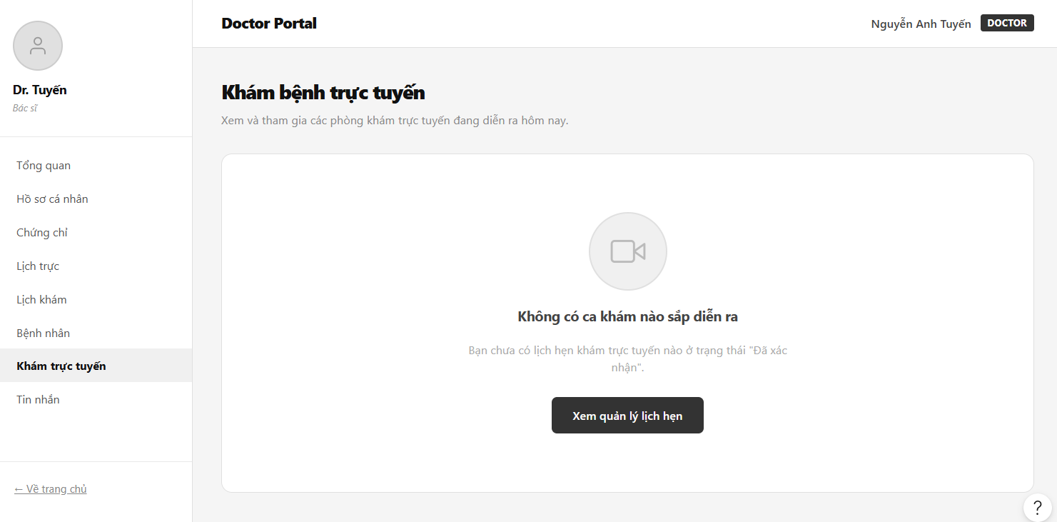
Field Name | Field Type | Description
Title | Heading | Real-time workspace title text displaying: “Khám bệnh trực tuyến”.
Subtitle | Text | Descriptive helper line: “Xem và tham gia các phòng khám trực tuyến đang diễn ra hôm nay.”
Không có ca khám nào sắp diễn ra | Empty State Box | Visual container panel alerting that no virtual channels match active confirmed time blocks.
Xem quản lý lịch hẹn | Button | Mid-aligned solid shortcut capsule navigation link to toggle the interface directly into the master Appointment Table grid.

Database Access
Table | CRUD | Description
Video_Calls | R | Fetch live room keys and virtual communication IDs active within the current system operational window.

- Fetch video room keys verified for current calendar schedules

SELECT v.video_call_id, a.appointment_id, u.user_name AS patient_name, v.room_token_string
FROM Video_Calls v
JOIN Appointments a ON v.appointment_id = a.appointment_id
WHERE a.doctor_id = ? AND a.status = 'confirmed' AND CAST(a.appointment_date AS DATE) = CAST(GETDATE() AS DATE);

In-App Messaging Panel
This use case allows the Doctor to conduct secure text consultations with patients, trace historical communication strings, and view attachment metadata streams.

UI Design
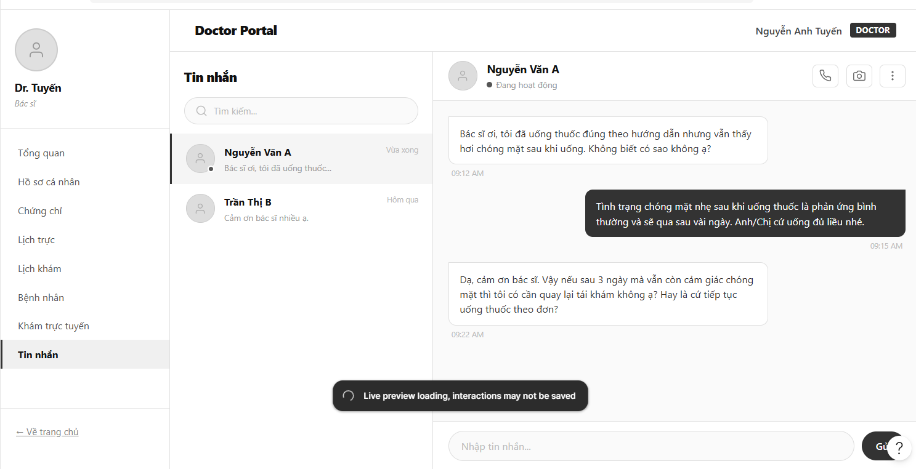
Field Name | Field Type | Description
Title | Heading | Left-column filter channel header text title: “Tin nhắn”.
Tìm kiếm... | Input Field | Small rectangular field container to browse text conversations by patient nickname rows.
Conversation Feed Row | Contact Ribbon | Multi-row listing tab mapping patient avatars, real-time online status indicators, and recent message snippets (e.g., “Vừa xong”).
Chat View Header | Workspace Top Bar | Identity banner rendering active conversation target names (e.g., “Nguyễn Văn A”) flanked by interactive shortcut dial icons (Phone, Camera, Settings).
Incoming Text Bubble | Chat bubble left | Soft light-gray shaded message container framing patient textual inputs with timestamp matrices (e.g., “09:12 AM”).
Outgoing Text Bubble | Chat bubble right | Solid color-filled message container anchoring physician response strings right-aligned across the window frame grid.

Database Access
Table | CRUD | Description
Messages | C, R | Query historical message blocks or append new incoming textual inputs into the appointment record.

- Fetch chronologically sorted text stream arrays belonging to a shared channel

SELECT message_id, sender_id, receiver_id, content, sent_time
FROM Messages
WHERE (sender_id = ? AND receiver_id = ?) OR (sender_id = ? AND receiver_id = ?)
ORDER BY sent_time ASC;

- Insert an outbound text message entry row into the communications feed table

INSERT INTO Messages (sender_id, receiver_id, content, sent_time, is_read)
VALUES (?, ?, ?, GETDATE(), 0);

ADMIN

Admin Dashboard Overview
This use case allows the System Administrator to monitor live operational metrics, view real-time appointment status analytics, and audit the most recent booking transactions across the platform.

UI Design
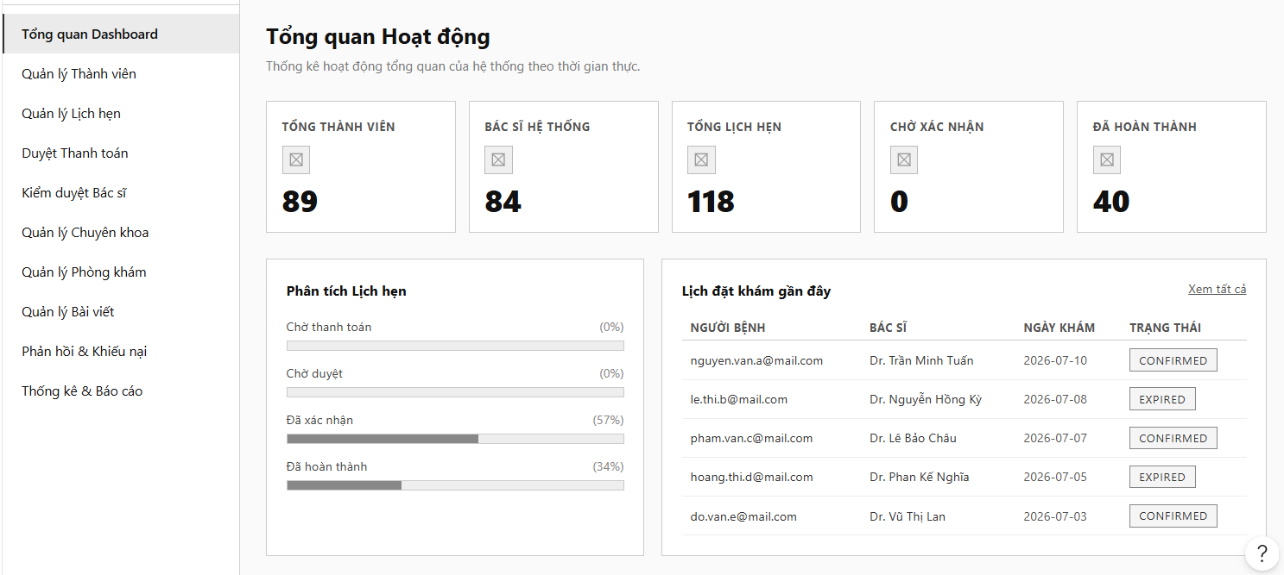

Field Name | Field Type | Description
Title | Heading | Main admin workspace header title reading: “Tổng quan Hoạt động”.
Subtitle | Text | Welcome instruction: “Chào mừng bạn quay lại. Dưới đây là báo cáo trực quan về hệ thống y tế.”
TỔNG THÀNH VIÊN | Metric Card | Numerical indicator card aggregating all registered user accounts (Patients/Doctors) with a subtext role note (e.g., “1 Quản trị viên”).
BÁC SĨ HỆ THỐNG | Metric Card | Numerical indicator card reflecting the size of the verified physician roster (e.g., “84 Đang liên kết tài khoản”).
TỔNG LỊCH HẸN | Metric Card | Numerical indicator card tracking total accumulated reservation database rows across all timelines.
CHỜ XÁC NHẬN | Metric Card | Urgent tracker card displaying appointments waiting for immediate doctor scheduling approvals.
ĐÃ HOÀN THÀNH | Metric Card | Success counter block aggregating completed clinical checkups where medical records were issued.
Phân tích Lịch hẹn | Analytical Panel | Visual breakdown row containing ratio percentage bars for each lifecycle state (Pending Payment, Pending, Confirmed, Completed).
Lịch đặt khám gần đây | Table Container | Spreadsheet grid compiling the most recent transactions with a “Xem tất cả” redirect link.
NGƯỜI BỆNH | Column Header | Data table cell mapping the patient's unique communication email account parameter.
BÁC SĨ | Column Header | Data table cell mapping the assigned medical specialist's full text name.
NGÀY KHÁM | Column Header | Data table cell displaying the scheduled examination calendar date grid.
TRẠNG THÁI | Column Header | Shaded structural capsule badge showing the current record lifecycle status code (e.g., “EXPIRED”, “CONFIRMED”).

Database Access
Table | CRUD | Description
Users | R | Count unique user registries grouped by structural systemic authorization roles.
Appointments | R | Pull total count metrics and fetch the top recent rows for the dashboard snapshot feed list.

- Calculate global metric aggregates for account registries and appointment counters

SELECT
(SELECT COUNT(user_id) FROM Users WHERE status = 'active') AS total_users,
(SELECT COUNT(doctor_id) FROM Doctors) AS total_doctors,
(SELECT COUNT(appointment_id) FROM Appointments) AS total_appointments;

- Query the most recent checkup requests for the real-time activity table feed

SELECT TOP 5 a.appointment_id, u.email AS patient_email, doc_u.user_name AS doctor_name, a.appointment_date, a.status
FROM Appointments a
JOIN Patients p ON a.patient_id = p.patient_id
JOIN Users u ON p.user_id = u.user_id
JOIN Doctors d ON a.doctor_id = d.doctor_id
JOIN Users doc_u ON d.user_id = doc_u.user_id
ORDER BY a.created_at DESC;

Member Account Directory
This use case allows the Administrator to audit registered accounts, verify doctor link credentials, toggle lifecycle lock states, and remove platform violators.

UI Design
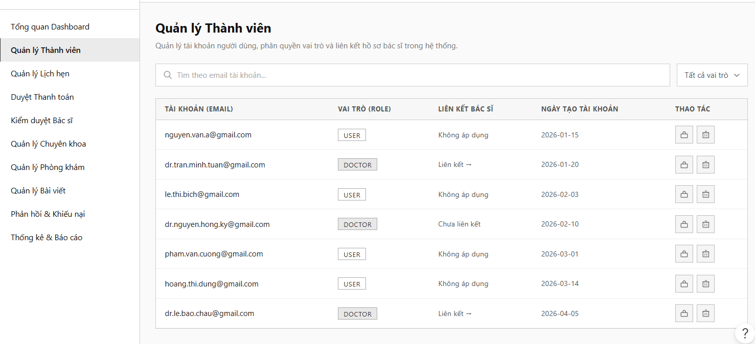

Field Name | Field Type | Description
Title | Heading | Section header title displaying: “Quản lý Thành viên”.
Subtitle | Text | Functional description: “Xem danh sách, phân vai trò, liên kết hồ sơ bác sĩ và xóa tài khoản thành viên.”
Tìm theo email tài khoản... | Input Field | Filter search element tracking full-text queries against registered user email dimensions.
Tất cả vai trò | Dropdown | Category combo-box to filter the account spreadsheet index by explicit credentials (USER, DOCTOR, ADMIN).
TÀI KHOẢN (EMAIL) | Column Header | Spreadsheet column header arranging user digital communication mail accounts.
VAI TRÒ (ROLE) | Column Header | Spreadsheet column header housing role identification capsule badges (e.g., “USER”, “DOCTOR”).
LIÊN KẾT BÁC SĨ | Column Header | Spreadsheet column header mapping relational database links to corresponding employee files (e.g., “Không áp dụng”, “Chưa liên kết”).
NGÀY TẠO TÀI KHÓAN | Column Header | Spreadsheet column header displaying the exact user registration calendar timestamp metrics.
THAO TÁC | Column Header | Operational action cell enclosing individual interactive lock icons and trash removal buttons.

Database Access
Table | CRUD | Description
Users | R, U, D | Query user lists matching filter matrices, update status blocks, or flag accounts as inactive.

- Query master account records matching text fields and role dimensions

SELECT u.user_id, u.email, u.role, u.created_at, u.status, d.doctor_id
FROM Users u
LEFT JOIN Doctors d ON u.user_id = d.user_id
WHERE (? IS NULL OR u.email LIKE ?) AND (? IS NULL OR u.role = ?)
ORDER BY u.created_at DESC;

Master Appointment Logs
This use case allows the Administrator to monitor all checkups across the network, analyze diagnostic notes, and manually override lifecycle status codes.

UI Design
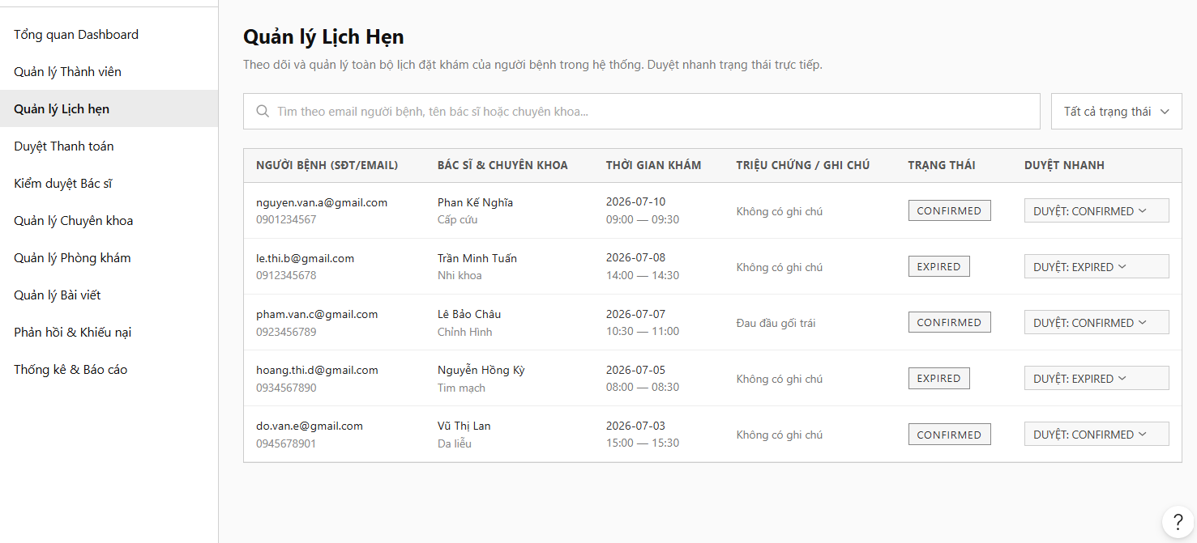

Field Name | Field Type | Description
Title | Heading | Main directory title reading: “Quản lý Lịch Hẹn”.
Subtitle | Text | Helper summary instruction: “Xem toàn bộ danh sách, lọc theo trạng thái, tìm kiếm người bệnh/bác sĩ và cập nhật tiến độ cuộc hẹn khám.”
Tìm theo email người bệnh... | Input Field | Large rectangular search field filtering row cells by patient emails, doctor names, or specialty keywords.
Tất cả trạng thái | Dropdown | Status controller dropbox layout sorting master lists by processing lifecycle codes (Pending Payment, Confirmed, Completed, etc.).
BÁC SĨ & CHUYÊN KHOA | Column Header | Table cell arranging the assigned doctor's full text name along with their specialized medicine label (e.g., “Bùi Quốc Đạt - Nhi Khoa”).
THỜI GIAN KHÁM | Column Header | Table cell assembling scheduling calendar timestamps along with 24h digital shift clock times.
TRIỆU CHỨNG / GHI CHÚ | Column Header | Table data cell displaying patient-submitted clinical notes (displays “Không có ghi chú” when cells are blank).
DUYỆT NHANH | Column Header | An administrative dropdown override component allows the manager to modify and update booking records instantly (e.g., “DUYỆT: EXPIRED”).

Database Access
Table | CRUD | Description
Appointments | R, U | Pull the comprehensive system appointment grid array or overwrite target status properties directly.

- Pull full multi-table unified appointment lists matching active filter controller nodes

SELECT a.appointment_id, pat_u.email AS patient_email, doc_u.user_name AS doctor_name, s.specialty_name,
a.appointment_date, a.start_time, a.symptoms_description, a.status
FROM Appointments a
JOIN Patients p ON a.patient_id = p.patient_id
JOIN Users pat_u ON p.user_id = pat_u.user_id
JOIN Doctors d ON a.doctor_id = d.doctor_id
JOIN Users doc_u ON d.user_id = doc_u.user_id
JOIN Specialties s ON d.specialty_id = s.specialty_id
WHERE (pat_u.email LIKE ? OR doc_u.user_name LIKE ? OR s.specialty_name LIKE ?)
AND (? IS NULL OR a.status = ?)
ORDER BY a.appointment_date DESC;

Bank Transfer Audit
This use case allows the Administrator to review manual patient bank transfers, match reference receipts, and release pending booking blocks.

UI Design
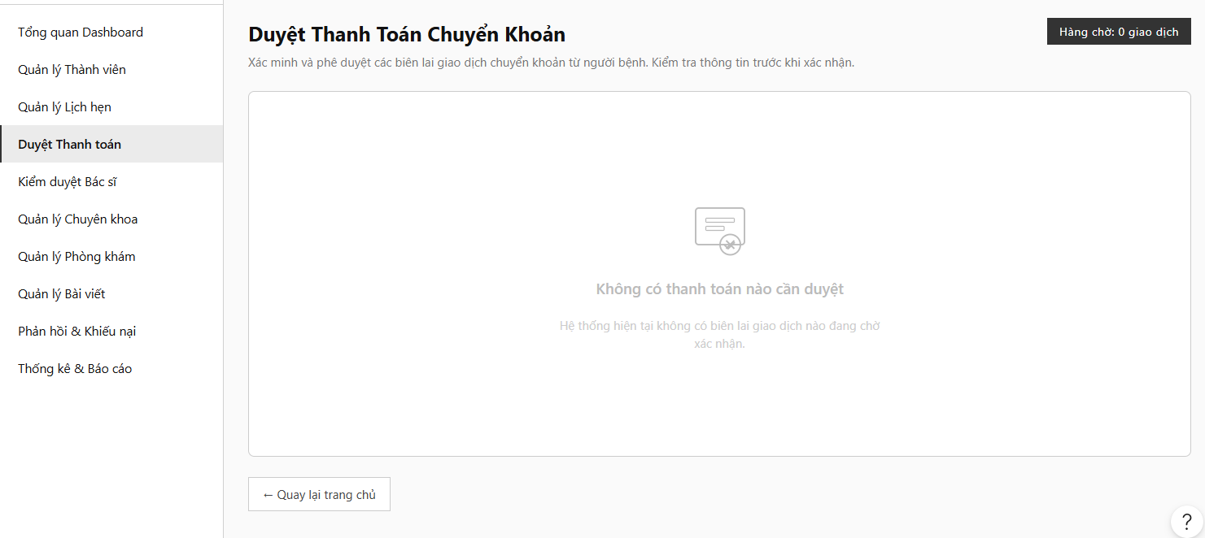

Field Name | Field Type | Description
Title | Heading | Verification layout section header: “Duyệt Thanh Toán Chuyển Khoản”.
Subtitle | Text | Operational directive: “Đối chiếu biên lai chuyển khoản ngân hàng của bệnh nhân và phê duyệt lịch hẹn khám.”
Hàng chờ:... giao dịch | Label tag | Top-right status informational capsule displaying the size of unverified payment slip arrays (e.g., “Hàng chờ: 0 giao dịch”).
Không có thanh toán nào... | Empty State Box | Flat large center-aligned dashboard fallback canvas framing a verification shield vector icon placeholder.
Sub-Message Field | Text | Supporting system notice text reading: “Hệ thống hiện tại không có biên lai giao dịch nào đang chờ xác nhận.”
Quay lại trang chủ | Button | Bottom-left direction utility icon capsule link button to exit the gateway manager panel.

Database Access
Table | CRUD | Description
Payments | R, U | Scan for unverified transaction slip rows (status = 'pending') or release payment locks upon clearance confirmation.

- Scan for transaction entries waiting for financial clearance

SELECT transaction_id, appointment_id, reference_code, amount, slip_proof_url, status
FROM Payments
WHERE payment_method = 'Bank_Transfer' AND status = 'pending'
ORDER BY created_at ASC;

Doctor Verification & Audit
This use case allows the Administrator to screen newly registered physician profile submissions, review medical background metrics, and grant system credentials.

UI Design
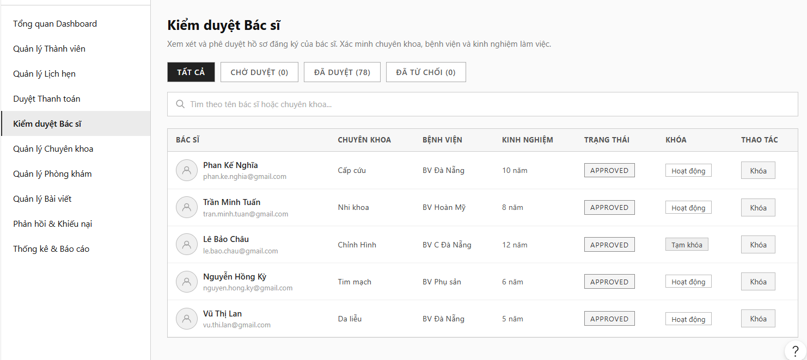

Field Name | Field Type | Description
Title | Heading | Section header title displaying: “Kiểm duyệt Bác sĩ”.
Subtitle | Text | Administrative task scoping label: “Quản lý danh sách bác sĩ đăng ký, phê duyệt, từ chối hoặc khóa tài khoản.”
CHỜ DUYỆT (0) | Tab controller | Horizontal segmented panel navigation option chip button tracking pending applications.
ĐÃ DUYỆT (78) | Tab controller | Horizontal segmented panel navigation option chip button tracking active permitted doctors.
KINH NGHIỆM | Column Header | Grid column logging the self-reported active service timeframe parameters (e.g., “10 năm”).
APPROVED | Label tag | Soft green rectangular clearance classification state indicator showing the doctor is fully verified.
Hoạt động | Button label | System toggle parameter display field recording active deployment status.
Khóa | Button | Functional action button layout row to freeze clinical profile visibility instantly.

Database Access
Table | CRUD | Description
Doctors | R, U | Fetch doctor profiles matching approval lifecycle stages or modify verified parameters.

- Select comprehensive doctor registration rows filterable by validation workflow states

SELECT d.doctor_id, u.user_name, u.email, s.specialty_name, dept.name AS facility_name, d.experience_years, u.status
FROM Doctors d
JOIN Users u ON d.user_id = u.user_id
JOIN Specialties s ON d.specialty_id = s.specialty_id
LEFT JOIN Departments dept ON d.department_id = dept.department_id
WHERE (? IS NULL OR u.status = ?) AND (u.user_name LIKE ? OR s.specialty_name LIKE ?)
ORDER BY u.created_at DESC;

Medical Specialties Management
This use case allows the Administrator to add new clinical specialty groups into the centralized system directory catalog, edit slug pathways, and track doctor counts.

UI Design
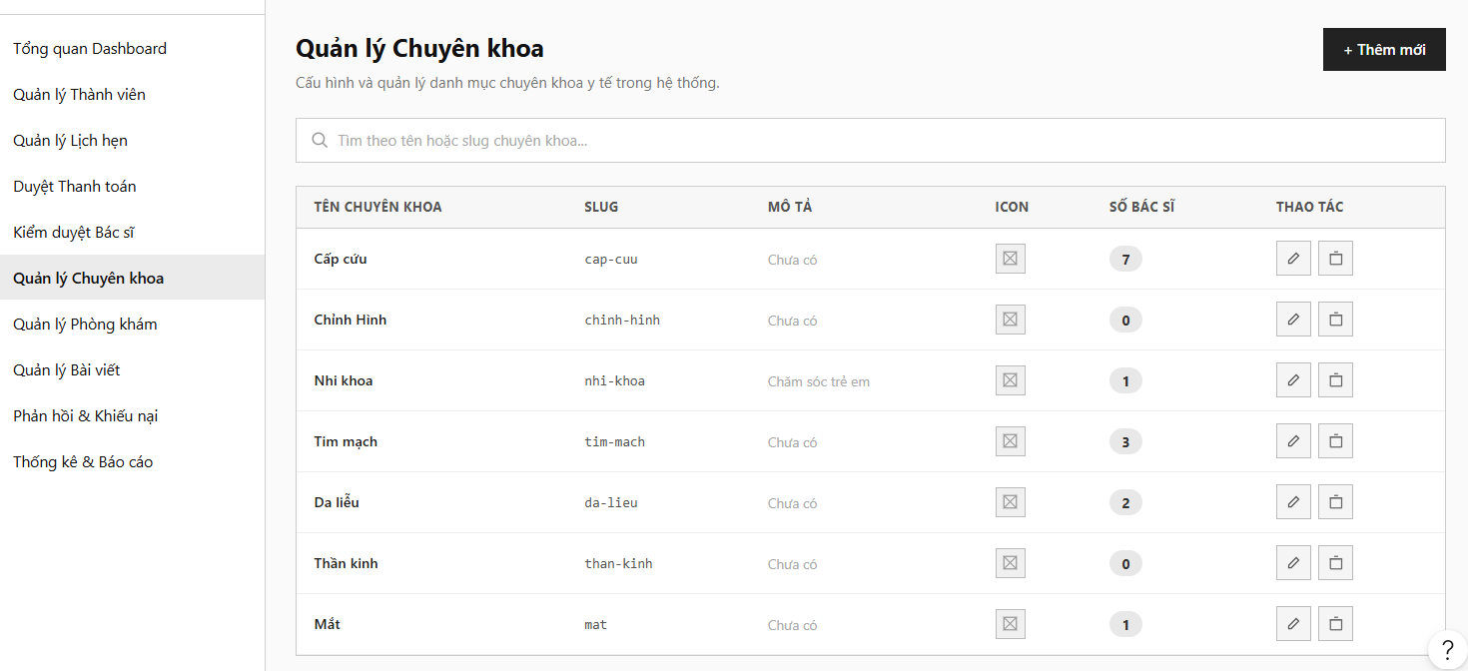

Field Name | Field Type | Description
Title | Heading | Configuration directory title reading: “Quản lý Chuyên khoa”.
Subtitle | Text | System tracking note: “Thêm, sửa, xóa các chuyên khoa y tế trong hệ thống.”
Thêm mới | Button | Top-right primary rectangular solid container button to summon a blank specialty insertion sheet modal.
Tìm theo tên hoặc slug... | Input Field | Search controller box tracing text parameters against specific data table records.
SLUG | Column Header | Table tracking column arranging clean web URL slug pathways (e.g., “cap-cuu”, “chinh-hinh”).
SỐ BÁC SĨ | Column Header | Table data cell displaying circular pill counters tracking the size of matching physician arrays (e.g., “7”, “0”).
Edit Icon | Action Icon | Miniature pencil block graphic selector to open active inline editing workflows.

Database Access
Table | CRUD | Description
Specialties | C, R, U, D | Administer complete relational entries managing core platform disease classifications and medical categories.

- Select all registered specialties alongside aggregated live physician deployment sizes

SELECT s.specialty_id, s.specialty_name, s.url_slug, s.description, s.icon_asset_path, COUNT(d.doctor_id) AS total_assigned_doctors
FROM Specialties s
LEFT JOIN Doctors d ON s.specialty_id = d.specialty_id
WHERE s.specialty_name LIKE ? OR s.url_slug LIKE ?
GROUP BY s.specialty_id, s.specialty_name, s.url_slug, s.description, s.icon_asset_path
ORDER BY s.specialty_name ASC;

Clinics & Facility Branches
This use case allows the Administrator to map network facility coordinates, publish clinical address locations, and monitor doctor capacities at each medical station.

UI Design
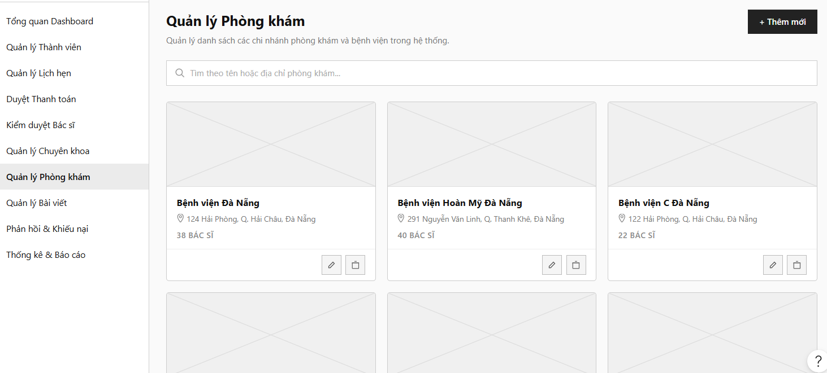

Field Name | Field Type | Description
Title | Heading | Section page headline: “Quản lý Phòng khám”.
Subtitle | Text | Description context label: “Thêm, sửa, xóa phòng khám trong hệ thống y tế.”
Thêm mới | Button | Top-right operational button trigger to create a new branch entry block.
Tìm theo tên hoặc địa chỉ... | Input Field | Full-width selector search input bar to match clinic database rows by branch strings.
Bệnh viện Đà Nẵng... | Header Text | Card node layout title string displaying the verified name coordinates of the medical center (e.g., “Bệnh viện Hoàn Mỹ Đà Nẵng”).
Address Line | Text field | Map pin graphic notation followed by physical operational addresses (e.g., “291 Nguyễn Văn Linh, Thạc Gián, Thanh Khê, Đà Nẵng”).
Staff Counter | Text | Small sub-text label displaying active doctor roster sizes mapped to the facility (e.g., “40 BÁC SĨ”).

Database Access
Table | CRUD | Description
Departments | C, R, U, D | Handle the data configuration flow for physical hospital buildings, facility locations, and branches.

- Fetch facility details coupled with total nested staff counts for the directory grid mapping

SELECT dept.department_id, dept.name AS branch_name, dept.location, COUNT(d.doctor_id) AS total_doctors_count
FROM Departments dept
LEFT JOIN Doctors d ON dept.department_id = d.department_id
WHERE dept.name LIKE ? OR dept.location LIKE ?
GROUP BY dept.department_id, dept.name, dept.location
ORDER BY dept.name ASC;

Content and Feedback Management
This use case allows the Administrator to manage the public blog article catalog, review medical checkup complaints, and issue resolution responses to patient accounts.

UI Design
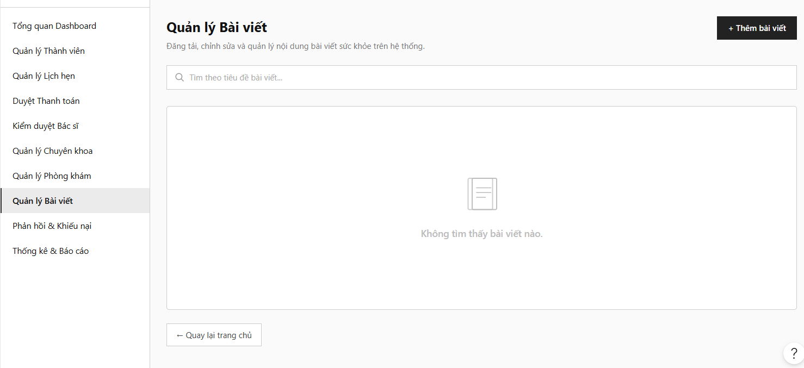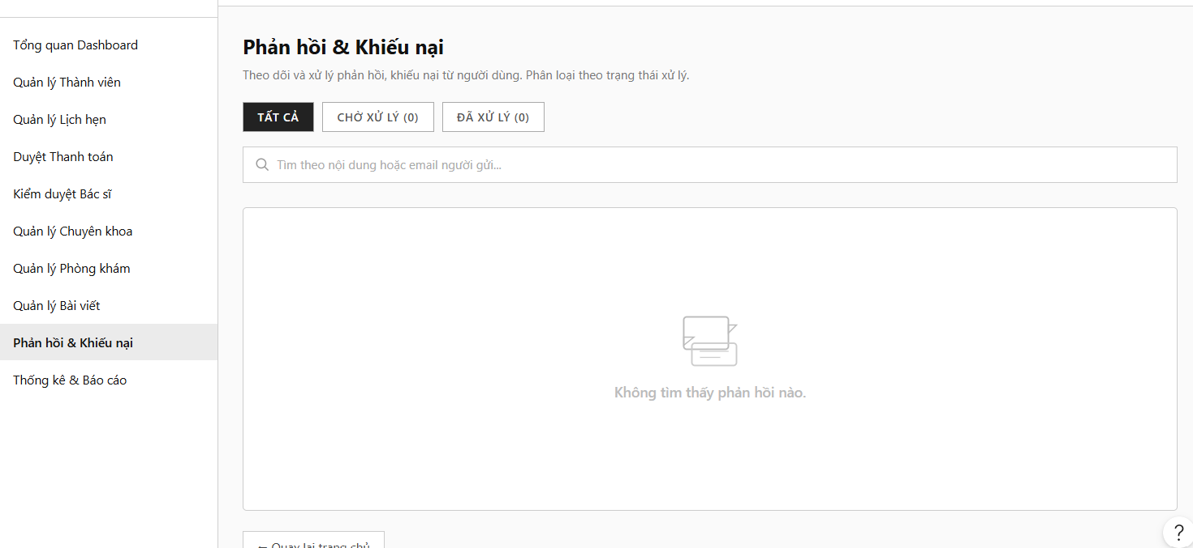
Field Name | Field Type | Description
Quản lý Bài viết | Sub-Section | Operational blog interface workspace heading reading: “Quản lý Bài viết”.
Thêm bài viết | Button | Top-right call-to-action button layout to spin up the text-editor engine sheet.
Phản hồi & Khiếu nại | Sub-Section | Active user support ticket section heading layout: “Phản hồi & Khiếu nại”.
CHỜ XỬ LÝ (0) | Tab controller | Segmented list row filter option button tracking unsolved open grievances.
ĐÃ XỬ LÝ (0) | Tab controller | Segmented list row filter option button tracking archived or resolved cases.
Tìm theo nội dung... | Input Field | Table text input placeholder filter searching entries by sender email addresses or ticket descriptions.
Fallback Icon | Icon placeholder | Center-aligned blank state fallback chat text bubble layout illustration.
Không tìm thấy phản hồi nào | Text label | Default text block alerting that zero customer complaint tickets match your query criteria.
Quay lại trang chủ | Button | Left-aligned system escape capsule navigation link to toggle dashboard view frameworks.

Database Access
Table | CRUD | Description
Articles | C, R, U, D | Audit or insert health tutorial publications or epidemic alert entries.
Complaints | R, U | Fetch consumer support rows or update resolution statement blocks to resolve issues.

- Query all submitted patient complaints filtering by matching handling states

SELECT complaint_id, appointment_id, title, description, status, created_at
FROM Complaints
WHERE (? IS NULL OR status = ?) AND (title LIKE ? OR description LIKE ?)
ORDER BY created_at DESC;

Statistics & Reports
This use case allows the System Administrator to view data visualization reports, track financial revenue, analyze monthly booking trends, monitor active physician performance, and audit new user registration rates over specific cyclical timeframes.

UI Design
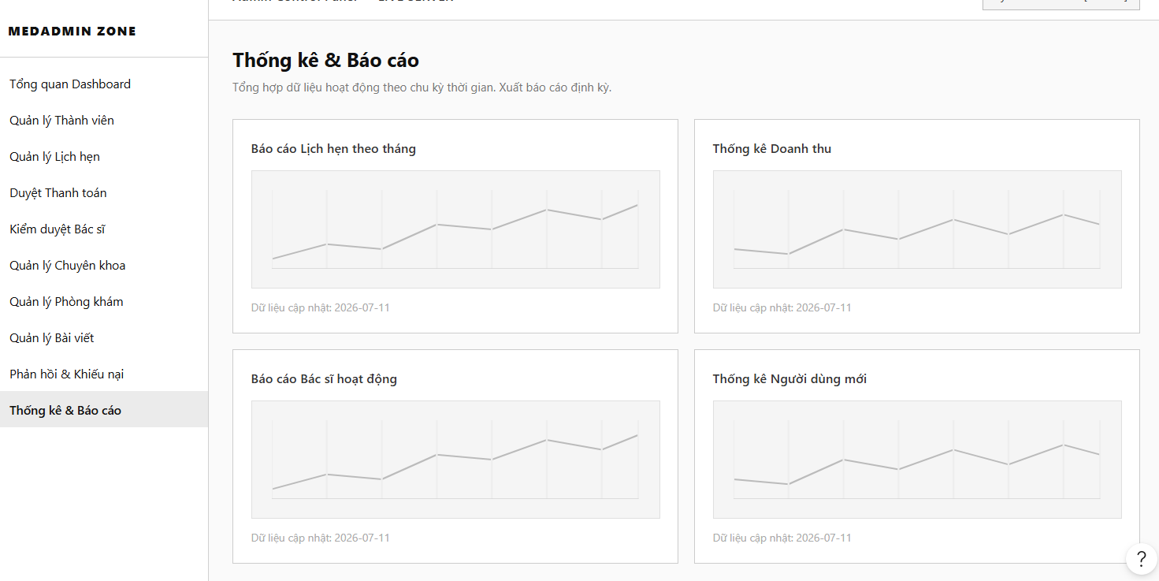
Field Name | Field Type | Description
Title | Heading | Main analytical panel workspace header title reading: “Thống kê & Báo cáo”.
Subtitle | Text | Functional description: “Tổng hợp dữ liệu hoạt động theo chu kỳ thời gian. Xuất báo cáo định kỳ.”.
Báo cáo Lịch hẹn theo tháng | Card Container | Data visualization box wrapping a line chart placeholder that displays monthly appointment count variations.
Thống kê Doanh thu | Card Container | Data visualization box wrapping a line chart placeholder that aggregates completed monetary transactions and checkup package revenues.
Báo cáo Bác sĩ hoạt động | Card Container | Data visualization box wrapping a line chart placeholder that tracks active medical specialists deployment patterns and examination completions.
Thống kê Người dùng mới | Card Container | Data visualization box wrapping a line chart placeholder that tracks new patient and user profile registration velocity.
Chart Canvas | Line Graph | Geometric wireframe vector chart areas rendering historical cyclical data analytics streams.
Dữ liệu cập nhật: 2026-07-11 | Text notation | Low-contrast timestamp label displaying the last database synchronization date matrix for the reports.

Database Access
Table | CRUD | Description
Appointments | R | Aggregate appointment database rows grouped by calendar months to compile checkup volume trends.
Payments / Transactions | R | Aggregate monetary data fields from completed digital transactions to calculate periodic net revenues.
Doctors | R | Query active verification profile logs to monitor operational healthcare workforce metrics.
Users | R | Group system account creations chronologically by signup timestamps to measure new user growth rates.

- Aggregate appointment counters grouped by calendar months for the line trend report

SELECT MONTH(appointment_date) AS checkup_month, COUNT(appointment_id) AS total_appointments
FROM Appointments
WHERE YEAR(appointment_date) = YEAR(GETDATE()) AND status = 'completed'
GROUP BY MONTH(appointment_date)
ORDER BY checkup_month ASC;

- Aggregate cleared checkup fees to compile periodic revenue statistics

SELECT MONTH(createdDate) AS revenue_month, SUM(amount) AS total_net_revenue
FROM [Transaction]
WHERE YEAR(createdDate) = YEAR(GETDATE()) AND status = 1 AND transactionType = 'Project Payment'
GROUP BY MONTH(createdDate)
ORDER BY revenue_month ASC;

- Group user profile creation instances chronologically to measure platform consumer growth rates

SELECT CAST(created_at AS DATE) AS registration_date, COUNT(user_id) AS new_users_count
FROM Users
WHERE created_at >= DATEADD(DAY, -30, GETDATE()) AND status = 'active'
GROUP BY CAST(created_at AS DATE)
ORDER BY registration_date ASC;

IV. Appendix

1. Assumptions & Dependencies
Assumptions:
- AS-1: Users will have stable internet access to utilize the JobTrans platform.
- AS-2: Users possess basic technological knowledge to navigate and use the platform's features effectively.
- AS-3: Employers and job seekers will actively participate and cooperate in the recruitment and application processes.
- AS-4: The information and data provided by users will be accurate and valid.
- AS-5: The approval and verification processes by the admin will be carried out promptly to maintain the platform's performance.
Dependencies:
- DE-1: The project relies on modern web technologies (HTML, CSS, JavaScript, and another technology) for developing the user interface.
- DE-2: The platform will utilize a database management system (such as MySQL) to store user information and job data.
- DE-3: Support from online payment service providers is required to facilitate financial transactions between users and the platform.
- DE-4: Need to cooperate with third-party services (such as GHTK) to transport the products that need to be submitted directly to customers.
- DE-5: The project will depend on software development partners to ensure that technical requirements are implemented correctly and according to the expected timeline.

2. Limitations & Exclusions
LI-1: Mobile Application: The initial release will not include a dedicated mobile application; the platform will be accessible only via web browsers.
LI-2: Multi-Language Support: The platform will initially support only one language (Vietnamese), with plans for additional languages in future releases.
LI-3: Advanced Analytics and Reporting: Comprehensive analytics and reporting features for both employers and job seekers will not be included in the initial releases.
LI-4: Integration with External Job Boards: The product will not support integration with third-party job boards or recruitment systems during the initial rollout.
LI-5: Social Media Sharing Features: Users will not be able to share job postings or applications on social media platforms in the initial release.
LI-6: Performance Metrics and Benchmarking: The platform will not offer built-in performance metrics or benchmarking tools for evaluating job applications or recruitment efficiency in the initial release.

3. Business Rules

ID | Category | Rule Definition
BR-01 | Validation | Notify Guest with MSG01 if they don't provide a valid email address when registering an account.
BR-02 | Validation | Notify User with MSG02 if they provide a password shorter than 8 characters during registration or password change.
BR-03 | Integrity | Notify Guest with MSG03 if the provided email has already been registered in the system.
BR-04 | Authorization | Notify User with MSG04 if login credentials are incorrect; notify with MSG05 and redirect by role (Patient / Doctor / Admin dashboard) if correct.
BR-05 | Validation | Notify User with MSG06 if the old password entered when changing password is incorrect.
BR-06 | Validation | Notify with MSG07 if the email is not registered, or MSG08 if the password reset OTP has been sent successfully.
BR-07 | Validation | Notify with MSG09 if the OTP entered is incorrect; notify with MSG10 and redirect to reset password form if correct.
BR-08 | Validation | Notify User with MSG11 if the re-entered password during reset does not match the new password.
BR-09 | Validation | Notify User with MSG26 if the new password entered in Change Password is the same as the current password.
BR-10 | Authorization | Only approved Doctors (status = 'approved') can receive appointment bookings from Patients.
BR-11 | Structural | A Doctor must have at least one active schedule (Doctor_Schedules.is_available = TRUE) before Patients can book an appointment with them.
BR-12 | Integrity | An appointment can only be booked for a schedule slot that is still available (is_available = TRUE); once booked, the slot must be marked unavailable.
BR-13 | Structural | An Examination record can only be created after the linked Appointment status is set to 'confirmed'.
BR-14 | Integrity | A Medical Record can only be issued after an Examination record exists for the same appointment.
BR-15 | Integrity | Medicines prescribed are always linked to a Medical Record; no prescription can exist without a parent Medical Record.
BR-16 | Action-Enabler | Display a confirmation pop-up before a Patient cancels an appointment.
BR-17 | Integrity | A Patient can submit only one Appointment Rating per appointment; a second attempt must be blocked with MSG13.
BR-18 | Structural | A Complaint can only be filed against an appointment that has status = 'completed'.
BR-19 | Authorization | Only Admin accounts can access User Management, Doctor Approval, Department & Specialty Management, Package Management, Payment Statistics, and Complaint Resolution screens.
BR-20 | Action-Enabler | Display a confirmation pop-up before Admin approves or rejects a Doctor registration request.
BR-21 | Notification | Notify Doctor with MSG14 when their registration is approved, or with MSG15 (including rejection reason) when rejected.
BR-22 | Notification | Notify Patient with MSG16 when their appointment is confirmed by the system, and MSG17 if it is cancelled by the Doctor.
BR-23 | Status | Automatically update Appointment status to 'completed' after the scheduled end time has passed and an Examination record exists.
BR-24 | Integrity | A Video Call session can only be initiated if the linked Appointment status is 'confirmed' and within the scheduled time window.
BR-25 | Validation | Notify with MSG18 if a Doctor or Patient attempts to send an empty message in the in-app messaging system.
BR-26 | Notification | Notify Patient with MSG19 when a Lab Test result linked to their examination is updated to 'completed'.
BR-27 | Integrity | Each Patient account must have exactly one Health Book (Health_Books); this record is created automatically upon Patient profile creation.
BR-28 | Authorization | Only the Patient linked to an appointment can submit a rating or complaint for that appointment.
BR-29 | Performance | Ensure doctor search and schedule availability results load within 5 seconds; display a timeout notice (MSG20) otherwise.
BR-30 | Integrity | A Patient must complete the deposit payment (Pay Deposit) within 15 minutes of initiating a booking; if not completed, the booking is automatically cancelled and the time slot is released.
BR-31 | Notification | Notify Patient with MSG27 when deposit payment is successful, or with MSG28 if the payment fails; send a confirmation email with appointment details in both cases.
BR-32 | Integrity | A deposit refund is only processed if the Patient cancels the appointment at least 24 hours before the scheduled time; cancellations within 24 hours forfeit the deposit.
BR-33 | Notification | Notify Patient with MSG29 when a refund has been successfully processed, or with MSG30 if the refund fails.
BR-34 | Structural | An Examination Package must have at least one service item and a price greater than zero before it can be made available for booking.
BR-35 | Integrity | The deposit amount is calculated as a fixed percentage of the Examination Package price and cannot be modified by the Patient during checkout.
BR-36 | Notification | Send an automated appointment reminder email to the Patient 24 hours and 1 hour before the scheduled appointment time.
BR-37 | Notification | Send an automated email to the Patient when their Medical Record and Prescription are issued, including a PDF attachment of the prescription.

4. Application Messages List
# | Message Code | Message Type | Context | Content
1 | MSG01 | In line | Invalid email format when Guest fills out the registration email field | Sai định dạng email
2 | MSG02 | In line | Password does not meet the minimum length of 8 characters | Mật khẩu phải có ít nhất 8 ký tự
3 | MSG03 | Toast message | Email is already registered when attempting to create an account | Email đã được đăng ký
4 | MSG04 | Toast message | Login failed due to incorrect credentials | Đăng nhập thất bại. Vui lòng kiểm tra lại thông tin
5 | MSG05 | Toast message | Login succeeded with correct credentials | Đăng nhập thành công
6 | MSG06 | Toast message | Old password is incorrect when changing password | Mật khẩu cũ không đúng
7 | MSG07 | Toast message | Email has not been registered when requesting password reset | Email chưa được đăng ký trong hệ thống
8 | MSG08 | Toast message | OTP sent successfully for password reset verification | Đã gửi mã OTP thành công. Vui lòng kiểm tra email
9 | MSG09 | Toast message | OTP verification failed during password reset | Mã OTP không chính xác
10 | MSG10 | Toast message | OTP verified successfully during password reset | Xác thực OTP thành công
11 | MSG11 | In line | Re-entered password does not match the new password during reset | Mật khẩu xác nhận không khớp
12 | MSG12 | Toast message | No doctors found when filtering by specialty or department on booking screen | Không tìm thấy bác sĩ phù hợp
13 | Toast message | In line | Patient attempts to submit a second rating for the same appointment | Bạn đã đánh giá lịch hẹn này rồi
14 | MSG14 | Toast message | Doctor registration has been approved by Admin | Tài khoản bác sĩ của bạn đã được duyệt
15 | MSG15 | Toast message | Doctor registration has been rejected by Admin (includes rejection reason) | Tài khoản bác sĩ của bạn đã bị từ chối
16 | MSG16 | Toast message | Appointment confirmed successfully after booking | Lịch hẹn của bạn đã được xác nhận
17 | MSG17 | Toast message | Appointment has been cancelled by the Doctor | Lịch hẹn của bạn đã bị huỷ bởi bác sĩ
18 | MSG18 | In line | Doctor or Patient attempts to send an empty message in in-app messaging | Vui lòng nhập nội dung trước khi gửi
19 | MSG19 | Toast message | Lab Test result linked to patient's examination has been updated to completed | Kết quả xét nghiệm của bạn đã có
20 | MSG20 | Toast message | Doctor search or schedule availability results exceeded response time limit | Hệ thống phản hồi chậm. Vui lòng thử lại
21 | MSG21 | Toast message | Appointment cancellation confirmed successfully by Patient | Đã huỷ lịch hẹn thành công
22 | MSG22 | Toast message | Complaint submitted successfully by Patient | Đã gửi khiếu nại thành công
23 | MSG23 | Toast message | Complaint has been resolved by Admin | Khiếu nại của bạn đã được giải quyết
24 | MSG24 | Pop up message | Confirmation required before Patient cancels an appointment | Bạn có chắc chắn muốn huỷ lịch hẹn này không?
25 | MSG25 | Pop up message | Confirmation required before Admin approves or rejects a Doctor request | Bạn có chắc chắn muốn thực hiện thao tác này không?
26 | MSG26 | In line | New password entered in Change Password is the same as the current password | Mật khẩu mới không được trùng mật khẩu cũ
27 | MSG27 | Toast message | Deposit payment completed successfully after booking | Thanh toán tiền cọc thành công
28 | MSG28 | Toast message | Deposit payment failed during booking checkout | Thanh toán thất bại. Vui lòng thử lại
29 | MSG29 | Toast message | Deposit refund has been successfully processed after cancellation | Hoàn tiền cọc thành công
30 | MSG30 | Toast message | Deposit refund failed to process | Hoàn tiền thất bại. Vui lòng liên hệ hỗ trợ
31 | MSG31 | Toast message | Booking session expired — time slot released after 15-minute payment timeout | Phiên đặt lịch đã hết hạn. Vui lòng đặt lại
32 | MSG32 | Toast message | Medical Record and Prescription issued successfully; email with PDF sent to patient | Hồ sơ bệnh án và đơn thuốc đã được tạo. Email đã gửi
33 | MSG33 | Toast message | Video Call session initiated successfully within confirmed appointment window | Cuộc gọi video đã được khởi tạo thành công
34 | MSG34 | Toast message | Video Call session failed to initiate (appointment not confirmed or outside time window) | Không thể khởi tạo cuộc gọi. Vui lòng kiểm tra lịch hẹn

