This is a web application with MVC structure build with Gradle. It uses Java-servlet for backend, in the View use JSP with the support of JSTL

Function:

Show the households in a table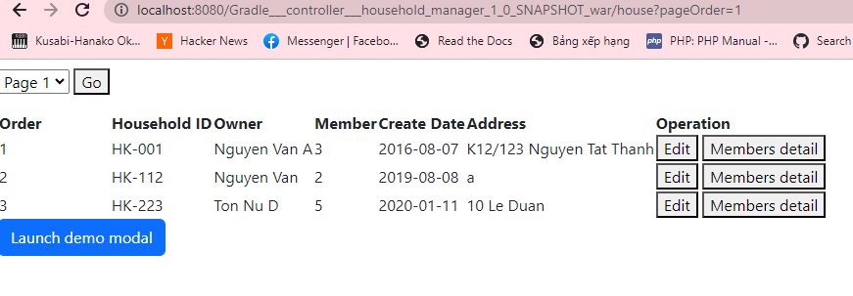

we can see the member in each household

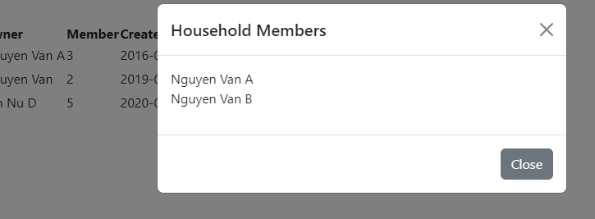

Update the information

