This is a web application with MVC structure build with Gradle. It uses Java-servlet for backend, in the View use JSP with the support of JSTL

Function:

Show the product list in a table

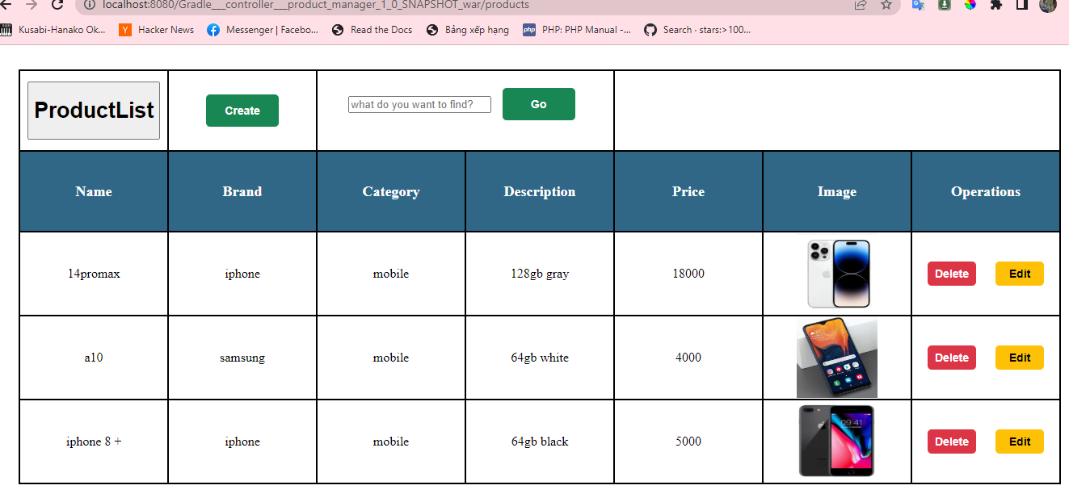

It can add new product:

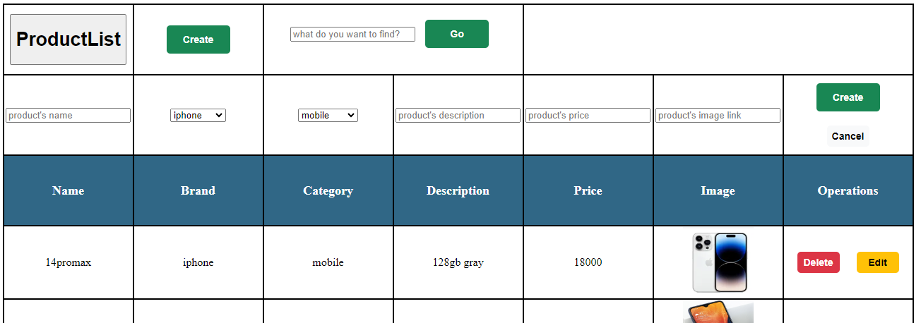

Edit current product:

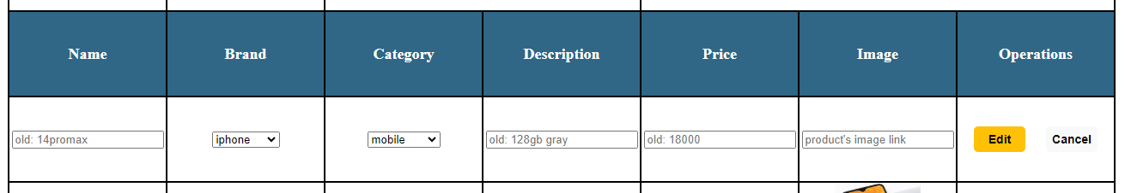

Delete the product

Full search:

