**Car API Testing Report:**

This is automation report for execution of car API testing scenarios

This report consists of 3 parts:

1. High-level overview of feature tests execution
2. Detailed Scenarios execution of respective features.
3. Bug Report
4. **High-level overview of feature tests execution**

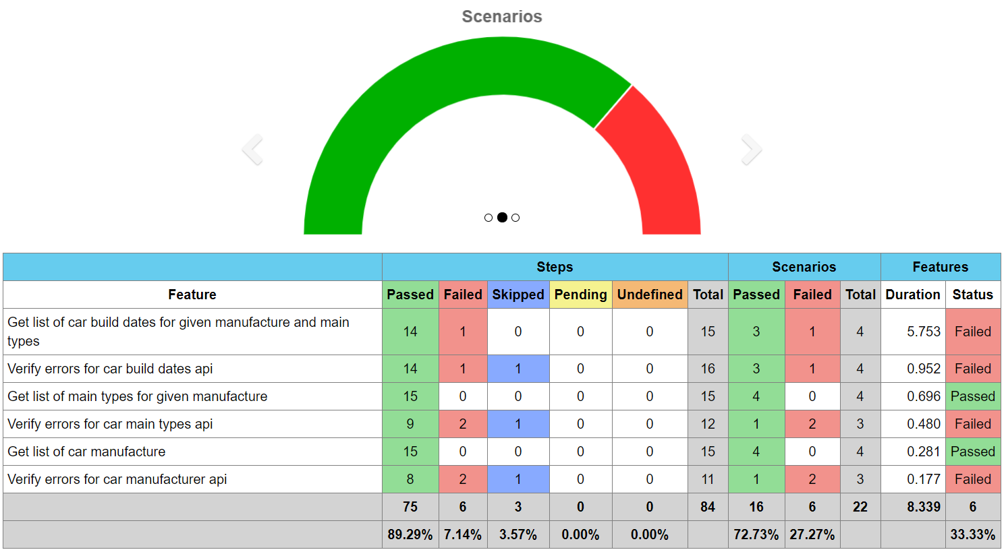

1. **Detailed Scenarios execution of respective features**

Please refer below table-

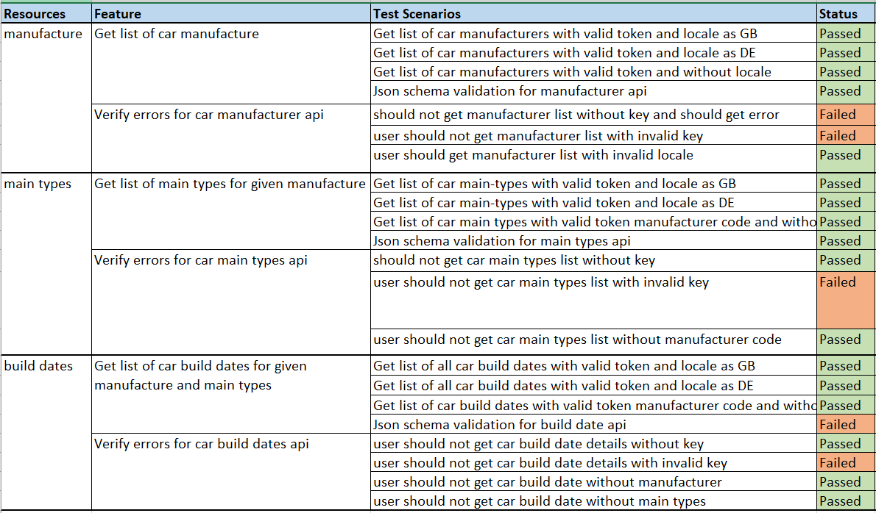

1. **Bug Report**

During Testing found following bugs, please find below defect status:

|  |  |  |  |
| --- | --- | --- | --- |
| **Defect ID** | **Summary** | **Status** | **Severity** |
| 1 | Invalid response Json schema for "build-dates” API "page", pageSize" and "totalPageCount" are not present in build dates response | Open | Critical |
| 2 | Inconsistent response status code for invalid parameters for Get request of below resources- a) Manufacturer API b) Main types API c) Build Dates API Some time getting 403 and sometimes 401 | Open | Major |
| 3 | Response body is blank and error message is not coming for status code 403, for below resources- a) Manufacturer API b) Main types API c) Build Dates API | Open | Major |
| 4 | Sometimes response body is blank and error message is not coming for status code 401 and sometimes it works properly with correct error response, for below resources- a) Manufacturer API b) Main types API c) Build Dates API | Open | Minor |

**Observation:**

|  |  |
| --- | --- |
| Summary | Comment |
| API is returning default translation with and without locale. | Require test data for different language as brand name, dates are same in each language. |

Here Severity are as follows:

* Critical: It represent very high severity 1.
* Major: It represent high severity 2.
* Minor: It represent low severity 3.