Activity 1

**Goal: Create a Mapping in Informatica Cloud**

Create a Mapping on Informatica Cloud that does the following:

* Set the Source to the **Cars** table in the provided database.
* Add a transformation mapping that extracts the same car brand names from every region and find the maximum price amongst all of them.
* Then pass that data to the **Max_Car_Prices** table in the same database.
* Do a similar mapping as above to find the minimum price of all cars and save it in the **Min_Car_Prices** table.

Source

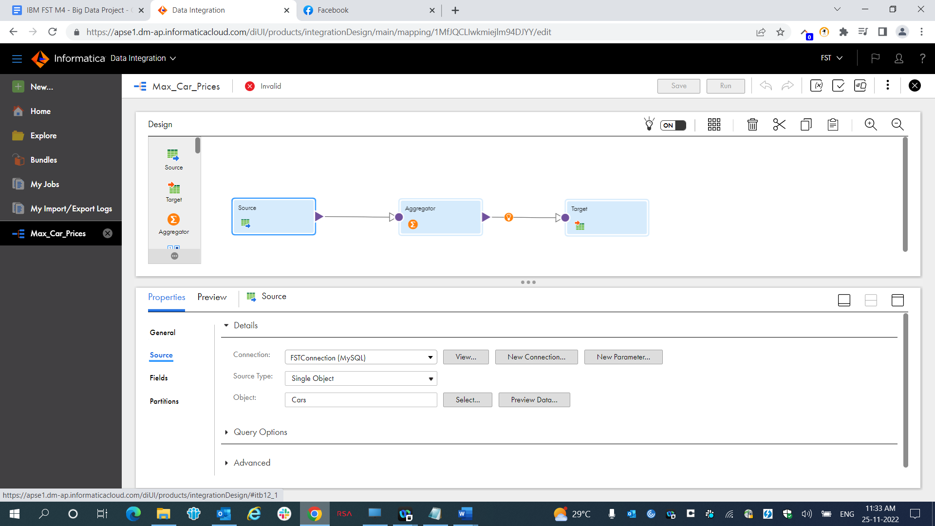

Aggregator

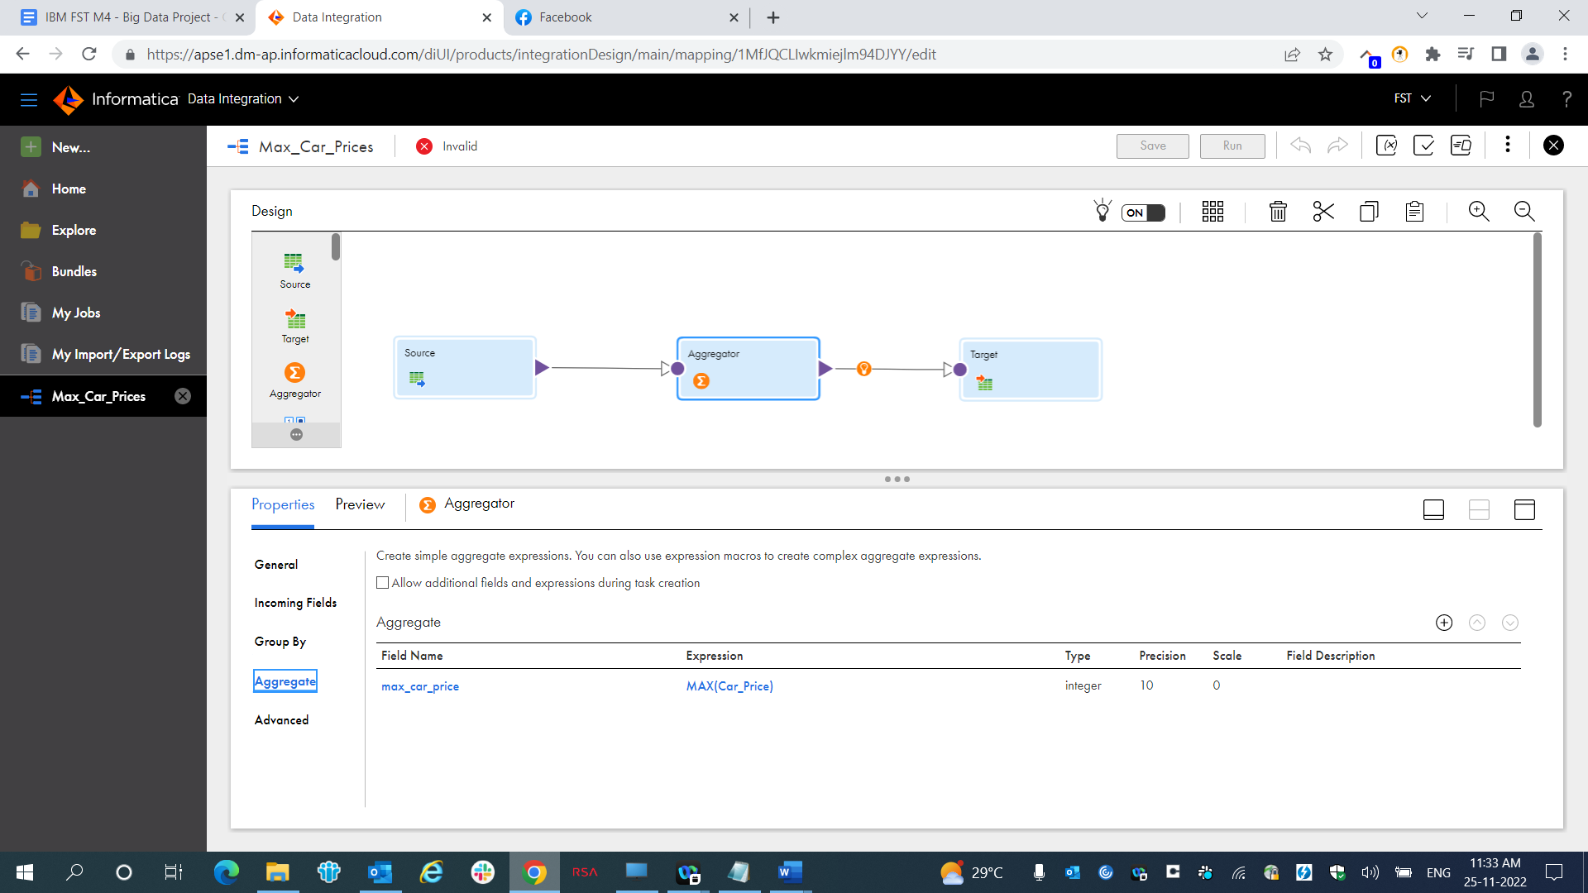

Target

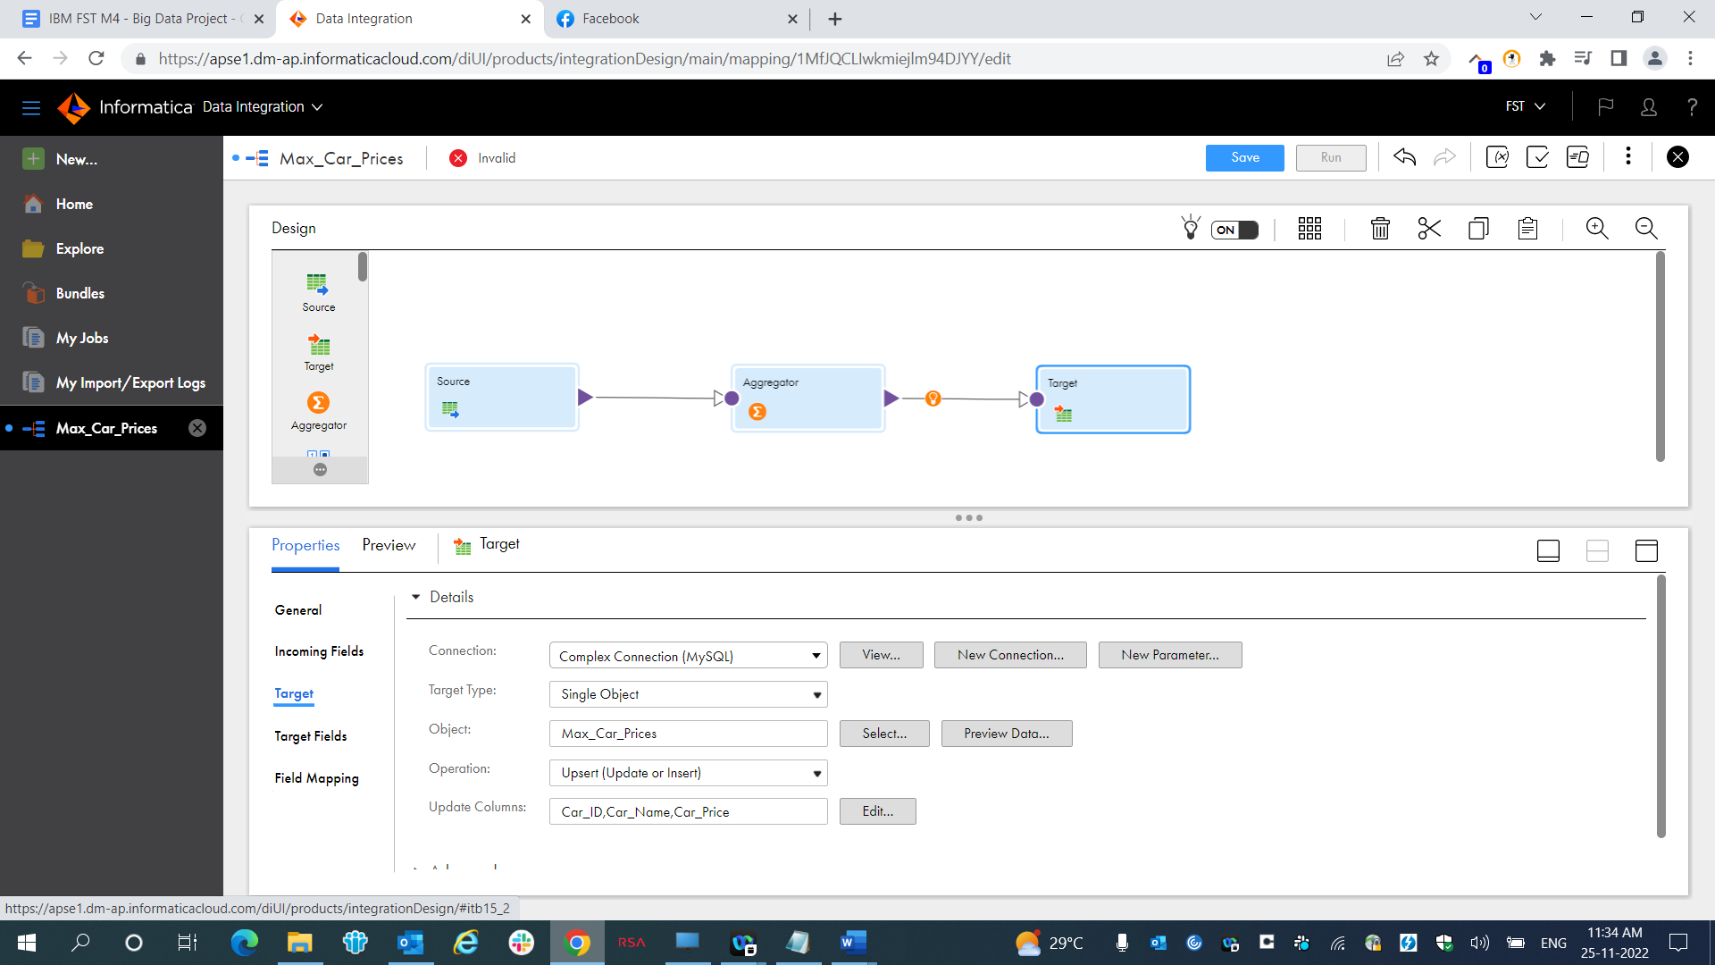

Result

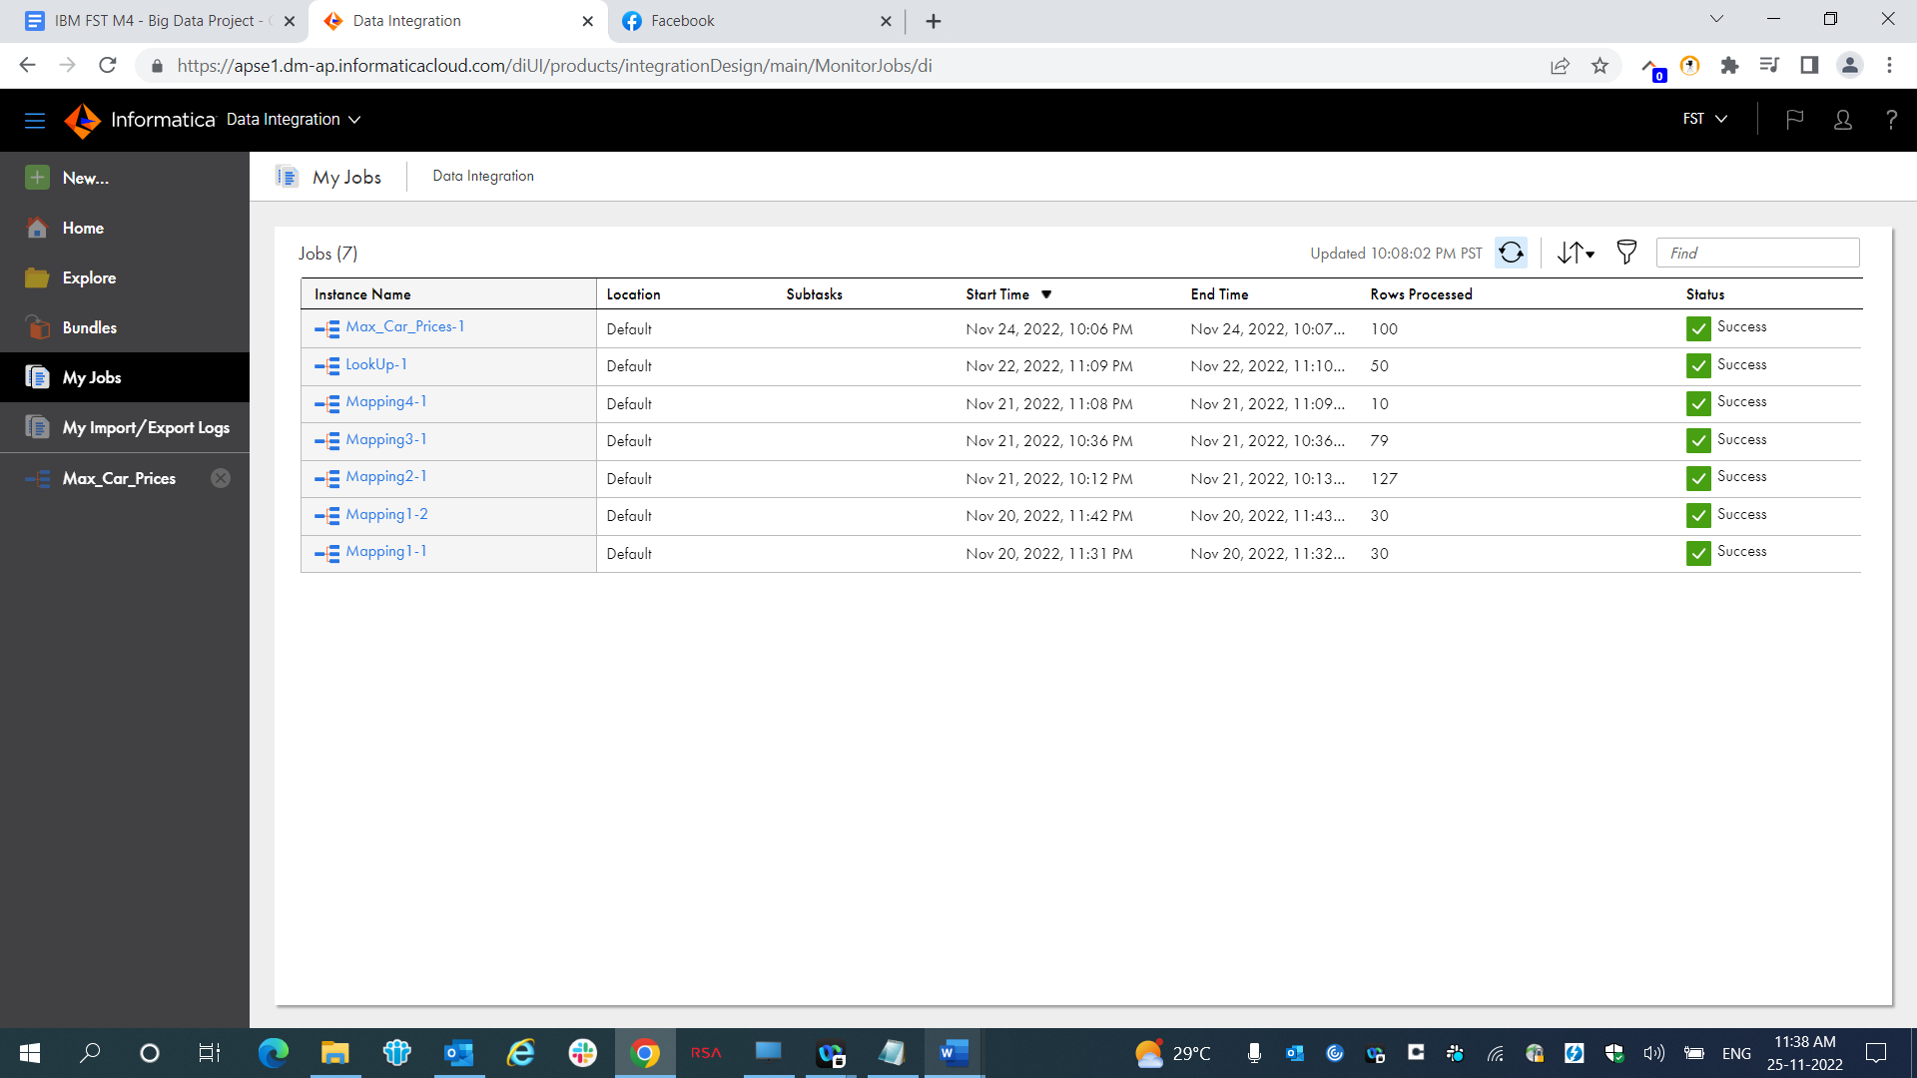

Source

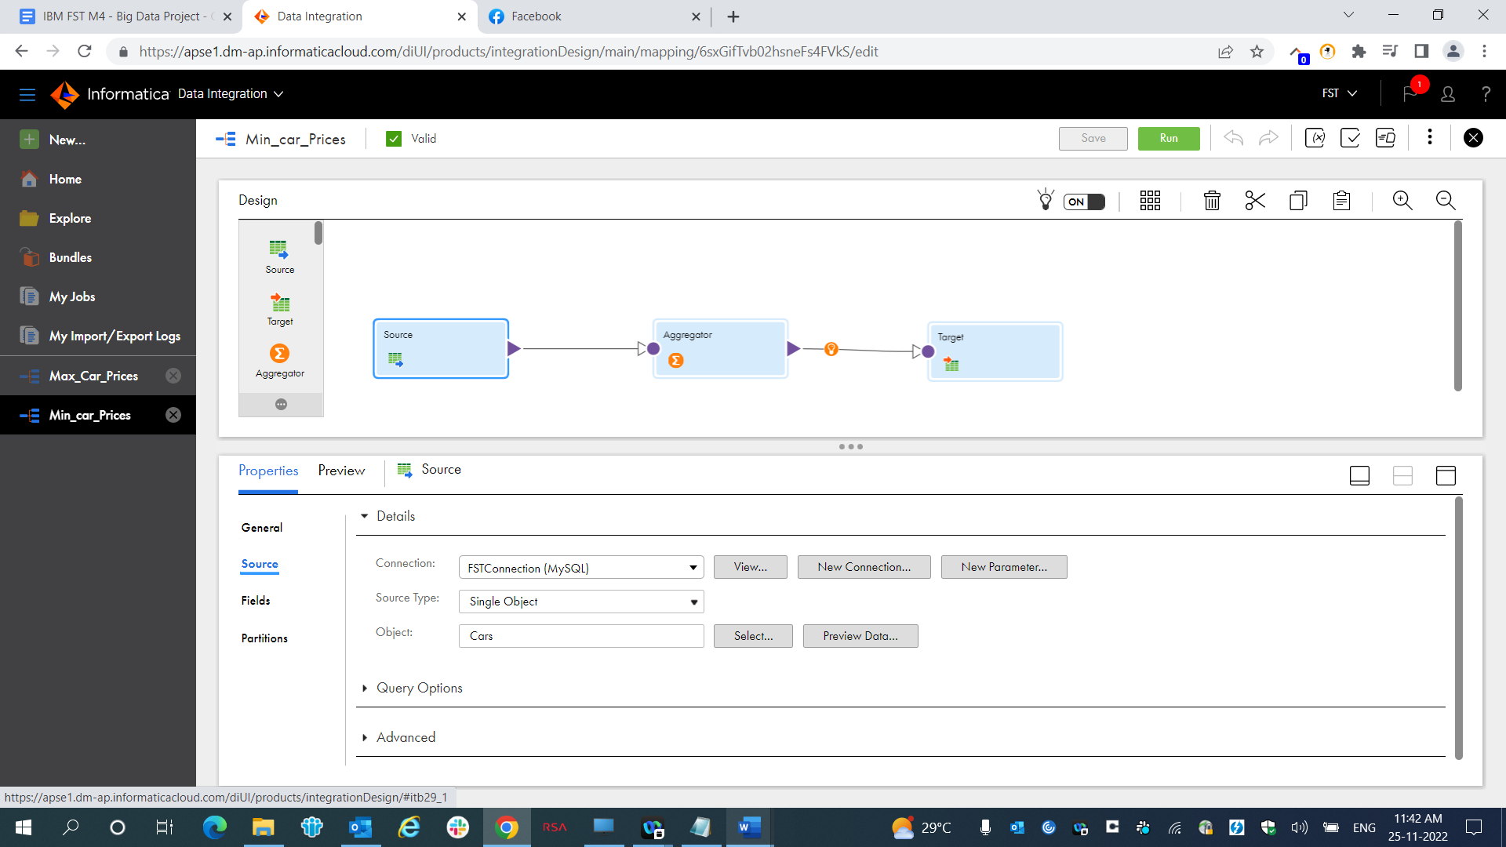

Aggregator

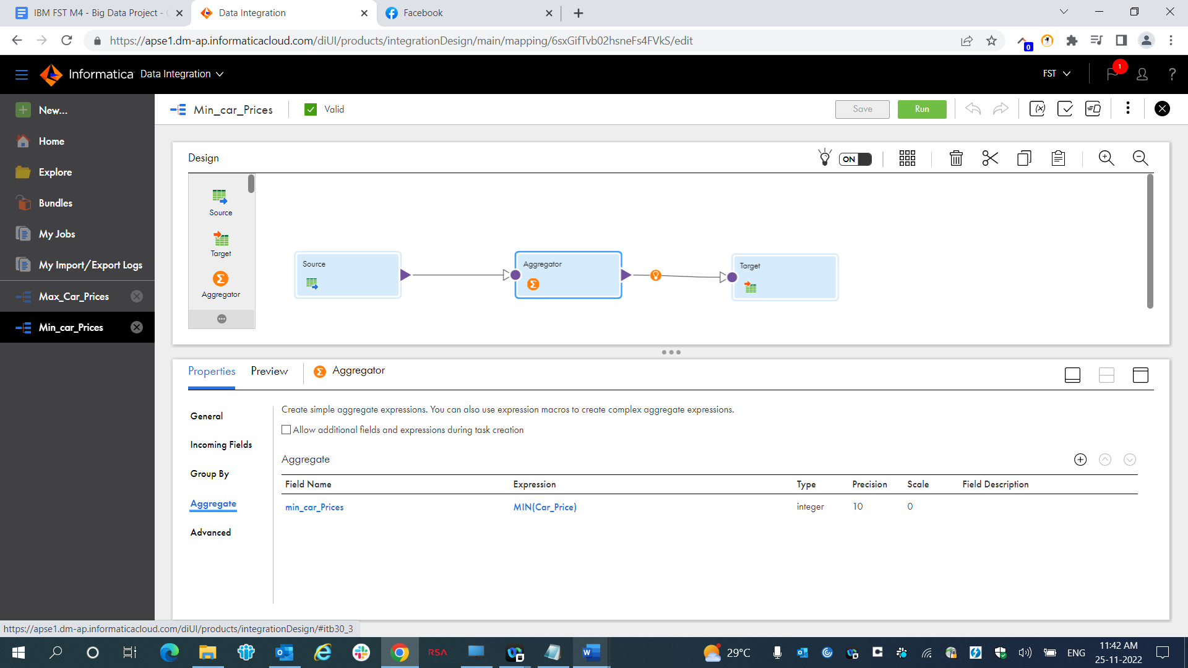

Target

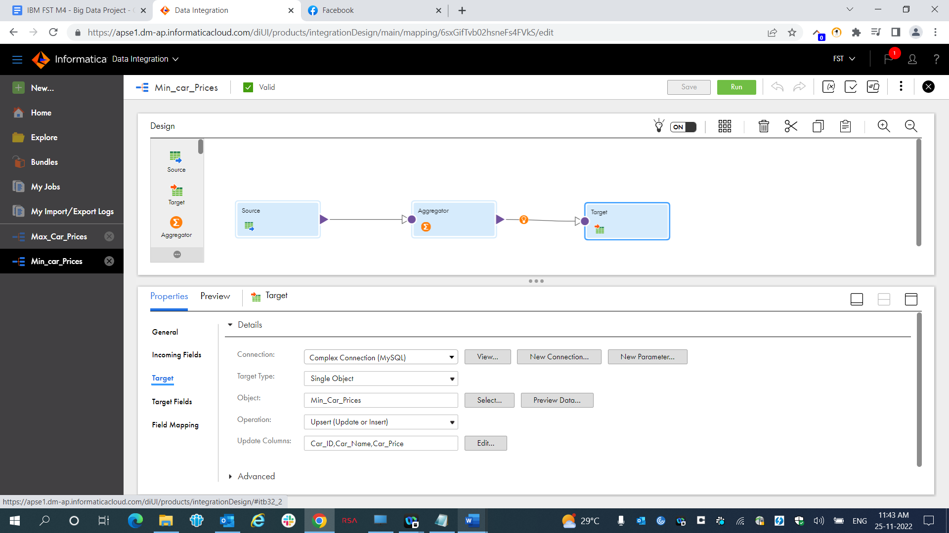

Result

