Dynamic Social Impact Theory (Latane, 1996) sought to describe the way by which culture is created through communication. More specifically, Latane outlined five propositions and six derivations related to the creation of culture through communication. The five propositions and six derivations and summarized below:
Proposition 1: “Individuals differ” with respect to many demographic, physiological, and psychological variables (p.2)
Proposition 2: “Individuals have relatively stable locations in space” (p.2)
Derivation 1: “The number of people located at any given physical distance from an individual should increase in approximate proportion to that distance” (p.3)
Proposition 3: “Social influence is proportional to a multiplicative function of the strength, immediacy, and number of sources” (p.4)
*Important to note is that by strength, he refers to stable components (physical size, intellect) and intrapersonal components (belonging to the same group)
Derivation 2: “Influence will be inversely proportional to the distance between people” (p.5)
Proposition 4: “The iterative, recursive outcome of individual influence processes will lead to the global self-organization of social influenceable attributes and the emergency of group-level phenomenon” (p.6)
Derivation 3: “People will become more similar to their neighbors, leading to spatial clustering” (p.8)
Derivation 4: “As a result of clustering, attributes will become more correlated” (p.9)
Derivation 5: “Since minorities are necessarily more exposed to opposing influence than majorities, they will typically decline in numbers except to the extent that they can be protected by clustering” (p.9)
Proposition 5: “Social influence will be incremental for unimportant issues, catastrophic for important ones” (p.9)
Derivation 6: “Incremental influence processes will lead to convergence; nonlinear influence processes will lead to continuing diversity” (p.9)

In this project, I will attempt to design and implement a program in C++ that simulates individual level communication and social organization based on proposition 1 (individuals differ), proposition 2 (individuals have relatively stable locations in space), derivation 1 (the number of people located at any given physical distance from an individual should increase in approximate proportion to that distance), proposition 3 (SI is a multiplicative function of strength, immediacy, and number of sources), and derivation 2 (influence is inverse to distance). Assuming that I am overall successful in incorporating these properties into a computer simulation, I predict the emergence of proposition 4 (the iterative outcome will lead to global self-organization), derivation 3 (spatial clustering), derivation 4 (attributes will become more correlated), and derivation 5 (minorities will decline in numbers except to the extent that they can be protected by clustering). Proposition 5 and derivation 6, which relate to the differing properties of important vs. nom-important issues and non-linear processes of influence, will not be covered in this project because of the implementation complexity of differing importance of issues; perhaps I will return to it if this first attempt is successful.
The graph: a data structure used to simulate social interaction
The graph structure is a fairly conventional structure in computer science (https://en.wikipedia.org/wiki/Graph_(abstract_data_type) and is defined as G = (V,E), where V is a set of vertices and E is a set of edges. It may involve the creation of a dynamic array (a sequence of contiguous memory locations), with each memory location containing potentially different data types (structs). Although simple arrays fulfill this requirement, a graph is different in that each element in the vector (dynamic array) may also contain another (adjacent) vector, which stores other elements in the original vector. For example, if we have a vector of elements called A, B, and C, element A may also contain an adjacent vector, which holds the memory location of element B. This connection in the second (adjacency) vector between A and B is called an edge, and edges can have weights. Weights may be used to simulate distance; for example, if you had a list of cities, and each of those cities had a road connecting to other cities, then the edge weight between city 1 and city 2 is equal to the distance between them. Because graphs are commonly used to simulate points in space in relation to other points in space, a graph seemed to be ideal for the goal of simulating DSI.
Implementation of Simulated Space and Distance
In the graph I have created, each vertex struct is meant to simulate an individual; each struct has an associated continuous (data type: long double) measurement of attitude, a (int[2]) location in two dimensional space, and an adjacency vector. Each element in the adjacency vector has the memory location of another vertex struct (another person) and the weight of the edge (distance between person 1 and 2). I created 400 different individuals (vertex structs) and pushed them into the original vector. Their locations were chosen in order for an informative visualization of interaction and an easy way to program distances: I chose a matrix as a visualization of 2-dimensional space (here, I never literally programmed a 2-dimensional array; rather, this description is only for visualizing distances between people).
Therefore, imagine the square: the square is 20 X 20, with a single individual in each cell of the square. The first 20 people have locations {0,0}, {0,1}… {0,19} and the next 20 people have the locations {1,0}, {1,1}… {1,19} while the last ten people have the locations {19,0} – {19,19}. Therefore, the first 20 are in the same row in our imagined square plot of land, and each second number connotes the column that they are positioned in.
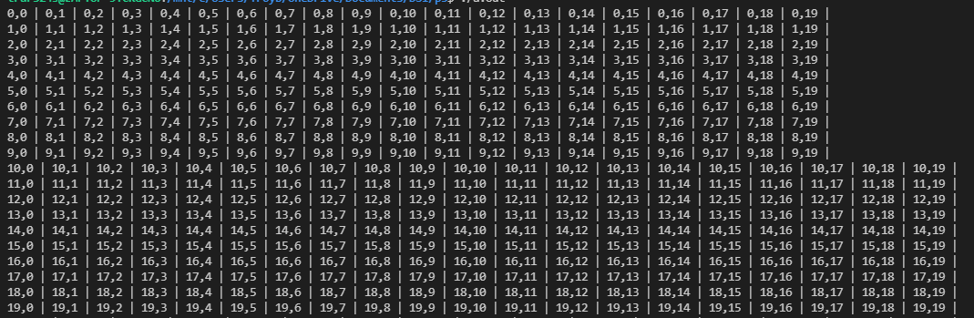
I made the graph undirected, which means that each edge between person {0,0} and any other person go both ways. For example, if struct 0,0 has an edge to struct 19,19 in the adjacency vector of 0,0, then struct 19,19 also has struct 0,0 in its adjacency vector. In other words, each path is bidirectional. I made it so that each struct has an edge to every other struct, which means that each person has access to every other person. To program the distance between each person (struct), I created a generalizable equation with X = X coordinate, Y = Y coordinate, a = person a, b = person b:
$$D= \sqrt{{(X_{a}- X_{b})}^{2}+ {(Y_{a}- Y_{b})}^{2}}$$
Therefore, regardless of whether or not the edge is a triangle hypotenuse, this equation still solves because
$$\sqrt{X^{2}+ 0^{2}}=|X|$$
Therefore, the edges are still accurate for the imagined square plot of land with people located at the center point of each cell within the plot of land.
Because each struct is positioned at a constant distance from every other struct throughout the program., I fulfill proposition 2, that individuals have stable locations in space. Also, because for any cell, the number of cells at an approximate given distance (for example, sqrt(5)) increases, I fulfill derivation 1: the number of people located at any given distance from an individual increases in approximate proportion to that distance.
Implementation of Communication
When implementing a simulation of communication, we must consider the properties of communication and influence: a single influence is directly proportional to strength and inversely proportional to distance. My measurement of attitude is continuous, which diverges from Latane’s measurement of attitude/ values as categorical. Therefore, I have taken the liberty of incorporating the continuous measurement of an individual’s attitude as another component of strength: imagine two people communicating. Of course, as Latane points out, there are naturally differences between them of group identification and status. However, let’s say that we want to measure social impact of other people saying “y’all” (this was one of his examples and was framed as categorical). The behavior of saying y’all, and the instigation of behavior in general, may be imagined as based off the continuous valence of the behavior and the end state (saying y’all may have high valence in the south because of the high valence of fitting in and being understood, while it may be low in the north because of the same goal state). If someone says y’all, it may not be apparent how strong the associated valence of that behavior is. Another example may be the associated valence with tan skin; if we assume person X has an associated valence with tan skin of 10 and person Y has an associated valence with tan skin of -15 and they communicate, it seems intuitive to me that the strength of their associations will play a role in where the end consensus, if there is convergence, will lie. Because of this, I have incorporated attitude strength as another component of Latane’s strength component. I have also incorporated individuals’ stable strength; the degree to which they can influence others and inverse the degree to which they are themselves influenced.
For a single social impact of person X on person Y in regard to a specific attitude for iteration i, I created the following equation:
$$∆ = \frac{{(Att}_{X_{0}}- {Att}_{Y_{0}})* {SS}_{X}}{{Dist}_{X,Y}* {SS}_{Y}}$$
$${Att}_{y_{i}}= {Att}_{y_{i-1}}+ \frac{∆}{C}$$
Delta = (initial attitude of X – initial attitude of Y) * stable strength of X / distance between X and Y * stable strength of Y; new Attitude of Y = current attitude of Y – delta / constant (see member function Graph::simulate).
Each element of this equation was necessary: we want the social impact to be a function of the attitude strength of the person doing the influencing, attitude strength of the person being influenced, stable strength of the person doing the influencing, stable strength of the person being influenced, and the distance between the people. Additionally, the numerator for the delta equation is the difference between attitudes because the ability for one attitude to influence another relies on their being a difference: if two people have the same degree of attitude valence, then there ought not be a change (observations of polarization are not replicated); therefore, delta is the difference between attitudes multiplied by the ratios of stable strengths divided by the distance so that social impact is multiplicative of strength (insofar as there is a difference of strengths) and the inverse of distance. Delta is then subtracted from the valence of the person being influenced to show the effect of the social impact. The constant is then included as the degree to which social impact can change attitudes; if the simulated culture has a lower amount of communication in general, then this constant is higher. I included the constant as a parameter of the function which is called for a single act of communication so that it may be changed.
For each adjacent element of each element, a single act of influence is instigated. Therefore, person 0,0 influences everyone else, then person 0,1 influences everyone else (including person 0,0). This presents a problem, which is that the overall system is dependent on the sequence of influences. To solve for this, I based delta off the attitudes of each person before the entire simulation iteration (attitude sub X sub initial, for example); therefore, the sequence does not matter; starting off with the influences that person 19,19, rather than 0,0, has on everyone else does not change the final outcome (in the code, the initial attitude variable is a data member of each struct, called ph for place holder). Additionally, because each person influences everyone else, the social impact becomes multiplicative of the number of influences; therefore, I have fulfilled proposition three, that social influence is proportional to a multiplicative function of the strength, immediacy, and number of sources. I have additionally fulfilled derivation 2, that influence is inversely proportional to the distance between people.
Running the simulation
To reiterate, I created 400 people positioned in a cell of a 20 x 20 matrix and adjusted their distances accordingly. I then randomly assigned each individual to either have a valence of 10 or a valence of 0; the end result was an average of 4.725. Then, I had each individual influence every other individual with a constant of 40 and everyone’s strength is equal (SS = 1). To more simply visualize the results, I made a visualization of the 20 x 20 matrix and made each person who has an attitude valence below or equal to the average symbolized by a dash ( - ) and each person above the average symbolized by an X ( X ). The results are below:
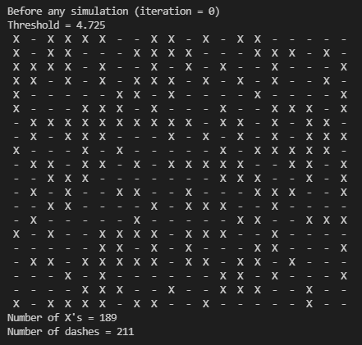
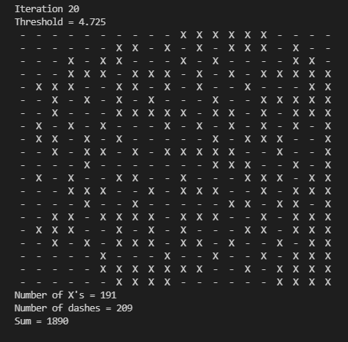
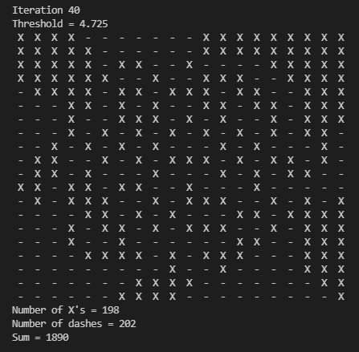
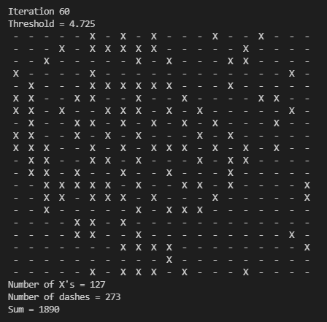
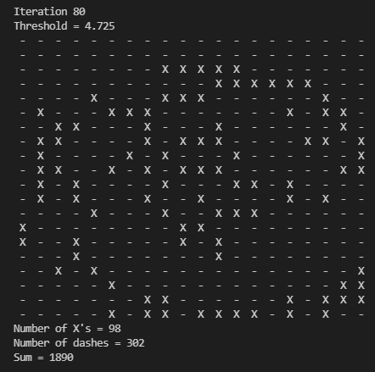
Firstly, I must include the important fact that this pattern does not show an extinction of overall valence; in fact, the summed valence is conserved and static throughout the entire simulation (if the reader wants to write a proof of why that is, please be my guest; with extremely large numbers of people and iterations however, this property begins to break down). The reason for the apparent minimization of X is because, for an X to appear, the valence of the cell must be greater than the average. Because, with i = number of iterations and f(i) = variance,
$$\lim_{i → ∞}{f\left(i\right)=0}$$
the number of Xs will eventually become zero; this is because C++ double data type allows for 15 decimal places, which has functional limitations for the precision of comparisons between a number and the overall average of the system as a whole in this context. Below is a graph of recorded variance as a function of iterations, which appears to show negative logarithmic growth:

Secondly, this shows the self-organization of the whole as based on clustering. This emergent property upholds proposition 4 (the iterative outcome of individual processes will lead to global self-organization), derivation 3 (people will become more similar to their neighbors, leading to spatial clustering), and derivation 4 (as a result of clustering, attributes will become more correlated).

A simpler 10 x 10 was also created, with a constant of 30 (every SS = 1). The results were interesting:
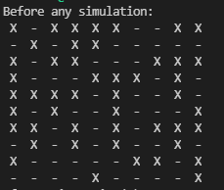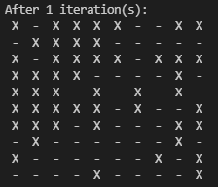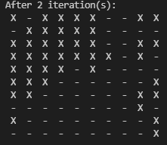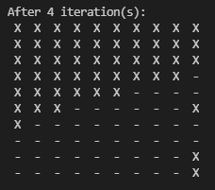
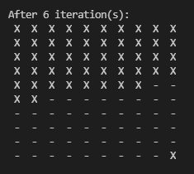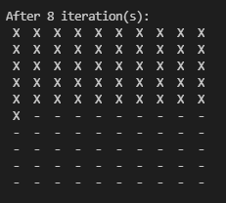
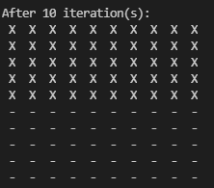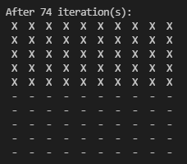
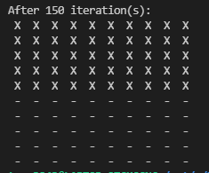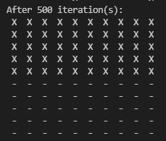
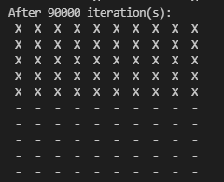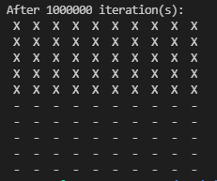
After 1,000,000 iterations (my CPU took about 4 minutes), the degree of difference between the upper half group of people and the mean was large enough to be recorded based on 15 decimal places. It is interesting to note that the attitude valence in the program was able to persist based on the number of neighboring cells; the maintained clusters were not in the center, perhaps because it is harder to maintain a difference from the mean in the center because corner nodes (0,0) were overall influenced to a smaller degree, due to the lack of immediate neighbors to the north or west. Therefore, non-center spatial clustering is more hardened to withstand the social influences of the system overall.

Variable Strength: Component 1: Stable Components
From Latane, 1996: “I use the term strength to refer to the net of all the individual factors making a person influential. Strength can be understood to be composed of two basic types of factors: stable, trans-situational, intrapersonal components (e.g. physical size, intellect, wealth) and dynamic, situation-specific, relational components (e.g. belonging to the same group)” (p.2).
During each social influence, the strength of the vertex doing the influencing will be a multiplier of delta, or change, of the person being influenced. One question I had while implementing this is, should the strength of the person being influenced act as a resistor of the influence that they are receiving? Although this goes slightly beyond Latane’s explicit description of strength, I think it ought to. Again, here is the equation for a single act of social influence of person X on person Y:
$$∆ = \frac{{(Att}_{X_{0}}- {Att}_{Y_{0}})* {SS}_{X}}{{Dist}_{X,Y}* {SS}_{Y}}$$
$${Att}_{y_{i}}= {Att}_{y_{i-1}}+ \frac{∆}{C}$$

Before the variation of strength, there was a property of conservation of attitude strength: if the entire system began with a sum of 100, it also ended with a sum of 100. However now, that is unlikely to persist because the effect of an attitude strength is now randomly contingent on the strength of the individual holding the attitude, the strength of the attitudes around him/ her, and the individual’s spatial location and the location’s interaction with strength.
Simulation with strength as a randomly assigned factor
Everyone in the system (400 total people for a 20 x 20) is first given a strength of 1 (this means that there is no change from the original system). Then, for every vertex (person) in the graph, there is a 1/7 chance that they will be given a strength of 1.25, replacing the pre-set strength of 1. Additionally, just as before, there is a 50% chance that each person will be given an attitude valence of 10.
During the simulation (constant = 50, iterations = 65), there was an eventually apparent East- West clustering and no longer a conservation of attitudes:
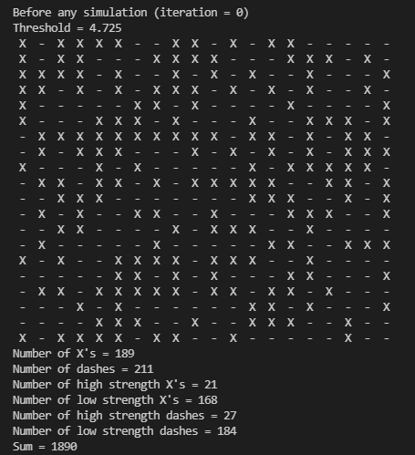
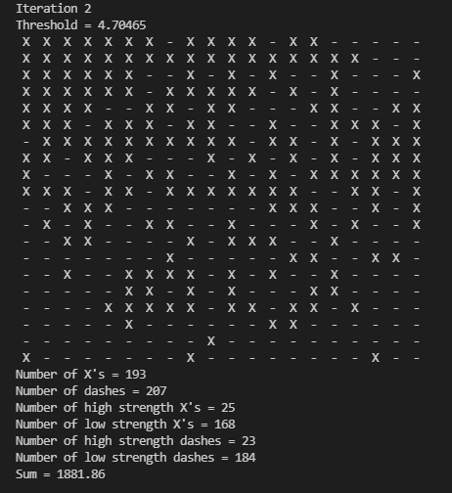
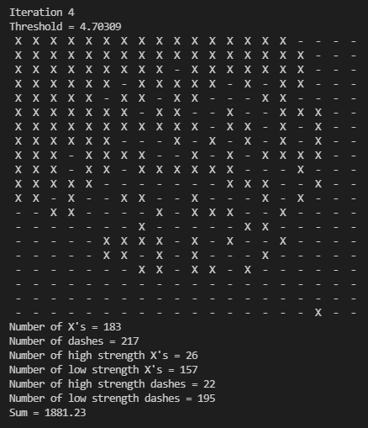
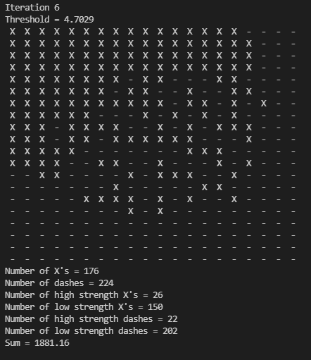
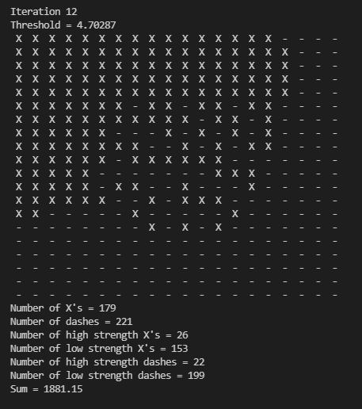
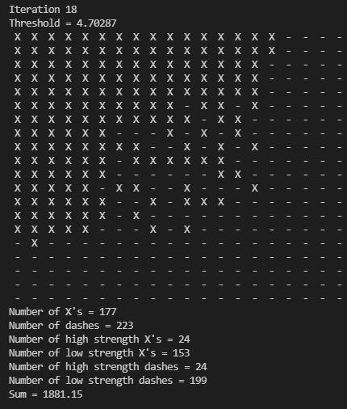
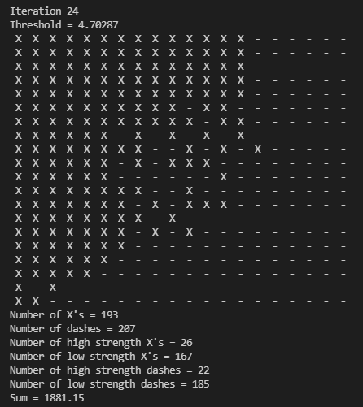
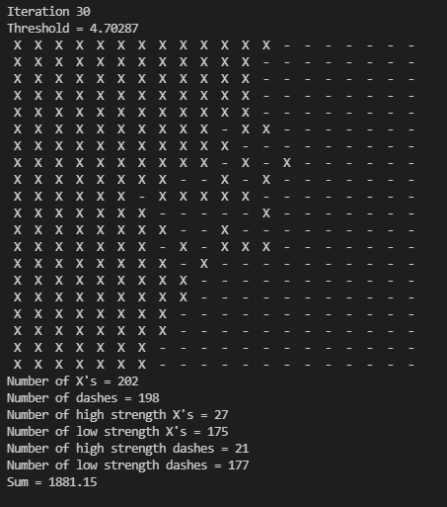
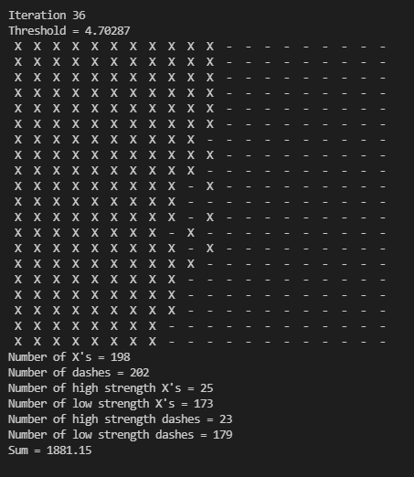
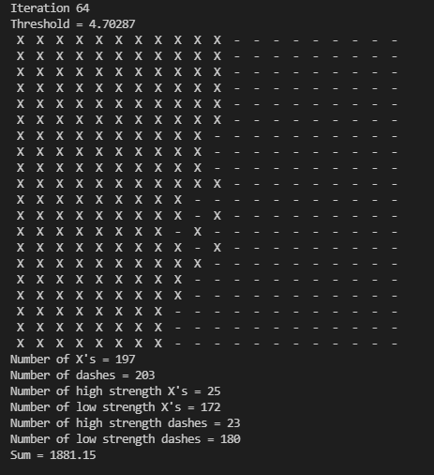

Now, we can make a simulation of a single individual possessing an attitude of 10, except now dramatically increase the strength (00 set at 50, attitude 10) and set the threshold for an X at 4.725, such as before.
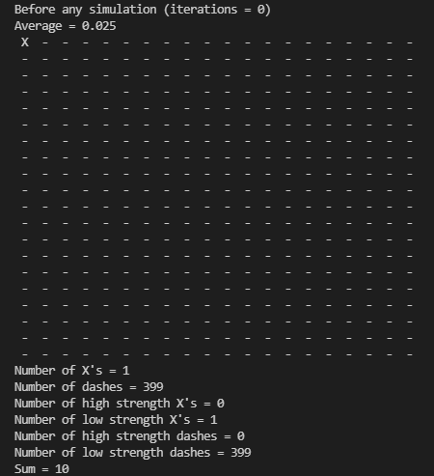
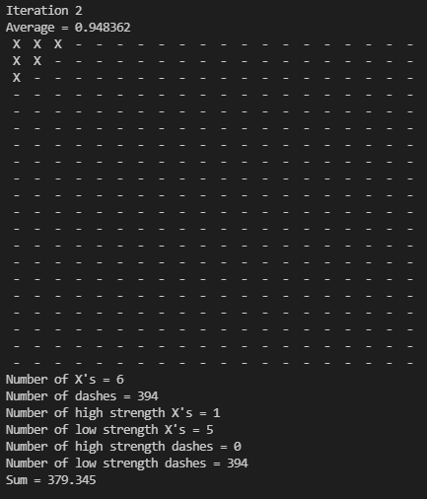
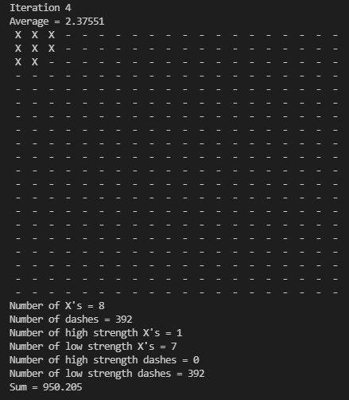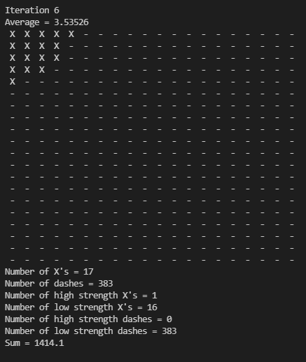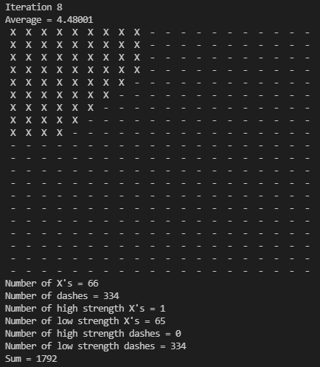
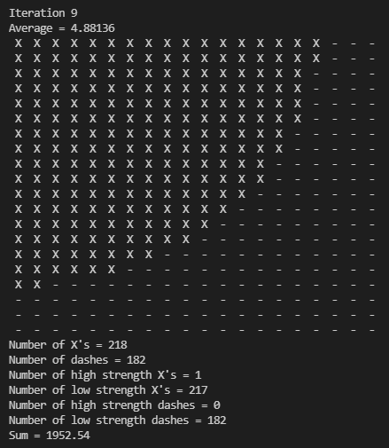
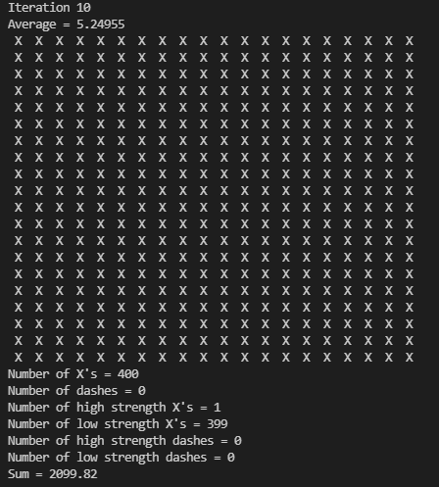

So apparently, strength can be an enormously significant factor; seems a tad cult-like…
Let’s return to the primary factors from Latane and recap how they have been accommodated:
- Proposition 1: “Individuals differ” with respect to many demographic, physiological, and psychological variables (p.2)
  - Vertices differ in regard to individual strength and degree of attitude magnitude
- Proposition 2: “Individuals have relatively stable locations in space” (p.2)
  - In relation to other vertices, all vertices maintained a stable location
- Derivation 1: “The number of people located at any given physical distance from an individual should increase in approximate proportion to that distance” (p.3)
  - If you have any vertex as the center, and increased the radius from that vertex, the number of vertices at a given approximate radius increases with the radius size.
- Proposition 3: “Social influence is proportional to a multiplicative function of the strength, immediacy, and number of sources” (p.4)
  - $∆ = \frac{{(Att}_{X_{0}}- {Att}_{Y_{0}})* {SS}_{X}}{{Dist}_{X,Y}* {SS}_{Y}}$
    - ${Att}_{y_{i}}= {Att}_{y_{i-1}}+ \frac{∆}{C}$
  - However, component 2 of strength, intrapersonal, has not been implemented.
  - The number of sources = number of iterations of influence per simulation iteration, which means the number of sources acts as a multiplier
- Derivation 2: “Influence will be inversely proportional to the distance between people” (p.5)
  - $∆ = \frac{{(Att}_{X_{0}}- {Att}_{Y_{0}})* {SS}_{X}}{{Dist}_{X,Y}* {SS}_{Y}}$
- Proposition 4: “The iterative, recursive outcome of individual influence processes will lead to the global self-organization of social influenceable attributes and the emergency of group-level phenomenon” (p.6)
  - Upheld: global self organization takes the form of clustering
- Derivation 3: “People will become more similar to their neighbors, leading to spatial clustering” (p.8)
  - Upheld: global self organization takes the form of clustering
- Derivation 4: “As a result of clustering, attributes will become more correlated” (p.9)
  - Upheld: visual clustering is the result of correlated attitude magnitudes
- Derivation 5: “Since minorities are necessarily more exposed to opposing influence than majorities, they will typically decline in numbers except to the extent that they can be protected by clustering” (p.9)
  - Upheld: in cases of minority groups, they continued to exist within clusters
- Proposition 5: “Social influence will be incremental for unimportant issued, catastrophic for important ones” (p.9)
  - Not implemented
- Derivation 6: “Incremental influence processes will lead to convergence; nonlinear influence processes will lead to continuing diversity”
  - Although variance approaches zero as iterations approach infinity, thereby upholding the first part, nonlinear influence processes were not implemented.

Therefore, as a first step, this attempt appears to be moderately successful. Future changes to the implementation will work towards implementing differences in intrapersonal strength, importance of attitudes, and nonlinear influence processes which would predict a continued diversity of attitudes rather than an averaging-out. Additionally, in the case of an influence between two people of the same attitude magnitude, no change in attitude was implemented while in reality, this ought to lead to an increase in the robustness of attitudes. Group polarization was also never addressed and will be implemented alongside the implementation of intrapersonal strength. Also, dual process models of persuasion provide another avenue; individual differences regarding reliance on heuristic vs. deliberative processing, or reliance on authority heuristics versus argument persuasiveness. In addition, multiple attitudes were never implemented; this will carry an interesting issue, being that attitudes are not necessarily independent of one another. The end goal of this project is to create a simulation of many different attitudes operating inter-dependently and contingently on group identification. The hope is that, eventually, this simulation will be able to predict future ideological changes in the United States; however, we are quite far away from the attainment of that goal.

Additional note: I had spent considerable time and effort finding a generalizable equation for average distance for any node from every other node. After reading the first draft of this summary, Paige Arthur provided a solution, which is shown below: n = number of columns (horizontal length), m = number of rows (vertical length), x = x coordinate, y = y coordinate. This may be useful in the future for determining why attitude is conserved without SS variation and not conserved with SS variation.
$$\overline{D}= \frac{\sum_{i=0}^{n}{\sum_{j=0}^{m}{\sqrt{{(x-i)}^{2}+ {(y-j)}^{2}}}}}{n*m-1}$$
References
Latané, B. (1996). Dynamic Social Impact: The Creation of Culture by Communication. Journal of Communication, 46(4), 13–25. https://doi.org/10.1111/j.1460-2466.1996.tb01501.x

