**Session on Git Basics and Commands**

**Date:**

**12/07/2020**

**Created By:**

**Arulraj.R**

**Gangeshwari.R.N**

***Agenda:***

1. What is Git?
2. Why we need it and Advantages of Git.
3. Installation and setup
4. Create and Clone Repository
5. Working with Branches
6. Basic operation Commands in Git
7. Practical Section
8. Difference between Git, GitHub, GitLab, BitBucket
9. References

***1. What is Git?***

* Distributed Version Control system
* VCS
  + Helps to work together and maintain history
* Advantages:
  + Work simultaneously
  + Avoid Overwriting
  + Maintain History
* DVCS
  + Main repository in cloud server
  + Each clone will be mirror of the server repository
  + Do all operations and sync in the internet to publish.
  + Restore back from any of the client if server lost.
* We have lot of software tools available for git clients

***2. Why we need it and Advantages of Git***

* + Why we need it? We can say the following few reasons
  + Handling the commits and history of changes.
  + To know the commit details, who made commit and who made the changes listed and when it was done and purpose of it
  + Handling same branch with different versions
  + Compare 2 branches and assemble together (Merge and remove conflicts)
  + Make a pull request for your changes.
* Advantages
  + Free and open source
  + Fast and small -> Operations perform locally
  + Implicit backup -> multiple copies
  + Security -> common cryptographic hash function (SHA1)
  + No need of powerful hardware -> developers only interact when publish
  + Easier branching
  + Working Directory and Staging Area or Index
  + 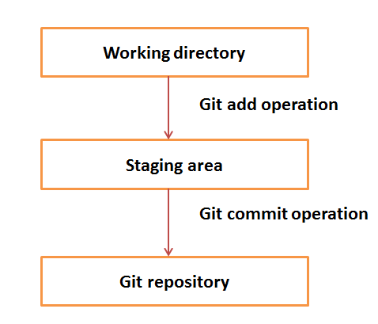

***3. Installation and setup***

**Debian OS:**

[ubuntu ~]$ sudo apt-get install git-core

[sudo] password for ubuntu:

[ubuntu ~]$ git --version

git version 1.8.1.2

**Cent OS:**

[CentOS ~]$

su -

Password:

[CentOS ~]# yum -y install git-core

[CentOS ~]# git --version

git version 1.7.1

**Windows:**

We have the installer file. And we can download it from official url and process installation.

***4. Create/Clone Repository***

**Create your own Repository**

1. Create a directory to contain the project.
2. Go into the new directory.
3. Type “*git init*”.
4. Write some code.
5. Type “*git add”* to add the files (see the [typical use page](https://kbroman.org/github_tutorial/pages/routine.html)).
6. Type “*git commit”*.

**Clone Repository**

1. Open Git Bash.
2. Change the current working directory to the location where you want the cloned directory.
3. Type *git clone*, and then paste the URL you copied earlier.
4. *$ git clone https://github.com/YOUR-USERNAME/YOUR-REPOSITORY*
5. Press **Enter** to create your local clone.
6. $ git clone https://github.com/*YOUR-USERNAME*/*YOUR-REPOSITORY*

***5. Working with Branches***

1. Checkout

* Switch between branches in a repository
* *git checkout [branch_name]*

1. Merge

* Used to Merge between the branches
* Before merge we need to be in master repository or the repository we have taken as base.
* *git merge*

1. Revert

* Revert to the specified earlier commit.
* *git log*
* *git revert [keyid]*

1. Rebase
2. Delete

* Delete a branch.
* *git branch –d branchname*

***6. Basic operation Commands in Git***

1. Status – check the commit status
   * *git status*
2. Log – display all Log details
   * *git log*
3. Diff
   * *git --diff*
4. Commit
   * *git commit*
5. Fetch
   * *git fetch*
6. Pull
   * *git pull*
7. Push
   * *git push*
8. Add
   * *git add [files]*
9. Remove
   * *git rm [filename]*
10. Stash
    * *git stash*

***7. Practical Section***

***8. Difference between Git, GitHub, GitLab, BitBucket***

***9. Refences:***

<https://git-scm.com/book/en/v2/>

<https://stackify.com/source-code-repository-hosts/>

<https://www.geeksforgeeks.org/bitbucket-vs-github-vs-gitlab/>