1. **What are the advantages of Bootstrap?**

🡪Bootstrap offers many advantages for web designers and developers, such as saving time and effort by providing ready-made components and styles that can be customized and combined. It also ensures consistency and compatibility, as it follows a standard design and coding convention, and uses a mobile-first approach.

1. **What is a Bootstrap Container, and how does it work?**

🡪 Container is used to set the content's margins dealing with the responsive behaviors of your layout.

🡪It contains the row elements and the row elements are the container of columns (known as grid system). The container class is used to create boxed content

1. **What are the default Bootstrap text settings?**

🡪Bootstrap uses a default font-size of 16px, and its line-height is 1.5.  All <p> elements have margin-top: 0 and margin-bottom: 1rem (16px by default).

1. **What do you know about the Bootstrap Grid System?**

🡪Bootstrap's grid system uses a series of containers, rows, and columns to layout and aligns content. It's built with flex-box and is fully responsive.

1. **What is the difference between Bootstrap 4 and Bootstrap 5.**

* Boostrap 4:-

🡪Bootstrap 4 has five levels: xs, sm, md, lg, and xl.

🡪Bootstrap 4 lacks SVG icons; we must rely on font-awesome for icons.

🡪Bootstrap 4 makes use of the Jekyll software.

🡪Bootstrap 4 uses fewer CSS properties.

* Boostrap 5

🡪Bootstrap 4 uses more CSS properties.

🡪Bootstrap 5 uses a fast static generator which is Hugo.

🡪The card deck class has been removed from bootstrap.

🡪Bootstrap 5 has its own set of SVG icons.

1. **What is a Button Group, and what is the class for a basic Button Group?**

🡪 “Button Groups” in Bootstrap is a class of name “btn-group” which is used to create a series of buttons in groups (without spaces) vertically or horizontally

1. **In Bootstrap 4, what is flexbox?**

🡪 Flexbox. The biggest difference between Bootstrap 3 and Bootstrap 4 is that Bootstrap 4 now uses flexbox, instead of floats, to handle the layout.

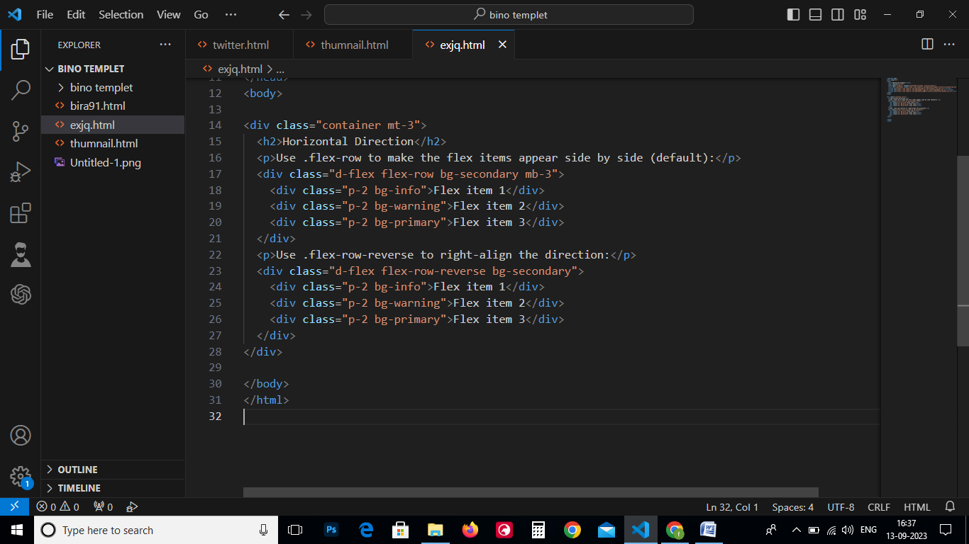

1. **How can one create an alert in Bootstrap**

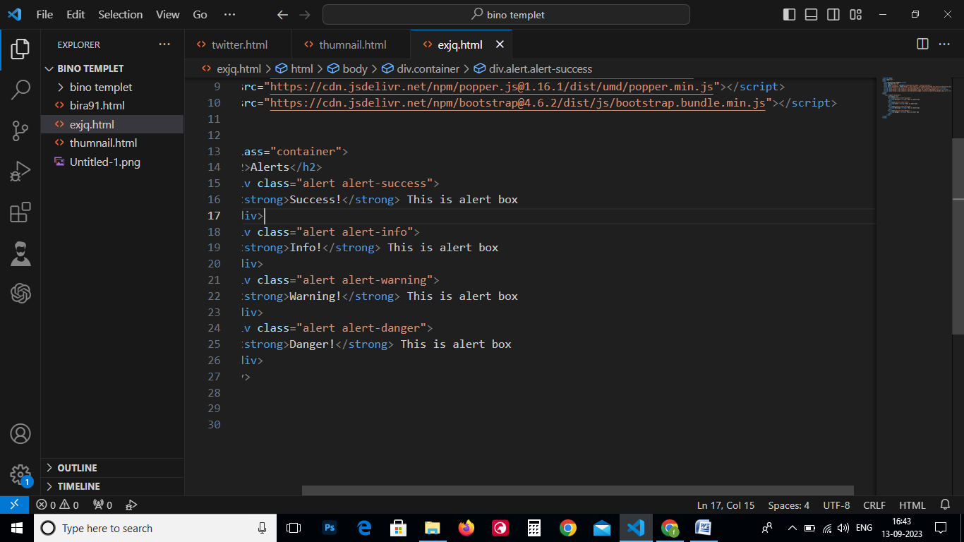

1. **What is a bootstrap card and how would you create one?**

🡪 A card is a flexible and extensible content container. It includes options for headers and footers, a wide variety of content, contextual background colors, and powerful display options. If you're familiar with Bootstrap 3, cards replace our old panels, wells, and thumbnails.

