1. **What are the new tags added in HTML5?**

🡪 <article> 🡪<dialog>

🡪 <aside> 🡪<figure>

🡪<details> 🡪<footer>

🡪<bdi> 🡪<main>

🡪<figcaption> 🡪<header>

🡪<mark> 🡪<meter>

🡪<nav> 🡪<progress>

1. **How to embed audio and video in a webpage?**

🡪Create a new HTML file in the same directory, called index. html .

🡪Add <audio> and <video> elements to the page; make them display the default browser controls. Give both of them <source> elements so that browsers will find the audio format they support best and load it.

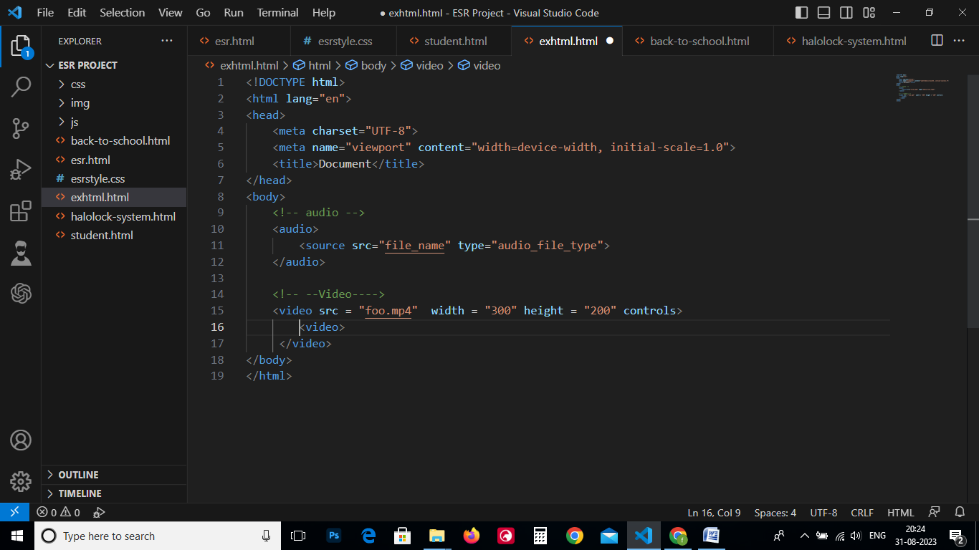

1. **Semantic element in HTML5?**

🡪 Semantic HTML elements are those that clearly describe their meaning in a human- and machine-readable way.

* <article>
* <aside>
* <details>
* <figcaption>
* <figure>
* <footer>
* <header>
* <main>
* <mark>
* <nav>
* <section>
* <summary>
* <time>

1. **Canvas and SVG tags**
   * **Canvas**

🡪 The HTML <canvas> element is used to draw graphics on a web page.

🡪 The graphic to the left is created with <canvas>. It shows four elements: a red rectangle, a gradient rectangle, a multicolor rectangle, and a multicolor text.

🡪 The <canvas> element is only a container for graphics. You must use JavaScript to actually draw the graphics.

🡪Canvas has several methods for drawing paths, boxes, circles, text, and adding images.

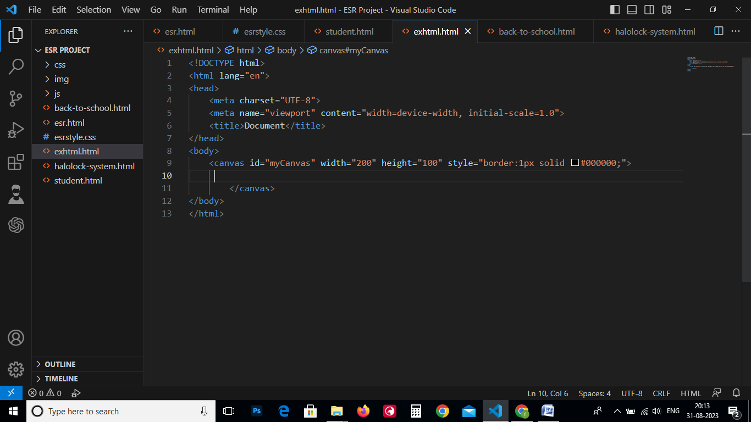

* + **SVG**

**🡪** The HTML <svg> element is a container for SVG graphics.

🡪SVG has several methods for drawing paths, boxes, circles, text, and graphic images.

🡪 SVG stands for Scalable Vector Graphics

🡪SVG is used to define graphics for the Web

🡪SVG is a W3C recommendation

