TRACEY SCOTT
SQLLAB
ASSIGNMENT 5.2 SCREEN SHOTS
02/23/2026
USERIDs of users who have not made an order. Uses MINUS set difference.
QUERY1
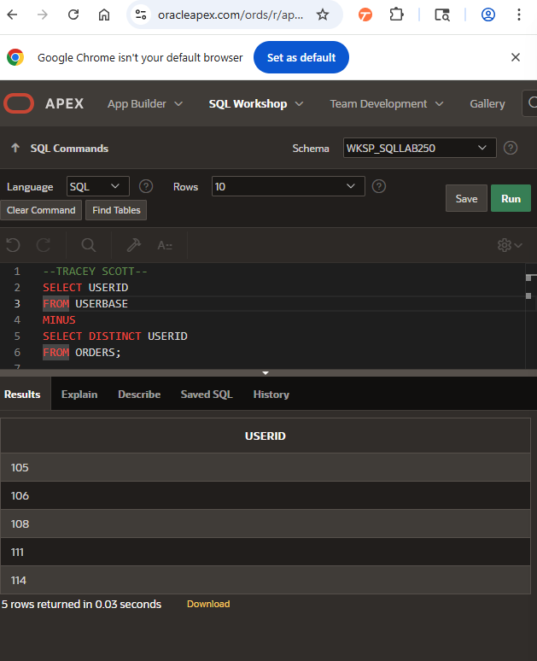

PRODUCTCODEs of products that have no reviews Uses MINUS set difference.
QUERY2
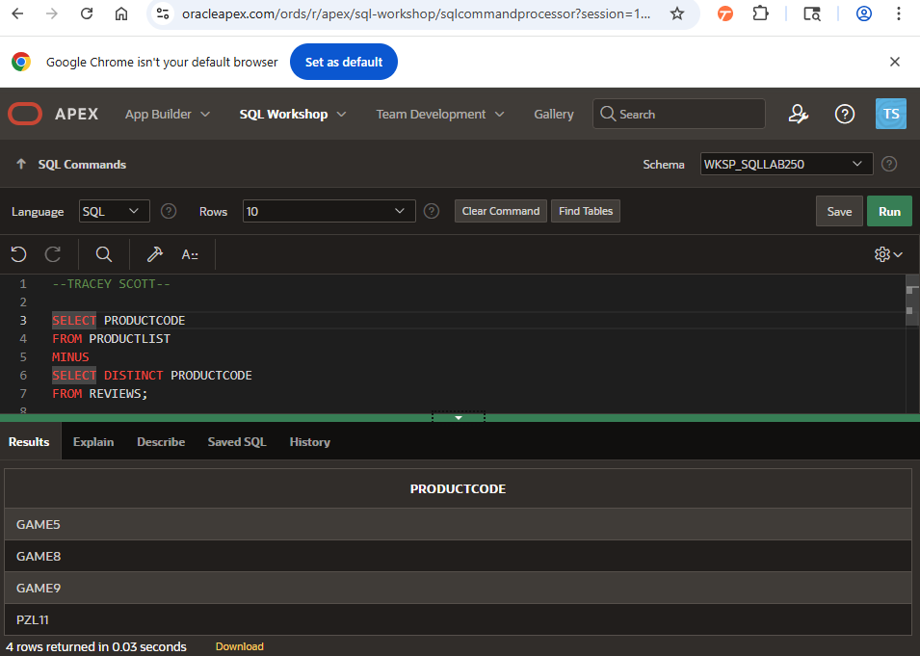

All USERBASE data + Adult/Minor label. Implemented with UNION ALL over two partitions adults vs minors.
QUERY3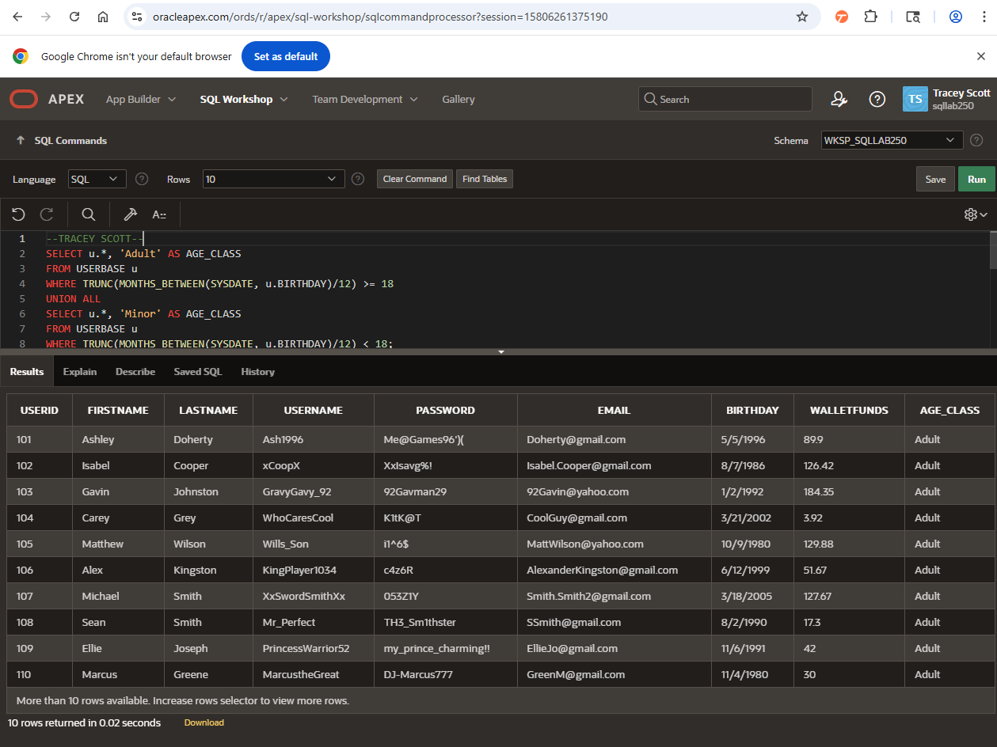

All data in PRODUCTLIST with "On Sale" if price <= 20.
QUERY4
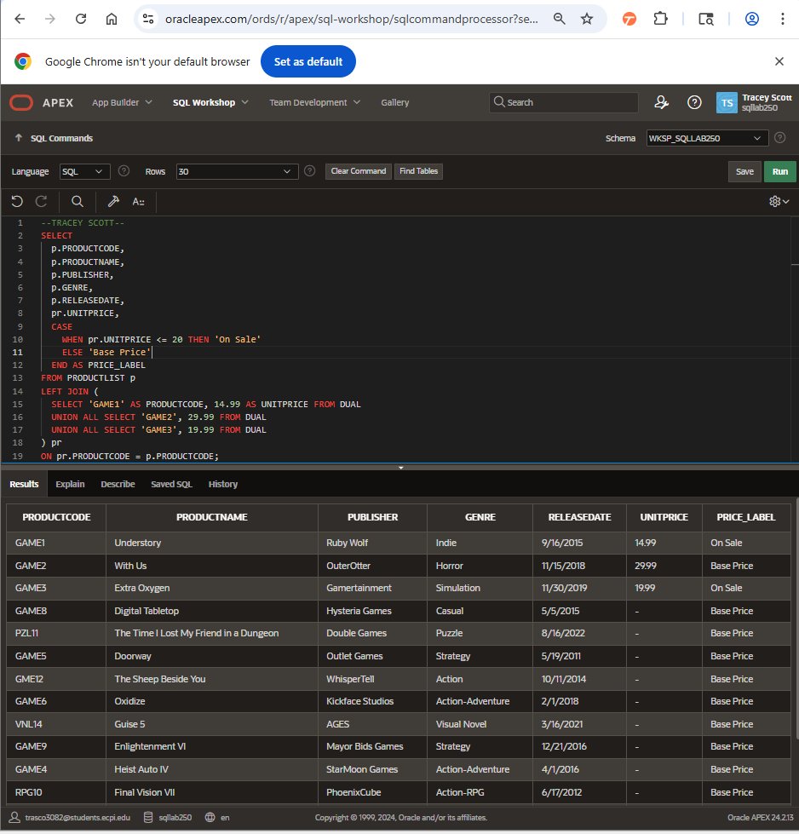

QUERY5
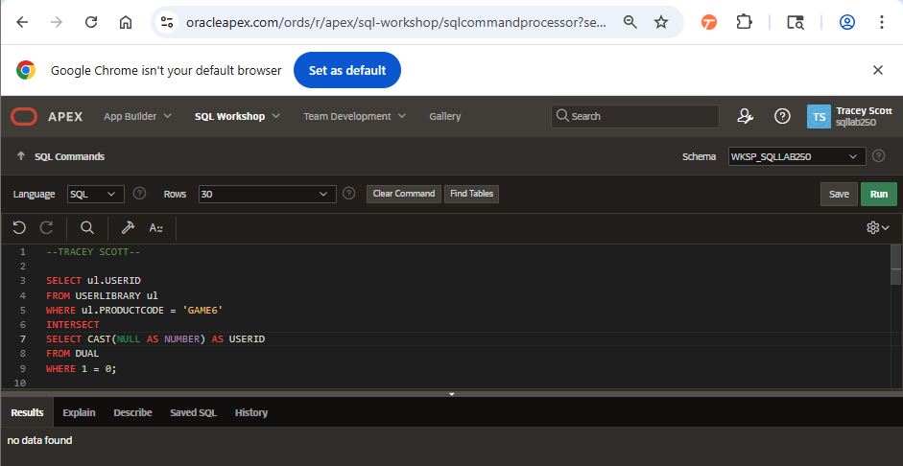
RODUCTCODE in the INTERSECT of WISHLIST and REVIEWS where POSITION in (1,2) and RATING >= 3.
QUERY6
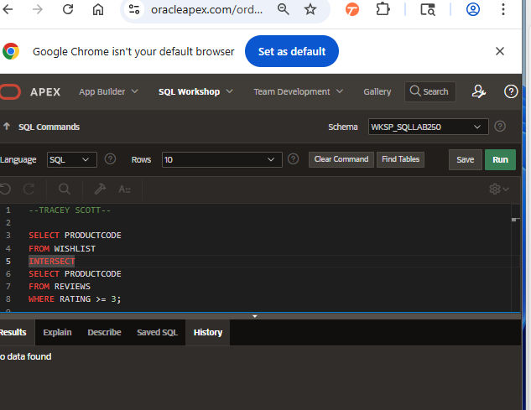
SERNAME and BIRTHDAY for any users who share the same BIRTHDAY. Self-join USERBASE on BIRTHDAY; avoid duplicate/self pairs.
QUERY7
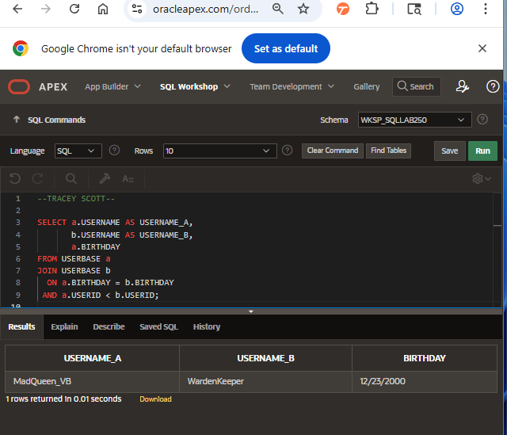
Cartesian Product of USERLIBRARY x WISHLISTN CROSS JOIN.
QUERY8
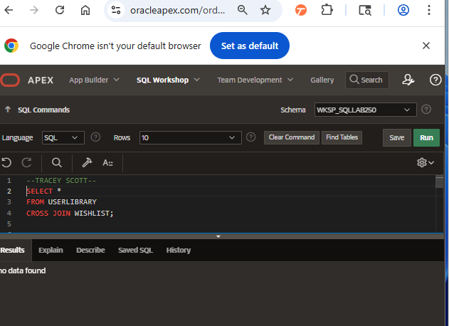
UNION ALL on USERBASE and PRODUCTLIST to generate data on all users and products
Align columns by casting to common types.
QUERY9
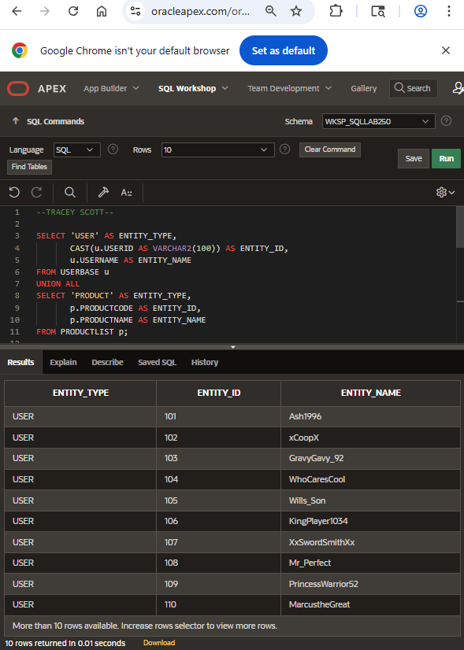

USERNAMEs of all users who have not received an INFRACTION. Uses MINUS users minus users with infractions.
QUERY11
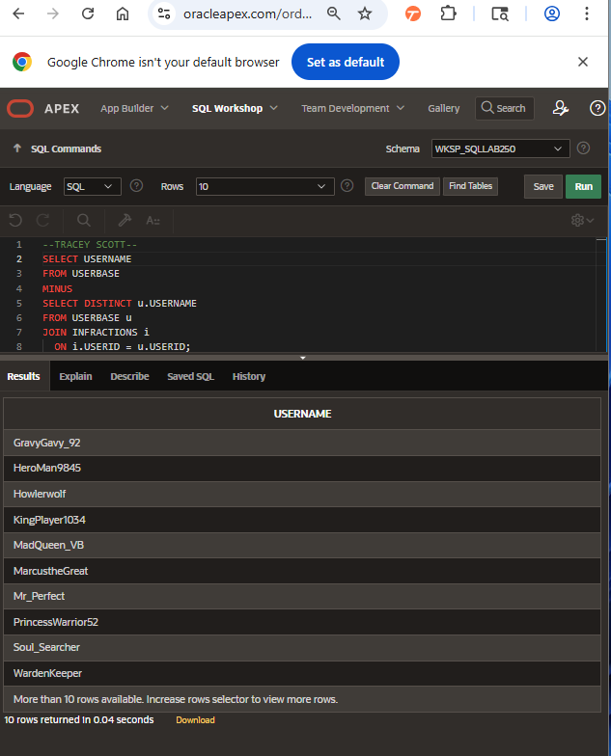

COMMUNITYRULES Title & Description that have not been broken. Uses MINUS (all rules minus rules referenced in INFRACTIONS.
QUERY12
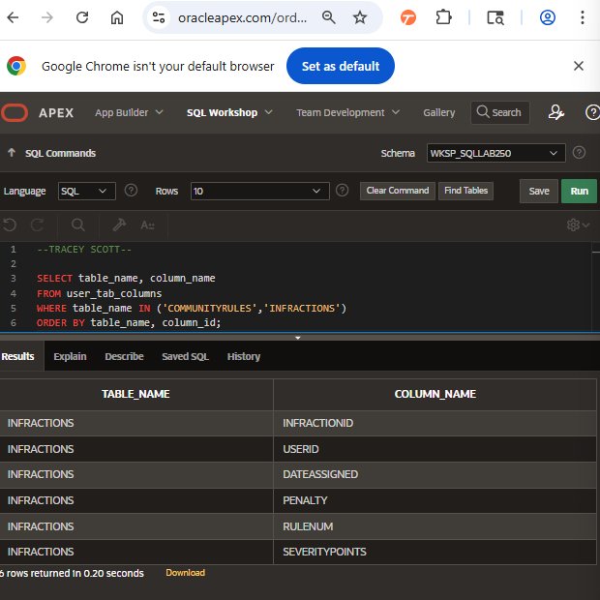
USERNAME and EMAIL of all users who have received a penalty. Uses INTERSECT to emphasize set operation.
QUERY13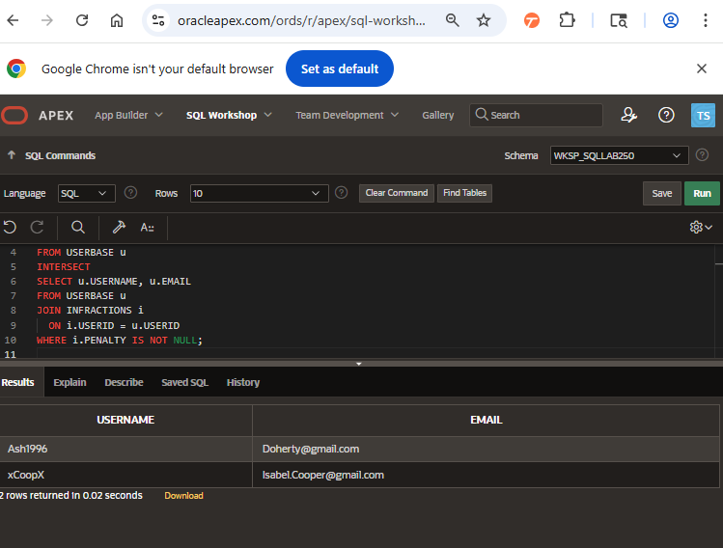
The dates where an INFRACTION was assigned and a USERSUPPORT ticket.
QUERY14
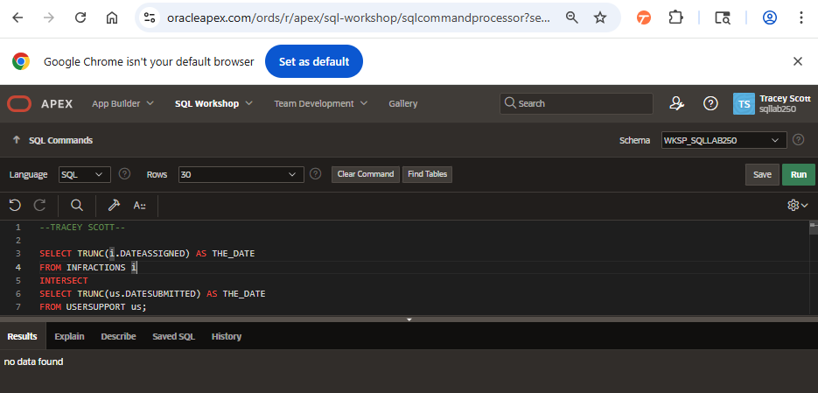
Every COMMUNITYRULES TITLE and PENALTY.
QUERY15
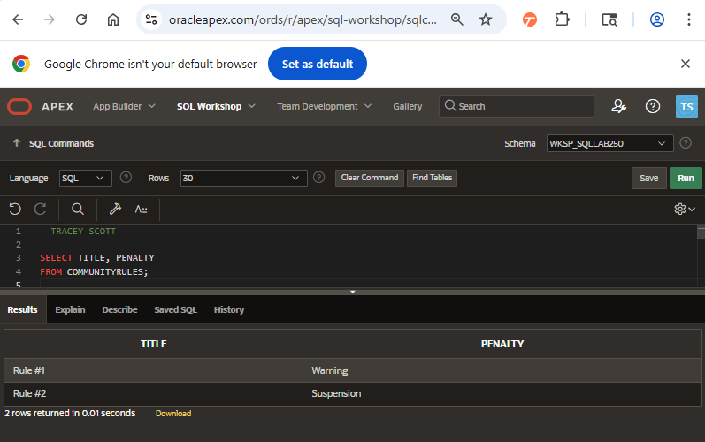

All COMMUNITYRULES with "Bannable" if SEVERITYPOINT >= 10 else "Appealable".
QUERY16
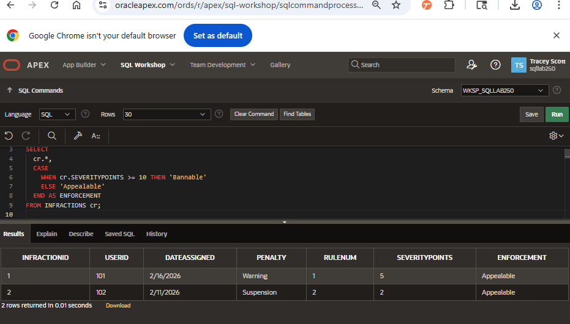
all USERSUPPORT with "High Priority" for tickets not closed and not updated in the past week or never updated.
QUERY17
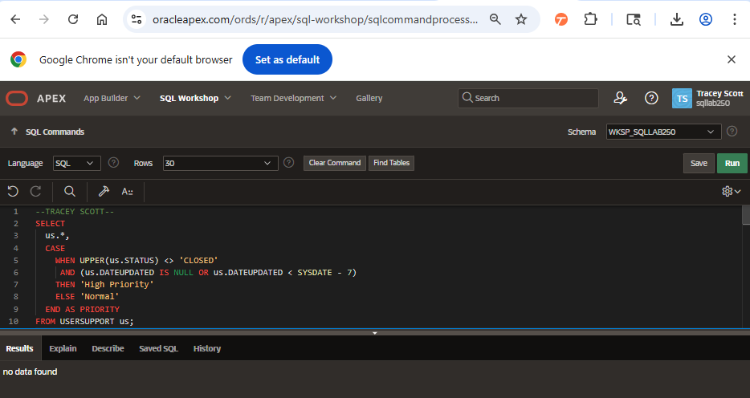
The Cartesian Product (CROSS JOIN) of USERSUPPORT and INFRACTIONS.
QUERY18
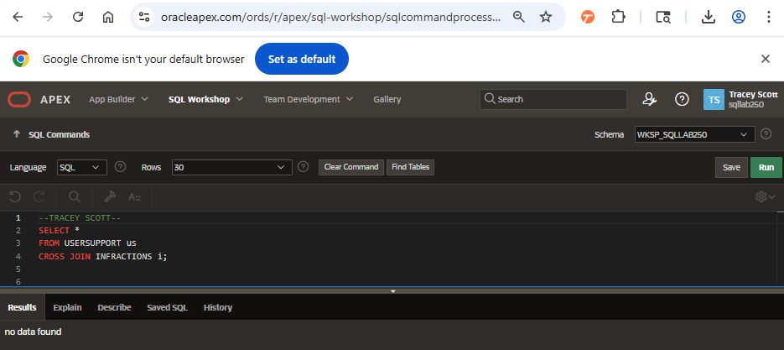
both TICKETIDs and DATEUPDATED for support tickets that are CLOSED and who’s last DATEUPDATED is on the same day (self-join).
QUERY19
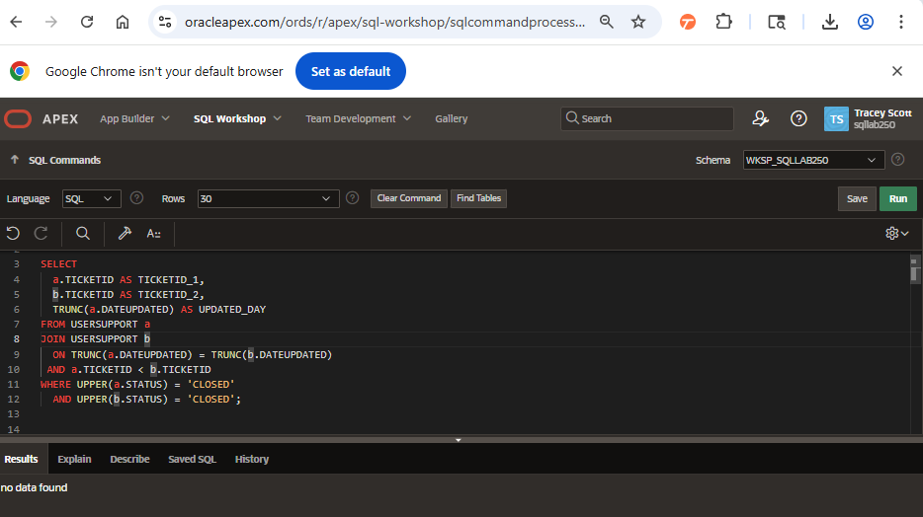

Union all on USERBASE and INFRACTIONS to generate data on user activity.
QUERY20
