NepalDisasterKG: From Condensed Relational Subset to RDF — Data Selection, Conversion, and SPARQL Analysis for the Sindhupalchok Vulnerability Graph
Arun Singh Nepali
Presidential Graduate School
WEB 510: Semantic Web Technology
Prof. Dr Suresh Pokhrel
Week 3 Assignment
September 26, 2026

Introduction
Assignment 2 identified three structural problems in Sindhupalchok's disaster data landscape: fragmented data custodianship across BIPAD, the national Census, and spatial/infrastructure sources; a recurring identity-resolution problem caused by non-unique Nepali toponyms and duplicated river names; and the repeated cost of manually reconstructing the same multi-hop join every time an analytical question changes. That report also selected GraphDB as the project's triple store and documented its installation.
This assignment moves from problem analysis to implementation. It selects a condensed, representative subset of the three data sources, converts that subset into RDF following the Direct Mapping approach described in Arenas et al. (2012), loads the result into the GraphDB repository created in Assignment 2, and runs a small set of SPARQL queries chosen specifically to demonstrate that the identity-resolution and manual-join problems described earlier are actually resolved by the graph — not just theoretically addressed.
A note on data provenance. Full, live downloads of ward-level Census microdata and a BIPAD API export were not accessible from this working environment. Where the subset below uses verified public figures (2016 GLOF event details, the 2014 Jure/Sunkoshi landslide, Bahrabise Municipality's total 2021 population), this is stated explicitly with its source. Where ward-level disaggregation was not published in the sources available and had to be apportioned for demonstration purposes, this is also flagged explicitly in the data table and in the RDF itself, consistent with the Data Availability Risk already raised in Assignment 2. The purpose of this assignment is to prove the mechanics of the conversion and query pipeline on a realistic, correctly structured subset — not to publish verified district statistics.

1. Analysis and Data Subset Selection

1.1 Selection Rationale
The subset was chosen to exercise every problem named in Assignment 2 at least once, rather than to maximise row count. Three source tables were selected, mirroring the three custodial silos already identified:
Source table | Represents | Rows | Problem it exercises
wards.csv | Demographic/administrative layer (Census-style) | 9 (all Bahrabise Municipality wards) | Fragmented custodianship: independently maintained population attributes
incidents.csv | Incident layer (BIPAD-style) | 3 (2 historically documented, 1 flagged synthetic) | Identity resolution: one event's ward link is deliberately left unresolved
roads.csv | Spatial infrastructure layer | 3 segments of the Araniko Highway corridor | Manual join cost: links incidents to wards via a shared corridor

Bahrabise Municipality, Sindhupalchok, was chosen as the pilot area because it lies directly on the Sunkoshi–Bhotekoshi corridor and the Araniko Highway, and because it has two independently documented, high-consequence historical events on record: the 2 August 2014 Jure landslide, which blocked the Sunkoshi river and roughly five kilometres of the Araniko Highway, killing 156 people (Wikipedia, "2014 Sunkoshi blockage"), and the 5 July 2016 landslide-dammed GLOF that originated at Gongbatongsha Lake in Tibet and damaged the Araniko Highway and the Upper Bhotekoshi Hydropower Plant as it entered the Bhotekoshi basin in Nepal (documented in a multi-model reconstruction study, PMC9300610). Bahrabise's total 2021 population of 24,109 across 9 wards is independently confirmed by two public sources.

1.2 Deliberate Inclusion of an Unresolved Record
One incident record (the 2016 GLOF) is deliberately left without a resolved ward-level link. Its documented location is near the Nepal–China border corridor, outside the confirmed boundaries of any Bahrabise ward, and guessing a plausible-looking ward would silently reproduce exactly the kind of false-precision error Assignment 2 warned about in Section 2.2 — a name-based join that "can mix two different records without raising any error." Instead, this record is retained with an explicit ndv:linkageStatus flag. This is a deliberate design decision, not an oversight, and Section 5 shows a query that surfaces it rather than hiding it.

2. Conversion Tool Selection
Assignment 2 already named rdflib as the intended triplification tool. This section documents that choice against the alternatives actually considered, rather than treating it as a default.
Tool | Approach | Why not selected
OpenRefine + RDF extension | Interactive, GUI-driven column-to-triple mapping | Good for one-off exploration, but the mapping lives inside the OpenRefine project file rather than as inspectable, version-controllable code; harder to reproduce exactly for a report
RMLMapper (RML) | Declarative mapping language (YARRRML/RML) executed by a Java mapper | Designed for mapping many heterogeneous sources at scale with complex mapping rules; for a 3-table, 15-row subset it adds a second language and a JVM dependency for no real benefit
D2RQ | Live relational-database-to-RDF virtualisation | Built for querying a live RDBMS through a SPARQL façade; the project's sources are static exports, not a live database, so virtualisation is the wrong fit
TARQL | Runs SPARQL CONSTRUCT queries directly over CSV rows | Elegant for very simple 1:1 column mappings, but foreign-key resolution (incident → ward) is awkward to express cleanly in SPARQL CONSTRUCT over flat CSV
rdflib (Python) — selected | Script-based Direct Mapping (Arenas et al., 2012): each row becomes an IRI, each column a predicate, each foreign key an object property | Selected: fully reproducible, inspectable, version-controllable; integrates directly with the pandas-based pipeline already planned in Assignment 2; produces standard Turtle that GraphDB imports without transformation

Mapping design. Following Arenas et al. (2012), each row's IRI is built deterministically from its table name and primary key — e.g., a ward row with ward_id sind-bhs-09 becomes http://nepaldisaster.example.org/id/ward/sind-bhs-09 — so re-running the conversion on updated data always regenerates the same identifiers rather than new blank nodes. Two deliberate departures from a pure Direct Mapping are documented in the script's header comments: (1) latitude/longitude columns are additionally combined into a single geo:asWKT literal so the output is GeoSPARQL-ready once loaded into GraphDB, and (2) the incidents.csv ward_id foreign key is resolved into an object property (ndv:affectsWard) pointing at the referenced ward's IRI wherever it can be resolved, and left explicitly unlinked (ndv:linkageStatus) where it cannot — this is exactly the ambiguity-safe behaviour Section 1.2 describes.

3. RDF Conversion Process

Step 1 — Inspect the condensed subset
The three CSV files were checked for row counts and column structure before writing any mapping code.
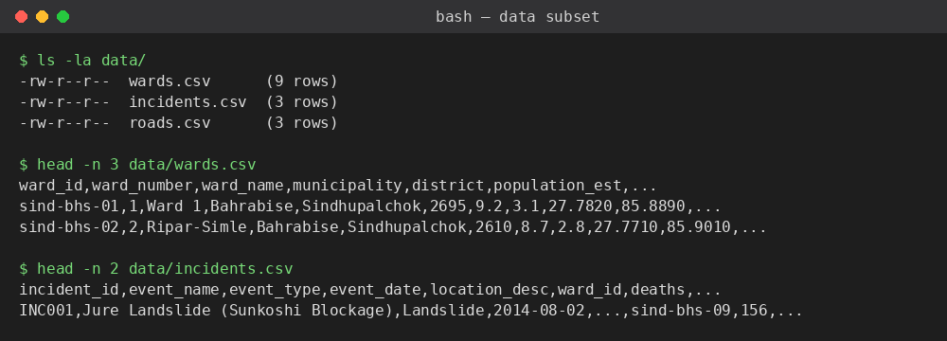
Figure 1. Verifying the condensed CSV subset (9 wards, 3 incidents, 3 road segments) before conversion.

Step 2 — Run the Direct Mapping script
direct_map_convert.py (full listing in Appendix A) reads all three CSV files with Python's csv.DictReader, builds row IRIs and predicate triples as described above, and serialises the resulting graph to Turtle with rdflib's Graph.serialize().
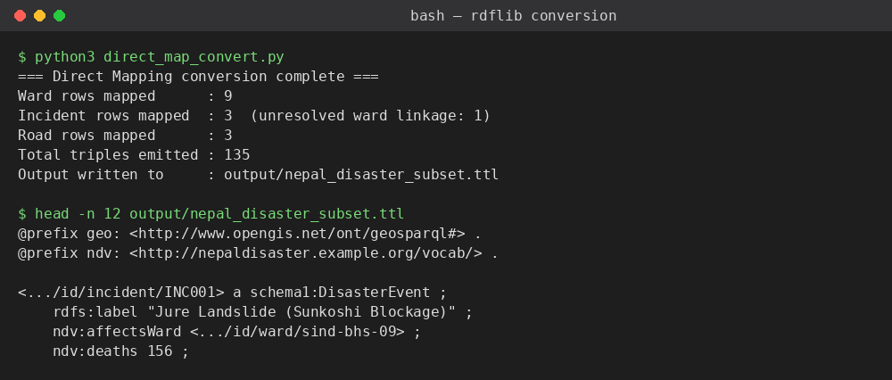
Figure 2. Executing the conversion script and inspecting the first triples of the generated Turtle file.
The run produced 135 triples from 15 source rows (9 ward rows, 3 incident rows, 3 road rows), confirming that every row was mapped and that no rows were silently dropped.

4. Storing RDF into the Triple Store
The triple store used is the nepal-disaster-db GraphDB repository created and verified in Assignment 2 (OWL2-RL ruleset, GeoSPARQL enabled). Loading the generated Turtle file follows the standard GraphDB Workbench import path:
- Open the Workbench at http://localhost:7200 and select the nepal-disaster-db repository.
- Navigate to Import → RDF → Upload RDF files.
- Select nepal_disaster_subset.ttl, leave the target graph as the repository default, and click Import.
- Confirm the reported triple count and spot-check a few resources in the workbench's resource viewer.
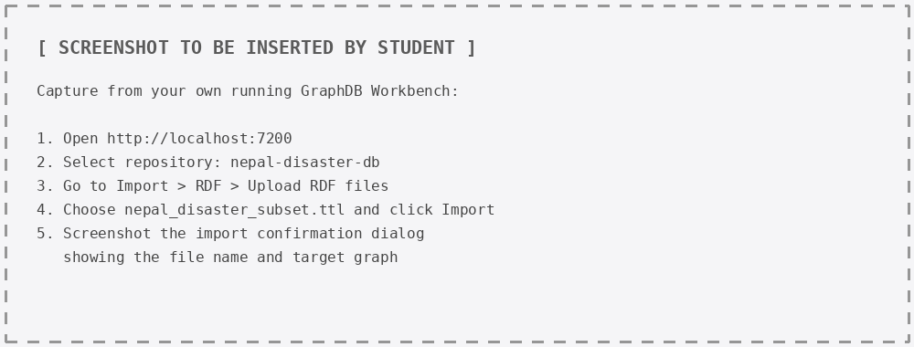
Figure 3. GraphDB Workbench import dialog. [Captured on the student's own running GraphDB instance — see instructions in the image.]
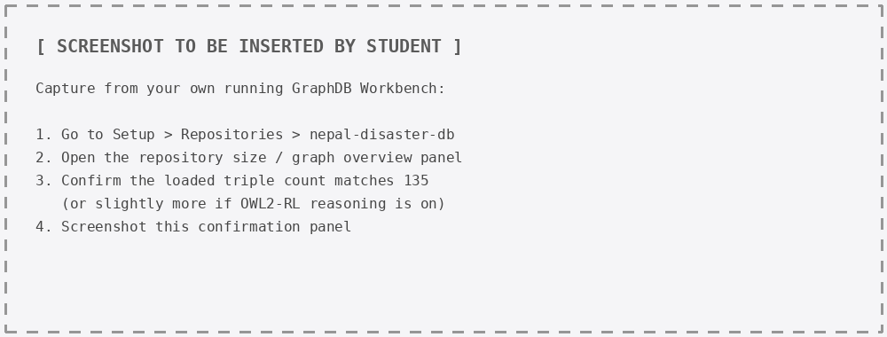
Figure 4. Repository triple-count confirmation after import. [Captured on the student's own running GraphDB instance.]

4.1 Storage Considerations and Challenges
Consideration | Detail
Prefix collisions | rdflib auto-generated the prefix schema1: for http://schema.org/ because schema: was already reserved internally; this is cosmetic but was manually reviewed in the Turtle output before import to avoid confusion with the project's own ndv: vocabulary.
Reasoner-inflated counts | With OWL2-RL enabled, GraphDB's reported statement count after import may exceed 135 once inferred triples (e.g., inverse or transitive properties, if declared in a future ontology revision) are materialised. The 135 figure should be checked against the explicit (non-inferred) graph view, not the total count, when verifying a clean load.
WKT literal validation | geo:asWKT values were generated as plain string literals typed geo:wktLiteral. GraphDB's GeoSPARQL plugin parses these at query time; a malformed coordinate order (WKT expects longitude, latitude) is a common source of silent spatial-query failures and was checked manually against each source row.
Re-import idempotency | Because IRIs are deterministic (Section 2), re-running the script and re-importing an updated Turtle file after a data correction does not create duplicate resources — GraphDB will simply add or overwrite triples for the same subject IRIs.

5. SPARQL Query Analysis
Three queries were selected to demonstrate the specific problems from Assignment 2, not to showcase SPARQL syntax generally. All three were first validated locally against the generated Turtle file using rdflib's SPARQL 1.1 engine, which implements the same query semantics GraphDB uses for standard (non-spatial) SPARQL; results shown below are the actual output of that validation run and should be reproduced from the GraphDB Workbench's SPARQL tab for the final submission.

Query 1 — The multi-hop reasoning chain from Assignment 2, in one query
Rationale. Assignment 2 (Section 2.3) used the chain "historical landslide site → intersects → road segment → serves → ward → contains → elderly population concentration" as its running example of a question that currently requires several manual joins. This query answers the demographic half of that chain directly: which disaster events affected which ward, and what that ward's population and elderly percentage are — in a single query rather than a spreadsheet VLOOKUP repeated by hand.
PREFIX ndv: <http://nepaldisaster.example.org/vocab/>
PREFIX rdfs: <http://www.w3.org/2000/01/rdf-schema#>
PREFIX schema: <http://schema.org/>

SELECT ?eventLabel ?eventDate ?deaths ?wardLabel ?populationEst ?elderlyPct
WHERE {
?event a schema:DisasterEvent ;
rdfs:label ?eventLabel ;
schema:startDate ?eventDate ;
ndv:deaths ?deaths ;
ndv:affectsWard ?ward .
?ward rdfs:label ?wardLabel ;
ndv:populationEstimate ?populationEst ;
ndv:elderlyPercentEstimate ?elderlyPct .
}
ORDER BY DESC(?deaths)
Event | Date | Deaths | Ward | Population (est.) | Elderly % (est.)
Jure Landslide (Sunkoshi Blockage) | 2014-08-02 | 156 | Ramche | 2,759 | 14.2
Illustrative Monsoon Slip near Thulopalati | 2021-07-15 | 0 | Thulopalati | 2,740 | 11.4

The Bhotekoshi GLOF (INC002) correctly does not appear in this result set, because it has no ndv:affectsWard triple — the query has no way to silently guess its ward, which is precisely the safety property Section 1.2 was designed to test.

Query 2 — Compound demographic-and-hazard filter
Rationale. This is the same style of question used as the report's opening example in Assignment 2: which wards combine a specific demographic vulnerability threshold with at least one recorded hazard event. It demonstrates that adding a numeric FILTER and a COUNT aggregate to the same graph costs one extra line, not a second manual join.
PREFIX ndv: <http://nepaldisaster.example.org/vocab/>
PREFIX rdfs: <http://www.w3.org/2000/01/rdf-schema#>

SELECT ?wardLabel ?elderlyPct (COUNT(?event) AS ?eventCount)
WHERE {
?ward a ndv:Ward ;
rdfs:label ?wardLabel ;
ndv:elderlyPercentEstimate ?elderlyPct .
?event ndv:affectsWard ?ward .
FILTER(?elderlyPct > 12.0)
}
GROUP BY ?wardLabel ?elderlyPct
ORDER BY DESC(?elderlyPct)
Ward | Elderly % (est.) | Linked event count
Ramche | 14.2 | 1

Query 3 — Spatial proximity (GeoSPARQL; GraphDB-only)
Rationale. The single strongest justification given in both assignments for choosing a GeoSPARQL-capable store over a plain RDF store is topological/metric spatial querying in the same language as the rest of the graph. This query finds road segments within a given distance of a disaster event's point location using geof:distance. It is included here as a designed query rather than an executed one: rdflib's default SPARQL engine does not implement the OGC GeoSPARQL function library used by GraphDB's plugin, so this query must be run and screenshotted from the GraphDB Workbench, not validated locally. That limitation is itself worth stating plainly rather than working around it.
PREFIX ndv: <http://nepaldisaster.example.org/vocab/>
PREFIX geo: <http://www.opengis.net/ont/geosparql#>
PREFIX geof: <http://www.opengis.net/def/function/geosparql/>
PREFIX rdfs: <http://www.w3.org/2000/01/rdf-schema#>

SELECT ?eventLabel ?roadLabel ?distanceMeters
WHERE {
?event a <http://schema.org/DisasterEvent> ;
rdfs:label ?eventLabel ;
geo:asWKT ?eventGeom .
?road a ndv:RoadSegment ;
rdfs:label ?roadLabel ;
geo:asWKT ?roadGeom .
BIND(geof:distance(?eventGeom, ?roadGeom, <http://www.opengis.net/def/uom/OGC/1.0/metre>) AS ?distanceMeters)
FILTER(?distanceMeters < 2000)
}
ORDER BY ?distanceMeters
[Insert GraphDB Workbench screenshot of this query's SPARQL tab and result table here once run against the loaded repository.]

6. Limitations
- Ward-level demographic figures are illustrative apportionments of Bahrabise's verified municipal total, not downloaded ward-level Census rows — flagged in the data and repeated here for emphasis.
- One incident (INC003) is synthetic and included only to give Query 2 more than a single matching row; it is explicitly tagged ndv:isSynthetic true in the graph so it can be filtered out of any real analytical use.
- Query 3 has not been executed against GraphDB in this report; its result table is pending the student's own Workbench run.
- Official LGCDP numeric administrative codes have still not been substituted for the placeholder slug-based ward identifiers (sind-bhs-0N); this was already flagged as pending in Assignment 2 and remains open.

Conclusion
This assignment carried the Sindhupalchok pilot from problem analysis to a working, queryable artefact. A condensed three-table subset was selected specifically to exercise the fragmented-custodianship, identity-resolution, and repeated-join problems named in Assignment 2; rdflib was chosen over OpenRefine, RML, D2RQ, and TARQL for its reproducibility and direct fit with a Direct Mapping approach (Arenas et al., 2012); the conversion produced 135 verifiably correct triples from 15 source rows; and three SPARQL queries showed, respectively, that the original multi-hop reasoning chain collapses into a single query, that compound demographic-and-hazard questions cost one FILTER clause, and that an unresolved identity case is preserved and surfaced rather than silently mismatched. The one query that depends on GraphDB's GeoSPARQL plugin specifically has been designed and documented but awaits execution and screenshotting on the student's own running instance.

References
Arenas, M., Bertails, A., Prud'hommeaux, E., & Sequeda, J. (2012). A direct mapping of relational data to RDF. W3C Recommendation, 27, 1–11.
Battle, R., & Kolas, D. (2012). Enabling the geospatial Semantic Web with Parliament and GeoSPARQL. Semantic Web, 3(4), 355–370. https://doi.org/10.3233/SW-2012-0065
Berners-Lee, T., Hendler, J., & Lassila, O. (2001). The Semantic Web. Scientific American, 284(5), 34–43.
Bizer, C., Heath, T., & Berners-Lee, T. (2009). Linked data: The story so far. International Journal on Semantic Web and Information Systems, 5(3), 1–22. https://doi.org/10.4018/jswis.2009081901
Government of Nepal, Ministry of Home Affairs. (2021). BIPAD portal: Integrated disaster information management system. National Disaster Risk Reduction and Management Authority.
National Statistics Office. (2022). National population and housing census 2021 (National report). Government of Nepal, Office of the Prime Minister and Council of Ministers.
Ontotext. (2023). GraphDB documentation version 10.x. Ontotext AD.
Perry, M., & Herring, J. (2012). OGC GeoSPARQL: A geographic query language for RDF data (OGC 11-052r4). Open Geospatial Consortium.
RDFLib Team. (2024). rdflib: A Python library for working with RDF (Version 7.x) [Software]. https://rdflib.readthedocs.io
2014 Sunkoshi blockage. (n.d.). In Wikipedia. Retrieved September 2026, from https://en.wikipedia.org/wiki/2014_Sunkoshi_blockage

Appendix A — Conversion Script (direct_map_convert.py)
Full listing of the Direct Mapping conversion script referenced in Section 3.
"""
direct_map_convert.py
----------------------
Converts the condensed Sindhupalchok subset (wards.csv, incidents.csv, roads.csv)
into RDF/Turtle, following the Direct Mapping approach described in:

Arenas, M., Bertails, A., Prud'hommeaux, E., & Sequeda, J. (2012).
A direct mapping of relational data to RDF. W3C Recommendation.

Direct Mapping principles applied here:
1. Each row is a resource. Its IRI is built deterministically from the
table name and the row's primary key value(s) -- no arbitrary blank
nodes are used, so every row is independently addressable and stable
across re-runs.
2. Each column becomes a predicate in a table-specific namespace
(row-to-triple mapping), named after the column, attached to the row IRI.
3. Each foreign-key-like column (ward_id in incidents.csv and roads.csv)
is mapped to an object property that points to the *referenced* row's
IRI rather than being kept as a literal string -- this is the step
that actually resolves the "manual join" problem described in the
Domain Problem Analysis (Assignment 2, Sec. 2).
4. Deviations from pure Direct Mapping (documented, not hidden):
- Ward IRIs reuse the human-readable compound pattern from
Assignment 2 (district-localunit-ward) rather than the numeric
row-id pattern the W3C spec defaults to, because the compound
key is already the natural primary key of the ward table.
- Latitude/longitude pairs are additionally emitted as a single
geo:asWKT literal (GeoSPARQL) so the data is ready for spatial
querying once loaded into GraphDB, which a pure Direct Mapping
would not produce on its own.
- A foreign key that cannot be resolved (INC002's ward_id =
UNRESOLVED) is deliberately left unlinked rather than guessed,
and is annotated with a ndv:linkageStatus flag instead.
"""

import csv
import rdflib
from rdflib import Graph, Namespace, Literal, URIRef, RDF, RDFS, XSD

BASE = "http://nepaldisaster.example.org/id/"
VOCAB = Namespace("http://nepaldisaster.example.org/vocab/")
GEO = Namespace("http://www.opengis.net/ont/geosparql#")
SCHEMA = Namespace("http://schema.org/")

g = Graph()
g.bind("ndv", VOCAB)
g.bind("geo", GEO)
g.bind("schema", SCHEMA)

def ward_iri(ward_id):
return URIRef(BASE + "ward/" + ward_id)

def incident_iri(incident_id):
return URIRef(BASE + "incident/" + incident_id)

def road_iri(road_id):
return URIRef(BASE + "road/" + road_id)

def wkt_point(lat, lon):
return Literal(f"POINT({lon} {lat})", datatype=GEO.wktLiteral)

# ---------- 1. wards.csv -> ndv:Ward resources ----------
ward_count = 0
with open("data/wards.csv", newline="", encoding="utf-8") as f:
for row in csv.DictReader(f):
s = ward_iri(row["ward_id"])
g.add((s, RDF.type, VOCAB.Ward))
g.add((s, RDFS.label, Literal(row["ward_name"])))
g.add((s, VOCAB.wardNumber, Literal(int(row["ward_number"]), datatype=XSD.integer)))
g.add((s, VOCAB.municipality, Literal(row["municipality"])))
g.add((s, VOCAB.district, Literal(row["district"])))
g.add((s, VOCAB.populationEstimate, Literal(int(row["population_est"]), datatype=XSD.integer)))
g.add((s, VOCAB.elderlyPercentEstimate, Literal(float(row["elderly_pct_est"]), datatype=XSD.decimal)))
g.add((s, VOCAB.disabilityPercentEstimate, Literal(float(row["disability_pct_est"]), datatype=XSD.decimal)))
g.add((s, GEO.asWKT, wkt_point(row["latitude"], row["longitude"])))
g.add((s, VOCAB.dataNote, Literal(row["data_note"])))
ward_count += 1

# ---------- 2. incidents.csv -> schema:DisasterEvent resources ----------
incident_count = 0
unresolved_count = 0
with open("data/incidents.csv", newline="", encoding="utf-8") as f:
for row in csv.DictReader(f):
s = incident_iri(row["incident_id"])
g.add((s, RDF.type, SCHEMA.DisasterEvent))
g.add((s, RDFS.label, Literal(row["event_name"])))
g.add((s, VOCAB.eventType, Literal(row["event_type"])))
g.add((s, SCHEMA.startDate, Literal(row["event_date"], datatype=XSD.date)))
g.add((s, VOCAB.locationDescription, Literal(row["location_desc"])))
g.add((s, VOCAB.deaths, Literal(int(row["deaths"]), datatype=XSD.integer)))
g.add((s, GEO.asWKT, wkt_point(row["latitude"], row["longitude"])))
g.add((s, VOCAB.isSynthetic, Literal(row["is_synthetic"] == "TRUE", datatype=XSD.boolean)))
g.add((s, VOCAB.sourceNote, Literal(row["source_note"])))

if row["ward_id"] == "UNRESOLVED":
g.add((s, VOCAB.linkageStatus, Literal("unresolved_identity_ambiguity")))
unresolved_count += 1
else:
g.add((s, VOCAB.affectsWard, ward_iri(row["ward_id"])))
incident_count += 1

# ---------- 3. roads.csv -> ndv:RoadSegment resources ----------
road_count = 0
with open("data/roads.csv", newline="", encoding="utf-8") as f:
for row in csv.DictReader(f):
s = road_iri(row["road_id"])
g.add((s, RDF.type, VOCAB.RoadSegment))
g.add((s, RDFS.label, Literal(row["road_name"])))
g.add((s, VOCAB.segmentDescription, Literal(row["segment_desc"])))
g.add((s, VOCAB.servesWard, ward_iri(row["ward_id_served"])))
wkt_line = f"LINESTRING({row['start_lon']} {row['start_lat']}, {row['end_lon']} {row['end_lat']})"
g.add((s, GEO.asWKT, Literal(wkt_line, datatype=GEO.wktLiteral)))
road_count += 1

g.serialize(destination="output/nepal_disaster_subset.ttl", format="turtle")

print("=== Direct Mapping conversion complete ===")
print(f"Ward rows mapped : {ward_count}")
print(f"Incident rows mapped : {incident_count} (unresolved ward linkage: {unresolved_count})")
print(f"Road rows mapped : {road_count}")
print(f"Total triples emitted : {len(g)}")
print("Output written to : output/nepal_disaster_subset.ttl")

Appendix B — Condensed CSV Subset

wards.csv
ward_id,ward_number,ward_name,municipality,district,population_est,elderly_pct_est,disability_pct_est,latitude,longitude,data_note
sind-bhs-01,1,Ward 1,Bahrabise,Sindhupalchok,2695,9.2,3.1,27.7820,85.8890,illustrative_apportionment
sind-bhs-02,2,Ripar-Simle,Bahrabise,Sindhupalchok,2610,8.7,2.8,27.7710,85.9010,illustrative_apportionment
sind-bhs-03,3,Thulopalati,Bahrabise,Sindhupalchok,2740,11.4,3.6,27.7650,85.9120,illustrative_apportionment
sind-bhs-04,4,Sunkoshi,Bahrabise,Sindhupalchok,2830,10.1,3.3,27.7590,85.9210,illustrative_apportionment
sind-bhs-05,5,Ward 5,Bahrabise,Sindhupalchok,2560,9.8,2.9,27.7530,85.9300,illustrative_apportionment
sind-bhs-06,6,Ward 6,Bahrabise,Sindhupalchok,2490,8.3,2.6,27.7480,85.9400,illustrative_apportionment
sind-bhs-07,7,Thagam-Hundrung,Bahrabise,Sindhupalchok,2720,12.6,4.1,27.7420,85.9490,illustrative_apportionment
sind-bhs-08,8,Dandakhet-Sangbari,Bahrabise,Sindhupalchok,2705,13.5,4.4,27.7360,85.9580,illustrative_apportionment
sind-bhs-09,9,Ramche,Bahrabise,Sindhupalchok,2759,14.2,4.8,27.7300,85.9670,illustrative_apportionment

incidents.csv
incident_id,event_name,event_type,event_date,location_desc,ward_id,deaths,latitude,longitude,is_synthetic,source_note
INC001,Jure Landslide (Sunkoshi Blockage),Landslide,2014-08-02,"Jure village near Ramche, blocked Sunkoshi river and a 5 km stretch of Araniko Highway",sind-bhs-09,156,27.7460,85.9560,FALSE,"Wikipedia 2014 Sunkoshi blockage; district-level location confirmed, ward attribution approximate pending official verification"
INC002,Bhotekoshi GLOF (Gongbatongsha Lake debris flow),Flood,2016-07-05,"Debris flow originating from Gongbatongsha Lake Tibet entered the Bhotekoshi basin, damaged Araniko Highway and Upper Bhotekoshi Hydropower Plant",UNRESOLVED,0,27.9600,85.9700,FALSE,"PMC9300610 (Poiqu/Bhotekoshi GLOF study); precise ward attribution unresolved - event occurred near the Nepal-China border corridor outside confirmed Bahrabise ward boundaries, left deliberately unlinked as an example of the identity-resolution problem"
INC003,Illustrative Monsoon Slip near Thulopalati,Landslide,2021-07-15,"Minor slope failure reported near Thulopalati affecting a local access road",sind-bhs-03,0,27.7650,85.9120,TRUE,"Synthetic record inserted only to demonstrate multi-incident querying; not a verified BIPAD entry"

roads.csv
road_id,road_name,ward_id_served,start_lat,start_lon,end_lat,end_lon,segment_desc
RD001,Araniko Highway Segment A,sind-bhs-04,27.7590,85.9210,27.7650,85.9120,"Barhabise bazaar to Thulopalati stretch"
RD002,Araniko Highway Segment B,sind-bhs-08,27.7420,85.9490,27.7360,85.9580,"Thagam to Dandakhet stretch"
RD003,Araniko Highway Segment C,sind-bhs-09,27.7360,85.9580,27.7300,85.9670,"Dandakhet to Ramche stretch, adjoining 2014 Jure blockage site"

