“Clipboard” Web-Application

Scope & Mission

@Thilina Ratnayake

**Team Members, Work Attributed:**

<insert name & twitter handle here>

<insert name & twitter handle here>

<insert name & twitter handle here>

Project Inception: 19 Dec 2014

**Table of Contents**

1. Team Contact Information
2. Description of Project
3. Stakeholders
4. Users
5. Risks
6. Assumptions
7. Project Goals, Tasks, Features
8. Project Architecture
9. Diagrams
10. **Team Composition & Contact Information:**

Project Manager, Lead Developer – Thilina Ratnayake – [Thilina.ratnayake1@gmail.com](mailto:Thilina.ratnayake1@gmail.com) - @tratnayake

Front-End Developer, (insert people here)

Back-End Developer, (insert people here)

1. **Description of Project**

A clipboard, is the usual symbol of an NCO (Non Comissioned Member, leader) within the Cadet program. They can be identified by metal clipboards carried in their left arm, usually containing all the tools and documents required to function in their leadership roles. **Every** clipboard, will usually contain the two following documents: attendance sheets, and uniform marking sheets.

The aim of this project, is to digitize and automate that time-honoured leadership artifact, or at-least reduce the amount of paperwork and manual work required to handle unit attendance and personelle tracking.

Currently, weekly attendance, is a time-intensive manual process that takes time away from training and is usually inaccurate. Unit attendance is a crucial reporting requirement within the organization, as attendance determines the amount of resources allotted for future training years etc. This is time intensive because each cadet (or their staff) must find their name in a list of either 30 others, or 150 others dependent upon unit and sub-unit size. If done through a single sign-in point, this creates a bottleneck. If done by flight-staff, on average, 30 seconds is taken up per cadets for attendance. There are usually errors because members are signed-in manually using pen and paper, and because data must be re-entered manually.

Class attendance, is secondary roll call that is taken in each of the classes through-out the unit as a form of error checking. The Administration staff will check both attendance lists to ensure that a cadet was indeed present. However, if a cadet shows up on one and not the other, this creates issues.

If a cadet is going to be sick, they are currently told to inform their supervisors or call-in to the office. If either the supervisor or admin staff do not note the cadet down as excused (which is possible considering how busy staff are on a weekly/nightly basis), the cadet will be noted as “Absent Without Excuse” and will have his/her standings affected.

Clipboard will solve this problem in the following ways:

1. It will automate and speed up the process by either allowing staff (either with a flight or at a single point) to take in attendance by either:
   * 1. scanning a cadets barcode (sewn into a uniform part)
     2. taking a picture of a cadets nametag (and using OCR to process it)
     3. or at worst case, allowing cadets to search for their name using a search box and quickly sign-in (using a tablet or computer).
2. All attendance results will be contained in a single point (database) leading to less errors.
3. Cadets that are sick, can e-mail into an automated inbox that will mark the cadet down as excused.
4. When it’s time to enter the attendance into FORTRESS, results can be exported easily into an EXCEL file.
5. **Stakeholders**

* Unit Staff (specifically administration officer’s)
  + More accurate reports
  + More time for training
* Cadets
  + Accurate attendance means better reporting. (Cadets can be sure that their efforts are being recorded properly, ensuring a fair process for selections)
  + Faster attendance means less time on admin, more time training.

1. **Users**
2. **Officers(Adult Staff)**
3. **Staff Cadets (Senior cadets)**
4. **Cadets**
5. **Risks**
   1. As per *INSERT REGULATION HERE*, cadets information must be kept private and secure. No PROTECTED A (or higher) information must be allowed to be stored on outside servers.
      1. **Solution:** Protected A information constitutes any information that could identify or HARM an individual if released. The only cadet information that will be stored on database servers will be:
         1. CIN: Cadet Identification Number
         2. Last Name
         3. First Name
         4. Unit Number
         5. Organizational Group
         6. Training Level
      2. If it is deemed necessary that no information may be stored on external servers, users will have the option to
         1. Run their own attendance database server
         2. Provide a flat-file for each session that will not be stored.
6. **Assumptions**
   1. Users will have their own workstation, tablet or barcode scanner to conduct attendance.
7. **Project Goals, Tasks and Features**

These features will first be outlined as a set of stories:

1. **As a staff cadet or adult staff member**, I will be allowed to create an account on Clipboard.
2. I will be able to create a “Unit” on Clipboard from importing an excel file.
3. I will be able to create and assign/associate “USER” accounts to other adult staff members or senior staff cadets within my unit.
4. I will be able to assign attendance points to user accounts.
5. I will be able to generate barcodes (and print as a pdf) for all cadets in my unit.
6. I will be able to schedule/create an “attendance session” on a specific date and time.
7. I will be able to set cadets as “EXCUSED” through response to an e-mail, or midway through an attendance session.
8. I will be able to enter attendance through
   1. Scanning a barcode through barcode scanner connected to workstation
   2. Scanning a barcode through mobile app
   3. Taking a picture of cadet’s nametag.
9. I will have access to a real-time dashboard to see attendance statistics
10. I will be able to export the results of an attendance session to an EXCEL file.
11. **As a senior cadet:**
12. I will be able to generate reports/statistics on my sub-unit’s attendance.
13. **Project Architecture**

There are 3 components to this project:

1. The central web application written in Node.JS that will run on a webserver.
2. Data store which will be run on an external MongoDB Database OR internally by a unit.
3. Mobile app that will allow tablets and mobile phones to utilize the barcode scanner.

**High Level Architecture Diagram**

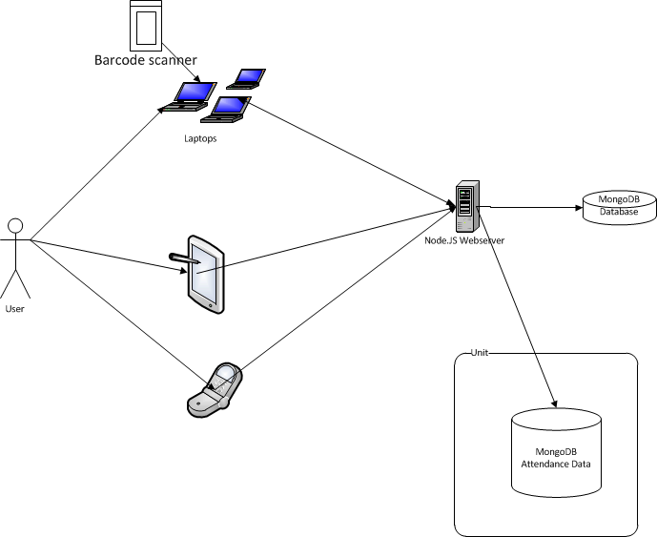

**Sitemap**

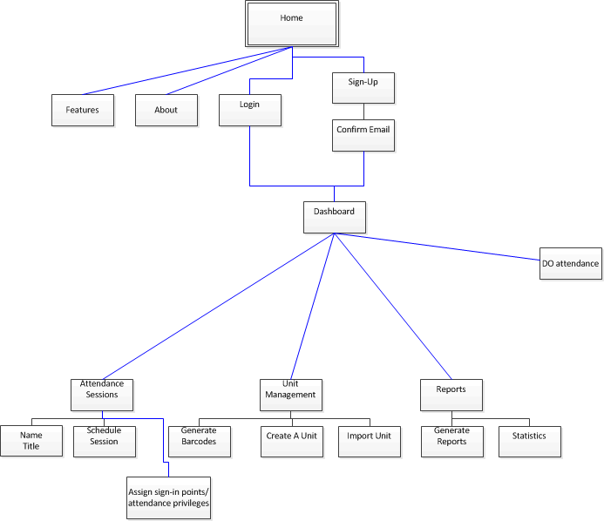

**Class Diagram**

