# TS Library Upgrade Plan

[[TOC]]

## Timeline



## Survey Activities

* Plan Focus Group (Jo)_
* Survey
  + design (Marcia, Jo, Rich, Aaron)
  + Marcia provided the original list of questions, to which one question. A section on hours was added, replacing Marcia’s original hours question.
  + send (Aaron)
  + Rose and Aaron plan to send a link to the survey in the May 7th Happenings.
  + Should we make provisions for snail mail?
  + analyze (Jo?, Rich, Marcia?, Aaron?)

## Weeding Activities

* Refine weeding criteria (Rich, Shelley?)
  + number of checkouts (from charged cards)
  + condition
  + age
  + relevance
  + items to replace
  + eliminate duplicates
* Weeding
  + For catalogued books (have Dewey numbers)
    - save card
    - check card for frequent or recent charges
    - create card if one doesn’t exist
      * author
      * title
* Presort Liturgical Material (Jo, Marcia?)
  + two categories to go into bins: keep, don’t keep
* Consult with Rabbi Perice (Jo, Marcia)

## Redesign Activities

### Plot Space

### Select Furniture

Desks:

* [Hertz Furniture - Library L-Desk Model #CLF-204L](https://www.hertzfurniture.com/circulation-desks--library-l-desk--12057--mo.html)
* [Glacier Library Circulation Desk Shell 60”x30“x29” Model #LCD-6029](https://www.hertzfurniture.com/circulation-desks--glacier-library-circulation-desk-shell--2405--mo.html) wrong picture?!
* [Glacier Library Circulation Desk Shell 36”x30“x29”H Model #LCD-3629](https://www.hertzfurniture.com/circulation-desks--glacier-library-circulation-desk-shell--2402--mo.html)
* [ACP Direct - Teacher Desks](https://www.acpdirect.com/Teacher-Desks-C467.aspx)
* Reflooring (carpeting, linoleum)
  + Happens after weeding.

## System Activities

* Rich get done testing LibraryThing with scanner

## Appendices

### Screenshot of the survey.

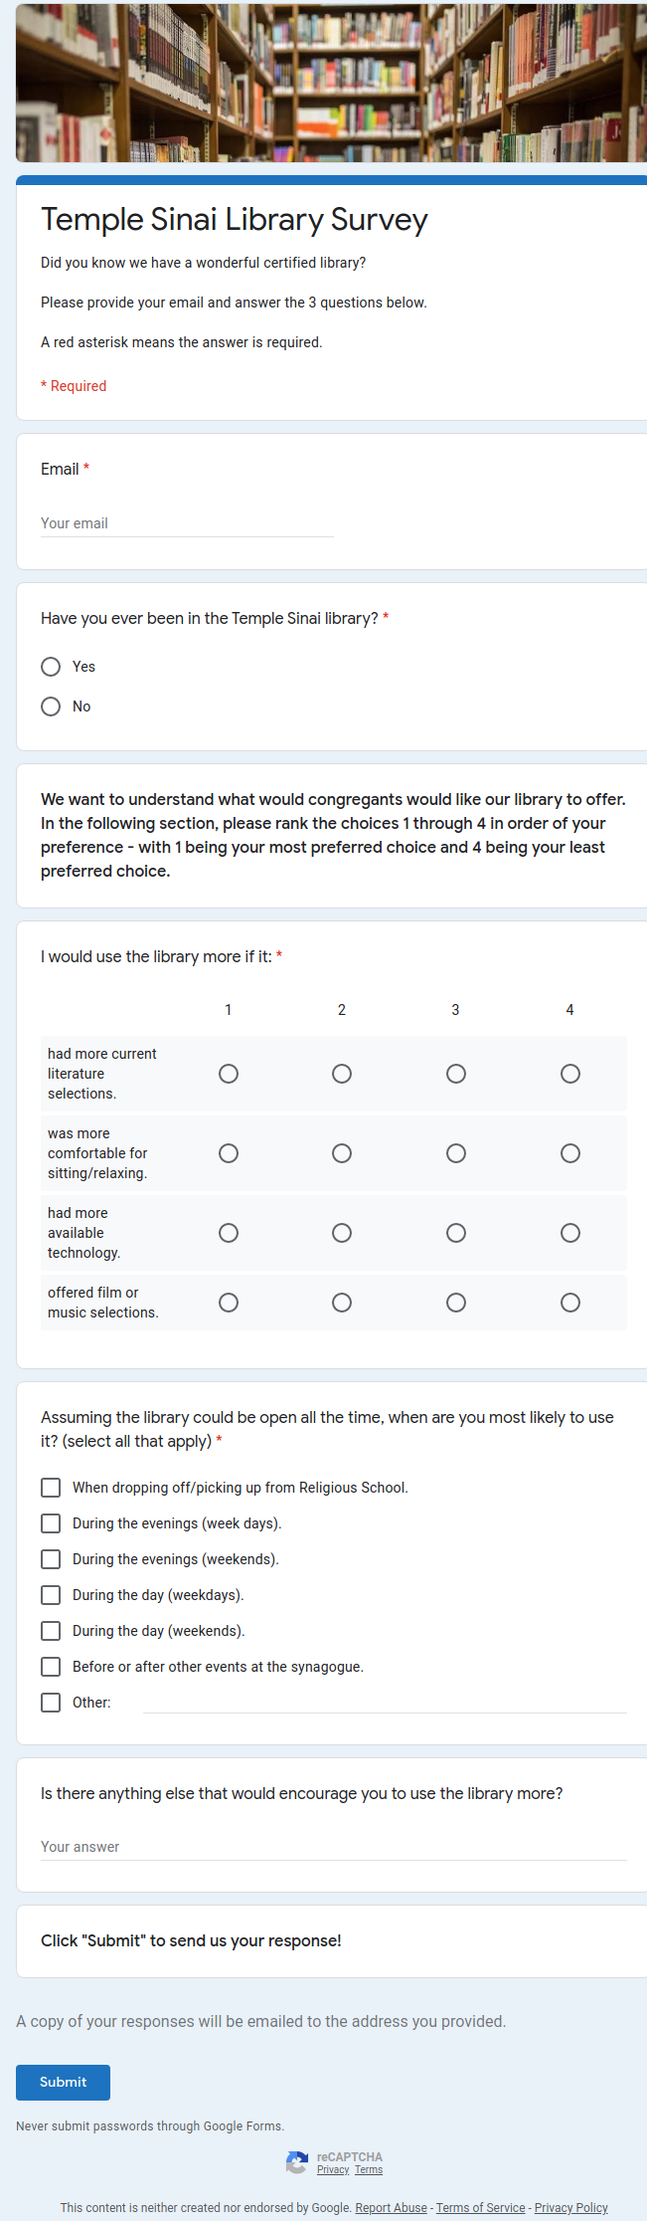

survey screenshot

### List of People for Project

* Analyze Survey:
* Carpeting: John Stevens
* Consult with Rabbi Perice: Jo, Marcia
* Plan Focus Group: Jo
* Presort Liturgical Material: Jo
* Refine Weeding Criteria: Rich, Janet, Shelley
* Send Survey: Rich, Aaron
* Survey Design: Jo, Aaron, Rich, Marcia
* Weeding: Jo, Marcia, Gail, Janet

### List of Projects for Person

* Aaron: Send Survey, Survey Design
* Gail: Weeding
* Janet: Refine Weeding Criteria, Weeding
* Jo: Survey Design, Weeding, Consult with Rabbi Perice, Plan Focus Group, Presort Liturgical Material
* John Stevens: Carpeting
* Marcia: Weeding, Survey Design, Consult with Rabbi Perice
* Rich: Refine Weeding Criteria, Send Survey, Survey Design
* Shelley: Refine Weeding Criteria