p.81 ex 2

Slavery in Britain

Ein Bild, das Zeichnung, Mann, Entwurf, Bild enthält.
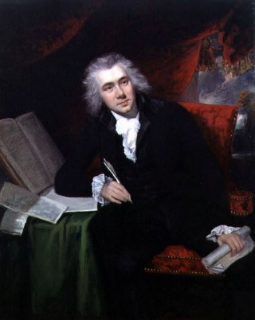The centuries that defined Britain’s involvement in slavery reach from the 17. to the 19. Century up until 1833 where the Slavery Abolition Act prohibited slavery and ended their involvement in the Atlantic triangular slave trade. In this time, they captured at least 3.4 million African people and brought them to America as slaves. The slaves were forced to work on plantations where mostly sugar cane was grown. Rum and sugar were the most exported items on Britain’s list, even though most of the Britons did not use products that were produced by slavery, such as coffee, rum, or sugar. Bristol, Glasgow, and Liverpool started to evolve into port cities and became very prosperous. Slavery has seen it’s end when the Slavery Abolition Act was passed and slave masters on the British Indies in the Caribbean Sea were compensated 20 million pounds, which would be 20 billion pounds by today’s rates which was 40% of all their state budget which was the highest amount of payoff the British government has made before the global financial crisis in 2007 till 2008. The horrible thing is that only the masters were compensated whereas the slaves did not get a single dime.

Unfortunately, most Britons don’t know about their past and just pretend these crimes against basic human rights never happened. Catherine Hall, which is the leader of the British slavery research project, says that most people do not even know slavery existed in British colonies or never thought about that time.

