Big Mountain Resort Report

To reduce operational costs by $1.45 Million, I recommend Big Mountain resort increase their ticket price. Big Mountain Resort currently charges 81 dollars for an adult weekend ticket; however, based on the features of the resort, they are able to charge between 106.24 and 85.52. Alternatively, since it is estimated 350,000 people will visit the resort this season and each person is likely to purchase five tickets, they will sell 1,750,000 tickets, which means they can increase ticket prices by 83 cents to cover the increased cost.

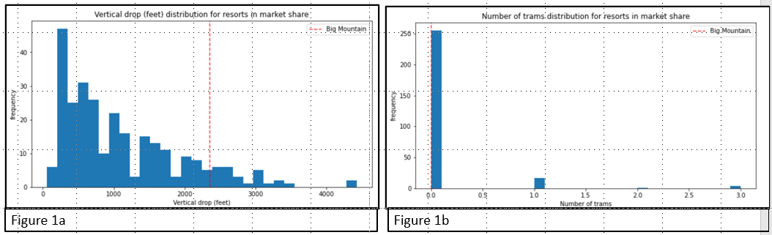Although the resort only needs to increase their ticket prices by 82 cents, their features suggest the price should be much higher. The eight most important features when evaluating a resort are vertical drop, snow Making acreage, total chairs, number of fast quads, number of runs, length of the longest run, number of trams, and skiable terrain in acres. Figure one shows how Big Mountain Resort ranks among the other resorts in the eight features. Big Mountain resort ranks relatively high for vertical drop; however, there are still many resorts with higher drops, which is shown in figure 1a. Additionally, figure 1b shows Big Mountain has zero trams like the majority of other resorts.

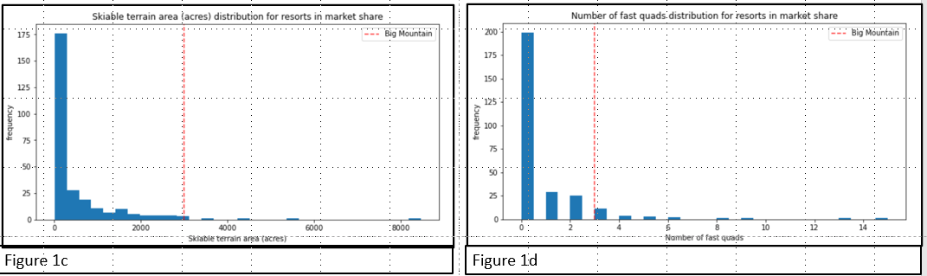Figures 1c through 1g shows there are only a few resorts with more skiable terrain, number of fast quads, and longest run, total number of runs, and total number of chairs than Big Mountain.

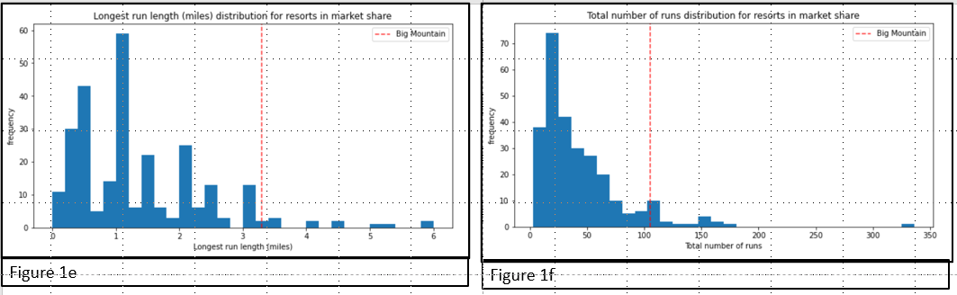

Finally, figure 1h shows that Big Mountain is near the top for snow making area.

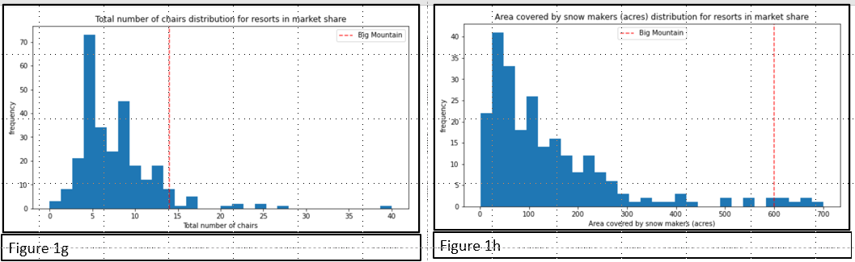

From the four scenarios, I would recommend adding an additional run, adding 150 feet to the vertical and drop and adding an additional lift. This scenario would support increasing the ticket price by 8.70, which would increase revenue by 15,217,391. Extending the vertical drop, adding another run, and additional chair lift is expected to increase ticket price by $1.61 and revenue by $2,815,217. Scenario three is the same as the previous one but adding 2 acres of snow making, which would have the same impact as the previous scenario; thus, adding additional snow has no effect. Finally, scenario 4 calls for increasing the longest run by .2 miles and adding 4 acres of snow making coverage, which would have no impact on ticket price or revenue.

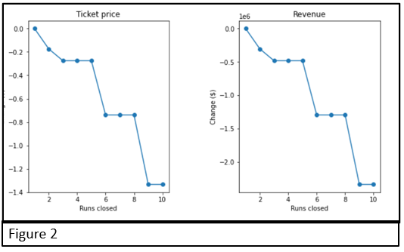Scenario one involved closing down the 10 least unused runs. If Big Mountain Resorts selects this scenario, I recommend the following: Since there is no change in revenue in closing down one run, closing one run will decrease cost without changing revenue. If closing down one does not reduce cost enough, then they should try closing down 2 runs. Finally, they can close down 5 runs because there is no change in revenue between closing 3, 4, and 5 runs. I would not suggest on closing down more than 5 runs because there would be a marketable decrease in revenue as shown in the figure 2.